**Laboratory of Natural Information Processing**

DA-IICT Gandhinagar

**3DNA**

**User Manual**

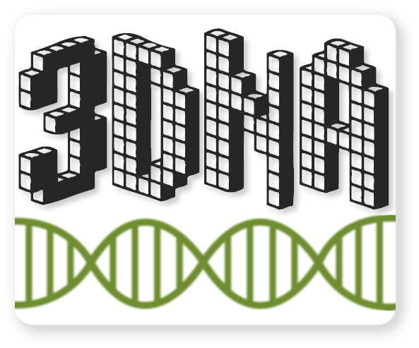

DNA Pen

**User Manual**

**© 2014 Manish K Gupta,**

**Laboratory of Natural Information Processing**

**DA-IICT, Gandhinagar, Gujarat 382007**

[**http://www.guptalab.org/3dna**](http://www.guptalab.org/3dna)

**The software described in this book is furnished under an open source license agreement and may be used only in accordance with the terms of the agreement. Any selling or distribution of the program or its parts, original or modified, is prohibited without a written permission from**

**Manish K Gupta.**

Documentation version 1.0

**Credits & Team**

***Principle Investigator:*** Dr.Manish K. Gupta

***Graduate Mentor:*** Dixita Limbachiya

***Developers:*** Shikhar Kumar Gupta, Foram Meghal Joshi

***Software Logo:*** Foram Meghal Joshi

**Acknowledgements**

The author would like to thank Bruno Lowagie (<http://itexpdf.com>) whose free open source libraries have been used for generating bar codes and PDF. We thank GLYPHICONS free for providing us with icons. (http://glyphicons.com)

**General Information**

Introduction

3DNA is a software suite that can be used to model, edit and visualize complex three dimensional (3D) structures. The software provides a 3D molecular canvas interface where user can model/design complex DNA structures. It also includes a random sequence generator which computes the DNA sequences corresponding to the structure designed on the molecular canvas. Using 3DNA we have created various complex structures with intricate interior cavities and tunnels.

This manual assumes that the user is familiar with the basics of DNA base pairing. The reader should refer to [Three-Dimensional Structures Self-Assembled from DNA Bricks](http://www.sciencemag.org/content/338/6111/1177.short) for further technical details on the language semantics.

Installing 3DNA

The software can be installed from the website [www.guptalab.org/3dna](http://www.guptalab.org/3dna)

**Getting Started**

Once you have successfully installed the software, open 3DNA by double clicking on the application, you will be prompted with a welcome screen with different options on the menu bar.

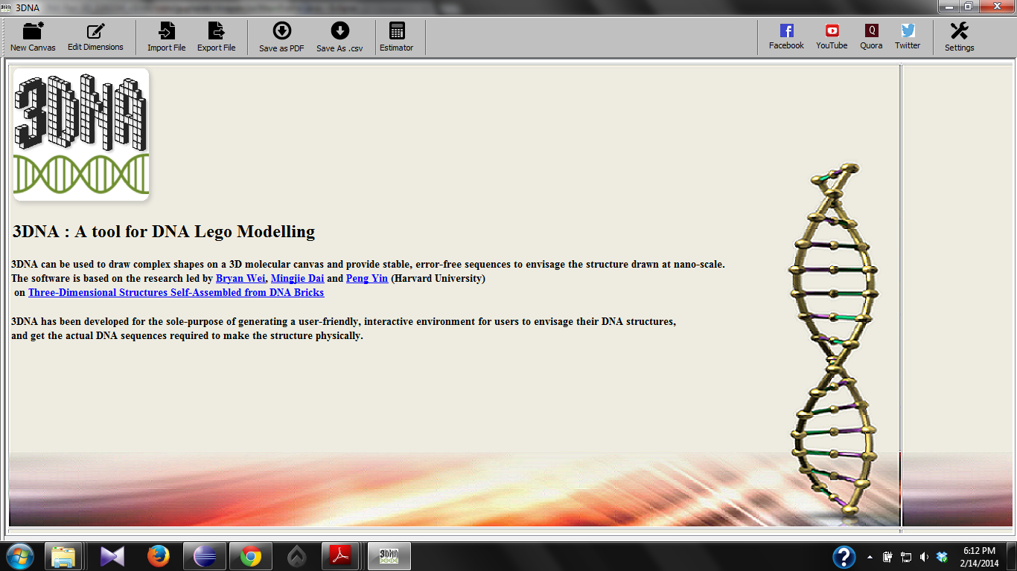

Figure 1: 3DNA Welcome Screen

The main features that the software provides the user with and which are spanned across these four options on the menu bar are:-

* Work on 3D Canvas
* Save DNA Sequences as PDF
* Save DNA Sequences as CSV file
* Edit Dimensions of the 3D Canvas
* Sequence Estimator
* Clear
* Social Media Options

Work on 3D Canvas

This option can be selected by clicking on the “New Canvas” button on the menubar. Once you select the canvas, you will be prompted to enter the dimensions i.e. length, width and depth of the 3D canvas. After entering the dimensions you will be able to see the front view of the molecular canvas of desired dimensions, with an input interface to interact with the canvas.

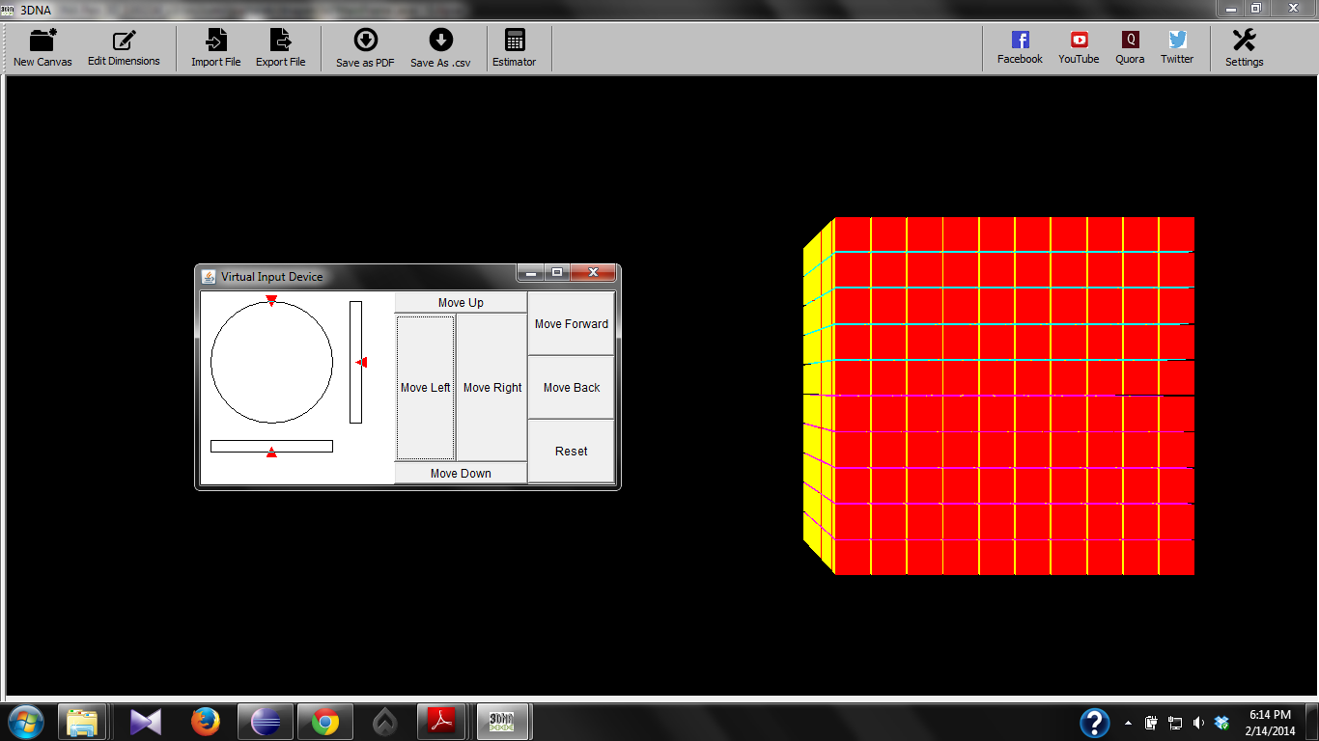

Figure 2: 3DNA 10x10x10 voxel Molecular Canvas

Drawing shapes on the canvas:

A user can model a 3D shape of his choice by deselecting DNA bricks on the molecular canvas. In total each DNA brick will be 32 base pair long.

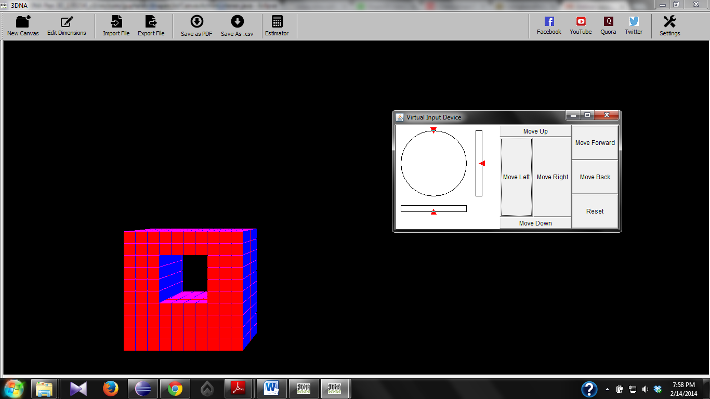

Figure 3: A structure composed on the 10x10x10 voxel Molecular Canvas

**Save Options:**

Once the user has drawn a custom 3D structure on the canvas he can get the corresponding DNA sequences of the shape drawn by clicking on the “Save as PDF” or “Save as .csv” options from the menu bar. The sequences generated by the software self-assemble in one step annealing reaction into prescribed 3D shapes.

Save as PDF:

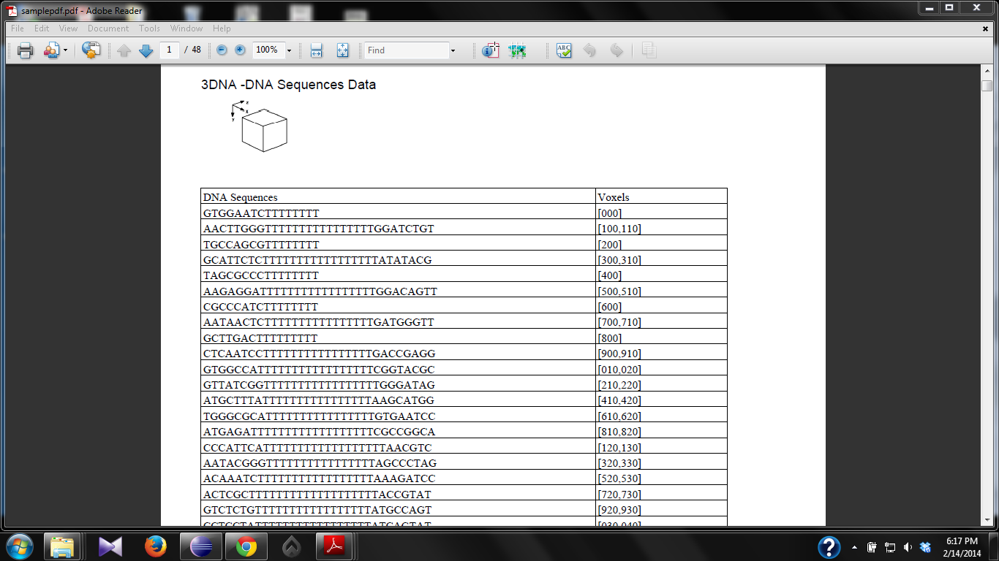

Figure 4: DNA sequences and voxels saved as .pdf file

Save as .csv:

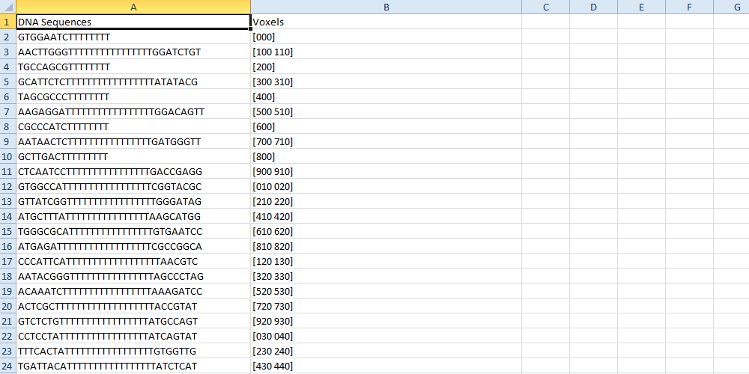

Figure 5: DNA sequences and voxels saved as .csv file

**Support and Feedback**

Users are requested to contact team at the feedback page on the website [www.guptalab.org/3dna](http://www.guptalab.org/3dna) for any issue with the software. Two platform specific installers (Windows and Mac) are available on the project home page along with source code.