DAY 1 - 2
The objective of this activity is to understand What Node.js is and how you can use it to create a Server and connect to the database.

Sessions/Research
- What is Node.js
  - Node.js runs single-threaded, non-blocking, asynchronous programming, which is very memory efficient.
  - Node.js eliminates the waiting and simply continues with the next request.
- What is Non-blocking I/O
- What is NPM
- How do you create a basic Http server on Node.js?
- What is Express.js? How do you create a server using Express?
- How do you connect to the database in Node.js
- Session Management in Express
- async/await

References
- https://nodejs.org/en
- https://expressjs.com

Programming
Create a CRUD API for product database having the following fields Name, Unit of measurement, Price, Image, Product Description. you can use the postman(https://www.getpostman.com/downloads/) app to test your API.

Day 3 - 4
The objective of this activity is to understand React Library and how it can be used to develop a frontend application.

Session/Research
- What is React
- What are components in React
https://medium.com/the-andela-way/understanding-react-components-37f841c1f3bb
- What are props and state in react
https://hackernoon.com/understanding-state-and-props-in-react-94bc09232b9c
- React Lifecycle
- Higher-Order Components
https://medium.com/@soorajchandran/introduction-to-higher-order-components-hoc-in-react-383c9343a3aa
- Refs
- Fragments
- Hooks
- Single Page Architecture?
- Routing in React
- What is Webpack and what is the purpose of Webpack
- What is Redux
- What are Store, reducer, and action in redux

References
- https://reactjs.org/
- https://hackernoon.com/reactjs-component-lifecycle-methods-a-deep-dive-38275d9d13c0
- https://reacttraining.com/react-router/web/guides/quick-start //To see
- https://webpack.js.org/concepts //To read
- https://redux.js.org/introduction/getting-started
- https://www.youtube.com/watch?v=Ke90Tje7VS0
- https://www.youtube.com/watch?v=93p3LxR9xfM

Programming
Use API created during nodejs to create a backend module for adding the product to the database.

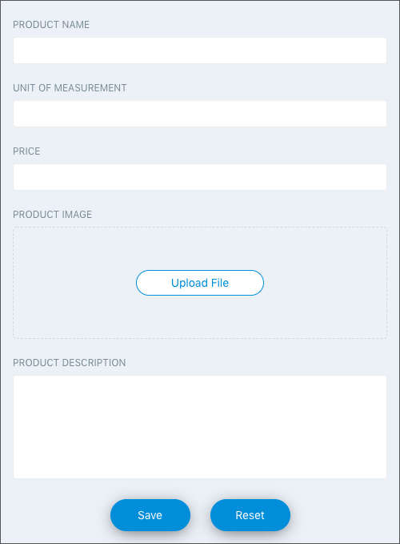

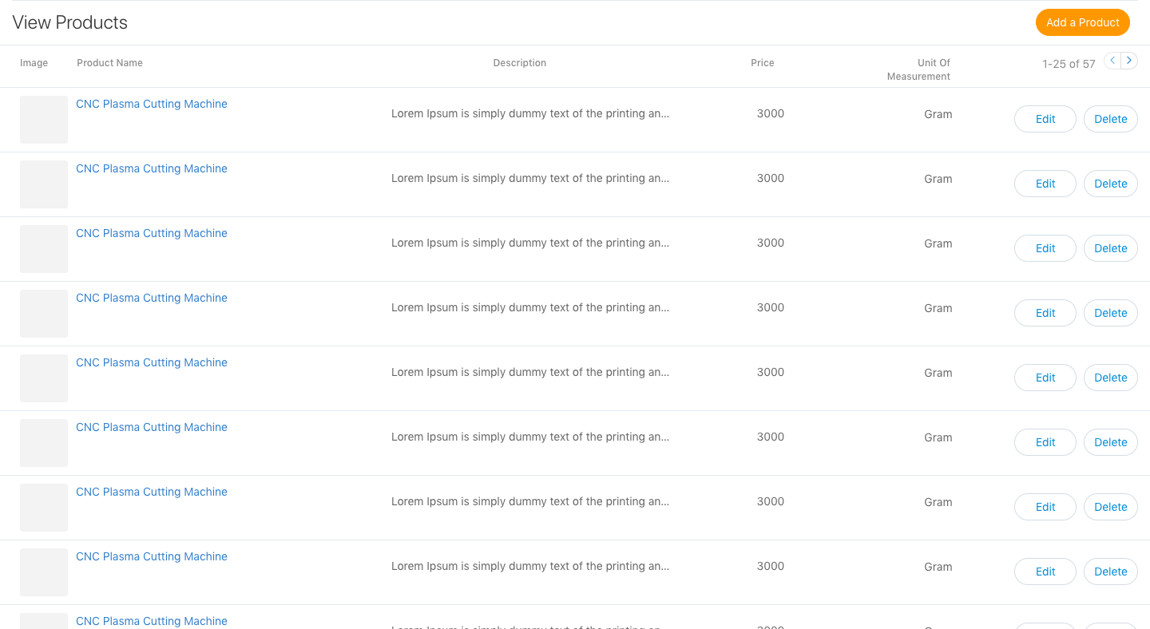

DAY 5-6

Programming
Use React, React Router, Webpack, Redux to develop following Shopping Cart
- Break the entire application in small reusable components and take approval from your mentor.
- Don't Start Developing before Mentor’s Approval
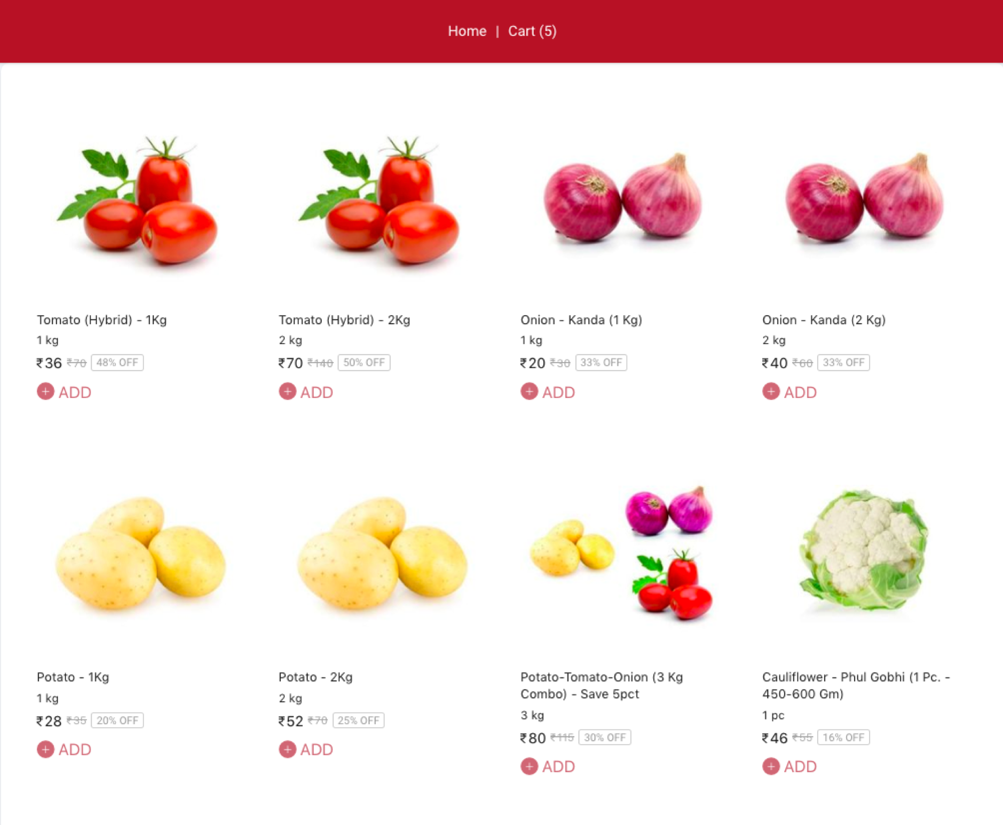
Fig 1) Homepage Containing Listing of Products

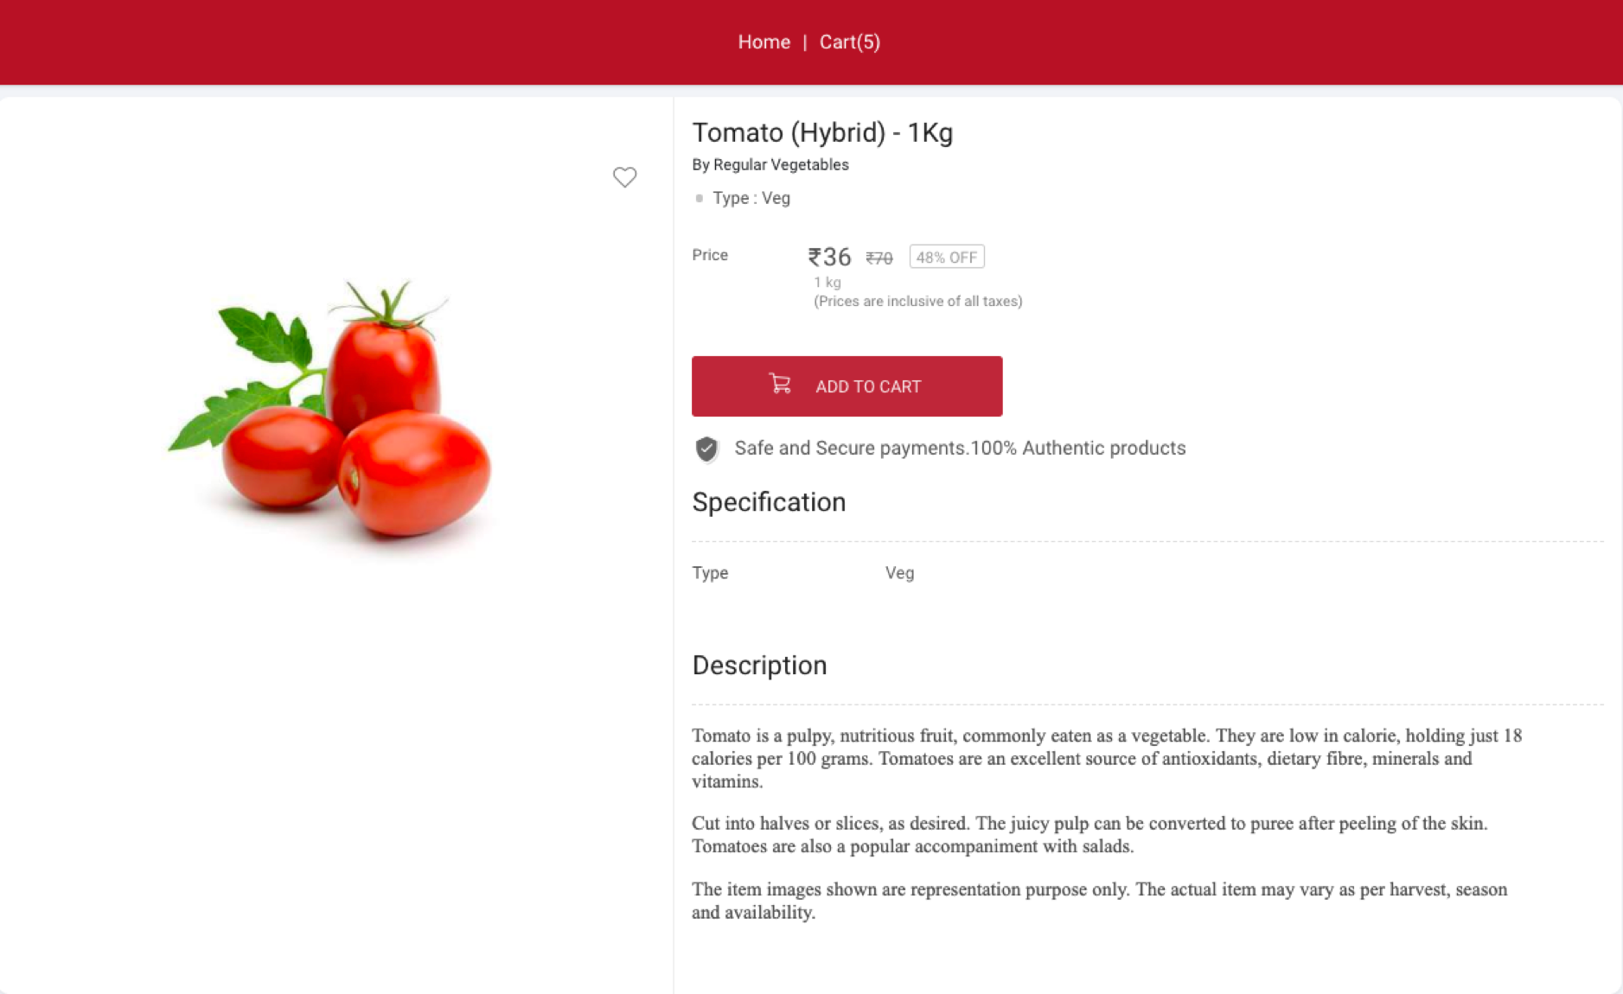

Fig 2) Detail Page of Particular Product
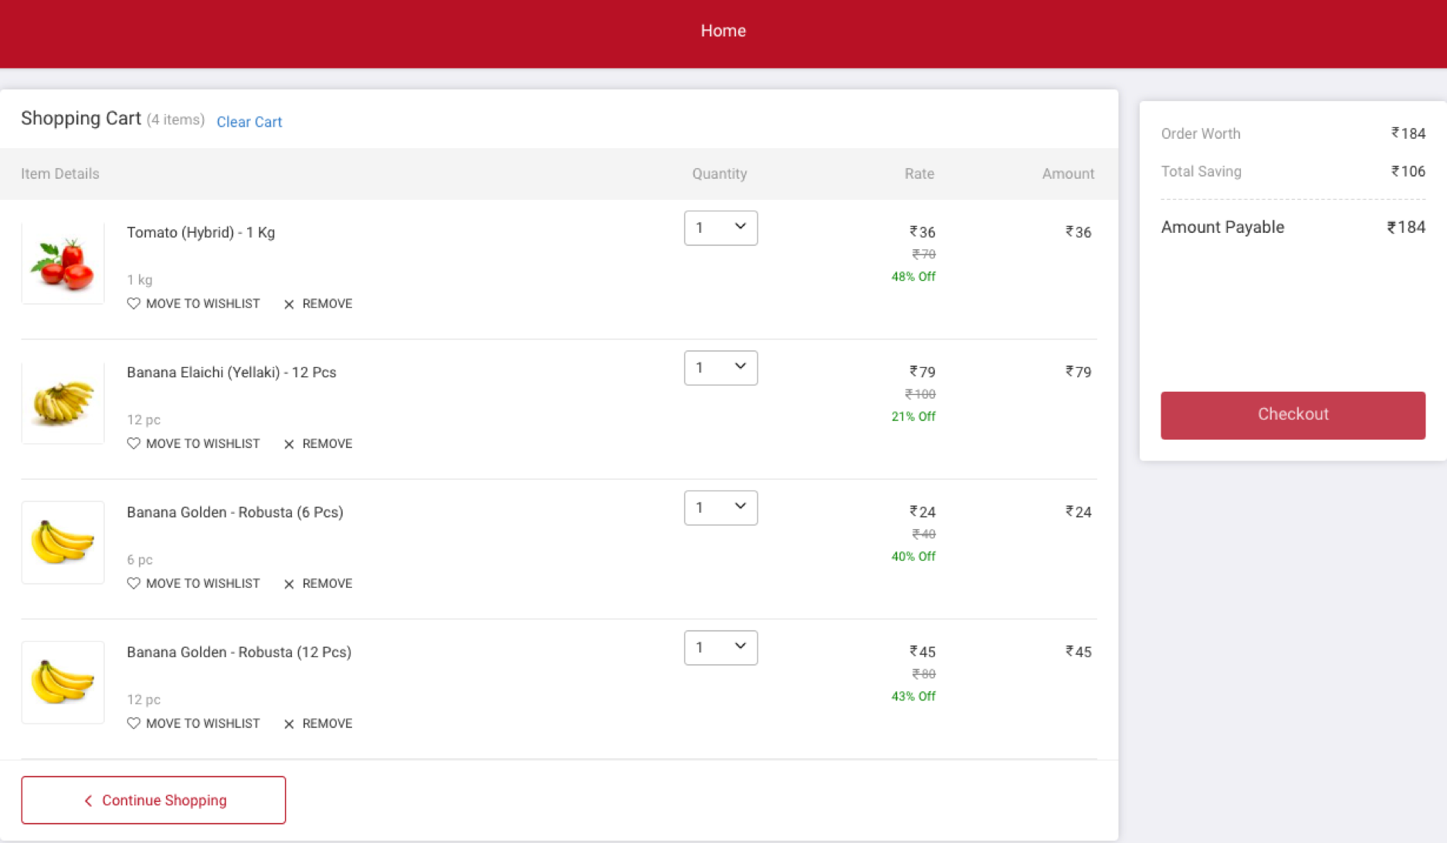
Fig 3) Checkout Page

