Sorting

The Problem
We are given a list L of n elements and we wish arrange the elements in order. Usually the elements to be sorted are part of a larger structure called a record. Each record contains a key which is the value to be sorted. As the keys are rearranged during the sorting process, the data associated with the keys is also rearranged.
Key | Additional data

Terminology
- An internal sort assumes that all of the data is stored in the computers main memory.
- An external sort assumes that large sets are stored in slower, external storage devices.
- A sorting algorithm is called in place if the amount of extra space it uses does not change as the input size changes.
- A sorting method is stable if equal keys remain in the same relative order as they were in the original data.

Selection sorts
During a selection sort the input is divided into two parts such that all of the elements in one part are larger than all of the elements in the other and one of the parts is sorted. Some examples of selection sorts include the bubble sort, the linear selection sort and the heap sort.

Bubble sort

The Bubble sort of a list of n elements involves up to n-1 passes through the list. During each pass, whenever two adjacent elements are out of order, they are exchanged. During the first pass, the largest element bubbles up to the end of the list. Hence, the second pass only needs to cover the first n-1 elements. As shown in the diagram above, the list is divided into two parts where the left part is unsorted and the right part is sorted. Furthermore, every element in the right part is larger than every element in the left part. The code for the Bubble sort involves a nested loop. The outer loop controls the number of passes through the list and the inner loop handles the comparisons between adjacent elements. The Bubble Sort is inefficient both in terms of the number of comparisons required and especially in terms of the amount of data movement. For this reason it should never be used.

Bubble Sort
Repeat until list is sorted
{
sorted = TRUE
pass through unsorted list from element 0 to element n-1
{
if a pair of adjacent elements is out of order
{
swap their values
sorted = FALSE
}
}
}

Linear selection sort

In the linear selection sort we find the smallest element in the list and put it in the first slot. Then we find the smallest element in the remaining portion and place it in the second slot. The general procedure is as follows

Linear selection sort on list[0..n-1]
for i from 0 to n-2 by 1
{
find the location, imin, of the smallest element in list[i..n-1]
swap(list[i],list[imin])
}

Analysis: The number of comparisons is not affected by the input, so we can perform one analysis for the best, worst and average cases. To find the minimum element in list[i..n-1] requires 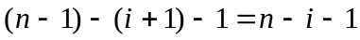 comparisons. The outer loop executes n-1 times and hence the total number of comparisons is
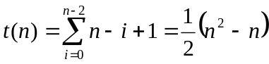
Note, however, that the swap function is in the outer loop and is only executed O(n) times. Hence, the selection sort has much less data movement than the bubble sort or the insertion sort for its worst and average cases.

Heapsort.

The Heapsort algorithm uses a special data structure known as a heap. Recall a complete binary tree has the maximum possible number of nodes at every level except possibly the last level in which all of the leaves are as far to the left as possible. Complete binary trees will have one of the following shapes

A heap is a complete binary tree with the partial order property that the value stored in a node is greater than or equal to any of its children. There is no relationship between the children. Note that each part of a heap is itself a heap.

10
7
9
4
2
7
5
2
1
6

Since a heap is complete we can store it in an array without the space requirements of a linked structure. The children of List(n) are List(2n+1) and List(2n+2). The parent of List(n) is List(floor((n-1)/2)). The heap above would be stored as follows.

10 | 7 | 9 | 4 | 7 | 5 | 2 | 2 | 1 | 6

The overall strategy of the heap sort is: Start with an unsorted array List[0..n-1]. Make the array into a heap. Remove the root List[0] which is the largest element. Since the largest element belongs at the end of the array, place it in position n-1. Restore the heap property of the subarray List[0..n-2]. Remove the root and place it in position n-2. Repeat this process until the heap has no more elements and the entire array is sorted.
heap | sorted array

The following description of a Heapsort algorithm is from Data Structures in C++ by Angela Shiflet.

- Place In Heap
The place in heap algorithm starts with a heap in the subarray List[0..k-1]. The algorithm inserts the element List[k] into the heap by percolating it up the tree as far as necessary to restore the heap property. When the algorithm is completed, the subarray List[0..k] is a heap.
PlaceInHeap
while ((not a heap) and (child not at the root))
find the parent
if (parent < child)
swap the parent and child
move the parent and child markers up the tree one level.
else
we have a heap.

- Build Heap.
The build a heap algorithm assumes that List[0] is a heap and calls the place in heap algorithm to add the remaining elements to the heap.
BuildHeap
for child from 1 to n-1
PlaceInHeap(child)
- Reheap
During the heapsort process, we repeatedly remove the root and exchange it with the last element in the heap. This increases the size of the sorted list by one and decreases the size of the binary tree by one. This exchange, however, often ruins the heap property of the binary tree. The reheap algorithm sifts the element in the root position down the tree until the heap property is restored.
Reheap(sort)
// restores the heap property to the subarray List[0..sort-1].
set parent equal to the root
set child equal to the left child
while ((not a heap) and (the left child exists))
if (right child exists)
set child equal to index of the larger child
if (larger child is greater than the parent)
swap parent and child
move parent down one level
set child equal to the left child
else
we have a heap
- Build sort tree.
The build a sort tree algorithm repeatedly exchanges the root with the last element in the heap and uses the reheap function to restore the heap property to the new and smaller subarray.
BuildSortTree
for sort from n-1 down to 1
swap(List[0], List[sort])
Reheap(sort)
- Heapsort
Calls the build heap and build sort tree algorithms to complete the heapsort process.
BuildHeap
BuildSortTree

Analysis: The Heapsort is O(log₂ n) in the best, worst and average cases. To keep things relatively simple, we consider the worst case analysis. In order to analyze the Heapsort algorithm we must analyze the running time required to build a heap and the running time required to build the sort tree.
Build heap.
The build heap function makes n-1 calls to the place in heap function. In the worst case, we must percolate the element being placed into the heap up through every level in the tree. Since a complete binary tree with n nodes has approximately log₂ n levels, we find that the running time required to build a heap is O(n log₂ n).
Build sort tree.
The build sort tree function makes n-1 calls to the reheap function. In the worst case, reheap must sift down the root through every level in the tree. The heap is initially of size n and decreases in size by one until the entire array is sorted. The following table summarizes the number of comparisons needed.

function call | approximate number of comparisons
reheap(n-1) | log₂ n
reheap(n-2) | log₂ (n-1)
reheap(2) | log₂ 3
reheap(1) | log₂ 2

Based on the table we compute the running time using Stirling’s formula 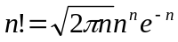.
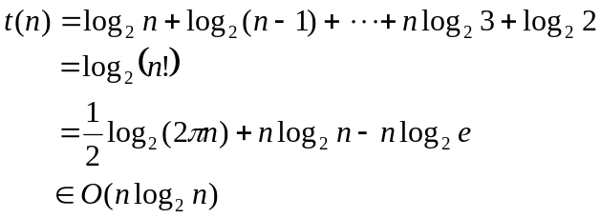
Therefore the heapsort algorithm are O(n log₂ n).

Insertion sort

During an insertion sort the input is divided into two parts such that one part is sorted and there is no relationship between all of the elements in one part and all of the elements in the other part.

To further the discussion, assume the left sublist is sorted and the right sublist is in random order as shown in the diagram above. Take the first item from the right sublist and insert it into the proper place in the left sublist. This decreases the size of the right unsorted sublist by one and increases the size of the left sorted sublist by one. When the length of the right unsorted sublist becomes zero, we are finished sorting. The progress is illustrated in the table where the shaded region represents the sorted part of the list.

original list | 10 | 4 | 8 | 12 | 2 | 6
pass 1 | 4 | 10 | 8 | 12 | 2 | 6
pass 2 | 4 | 8 | 10 | 12 | 2 | 6
pass 3 | 4 | 8 | 10 | 12 | 2 | 6
pass 4 | 2 | 4 | 8 | 10 | 12 | 6
pass 5 | 2 | 4 | 6 | 8 | 10 | 12

During the sorting process we use the index firstOutOfOrder to point to the first element in the unsorted list. Since the first item in the list (index zero) may be considered sorted, we initially set firstOutOfOrder equal to one. The elements in the right sublist are inserted into the left sublist one at a time for a total of n-1 passes through the list. The insertion is accomplished in the following manner: If the “first element out of order” is smaller than the last element in order, we store the “first element out of order” in a temporary location and begin moving the elements in the sorted part of the list one slot to the right until we find the proper location for the first element out of order. The proper location is the first slot for which the “first element out of order” is larger than the element to its left.

Insertion sort on list[0..n-1]
for firstOutOfOrder from 1 to n-1 by 1
{
temp = list[firstOutOfOrder]
location = firstOutOfOrder
while ((location > 0) and (list[location-1] > temp)
{
list[location] = list[location-1]
location--
}
list[location] = temp
}

Note that if the first element out of order is larger than the last element in order, then the “first element out of order” is actually in its proper location and the body of the while loop is not executed. Also note the temporary storage is necessary, since otherwise we would simply back up over the “first element out of order” which we were trying to insert.
i-1
i
i
1
3
2
a₀ a₁ a₂  a_{i-2} a_{i-1} a_{i} a_{i+1}  a_{n-1}

Best case: In the best case the list to be sorted is already in proper order and none of the elements need to be shifted. In this case the while loop’s test is executed only once and
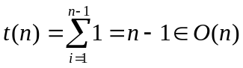
Worst case: In the worst case the list to be sorted is in reverse order and when firstOutOfOrder = i the while loop’s test is executed i times (see diagram above).
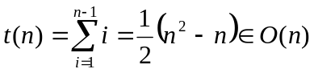
Average case: In the average case we compute the expected value for the number of times the while loop’s test is executed. When firstOutOfOrder = i we have i+1 possible positions for the “first out of order element” a_{i} and the probability of that we will insert a_{i} in position j is 1/(1+i). Note in computing the expected value for the i’th element we have a total of i+1 terms and the last two terms both involve i executions of the while loops test (the last test provides two pieces of information – as shown in the diagram above you can use the results of the final test to place a_{i} in one of two positions).
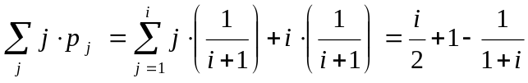
The total for all n-1 insertions is
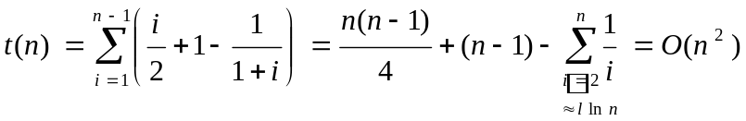
If you study the while loop, you will notice that the number of data moves is proportional to the number of while loop tests and hence, the number of moves is O(n²) for the worst and average cases.

Merge sort

During a merge sort the input is divided into two parts such that both parts are sorted but there is no relationship between all of the elements in one part and all of the elements in the other part.

The merge sort is a “divide and conquer” algorithm with the following logic.
- Divide the list into two approximately equal sublists.
- Sort the sublists recursively.
- Merge the sorted sublists.

258102024131427
2581020
24131427
25 8
10 20
24 13
14 27
25
27
14
13
24
20
10
8
8 25
10 20
13 24
14 27
8 10 20 25
13 14 24 27
8 10 13 14 20 24 25 27
Divide
Merge

Most of the sorting work done in a merge sort is completed during the merging phase. In the merging phase we choose the smaller element from the two sublists and place it in a temporary list.
8 10 20 25
13 14 24 27
8 

The general outline of the Merge sort algorithm is as follows
Mergesort(first,last)
If there is more than one element in the sublist
{
middle = (first+last)/2
Mergesort(first,middle)
Mergesort(middle+1,last)
Merge(first,middle,last)
}

Merge(first,middle,last)
Initialize indices.
Allocate space for a temporary list.
While either sublist is not empty
{
Copy the smaller element from the sublists into the temp.
Advance the indices of temp and the sublist just used.
}
Copy the remaining elements of the first sublist (if any) into temp.
Copy the remaining elements of the first sublist (if any) into temp.
Copy temp into the original list.

Analysis: Since the number of comparisons is not affected by the order of the elements being sorted, we can do one analysis for the best, worst and average cases. Being precise we note that

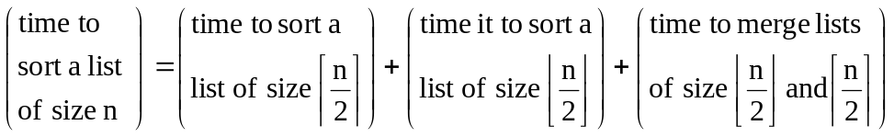

This results in the recurrence

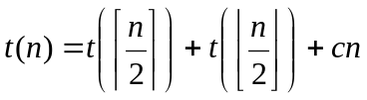

The presence of floors and ceilings make the algorithm difficult to analyze. We make the simplifying assumption that n is a power of 2. Then the recurrence simplifies to

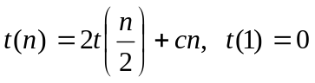

Solve using the iteration technique

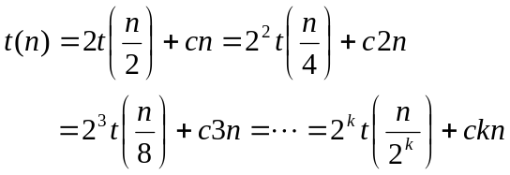

We note that 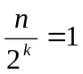 when 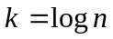from which 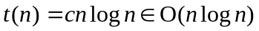.

Split sort

During a split sort the input is divided into two parts such that both parts are unsorted and all of the elements in one part are larger than all of the elements in the other part.

The classic example of a split sort is the Quick sort developed by C.A.R. Hoare in 1962. Quick sort is one of the fastest sorts in practice although it is embarrassingly slow for the case where the data is already sorted. During the Quick sort an element called the pivot is chosen. There are several methods for choosing the pivot, but for now we simply choose the first element in the list. Then we partition the list into three sets including (i) all of the elements less than the pivot (ii) the pivot and (iii) all of the elements greater than the pivot. Most of the sorting work is completed during this partitioning phase. The details of partitioning are illustrated in the example below. The color blue represents the left pointer and the color pink represents the right pointer.

Select the first element in the list as the pivot and initialize the pointers.

H | C | T | F | W | N | Q | I | E | C
0 | 1 | 2 | 3 | 4 | 5 | 6 | 7 | 8 | 9 | 10

Increment the left index until it points to a letter larger than the pivot and decrement the right index until it points to a letter smaller than the pivot and swap.

H | C | C | F | W | N | Q | I | E | T
0 | 1 | 2 | 3 | 4 | 5 | 6 | 7 | 8 | 9

Repeat the process.

H | C | C | F | E | N | Q | I | W | T
0 | 1 | 2 | 3 | 4 | 5 | 6 | 7 | 8 | 9

Repeat again. This time the pointers cross and we do not swap. Instead we terminate the process by exchanging the pivot with the element indicated by the right (pink) pointer.

E | C | C | F | H | N | Q | I | W | T
0 | 1 | 2 | 3 | 4 | 5 | 6 | 7 | 8 | 9

The Quick sort algorithm is as follows

Quicksort(first,last)
{
if (first < last)
{
pivotLocation = partition(first,last)
Quicksort(first, pivotLocation-1)
Quicksort(pivotLocation+1,last)
}
}

Inside the while loop below we (i) increment the left index until reach an element that belongs to the right of the pivot (ii) decrement the right index until reach an element that belongs to the left of the pivot and (iii) swap the elements if the indices have not crossed. After the while loop we move the pivot to its proper position and return the pivot position via the index right.

partition(first, last)
{
left = first
right = last+1
pivot = list[first]

while (left < right)
{
do
{
left++
} while((list[left] < pivot) and (left < last))

do
{
right--
} while(list[right] > pivot)

if (left < right)
swap(left,right)
}

swap(first,right)
return right
}

Best case:
The partition always divides the list into two equal parts. We then obtain the recurrence 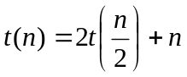
where the left hand side represents the time to Quicksort n elements and the right hand side represents the time to partition the n elements and then Quicksort two lists of length n/2. Since we have already solved this recurrence we investigate a different strategy.
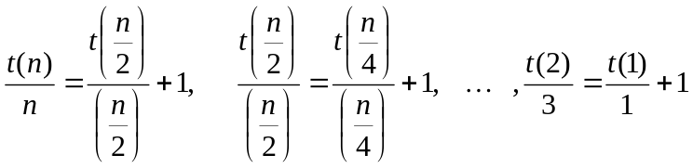
Adding the equations and subtracting off the common terms we obtain
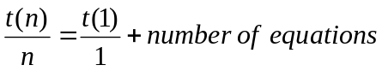
If we assume that n is a power of 2, then the number of equations is log₂ n and 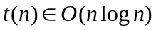.

Worst case:
If the list is already sorted and the first element is chosen as the pivot, the list will be divided into a list of length zero and a list of length n. The same problem occurs at the other end of the list if the elements are in reverse order. We obtain the “chip and conquer” recurrence
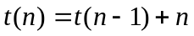
Applying the same logic as in the best case we compute
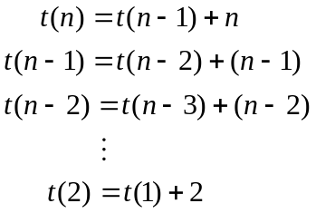

Adding the equations and subtracting off the common terms we obtain
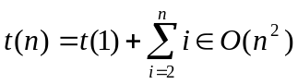

Average case:
Assume that all of the possible pivot positions are equally. We summarize all of the possible partitions below
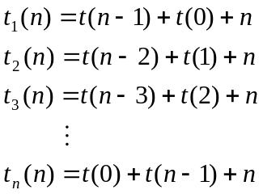
To compute the average we compute the sum on both sides and note that
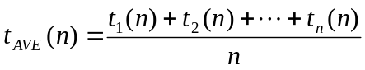
from which
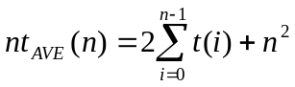
or
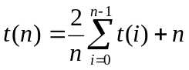.
This recurrence is a “full history” recurrence since it involves all of the previous generations. The key to solving it is algebraic treachery. First reduce the index by one
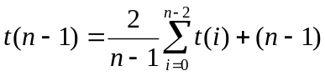
Multiply the original recurrence by n, multiply the reduced recurrence by n-1, subtract and simplify to obtain
Our motivation for this step is to eliminate the summation. Divide both sides by n(n+1) and introduce the notation w(n)
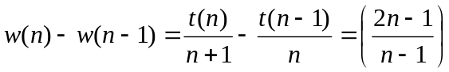
Write down this equation for indices n, n-1, n-2,…,3,2,1 and sum on both sides to obtain
where we have used the Harmonic series for the first sum and a partial fractions decomposition and a telescoping sum for the second sum. Simplifying yields
.

Speed limit on comparison based sorting

As with searching we use the information theoretic lower bound technique of creating a comparison tree. The progress of any comparison based sorting algorithm (makes comparisons of L[i] with L[j]) can be described by a path through a binary tree. Each node in the tree represents one comparison and the left and right branches represent the paths the algorithm takes depending on the results of the comparison. The comparison tree must have at least n! nodes, since there are n! permutations of a list containing n items. The maximum number of comparisons needed to sort the list is equal to the height of the tree plus one. Using the theorem

Theorem: A binary tree of height h has at most 2^{h+1}-1 nodes. Equivalently, the height of a binary tree with n nodes is at least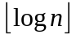.

we find that that we need at least 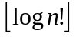+1 comparisons. Using the bounding argument shown below we determine that the worst and case running times of comparison based sorting is 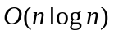.
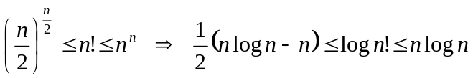

Summary

In the table below we summarize some of the properties of the various sorting algorithms we have been studying.
Table: Comparison of Sorting Algorithms
Algorithm  Category | Sorting  Algorithm | Worst  Case | Average  Case | Best  Case | In  Place | Stable | Recursive
Selection | Bubble | O(n²) | O(n²) | O(n) | yes | yes | no
Selection | Linear selection | O(n²) | O(n²) | O(n²) | yes | no | no
Selection | Heap | O(n log₂ n) | O(n log₂ n) | O(n log₂ n) | yes | no | no
Insertion | Insertion | O(n²) | O(n²) | O(n) | yes | yes | no
Merge | Merge | O(n log₂ n) | O(n log₂ n) | O(n log₂ n) | no | yes | yes
Split | Quick | O(n²) | O(n log₂ n) | O(n log₂ n) | yes | no | yes

Project

- Bubble sort.
  - Illustrate the steps of the bubble sort algorithm on the data “S T A B L E”.
  - Implement the Bubble sort algorithm in C++.
  - How many comparisons does the bubble sort do in the best case?
  - What arrangement of keys is a best case?
  - How many comparisons does the bubble sort do in the worst case?
  - What arrangement of keys is a worst case?
  - Is the bubble sort stable? (Explain why or why not?)
- Insertion sort.
  - Illustrate the steps of the insertion sort on the data “I N S E R T I O N”.
  - Provide an example illustrating why the insertion sort is stable.
- Selection sort.
  - Illustrate the steps of the selection sort on the data “S E L E C T I O N”.
  - Provide an example showing that the selection sort is not stable.
- Merge sort
  - Illustrate the steps of the merge sort on the data “M E R G E S O R T”
  - Devise a Mergesort algorithm that recursively splits the list into three approximately equal pieces and then merges them. Set up and solve the recurrence that models this algorithm.
- Quick sort.
  - Illustrate the steps involved in partitioning the data “Q U I C K S O R T” using the first element as a pivot.
  - Implement the Quicksort algorithm in C++ using the median-of-three method of determining the pivot. Rather than using the first element as the pivot, compute the median of the first, middle and last elements and swap with the first element before partitioning. Obviously, do not attempt to use the median-of-three technique when the length of the list is less than three.
  - Implement the Quicksort algorithm in C++ so that it uses the Insertion sort once the length of the sublist becomes less than or equal to 15.
- Benchmarking
Write a C++ application that will benchmark the following five sorting algorithms.
- Insertion sort
- Selection sort
- Merge sort
- Quicksort
- Combo sort (from problem 2c)
The application will consist of the following three parts.
-------------------------
Part 1 (Random List)
-------------------------
Run 500 trials. In each trial, generate a list of 10,000 random integers and use that same list for each of the six sorting algorithms. Compute the average running time over the 500 trials.
-----------------------
Part 2 (Sorted List)
-----------------------
Run 500 trials. In each trial, generate a list of 10,000 integers in sorted order (just let List[i] = i) and use that same list for each of the six sorting algorithms. Compute the average running time over the 500 trials.
---------------------------------
Part 3 (Reverse Sorted List)
---------------------------------
Run 500 trials. In each trial, generate a list of 10,000 integers in reverse sorted order (just let List[i] = 10000-i) and use that same list for each of the six sorting algorithms.
--------
Output
--------
You are to output the results of each part. Your output should look something like:
Sorting algorithm performance.
Each list contained 10,000 elements and each average was over 500 trials.
PART 1  Random Order | PART 2  Sorted Order | PART 3  Reverse Sorted Order
Insertion Sort:  Average: __ ms  Selection Sort:  Average: __ ms  Merge Sort:  Average: __ ms  Quick Sort:  Average: __ ms  Combo Sort:  Average: __ ms | Insertion Sort:  Average: __ ms  Selection Sort:  Average: __ ms  Merge Sort:  Average: __ ms  Quick Sort:  Average: __ ms  Combo Sort:  Average: __ ms | Insertion Sort:  Average: __ ms  Selection Sort:  Average: __ ms  Merge Sort:  Average: __ ms  Quick Sort:  Average: __ ms  Combo Sort:  Average: __ ms

