**A Project Report**

On

# “HOME AUTOMATION”

Submitted in partial fulfillment of the requirements of the degree of

**Bachelor of Engineering** in

**Computer Engineering** by

Mr. MANISH GUPTA 116CP1345A

Mr.DEENBANDHU GUPTA 117CP3186A

Mr. MANGESH GUNJAL 116CP1432A

Internal guide:

Prof. SWATI GUPTA



Department of Computer Engineering

**Mahatma Gandhi Mission’s College of Engineering and Technology**

Kamothe, Navi Mumbai - 410 209

**University of Mumbai**

Academic Year - 2019-2020

**Project Report Internal Approval for Bachelor of Engineering**

# CERTIFICATE

This is to certify that the project entitled **“HOME AUTOMATION”** is a bonafide work of “**Mr. GUPTA MANISH(116CP1345A)**, **Mr. GUPTA DEENBANDHA(**117CP3186A**)**,

**Mr. MANGESH GUNJAL(**116CP1432A**)”** submitted to the University of Mumbai in partial fulfillment of the requirement for the award of the degree of

**“Bachelor of Engineering”** in **“Computer Engineering”**.

Prof.Swati Gupta Prof. Abhijit Patil

Project Guide Project Co-ordinator

Dr. K. Sankar

Head of Department Director / Principal

# 

# Declaration

We declare that this written submission represents our ideas in our own words and where other's ideas or words have been included, we have adequately cited and referenced the original sources. We also declare that we have adhered to all principles of academic honesty and integrity and have not misrepresented or fabricated or falsified any idea/data/fact/source in our submission. We understand that any violation of the above will be cause for disciplinary action by the Institute and can also evoke penal action from the sources which have thus not been properly cited or from whom proper permission has not been taken when needed.

------------------------------------------

(Signature)

Mr.GUPTA MANISH

(116CP1345A)

------------------------------------------

(Signature)

Mr. Gupta Deenbandhu

(117CPA)

------------------------------------------

(Signature)

Mr.Gunjal Mangesh

(116CPA)

Date:

Place:

Sr. Table of Contents Pg. no.

|  |  |  |
| --- | --- | --- |
| 1. | List of Figures | Iii |
| 2. | Abstract | Iv |

|  |  |  |
| --- | --- | --- |
| 1. | Introduction | 1 |
| 1.1. | Introduction | 1 |
| 1.2. | Background | 3 |
| 1.3. | Project Objectives | 4 |
| 1.4. | Project Scope | 4 |
| 1.5. | Technology Exposures That Project Provides | 5 |
| 1.6. | Project Management | 5 |
| 2. | Home automation and history | 6 |
| 3. | Literature Review | 7 |
| 4. | Existing system | 8 |
| 5. | Proposed System | 9 |
| 5.1. | Proposed System Work Flow | 11 |
| 6. | System architecture | 12 |
| 7. | Block diagram | 13 |
| 8. | Hardware requirement | 14 |
| 9. | Technology used | 20 |
| 10. | Hardware and Programming Language Description | 22 |
| 11. | Software Description | 23 |
| 12. | Scope and application | 23 |
| 13. | Limitation.. | 24 |
| 14. | Further Enhancement. | 24 |
| 16. | Conclusion | 24 |
| 17. | Future scope | 25 |
| 18. | References | 26 |

Sr. no. List of Figures Pg. no.

|  |  |  |
| --- | --- | --- |
| 1. | Smart home | 2. |
| 2. | Workflow modal | 5. |
| 3. | Work flow of Existing System | 8. |
| 4. | Basic Flow of Proposed System | 10. |
| 6. | System architecture | 12. |
| 8. | Raspberry pi | 14. |
| 9. | Aurdino | 15. |
| 10. | Relay and relay driver | 16. |
| 11. | Mobile android app | 17. |
| 12. | Start Mode Activity | 18. |
| 13. | Option Mode Activity | 18. |
| 14. | Voice Mode Activity | 19. |
| 15. | Switch Mode Activity | 19. |
| 16. | Raspberry pi board | 20. |
| 17. | Raspberry pi pin diagram | 21. |
| 18. | Block Diagram of Hardware Description | 22. |

**HOME AUTOMATION**

**Abstract**

This project presents the overall design of Home Automation System (HAS) with low cost and wireless system. This system is designed to assist and provide support in order to fulfill the needs of elderly and disabled in home. Also, the smart home concept in the system improves the standard living at home. The switch mode and voice mode are used to control the home appliances.The main control system implements wireless technology to provide remote access from smart phone. Voice Based Home Automation System using Raspberry Pi is the project which will be very useful for old age people and disabled people, basically for one’s who cannot perform basic activities efficiently. It is the idea which corresponds to the new era of automation and technology. The main aim of the home automation system is to make life easier. Mobile devices are very common among everyone due to its user friendly interface and portability features. In this project we aim to control electrical home appliances by android voice commands using Wi-Fi as communication protocol between Raspberry Pi and Android device. Raspberry Pi becomes a better option for home automation via internet due to its feature of inbuilt Wi-Fi and Bluetooth. The design remains the existing electrical switches and provides more safety control on the switches with low voltage activating method. The switches status is synchronized in all the control system whereby every user interface indicates the real time existing switches status. The system intended to control electrical appliances and devices in house with relatively low cost design, user-friendly interface and ease of installation.

1. **INTRODUCTION**

**1.1.Introduction**

In today’s day to day life automation can play a major role. Automation makes thing simple. The main benefit of any automated system is reducing human labor, efforts, time and errors due to human negligence.A Raspberry Pi is a credit card-sized computer which can be used for developing various applications. This project is based on Internet of Things (IoT). Internet of Things is a network of devices such as electrical appliances for connectivity which enables these devices to connect and exchange data. This project represents a flexible way to control devices. In this project we are working on an android application where a user will provide voice commands for controlling devices such as “Turn light on” which will be connected to raspberry pi and according to it the required process will work via Wi-Fi. MySQL database and PHP is required for connectivity. This automation can be used majorly not only in home but offices and hospitals also. User can register and authenticate himself/herself in android device and after successful login he/she can give the input commands and operate the devices. It also provides security from third party users. It allows controlling number of home appliances simultaneously. Python is used as the main programming language which is default, provided by Raspberry Pi. This system requires micro SD card with an OS (Ubuntu Mate) for Raspberry Pi. Using this we can say a regular home is converted to smart home.

Voice Based Home Automation System Using Raspberry Pi is the hardware and software project in which user get the chance to operate all the electronic devices using smartphone through voice commands .User may Launch an application of “Home Control” in smartphone and connect to appropriate Wi-Fi for connection with Raspberry Pi then he/she may get registered. After successful Registration user must Login in to operate the application and give voice command accordingly. The process of command matching is done and Raspberry Pi Performs operation of ON/OFF on that particular device. This way user gets the flexibility to do this activity easily and efficiently.

Everyone wants their assets to be protected from threats and harm. People want security in everyplace possible when they are away from their homes. In 21st century crime rates have got increased and people want security so This system is designed in that way to provide automated advance security for their homes.

Home automation system has grown rapidly, which provide us with convenience, comfort and mainly quality of life and focus on security for all the residents. people are habitual of automated devices, which are commonly known as smart devices, with the rapid development in the field of technology everyday new devices are created, the IOT has also emerge as boost up to make smart device even smarter. In today’s era most homes consist of electrical devices which are controlled manually but with evolution of IOT these devices made the working simpler and controllable by automation. Today the main concern is security. With the use of these IOT based devices security can be achieved and full equipped home security measures can be taken.

This paper focus on working and implementation of some techniques and methods of home automation for security which are already existed and compares the time cost and speed and functionalities. Markets are full of many home automation technologies; our research paper compares some existing technology and has selected a choice of available technology and highlight their drawbacks and advantages.

The rest of the paper has following sections which will cover the applications of Tech used and its advantage and drawbacks in our paper and also covers all the methiodal of our research and further we will conclude in our last section.

All the applications are now cloud based support and devices itself are cloud oriented and connected to all the nearby devices. internet of things is just interconnection of all the connected devices with each other to share data and to make things easier.

These types of devices are now well equipped with performing actions which are not possible earlier. The main point here is now devices are more capable of doing thing in protecting our home and surveillance.

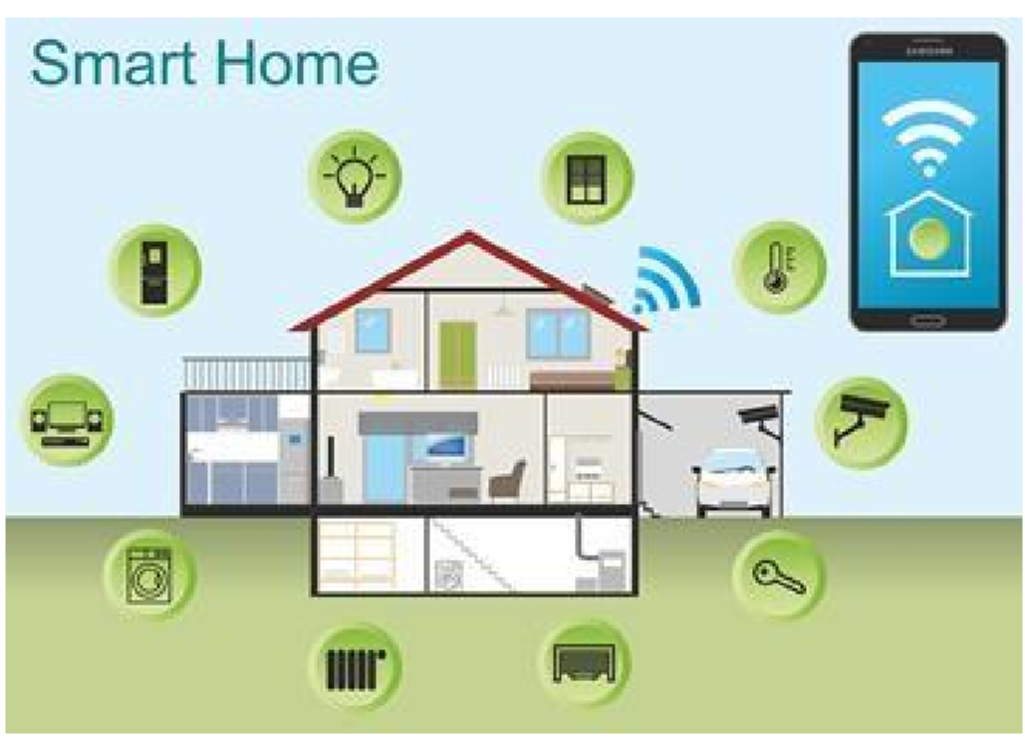

Fig:1 Smart Home

**1.2. Background.**

The “Home Automation” concept has existed for many years. The terms “Smart Home”, “Intelligent Home” followed and has been used to introduce the concept of networking appliances and devices in the house. Home automation Systems (HASs) represents a great research opportunity in creating new fields in engineering, and Computing. HASs includes centralized control of lighting, appliances, security locks of gates and doors and other systems, to provide improved comfort, energy efficiency and security system. HASs becoming popular nowadays and enter quickly in this emerging market. However, end users, especially the disabled and elderly due to their complexity and cost, do not always accept these systems.

Due to the advancement of wireless technology, there are several different of connections are introduced such as GSM, WIFI, and Bluetooth. Each of the connection has their own unique specifications and applications. Among the four popular wireless connections that often implemented in HAS project, WIFI is being chosen with its suitable capability. The capabilities of WIFI are more than enough to be implemented in the design. Also, most of the current laptop/notebook or Smartphone come with built-in WIFI adapter. It will indirectly reduce the cost of this system.

This project forwards the design of home automation and security system using Raspberry pi, a credit sized computer. Raspberry pi provides the features of a mini computer, additional with its GPIO pins where other components and devices can be connected. GPIO registers of raspberry pi are used for the output purposes. We have design a power strip that can be easily connected to GPIO Pins of the Raspberry pi. The home appliances are connected to the input/output ports of Raspberry pi along with the power strip and their status is passed to the raspberry pi. The android running OS in any phone connected to a network can access the status of the home appliances via an application. It presents the design and implementation of automation system that can monitor and control home appliances via android phone or tablet.

* 1. **Project Objectives**

Android controlled Smart Home Automation should be able to control the home appliances wirelessly with effectively and efficiently.

**Controlling Home Appliances via Application (Switch and Voice Mode)**

To develop an application that includes the features of switches and voice mode application. Switch Mode or Voice Mode can be used to control the switches of home appliances.

**Real Time Video Streaming from IP camera**

To receive the quality video from the camera to the android application.

**Secure Connection Channels between Application and Raspberry pi**

Use of secure protocols over Wi-Fi so that other devices cannot control the appliances. Options for secure connection is SSL over TCP, SSH

**Controlled by any device capable of Wi-Fi (Android, iOS, PC)**

To make the home appliances flexible in control, any device capable of Wi-Fi connectivity will able to control the home appliances from remote location.

**Extensible platform for future enhancement**

The application is to be highly extensible, with possibility of adding features in the future as needed.

**1.4 Scopes**

The project aims at designing a prototype for controlling the home appliances that can be controlled wirelessly via an application that provides the features ofspeech recognition, video streaming, and switch mode. An application is run on android device. The system can be used in wide range of areas.

The system integrated with different features can be applied in the following fields.

**• The system can be used in home, small offices to the big malls**

The system can be used from home to offices to control the electrical appliances.

**• For remote access of appliances in internet or intranet.**

The home/office appliances can be controlled in intra-network or can be accessed via

Internet.

**• For the development of technology friendly environment**

The system incorporates the use of technology and making smart home automation. By

the use of day to day gadgets we can utilize them for different prospective.

**1.5. Technology Exposures That Project Provides:**

1. Google’s Android open source technology.

2. Wi-Fi technology.

3. Interfacing Wireless Adapter to Raspberry pi.

4. Interfacing relays with ac and dc power sources.

5. Using Transistor as a Switch.

6. Embedded programming.

**1.6. Project Management**

This project constituted development of application as its major part as well as the hardware to control home appliances. Management of any project has several steps or processes in it. So, our projects can be described under the following steps-:

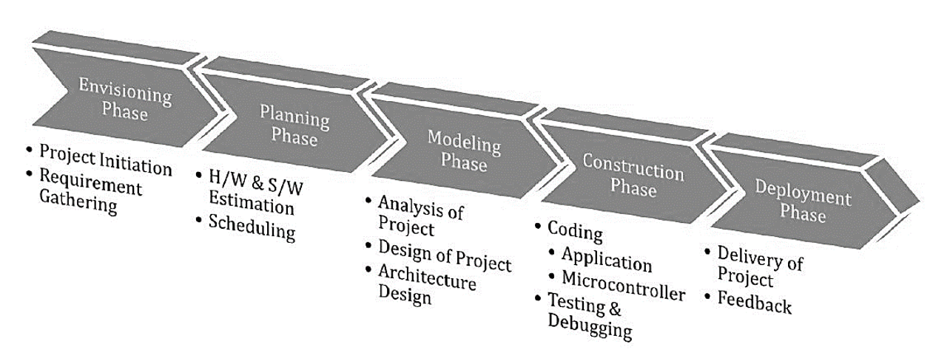

Fig:2 Waterfall model

**1.5.1. Experimentation**

In this step, we were discussing about the necessary equipments and materials. We were studying about the similar projects, gathering the information of programming language to be used. We were developing simple algorithms and flowcharts.

**1.5.2 Design**

In this phase, we were designing the layout of the application. The necessary features to be included. We were designing the power strip to connect the home appliances that can be controlled via GPIO pins.

**1.5.3. Development and Testing**

In this phase, the development of application was performed. The bugs were identified and removed. We consulted many software experts for the evaluation of our application. Hardware design includes the design of power strip.

**2. HOME AUTOMATION & HISTORY**

In 19th century, concept of home automation came into the picture. The Electronic Computing Home Operator was developed in the April 1968 and has been enhanced from a set of spare electronics. Further X10 standard was developed to allow transmitters and receivers to broadcasting messages such as “turn ON” and “turn OFF” via radio frequency. X10 system has number of disadvantages. With the invention of the Raspberry pi which is small credit card size computer having large number of peripherals along with communication ports like Ethernet, USB ports, HDMI port, now a day’s home automation is become very easy and interesting. Home automation includes all that a building automation provides like door and window controls, climate controls, control of multimedia home theatres, pet feeding, plant watering and so on. Home automation is nothing but ‘Smart home’ or ‘Intelligent home’. Such smart homes or intelligent homes are controlled with the help of various technologies. GSM, WIFI, Bluetooth, Zig bee and so on are used for the purpose of home automation.

**3. Literature Review:**

As per our survey, there exist many systems that can control home appliances using android based phones/tablets. Each system has its unique features. Currently certain companies are officially registered and are working to provide better home automation system features. Following models describes the work being performed by others

N. Sriskanthan [7] explained the model for home automation using bluetooth via PC. But unfortunately the system lacks to support mobile technology.

Muhammad Izhar Ramli [8] designed a prototype electrical device control system using Web. They also set the server with auto restart if the server condition is currently down.

Hasan [9] has developed a telephone and PIC remote controlled device for controlling the devices pin check algorithm has been introduced where it was with cable network but not wireless communication.

Amul Jadhav [10] developed an application in a universal XML format which can be easily ported to any other mobile devices rather than targeting a single platform. Each of these system has their own unique features and on comparison to one another lacks some advancement.

Our designed system has application layer prototype. The application is able to synthesize the speech data with the help of Google Voice Reorganization. The synthesized data are analyzed and further processing is carried out. In layman words, our design system provides features of controlling the home appliances using voice commands.

The use of socket programming is performed to connect the android application with the raspberry pi. This further adds security to our system. The data are received only by the server at the specified port and data are further analyzed. Our project is different in a sense it has its own software level application to control the home appliances.

**4. EXISTING SYSTEM**

In traditional method we have switches, switch boards which are connected through wires to each electronic device. In existing system of Arduino the foremost aim of technology has been to increase efficiency and decrease effort. It thus is of extreme importance to simplify human interfacing with technology. Automation is one such area that aims that achieves simplicity while increasing efficiency. Voice controlled Home Automation System aims to further the cause of automation so as to achieve the goal of simplicity. Applications are being developed on Android system that is useful to us in various ways. Another upcoming technology is natural language processing which enables us to command and control things with our voice. Combining all of these, it presents a microcontroller based voice controlled home automation system using smartphones. Such a system will enable users to have control every appliance in his/her home with their voice. An Arduino Uno microcontroller circuit processes commands and perform operations on devices. The connection between the Arduino and the smartphone is achieved by Bluetooth, which is used for sharing data.

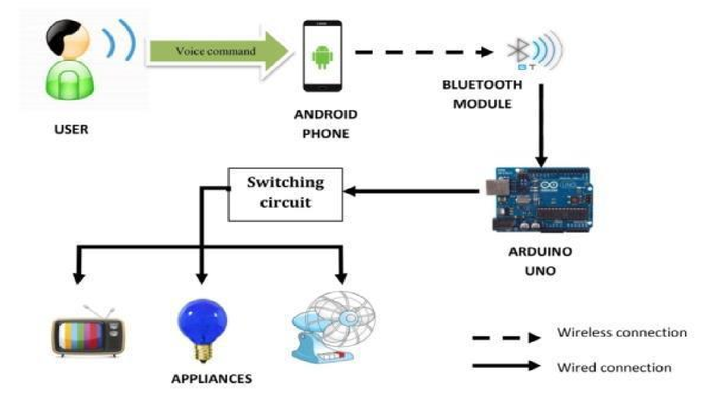

Fig:3 Work flow of Existing System

**5. Proposed System:**

The android OS provides the flexibility of using the open source. The inbuilt sensors can be accessed easily. We have built an application with following features. Android Phone acts as a client and data are sent via sockets programming.

1. Switch Mode

1. Voice Mode

Switch mode uses the radio buttons that are used to control the home appliances. The radio button sends the status of the switch.

Voice Mode is used to control the home appliances using voice command. Using the inbuilt microphone of Smartphone, the application creates an intent that fetches the speech data to the Google server which responds with a string data. The string data are further analyzed and then processed.

All the devices are connected to a common network. Smartphone, raspberry pi and are connected to the common network Router is used to create a common network.

Wi-Fi Adapter is used to connect raspberry pi to the network. Raspberry pi is used to maintain the server. The pi collects the data analyses it and further activates GPIO pins as necessary. The GPIO pins of raspberry pi are connected to the relay. Relay switch are used to connect the home appliances

**Advantages of Wi-Fi over other wireless technologies like Bluetooth and ZigBee:**

Bluetooth is generally used for point to point networks and Bluetooth operates at a much slower rate of around 720 Kbps which is very small for video transfer or moving large amount of data like the image captured from a camera, whereas the bandwidth of Wi-Fi can be up to 150Mbps and very ideal for video transmission.

Wi-Fi is very much secure means of communication than Bluetooth.

Wi-Fi connection to send video, audio, and telemetry operation, while accepting remote control commands from an operator who can be located virtually anywhere in the world.

Robots are already being eyed for obvious tasks like conducting search-and rescue missions during emergencies or hauling gear for soldiers in the jungle or woods. The mechanics of the robot uses the concept that has been developed to ensure robust navigation, search and transportation in rough terrain.

The proposed system includes a voice controlled system that will enable users to control basic level home automation. The system includes a Raspberry Pi whose GPIO pins will be used to transfer signals to a controller based on voice commands filtered by the Raspberry Pi’s module. A user friendly interface is built for the android device that allows the user to interact with the Raspberry Pi. The overall design of Home Automation System (HAS) implements wireless communication between a Raspberry Pi module and an android based application. The main operating system uses Wi-Fi to provide remote access from raspberry pi. The Home Automation project is based on a Raspberry Pi 3 processor. The android application controls the Raspberry Pi wirelessly to perform the necessary function. . The connection between the Raspberry Pi and the controller is established via interconnection. The simplification of services would entail a wider adoption of existing technology and would help people with varied disabilities access the same technology. Voice controlled House Automation System leverages the power of Raspberry Pi to provide a holistic voice controlled automation system.

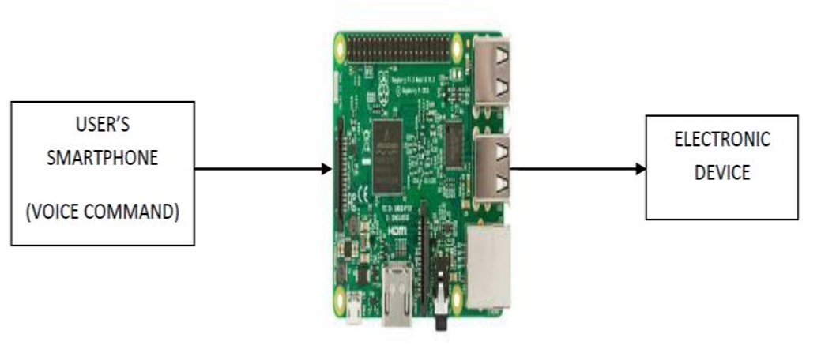

Fig :4 Basic Flow of Proposed System

The instructions from the user will be transmitted through the Wi-Fi network. The raspberry pi board is configured according to the home system and it will enable the relay circuit as per user request. The relay circuit is used to control the Electronic devices and can add additional security features. The main objectives of the proposed system is to design and to implement a cheap and open source home automation system that is capable of controlling and automating most of the house appliances through an android device.

**5.1. Proposed System Work Flow**

In proposed flowchart of voice based home automation using the technology of the Raspberry Pi. The system flow starts from the android app first user have to launch the “Home Control” app in his/her smartphone. Then check for available Wi-Fi modules and connect to particular Wi-Fi which is also connected to the raspberry pi. Once smartphone is connected to the Wi-Fi user has to provide the IP address of the Raspberry Pi. Then user gets registered. After this user Login where users credentials is checked. If it is right user moves to next page where user has to give the voice command to switch desired appliance on/off. Like

device name on/off. Voice is converted to text in the android phone itself. Then the Text is transmitted to raspberry pi from the phone through wireless connection. After this text matching is done on successful text matching that appliance is switched on/off. Finally after the use user may Logout from the app. This is the flow of proposed system that is voice based home automation using Raspberry Pi technology.

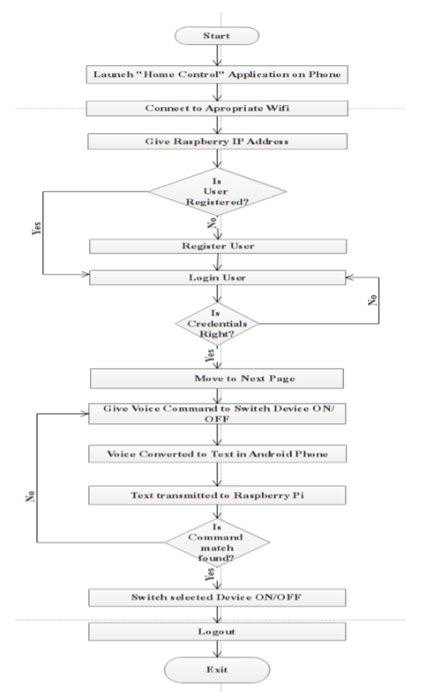

**6. SYSTEM ARCHITECTURE**

The system architecture gives overall flow of the project and how system components are connected to each other and perform there role of work in this project. Raspberry pi is main technology used in this project. A 5v power supply is provided and passed through regulator so that it can be converted to 3.3v and provided to raspberry pi. The voice command is given as input to android device which is connected to raspberry pi and the output from raspberry pi is given to relay switch. Relay switch is connected to electronic device which does the main function of switching on/off. [6]

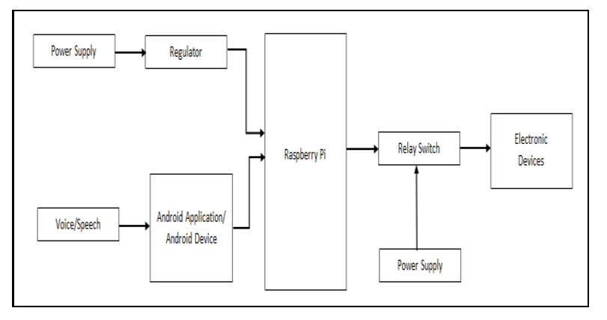

Fig :5 System Architecture

**7. Block Diagram**

**Block diagram of proposed system**

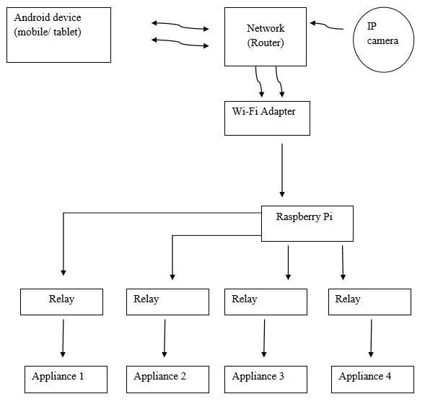

**8. HARDWARE REQUIREMENTS**

1. System: Raspberry Pi model B

2. Ram: 1 GB.

3. Monitor: 15 VGA Color.

4. SD card: 16GB class 10.

5. External mouse and keyboard.

6. HDMI to VGA convertor

**Hardware:**

The Hardware Requirements of the Systems are:

• RASPBERRY PI

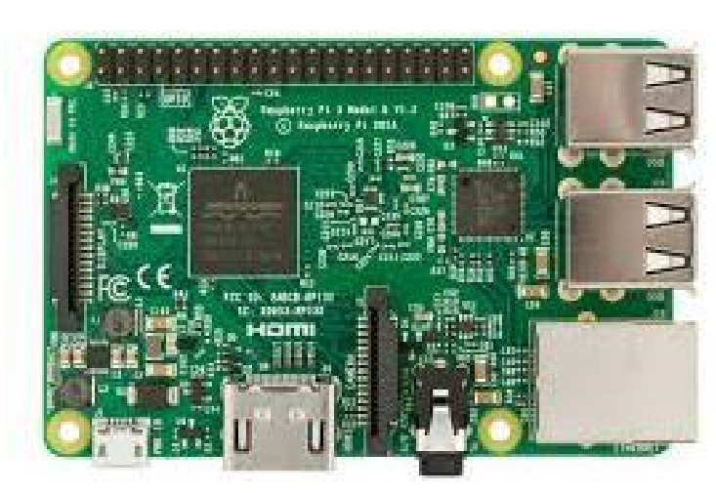

Fig :6 Raspberry Pi

Raspberry Pi is a microcontroller that has potential to work same as computer. It runs with the Python programming language, and is a great way to learn about hardware hacking and coding.

The Raspberry Pi is the third generation Raspberry Pi.

Raspberry Pi has:

802.11n Wireless LAN.

* A 1.2GHz 64-bit quad-core ARMv8 CPU.
* Bluetooth 4.1.
* Bluetooth Low Energy (BLE).
* 1GB RAM.
* 4 USB ports.
* 40 GPIO pins.
* Full HDMI port and Ethernet port.
* Combined 3.5mm audio jack and composite video.
* Camera interface (CSI) and Display interface (DSI).
* Micro SD card slot (now push-pull rather than pushpush).
* Video Core IV 3D graphics core.

**ARDUINO BOARD:-**

* Arduino is a popular open-source single-board microcontroller.
* An Arduino board consists of an 8-bit Atmel AVR microcontroller. In this

Arduino board AT mega 328p micro controller is used. Micro controller has

32 pins and it was internally connected in Arduino board.

* Arduino programs are written in C, C++ and java programs, although users only

only need define two functions to make a runnable program, those are set up()

and loop().

* setup() – a function run once at the start of a program that can initialize settings.
* loop() – a function called repeatedly until the board powers off.
* Program will be written in personal Computer(PC) and program will be up

up loaded to Arduino board through USB cable.

* After uploading program USB cable will be removed from the Arduino board,

and supply is given by the 5v 1A adopter to the arduino board.

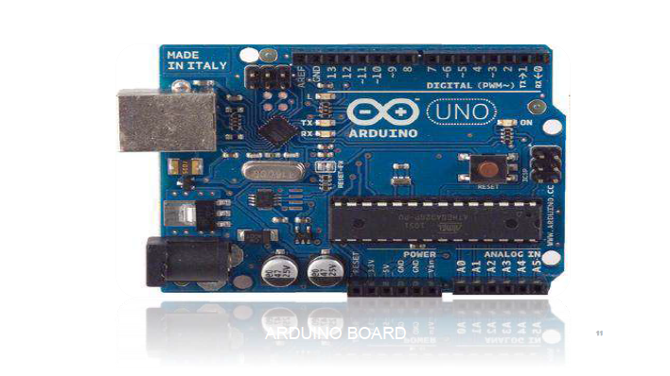

Fig :7 Arduino

**• RELAY AND RELAY DRIVER :**

Relay is the electromagnetic switch. Relay allows one circuit to switch another circuit while they are separated. Relay is used when we want to use a low voltage circuit to turn ON and OFF the device which required high voltage for its operation. [7] Relay is divided into two parts, one is input and other is output. Input side is nothing but a coil which generate magnetic field when small input voltage is given to it.

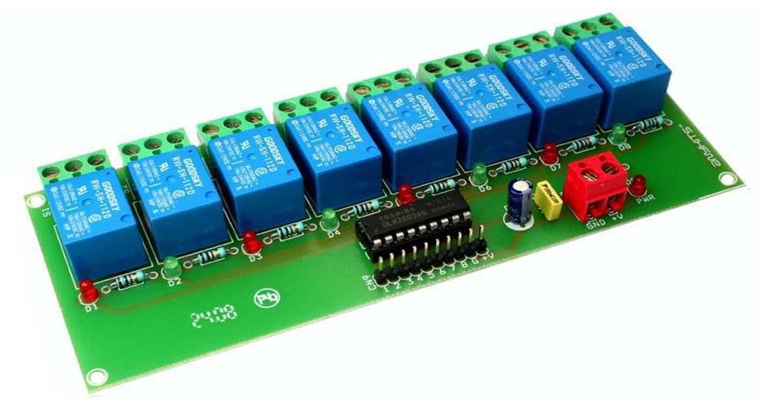

Fig:8 Relay and Relay Driver

**• ANDROID MOBILE DEVICES :**

The android application is downloaded and installed on the android device to provide the user with an interface to interact with the Raspberry Pi. This application allows the user to control the appliance.

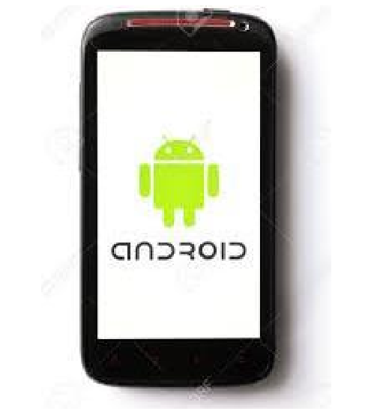

Fig :9 Android Mobile App

**Application Description:**

Application Consists of Graphical User Interfaces. It consists of following different activities.

1. Start Mode Activity
2. Option Mode Activity

3. Voice Mode Activity

4. Switch Mode Activity

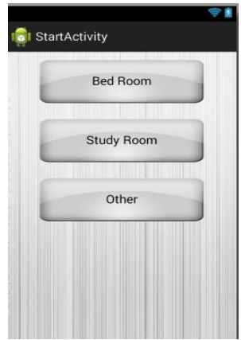 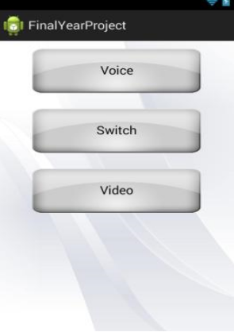

Figure :10 Start Mode Activity Figure:11 Option Mode Activity

**Start Mode Activity:**

In this mode, all the rooms of the home are displayed. The user can select the necessary room from the option to control the appliances connected to specified room.

**Option Mode Activity:**

This mode provides the user for the option to control. The user can select either switch mode or voice mode to control the appliances.

**Voice Mode Activity:**

This mode provides the user to give the speech feedback to the application. The speech data are processed and required appliances are controlled.

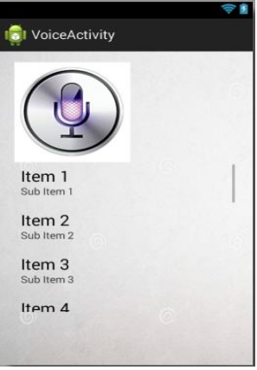 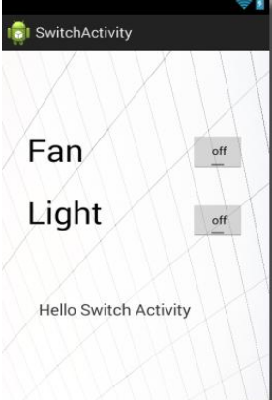

Fig:12 Voice Mode Activity Fig:13 Switch Mode Activity

**Switch Mode Activity:**

This mode provides the user with on/off buttons to control the required home appliances.

**9. TECHNOLOGY USED**

**• RASPBERRY PI** :

Raspberry Pi is an elevation to upcoming future technologies which improves connectivity with Bluetooth and Wi-Fi on board. The Raspberry Pi has improved power management, up to 2.5 Amps, to support more powerful external USB devices. The Raspberry Pi 3 has four in-built USB ports helps to provide connectivity for a mouse, keyboard, or any other USB hub. We can power the Raspberry Pi by just plugging any USB power supply into

the micro- USB port. There’s no power button so the Pi will begin to boot as soon as power is applied, to turn it off, simply shut down the Pi and then remove power. The four in-built USB ports can give output up to 1.2A which enables to connect more USB devices that requires more power. This does require a 2Amp micro USB Power Supply. On top of all that, the low-level peripherals on the Pi make it great for hardware hacking. The 40-pin GPIO header on the Pi gives access to 27 GPIO as well as 3.3 and 5V sources.

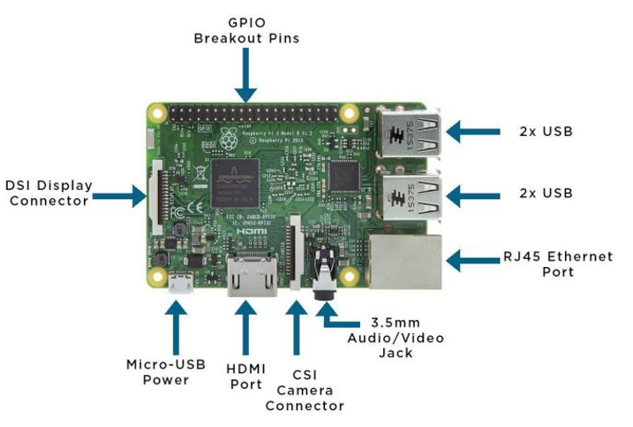

Fig -:14 Raspberry Pi Board

As Studied earlier, Raspberry Pi has major 40 Pins from which 27 are General Purpose Input Output Pins (GPIO). These GPIO Pins are used to perform main task of providing output to the Electronic Devices for Automation.in this project, Electronic Devices can be connected to any of the GPIO and based on that configuration is done.

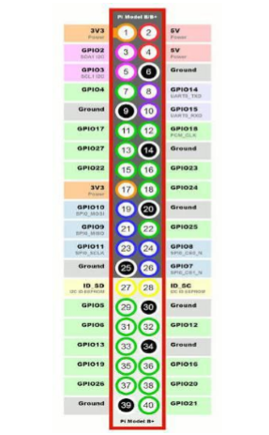

Fig -:15 Pin Diagram of Raspberry Pi

**10. Hardware and Programming Language Description**

**Hardware Description:**

The power strip is designed and relays are connected to power strip. The home appliances are connected to the power strip. The Relays are connected to the GPIO pins of the raspberry pi.

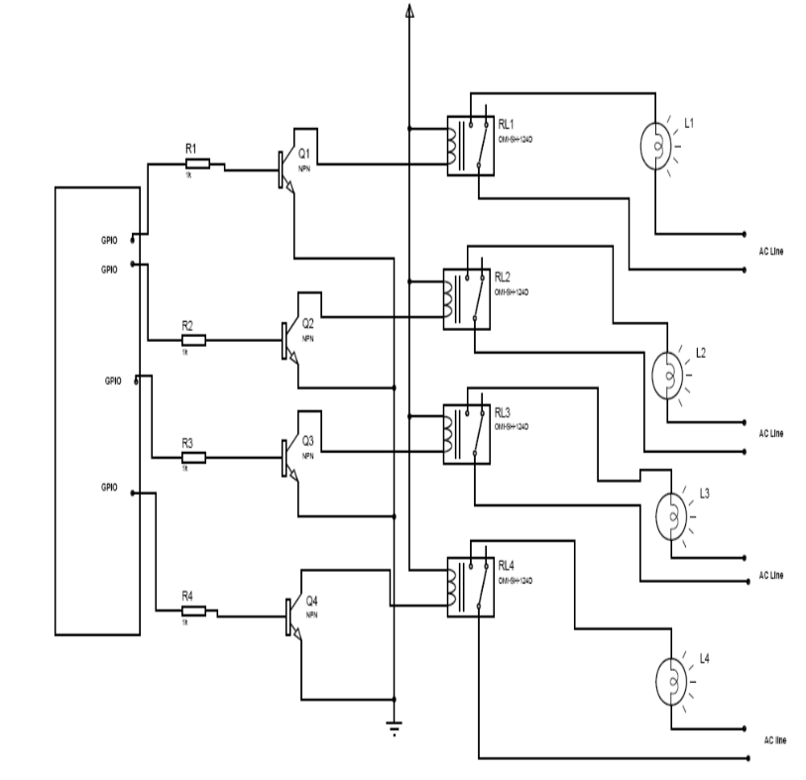

Fig:16 Block diagram of hardware discription

**11. Software Description**

We have used two different programming languages for our project. For the development of the application on android, we have used Java Platform. Android Software Development kit incorporates Eclipse software where Java programming is performed.

Eclipse software is used to write the codes for the application under Java Platform. Raspbian OS is used at the raspberry pi. Server is established at raspberry pi. Python Language is used to write the codes of server, and to control the GPIO Pins of OS.

**11.1.Java:**

Java is a set of several computer software products and specifications from Oracle Corporation that provides a system for developing application software and deploying it in a cross-platform computing environment. Java is used in a wide variety of computing platforms from embedded devices and mobile phones on the low end, to enterprise servers and supercomputers on the high end.

**11.2. Python:**

Python is an interpreter, interactive, object-oriented programming language. It incorporates modules, exceptions, dynamic typing, very high level dynamic data types, and classes. Python combines remarkable power with very clear syntax. It has interfaces too many system calls and libraries, as well as to various window systems, and is extensible in C or C++. It is also usable as an extension language for applications that need a programmable interface.Python is a high-level generalpurpose programming language that can be applied to many different classes of problems.

**11.3. Raspbian:**

Raspbian is a free Operating System based on Debian optimized for the raspberry pi hardware. Raspbian comes with more than 35000 packages; pre-combined software bundled in a nice format for easy installation on Raspberry pi.

**13. Scope and Application**

This system is designed to assist and provide support in order to fulfill the needs of elderly and disabled in home. Household appliances can be easily controlled via a Mobile/Tablet. Status of light, fan and other electrical appliances can be known. With the help of IP camera, video of rooms or certain area of a house can be recorded. This helps to provide security.

**14. Limitations**

Android devices having lower API version than 16 requires internet access to convert the speech data to string data. Currently, the application is made for Android Smart Phones; other OS platform doesn’t support our application.

During voice mode, external noises (voice) may affect our result. The speech instruction that we command in our voice mode may not give exact result as expected.

**15. Further Enhancements:**

Looking at the current situation we can build cross platform system that can be deployed on various platforms like iOS, Windows. Limitation to control only several devices can be removed by extending automation of all other home appliances. Network can be connected to internet and Security cameras can be controlled from other places, allowing the user to observe activity around a house or business. Security systems can include motion sensors that will detect any kind of unauthorized movement and notify the user. Scope of this project can be expanded to many areas by not restricting to only home.

**16. Conclusion:**

The prime objective of our project is to use the Smartphone to control the home appliances effectively. The switch mode and voice mode are used to control the home appliances. The video feedback is received in the android app which streams the video of IP- Camera.

This project is based on the Raspberry pi, Android platform Java and Python. These platforms are Free Open Source Software. So the overall implementation cost is low and can be easily configured.

User can easily interact with the android phone/tablet. The user can send commands via the switch mode or speech mode. The data are being analyzed by the application and are sent over a network. The Raspberry pi acts as a server, analyses the data and activates the GPIO (General Purpose Input Output) Pins. The GPIO Pins are connected to the relays switch which activated the required home appliances.

In this way, automation process is carried out. This is a simple prototype. Using this as a reference further it can be expanded to many other programs.

**17. FUTURE SCOPE**

The future scope of this project is:

1. Authentication: In future use, we can give voice authentication to provide security. In this only authenticated person voice can access secured device (like locker).
2. Sensor: By using sensors we reduce the effort of declaring each and every device a

name. Example: If a person gives a command “lights on” the sensor will sense person

location and only that light will get on.

1. Smart Doors: The smart Doorbell can be made by implementing voice and video calls with the person standing right outside the door and the owner remotely. Thereby increasing the safety quotient of the system.

**18. References**

1. https://docs.python.org/

2.http://developer.android.com/training/index.html

3. <http://elinux.org/RPi_Hub>

4.http://www.raspberrypi.org/

5. <http://stackoverflow.com/>

6. <http://electronics.howstuffworks.com/>

7. N. Sriskanthan and Tan Karand. “Bluetooth Based Home Automation System”. Journal of Microprocessors and Microsystems, Vol. 26, pp.281-289, 2002.

8. Muhammad Izhar Ramli, Mohd Helmy Abd Wahab, Nabihah, “TOWARDS SMART HOME: CONTROL ELECTRICAL DEVICES ONLINE” ,Nornabihah Ahmad International Conference on Science and Technology: Application in Industry and Education (2006)

9. E. Yavuz, B. Hasan, I. Serkan and K. Duygu. “Safe and Secure PIC Based Remote Control Application for Intelligent Home”. International Journal of Computer Science and Network Security, Vol. 7, No. 5, May 2007

10. Amul Jadhav, S. Anand, Nilesh Dhangare, K.S. Wagh “Universal Mobile Application Development (UMAD) On Home Automation” Marathwada Mitra Mandal’s Institute of Technology, University of Pune, India Network and Complex Systems ISSN 2224-610X (Paper) ISSN 2225-0603 (Online) Vol 2, No.2, 201