Loan Approval Prediction & Analytics System
Submitted by: Manu Gupta
This document contains SQL, Python, Machine Learning and Power BI work with original screenshots.
Screenshot:
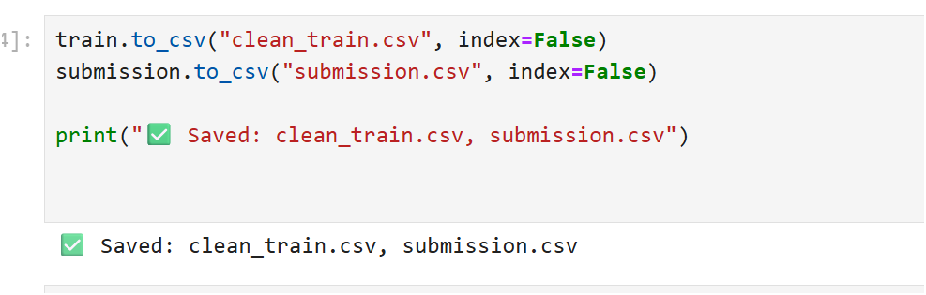
Screenshot:
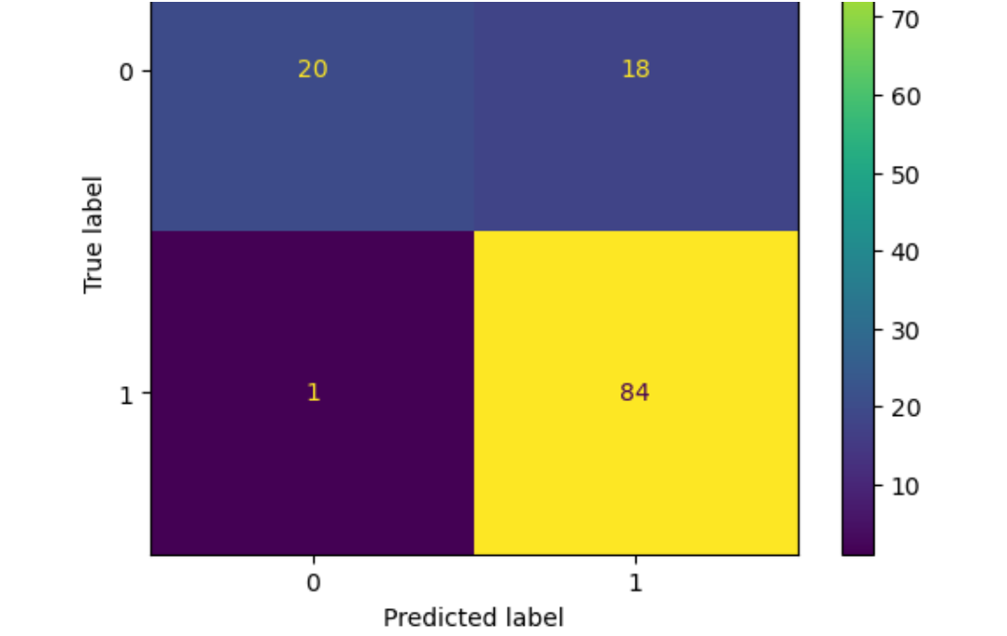
Screenshot:
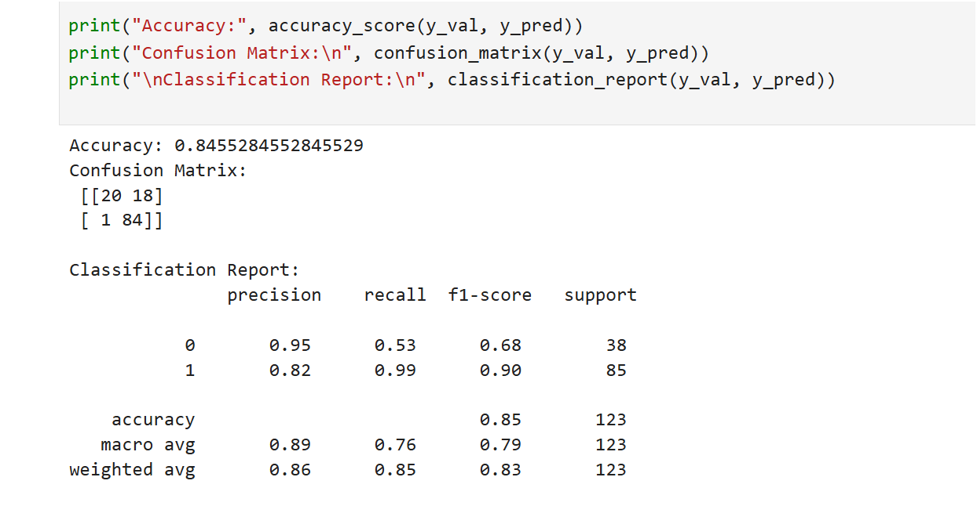
Screenshot: cccfdde9-91e1-4cce-9258-86a4802b7a84.png
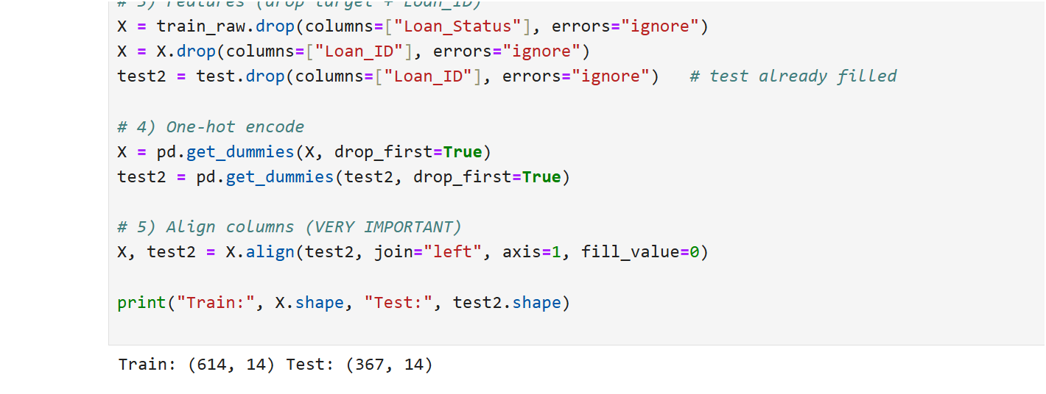

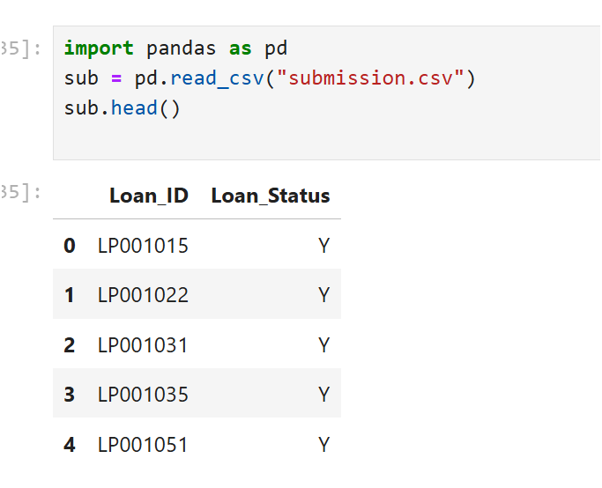

Screenshot:
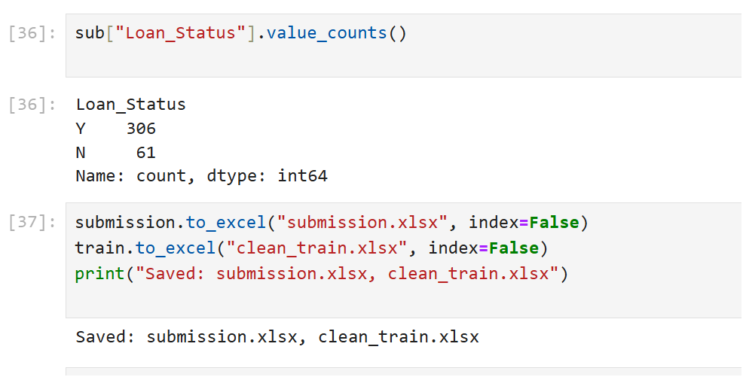
Screenshot:
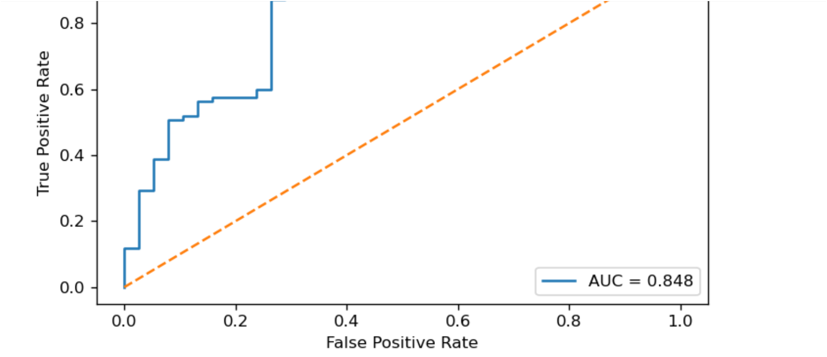

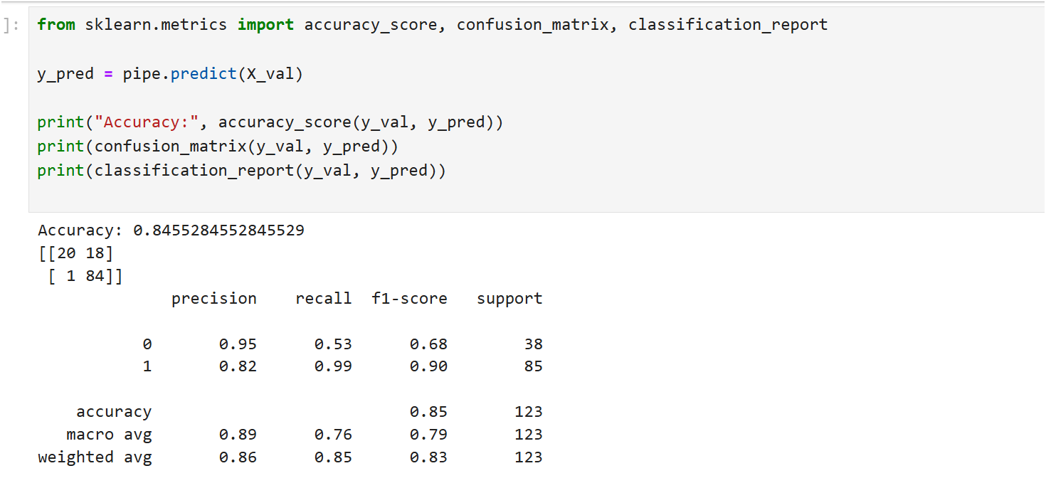
Screenshot
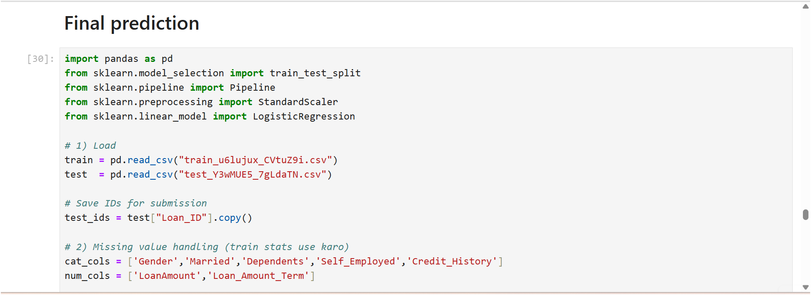
Screenshot:

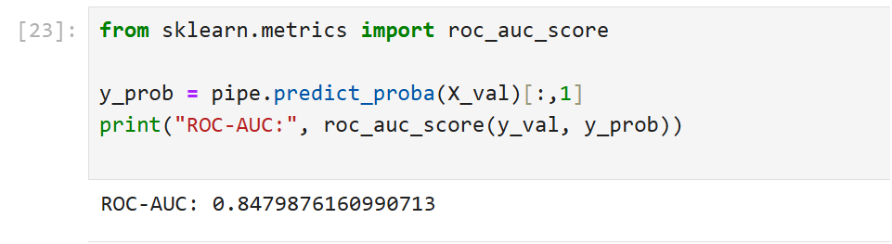

Screenshot:
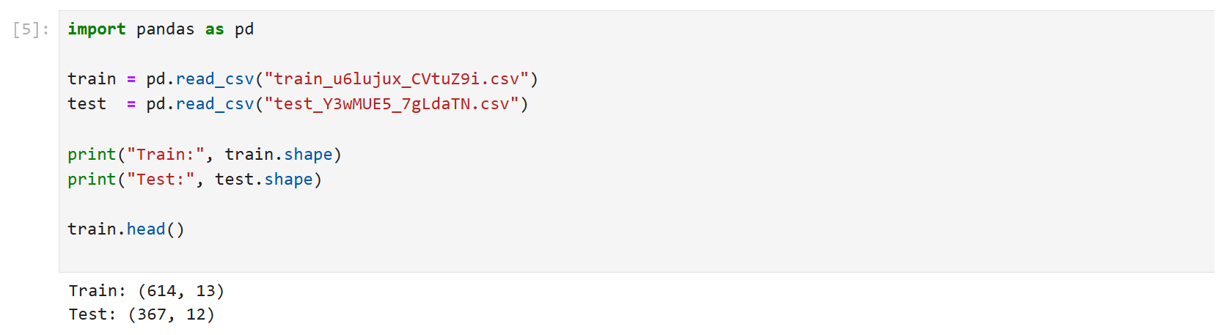
Screenshot:
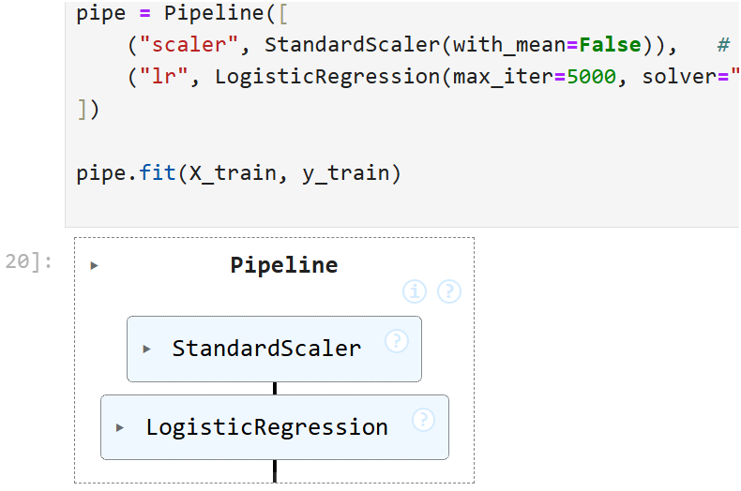

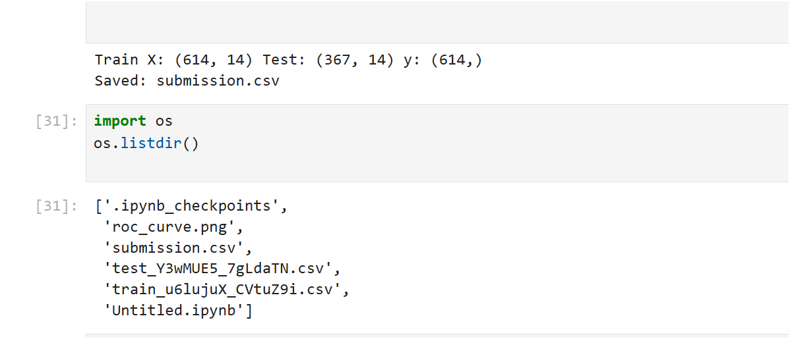
Screenshot:
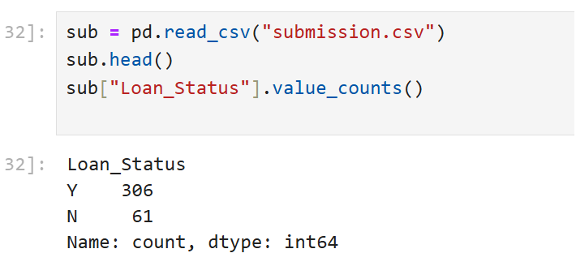

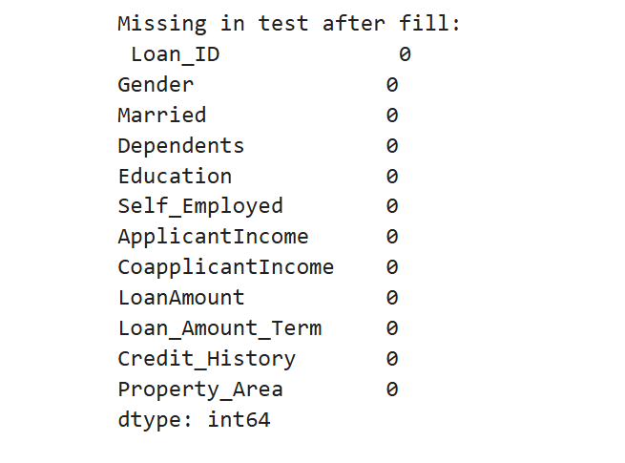

Screenshot:
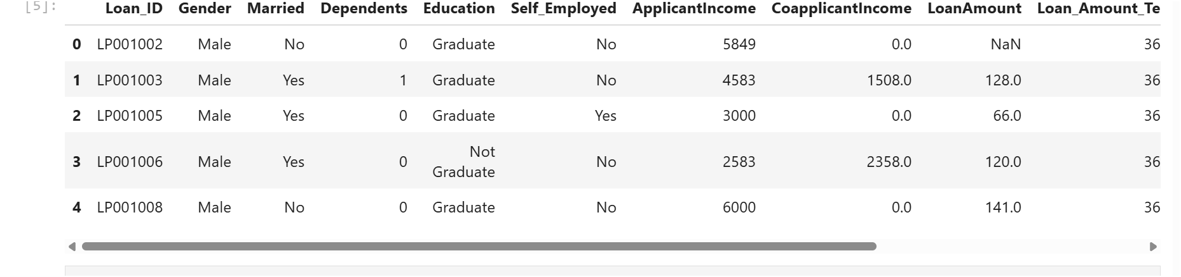
Screenshot:
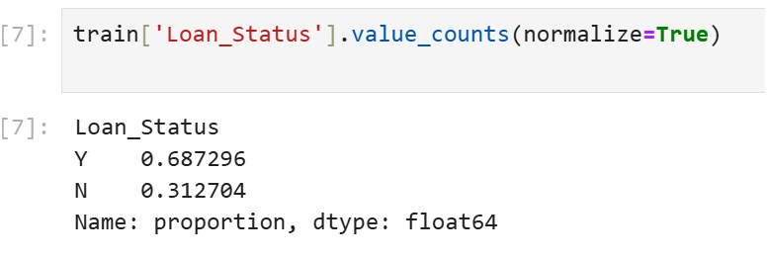

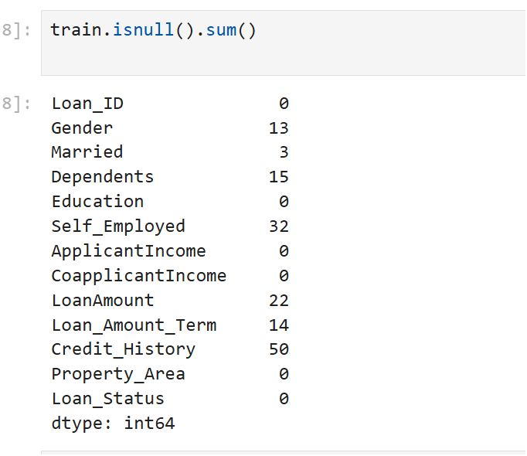

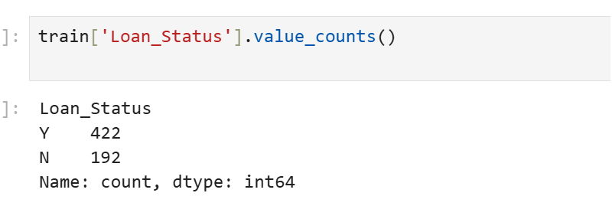

Screenshot:
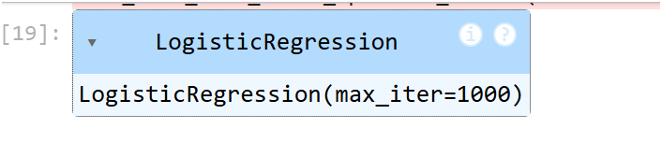
Screenshot:
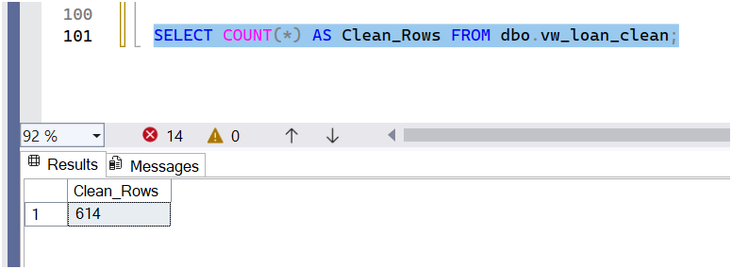
Screenshot:
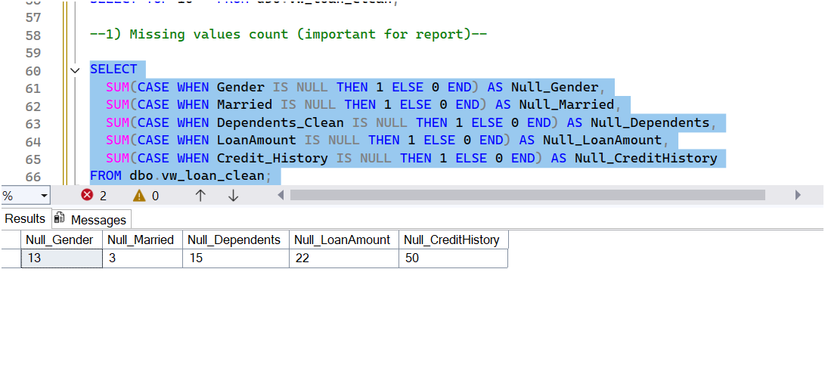
Screenshot:
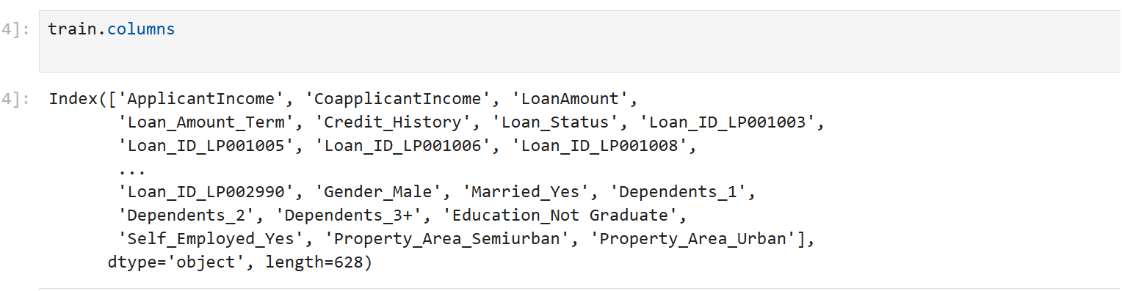
Screenshot
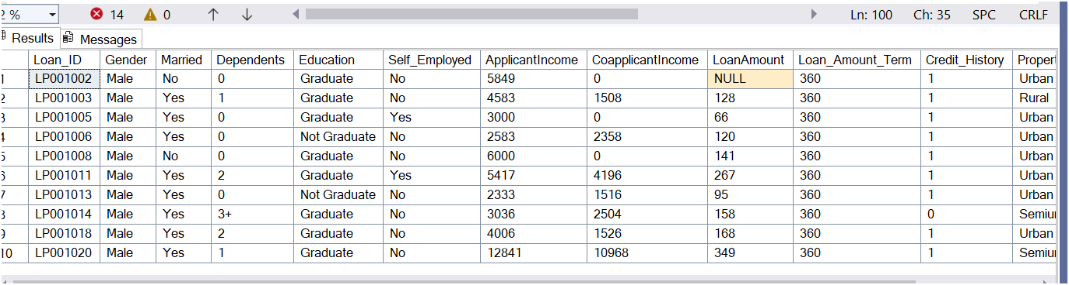

Screenshot:
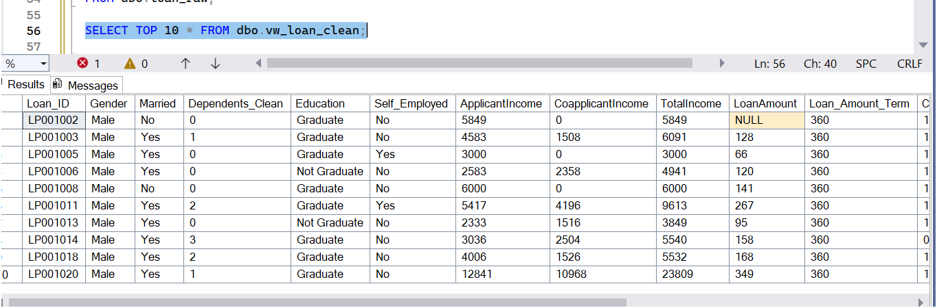
Screenshot:
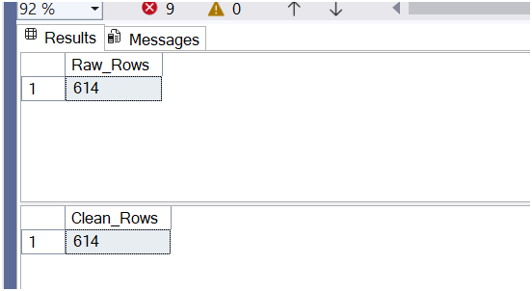
Screenshot:
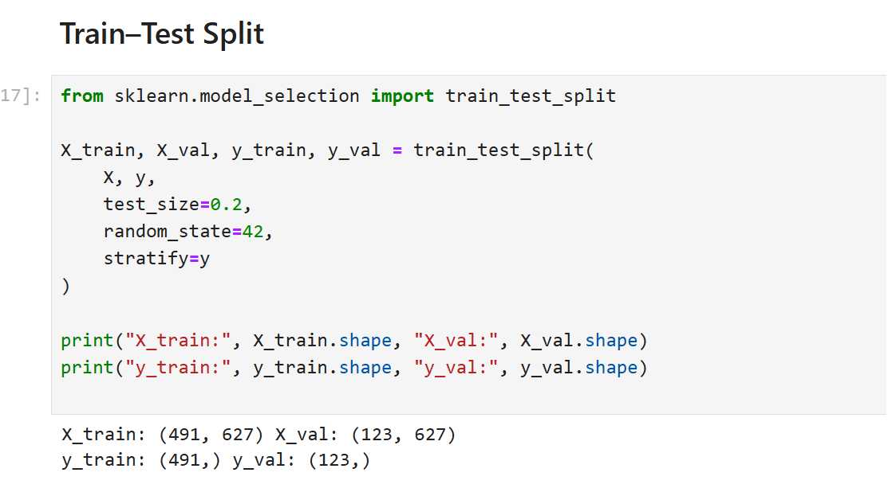
Screenshot:
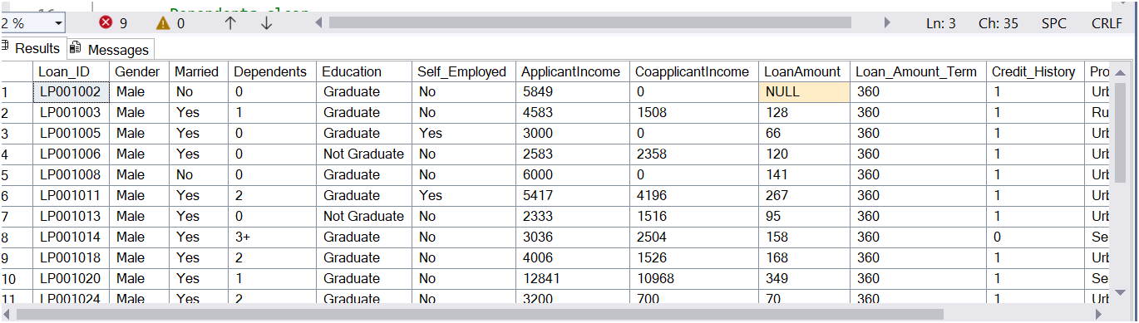
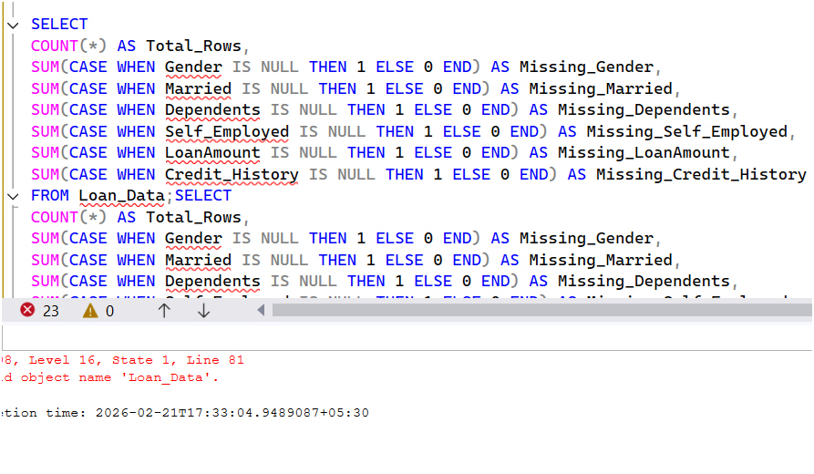

Screenshot
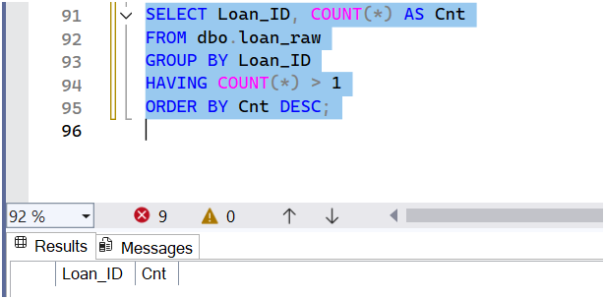

Power BI Dashboard Documentation – Loan
Approval Analytics
Objective: To analyze loan approval patterns using interactive visuals.
Data Source: Clean dataset from SQL view vw_loan_clean (614 records).
KPIs Created: Total Applications, Approved Loans, Rejected Loans, Approval Rate %.
DAX Measures Used:
Total Applications = COUNT(vw_loan_clean[Loan_ID])
Approved Loans = CALCULATE(COUNT(vw_loan_clean[Loan_ID]), vw_loan_clean[Loan_Status]
= 'Y')
Rejected Loans = CALCULATE(COUNT(vw_loan_clean[Loan_ID]), vw_loan_clean[Loan_Status] =
'N')
Approval Rate % = DIVIDE([Approved Loans], [Total Applications], 0)
Today Date = TODAY()
Visuals: Donut chart (Loan Status), Bar chart (Education), Column chart (Area), Donut (Gender), Income vs Loan Status.
Filters: Gender, Education, Property Area, Income Group.
Insights: Semiurban area highest approvals, low income higher rejection, graduates higher approvals, medium loan common.
Conclusion: Dashboard provides decision-making insights for loan approvals.

