Report
Of
Internship in Frontend Web Development at CodSoft
Submitted
To
School of Computer Science and Engineering
IILM University, Greater Noida, U.P.
In partial fulfilment of the requirement of degree of
B.Tech CSE
By
Name of Student: AMIT KUMAR
Roll Number: 25SCS1003005483
Class: 2CSE13 (3rd Semester)
Session: 2025-2029
Organization: CodSoft
Role: Frontend Development Intern
2025-26

CANDIDATE'S DECLARATION
I, Amit Kumar, do hereby declare that the internship report titled “Internship in Frontend Web Development at CodSoft” has been completed by me to fulfil the requirement for the award of the degree of Bachelor of Technology in CSE. All the references have been quoted and I have not taken as such any material from any other source. I affirm to you that this report is my own and has not been submitted to any other institute for any degree/diploma requirement and further I shall be solely responsible for any kind of copyright violation in this regard.
Signature
Student Name: Amit Kumar
Roll No.: 25SCS1003005483

ACKNOWLEDGEMENT
I am using this opportunity to express my gratitude to everyone who supported me throughout the CodSoft Frontend Development Internship program. I am thankful for their aspiring guidance, invaluably constructive criticism and friendly advice during this work. I am sincerely grateful to the CodSoft team for sharing their truthful and illuminating views on a number of issues related to this work, and to the faculty of the School of Computer Science and Engineering, IILM University, for their continuous support and guidance throughout the internship.
I express my gratitude to my parents for their blessings.
Signature
Student Name: Amit Kumar
Roll No.: 25SCS1003005483

TABLE OF CONTENTS
Chapter No. | Chapter Name | Page Nos.
 | Cover Page | ---
1. | Candidate's Declaration | ii
2. | Acknowledgment | iii
3. | Internship Communication Proof | iv
4. | Project Description  4.1 Introduction  4.2 Organization Profile  4.3 Problem Statement  4.4 Project Objectives  4.5 Scope of the Project  4.6 Technologies and Tools Used  4.7 System Architecture  4.8 Methodology  4.9 Expected Outcomes  4.10 Offer Letter and Other Communication Proof | 1 - 8
5. | Bibliography/References | 9

INTERNSHIP OFFER & COMMUNICATION PROOF
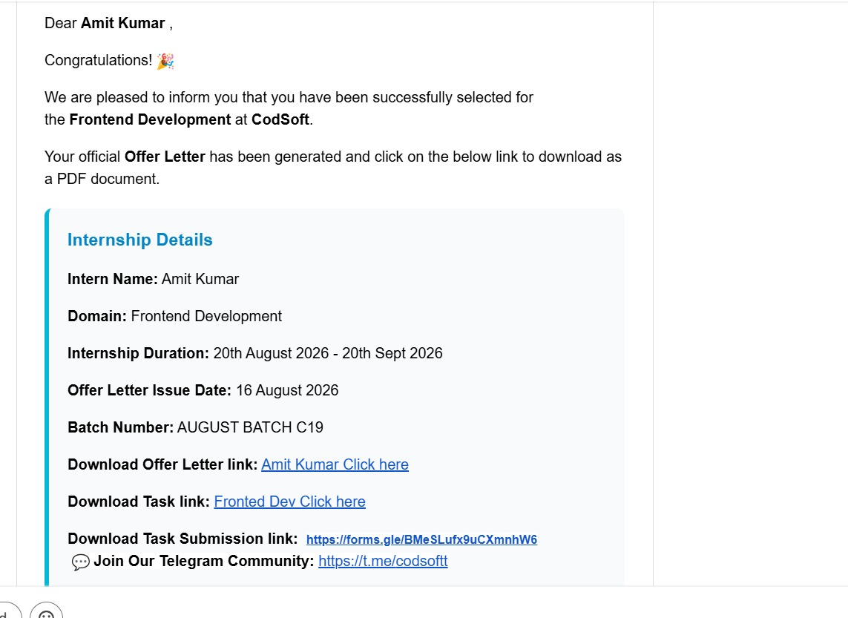

4. Project Description

4.1 Introduction
This report presents the work carried out during my internship as a Frontend Development Intern under the CodSoft Internship Program. The internship focused on building modern, responsive, and interactive web applications using HTML, CSS, and JavaScript. Over the course of the internship, I designed and implemented five independent frontend projects — a Personal Portfolio Website, a To-Do List Application, an Expense Tracker, a Music Player, and a Blog Website — each demonstrating a different aspect of client-side web development, from responsive layout design to local data persistence and interactive media handling.

4.2 Organization Profile
CodSoft is an ed-tech and technology solutions company that offers virtual internship programs to students and early-career professionals across domains such as web development, Android development, data science, artificial intelligence, and Python programming. The CodSoft Virtual Internship is a self-paced, project-based program in which interns are assigned a set of real-world tasks and are expected to design, build, and submit working solutions within a fixed internship duration, gaining practical, hands-on exposure to industry-relevant tools and workflows.

4.3 Problem Statement
Modern businesses and individuals increasingly rely on responsive, interactive web applications to showcase their work, manage daily tasks, track personal finances, consume media, and share content. There was a need to design and develop a set of practical, fully responsive frontend applications — built purely with HTML, CSS, and JavaScript — that demonstrate clean UI/UX design, client-side data validation, local data persistence, and smooth interactivity across devices and screen sizes.

4.4 Project Objectives
- Design and build a fully responsive personal portfolio website with dedicated sections for Home, About, Skills, Projects, Resume, and Contact.
- Develop a task management (To-Do List) application with add, edit, delete, and completion-tracking features, backed by Local Storage.
- Build a personal expense tracker capable of recording income and expenses and computing real-time financial summaries.
- Create a web-based music player with standard playback controls and a responsive, modern interface.
- Develop a responsive blog website with categorized posts, a search feature, and individual article pages.
- Apply consistent principles of responsive design, smooth animations, form validation, and cross-browser compatibility across all five projects.

4.5 Scope of the Project
The scope of this internship was limited to building purely client-side, static frontend applications using HTML, CSS, and JavaScript, without any backend server or database. The work covered: (a) building a responsive personal portfolio website with interactive UI elements and a downloadable resume; (b) developing a to-do list application with full CRUD functionality and Local Storage persistence; (c) building an expense tracker with category-based filtering and automatic balance calculation; (d) developing a music player with play/pause/seek/volume controls; and (e) building a blog website with search, categories, and pagination. Deployment as a production, database-backed, or cloud-hosted service was outside the scope of this internship.

4.6 Technologies and Tools Used
- HTML5: Used to structure the semantic content and layout of all five web applications.
- CSS3: Used for responsive styling, Flexbox/Grid layouts, hover animations, transitions, and dark mode support.
- JavaScript (ES6+): Used to implement interactivity, form validation, DOM manipulation, and application logic across all projects.
- Local Storage API: Used to persist task data, expense records, and user preferences across page refreshes.
- Font Awesome / Google Fonts: Used for iconography and typography to enhance the visual design of each interface.
- Git & GitHub: Used for version control and to host the public project repositories.
- VS Code: Used as the primary code editor for developing and debugging all five projects.

4.7 System Architecture
Each of the five applications follows a lightweight, purely client-side architecture with no backend dependency:
- Portfolio Website: A multi-section single-page layout (Home, About, Skills, Projects, Resume, Contact) navigated via a responsive menu with smooth scrolling and a validated contact form.
- To-Do List Application: A component-driven structure where tasks are rendered dynamically from an array stored in Local Storage, with functions handling add, edit, delete, filter, and completion toggling.
- Expense Tracker: A transaction-management structure where each income/expense entry is stored as an object in Local Storage, with summary cards recalculated on every transaction change.
- Music Player: An interface built around the HTML5 Audio API, with event listeners driving play/pause state, progress-bar seeking, volume control, and track metadata display.
- Blog Website: A card-based homepage listing blog posts, linking to individually rendered detail pages, with client-side search and category/tag filtering.

4.8 Methodology
Development began with setting up a consistent project structure (separate HTML, CSS, and JavaScript files) and a shared design language across all five applications, including a common color palette, typography, and responsive breakpoints. The Personal Portfolio Website was built first, starting with a mobile-first responsive layout, followed by the addition of smooth scrolling, hover animations, a responsive navigation menu, and a validated contact form, along with a downloadable resume/CV button.
Next, the To-Do List Application was developed by implementing task creation with input validation, followed by edit and delete functionality, completion toggling, and search/filter options, with all task data persisted using the Local Storage API so that data survives a page refresh. The Expense Tracker was then built by creating a transaction form for income and expenses, followed by automatic calculation of total income, total expenses, and current balance, category-based filtering, and summary cards for a quick financial overview.
The Music Player was developed around the native HTML5 Audio element, with custom-styled play/pause/next/previous controls, a seekable progress bar, volume control, and continuously updated playback time and track information. Finally, the Blog Website was built with a featured-posts homepage, responsive blog cards, individual blog detail pages, category/tag organization, a search feature, and pagination. Each application was tested across multiple screen sizes and browsers, and all five projects were maintained under Git version control and pushed to public GitHub repositories for tracking and submission.

4.9 Expected Outcomes
- A fully responsive personal portfolio website that clearly showcases skills, projects, and a downloadable resume.
- A working to-do list application with add, edit, delete, completion-tracking, search/filter, and Local Storage persistence.
- A functional expense tracker that accurately computes income, expenses, balance, and category-based summaries.
- A responsive, interactive music player with complete standard playback controls.
- A responsive blog website with categorized, searchable articles and individual post pages.
- Practical, hands-on experience with responsive web design, JavaScript application logic, and client-side data persistence, gained through the CodSoft Frontend Development Internship.

4.10 Offer Letter and Other Communication Proof
The internship offer communication received from CodSoft, confirming selection for the Frontend Development track, the internship duration, and the relevant task and submission links, is provided below and in the Internship Offer & Communication Proof section of this report.

5. Bibliography / References
MDN Web Docs. HTML, CSS and JavaScript Reference. Available at: https://developer.mozilla.org/
W3Schools. HTML, CSS and JavaScript Tutorials. Available at: https://www.w3schools.com/
Font Awesome. Icon Library and Toolkit. Available at: https://fontawesome.com/
Google Fonts. Open Source Font Library. Available at: https://fonts.google.com/
CodSoft. Virtual Internship Program. Available at: https://www.codsoft.in/
Project Repository. Frontend Development Internship Projects. Available at: https://github.com/

