Software Engineering Documentation

Note: We will not be able to have a daily meet as followed in an Agile Lifecycle. However, a Weekly meet as the end Sprint meet and new Sprint meet will happen.

Timeline of the project:

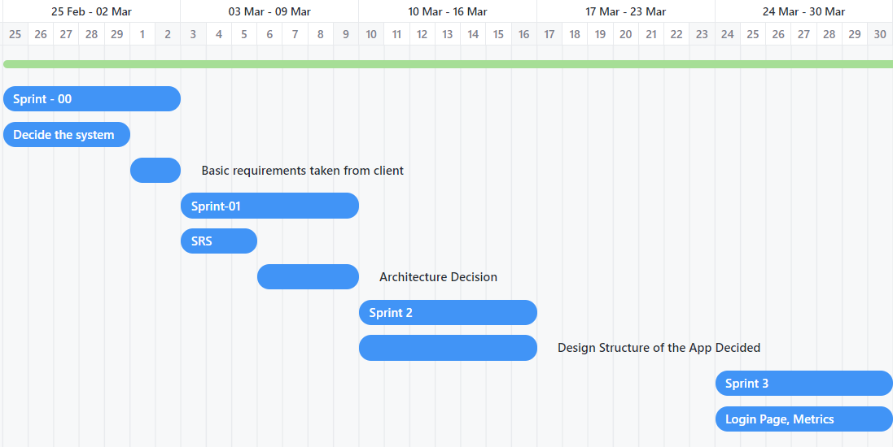

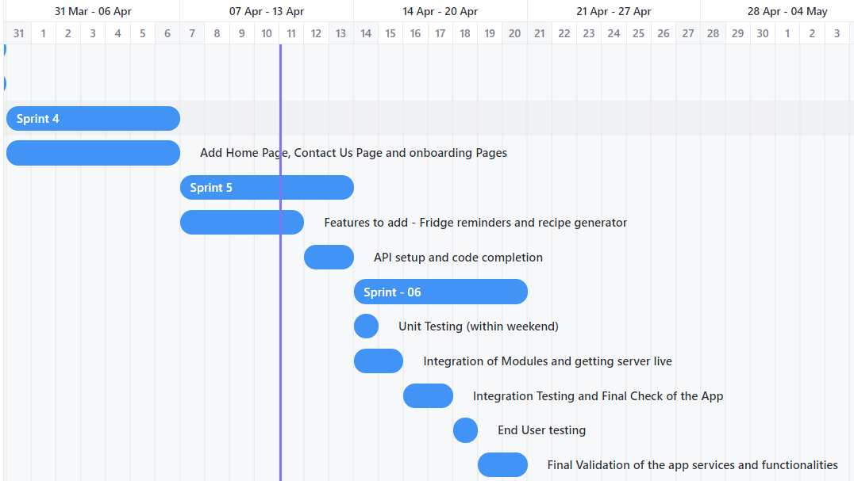

Meeting Minutes

Meet - 01 @ 02-03-2024

Tasks Assigned for Sprint -01:

Sumeet S Patil :

1. Functional and Non-Functional Requirements to be decided.

2. The Structure of the App must be decided.

3. Tech Stack to be decided

Mukund Gupta:

1. UML Diagrams
2. Services offered feasibility to be decided

Tanmay:

1. Architecture decisions
2. Constraints of the system

Meet - 02 @ 09-03-2024

Goals Achieved:

1. SRS version 1.0 done
2. Tech Stacks decided
3. Architecture decided

Tasks Assigned for Sprint -02:

Sumeet S Patil

1. Design the structure of the system

Mukund Gupta:

1. Learn Flutter

Tanmay Parashar:

1. Learn Flutter

Meet -03 @ 16-03-2024

Goals Achieved:

1. App design partially done
2. Flutter Partially learnt

Reason of incomplete goals:

Minors were round the corner, so a lot of assignment deadlines were to be catered leading to less dedication of time towards the project

Tasks Assigned:

Sumeet S Patil:

1. Complete the structure till the start of next Sprint

Mukund Gupta:

1. Learn Flutter decently

Tanmay Parashar:

1. Learn Flutter decently

Meet -04 @ 23-03-2024

Goals Achieved:

1. Structure of the App Ready

New Client Request: Fridge reminders to be added as a feature

Tasks Assigned for Sprint - 03:

Sumeet S Patil

1. Create the Login Page

Mukund Gupta and Tanmay:

1. Decide the software metrics to be used
2. Update the SRS accordingly to accommodate the new feature

Meet -05 @ 31-03-2024

Goals Achieved:

1. SRS updated as per need
2. Software Metrics decided
3. Login Page <Version 1.0> done

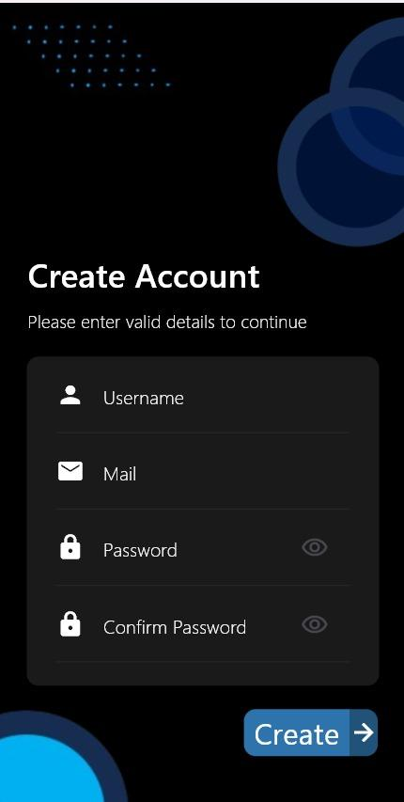

Tasks assigned for Sprint -04:

Sumeet S Patil: onboarding Pages

Mukund Gupta: Contact Us Page

Tanmay: Home Page

Meet @ 04-04-2024

Client meets with Dr. [Romi Banerjee](mailto:romibanerjee@iitj.ac.in) , [Sumeet S Patil (B22CS052)](mailto:b22cs052@iitj.ac.in), [Tanmay Parashar (B22CS053)](mailto:b22cs053@iitj.ac.in)

Absence of Mukund Gupta: SWC work, previously committed to it

Outcomes:

1. Fridge reminder feature to be focused more currently.
2. Design and requirements of the client clearly stated

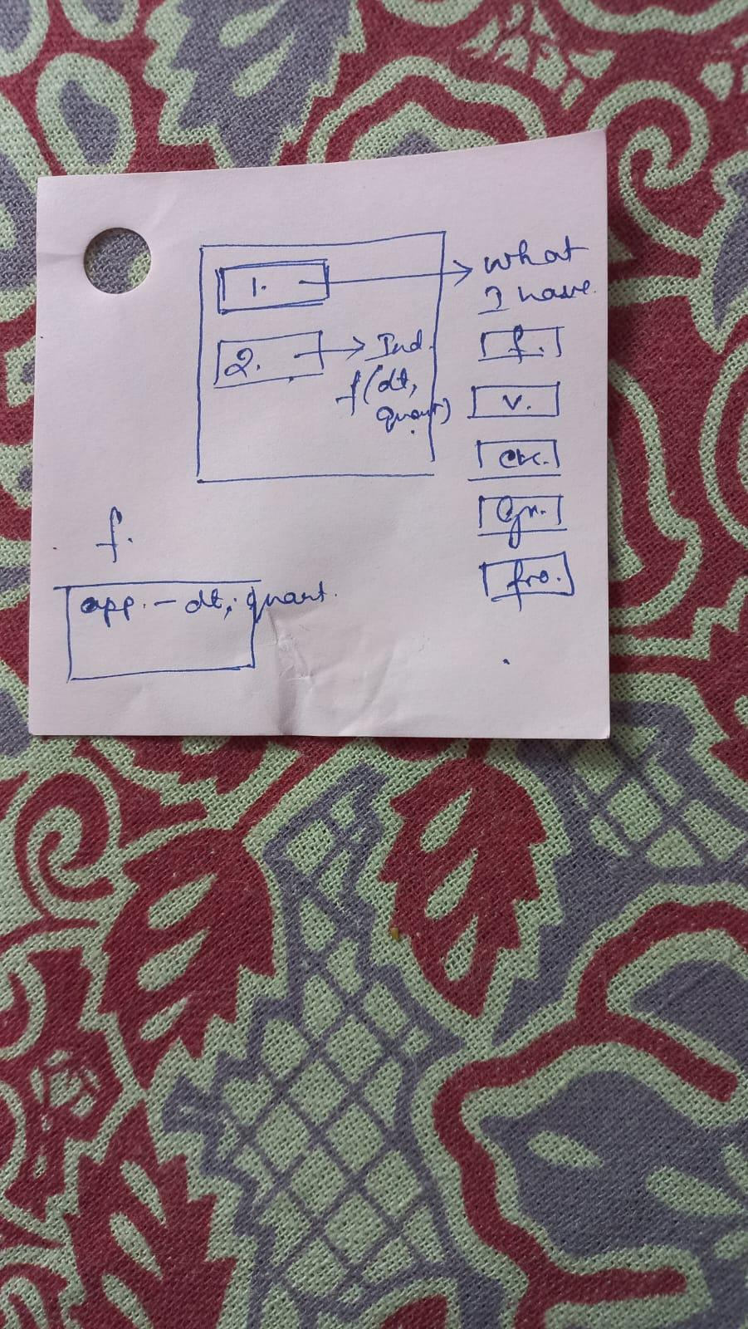

Rough Idea of Client Requirements

Meet @ 06-04-2024

Goals Achieved:

1. Onboarding Pages done
2. Contact Us Page done

Reason for non-completion of Home Page: The basic structure of the page never remained fixed, leading to difficulty in creation of the page

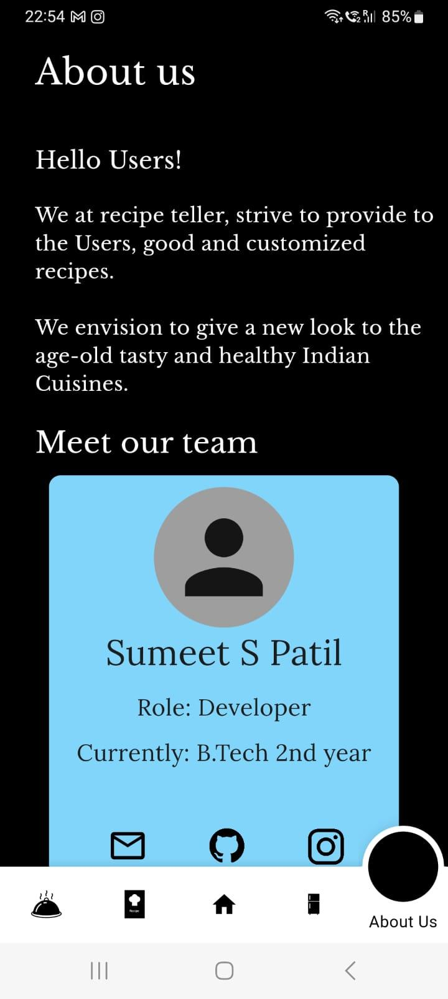 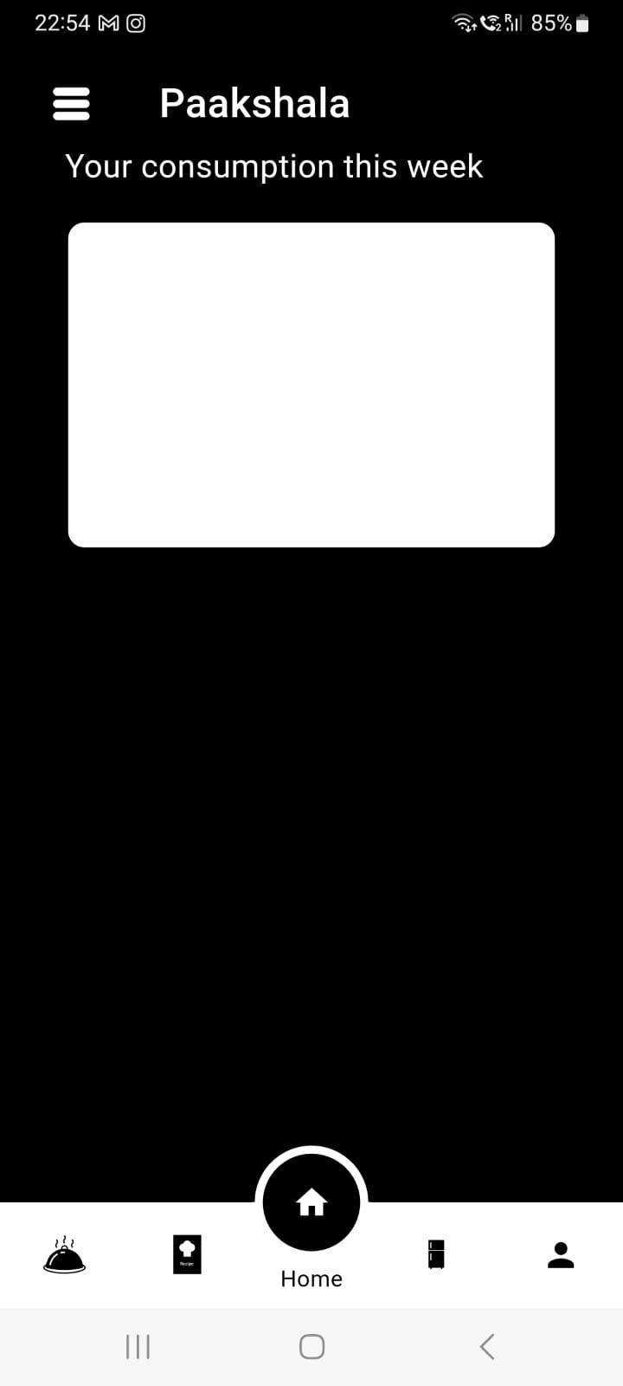

Contact Us Page Home Page 1.0

Onboarding Pages have been uploaded on the central server @ github

Tasks Assigned for Sprint - 05:

Sumeet S Patil: Finish the Fridge reminder service

Mukund Gupta: Finish the recipe generator service

Tanmay: Finish Homepage and unit test cases