Software Requirement Specification Document

With UML Diagrams

**<Version 1.0>**

Problem Statement:

A user-centric culinary assistant application designed to help individuals make informed dietary choices by suggesting recipes based on available ingredients and providing nutritional insights for each dish. This solution aims to promote healthier eating habits and reduce food waste by optimizing the use of household ingredients.

|  |
| --- |
| (Not Part of SRS – Team Description only) Stake Holders:  Romi Banerjee……………………………………. (Professor)  Bhavna ………………………………… (Teaching Assistant)  Sumeet S Patil ……………………………………(B22CS052)  Mukund Gupta……………………………………(B22CS086)  Tanmay Parashar………………………………..(B22CS053) |

Table of Contents

Introduction …………………………………………………………………………. 3

1.1 Purpose

1.2 Objective of the system

1.3 Definitions, Acronyms and Abbreviations

1.4 References

1.5 Overview

Requirements ………………………………………………………………………. 4

1.6 Functional Requirements

1.7 Non-Functional Requirements

1.8 Constraints

Overall Description …………………………………………………………………5

1.9 System Environment and Modules

1.9.1 Module-1: Profile and Health Metrics

1.9.2 Module-2: System and Messaging

1.9.3 Module-3: Sensors and Hardware Access

1.10 User Interfaces and Use Cases

1.10.1 User Interface

1.10.2 Services

1.11 Reliability and Availability

1.12 Security

Software Architecture……………………………………………………………13

1. Introduction

The Team aims to build a system that caters the challenges faced by Users who have trouble in deciding what to cook . The aim of this document is to analyse and gather insights from various stakeholders and developers helping in maintaining clarity and transparency before entering into the development phase.

# 1.1 Purpose

The purpose of this document is to outline the detailed requirements for an app that assists users in identifying possible dishes to cook based on available ingredients, along with providing nutritional information for each dish.

# 1.2 Objective

The primary objective is to facilitate meal preparation by suggesting recipes based on input ingredients and providing users with dietary and nutritional information to promote healthy eating habits.

# 1.3 Definitions, Acronyms and Abbreviations

* **API:** Application Programming Interface
* **UI:** User Interface
* **UX:** User Experience

# 1.4 References

The document has references from the following resources:

***TODO***

# 1.5 Overview

The document elaborates the functionality of the system and also the non-functional requirements of the client and the constraints on the system.

2. Requirements

# 2.1 Functional Requirements

* Input of available ingredients by the user.
* Dish suggestions based on the ingredients provided.
* Display nutritional information for each suggested dish.
* User profile management.

# 2.2 Non-Functional Requirements

* Responsive UI/UX design.
* High reliability and accuracy of dish suggestions and nutritional data.
* Secure user data storage and privacy protection.

# 2.3 Constraints

* The system is constrained to be used on a mobile
* The system can not be used without internet connection
* The system is subjected to some errors as it will stand on the foundation of a predictive model.

3. Overall Description

This section of the document will span over the description of the functional requirement in detail and give an insight of the entire system.

# 3.1 System Environment and Modules

This section will have description of the modules and the classes in the modules.

3.1.1 **Module-1: User Information:**

This module has the profile information of the user and the nutrition consumed by the user in a particular week. This module basically relies on other modules to receive the data it represents. The HomePage class asks the user for their information like name , age , etc while the NutritionConsumed class takes the data given by DishNutrition and shows the weekly nutrition consumed by the user.

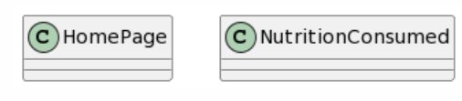

3.1.1.1 HomePage Class

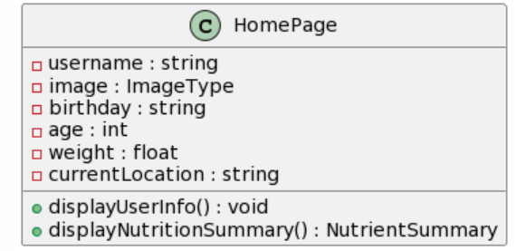

3.1.1.2 Nutrtion Consumed Class

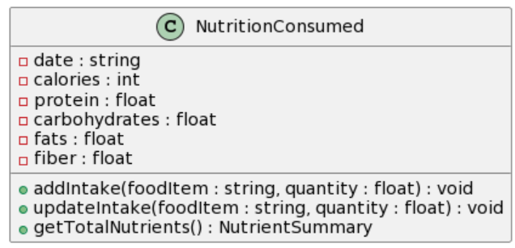

3.1.2 **Module-2: Dish Selector(Main):**

This is the main module that caters the functional requirements of the system. It has the model that provides the dish to make and take the ingredients owned by the user. In the IngredientInput the user adds their inventory . The DishRecommendation app takes the data from the IngredientInput and uses the class Model to present the user with a list of appropriate dishes to make.

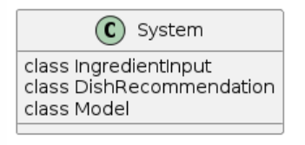

3.1.2.1 Ingredient Input

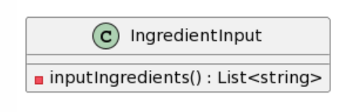

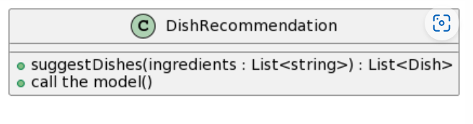3.1.2.2 Dish Recommendation Class

3.1.2.3 Model Class

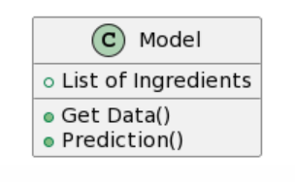

3.1.3 *Module-3: Nutritional Teller:*

This module basically tells the nutritional value of each dish based on the ingredients given by the user . DishNutriton Class fetches various macronutrient data from the data set and presents it to the user. This information is also given to the NutritionConsumed class to present on a weekly basis.The modelNutrition Class basically accesses the data for DishNutrition.

3.1.3.1 Dish Nutrition class

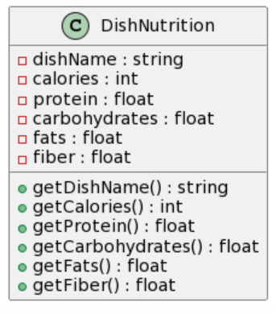

3.1.3.2 Model Nutrition class

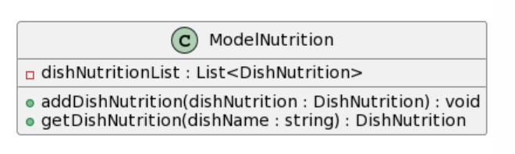

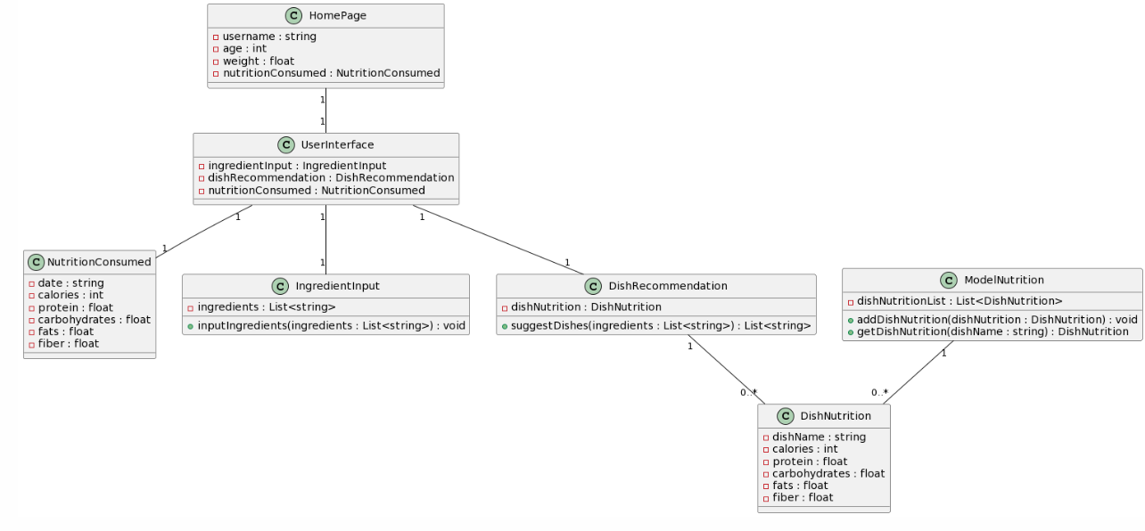

# 3.2 User Interface and Services

This section will describe the basic user interface, the services the user can access and major use cases of the app.

3.2.1 *User Interface* ***TODO***

3.2.2 *Services*

This section will tell the workflow the system when a service is retrieved.

* 1. 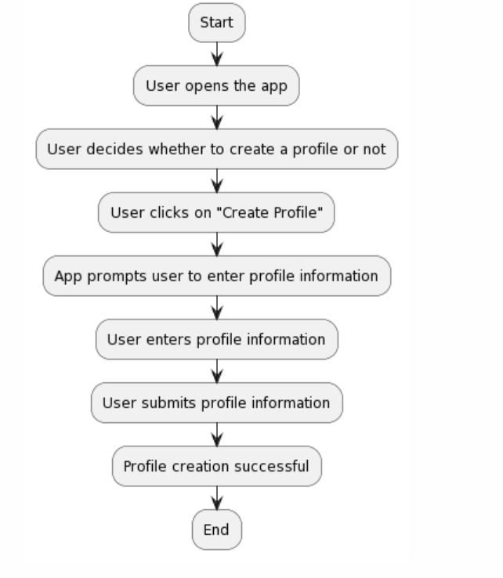The Profile Creation

* 1. Plan A Dish

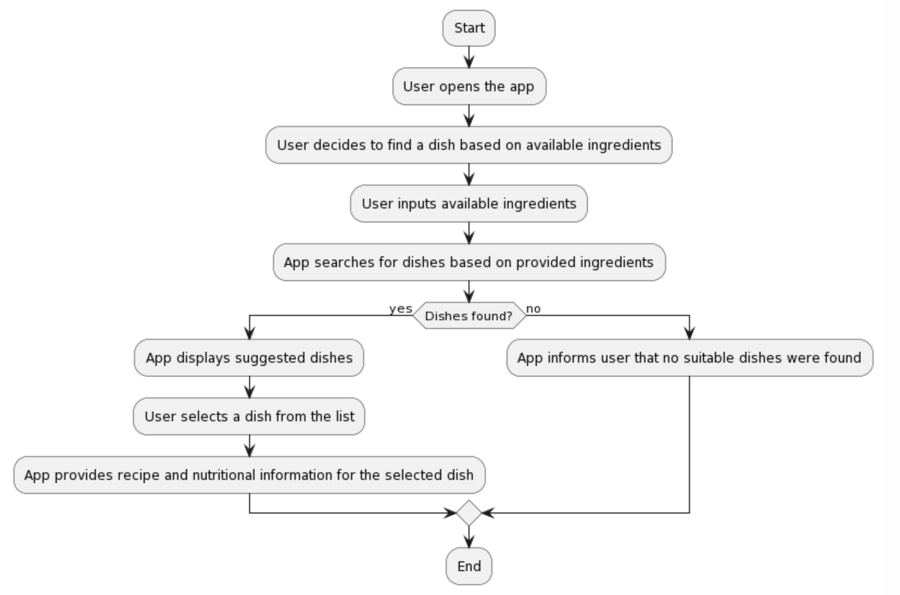

* 1. Checking Nutritional Value

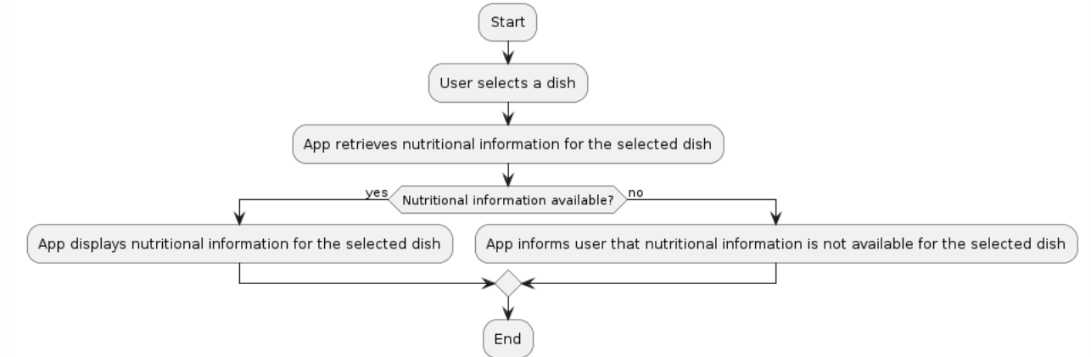

# 3.3 Reliability

The system completely relies on a Model that predicts your requirement based on previously seen data. So, the system may not be 100 % accurate. However, the system will surely give you an idea about the scenario.

# 3.4 Security and Permissions needed

The system needs the following permissions:

* Internet
* Notification Access

The System follows IEEE Security Standards and will not use any data for the commercial benefit of the system

4. Software Architecture

A brief document is available at the link attached below. Please have a look to know more

<https://docs.google.com/document/d/1upvBY850hUYmp7YMUsqp_0DUoYEgzCM1KYQ3lrMjQ2M/edit?usp=sharing>