Product Design
Team | 32 | Nitesh Gupta, Kartik Garg, Ankit Vaishy

Design Model :

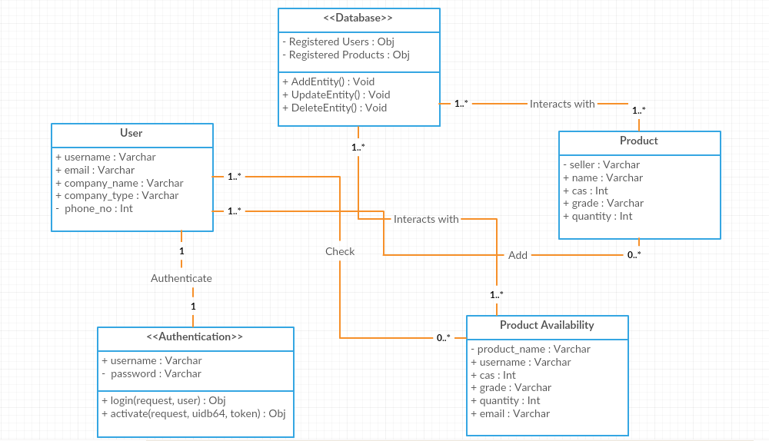

Authentication | Class state  - Stores the token and state for the person trying to login  Class behavior  - Use the implemented method to handle sign up/login , etc.
Back-end (Database) | Class state  - Maintains information about the major entities like users, products, etc.  Class behavior  - Implement CRUD for various entities.
Check Availability | Class state  - Stores information about the product requested by user.  Class behavior  - Informs admin about requested product and the user who requested.
Product | Class state  - Stores information about the products in database.  Class behavior  - Handle CRUD on products
Sequence Diagram(s)

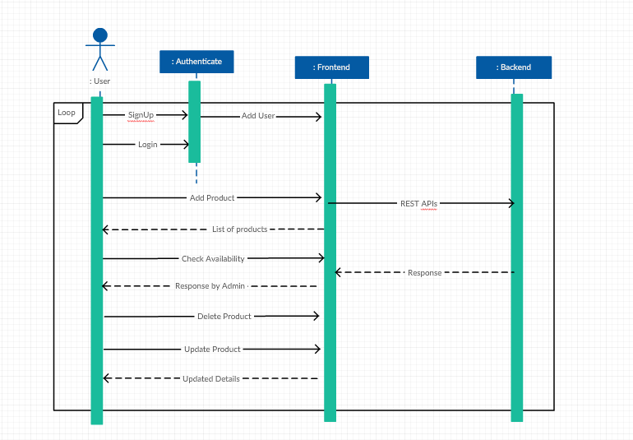

Design Rationale

- We first tried to use taggit for importing data from database but after implementing it we got to know that it take two space separated words as two strings but we need them as a single string. So finally we implemented by using django-excel and simple python functions.

- For implementing search query, at first we stored information of parent table in child table in database and simply iterated in second table. But then we realized that whenever there is an update or delete in parent table, it will cause problems. So to maintain referential integrity, we added a many-to-one relationship between both tables.

