Software Requirements Specification (SRS) Document

Project number | SSAD39
Project Title | PharmaNexus
Document | Software Requirements Specification (SRS)
Team Name | Team 32
Team Members | Nitesh Gupta, Kartik Garg, Ankit Vaishy

Brief problem statement
It is a web based application that helps users to buy raw materials and sell products. Major task in our project is handling the database which is quite huge and providing users results for their queries.

System requirements
- Programming Language – Python( version 3.x)
- Web Framework – Django (Version 1.10.7)
- Database Management System – MySQL(version 1.3.10)
- No hardware Requirement as such.

Users profile
Sign-in will be required for all type of users. If they don’t have account, they can create it on our platform. Basically users related to Pharmaceutical and chemical companies will use our website to either buy or sell the products. The front end will be designed in such a way, a non-technical person with no pre-requisite knowledge would be able to navigate our site.

Feature requirements (described using use cases)

No. | User Case Name | Description | Release
1 | Home | A tab on main page of the website which will have Description about the company Chembid and Search Bar. | R1
2 | Buy Impurities | A tab on main page of the website which will have Procedural details about how to buy impurities. | R1
3 | Available Product | A tab on main page Showing list of products uploaded by user | R1
4 | Mainproducts | A tab on main page for admin after authentication where he can view all the  products uploaded by him | R1
5 | Login/signup | A tab on main page for user to login/Signup in order to get search results or to Buy anything and for admin to view his dashboard. | R1
6 | Search Tab | A Search Box for user to search products by sub-component (API’S) and by the name of product | R1
7 | Edit product/mainproduct/impurity | A button for user/admin to edit details of the uploaded product | R2
8 | Add new Product/impurity/main-product | A tab on available product page ,buy impurity and main-product ,on clicking it, user/admin who are logged in can add a new product so that their product will be viewable by other users/companies. | R2
9 | Check availibility | A tab on available product page and buy impurity,clicking on which gives a notification to admin about the details of product and user | R2
10 | Admin Dashboard | A dashboard for admin which includes list of user registered, edit/delete feature for uploaded product and A master page containing all the uploaded products and an ability to prompt that someone has requested for details. | R1
11 | Import Excel file | A feature using which admin can directly add products to database by importing excel file | R2
12 | Impurity/product request | A feature where details of user who requested for product/impurity is displayed | R2

Use case diagram

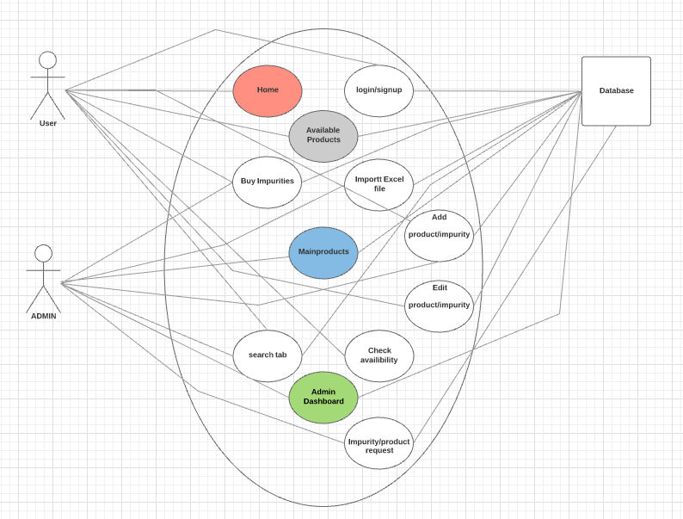

Use case description

Use Case Number: | UC-01
Use Case Name: | Home
Overview: | A tab on main page of the website which will have Description about the company Chembid and Search Bar. .
Actors: | User
Pre condition: | True
Flow: | 1)User clicks on the tab  2)Information displayed
Alternate Flows: | None
Post Condition: | True

Use Case Number: | UC-02
Use Case Name: | Buy Impurities
Overview: | A tab on main page of the website which will have Procedural details about how to buy impurities.
Actors: | User
Pre condition: | True
Flow: | 1)User clicks on the tab  2)Information displayed
Alternate Flows: | None
Post Condition: | True

Use Case Number: | UC-03
Use Case Name: | Buy Surplus Products
Overview: | A tab on main page of the website which will have Procedural details about how to buy Surplus Product
Actors: | User
Pre condition: | True
Flow: | 1)User clicks on the tab  2)Information displayed
Alternate Flows: | None
Post Condition: | True

Use Case Number: | UC-04
Use Case Name: | How It Works
Overview: | A tab on main page of the website which will explain how Chembid works.
Actors: | User
Pre condition: | True
Flow: | 1)User clicks on the tab  2)Information displayed
Alternate Flows: | None
Post Condition: | True

Use Case Number: | UC-05
Use Case Name: | About Us
Overview: | A tab on main page of the website which will have Description about the Chembid Team.
Actors: | User
Pre condition: | True
Flow: | 1)User clicks on the tab  2)Information displayed
Alternate Flows: | None
Post Condition: | True

Use Case Number: | UC-06
Use Case Name: | Contact Us
Overview: | A tab on main page of the website which will have a form which user has to fill in order to get his query addressed and other means to contact the Help-desk team.
Actors: | User
Pre condition: | True
Flow: | 1)User clicks on the tab  2)Information displayed
Alternate Flows: | None
Post Condition: | True

Use Case Number: | UC-07
Use Case Name: | Login
Overview: | A tab on main page for user to login in order to get search resulst or to Buy anything and for admin to view his dashboard.
Actors: | User, Admin
Pre condition: | True
Flow: | 1)User/admin clicks on the tab  2)Login Page Displayed  3)User asked to Sign up/login and admin asked to login  4)Validation  4)After login user redirected to home page and admin to admin dashboard
Alternate flows: | 1) if login failed user/admin asked to check credentials and asked to Sign up if not registered.
Post Condition: | Validation

Use Case Number: | UC-08
Use Case Name: | Search Bar
Overview: | A Search Box for user to search products by sub-component(API’S) and by the name of product
Actors: | User,database
Pre condition: | True
Flow: | 1)User types to search  2)Information is displayed if user is loged in.
Alternate flows: | If user fails to login, he will be redirected to home/main page
Post Condition: | User is Logged in

Use Case Number: | UC-09
Use Case Name: | Upload Product
Overview: | A Page on which user who are logged in can upload their product so that their product will be viewable by other users/companies.
Actors: | User
Pre condition: | True
Flow: | 1)User types the product he want to sell  2)Database will be updated
Alternate flows: | If user is not logged in, he will be asked to log in.
Post Condition: | The product is added on the admin dashboard

Use Case Number: | UC-10
Use Case Name: | Admin Dashboard
Overview: | A dashboard for admin which includes list of users registered, edit/delete feature for uploaded product and A master page containing all the uploaded products and an ability to prompt that someone has requested for details.
Actors: | Admin
Pre condition: | Admin validation
Flow: | 1)Redirected to admin dashboard
Alternate flows: | If admin is not logged in, he will be asked to login.
Post Condition: | none

Use Case Number: | UC-11
Use Case Name: | Search bar(2)
Overview: | This will be a search bar on the view products page so that user can search products by name and id
Actors: | User
Pre condition: | User logged in
Flow: | 1)User enters search query  2)Result will be displayed according to his query
Alternate flows: | none
Post Condition: | User must be logged in to view the results

Use Case Number: | UC-12
Use Case Name: | Import Csv file
Overview: | A feature using which admin can directly add products to database by importing csv file
Actors: | Admin
Pre condition: | Admin validation
Flow: | 1)Admin selects the file to be uploaded  2)Database will be updated
Alternate flows: | none
Post Condition: | Database updated

