* A Jenkins server was created on localhost.
* All the required Plugins were installed, major plugins are listed below:

Email Extension

Git plugin

GitHub Authentication plugin

GitHub Integration Plugin

GitHub plugin

JaCoCo plugin

Maven Integration plugin

OWASP Dependency-Check Plugin

PAM Authentication plugin

Pipeline Maven Integration Plugin

Pipeline: GitHub

Pipeline: Groovy

Pipeline: SCM Step

SonarQube Scanner for Jenkins

* Some global tool configuration & system configuration were added to provide the executable path, and some other configs :

Git installations, SonarQube Scanner installations, Maven installations, Dependency-Check installations , Extended E-mail Notification, SonarQube servers

* Jenkins Job configuration:

Job type: pipeline

Pipeline definition using pipeline script . ( Content of pipeline script has been attached as file name [Jenkins_file.groovy](https://github.com/guptankurrr/Assignment2/blob/main/Jenkins_file.groovy) )

Stages in Jenkins job:

Checkout

SonarQube Analysis

Build with JaCoCo

Run Tests with JaCoCo

Publish JaCoCo Coverage Report

Run Cyclomatic Complexity Analysis

Run Dependency-Check

Archive Reports

Publish Dependency-Check Results

Credentials created:

Cred for sonarqube

Cred for github  
NVD-API-KEY

Cred for email auth

Components installed:

[jenkins](https://2.mirrors.in.sahilister.net/jenkins/war/2.485/jenkins.war)

jdk-17

sonar-scanner-cli  
sonarqube

Git

maven

lizard

dependency-check

Jacoco:

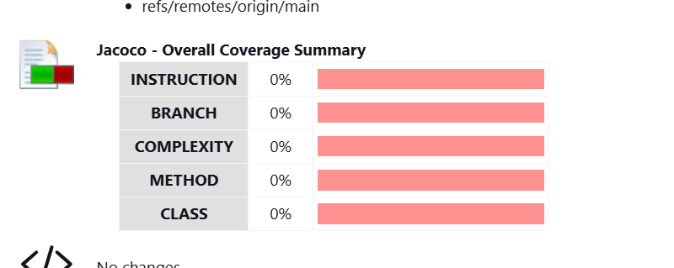

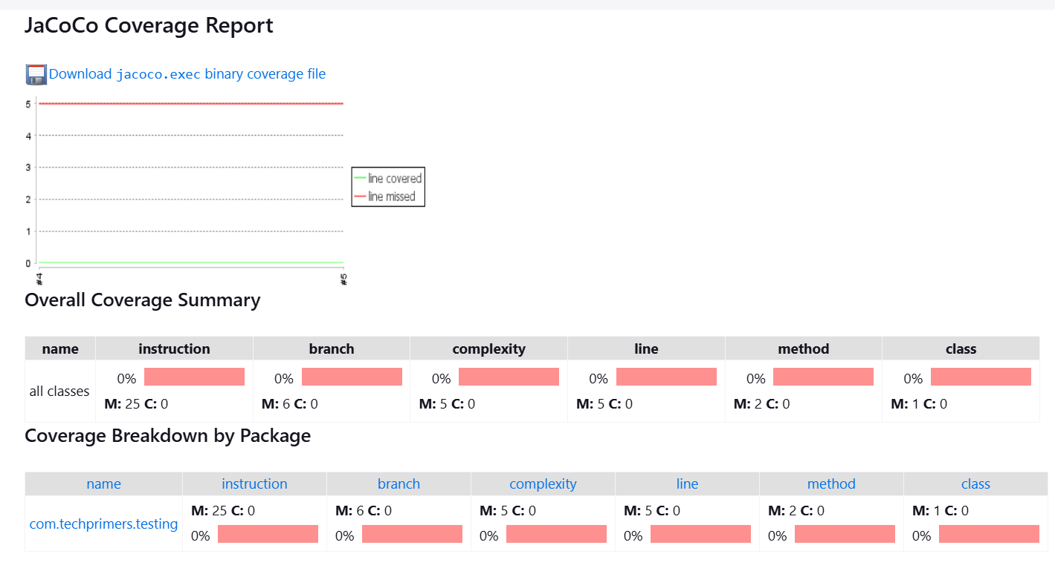

Sonarqube dashboard snippets:

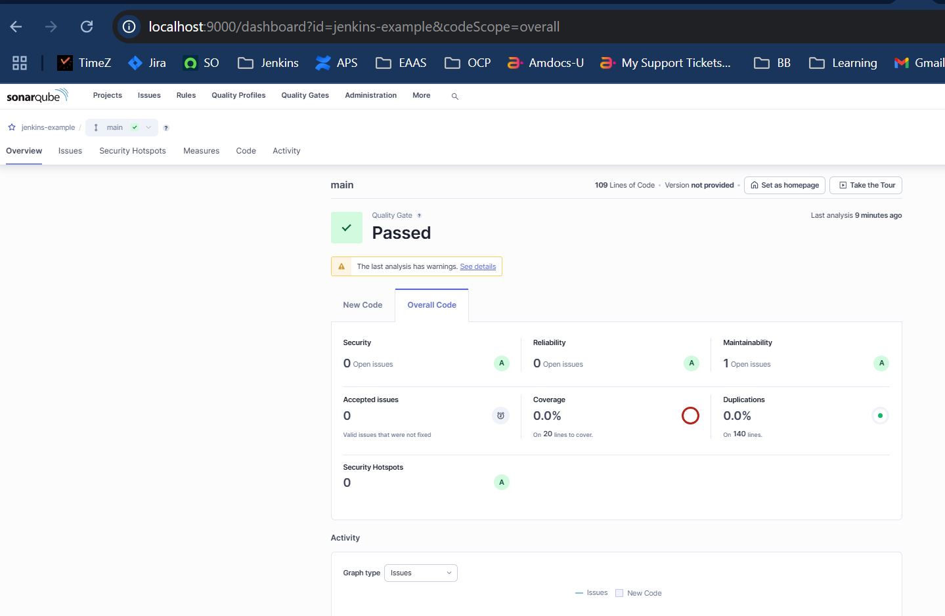

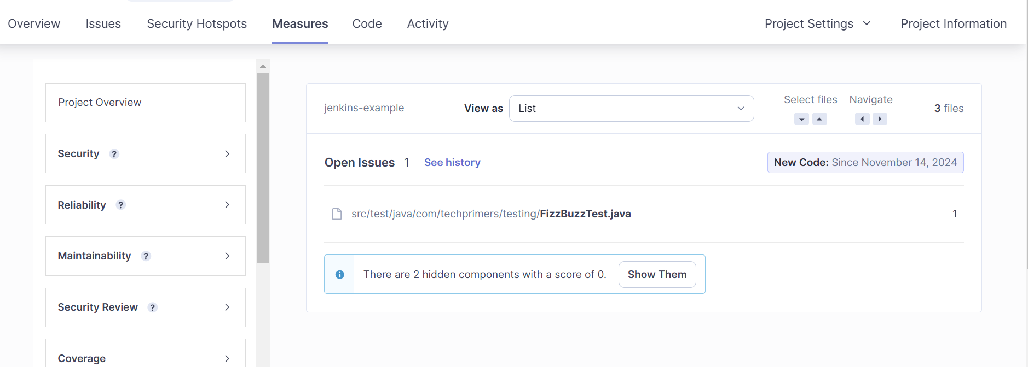

Cyclomatic Complexity Analysis using lizard: ( attached in github repo also )



OWASP Dependency-Check report: It was not generated because it is taking too much time :

C:\Users\guptanku\.jenkins\workspace\Assignment>"C:\Program Files\dependency-check\dependency-check/bin/dependency-check.bat" --scan . --out dependency-check-report --format HTML --nvdApiKey be7f8997-aef6-4e00-9c65-3176a78afabd

[INFO] Checking for updates

[INFO] NVD API has 269,799 records in this update

[INFO] Downloaded 10,000/269,799 (4%)

[INFO] Downloaded 20,000/269,799 (7%)

[INFO] Downloaded 30,000/269,799 (11%)

[WARN] Retrying request /rest/json/cves/2.0?resultsPerPage=2000&startIndex=28000 : 2 time

[WARN] Retrying request /rest/json/cves/2.0?resultsPerPage=2000&startIndex=32000 : 2 time

[WARN] Retrying request /rest/json/cves/2.0?resultsPerPage=2000&startIndex=34000 : 2 time

[WARN] Retrying request /rest/json/cves/2.0?resultsPerPage=2000&startIndex=28000 : 3 time

[WARN] Retrying request /rest/json/cves/2.0?resultsPerPage=2000&startIndex=32000 : 3 time

[WARN] Retrying request /rest/json/cves/2.0?resultsPerPage=2000&startIndex=32000 : 4 time

[WARN] NVD API request failures are occurring; retrying request for the 5 time

[INFO] Downloaded 40,000/269,803 (15%)

[INFO] Downloaded 50,000/269,803 (19%)

[INFO] Downloaded 60,000/269,803 (22%)

[INFO] Downloaded 70,000/269,803 (26%)

[INFO] Downloaded 80,000/269,803 (30%)

[INFO] Downloaded 90,000/269,803 (33%)

[INFO] Downloaded 100,000/269,803 (37%)

[WARN] Retrying request /rest/json/cves/2.0?resultsPerPage=2000&startIndex=164000 : 2 time

[WARN] Retrying request /rest/json/cves/2.0?resultsPerPage=2000&startIndex=184000 : 2 time

[INFO] Downloaded 110,000/269,803 (41%)

[INFO] Downloaded 120,000/269,803 (44%)

[INFO] Downloaded 130,000/269,804 (48%)

[INFO] Downloaded 140,000/269,804 (52%)

[INFO] Downloaded 150,000/269,804 (56%)