Contents
How interrupt occurs with interrupt vector table 4
Interrupt latency 7
32 bit and 64 bit compilers 16
Mutex 20
When Mutex Will Be Used 23
✔ 1. Shared Data Between Tasks 23
✔ 2. Shared Hardware Peripherals 23
✔ 3. Critical Section Protection 23
✔ 4. Prevent Race Conditions 23
✔ 5. Resource Locking With Priority Inversion Protection 23
👍 Advantages (Pros) 24
1. Prevents Data Corruption 24
2. Prevents Race Conditions 24
3. Supports Priority Inheritance 24
4. Very Easy to Use 24
👎 Disadvantages (Cons) 24
1. Risk of Deadlocks 24
2. Blocking Delays 24
3. Misuse Causes System Freeze 24
4. Not Suitable for High-Frequency ISRs 24
5. More Overhead 24
🆚 Mutex vs Semaphore – Quick Difference 25
📝 Easy Rule to Remember 25
✔ Use mutex → when protecting a resource 25
✔ Use semaphore → when signaling an event 25
✅ How an Interrupt Causes the CPU to Jump to an ISR 29
🧠 1. Interrupt Vector Table (IVT) – the map of all ISR addresses 29
🧲 2. Interrupt occurs → hardware sets a flag → CPU is notified 30
⛓️ 3. Interrupt Controller selects which interrupt to run 30
🏃‍♂️ 4. CPU automatically jumps to the IVT 31
⚙️ 5. CPU saves context 31
📝 6. CPU Executes the ISR Code 32
🔙 7. ISR returns using a special instruction 32
📌 ESP32 Specifically (Xtensa architecture) 32
🧠 Summary (Simple Words) 33
Embedded C Interview Questions for Freshers 34
1. What do you understand by segmentation fault? 34
2. What do you understand by startup code? 34
3. What is ISR? 34
4. What is Void Pointer in Embedded C and why is it used? 36
5. Why do we use the volatile keyword? 36
6. What are the differences between the const and volatile qualifiers in embedded C? 37
7. What Is Concatenation Operator in Embedded C? 37
8. What do you understand by Interrupt Latency? 38
9. How will you use a variable defined in source file1 inside source file2? 39
10. What is Embedded C Programming? How is Embedded C different from C language? 40
11. What are the differences between Inline and Macro Function? 40
12. Is it possible for a variable to be both volatile and const? 41
13. Is it possible to declare a static variable in a header file? 42
14. What do you understand by the pre-decrement and post-decrement operators? 42
15. What is a reentrant function? 43
Embedded C Interview Questions for Experienced 43
1. Is it possible to protect a character pointer from accidentally pointing it to a different address? 43
2. What are the reasons for segmentation fault in Embedded C? How do you avoid these errors? 44
3. Is it recommended to use printf() inside ISR? 45
4. Is it possible to pass a parameter to ISR or return a value from it? 46
5. What Is a Virtual Memory in Embedded C and how can it be implemented? 46
6. What is the issue with the following piece of code? 47
7. The following piece of code uses __interrupt keyword to define an ISR. Comment on the correctness of the code. 48
8. What is the result of the below code? 48
9. What are the reasons for Interrupt Latency and how to reduce it? 49
10. Why is the statement ++i faster than i+1? 50
11. What do you understand by Wild Pointer? How is it different from Dangling Pointer? 51
12. What are the differences between the following 2 statements #include "..." and #include <...>? 51
13. When does a memory leak occur? What are the ways of avoiding it? 52
14. What kind of loop is better - Count up from zero or Count Down to zero? 53
15. What do you understand by a null pointer in Embedded C? 54
16. Following are some incomplete declarations, what do each of them mean? 54
Embedded C Programming 55
1. Write an Embedded C program to multiply any number by 9 in the fastest manner. 55
2. How will you swap two variables? Write different approaches for the same. 56
3. Write a program to check if a number is a power of 2 or not. 57
4. Write a program to print numbers from 1 to 100 without making use of conditional operators? 57
5. Write a MIN macro program that takes two arguments and returns the smallest of both arguments. 57
Embedded C MCQ 58
Modbus protocol 92

How interrupt occurs with interrupt vector table
Here’s a clear step-by-step explanation of how an interrupt occurs using the Interrupt Vector Table (IVT)—especially for ARM Cortex-M (STM32).

🔹 1. What is Interrupt Vector Table?
👉 The Interrupt Vector Table (IVT) is an array of addresses.
- Each entry = address of ISR (Interrupt Service Routine)
- Located at fixed memory (usually Flash start: 0x00000000)

🔹 2. Structure of Vector Table (Cortex-M)
Index | Description
0 | Initial Stack Pointer
1 | Reset Handler
2 | NMI Handler
3 | HardFault Handler
... | Other exceptions
n | Peripheral ISR (I2C, UART, etc.)

🔹 3. How Interrupt Occurs (Step-by-Step)
🟢 Step 1: Interrupt Event
- Peripheral triggers interrupt
(e.g., I2C, Timer, GPIO)

🟢 Step 2: NVIC Receives Request
- NVIC (Nested Vectored Interrupt Controller) checks:
  - Interrupt enabled?
  - Priority?

🟢 Step 3: Current Instruction Completes
- CPU finishes current instruction
- Ensures consistency

🟢 Step 4: Context Saving (Stacking)
CPU automatically pushes to stack:
- PC (Program Counter)
- LR (Link Register)
- xPSR
- R0–R3, R12

🟢 Step 5: Vector Table Lookup
- NVIC finds interrupt number (IRQn)
- Uses it as index in IVT
👉 Fetch ISR address from vector table

🟢 Step 6: Jump to ISR
- PC is loaded with ISR address
- ISR execution starts

🟢 Step 7: ISR Execution
Example:
void I2C1_EV_IRQHandler(void)
{
// handle I2C interrupt
}

🟢 Step 8: Return from Interrupt
- BX LR (or automatic return)
- CPU restores registers from stack
- Execution resumes from previous code

🔹 4. Visual Flow
Interrupt occurs
↓
NVIC checks priority
↓
Finish current instruction
↓
Push registers to stack
↓
Read ISR address from Vector Table
↓
Jump to ISR
↓
Execute ISR
↓
Pop registers
↓
Resume main program

🔹 5. Example Vector Table Entry
void (* const vector_table[])(void) = {
(void *)0x20001000, // Initial SP
Reset_Handler,
NMI_Handler,
HardFault_Handler,
I2C1_EV_IRQHandler, // Example interrupt
};

🔹 6. Important Concepts
✔ Vectored Interrupt
- Direct jump using table (fast)
✔ NVIC
- Handles priority & nesting
✔ Tail-Chaining (Optimization)
- Skips restore/save if back-to-back interrupts

🔹 7. Interview One-Liner
👉
“When an interrupt occurs, NVIC uses the interrupt number to index into the vector table, fetches the ISR address, and the CPU jumps to it after saving context.”

🔹 8. Key Points to Remember ⚠️
- Vector table = array of ISR addresses
- First entry = stack pointer
- Stored in Flash (default)
- Can be relocated (RAM) using VTOR register

Interrupt latency

Interrupt latency = the time delay between an interrupt event occurring and the CPU starting to execute the Interrupt Service Routine (ISR).

🔹 1. Simple Definition
👉
Interrupt Latency = Time from interrupt signal → first ISR instruction execution

🔹 2. What Happens Internally (Step-by-Step)
When an interrupt occurs (e.g., in an STM32 Cortex-M):
- Current instruction completes
- CPU saves context (PC, registers) to stack
- Interrupt controller (NVIC) selects highest priority interrupt
- Vector table lookup happens
- PC jumps to ISR

🔹 3. Components of Latency
Total latency depends on:
✔ Hardware delay
- Synchronization of interrupt signal
- NVIC processing
✔ CPU delay
- Current instruction completion
- Pipeline flush
✔ Context saving
- Registers pushed to stack
✔ Software delay (optional)
- Interrupt disabled (__disable_irq())
- RTOS critical sections

🔹 4. Typical Values (Cortex-M)
- Cortex-M3/M4: ~12 cycles (best case)
- With FPU / stacking: higher (~20–30 cycles)

🔹 5. Factors Affecting Latency ⚠️
🔸 Increases latency:
- Interrupts disabled
- Long critical sections
- Low interrupt priority
- Nested interrupts
- Flash wait states
- Cache/memory delays
🔸 Reduces latency:
- High priority interrupt
- Zero-wait RAM execution
- Minimal ISR overhead

🔹 6. Interrupt Latency vs Response Time
- Latency → time to start ISR
- Response time → time to finish ISR

🔹 7. Example (Embedded)
__disable_irq();
// critical section (interrupt delayed here)
__enable_irq();
👉 Any interrupt during this time → latency increases

🔹 8. Real-World Impact
- Missed sensor data
- Communication errors (I2C/SPI/UART)
- Timing jitter in real-time systems

🔹 9. Interview One-Liner
👉
“Interrupt latency is the delay between an interrupt request and the execution of its ISR, mainly caused by instruction completion, context saving, and interrupt priority handling.”

🔹 10. Pro Tips (Very Important)
✔ Keep ISRs short
✔ Avoid disabling interrupts too long
✔ Use DMA for heavy transfers
✔ Use proper priority configuration

If you want, I can explain:
✔ Interrupt latency measurement using GPIO toggle (very common interview)
✔ NVIC priority grouping in STM32
✔ Nested interrupt handling (tail chaining concept)

ARM Exceptions
In an ARM controller (especially Cortex-M series), exceptions are events that change the normal program flow and transfer control to a special function called an exception handler.

🔹 What are ARM Exceptions?
An exception occurs when:
- An interrupt happens (external/internal)
- A fault/error occurs
- A system service is requested
👉 CPU stops current execution, saves context, and jumps to a handler via the vector table.

🔹 Types of ARM Exceptions (Cortex-M)
1. Reset
- Occurs on power-up or reset signal
- Loads:
  - Initial SP (Stack Pointer)
  - Reset handler address
- Starts program execution

2. NMI (Non-Maskable Interrupt)
- Highest priority (cannot be disabled)
- Used for critical events
  - Watchdog timeout
  - Hardware failure

3. Hard Fault
- Occurs for severe errors
- Examples:
  - Invalid memory access
  - Bus error (if not handled separately)

4. Memory Management Fault
- Triggered when:
  - Access violation
  - MPU (Memory Protection Unit) fault

5. Bus Fault
- Occurs due to:
  - Invalid memory access
  - Bus errors (AHB/APB)

6. Usage Fault
- Caused by programming errors:
  - Divide by zero
  - Undefined instruction
  - Unaligned access

7. SVCall (Supervisor Call)
- Generated by software using instruction:
SVC #imm
- Used for:
  - OS system calls (e.g., FreeRTOS)

8. Debug Monitor
- Used during debugging
- Triggered by breakpoints/watchpoints

9. PendSV (Pending Supervisor)
- Used for context switching
- Very important in RTOS
👉 Example:
- FreeRTOS uses PendSV for task switching

10. SysTick
- Timer exception
- Generates periodic interrupts
👉 Used for:
- OS tick (scheduler timing)

11. External Interrupts (IRQ)
- From peripherals:
  - GPIO
  - UART
  - I2C
  - SPI
Handled via:
👉 NVIC (Nested Vectored Interrupt Controller)

🔹 Exception Priority (Important)
Priority order (high → low):
- Reset
- NMI
- Hard Fault
- Other faults
- SVCall
- PendSV
- SysTick
- IRQs
👉 Lower number = higher priority

🔹 Exception Entry (What CPU does)
When exception occurs:
- Current instruction completes
- CPU pushes to stack:
  - R0–R3
  - R12
  - LR
  - PC
  - xPSR
- Loads handler address from vector table
- Jumps to handler

🔹 Exception Return
- Done using special value in LR (EXC_RETURN)
- CPU restores registers from stack
- Resumes previous execution

🔹 Vector Table (Very Important)
- Located at address 0x00000000 (default)
- Contains:
  - Initial SP
  - Handler addresses
Example:
0x00000000 → Initial SP
0x00000004 → Reset Handler
0x00000008 → NMI Handler
0x0000000C → HardFault Handler
...

🔹 Simple Flow
Interrupt/Fault occurs
↓
CPU saves context (stack)
↓
Fetch handler from vector table
↓
Execute ISR / Handler
↓
Return → restore context

🔹 Interview Tips (Very Important)
- Difference between Fault vs Interrupt
- Role of NVIC
- Why PendSV used in RTOS
- What is EXC_RETURN
- What registers are stacked automatically

32 bit and 64 bit compilers

The difference between 32-bit compiler and 64-bit compiler mainly comes down to how they handle memory, data size, and CPU architecture.

🔹 What is a 32-bit Compiler?
A 32-bit compiler generates code for a 32-bit CPU architecture.
✅ Key Features:
- Address space: up to 4 GB RAM (2³²)
- Pointer size: 4 bytes
- Registers: 32-bit wide
- Compatible with older systems
🔧 Example:
- Compiling with GCC using:
gcc -m32 program.c

🔹 What is a 64-bit Compiler?
A 64-bit compiler generates code for a 64-bit CPU architecture.
✅ Key Features:
- Address space: theoretically 16 EB (2⁶⁴) (practically limited by OS)
- Pointer size: 8 bytes
- Registers: 64-bit wide
- Better performance for large data & computations
🔧 Example:
gcc -m64 program.c

🔥 Key Differences (Important for Interviews)
Feature | 32-bit Compiler | 64-bit Compiler
Addressable RAM | ~4 GB | > 4 GB (huge)
Pointer size | 4 bytes | 8 bytes
Performance | Lower | Higher (for large data)
Registers | Fewer | More
Compatibility | Legacy systems | Modern systems

🔹 Practical Impact in C/C++
Example:
#include <stdio.h>
int main() {
printf("%zu\n", sizeof(void*));
}
- 32-bit → Output: 4
- 64-bit → Output: 8
👉 This is a very common interview question

🔹 When to Use What?
Use 32-bit:
- Embedded systems (like microcontrollers)
- Memory-constrained environments
- Legacy applications
Use 64-bit:
- Modern OS (Linux, Windows)
- High-performance computing
- Large memory applications

🔹 Important for You (Embedded + Linux)
Since you're working with:
- Linux Mint
- ESP32 / low-level drivers
👉 Most embedded targets are 32-bit (or even 8/16-bit)
👉 But your host machine compiler is 64-bit
So you often use:
- Cross-compilers (e.g., ARM toolchain)
Example:
arm-none-eabi-gcc // for microcontrollers (32-bit ARM)

🔹 Interview Tip ⭐
They may ask:
👉 “What changes when moving from 32-bit to 64-bit?”
Answer:
- Pointer size changes
- Memory addressing increases
- ABI (calling convention) changes
- Structure padding may change

If you want, I can also explain:
✅ Structure padding difference (very important)
✅ 32 vs 64-bit assembly difference
✅ ABI / calling convention (deep interview topic)
gcc compiler in linux pc is 64 or 32 bit
On most modern Linux PCs (including your Linux Mint system), GCC is typically 64-bit by default.

🔹 How it works
✅ Default case (modern systems)
- If your OS is 64-bit, GCC is:
  - 64-bit compiler
  - Generates 64-bit binaries by default
👉 Example:
gcc test.c
This produces a 64-bit executable

🔹 How to check on your system
1. Check GCC version info:
gcc -v
Look for:
Target: x86_64-linux-gnu
👉 x86_64 = 64-bit

2. Check compiled binary:
file a.out
Output:
ELF 64-bit LSB executable

🔹 Can GCC compile 32-bit also?
👉 YES (if libraries are installed)
gcc -m32 test.c
But you may need:
sudo apt install gcc-multilib

🔹 Summary
System Type | GCC Default Output
32-bit OS | 32-bit binary
64-bit OS | 64-bit binary ✅

🔥 Important for you (interview point)
👉 GCC itself can support both 32-bit and 64-bit,
but default depends on system architecture

If you want, I can show:
✅ Difference in assembly (32 vs 64)
✅ Memory layout changes
✅ ABI differences (very important for low-level jobs)

Virtual memory:
Real memory (Physical RAM) is the actual, high-speed hardware storing active data, while virtual memory is a technique using disk space to simulate extra RAM. Virtual memory allows running larger applications by swapping data between RAM and storage, making the system act as if it has more memory than physically installed.
Real Memory (Physical RAM)
- Definition: The actual physical hardware (Random Access Memory) installed on the motherboard.
- Speed: Extremely fast, enabling immediate CPU access to data.
- Capacity: Limited by the amount of physical RAM modules installed (e.g., 8GB, 16GB).
- Volatility: Data is lost when power is turned off.
- Role: Holds the operating system, running applications, and data currently in use.
Virtual Memory
- Definition: A memory management technique that creates an illusion of a larger, contiguous memory space for applications, using both hardware RAM and hard disk/SSD space.
- Speed: Slower than physical RAM because it relies on disk storage.
- Capacity: Much larger, limited only by the size of the hard disk/SSD.
- Mechanism: Uses techniques like paging or segmentation to swap inactive data from RAM to a "paging file" or "swap space" on the hard drive, and back when needed.
- Role: Enables running more applications simultaneously than physically possible, and allows programs to use more memory than is physically available.
Key Differences
Feature | Real Memory (RAM) | Virtual Memory
Physical Component | Yes (RAM Chips) | No (Uses Disk Space)
Speed | Very Fast | Slower
Capacity | Small (e.g., 16 GB) | Large (Limited by Disk)
Cost | High | Low (Uses existing Disk)
Management | Managed by Hardware | Managed by Operating System

Mutex
Mutex is a synchronization primitive in multithreading or multitasking environment.
Its purpose is to protect the shared data from simultaneous access by multiple threads at same time. It will ensure access the share data by thread or task at a time.
Mutex will allow the thread to lock the resource and process it, other threads will wait until the thread locked the resource will unlock it.
Mutex vs Semaphore
In the Operating System, Mutex and Semaphores are kernel resources that provide synchronization services (also known as synchronization primitives). Synchronization is required when multiple processes are executing concurrently, to avoid conflicts between processes using shared resources.
Mutex
A mutex is different from a binary semaphore, which provides a locking mechanism. It stands for Mutual Exclusion Object. Mutex is mainly used to provide mutual exclusion to a specific portion of the code so that the process can execute and work with a particular section of the code at a particular time.
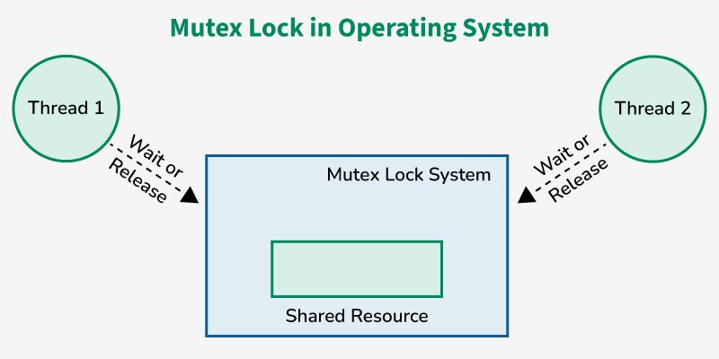Mutex
- A mutex enforces strict ownership. Only the thread that locks the mutex can unlock it.
- It is specifically used for locking a resource to ensure that only one thread accesses it at a time.
- Due to this strict ownership, a mutex is not only typically used for signaling between threads, but it is used for mutual exclusion also to ensuring that a resource is accessed by only one thread at a time.
- Mutex uses a priority inheritance mechanism to avoid priority inversion issues.
Note: The priority inheritance mechanism keeps higher-priority processes in the blocked state for the minimum possible time. However, this cannot avoid the priority inversion problem, but it can reduce its effect up to an extent.
Using Mutex
The producer-consumer problem: Consider the standard producer-consumer problem. Assume, we have a buffer of 4096-byte length. A producer thread collects the data and writes it to the buffer. A consumer thread processes the collected data from the buffer. The objective is, that both the threads should not run at the same time.
Solution: A mutex provides mutual exclusion, either producer or consumer can have the key (mutex) and proceed with their work. As long as the buffer is filled by the producer, the consumer needs to wait and vice versa. At any point in time, only one thread can work with the entire buffer. The concept can be generalized using semaphore.
Advantages of Mutex
- No race condition arises, as only one process is in the critical section at a time.
- Data remains consistent and it helps in maintaining integrity.
- It is a simple locking mechanism that into a critical section and is released while leaving the critical section.
Disadvantages of Mutex
- If after entering into the critical section, the thread sleeps or gets preempted by a high-priority process, no other thread can enter into the critical section. This can lead to starvation.
- When the previous thread leaves the critical section, then only other processes can enter into it, there is no other mechanism to lock or unlock the critical section.
- Implementation of mutex can lead to busy waiting, which leads to the wastage of the CPU cycle.

When Mutex Will Be Used
A mutex (mutual exclusion) is used when only ONE task/thread should access a shared resource at a time.
Use a mutex when:

✔ 1. Shared Data Between Tasks
Example:
Two tasks updating the same global variable or structure.

✔ 2. Shared Hardware Peripherals
Example:
- UART access
- I2C bus control
- SPI device access
Only one task should use these at a time.

✔ 3. Critical Section Protection
Any section of code that must not be interrupted.
Example:
xSemaphoreTake(xMutex, portMAX_DELAY);
shared++;
xSemaphoreGive(xMutex);

✔ 4. Prevent Race Conditions
When tasks run in parallel and may corrupt data if accessed simultaneously.

✔ 5. Resource Locking With Priority Inversion Protection
Mutexes (in RTOS) support priority inheritance, improving determinism.

👍 Advantages (Pros)

1. Prevents Data Corruption
Ensures only one task writes/reads critical data at a time.

2. Prevents Race Conditions
Avoid unpredictable behavior when tasks run concurrently.

3. Supports Priority Inheritance
If low priority task holds mutex → High priority task waits →
Mutex temporarily boosts(low → high).
This avoids priority inversion.

4. Very Easy to Use
Take (lock) → use → give (unlock).

👎 Disadvantages (Cons)

1. Risk of Deadlocks
If two tasks wait on each other’s mutex:
Task A waits for B
Task B waits for A

2. Blocking Delays
A high-priority task may block waiting for mutex, increasing worst-case timing.

3. Misuse Causes System Freeze
If task takes mutex and never releases (due to crash or return) →
System hangs.

4. Not Suitable for High-Frequency ISRs
Interrupts should not use mutexes (use semaphores instead).

5. More Overhead
Mutex has more overhead than a binary semaphore due to priority inheritance.

🆚 Mutex vs Semaphore – Quick Difference
Feature | Mutex | Binary Semaphore
Ownership | Owner must release | Anyone can release
Priority inheritance | Yes | No
Used for | Protecting shared resource | Signaling between tasks/ISR
Can cause deadlock | Yes | No (rare)

📝 Easy Rule to Remember

✔ Use mutex → when protecting a resource

✔ Use semaphore → when signaling an event

A deadlock occurs . This creates a circular wait condition, where no process can proceed, and the system comes to a standstill. For example, Process A holds Resource 1 and needs Resource 2, while Process B holds Resource 2 and needs Resource 1.

Semaphore
A semaphore is a non-negative integer variable that is shared between various threads. Semaphore works upon signaling mechanism, in this a thread can be signaled by another thread.
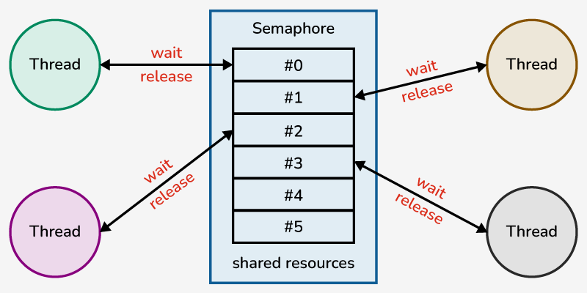Semaphore
- It provides a less restrictive control mechanism. Any thread can invoke signal() (also known as release() or up()) and any other thread can invoke wait() (also known as acquire() or down()).
- There is no strict ownership in semaphores, meaning the thread that signals doesn't necessarily have to be the same one that waited.
Note: Semaphores are often used for coordinating signaling between threads. Semaphore uses two atomic operations for process synchronization: Wait (P) & Signal (V).
Using Semaphore
The producer-consumer problem: Consider the standard producer-consumer problem. Assume, we have a buffer of 4096-byte length. A producer thread collects the data and writes it to the buffer. A consumer thread processes the collected data from the buffer. The objective is, both the threads should not run at the same time.
Solution: A semaphore is a generalized mutex. instead a single buffer, we can split the 4 KB buffer into four 1 KB buffers (identical resources). A semaphore can be associated with these four buffers. The consumer and producer can work on different buffers at the same time.
Advantages of Semaphore
- Multiple threads can access the critical section at the same time.
- Semaphores are machine-independent.
- Only one process will access the critical section at a time, however, multiple threads are allowed.
- Semaphores are machine-independent, so they should be run over microkernel.
- Flexible resource management.
Disadvantages of Semaphore
- It has priority inversion.
- Semaphore operations (Wait, Signal) must be implemented in the correct manner to avoid deadlock.
- It leads to a loss of modularity, so semaphores can't be used for large-scale systems.
- Semaphore is prone to programming error and this can lead to deadlock or violation of mutual exclusion property.
- Operating System has to track all the calls to wait and signal operations.
Difference Between Mutex and Semaphore
Mutex | Semaphore
A mutex is an object. | A semaphore is an integer.
Mutex works upon the locking mechanism. | Semaphore uses signaling mechanism.
Operations on mutex: Lock & Unlock | Operation on semaphore: Wait & Signal
Mutex does not have any subtypes. | Semaphore is of two types: Counting Semaphore & Binary Semaphore
A mutex can only be modified by the process that is requesting or releasing a resource. | Semaphore work with two atomic operations (Wait, signal) which can modify it.
If the mutex is locked then the process needs to wait in the process queue and mutex can only be accessed once the lock is released. | If the process needs a resource and no resource is free. So, the process needs to perform a wait operation until the semaphore value is greater than zero.
Misconception of Mutex and Semaphore
There is an ambiguity between binary semaphore and mutex. We might have come across that a mutex is a binary semaphore. But it is not! The purposes of mutex and semaphore are different. Maybe, due to similarity in their implementation of a mutex would be referred to as a binary semaphore.
- A mutex is a locking mechanism used to synchronize access to a resource.
- Only one task (can be a thread or process based on OS abstraction) can acquire the mutex.
- It means there is ownership associated with a mutex and only the owner can release the lock (mutex).
While, a semaphore is a signaling mechanism used to control access to shared resources in an operating system. For example, imagine you are downloading a large file on your computer (Task A) while simultaneously trying to print a document (Task B). When the print job is initiated, it triggers a semaphore that checks if the download is complete.
- If the download is still in progress, the semaphore prevents the print task from proceeding, effectively saying, "Wait until the download finishes."
- Once the download completes, the semaphore signals that Task B can start printing.
- This ensures that both tasks do not interfere with each other and helps manage system resources efficiently, allowing tasks to run smoothly without conflict.

when the interrupt occurs an isr will execute with the interrupt vector table address how the interrupt signal pointing to isr address

ChatGPT said:
Here’s the clear explanation of how an interrupt signal leads the CPU to execute the ISR, especially in ESP32 (or any MCU):

✅ How an Interrupt Causes the CPU to Jump to an ISR
When an interrupt occurs, the CPU does NOT “point” directly to your ISR address.
Instead, the CPU looks up a predefined entry in the Interrupt Vector Table (IVT).
Let’s break it down:

🧠 1. Interrupt Vector Table (IVT) – the map of all ISR addresses
Every MCU (including ESP32) has a table in memory:
Interrupt Number → ISR Function Address

Example illustration:
Interrupt ID | Vector Table Entry (Address)
0 | 0x4000_0200 (Timer ISR address)
1 | 0x4000_0204 (GPIO ISR address)
2 | 0x4000_0208 (UART ISR address)
… | ...
Each entry stores a function pointer — the address of the ISR.

🧲 2. Interrupt occurs → hardware sets a flag → CPU is notified
Example: GPIO pin edge detected.
The hardware:
- Sets an interrupt pending flag.
- Sends a signal to the interrupt controller (ESP32 uses two interrupt controllers: INTMUX + Level/Priority system).

⛓️ 3. Interrupt Controller selects which interrupt to run
The interrupt controller decides:
- Which interrupt has highest priority?
- Should the CPU be interrupted right now?
- What interrupt ID to send?
It sends the interrupt number to the CPU.

🏃‍♂️ 4. CPU automatically jumps to the IVT
The CPU does:
ISR_address = InterruptVectorTable[interrupt_number]
PC = ISR_address

Here, PC (Program Counter) is updated with the ISR address.
📌 This is the key step:
The CPU does not receive the ISR address directly —
it receives the interrupt ID, then fetches the ISR entry from the IVT.

⚙️ 5. CPU saves context
Before running ISR:
- Saves PC
- Saves registers
- Changes mode (if using privileged modes)
This allows returning exactly where it left off.

📝 6. CPU Executes the ISR Code
Your ISR runs:
void IRAM_ATTR gpio_isr_handler(void* arg) {
// Your interrupt logic
}

🔙 7. ISR returns using a special instruction
Such as:
eret / iret / rfi (architecture dependent)

This restores saved registers and PC → program continues normally.

📌 ESP32 Specifically (Xtensa architecture)
ESP32 uses:
- Two levels of vector tables
- Multiple interrupt levels (1–7)
- Fast Interrupts (level > 2)
- ISR functions often placed in IRAM (fast RAM) for speed
FreeRTOS layer also wraps/dispatches ISRs.

🧠 Summary (Simple Words)
- Interrupt occurs
- Interrupt controller gives the CPU an interrupt number
- CPU looks up the interrupt vector table
- CPU fetches the ISR address from the table
- CPU jumps to the ISR
- ISR runs and then returns

Embedded C is the most popular choice of language used for developing embedded systems because of its simplicity, efficiency, less time required for development, and its portability from one system to another. As we know that the embedded systems have constraints on hardware resources such as CPU, memory sizes, etc, it becomes very important to use the resources judiciously and responsibly. To achieve this, Embedded C usually can interact with the hardware resources with necessary abstractions.
In this article, we will see the most commonly asked interview questions in Embedded C for both freshers and experienced developers.

Embedded C Interview Questions for Freshers

1. What do you understand by segmentation fault?
A segmentation fault occurs most commonly and often leads to crashes in the programs. It occurs when a program instruction tries to access a memory address that is prohibited from getting accessed.
Create A Free Personalised Study Plan
Get into your dream companies with expert guidance
Real-Life Problems
Prep for Target Roles
Custom Plan Duration
Create My Plan

2. What do you understand by startup code?
A startup code is that piece of code that is called before the execution of the main function. This is used for creating a basic platform for the application and it is written in assembly language.

3. What is ISR?
ISR expands to Interrupt Service Routines. These are the procedures stored at a particular memory location and are called when certain interrupts occur. Interrupt refers to the signal sent to the processor that indicates there is a high-priority event that requires immediate attention. The processor suspends the normal flow of the program, executes the instructions in ISR to cater for the high priority event. Post execution of the ISR, the normal flow of the program resumes. The following diagrams represent the flow of ISR.
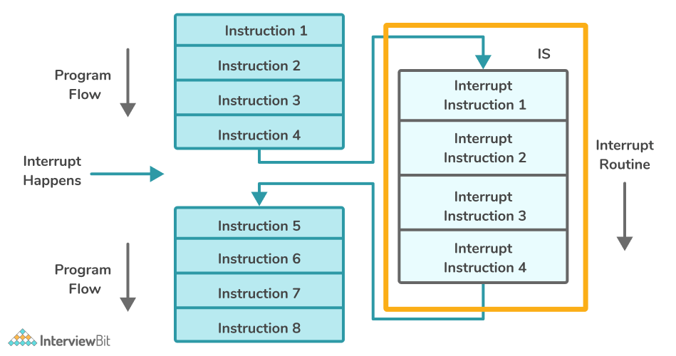
You can download a PDF version of Embedded C Interview Questions.
Download PDF

4. What is Void Pointer in Embedded C and why is it used?
Void pointers are those pointers that point to a variable of any type. It is a generic pointer as it is not dependent on any of the inbuilt or user-defined data types while referencing. During dereferencing of the pointer, we require the correct data type to which the data needs to be dereferenced.
For Example:
int num1 = 20; //variable of int datatype
void *ptr; //Void Pointer
*ptr = &num1; //Point the pointer to int data
print("%d",(*(int*)ptr)); //Dereferencing requires specific data type

char c = 'a';
*ptr = &c; //Same void pointer can be used to point to data of different type -> reusability
print("%c",(*(char*)ptr));
Void pointers are used mainly because of their nature of re-usability. It is reusable because any type of data can be stored.

5. Why do we use the volatile keyword?
The volatile keyword is mainly used for preventing a compiler from optimizing a variable that might change its behaviour unexpectedly post the optimization. Consider a scenario where we have a variable where there is a possibility of its value getting updated by some event or a signal, then we need to tell the compiler not to optimize it and load that variable every time it is called. To inform the compiler, we use the keyword volatile at the time of variable declaration.
// Declaring volatile variable - SYNTAX
// volatile datatype variable_name;
volatile int x;
Here, x is an integer variable that is defined as a volatile variable.

6. What are the differences between the const and volatile qualifiers in embedded C?
const | volatile
The keyword “const” is enforced by the compiler and tells it that no changes can be made to the value of that object/variable during program execution. | The keyword “volatile” tells the compiler to not perform any optimization on the variables and not to assume anything about the variables against which it is declared.
Example: const int x=20;, here if the program attempts to modify the value of x, then there would be a compiler error as there is const keyword assigned which makes the variable x non-modifiable. | Example: volatile int x;, here the compiler is told to not assume anything regarding the variable x and avoid performing optimizations on it. Every time the compiler encounters the variable, fetch it from the memory it is assigned to.

7. What Is Concatenation Operator in Embedded C?
The Concatenation operator is indicated by the usage of ##. It is used in macros to perform concatenation of the arguments in the macro. We need to keep note that only the arguments are concatenated, not the values of those arguments.
For example, if we have the following piece of code:
#define CUSTOM_MACRO(x, y) x##y

main(){

int xValue = 20;
printf(“%d”, CUSTOM_MACRO(x, Value)); //Prints 20

}
We can think of it like this if arguments x and y are passed, then the macro just returns xy -> The concatenation of x and y.
Start Your Coding Journey With Tracks
Master Data Structures and Algorithms with our Learning Tracks
Topic Buckets
Mock Assessments
Reading Material
View Tracks

8. What do you understand by Interrupt Latency?
Interrupt latency refers to the time taken by ISR to respond to the interrupt. The lesser the latency faster is the response to the interrupt event.
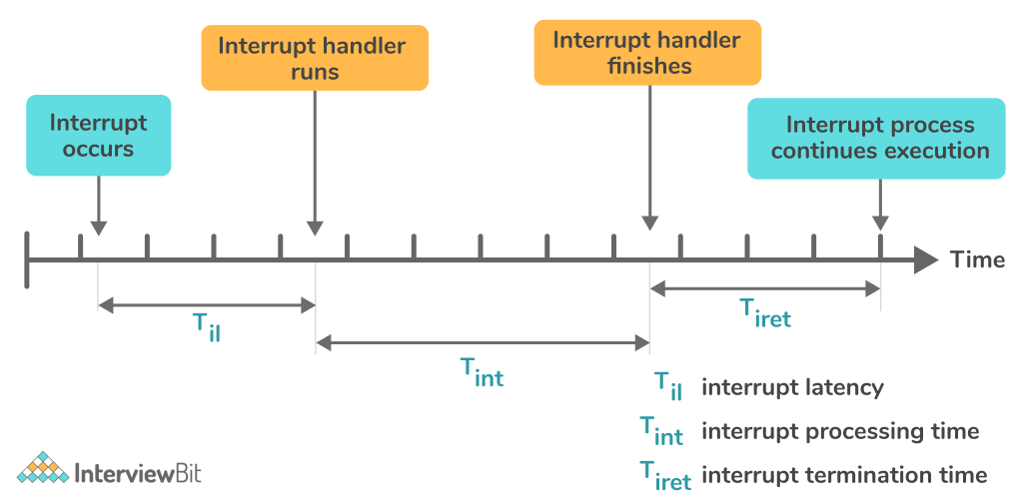

9. How will you use a variable defined in source file1 inside source file2?
We can achieve this by making use of the “extern” keyboard. It allows the variable to be accessible from one file to another. This can be handled more cleanly by creating a header file that just consists of extern variable declarations. This header file is then included in the source files which uses the extern variables. Consider an example where we have a header file named variables.h and a source file named sc_file.c.
/* variables.h*/
extern int global_variable_x;
/* sc_file.c*/
#include "variables.h" /* Header variables included */
#include <stdio.h>
void demoFunction(void)
{
printf("Value of Global Variable X: %d\n", global_variable_x++);
}

10. What is Embedded C Programming? How is Embedded C different from C language?
Embedded C is a programming language that is an extension of C programming. It uses the same syntax as C and it is called “embedded” because it is used widely in embedded systems. Embedded C supports I/O hardware operations and addressing, fixed-point arithmetic operations, memory/address space access, and various other features that are required to develop fool-proof embedded systems.
Following are the differences between traditional C language and Embedded C:
C Language | Embedded C Language
It is of native development nature | It is used for cross-development purposes
C is independent of hardware and its underlying architecture | Embedded C is dependent on the hardware architecture.
C is mainly used for developing desktop applications. | Embedded C is used in embedded systems that have limited resources like ROM, RAM, etc.

11. What are the differences between Inline and Macro Function?
Category | Macro Function | Inline Function
Compile-time expansion | Macro functions are expanded by the preprocessor at the compile time. | Inline functions are expanded by the compiler.
Argument Evaluation | Expressions passed to the Macro functions might get evaluated more than once. | Expressions passed to Inline functions get evaluated once.
Parameter Checking | Macro functions do not follow strict parameter data type checking. | Inline functions follow strict data type checking of the parameters.
Ease of debugging | Macro functions are hard to debug because it is replaced by the pre-processor as a textual representation which is not visible in the source code. | Easier to debug inline functions which is why it is recommended to be used over macro functions.
Example | #define SQUARENUM(A) A * A -> The macro functions are expanded at compile time. Hence, if we pass, the output will be evaluated to 3+2*3+2 which gets evaluated to 11. This might not be as per our expectations. | inline squareNum(int A){return A * A;} -> If we have printf(squareNum(3+2));, the arguments to the function are evaluated first to 5 and passed to the function, which returns a square of 5 = 25.

12. Is it possible for a variable to be both volatile and const?
The const keyword is used when we want to ensure that the variable value should not be changed. However, the value can still be changed due to external interrupts or events. So, we can use const with volatile keywords and it won’t cause any problem.
Discover your path to a Successful Tech Career For FREE!
Answer 4 simple questions & get a career plan tailored for you

13. Is it possible to declare a static variable in a header file?
Variables defined with static are initialized once and persists until the end of the program and are local only to the block it is defined. A static variables declaration requires definition. It can be defined in a header file. But if we do so, a private copy of the variable of the header file will be present in each source file the header is included. This is not preferred and hence it is not recommended to use static variables in a header file.

14. What do you understand by the pre-decrement and post-decrement operators?
The Pre-decrement operator (--operand) is used for decrementing the value of the variable by 1 before assigning the variable value.
#include < stdio.h >
int main(){
int x = 100, y;

y = --x; //pre-decrememt operators -- first decrements the value and then it is assigned

printf("y = %d\n", y); // Prints 99
printf("x = %d\n", x); // Prints 99
return 0;
}
The Post-decrement operator (operand--) is used for decrementing the value of a variable by 1 after assigning the variable value.
#include < stdio.h >
int main(){
int x = 100, y;

y = x--; //post-decrememt operators -- first assigns the value and then it is decremented

printf("y = %d\n", y); // Prints 100
printf("x = %d\n", x); // Prints 99
return 0;
}

15. What is a reentrant function?
A function is called reentrant if the function can be interrupted in the middle of the execution and be safely called again (re-entered) to complete the execution. The interruption can be in the form of external events or signals or internal signals like call or jump. The reentrant function resumes at the point where the execution was left off and proceeds to completion.

Embedded C Interview Questions for Experienced

1. Is it possible to protect a character pointer from accidentally pointing it to a different address?
It can be done by defining it as a constant character pointer. const protects it from modifications.

2. What are the reasons for segmentation fault in Embedded C? How do you avoid these errors?
Following are the reasons for the segmentation fault to occur:
- While trying to dereference NULL pointers.
- While trying to write or update the read-only memory or non-existent memory not accessible by the program such as code segment, kernel structures, etc.
- While trying to dereference an uninitialized pointer that might have been pointing to invalid memory.
- While trying to dereference a pointer that was recently freed using the free function.
- While accessing the array beyond the boundary.
Some of the ways where we can avoid Segmentation fault are:
- Initializing Pointer Properly: Assign addresses to the pointers properly. For instance:
  - We can also assign the address of the matrix, vectors or using functions like calloc, malloc etc.
  - Only important thing is to assign value to the pointer before accessing it.
int varName;
int *p = &varName;
- Minimize using pointers: Most of the functions in Embedded C such as scanf, require that address should be sent as a parameter to them. In cases like these, as best practices, we declare a variable and send the address of that variable to that function as shown below:
int x;
scanf("%d",&x);
In the same way, while sending the address of variables to custom-defined functions, we can use the & parameter instead of using pointer variables to access the address.
int x = 1;
x = customFunction(&x);
- Troubleshooting: Make sure that every component of the program like pointers, array subscripts, & operator, * operator, array accessing, etc as they can be likely candidates for segmentation error. Debug the statements line by line to identify the line that causes the error and investigate them.

3. Is it recommended to use printf() inside ISR?
printf() is a non-reentrant and thread-safe function which is why it is not recommended to call inside the ISR.

4. Is it possible to pass a parameter to ISR or return a value from it?
An ISR by nature does not allow anything to pass nor does it return anything. This is because ISR is a routine called whenever hardware or software events occur and is not in control of the code.

5. What Is a Virtual Memory in Embedded C and how can it be implemented?
Virtual memory is a means of allocating memory to the processes if there is a shortage of physical memory by using an automatic allocation of storage. The main advantage of using virtual memory is that it is possible to have larger virtual memory than physical memory. It can be implemented by using the technique of paging.
Paging works as follows:
- Whenever a process needs to be executed, it would be swapped into the memory by using a lazy swapper called a pager.
- The pager tries to guess which page needs to get access to the memory based on a predefined algorithm and swaps that process. This ensures that the whole process is not swapped into the memory, but only the necessary parts of the process are swapped utilizing pages.
- This decreases the time taken to swap and unnecessary reading of memory pages and reduces the physical memory required.

6. What is the issue with the following piece of code?
int square (volatile int *p){
return (*p) * (*p) ;
}
From the code given, it appears that the function intends to return the square of the values pointed by the pointer p. But, since we have the pointer point to a volatile integer, the compiler generates code as below:
int square ( volatile int *p){
int x , y;
x = *p ;
y = *p ;
return x * y ;
}
Since the pointer can be changed to point to other locations, it might be possible that the values of the x and y would be different which might not even result in the square of the numbers. Hence, the correct way for achieving the square of the number is by coding as below:
long square (volatile int *p ){
int x ;
x = *p ;
return x*x;
}

7. The following piece of code uses __interrupt keyword to define an ISR. Comment on the correctness of the code.
__interrupt double calculate_circle_area (double radius){
double circle_area = PI ∗ radius ∗ radius;
printf ( 'Area = %f ' , circle_area);
return circle_area;
}
Following things are wrong with the given piece of code:
- ISRs are not supposed to return any value. The given code returns a value of datatype double.
- It is not possible to pass parameters to ISRs. Here, we are passing a parameter to the ISR which is wrong.
- It is not advisable to have printf inside the ISR as they are non-reentrant and thereby it impacts the performance.

8. What is the result of the below code?
void demo(void){
unsigned int x = 10 ;
int y = −40;
if(x+y > 10) {
printf("Greater than 10");
} else {
printf("Less than or equals 10");
}
}
In Embedded C, we need to know a fact that when expressions are having signed and unsigned operand types, then every operand will be promoted to an unsigned type. Herem the -40 will be promoted to unsigned type thereby making it a very large value when compared to 10. Hence, we will get the statement “Greater than 10” printed on the console.

9. What are the reasons for Interrupt Latency and how to reduce it?
Following are the various causes of Interrupt Latency:
- Hardware: Whenever an interrupt occurs, the signal has to be synchronized with the CPU clock cycles. Depending on the hardware of the processor and the logic of synchronization, it can take up to 3 CPU cycles before the interrupt signal has reached the processor for processing.
- Pipeline: Most of the modern CPUs have instructions pipelined. Execution happens when the instruction has reached the last stage of the pipeline. Once the execution of an instruction is done, it would require some extra CPU cycles to refill the pipeline with instructions. This contributes to the latency.
Interrupt latency can be reduced by ensuring that the ISR routines are short. When a lower priority interrupt gets triggered while a higher priority interrupt is getting executed, then the lower priority interrupt would get delayed resulting in increased latency. In such cases, having smaller ISR routines for lower priority interrupts would help to reduce the delay.
Also, better scheduling and synchronization algorithms in the processor CPU would help minimize the ISR latency.

10. Why is the statement ++i faster than i+1?
- ++i instruction uses single machine instruction like INR (Increment Register) to perform the increment.
- For the instruction i+1, it requires to load the value of the variable i and then perform the INR operation on it. Due to the additional load, ++i is faster than the i+1 instruction.

11. What do you understand by Wild Pointer? How is it different from Dangling Pointer?
A pointer is said to be a wild pointer if it has not been initialized to NULL or a valid memory address. Consider the following declaration:
int *ptr;
*ptr = 20;
Here the pointer ptr is not initialized and in the next step, we are trying to assign a valid value to it. If the ptr has a garbage location address, then that would corrupt the upcoming instructions too.
If we are trying to de-allocate this pointer and free it as well using the free function, and again if we are not assigning the pointer as NULL or any valid address, then again chances are that the pointer would still be pointing to the garbage location and accessing from that would lead to errors. These pointers are called dangling pointers.

12. What are the differences between the following 2 statements #include "..." and #include <...>?
Both declarations specify for the files to be included in the current source file. The difference is in how and where the preprocessor looks for including the files. For #include "...", the preprocessor just searches for the file in the current directory as where the source file is present and if not found, it proceeds to search in the standard directories specified by the compiler. Whereas for the #include <...> declaration, the preprocessor looks for the files in the compiler designated directories where the standard library files usually reside.

13. When does a memory leak occur? What are the ways of avoiding it?
Memory leak is a phenomenon that occurs when the developers create objects or make use of memory to help memory and then forget to free the memory before the completion of the program. This results in reduced system performance due to the reduced memory availability and if this continues, at one point, the application can crash. These are serious issues for applications involving servers, daemons, etc that should ideally never terminate.
Example of Memory Leak:
#include <stdlib.h>

void memLeakDemo()
{
int *p = (int *) malloc(sizeof(int));

/* Some set of statements */

return; /* Return from the function without freeing the pointer p*/
}
In this example, we have created pointer p inside the function and we have not freed the pointer before the completion of the function. This causes pointer p to remain in the memory. Imagine 100s of pointers like these. The memory will be occupied unnecessarily and hence resulting in a memory leak.
We can avoid memory leaks by always freeing the objects and pointers when no longer required. The above example can be modified as:
#include <stdlib.h>;

void memLeakFix()
{
int *p = (int *) malloc(sizeof(int));

/* Some set of statements */

free(p); // Free method to free the memory allocated to the pointer p
return;
}

14. What kind of loop is better - Count up from zero or Count Down to zero?
Loops that involve count down to zero are better than count-up loops. This is because the compiler can optimize the comparison to zero at the time of loop termination. The processors need not have to load both the loop variable and the maximum value for comparison due to the optimization. Hence, count down to 0 loops are always better.

15. What do you understand by a null pointer in Embedded C?
A null pointer is a pointer that does not point to any valid memory location. It is defined to ensure that the pointer should not be used to modify anything as it is invalid. If no address is assigned to the pointer, it is set to NULL.
Syntax:
data_type *pointer_name = NULL;
One of the uses of the null pointer is that once the memory allocated to a pointer is freed up, we will be using NULL to assign to the pointer so that it does not point to any garbage locations.

16. Following are some incomplete declarations, what do each of them mean?
1. const int x;
2. int const x;
3. const int *x;
4. int * const x;
5. int const * x const;
- The first two declaration points 1 and 2 mean the same. It means that the variable x is a read-only constant integer.
- The third declaration represents that the variable x is a pointer to a constant integer. The integer value can't be modified but the pointer can be modified to point to other locations.
- The fourth declaration means that the variable x is a constant pointer to an integer value. It means that the integer value can be changed, but the pointer can't be made to point to anything else.
- The last declaration means that the variable x is a constant pointer to a constant integer which means that neither the pointer can point to a different location nor the integer value can be modified.

Embedded C Programming

1. Write an Embedded C program to multiply any number by 9 in the fastest manner.
This can be achieved by involving bit manipulation techniques - Shift left operator as shown below:
#include<stdio.h>
void main(){
int num;
printf(“Enter number: ”);
scanf(“%d”,&num);
printf(“%d”, (num<<3)+num);
}

2. How will you swap two variables? Write different approaches for the same.
- Using Extra Memory Space:
int num1=20, num2=30, temp;
temp = num1;
num1 = num2;
num2 = temp;
- Using Arithmetic Operators:
int num1=20, num2=30;
num1=num1 + num2;
num2=num1 - num2;
num1=num1 - num2;
- Using Bit-Wise Operators:
int num1=20, num2=30;
num1=num1 ^ num2;
num2=num2 ^ num1;
num1=num1 ^ num2;
- Using One-liner Bit-wise Operators:
int num1=20, num2=30;
num1^=num2^=num1^=num2;
The order of evaluation here is right to left.
- Using One-liner Arithmetic Operators:
int num1=20, num2=30;
num1 = (num1+num2)-(num2=num1);
Here the order of evaluation is from left to right.

3. Write a program to check if a number is a power of 2 or not.
We can do this by using bitwise operators.
void main (){
int num;
printf ("Enter any no:");
scanf ("%d", &num);
if (num & & ((num & num-1) == 0))
printf ("Number is a power of 2");
else
printf ("Number is not a power of 2");
}

4. Write a program to print numbers from 1 to 100 without making use of conditional operators?
void main (){
int i=0;
while (100 – i++)
printf ("%d", i);
}

5. Write a MIN macro program that takes two arguments and returns the smallest of both arguments.
#define MIN(NUM1,NUM2) ( (NUM1) <= (NUM2) ? (NUM1) : (NUM2) )
Useful Resource
C Interview Questions
C++ Interview Questions
Practice Coding
InterviewBit Blog
Online C++ Compiler

Embedded C MCQ
1.How will you free the allocated memory?
2.Which among the below options are true with regards to the below list of definitions:
int num;
unsigned unum;
long lnum;
long long llnum;
3.Which among the below options are correct for defining a macro that returns a square of two arguments?
4.Which among the following will happen if we try to assign a value to the array index whose subscript exceeds the array size?
5.Which among the below options are correct for const and volatile?
6.What does (void*)ptr represent?
7.What is the function used for rounding off the value to the nearest value?
8.Which among the following options best define endianness?
9.Which among the below options are correct for the following declaration of code?
int (*ptr)[10];
10.Which among the below options does the task of processing enum types?

Serial Peripheral Interface (SPI)
Serial peripheral interface (SPI) is a short-distance serial communication interface that uses a high-speed clock (compared to I2C) and is suitable for higher data rates. SPI interface has different variants for serial communication, but the four-wire interface is the most popular one. These four signals are:
- SCLK (serial clock)
- MOSI (master-out-slave-in)
- MISO (master-in-slave-out)
- CS (chip select)
These signals might have other names as well, but the purpose remains the same. The SPI communication uses a master-slave architecture, where multiple slaves are connected to the master.
The SCLK is the serial clock that comes from the master for synchronization and data sampling. Therefore, the master should generate clock pulses whenever SPI communication happens.
The MOSI, or master-out-slave-in, is the serial data coming out of master and entering into the slaves.
The MISO, or master-in-slave-out, is the serial data entering into the master from the slaves.
The CS, or chip select, is an active low control signal from the master to a slave that enables that specific slave device. This signal is also known as slave select (SS). As there can be multiple slave devices connected to the same SPI bus, only one of the slave devices is active at one time.
Naming does not always matter, and you should confirm from the datasheet of the slave that the chip-enabling control signal is active-low or active-high and set it accordingly in the overlay.
The figure below shows three slave devices connected to a single SPI master. The SCLK, MOSI and MISO lines are shared between all slaves, while they each have their own CS signal. In this case, the master has three chip select signals to select one of the devices uniquely. At any given time, only one of the chip select signals should be asserted, and therefore, only one slave could read/write from the bus.
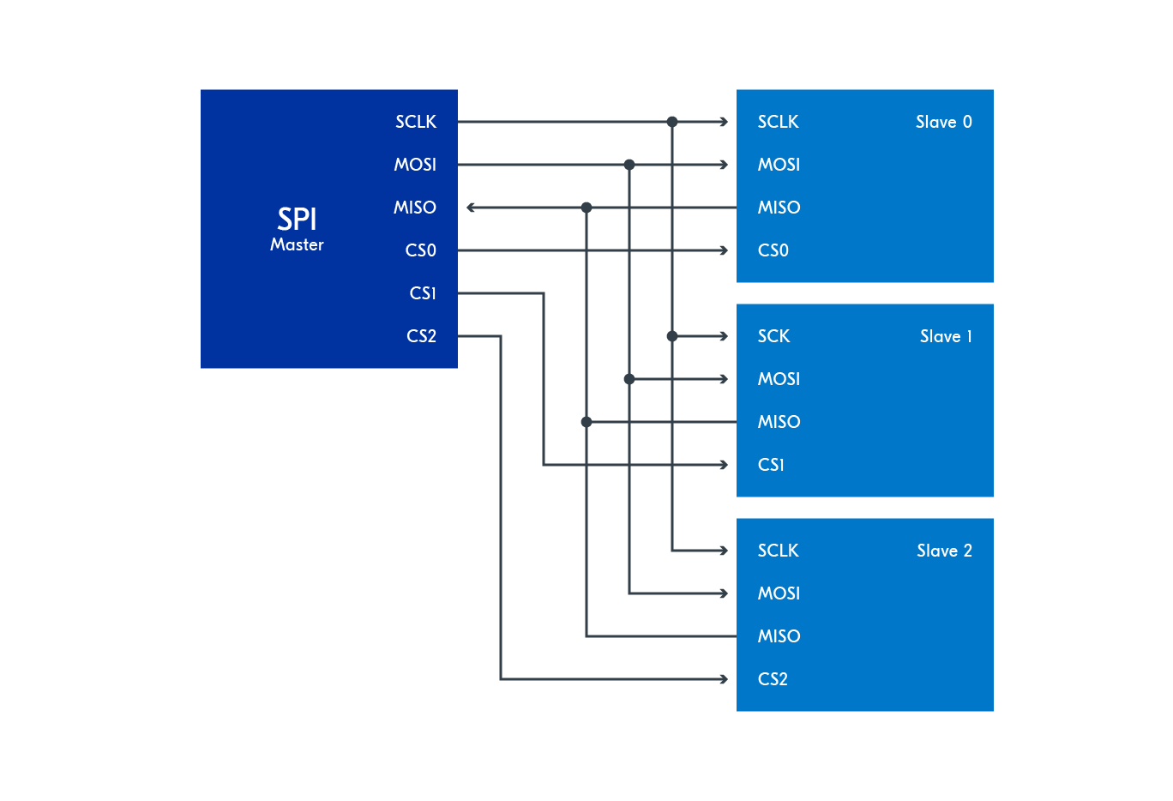SPI configuration: 3 slave devices connected to single master
All Nordic chips support SPI in multiple modes (refer to the respective product specification of the SoC/SiP).
- SPI: This is the SPI master interface.
- SPIM: This is the SPI master interface with EasyDMA. The DMA interface (direct memory access) eliminates the need for CPU supervision while transferring a chunk of data and is more suited when large amounts of data are concerned or when we want the CPU to do something else.
- SPIS: This is the SPI slave interface with EasyDMA. This is out of the scope of this lesson.
The figure below shows an SPI master-slave on an nRF SoC. PSEL here shows the configuration of the pin (pins are configured using respective configuration registers). Data coming from MISO is stored in the receive buffer, and the data from the transmit buffer goes onto the pin MOSI, while the clock signal is always generated by the master.
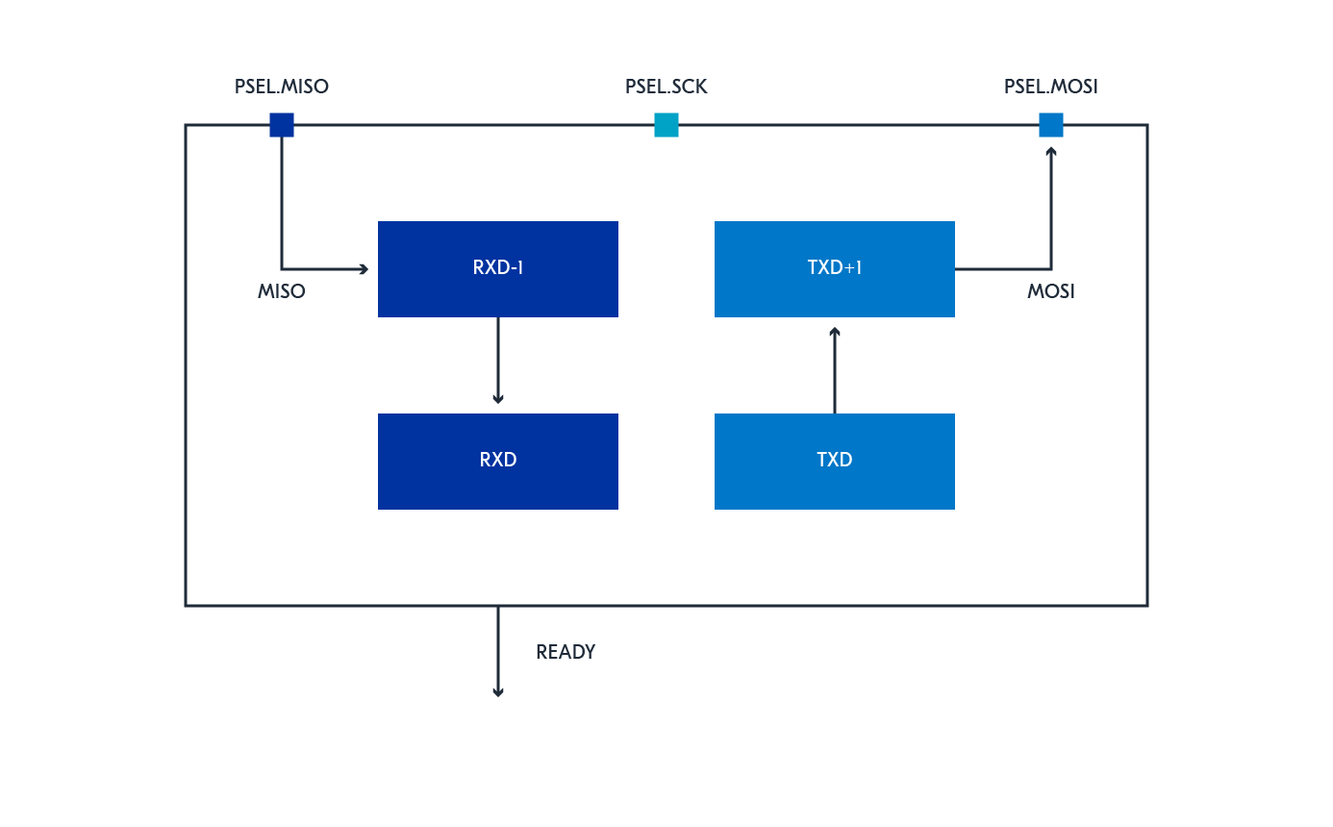
The SPI slave uses transmit (TXD) and receive (RXD) buffers and these are double-buffered to enable some degree of uninterrupted data flow in and out of the SPI. Furthermore, the SPI master does not implement support for chip select directly. Therefore, the CPU must use available GPIOs to select the correct slave and control this independently of the SPI master.
The SPI master supports SPI modes 0-3. These modes are based on the clock polarity (CPOL) and clock phase (CPHA). Polarity means whether the clock signal starts at logical low (CPOL=0) or logical high (CPOL=1) when the chip select is asserted. Phase in this context means that the data bit is sampled at which transition. If CPOL=0 then CPHA=0 means low-to-high transition, and CPHA=1 means high-to-low transition. In the other case, when CPOL=1, then CPHA=0 means high-to-low transition, and CPHA=1 means low-to-high transition. The figure below shows the sampling of the data bit for these different modes.
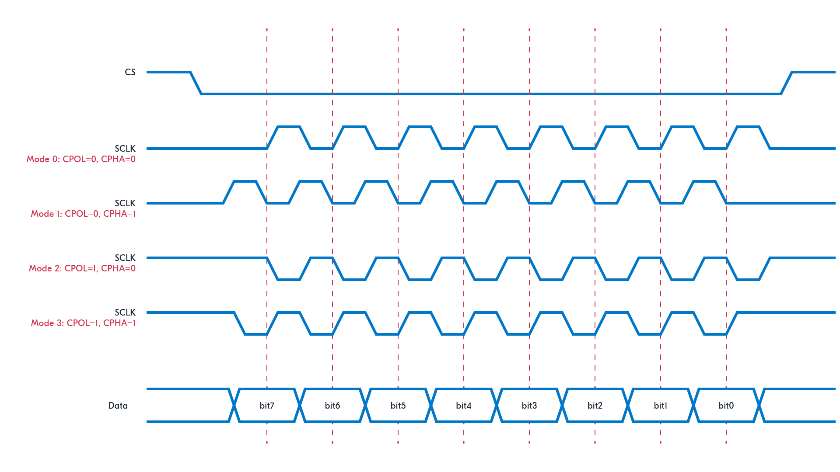
When using an SPI slave, we should consult the technical documents to see which SPI modes are supported by the end device (e.g sensor). We will take a closer look at this in the exercise section of this lesson.

I2C Communication Protocol
I2C stands for Inter-Integrated Circuit. It is a bus interface connection protocol incorporated into devices for serial communication. It was originally designed by Philips Semiconductor in 1982. Recently, it is a widely used protocol for short-distance communication. It is also known as Two Wired Interface(TWI).
Working of I2C Communication Protocol
It uses only 2 bi-directional open-drain lines for data communication called SDA and SCL. Both these lines are pulled high.
Serial Data (SDA) : Transfer of data takes place through this pin.
Serial Clock (SCL) : It carries the clock signal.
I2C operates in 2 modes
- Master mode
- Slave mode
Each data bit transferred on SDA line is synchronized by a high to the low pulse of each clock on the SCL line.
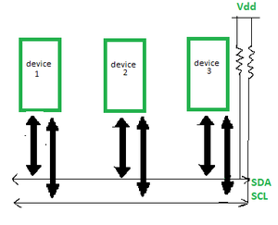
According to I2C protocols, the data line can not change when the clock line is high, it can change only when the clock line is low. The 2 lines are open drain, hence a pull-up resistor is required so that the lines are high since the devices on the I2C bus are active low. The data is transmitted in the form of packets which comprises 9 bits. The sequence of these bits are -
- Start Condition: 1 bit
- Slave Address: 8 bit
- Acknowledge: 1 bit
Steps of I2C Data Transmission?
Here are the steps of I2C (Inter-Integrated Circuit) data transmission
- Start Condition: The master device sends a start condition by pulling the SDA line low while the SCL line is high. This signals that a transmission is about to begin.
- Addressing the Slave: The master sends the 7-bit address of the slave device it wants to communicate with, followed by a read/write bit. The read/write bit indicates whether it wants to read from or write to the slave.
- Acknowledge Bit (ACK): The addressed slave device responds by pulling the SDA line low during the next clock pulse (SCL). This confirms that the slave is ready to communicate.
- Data Transmission: The master or slave (depending on the read/write operation) sends data in 8-bit chunks. After each byte, an ACK is sent to confirm that the data has been received successfully.
- Stop Condition: When the transmission is complete, the master sends a stop condition by releasing the SDA line to high while the SCL line is high. This signals that the communication session has ended.
What is Start and Stop Conditions ?
START and STOP can be generated by keeping the SCL line high and changing the level of SDA. To generate START condition the SDA is changed from high to low while keeping the SCL high. To generate STOP condition SDA goes from low to high while keeping the SCL high, as shown in the figure below.
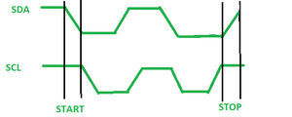Start and Stop Condition
What is Repeated Start Condition?
Between each start and stop condition pair, the bus is considered as busy and no master can take control of the bus. If the master tries to initiate a new transfer and does not want to release the bus before starting the new transfer, it issues a new START condition. It is called a REPEATED START condition.
Read/Write Bit
A high Read/Write bit indicates that the master is sending the data to the slave, whereas a low Read/Write bit indicates that the master is receiving data from the slave.
ACK/NACK Bit
After every data frame, follows an ACK/NACK bit. If the data frame is received successfully then ACK bit is sent to the sender by the receiver.
Addressing
The address frame is the first frame after the start bit. The address of the slave with which the master wants to communicate is sent by the master to every slave connected with it. The slave then compares its own address with this address and sends ACK.
I2C Packet Format
In the I2C communication protocol, the data is transmitted in the form of packets. These packets are 9 bits long, out of which the first 8 bits are put in SDA line and the 9th bit is reserved for ACK/NACK i.e. Acknowledge or Not Acknowledge by the receiver.
START condition plus address packet plus one more data packet plus STOP condition collectively form a complete Data transfer.
Features of I2C Communication Protocol
- Half-duplex Communication Protocol -
Bi-directional communication is possible but not simultaneously.
- Synchronous Communication -
The data is transferred in the form of frames or blocks.
- Can be configured in a multi-master configuration.
- Clock Stretching -
The clock is stretched when the slave device is not ready to accept more data by holding the SCL line low, hence disabling the master to raise the clock line. Master will not be able to raise the clock line because the wires are AND wired and wait until the slave releases the SCL line to show it is ready to transfer next bit.
- Arbitration -
I2C protocol supports multi-master bus system but more than one bus can not be used simultaneously. The SDA and SCL are monitored by the masters. If the SDA is found high when it was supposed to be low it will be inferred that another master is active and hence it stops the transfer of data.
- Serial transmission -
I2C uses serial transmission for transmission of data.
- Used for low-speed communication.
Comparison between I2C and SPI Communication Protocols
Features | I2C Communication Protocol | SPI Communication Protocol
Number of wires | 2 (SDA and SCL) | 4 (MOSI, MISO, SCK, and SS)
Communication type | Half-duplex | Full-duplex
Maximum number of devices | Limited by addressing scheme | Limited by number of chip select (SS) lines
Data transfer speed | Slower | Faster
Error handling | Improved due to ACK/NACK feature | Not as robust
Cost | Cost-efficient due to fewer wires | More expensive due to additional wires
Complexity | Simpler due to fewer wires | More complex due to additional wires
Multi-master configuration | Yes | No
Synchronous communication | Yes | Yes
Clock stretching | Yes | No
Arbitration | Yes | No
Advantages of I2C Communication Protocol
- Can be configured in multi-master mode.
- Complexity is reduced because it uses only 2 bi-directional lines (unlike SPI Communication).
- Cost-efficient.
- It uses ACK/NACK feature due to which it has improved error handling capabilities.
- Fewer Wires: Only two wires are needed, making it easier to set up.
- Multiple Devices: You can connect many devices to the same bus.
- Simple Communication: It’s relatively easy to program and use.
Disadvantages of I2C Communication Protocol
- Speed Limitations: I2C is slower compared to some other protocols like SPI.
- Distance: It’s not suitable for long-distance communication.
- Half-duplex communication is used in the I2C communication protocol.
Conclusion
The I2C communication protocol is a simple and effective way for devices to communicate with each other. It allows multiple devices to connect using just two wires, making it easy to add new components to a system. I2C is popular in various applications because it supports multiple devices, is relatively easy to implement, and requires less wiring compared to other protocols. Overall, I2C is a reliable choice for connecting sensors, displays, and other peripherals in electronic projects.

Basics of the I2C Communication Protocol
So far, we’ve talked about the basics of SPI communication and UART communication, so now let’s go into the final protocol of this series, the Inter-Integrated Circuit, or I2C.
You’ll probably find yourself using I2C if you ever build projects that use OLED displays, barometric pressure sensors, or gyroscope/accelerometer modules.
Introduction to I2C Communication
I2C combines the best features of SPI and UARTs. With I2C, you can connect multiple slaves to a single master (like SPI) and you can have multiple masters controlling single, or multiple slaves. This is really useful when you want to have more than one microcontroller logging data to a single memory card or displaying text to a single LCD.
Like UART communication, I2C only uses two wires to transmit data between devices:
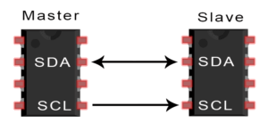
SDA (Serial Data) – The line for the master and slave to send and receive data.
SCL (Serial Clock) – The line that carries the clock signal.

I2C is a serial communication protocol, so data is transferred bit by bit along a single wire (the SDA line).
Like SPI, I2C is synchronous, so the output of bits is synchronized to the sampling of bits by a clock signal shared between the master and the slave. The clock signal is always controlled by the master.
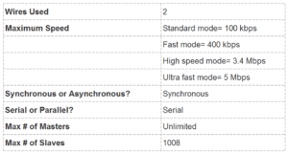
How I2C Works
With I2C, data is transferred in messages. Messages are broken up into frames of data. Each message has an address frame that contains the binary address of the slave, and one or more data frames that contain the data being transmitted. The message also includes start and stop conditions, read/write bits, and ACK/NACK bits between each data frame:
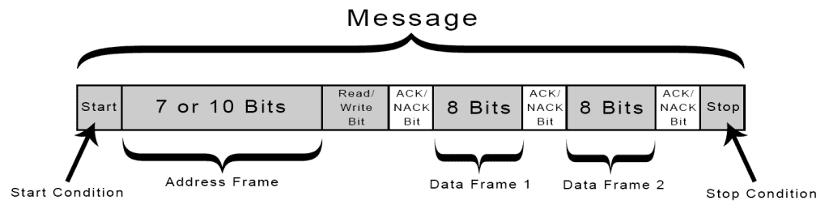
Start Condition: The SDA line switches from a high voltage level to a low voltage level before the SCL line switches from high to low.
Stop Condition: The SDA line switches from a low voltage level to a high voltage level after the SCL line switches from low to high.
Address Frame: A 7 or 10 bit sequence unique to each slave that identifies the slave when the master wants to talk to it.
Read/Write Bit: A single bit specifying whether the master is sending data to the slave (low voltage level) or requesting data from it (high voltage level).
ACK/NACK Bit: Each frame in a message is followed by an acknowledge/no-acknowledge bit. If an address frame or data frame was successfully received, an ACK bit is returned to the sender from the receiving device.
Addressing
I2C doesn’t have slave select lines like SPI, so it needs another way to let the slave know that data is being sent to it, and not another slave. It does this by addressing. The address frame is always the first frame after the start bit in a new message.
The master sends the address of the slave it wants to communicate with to every slave connected to it. Each slave then compares the address sent from the master to its own address. If the address matches, it sends a low voltage ACK bit back to the master. If the address doesn’t match, the slave does nothing and the SDA line remains high.
Read/Write Bit
The address frame includes a single bit at the end that informs the slave whether the master wants to write data to it or receive data from it. If the master wants to send data to the slave, the read/write bit is a low voltage level. If the master is requesting data from the slave, the bit is a high voltage level.
The Data Frame
After the master detects the ACK bit from the slave, the first data frame is ready to be sent.
The data frame is always 8 bits long, and sent with the most significant bit first. Each data frame is immediately followed by an ACK/NACK bit to verify that the frame has been received successfully. The ACK bit must be received by either the master or the slave (depending on who is sending the data) before the next data frame can be sent.
After all of the data frames have been sent, the master can send a stop condition to the slave to halt the transmission. The stop condition is a voltage transition from low to high on the SDA line after a low to high transition on the SCL line, with the SCL line remaining high.
Steps of I2C Data Transmission
1. The master sends the start condition to every connected slave by switching the SDA line from a high voltage level to a low voltage level before switching the SCL line from high to low:
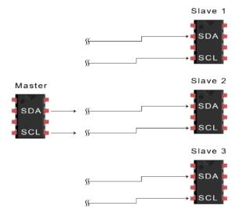
2. The master sends each slave the 7 or 10 bit address of the slave it wants to communicate with, along with the read/write bit:
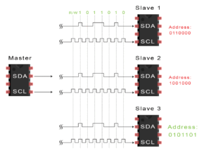
3. Each slave compares the address sent from the master to its own address. If the address matches, the slave returns an ACK bit by pulling the SDA line low for one bit. If the address from the master does not match the slave’s own address, the slave leaves the SDA line high.
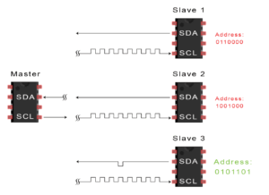
4. The master sends or receives the data frame:
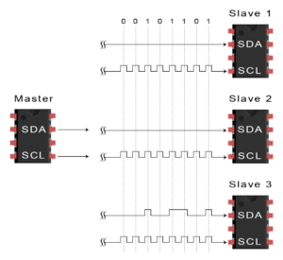
5. After each data frame has been transferred, the receiving device returns another ACK bit to the sender to acknowledge successful receipt of the frame:
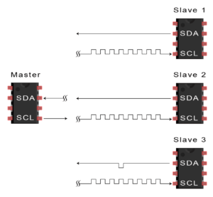
6. To stop the data transmission, the master sends a stop condition to the slave by switching SCL high before switching SDA high:
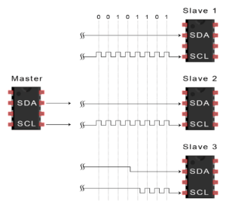
Single Master with Multiple Slaves
Because I2C uses addressing, multiple slaves can be controlled from a single master. With a 7 bit address, 128 (2⁷) unique address are available. Using 10 bit addresses is uncommon, but provides 1,024 (2¹⁰) unique addresses. To connect multiple slaves to a single master, wire them like this, with 4.7K Ohm pull-up resistors connecting the SDA and SCL lines to Vcc:
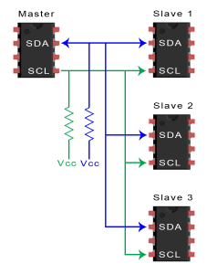
Multiple Masters with Multiple Slaves
Multiple masters can be connected to a single slave or multiple slaves. The problem with multiple masters in the same system comes when two masters try to send or receive data at the same time over the SDA line. To solve this problem, each master needs to detect if the SDA line is low or high before transmitting a message. If the SDA line is low, this means that another master has control of the bus, and the master should wait to send the message. If the SDA line is high, then it’s safe to transmit the message. To connect multiple masters to multiple slaves, use the following diagram, with 4.7K Ohm pull-up resistors connecting the SDA and SCL lines to Vcc:
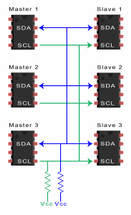
Advantages and Disadvantages of I2C
There is a lot to I2C that might make it sound complicated compared to other protocols, but there are some good reasons why you may or may not want to use I2C to connect to a particular device:
Advantages
- Only uses two wires
- Supports multiple masters and multiple slaves
- ACK/NACK bit gives confirmation that each frame is transferred successfully
- Hardware is less complicated than with UARTs
- Well known and widely used protocol
Disadvantages
- Slower data transfer rate than SPI
- The size of the data frame is limited to 8 bits
- More complicated hardware needed to implement than SPI

- What is an ARM microcontroller?
  - Answer: An ARM microcontroller is a type of microprocessor specifically designed for embedded systems. It integrates a central processing unit (CPU) based on the ARM architecture, along with memory, peripherals, and other components onto a single integrated circuit (IC). ARM microcontrollers are known for their low power consumption, high performance, and wide range of applications in devices like smartphones, wearables, IoT devices, automotive systems, and industrial controls.
- What are the key features of the ARM architecture?
  - Answer: The ARM architecture is known for its:
  - Reduced Instruction Set Computing (RISC): Uses a small, efficient instruction set, leading to faster execution and lower power consumption.
  - Load/Store Architecture: Data access is restricted to load and store instructions, simplifying memory management and improving performance.
  - Pipeline Processing: Instructions are processed in a sequential manner, allowing multiple instructions to be executed simultaneously, enhancing performance.
  - Thumb Instruction Set: A 16-bit instruction set for code density, suitable for memory-constrained devices.
  - Low Power Consumption: Designed to minimize power consumption, making it ideal for battery-powered devices.
- Explain the different ARM processor cores.
  - Answer: ARM offers various processor cores catering to different performance and power requirements:
  - Cortex-M series: Focuses on low-power embedded applications, featuring simplicity and efficiency.
  - Cortex-A series: Targets high-performance applications like smartphones and tablets, emphasizing speed and multimedia capabilities.
  - Cortex-R series: Designed for real-time applications requiring predictable performance and low latency, often used in automotive and industrial systems.
- What is the difference between ARM and Thumb instructions?
  - Answer:
  - ARM instructions: 32-bit instructions, offering greater flexibility and performance.
  - Thumb instructions: 16-bit instructions, designed for code density and memory efficiency, suitable for applications with limited memory resources.
- Describe the concept of memory-mapped I/O in ARM microcontrollers.
  - Answer: Memory-mapped I/O is a technique where peripheral devices are accessed as if they were memory locations. The microcontroller's memory space includes addresses dedicated to peripherals. By writing or reading data to these memory locations, you can control or access the corresponding peripherals. This simplifies communication and reduces the need for specialized I/O instructions.
- Explain the different memory types commonly found in ARM microcontrollers.
  - Answer:
  - Flash memory: Non-volatile memory used for storing the program code, configuration data, and other permanent data. It can be programmed and erased electronically.
  - SRAM: Volatile memory used for temporary data storage during program execution. It is faster than Flash memory but loses its contents when power is removed.
  - EEPROM: Non-volatile memory used for storing configuration data that may need occasional updates. It can be programmed and erased in smaller blocks compared to Flash memory.
- What are the different types of interrupts available in ARM microcontrollers?
  - Answer:
  - External interrupts: Triggered by external events like a button press or sensor signal.
  - Internal interrupts: Generated by internal events within the microcontroller, such as a timer overflow or a hardware fault.
  - Software interrupts: Initiated by software instructions to handle specific tasks or handle exceptions.
- Describe the role of the Nested Vector Interrupt Controller (NVIC) in an ARM microcontroller.
  - Answer: The NVIC is responsible for managing interrupts in ARM microcontrollers. It prioritizes interrupts, manages interrupt latency, and provides mechanisms for enabling and disabling interrupts. It ensures that the most critical interrupts are handled first, maintaining system responsiveness and preventing conflicts.
- What is the concept of a "stack" in ARM programming?
  - Answer: The stack is a region of memory used for storing temporary data during program execution. It operates on a Last-In, First-Out (LIFO) basis, where the most recently added data is the first to be retrieved. The stack is used for:
  - Function calls: Storing return addresses and local variables for function execution.
  - Interrupt handling: Saving the current processor state before processing an interrupt and restoring it upon completion.
  - Exception handling: Storing information about an exception for debugging purposes.
- Explain the difference between a direct memory access (DMA) controller and a general-purpose I/O (GPIO) port.
  - Answer:
  - DMA controller: A specialized hardware component that allows data transfers between memory and peripherals directly, without involving the CPU. It improves efficiency and performance, freeing up the CPU for other tasks.
  - GPIO port: A group of general-purpose pins that can be configured as inputs or outputs. They are used for communicating with external devices, controlling LEDs, reading sensor data, and other general-purpose I/O operations.
- What are the different modes of operation for an ARM microcontroller?
  - Answer:
  - User mode: Normal operating mode for application code execution.
  - Privileged mode: Allows access to system resources and privileged instructions, often used by the operating system or system-level software.
  - Interrupt mode: Activated when an interrupt occurs, allowing the system to handle interrupts efficiently.
  - Debug mode: Used for debugging and analyzing program execution.
  - System mode: Used for system-level tasks and initialization, typically accessed only during system startup.
- What is a real-time operating system (RTOS) and how does it benefit ARM microcontroller applications?
  - Answer: An RTOS is a specialized operating system designed for real-time applications, where timing and predictable performance are critical. It provides:
  - Task scheduling: Manages multiple tasks, ensuring they execute in a timely and efficient manner.
  - Resource management: Controls access to resources like memory, peripherals, and communication channels.
  - Real-time communication: Facilitates communication between tasks and peripherals with low latency and guaranteed deadlines.
  - Benefits for ARM microcontroller applications:
  - Improved responsiveness: Enables faster reaction to real-time events and reduced latency.
  - Enhanced determinism: Ensures predictable behavior and execution times.
  - Increased reliability: Offers mechanisms for fault detection and handling.
- What is the significance of the ARM System-on-Chip (SoC) architecture?
  - Answer: An SoC integrates multiple components, including the CPU, memory, peripherals, and other functionalities, onto a single chip. This integration benefits ARM microcontrollers by:
  - Reduced footprint: Consumes less space on a circuit board.
  - Lower power consumption: Improves energy efficiency compared to separate components.
  - Improved performance: Optimized communication and data flow between integrated components.
  - Lower cost: Reduces manufacturing complexity and costs.
- Explain the concept of a "peripheral" in an ARM microcontroller.
  - Answer: Peripherals are specialized hardware components connected to the ARM microcontroller, enabling communication with external devices or performing specific functions. Common examples include:
  - Timers: Generate time intervals for timing-critical operations.
  - Serial ports: Allow communication with other devices using serial protocols like UART.
  - Analog-to-digital converters (ADCs): Convert analog signals to digital values for processing.
  - Digital-to-analog converters (DACs): Convert digital values to analog signals for controlling external devices.
- How does the ARM architecture support multi-core processing?
  - Answer: ARM architectures support multi-core processing by integrating multiple processor cores on a single chip. These cores can execute different tasks simultaneously, improving overall system performance and parallelism. ARM provides mechanisms for inter-core communication and synchronization to ensure coordinated execution and avoid resource contention.
- What are some popular development tools and IDEs for ARM microcontrollers?
  - Answer:
  - Keil uVision: A widely used IDE for ARM development, offering a comprehensive set of tools and a user-friendly interface.
  - IAR Embedded Workbench: Another popular IDE with advanced features for code optimization and debugging.
  - ARM mbed Studio: A cloud-based IDE focused on simplifying IoT development using ARM microcontrollers.
  - Eclipse with GNU ARM Embedded Toolchain: An open-source IDE and toolchain combination that provides flexibility and customization options.
- What is the role of a debugger in ARM microcontroller development?
  - Answer: A debugger is an essential tool for analyzing program behavior and identifying errors. It allows you to:
  - Set breakpoints: Pause program execution at specific points to inspect variables and memory.
  - Step through code: Execute instructions one at a time to trace program flow.
  - Inspect variables: View the values of variables at different points during execution.
  - Monitor memory: Observe memory contents and identify memory access issues.
- What are the different types of programming languages commonly used with ARM microcontrollers?
  - Answer:
  - Assembly language: Provides direct control over the microcontroller's hardware, but requires a deep understanding of the architecture.
  - C/C++: Widely used for embedded systems development, offering a balance of performance and readability.
  - Python: Can be used with ARM microcontrollers through libraries like MicroPython, making it suitable for rapid prototyping and scripting tasks.
- Describe the process of creating a simple ARM microcontroller program.
  - Answer:
  - 1. Choose an ARM microcontroller: Select the appropriate microcontroller based on your project requirements.
  - 2. Create a new project: Set up a new project in your chosen IDE, configuring the compiler and linker settings for the target microcontroller.
  - 3. Write the code: Write the program using your chosen programming language, defining the microcontroller's configuration, peripherals, and desired functionality.
  - 4. Compile and link: Use the IDE's compiler and linker to translate the code into machine-readable instructions.
  - 5. Download and debug: Transfer the compiled code to the microcontroller's memory using a debugger or a programming tool. Use the debugger to test and debug the program.
- What are some common applications of ARM microcontrollers in the real world?
  - Answer:
  - Consumer electronics: Smartphones, tablets, wearable devices, smart home appliances.
  - Automotive: Engine control units (ECUs), infotainment systems, driver-assistance features.
  - Industrial automation: Robotics, process control systems, machine automation.
  - Internet of Things (IoT): Smart sensors, wearable devices, connected devices, network gateways.
  - Medical devices: Implantable devices, diagnostic equipment, patient monitoring systems.
- What are some of the challenges faced by freshers when working with ARM microcontrollers?
  - Answer:
  - Learning curve: Understanding the ARM architecture, peripherals, and development tools can be challenging for beginners.
  - Debugging: Finding and fixing errors in embedded systems can be complex and time-consuming.
  - Hardware limitations: Working within the constraints of memory, power consumption, and peripheral limitations.
  - Real-time constraints: Meeting deadlines and ensuring predictable performance in time-critical applications.
- What advice would you give to freshers who are starting their journey in ARM microcontroller development?
  - Answer:
  - Start with a basic board: Use a starter kit or development board with a simple ARM microcontroller to get familiar with the basics.
  - Study the documentation: Read the datasheets, application notes, and tutorials provided by the microcontroller manufacturer.
  - Practice with simple projects: Start with small, achievable projects to build your skills and confidence.
  - Seek online resources: Explore online forums, blogs, and communities for support and learning from others.
  - Be patient and persistent: Embedded development can be challenging, but persistence and a willingness to learn are key to success.
- How can you ensure the security of your ARM microcontroller-based application?
  - Answer:
  - Use secure boot: Implement a secure boot process to verify the integrity of firmware and prevent unauthorized modifications.
  - Protect memory: Use memory protection units (MPUs) to restrict access to sensitive data and prevent unauthorized code execution.
  - Secure communication: Employ encryption and authentication protocols for secure data exchange over communication channels.
  - Regular updates: Stay up-to-date with security patches and firmware updates to mitigate vulnerabilities.
- What are some of the future trends in ARM microcontroller technology?
  - Answer:
  - Artificial intelligence (AI): ARM microcontrollers are increasingly being used in AI applications, enabling edge computing and machine learning capabilities at the device level.
  - Low-power computing: Advancements in power efficiency are enabling the development of energy-harvesting devices and long-lasting battery-powered applications.
  - 5G connectivity: ARM microcontrollers are playing a key role in enabling 5G-powered IoT devices and applications.
  - Quantum computing: ARM architecture is being explored for integrating with quantum computing technologies, paving the way for revolutionary advancements.
- Explain the concept of a "memory map" in an ARM microcontroller.
  - Answer: A memory map is a diagram that shows the organization and allocation of memory addresses in an ARM microcontroller. It illustrates the different memory regions, their sizes, and the devices or functions associated with each region. Understanding the memory map is crucial for proper program execution, memory management, and access to peripherals.
- What is the significance of the ARM processor's status register?
  - Answer: The status register stores various information about the ARM processor's current state, including:
  - Interrupt enable flags: Indicate whether interrupts are enabled or disabled.
  - Condition code flags: Reflect the outcome of previous arithmetic or logical operations.
  - Mode bits: Specify the processor's current mode of operation (User, Privileged, etc.).
  - Flags for specific features: May include flags for features like data cache or instruction cache enable/disable.
- Describe the different ways to access peripherals in an ARM microcontroller.
  - Answer: Peripherals are typically accessed through memory-mapped I/O, where they are assigned specific memory addresses. You can access peripherals by:
  - Reading/writing to memory locations: Accessing the peripheral's registers by reading or writing data to its corresponding memory addresses.
  - Using dedicated peripheral drivers: Using libraries or drivers provided by the manufacturer to simplify peripheral interaction.
  - Direct register access: Directly accessing peripheral registers through assembly instructions, providing low-level control but requiring more expertise.
- What is the role of the "Program Counter" (PC) in an ARM microcontroller?
  - Answer: The PC is a special-purpose register that stores the address of the next instruction to be executed. The CPU fetches and executes instructions from the memory location pointed to by the PC. The PC is updated after each instruction execution to ensure program flow.
- Explain the concept of "instruction pipelining" in the ARM architecture.
  - Answer: Instruction pipelining is a technique used by ARM processors to improve performance. It involves breaking down the execution of an instruction into multiple stages (fetch, decode, execute, write back), allowing different stages to process different instructions simultaneously. This overlapping execution of instructions increases the overall throughput and speed of the processor.
- What is the difference between a "register" and a "memory location" in ARM programming?
  - Answer:
  - Register: A small, high-speed storage unit within the CPU used to temporarily hold data during program execution. Registers provide fast access to frequently used data, enhancing performance.
  - Memory location: A storage unit in the microcontroller's main memory (RAM or Flash) used for storing data, program instructions, and other information. Memory locations offer larger storage capacity compared to registers but have slower access times.
- Describe the role of the "stack pointer" (SP) in ARM programming.
  - Answer: The SP is a special-purpose register that points to the top of the stack in memory. It plays a crucial role in function calls, interrupt handling, and exception management. The SP is updated as data is pushed or popped from the stack, maintaining the stack's integrity.
- What are some common error types that freshers might encounter while working with ARM microcontrollers?
  - Answer:
  - Syntax errors: Errors in the code syntax, such as incorrect keywords, missing semicolons, or improper variable declarations.
  - Runtime errors: Errors that occur during program execution, such as division by zero, accessing invalid memory addresses, or unexpected hardware behavior.
  - Hardware configuration errors: Incorrect configuration of peripherals, memory, or interrupts can lead to unexpected behavior or program failure.
  - Logical errors: Mistakes in the program logic, resulting in incorrect calculations or unexpected outcomes.
- Explain the concept of a "watchdog timer" in ARM microcontrollers.
  - Answer: A watchdog timer is a hardware feature that monitors the microcontroller's operation and resets the system if it detects a failure. It is typically configured to reset the system if the CPU does not "kick" the timer within a specific time interval. This mechanism helps prevent the microcontroller from becoming stuck in an unresponsive state due to software bugs or hardware malfunctions.
- What is the role of the "interrupt vector table" in an ARM microcontroller?
  - Answer: The interrupt vector table is a special memory region that stores the addresses of interrupt service routines (ISRs) for different interrupt sources. When an interrupt occurs, the CPU uses the interrupt vector table to identify the corresponding ISR and jump to its address for handling the interrupt.
- Describe the concept of "interrupt latency" in ARM microcontroller applications.
  - Answer: Interrupt latency is the time delay between the occurrence of an interrupt and the start of the corresponding interrupt service routine (ISR). It is a crucial factor in real-time applications, as it determines how quickly the system can react to events and respond to external stimuli. Lower latency is generally desirable for responsive and reliable real-time systems.
- Explain the difference between "blocking" and "non-blocking" functions in ARM microcontroller programming.
  - Answer:
  - Blocking function: A function that suspends program execution until it completes its operation. For example, a blocking read function will wait until data is available before returning. Blocking functions can hinder system responsiveness and cause delays if they are used in time-critical applications.
  - Non-blocking function: A function that returns immediately, even if its operation is not complete. Non-blocking functions are often used to avoid delays and maintain system responsiveness. For example, a non-blocking read function might return immediately, indicating whether data is available or not.
- What is the importance of "context switching" in ARM microcontroller applications using an RTOS?
  - Answer: Context switching is the process of saving the state of the currently executing task and restoring the state of another task to allow it to execute. In an RTOS, context switching enables the efficient scheduling and execution of multiple tasks by switching between them as needed. It is crucial for multitasking and real-time responsiveness.
- What is a "semaphore" and how is it used in ARM microcontroller applications?
  - Answer: A semaphore is a synchronization primitive that allows multiple tasks to access a shared resource in a controlled manner. It provides a mechanism for mutual exclusion and resource allocation. A semaphore acts as a counter, and tasks can acquire or release the semaphore to access the resource. Semaphores are commonly used in RTOS applications to prevent race conditions and ensure the proper synchronization of tasks.
- Explain the concept of "memory fragmentation" in ARM microcontroller applications.
  - Answer: Memory fragmentation occurs when available memory becomes scattered into small, non-contiguous blocks, even though the total amount of free memory is sufficient for a particular task. This can hinder program execution if a task requires a contiguous block of memory larger than any available fragmented block. Memory fragmentation can be addressed through memory management techniques like garbage collection or compaction.
- What are some of the common techniques used to optimize code for ARM microcontrollers?
  - Answer:
  - Use efficient data structures: Choose data structures that minimize memory usage and optimize access times.
  - Reduce function call overhead: Minimize function calls, especially for frequently executed code, to reduce stack operations and improve performance.
  - Optimize loops: Use techniques like loop unrolling or loop fusion to reduce loop overhead and improve execution speed.
  - Take advantage of compiler optimizations: Utilize compiler flags to enable code optimizations, such as loop unrolling, instruction scheduling, and register allocation.
  - Profile and analyze: Use profiling tools to identify performance bottlenecks and focus optimization efforts on critical code sections.
- What is the role of the "cache memory" in an ARM microcontroller?
  - Answer: Cache memory is a small, high-speed memory component used to store frequently accessed data, reducing the need to access slower main memory. It acts as a temporary storage for data that is likely to be reused. When the CPU needs data, it first checks the cache. If the data is present in the cache (cache hit), it is retrieved quickly. If the data is not in the cache (cache miss), the CPU has to access main memory, which is slower. Cache memory significantly improves system performance by reducing memory access times.
- Explain the concept of "DMA transfer" in an ARM microcontroller.
  - Answer: DMA (Direct Memory Access) is a technique that allows data transfers between memory and peripherals directly, without involving the CPU. A DMA controller handles these transfers, freeing up the CPU for other tasks. DMA is beneficial for high-throughput data transfers, such as transferring data from a sensor to memory or from memory to a display device. It reduces CPU overhead and improves data transfer efficiency.
- What is the purpose of the "memory management unit" (MMU) in an ARM microcontroller?
  - Answer: The MMU is a hardware component that handles memory management and protection. It translates virtual memory addresses used by the CPU into physical memory addresses, providing memory protection, virtual memory support, and memory access control. The MMU ensures that programs can access only their designated memory regions, preventing unauthorized access and data corruption.
- Explain the different types of "memory access" in an ARM microcontroller.
  - Answer:
  - Sequential access: Data is accessed in a linear sequence, like reading data from a tape drive.
  - Direct access: Data can be accessed directly, without having to read through preceding data, like accessing data on a hard disk drive.
  - Random access: Data can be accessed in any order, with equal access time for any location, like accessing data in RAM.
- Describe the role of the "system timer" in an ARM microcontroller.
  - Answer: The system timer is a hardware component that generates periodic interrupts or time intervals. It is used for various tasks, including:
  - Timing events: Measuring time intervals and triggering events based on specific time durations.
  - Scheduling tasks: Providing a time base for task scheduling and managing real-time processes.
  - Creating delays: Implementing software delays or pauses in program execution.
  - Generating interrupts: Triggering interrupts for specific time intervals or when the timer reaches a predetermined count.
- What is the purpose of the "GPIO port" in an ARM microcontroller?
  - Answer: The GPIO (General Purpose Input/Output) port is a group of general-purpose pins that can be configured as inputs or outputs. These pins are used for a wide range of tasks, including:
  - Reading sensor data: Connecting sensors to GPIO input pins and reading their signals.
  - Controlling LEDs: Driving LEDs on or off using GPIO output pins.
  - Communicating with other devices: Establishing communication with other devices through serial or parallel interfaces.
  - Implementing simple control systems: Controlling actuators, motors, or other devices based on input signals or user commands.
- Explain the concept of "interrupt handling" in an ARM microcontroller.
  - Answer: Interrupt handling is a mechanism that allows the ARM microcontroller to respond to external or internal events asynchronously. When an interrupt occurs, the CPU temporarily suspends its current operation, saves its current state, and jumps to a specific interrupt service routine (ISR) for handling the interrupt. The ISR processes the interrupt event, performs necessary actions, and then restores the CPU's previous state to resume normal program execution. This allows the microcontroller to respond to events efficiently without interrupting its ongoing tasks.
- What are some of the challenges associated with interrupt handling in ARM microcontroller applications?
  - Answer:
  - Interrupt latency: The time delay between the interrupt occurrence and the start of the ISR can impact system responsiveness, especially in real-time applications.
  - Reentrant code: ISRs must be reentrant, meaning they can be called again before a previous call is completed, to avoid data corruption or unexpected behavior.
  - Concurrency issues: Interrupt handlers may need to access shared resources, requiring synchronization mechanisms to prevent race conditions.
  - Interrupt priority: Handling multiple interrupts with different priorities requires proper configuration and management to ensure the most critical interrupts are handled promptly.
- Describe the different types of "interrupts" in ARM microcontrollers.
  - Answer:
  - External interrupts: Triggered by external events, like a button press, a sensor signal, or a communication event.
  - Internal interrupts: Generated by internal events within the microcontroller, such as a timer overflow, a hardware error, or a software exception.
  - Software interrupts: Initiated by software instructions, allowing the program to interrupt its own execution for specific tasks or to handle exceptions.
- What is the purpose of the "NVIC" (Nested Vector Interrupt Controller) in an ARM microcontroller?
  - Answer: The NVIC is a hardware component that manages interrupts in ARM microcontrollers. It provides a mechanism for:
  - Interrupt prioritization: Assigning priorities to different interrupt sources to ensure that the most critical interrupts are handled first.
  - Interrupt enable/disable: Controlling which interrupt sources are enabled or disabled.
  - Interrupt latency management: Reducing interrupt latency by optimizing the interrupt handling process.
  - Interrupt nesting: Handling nested interrupts, where an interrupt occurs while another interrupt is being processed.
- Explain the concept of "interrupt nesting" in ARM microcontroller applications.
  - Answer: Interrupt nesting occurs when an interrupt occurs while another interrupt is being processed. In such scenarios, the CPU suspends the current ISR, saves its state, and jumps to the ISR for the higher-priority interrupt. Once the higher-priority interrupt is handled, the CPU restores the state of the previously interrupted ISR and resumes its execution. Interrupt nesting is a common occurrence in systems with multiple interrupt sources and requires careful management to ensure proper interrupt handling and prevent data corruption.

Modbus protocol

