1. Bit Manipulation Questions (Frequently Asked!)
Bit-level operations are fundamental in embedded systems eg. Set Bit, Clear Bit, Toggle Bit, Count Number of Set Bits in a given data etc.
🔄 Q: Reverse the bits of a 32-bit unsigned integer
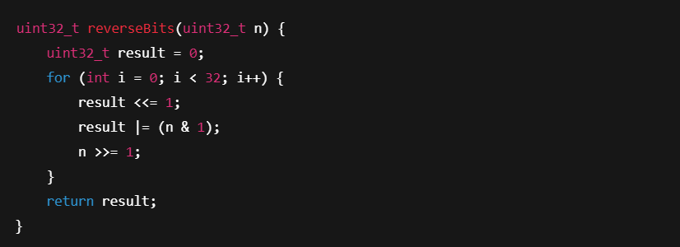
📌 Why it’s asked: Tests your understanding of bit shifts, performance, and logical operations.
✅ Tips to Prepare:
- Practice operations like rotating bits, counting set bits, finding parity.
- Know how these apply in real-world cases like setting GPIOs or interpreting hardware register flags.

🔁 2. Swapping Arrays
🔄 Q: Swap the contents of two arrays without using a third array
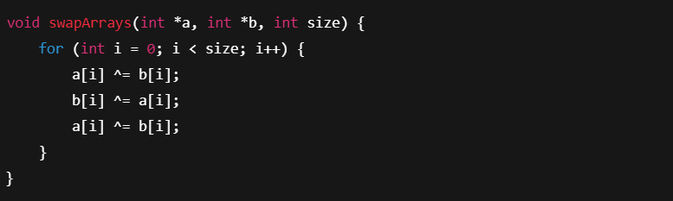
📌 Why it’s asked: Assesses understanding of memory access and data manipulation without additional space.
✅ Tips to Prepare:
- Understand pointer arithmetic.
- Practice in-place array operations: swap, rotate, reverse.

🔤 3. Reverse a String (In-place)
🔄 Q: Reverse a null-terminated string in C
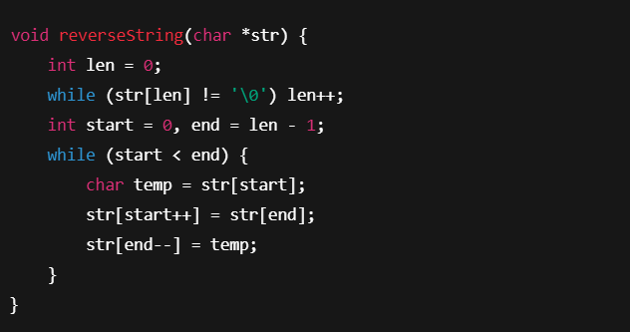
📌 Why it’s asked: Tests handling of strings, memory safety, and edge cases (empty string, one char, etc.).
✅ Tips to Prepare:
- Work with pointers and avoid buffer overruns.
- Be ready to explain memory usage (stack vs heap).

🧠 4. Understanding volatile and const volatile
We see this one a lot in embedded interviews.
❓Q: When do you use volatile?
- For hardware registers
- For shared variables modified in an ISR
- For flags changed by external processes
✅ Prep Tip: Write sample ISR + main loop code that shares a volatile flag.

📚 5. Data Segments & Memory Map Questions
Typical embedded systems questions include:
- What is stored in .bss, .data, .text?
- What happens at startup with these segments?
✅ Prep Tip: Study startup files (startup.s), linker scripts (.ld), and memory maps for your target MCU.

⚙️ 6. Interrupts and ISRs
❓Q: How do you write an ISR in Embedded C? What should be avoided?
- Avoid heavy computation or blocking code in ISRs.
- Declare shared variables as volatile.
✅ Prep Tip: Practice writing GPIO toggle code inside an ISR and configure NVIC or interrupt vectors for your MCU.

💬 Behavioral/Scenario-Based Questions
🔹 How do you debug a hanging embedded system?
🔹 How would you write a driver for a new peripheral?
🔹 What’s your approach when an interrupt isn’t triggering?
✅ Prep Tip: Walk through real experiences — share how you diagnosed an issue using tools like JTAG, oscilloscopes, or by checking register values.

🛠️ Additional Practice Topics
- Endianness: How to detect and convert
- Memory alignment and padding
- Implementing circular buffers
- Writing delay functions using timers (not for loops!)
- Debouncing switches
- State machines in C

✅ Final Preparation Tips
- 🔍 Use simulators or evaluation boards: STM32CubeIDE, Keil uVision, MPLAB X
- 🧪 Code daily: Use platforms like [Coding Ninjas, HackerRank, or LeetCode] (filter for C/Embedded problems)
- 📖 Refer to real manuals: Get used to reading microcontroller datasheets and reference manuals
- 🎯 Mock yourself: Time-box your practice sessions — 45 minutes per coding round is common

