Problem before Docker

1. An application works in developer’s laptop but not in testing or production. This is due to difference in computing environment between dev, test and prod.
2. Developing an application requires starting several of microservices in one machine. So if you are starting fifty of those services you require fifty VMs on that machine

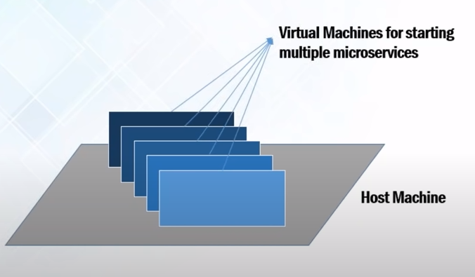

The idea behind micro service is that some type of applications becomes easier to build and maintain when they are broken down into smaller, composable pieces which work together. Each component is developed separately, and the application is then simply the sum of it’s constituent components.

How Docker solve these problems

1. You can run several microservices in the same VM by running various Docker containers for each microservice.
2. Provide a consistent computing environment throughout the SDLC. Containers are created by developer only, so we can use same environment throughout the SDLC Dev, Test, Prod. So there will not be difference in computing environment.

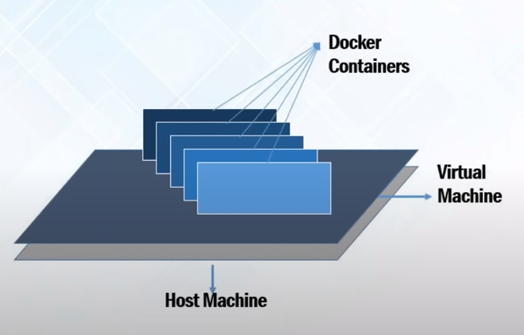

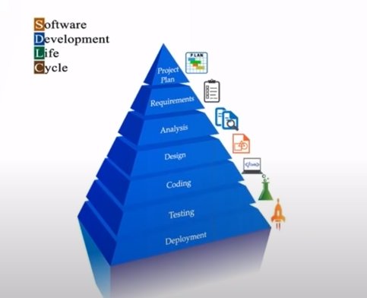

Docker

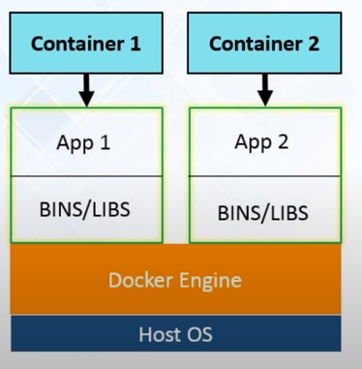

Docker is a tool designed to make it easier to create, deploy and run application by using containers.

Docker containers are lightweight alternatives to VMs and it uses the host OS.

You don’t have to pre-allocate any RAM in containers.

Docker is a client server Architecture.

Docker is written Go Language.

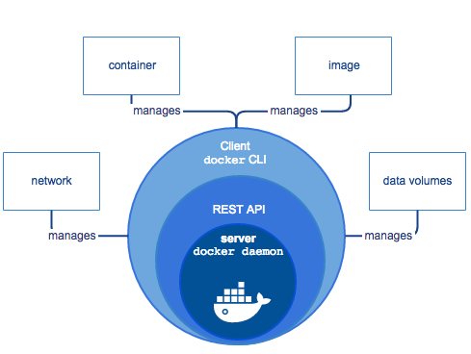

API URL is <https://docs.docker.com/engine/api/v1.24/>

General Work Flow of Docker

Docker File:- Developer write code that defines and application, requirement and dependency in an easy to write file, called as Docker File.

Docker Image: - Docker File produces Docker Image. All the dependency are present in Image.

Docker Container:- Docker container are run-time instance of Image.

Docker Hub:- Docker Hub contains Docker Images. It behave like git repository, which contains public and private images.

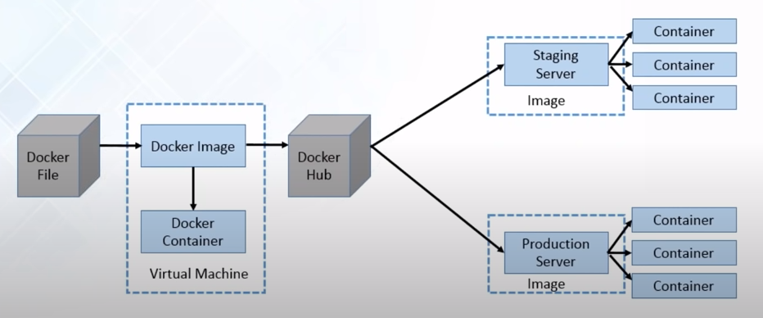

Docker Registry

Docker Registry is a storage component for Docker Image

We can store the image in either public/private repositories.

Docker Hub is docker’s very own cloud repository.

Docker Image

Read only templates used to create containers

Built by docker user

Stored in docker hub or your local registory

Docker Containers

Isolated Application platform

Contains everything needed to run the application

Built from one or more images.

Containers is a process not entire OS.

It work on namespace basis. Whenever you create container, it will create PID, Name, Network, IPC, mount interfaces.

Service docker status

Check docker status

Service docker start

Start the docker

Docker info

Display docker infor

Docker version

Check docker version

Docker –-help

Take help

Docker container run Ubuntu cat /etc/os-release

Run container and run command inside that container.

Docker Container run Ubuntu sleep 30

Run container and sleep for 30 second

-it

Interactive and TTY

Ctrl + p then q

Netstat –nltp

Show the open ports