Automatic Ticket Assignment
(Interim Report)

Submitted by
Group B
PGP-AIML
Jan Batch

Supervised By
Sumit

Index
Table of Contents

- Team Details.................................................................................. 3
- Summary of problem Statement,Data and findings...................... 4
Problem Statement........................................................................ 4
Objective....................................................................................... 5
Observations from the given Dataset.............................................5
- Summary of the Approach to EDA and Pre-Processing.................8
Observations from Target Class......................................................8
Cleaning Process Steps ...............................................................8
- Decide Model and Model Building................................................12
Algorithms used.............................................................................12
- Model performance- Approach to improve model.........................12
- Code Snippet..................................................................................13
- Finalized Results............................................................................13
- Link to code & References.............................................................13

Team Details

Ashish | ashish12459@gmail.com
Ashitha | itsashkr@gmail.com
Bragadeesh Sundarajan | bragadeeshs@gmail.com
Pawan Gupta | gupta.pawan227@gmail.com

Summary of problem statement, data and findings

Understanding The Business:-

In any Support System which is following Customer Centric Approach, Incident Management plays an important role in delivering quality support to customers. An incident ticket is created by various groups of people within the organization to resolve an issue as quickly as possible based on its severity. Whenever an incident is created, it reaches the Service desk team and then it gets assigned to the respective teams to work on the incident.

The Service Desk team (L1/L2) will perform basic analysis on the user's requirement, identify the issue based on given descriptions and assign it to the respective teams.

The manual assignment of these incidents might have below disadvantages:

- More resource usage and expenses.
- Human errors - Incidents get assigned to the wrong assignment groups
- Delay in assigning the tickets
- More resolution times
- If a particular ticket takes more time in analysis, other productive tasks get affected for the Service Desk

If this ticket assignment is automated, it can be more cost-effective, less resolution time and the Service Desk team can focus on other productive tasks.

Objective

From the given problem description, Currently in manual assignment wrong allocation of ticket is happening so due to this manual intervention is required to re-allocate the tickets which is causing delay in resolution.

So we come with a two solution approach which is based upon Deep Learning & AI based model.

- Using a traditional Machine learning algorithm to resolve the problem
- Using a AI Based algorithm to resolve the problem

Understanding the data:-

- Four columns – Short Description, Description, Caller and Assignment group
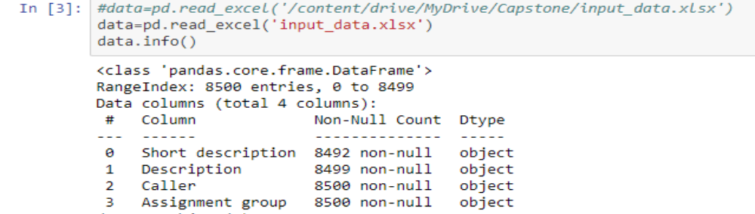
- 74 Assignment groups found - Target classes

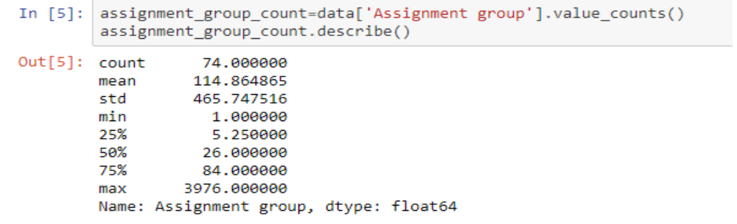
- Caller names in a random fashion (may not be useful for training data)
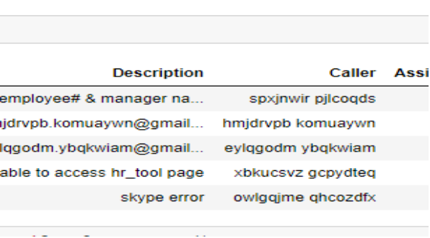

- European non-English language also found in the data

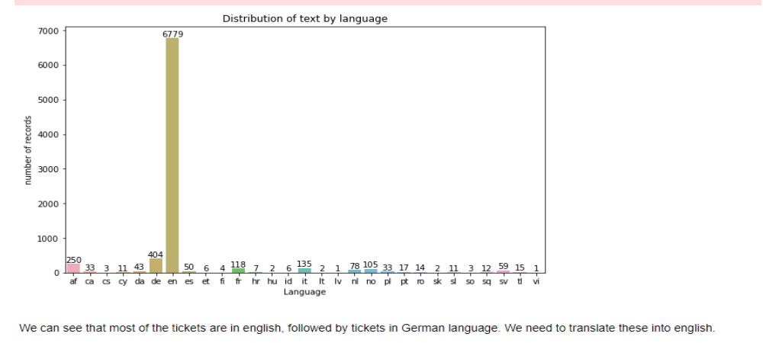
- Email/chat format in description
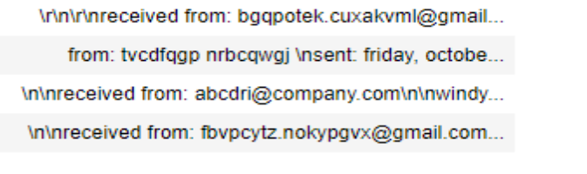

- Symbols & other characters in the description
- Hyperlinks, URLS & few image data found in the description
Blanks found either in the short description or description field
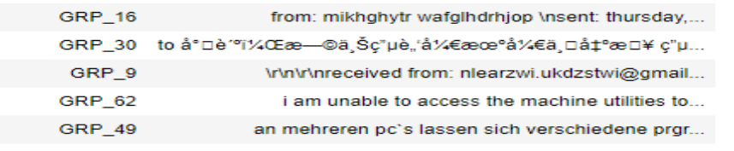
- Few descriptions same as the short description
- Few words were combined together
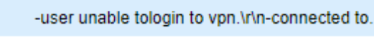
- Spelling mistakes and typo errors are found
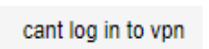

Summary of the Approach to EDA and Pre-Processing

Observations from Target Class
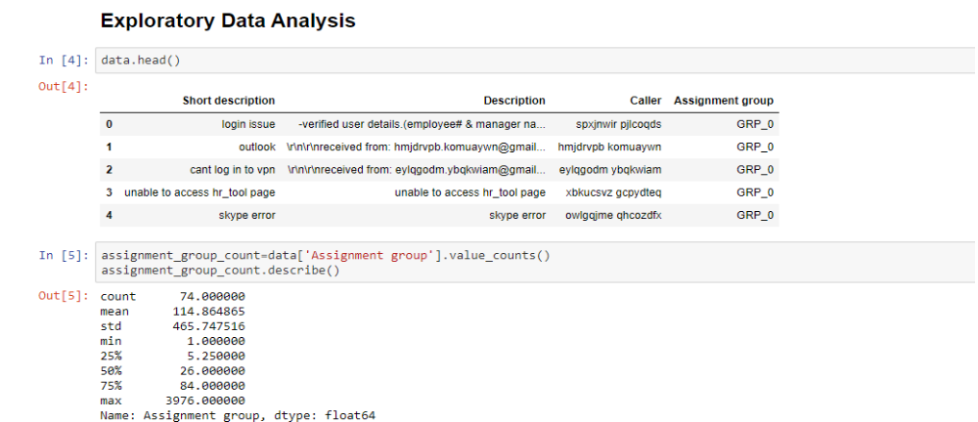
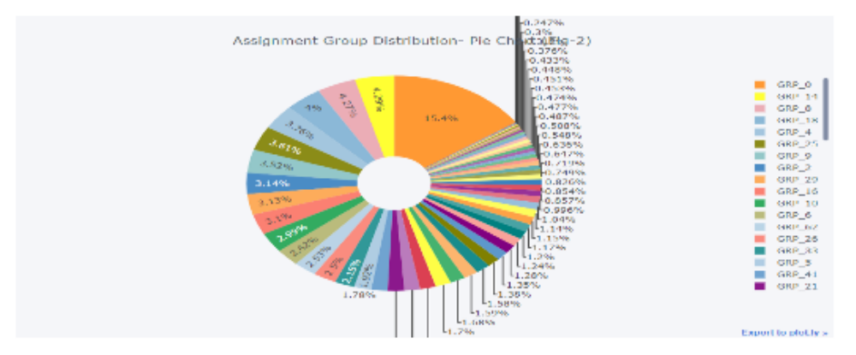

Following is the list of observation from EDA that we have performed on given dataset.
- There are 4 Columns and all are of string types.
- Total 8500 rows are available in given data set.
- Total 74 assignment group are available in given data set.
- Assignment group is our prime focus to resolve the problem.
- We can classify this problem as multi-class classification problem.
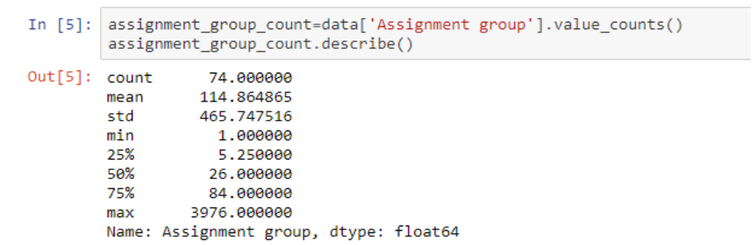
- From the below screenshot we can say that 1 group that is having max number of ticket allocation while 6 group is having only 1 ticket allocated.

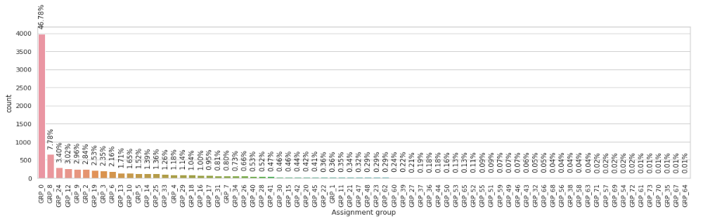

- Top 20 and bottom 20 group assignments.

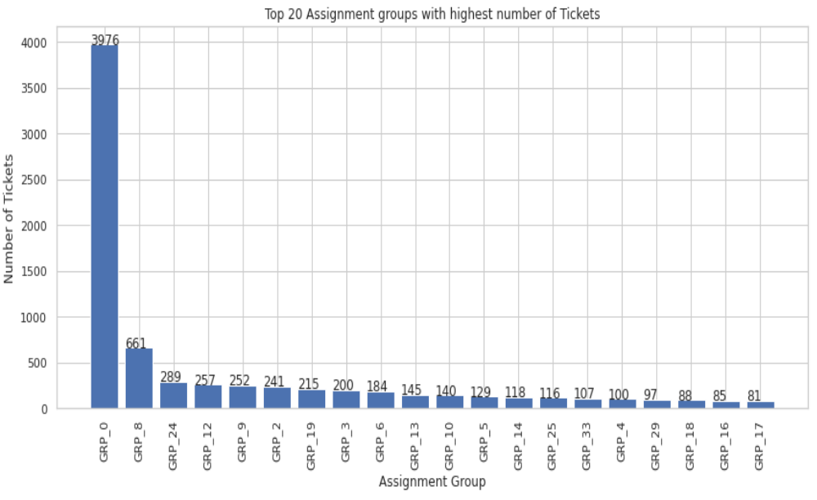
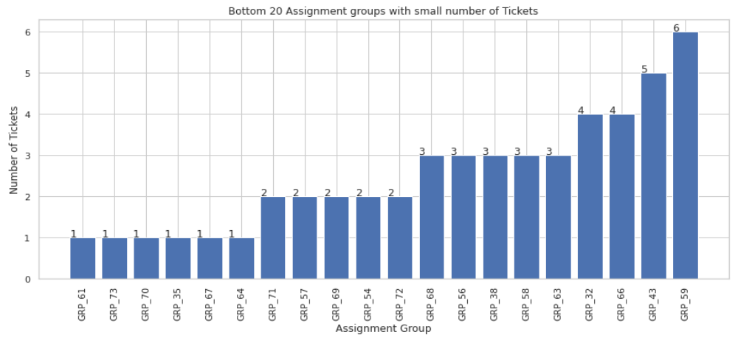

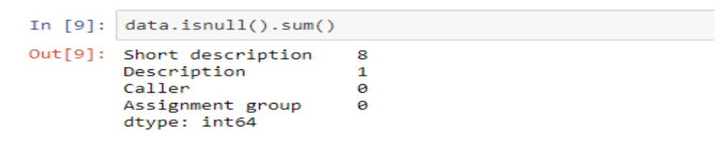
- From the above screenshot we can say that there are 8 columns which are blank in short Description and 1 in description which we have handled by copying the short description to Description and replace nan values with “”.

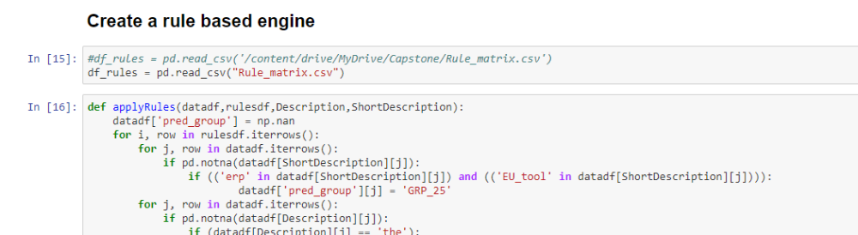
- Created a rule based engine for allocation of tickets to newer group so that we can come up with right allocation of tickets. Before applying the rules we are having 8500 record with allocation. After applying rules we are having 8204 records in our data set.

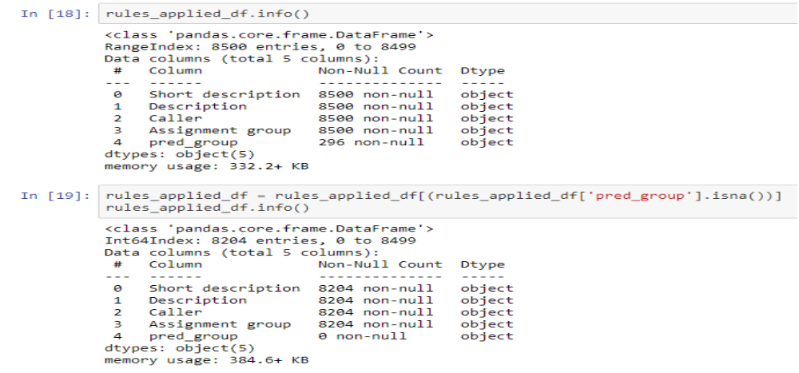
- After applying rules we are having now 63 groups in our data set.

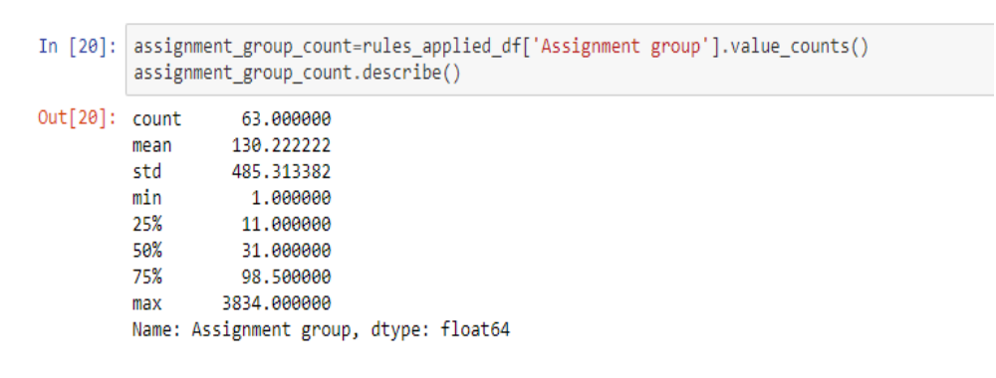

- From the given data set we have identified that there are some garbled text which we have converted into their respective language by using ftfy library.

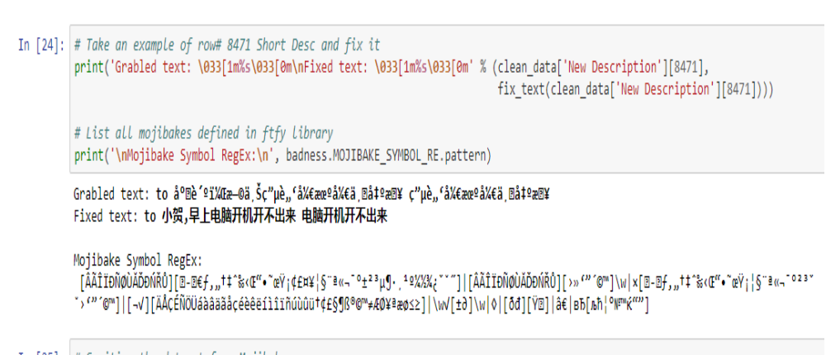

Cleaning Process Steps

Below steps have been performed for initial pre-processing and clean up of data.

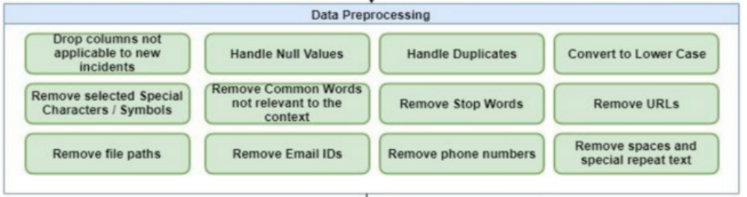
- Dropped the caller field as the data was not found to be useful for analysis,
Replaced Null values in Short description & description with space.
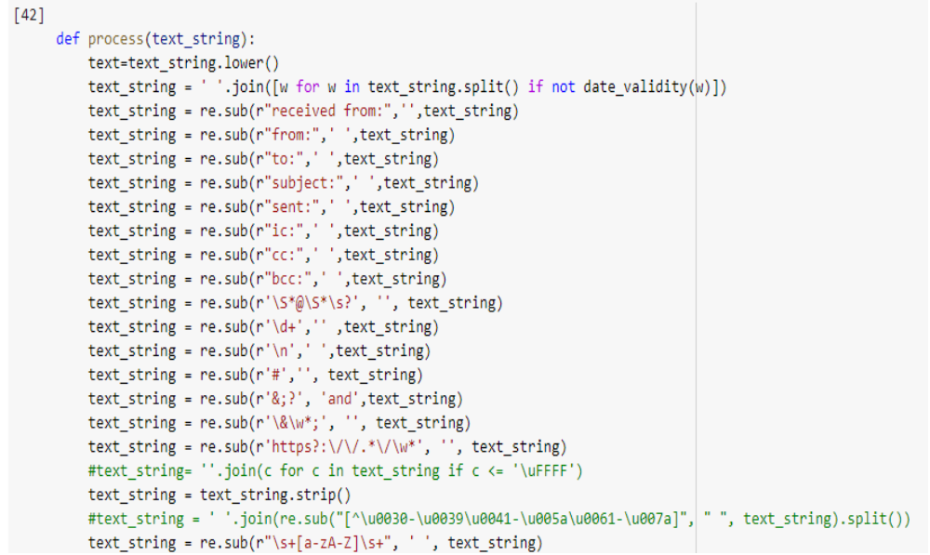

- Merged Short Description & Description fields for analysis
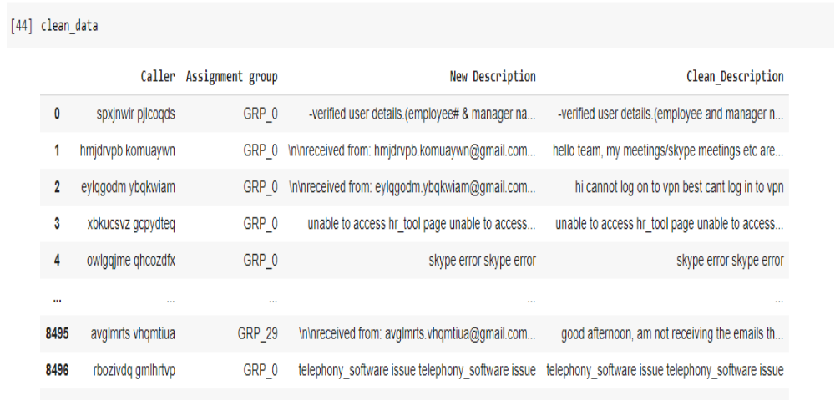

- Changed the case sensitivity of words to the common one
- Removed Hashtags and kept the words, Hyperlinks, URLs, HTML tags & non-ASCII symbols from merged fields.
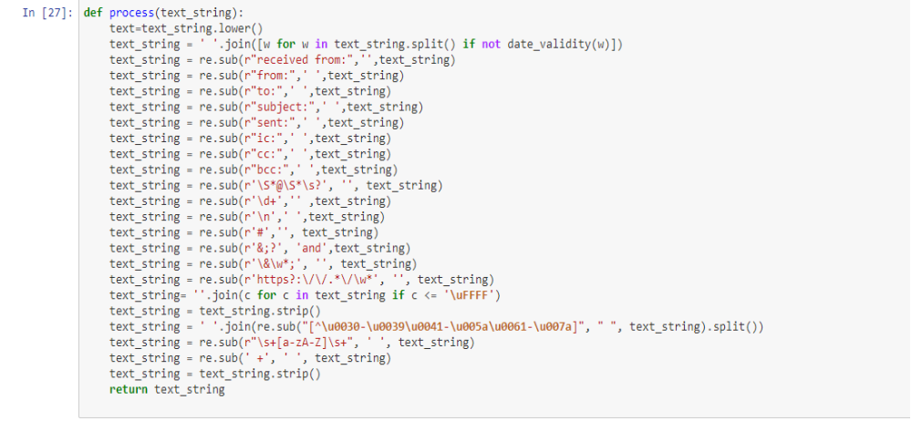

- Translating all languages (German) to English

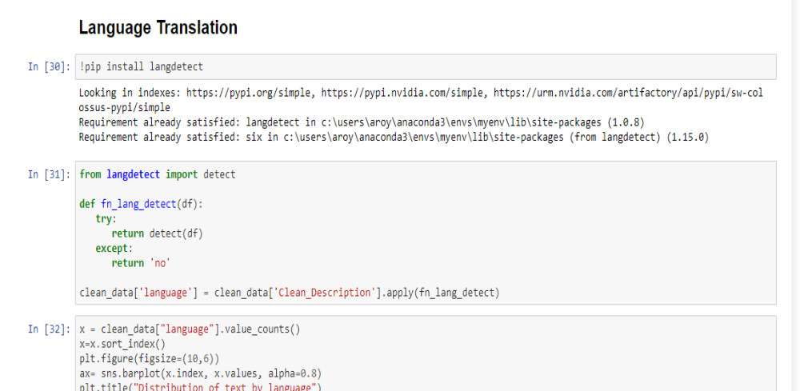
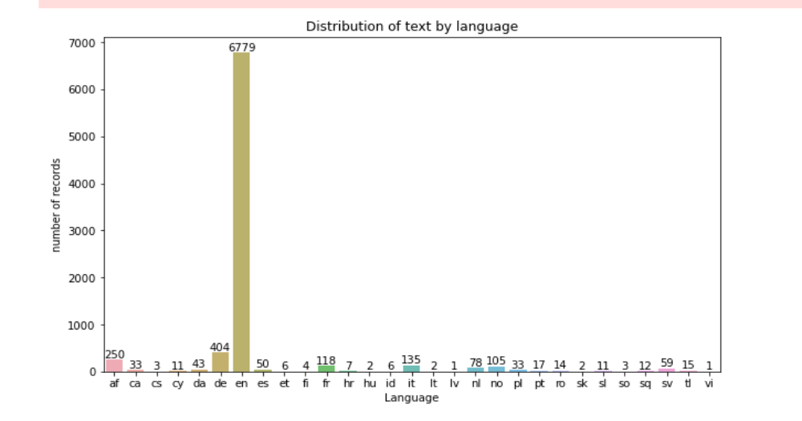

- We have tried to translate the data with go slate API of google to translate the data but due to limit of processing not more than 100 records from one IP address we are not able to do so. So to overcome from this problem we have created batching of 100 records and process the same and create pkl file of each 100 records. Once we are able to do the translating all the data we have merged the all into one single files.
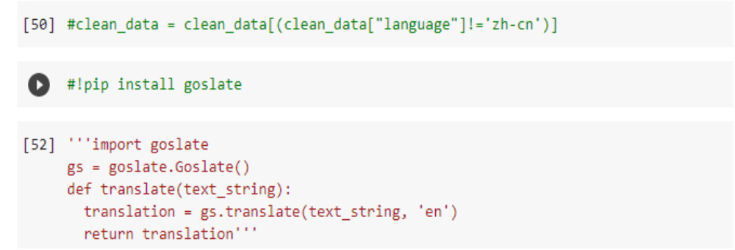
- We have also tried to do the language translation by creating corpus of keywords and after that applied the same in data set to identified the same.

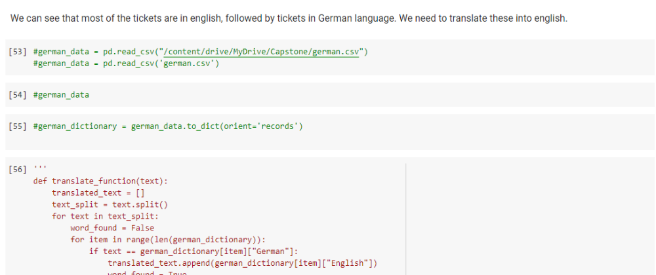

Data Augmentation:- For data augmentation we have used nltk library to do the same.
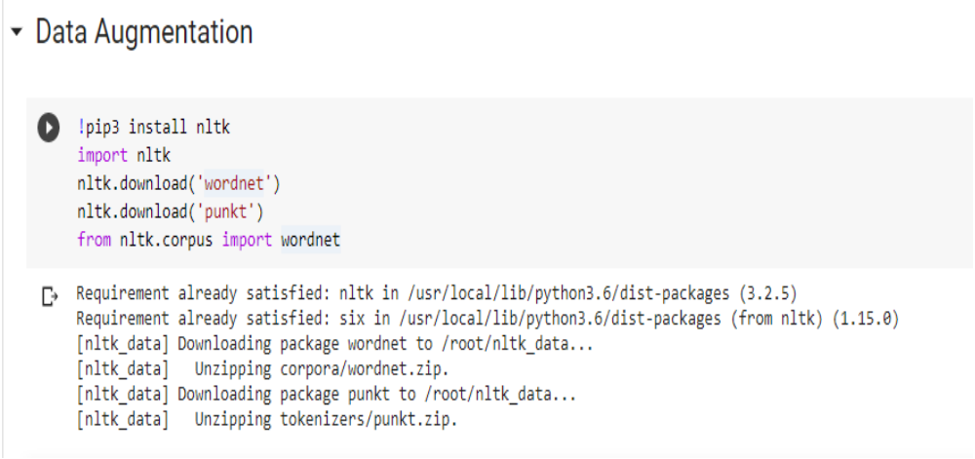

- First we have drop the duplicate words while maintaining word order.

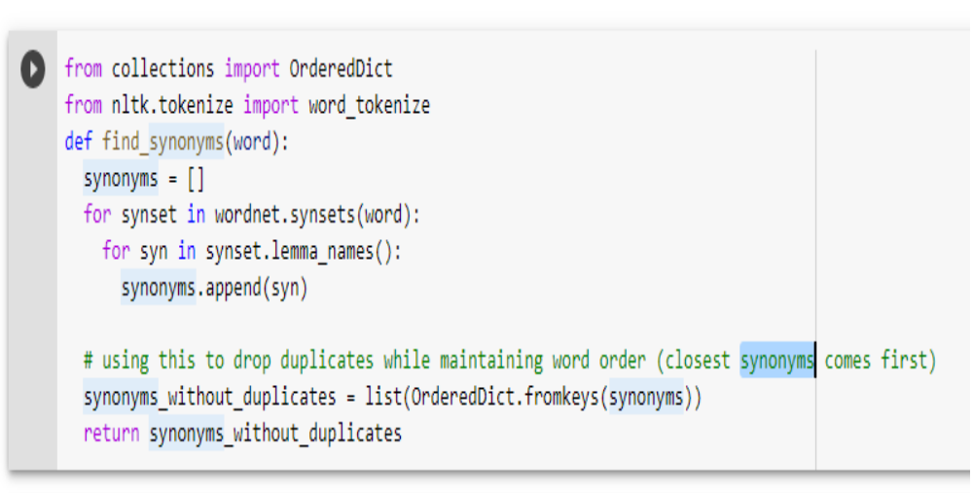
- Created new set of sentences for data augmentation.

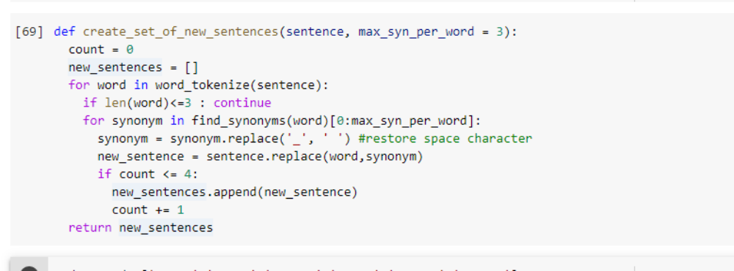
- Stop word removal & Lemmatise Text:- For the purpose of analyzing text data and building NLP models, these stop words need to removed.

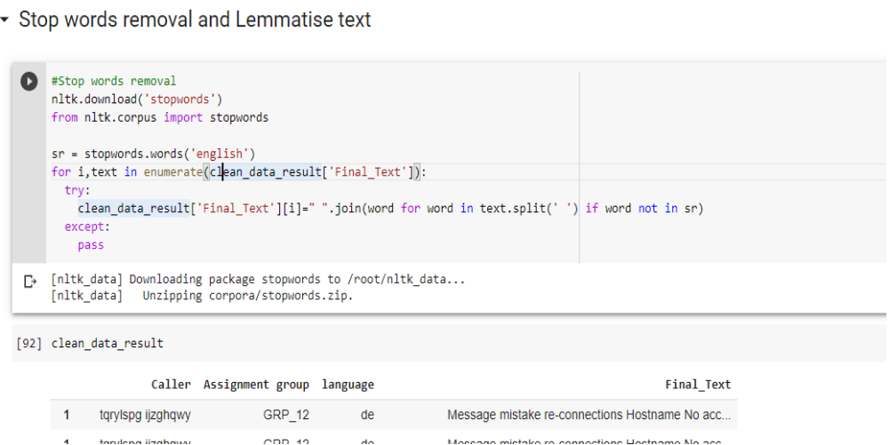

- Performing lemmatization
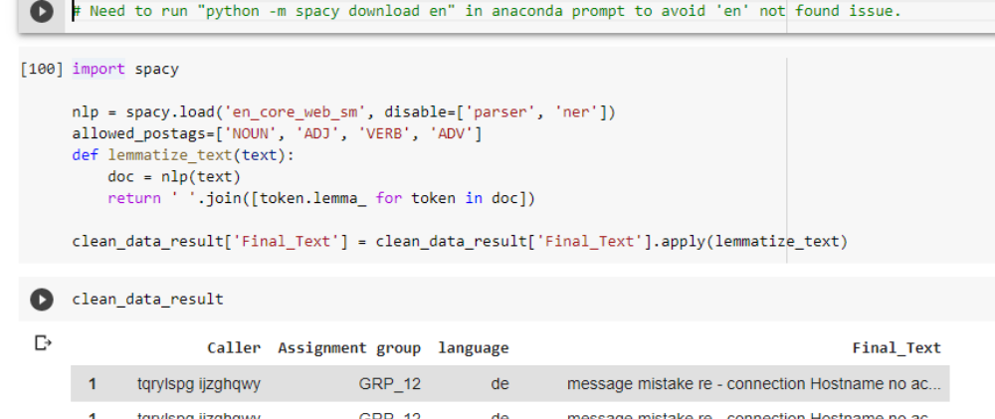
- Top unigrams in dataset with and without stop words.

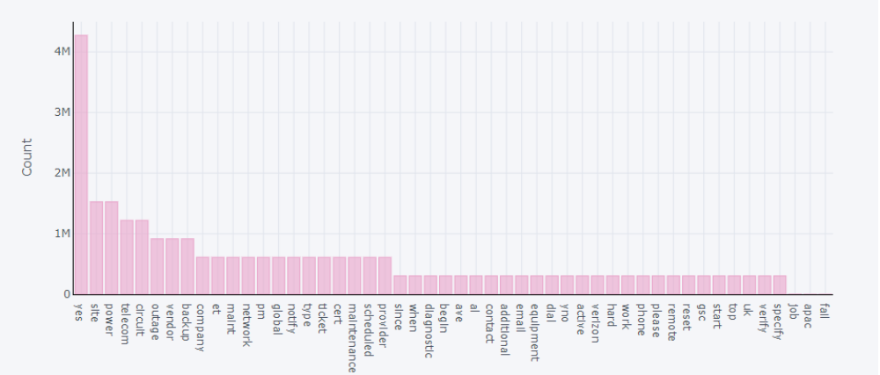

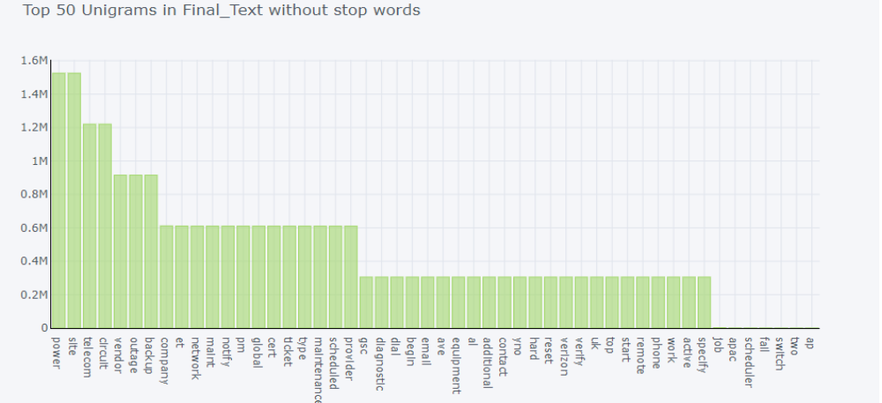

Word Cloud:-Visualizing this as a word cloud for top three groups that has got maximum records. A word cloud enables us to visualize the data as cluster of words and each words displayed in different font size based on the number of occurences of that word . Basically; the bolder and bigger the word show up in the visualization, it implies its more often it’s mentioned within a given text compared to other words in the cloud and therefore would be more important for us.
For Group 0

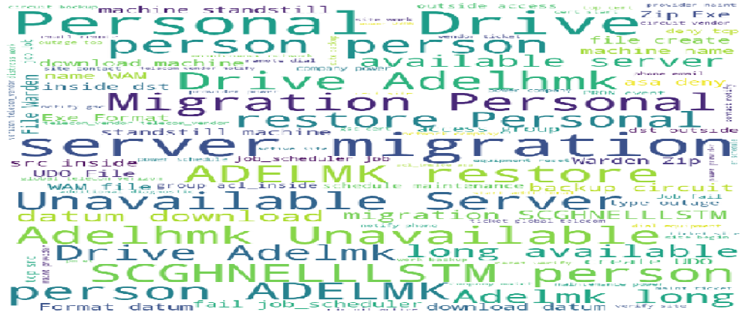

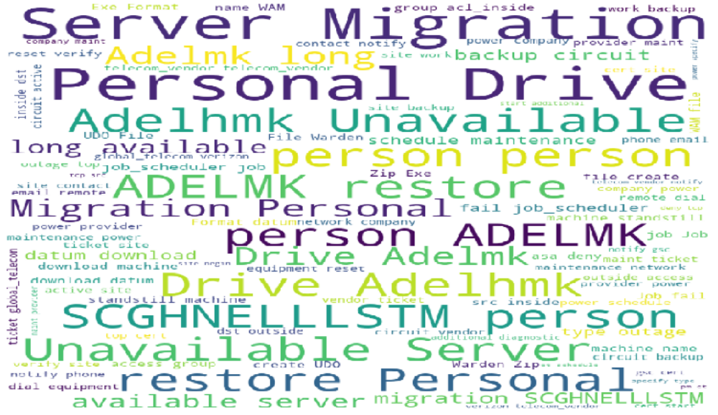
Deciding Models and Model Building :-

Preparing dataframe for Model Building:-
- Created a targeted Categorical Column and assign unique label code to understand word labels.

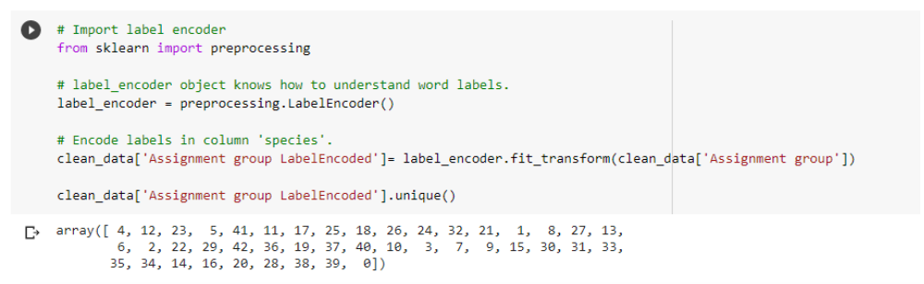

Feature Extraction:- Bag of Words using countVectorizer
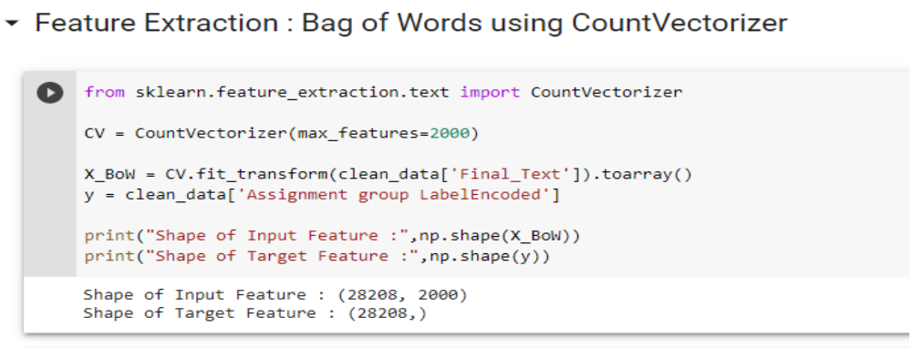
Machine Learning Models:- We have used following ML models to achieve the required accuracy and following is the output of each model.

We have splitted our data as per below approach.

- Splitting into Testing/Training data 70/30 ratio. We have used stratify flag as Yes which ensures that there is equal distribution of data among groups while creating testing and training data.
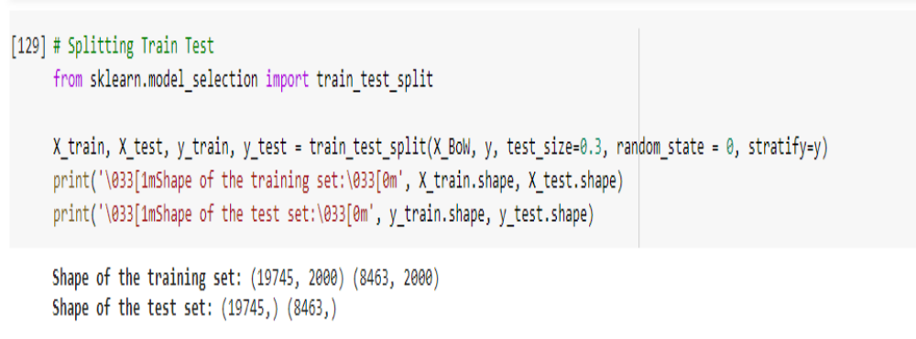

Logistic Regression:- Logistic regression is a statistical model that in its basic form uses a logistic function to model a binary dependent variable, although many more complex extensions exist. In regression analysis, logistic regression (or logit regression) is estimating the parameters of a logistic model(a form of binary regression). We have achieved the accuracy of 70.92 % by using this method.

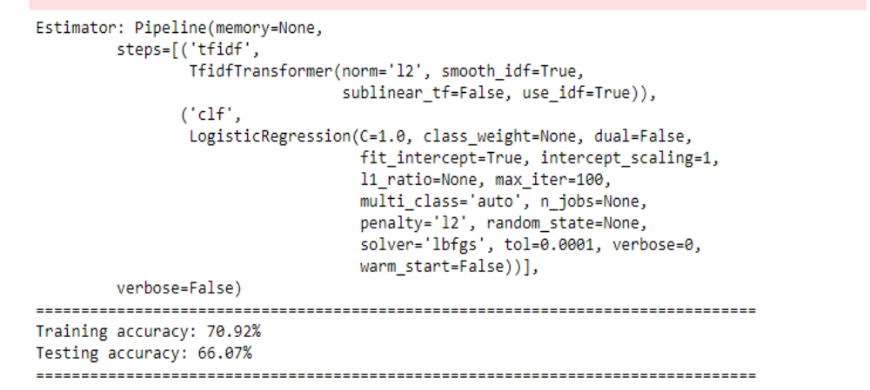

Naive Bayes Classfier:-

Naive Bayes classifiers are a collection of classification algorithms based on Bayes' Theorem. It is not a single algorithm but a family of algorithms where all of them share a common principle, i.e. every pair of features being classified is independent of each other. By using this model we have achieved the accuracy of 53%.
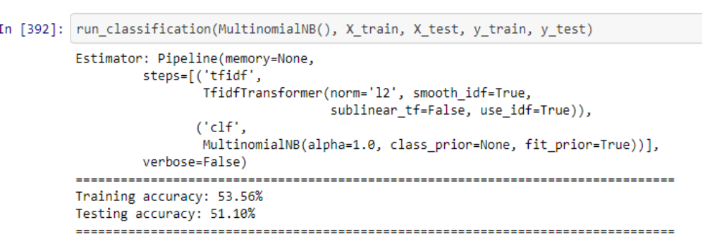
K-nearest Neighbor:-
K nearest neighbors is a simple algorithm that stores all available cases and classifies new cases based on a similarity measure (e.g., distance functions).KNN has been used in statistical estimation and pattern recognition already in the beginning of 1970's as a non-parametric technique. By using this method we have achieved the accuracy of 76.69%.

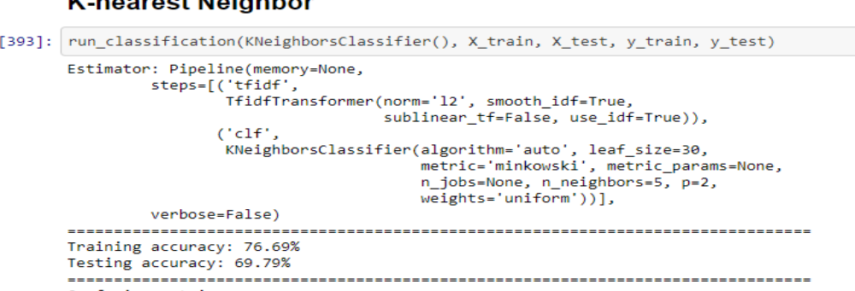
Support Vector Machine:-A support vector machine (SVM) is a supervised machine learning model that uses classification algorithms for two-group classification problems. After giving an SVM model sets of labeled training data for each category, they're able to categorize new text. So we're working on a text classification problem . By using this we achieved accuracy of 78.43%.

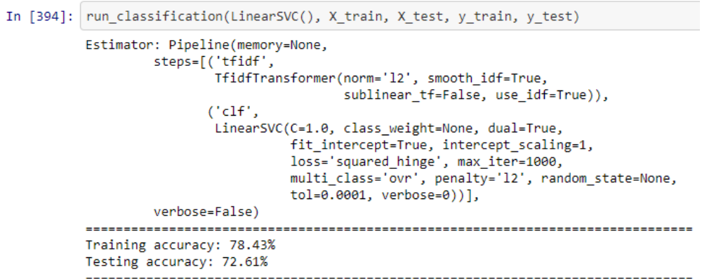

Decision Tree:-A decision tree is a flowchart-like structure in which each internal node represents a "test" on an attribute (e.g. whether a coin flip comes up heads or tails), each branch represents the outcome of the test, and each leaf node represents a class label (decision taken after computing all attributes). By using this we achieved accuracy of 82.08%.
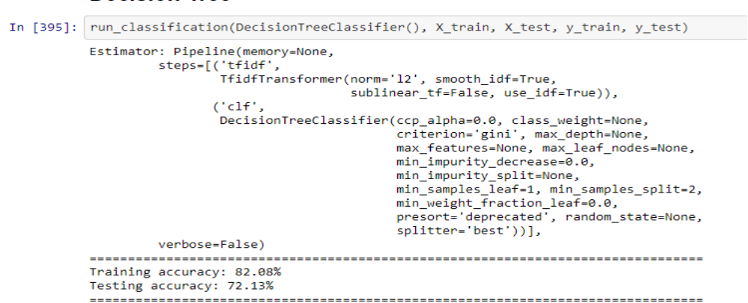

Random Forest:-Random forests or random decision forests are an ensemble learning method for classification, regression and other tasks that operate by constructing a multitude of decision trees at training time and outputting the class that is the mode of the classes or mean/average prediction of the individual trees.By using this we achieved accuracy of 82.08%.
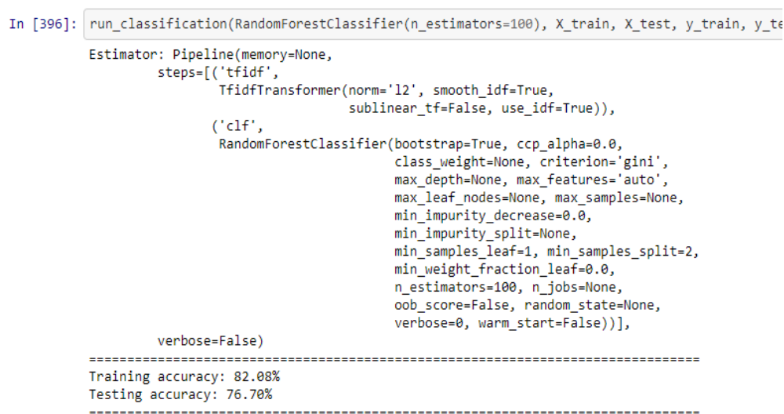
Deep Learning Models:- We have used following DL models for our accuracy.
- GRU :-Gated recurrent units (GRUs) are a gating mechanism in recurrent neural networks .The GRU is like a long short-term memory (LSTM) with a forget gate, but has fewer parameters than LSTM, as it lacks an output gate. By using this model we have achieved the accuracy of .

- LSTM :- Long short-term memory (LSTM) is an artificial recurrent neural network (RNN) architecture used in the field of deep learning. LSTM networks are well-suited to classifying, processing and making predictions based on time series data, since there can be lags of unknown duration between important events in a time series. By using this model we have achieved the accuracy of .

Model performance-

We will improve our model performance on the basis of following parameter.

- Hyper parameter Tuning
- Ensemble Methods
- Model Comparison Charts

On the basis of above parameter we will try to achieve and justify our model to achieve target of 75%.

- Accuracy
- F1-Score

Code Snippet

https://github.com/guptapawan227/Capstone_AIML

Finalized Results

Results will be added in this report once we will complete the project before final submission.

Link to Code & References

https://github.com/guptapawan227/Capstone_AIML

