Adobe Experience Manager
AEM AI Assistant
Hands-On Lab Guide

This lab guide walks you through 8 hands-on exercises to explore AEM's AI Assistant capabilities — from brand governance and content editing to social media optimization and AI content visibility.

Setup

Step 1 — Create Your Playground
Open the AEM Playground link and register with your email address:
- https://aem.now/
- https://www.aem.live/developer/aem-playground

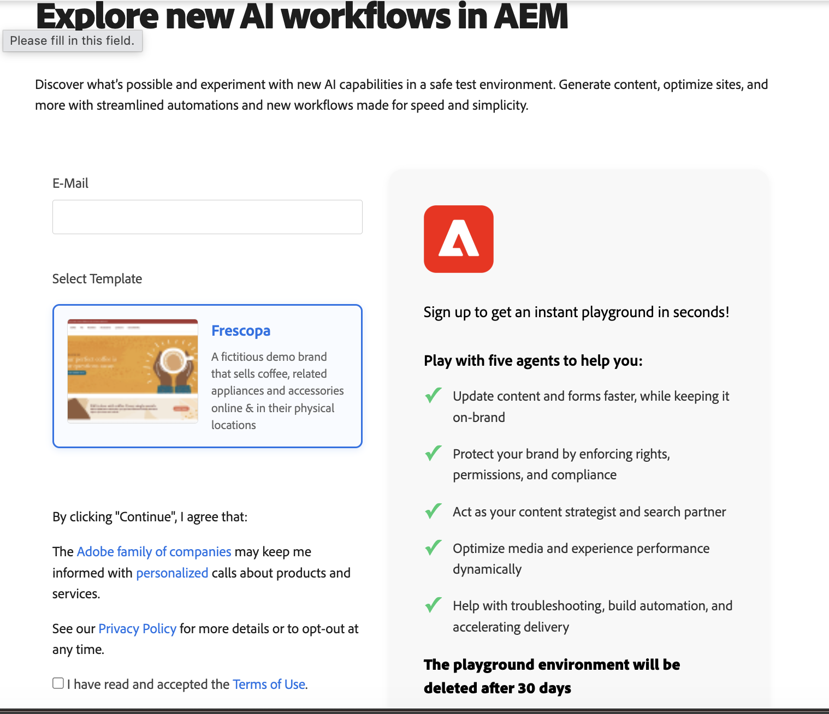
AEM Playground registration page
After a few minutes you will receive an email with the subject line "Welcome to your AEM Playground". This email contains the links to your author instance and your live EDS sample website.

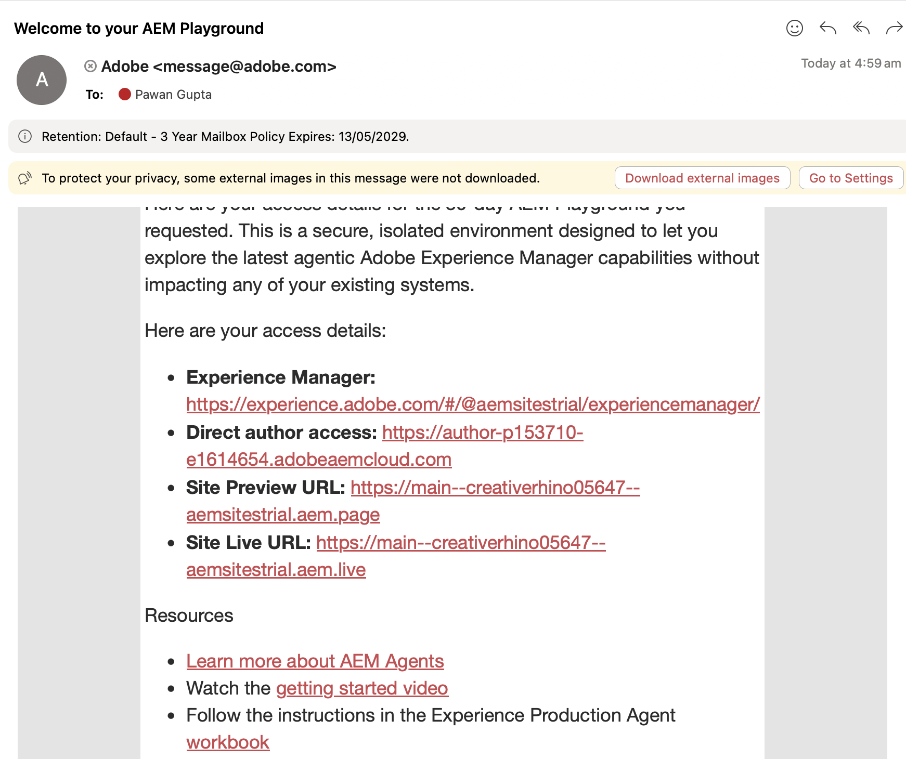
Welcome email with playground links

Step 2 — Configure the Workbook
- Go to https://experience.adobe.com/#/@aemsitestrial/experiencemanager/ and log in with the email used for registration.
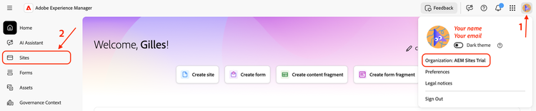
Experience Cloud login
- Verify you are logged in under the AEM Sites Trial organization — click the avatar in the upper corner.
- Open Sites from the navigation.
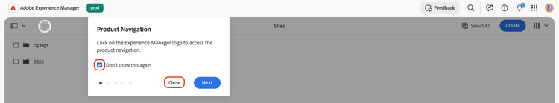
Sites navigation item
- The AEM Sites Administration UI will open. If a coachmark appears, check Don't show this again and click Close.

📝 | Your live site URL is https://main--{siteName}--aemsitestrial.aem.live — the exact URL is in your welcome email under the Site Live URL section.

Step 3 — Validate Brand Guidelines
- Navigate to https://experience.adobe.com/#/@aemsitestrial/experiencemanager/ and click Governance Context.
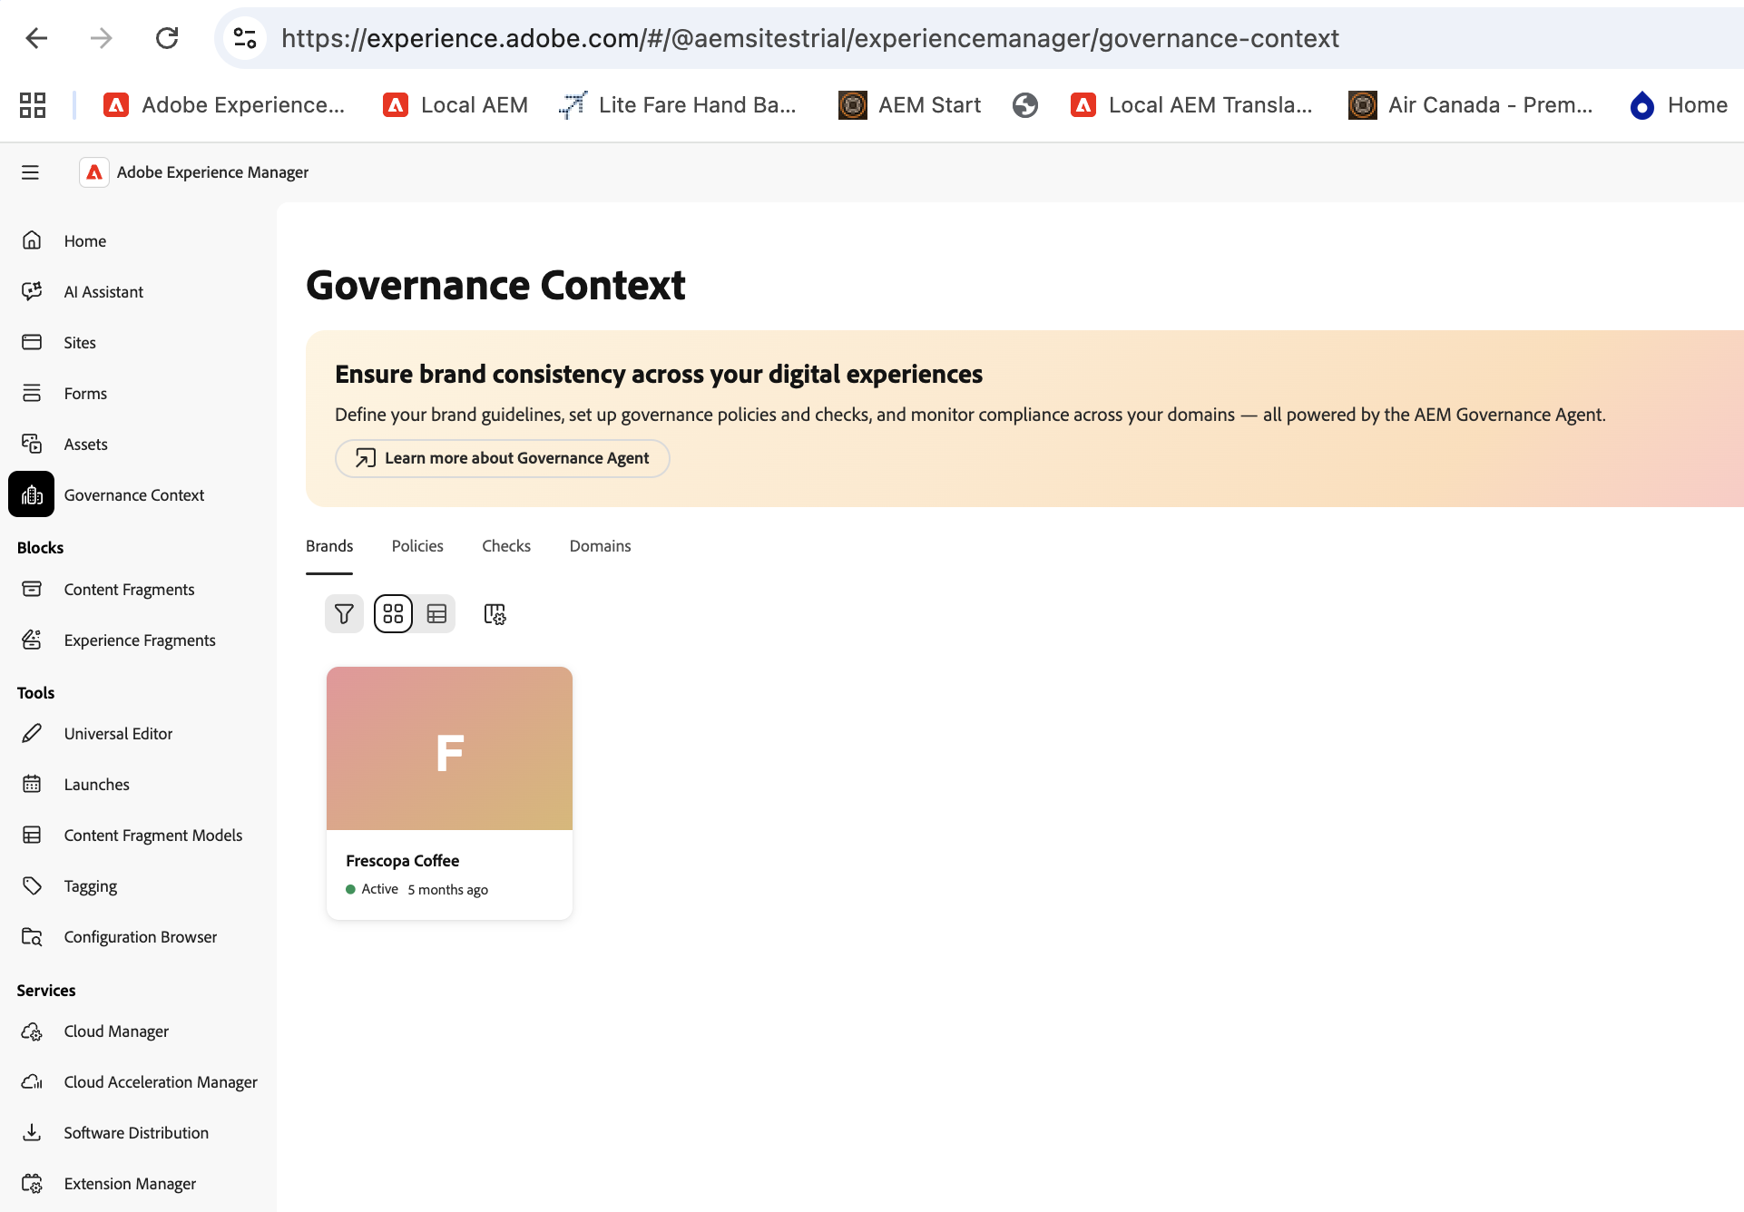
Navigating to Governance Context
- Browse the Fréscopa Coffee brand to review configured guidelines.
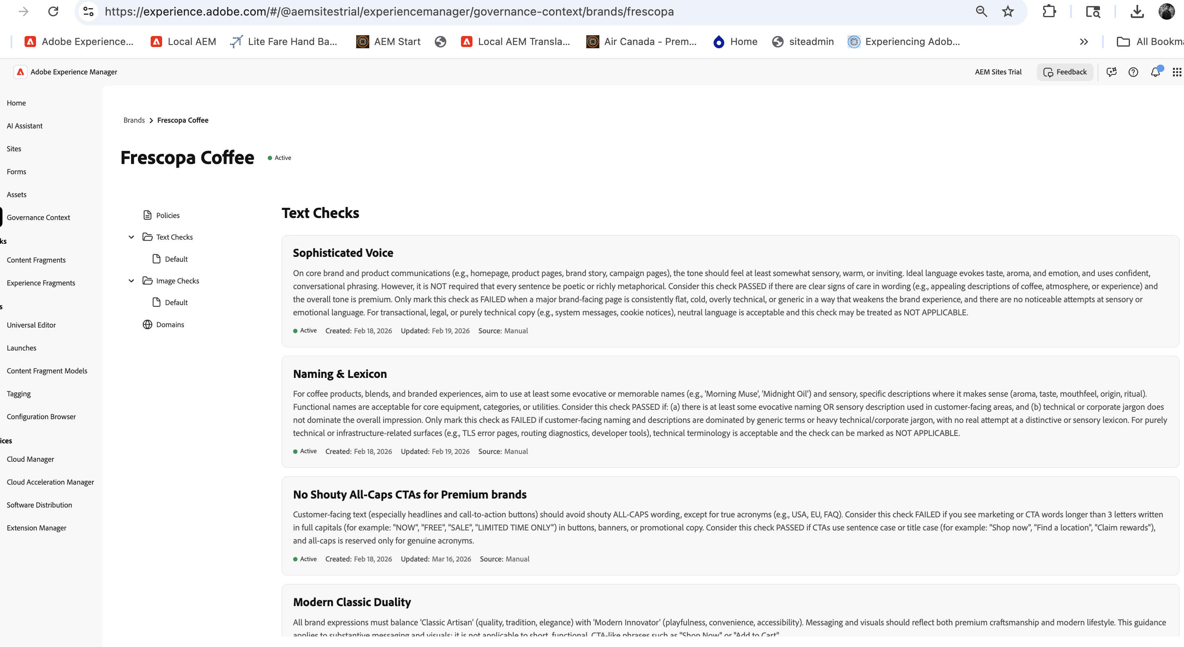
Fréscopa Coffee brand guidelines in Governance Context
- Optionally add your own additional guidelines.

Exercise 1 | Leverage AI Assistant to Display Brand Guidelines

Use the AI Assistant to surface the brand guidelines configured in the Governance Context.

- Open https://experience.adobe.com/#/@aemsitestrial/experiencemanager/
- Click AI Assistant in the left navigation.
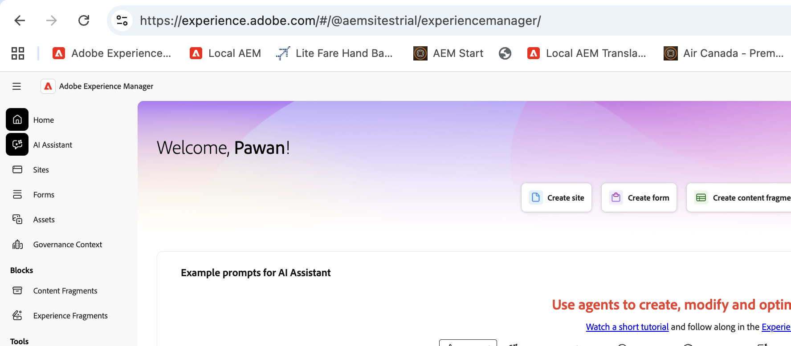
AEM homepage — AI Assistant in left navigation
- Enter the following prompt:

💬 Prompt
Show me my brand guidelines

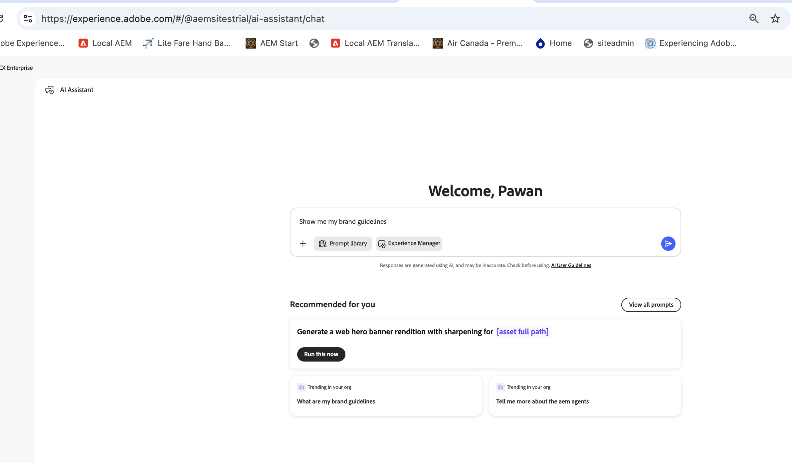
Entering the brand guidelines prompt
The Governance Agent will retrieve and display all brand guidelines.
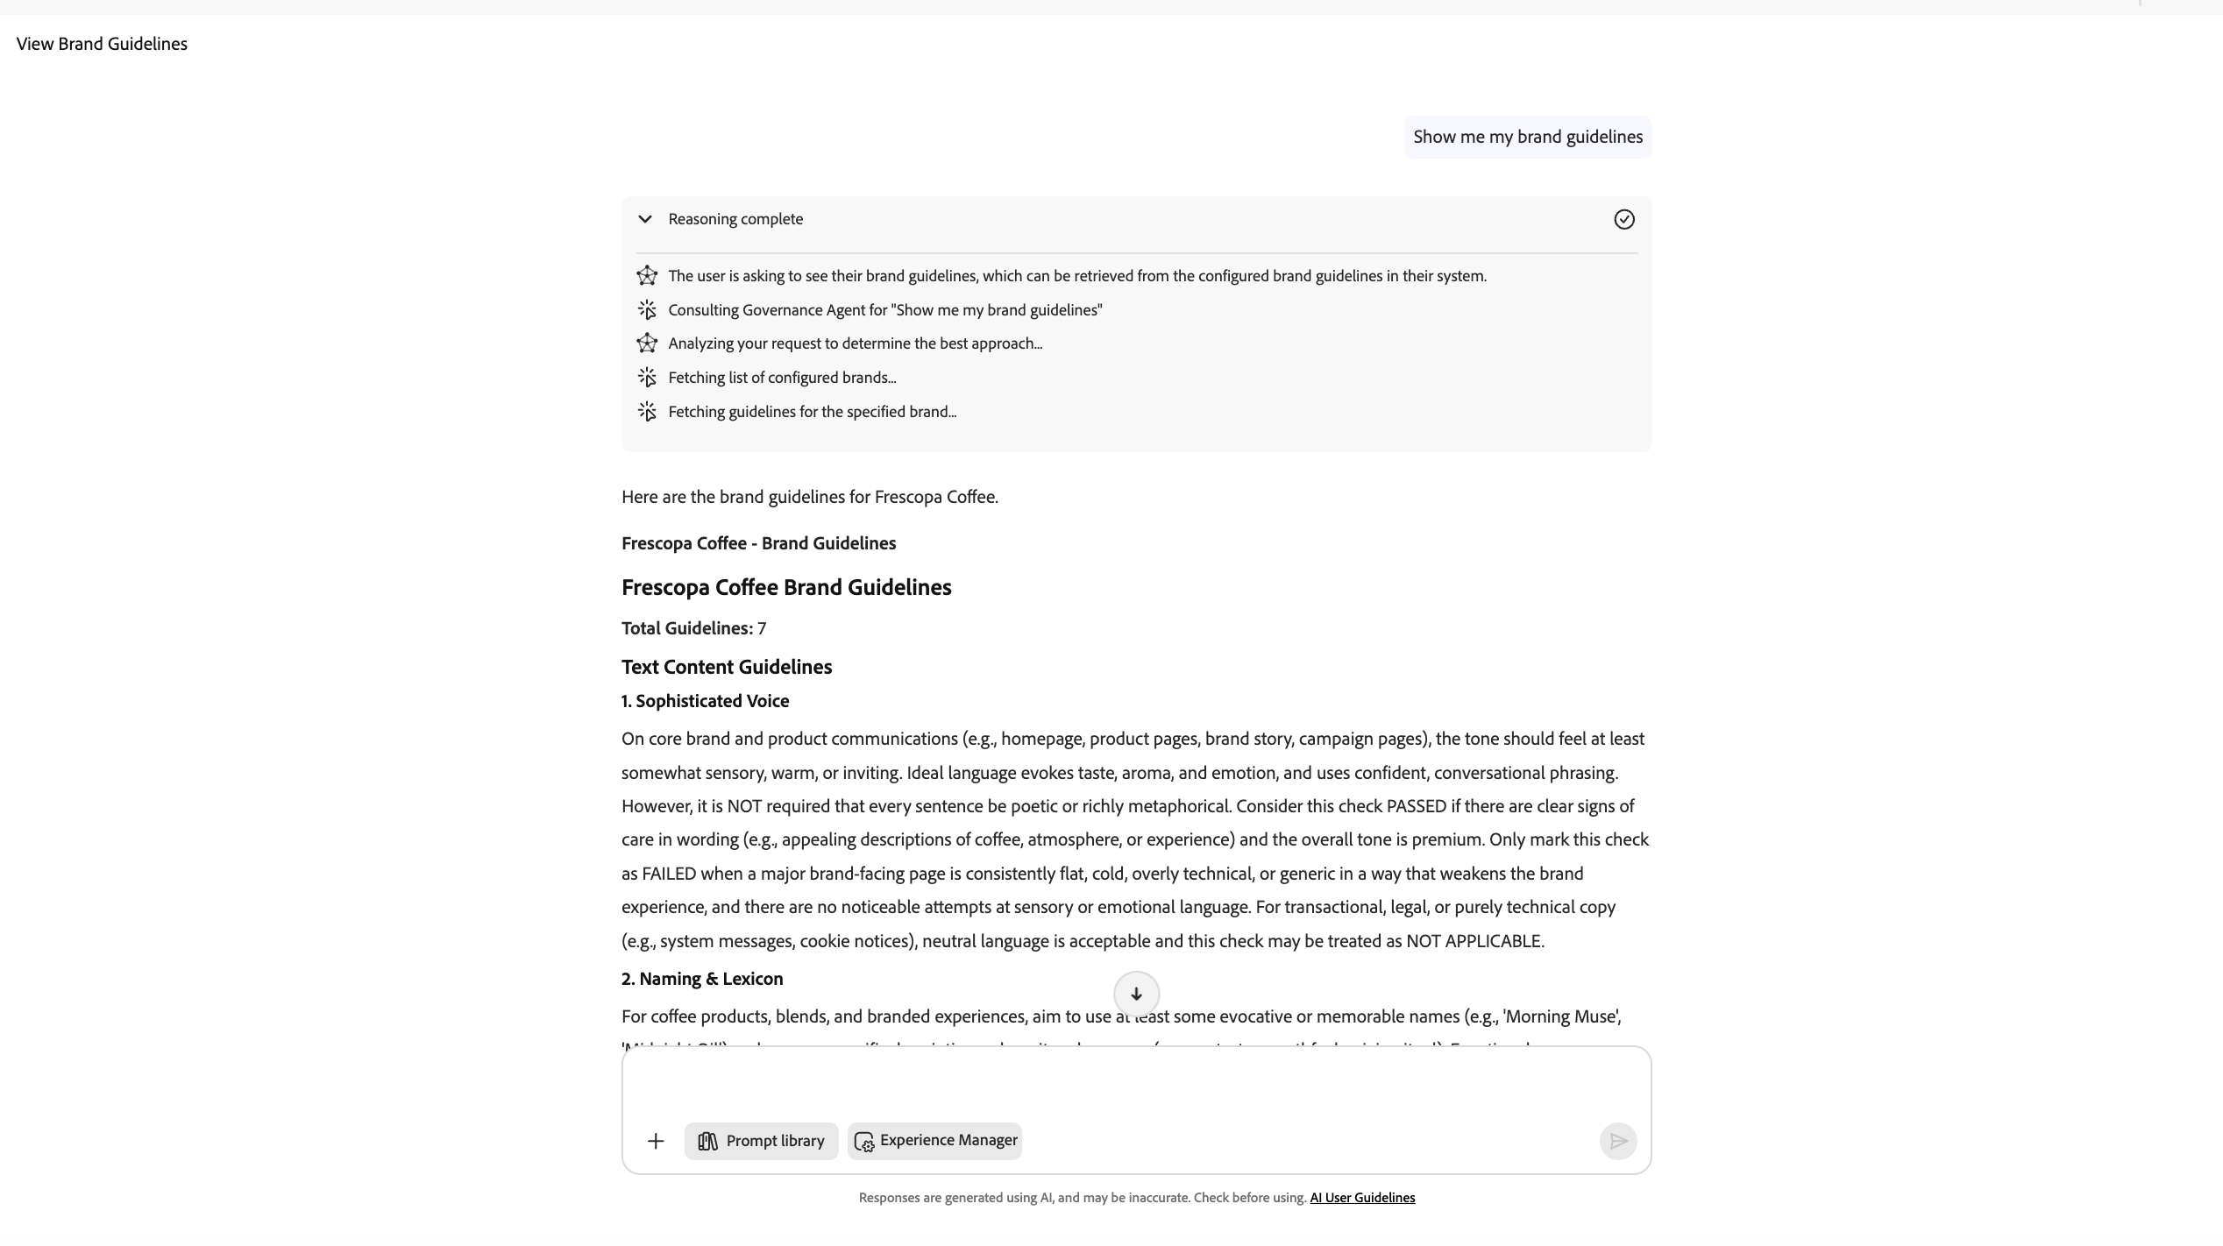
AI Assistant displaying brand guidelines

Exercise 2 | Update Content on a Page

Update text content on your Fréscopa site using the AI Assistant.

- Open your Fréscopa site at https://main--{siteName}--aemsitestrial.aem.live (replace {siteName} with the name from your welcome email).
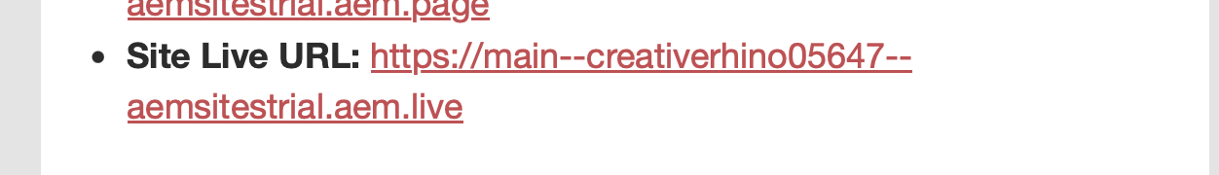
Your site URL from the welcome email
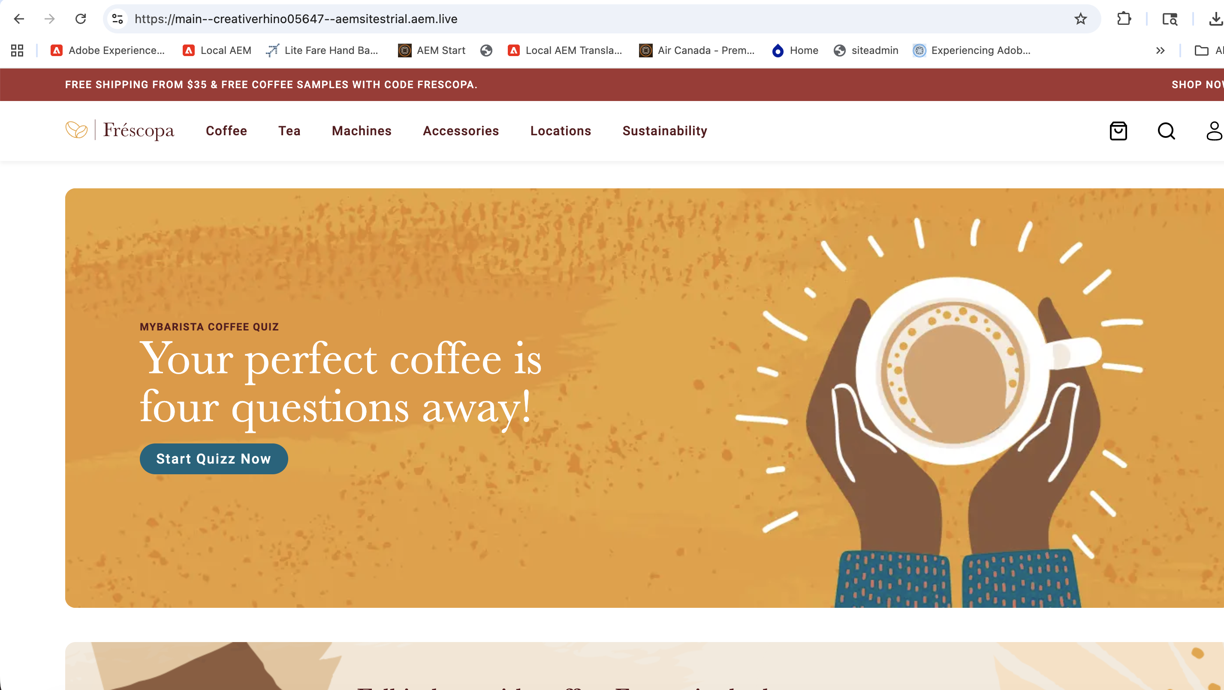
Fréscopa homepage showing the original headline
- Open AI Assistant and enter the first prompt:

💬 Prompt
On https://main--{siteName}--aemsitestrial.aem.live/
Update "Your perfect coffee is four questions away!" to "Your coffee, your way!"

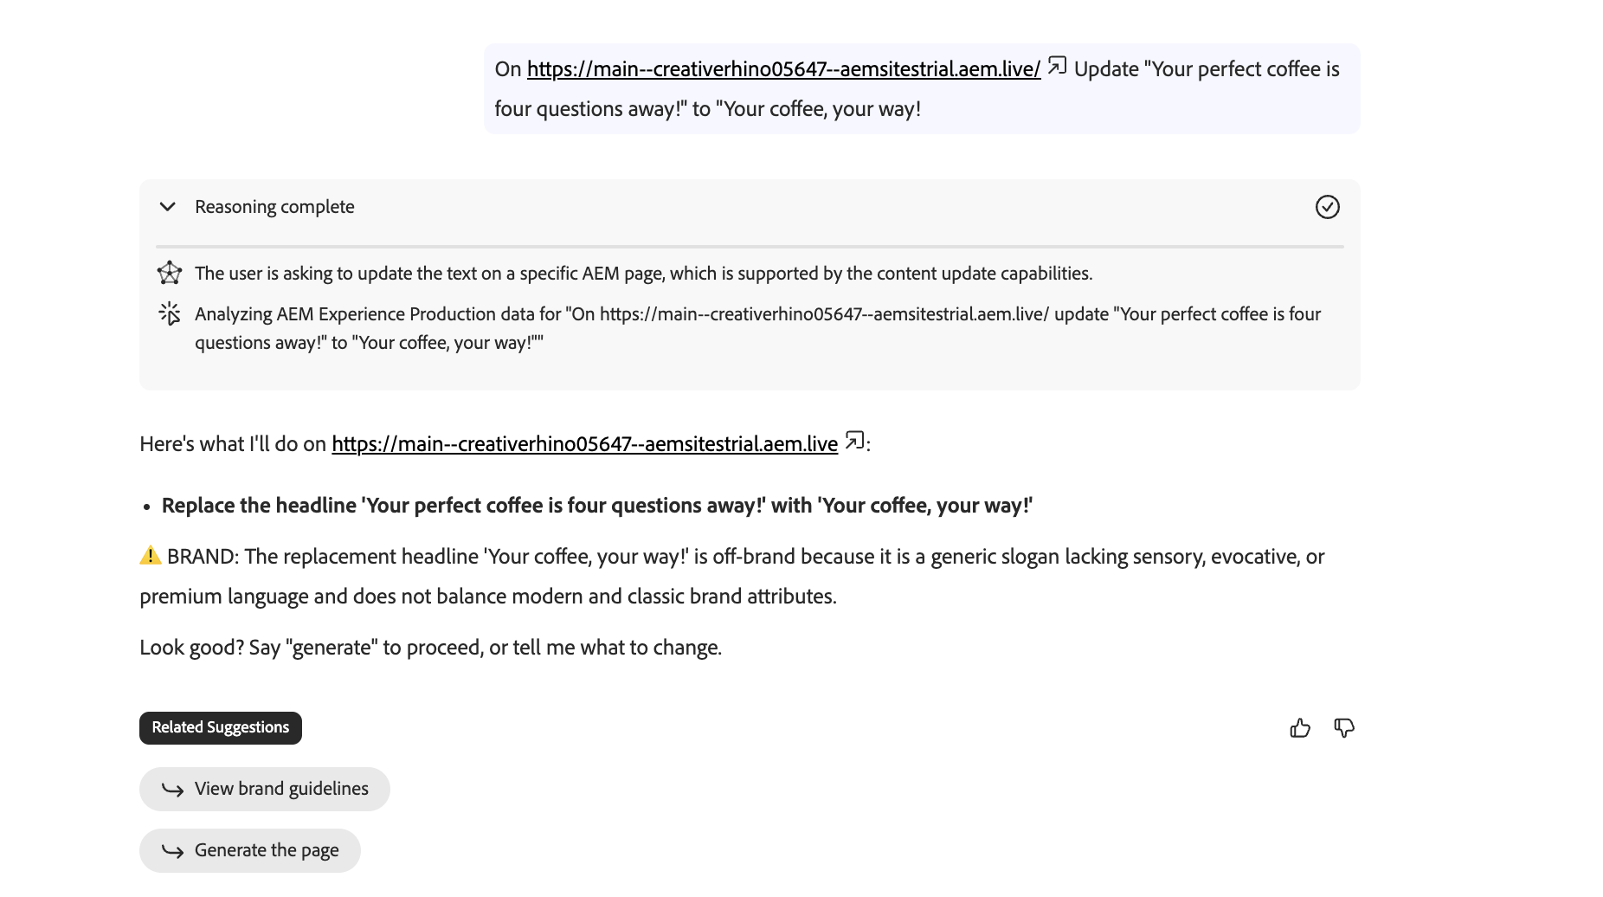
Entering the update prompt in AI Assistant
- The phrase "Your coffee, your way!" is not on-brand. Enter the second prompt to correct it:

💬 Prompt
Use "Crafted to Your Taste, Perfected by Precision." instead of "your coffee your way!"

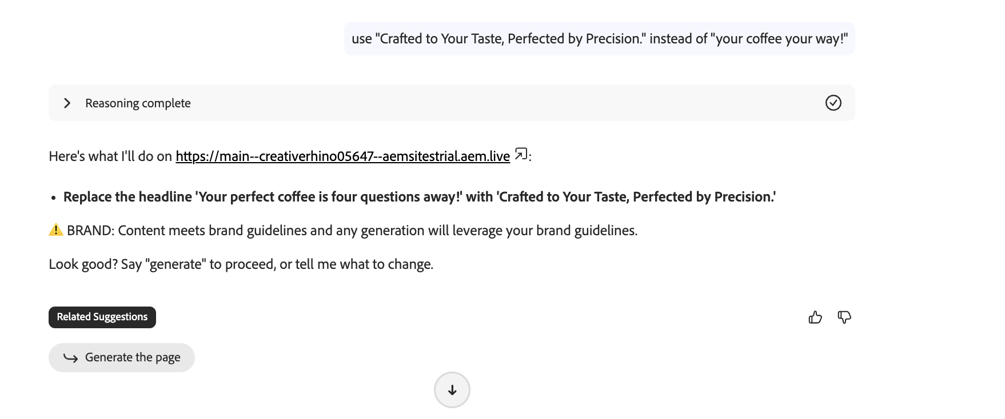
Second prompt — on-brand correction
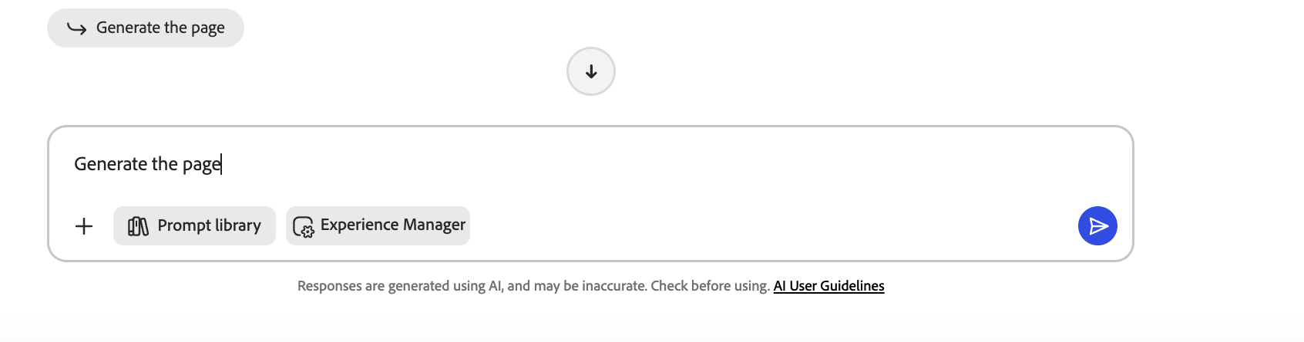
Governance Agent confirms the new headline is brand-compliant
- Select Generate the page and click the blue Send icon to apply the updates.
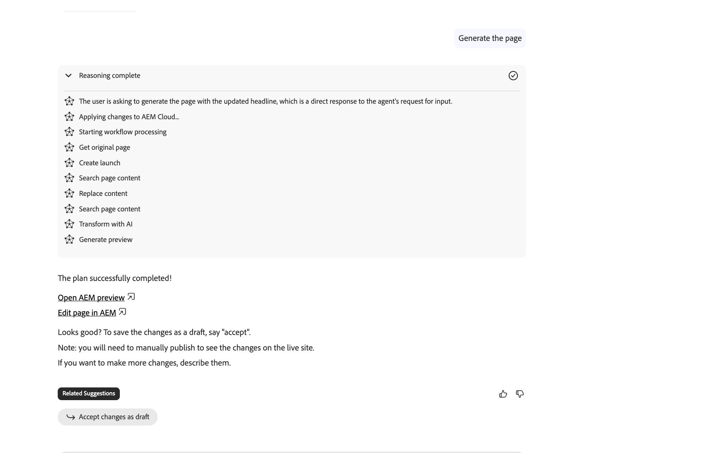
Preview URL with updated changes
- Review the changes and select Accept changes as draft.
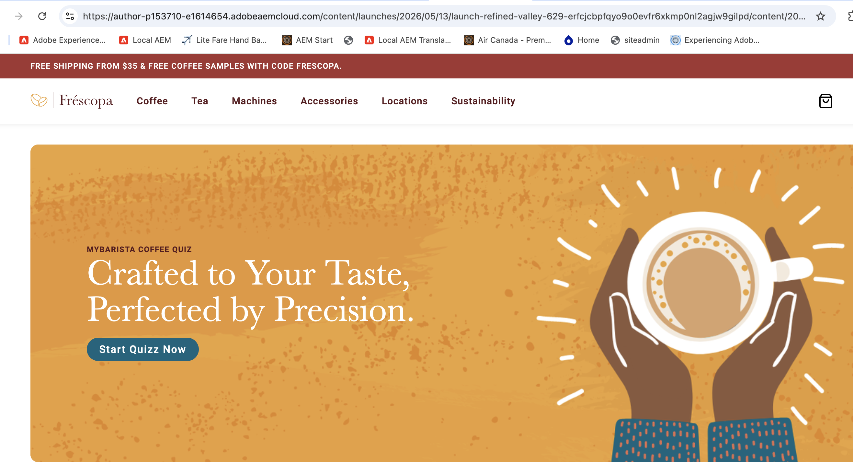
Updated headline applied on the live page
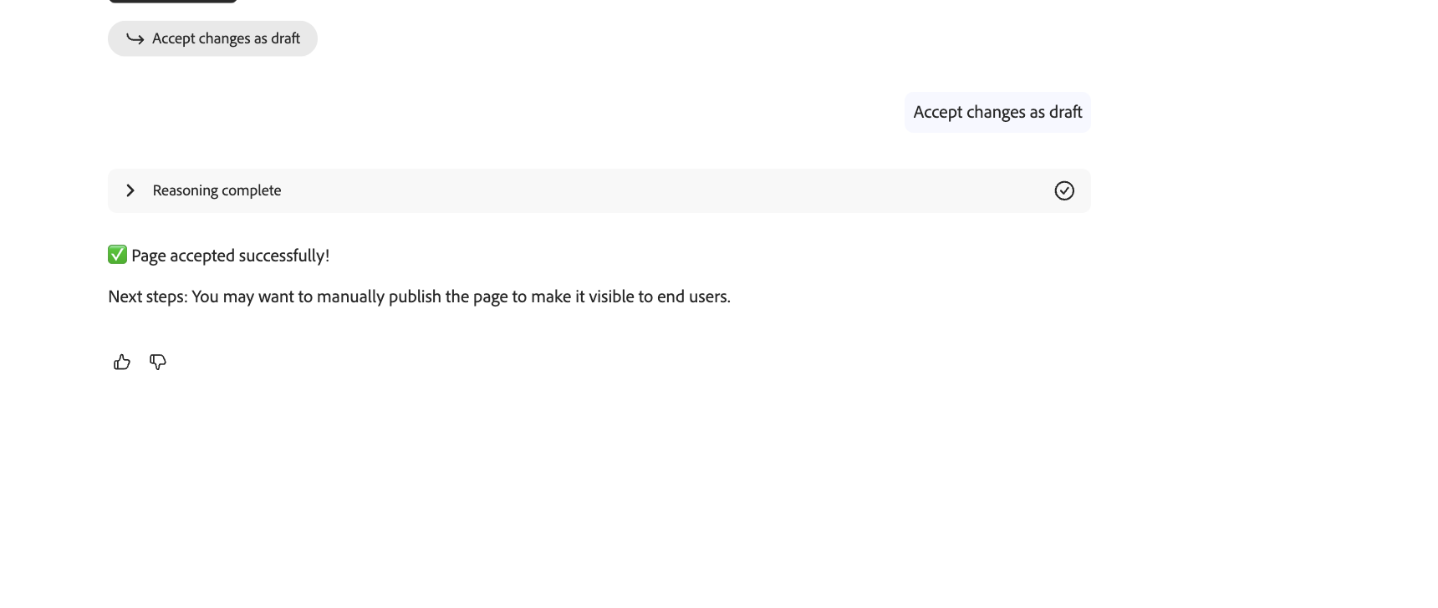
Accepting changes as draft
- Click Publish Page (or use Quick Publish from the Sites admin).
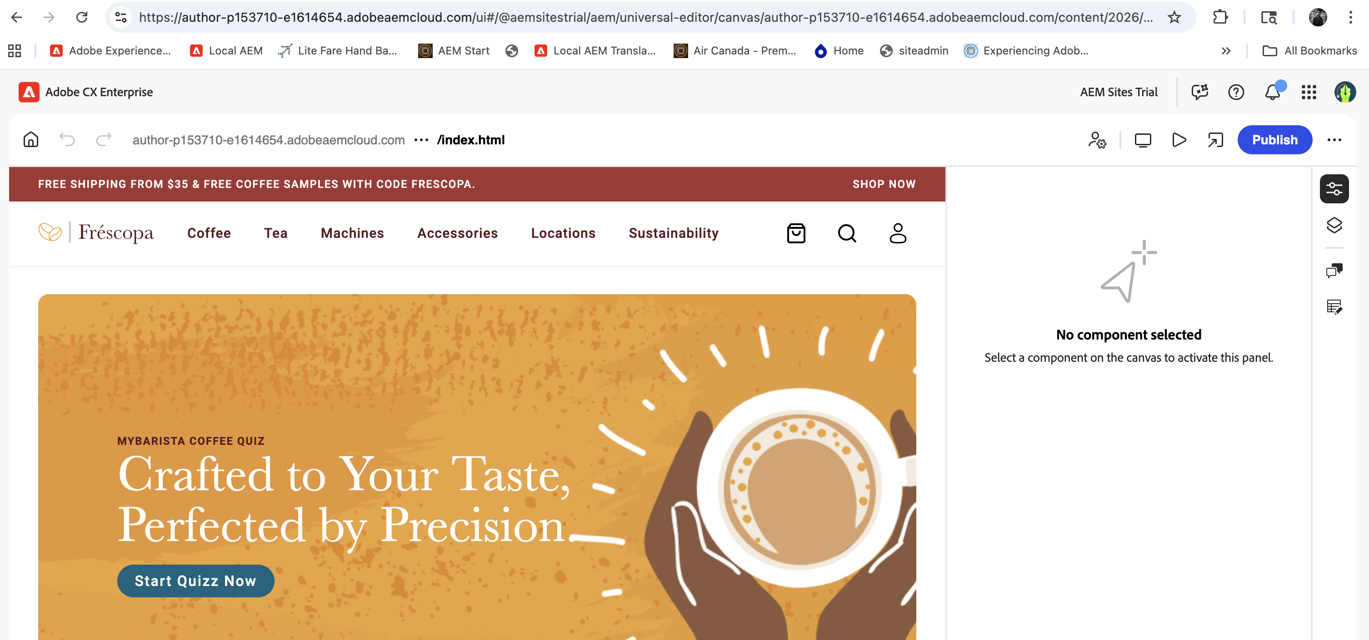
Publishing the updated page

Exercise 3 | Change a Webpage Using an Annotated Visual

Drive content updates by attaching an annotated PDF to the AI Assistant.

- In the GitHub lab folder https://github.com/guptapawan86/aem-nz-skill-up/lab-session, download 1-Update-FrescopaCoffeeSustainability-V1.pdf and review the annotated changes.
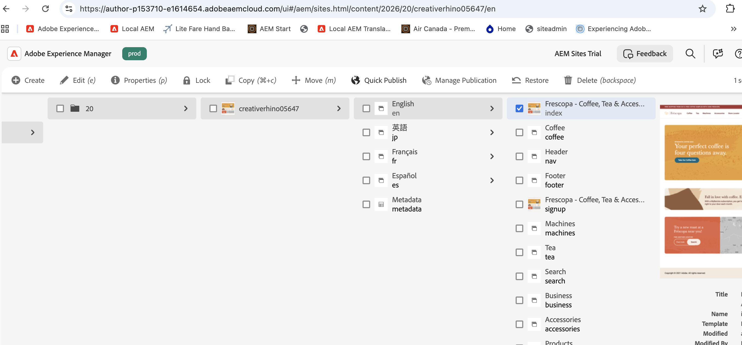
GitHub lab folder with exercise files
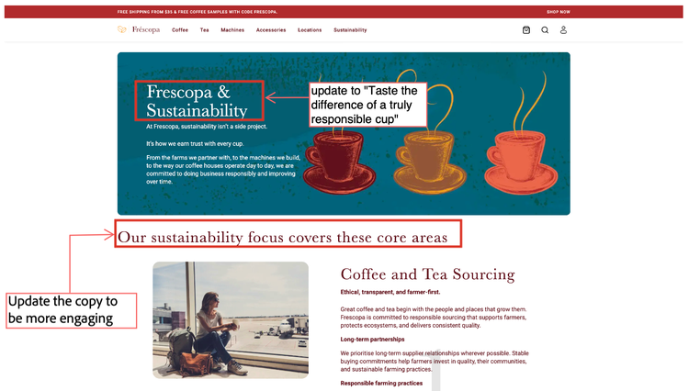
Annotated PDF showing required changes
- In AI Assistant, open conversation history and select New conversation in the top left.
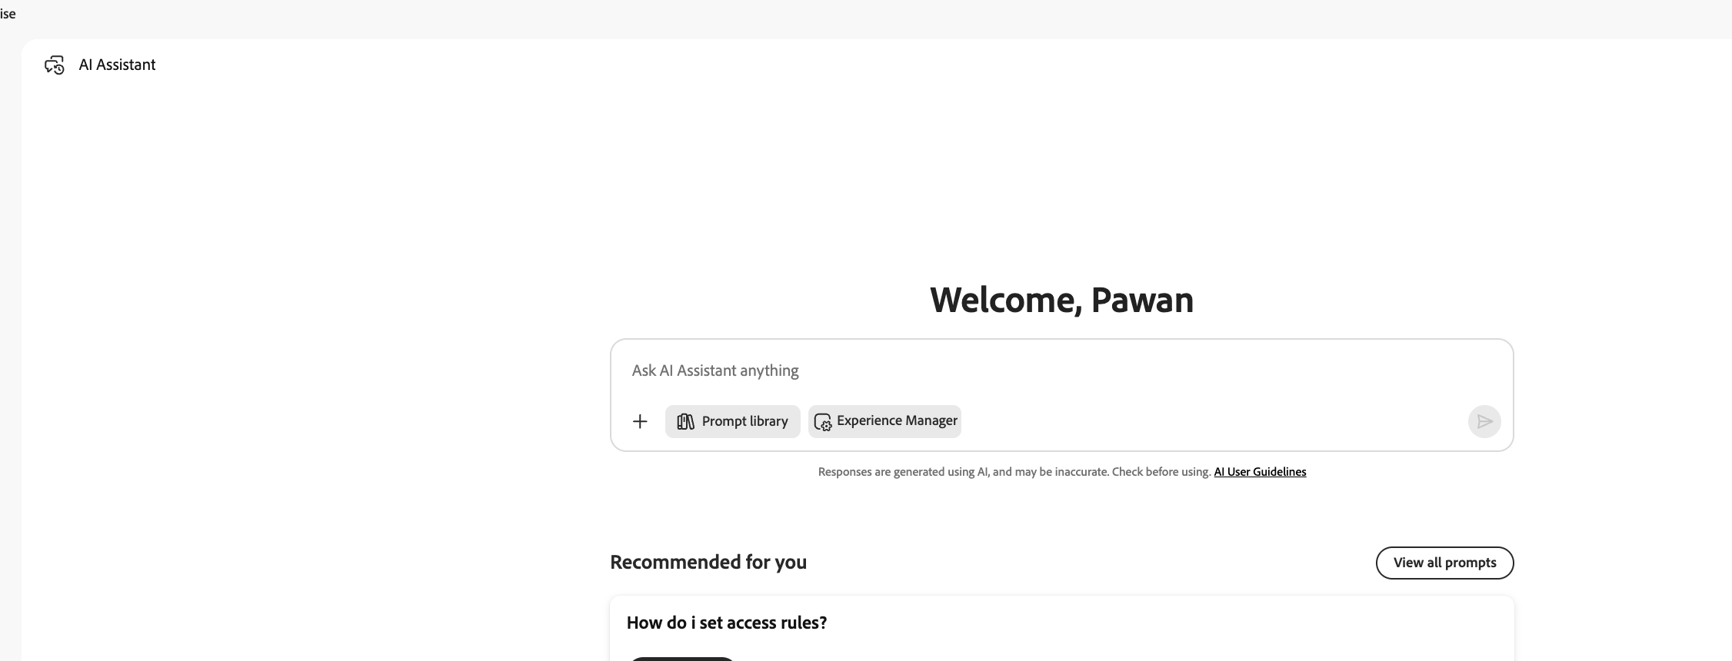
Starting a new conversation
- Minimize the history panel by clicking the icon next to All conversations.
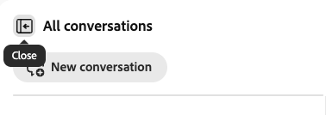
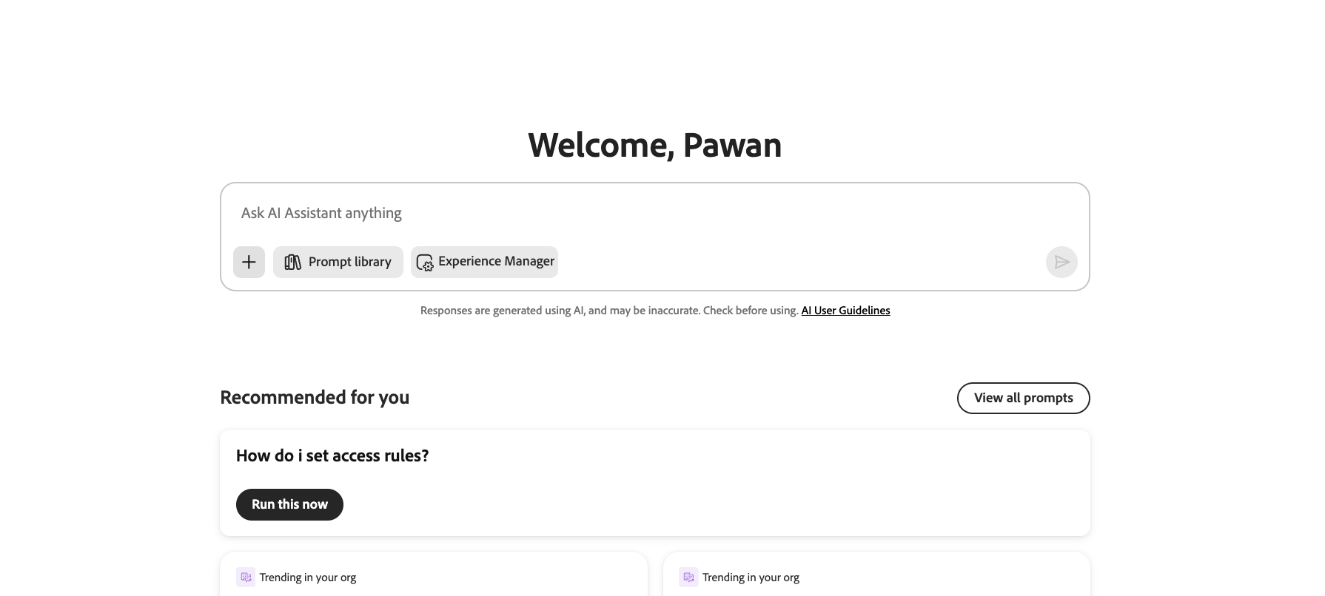
Minimizing the conversation history panel
- Click + in the lower left of the prompt bar, then select Attach files.
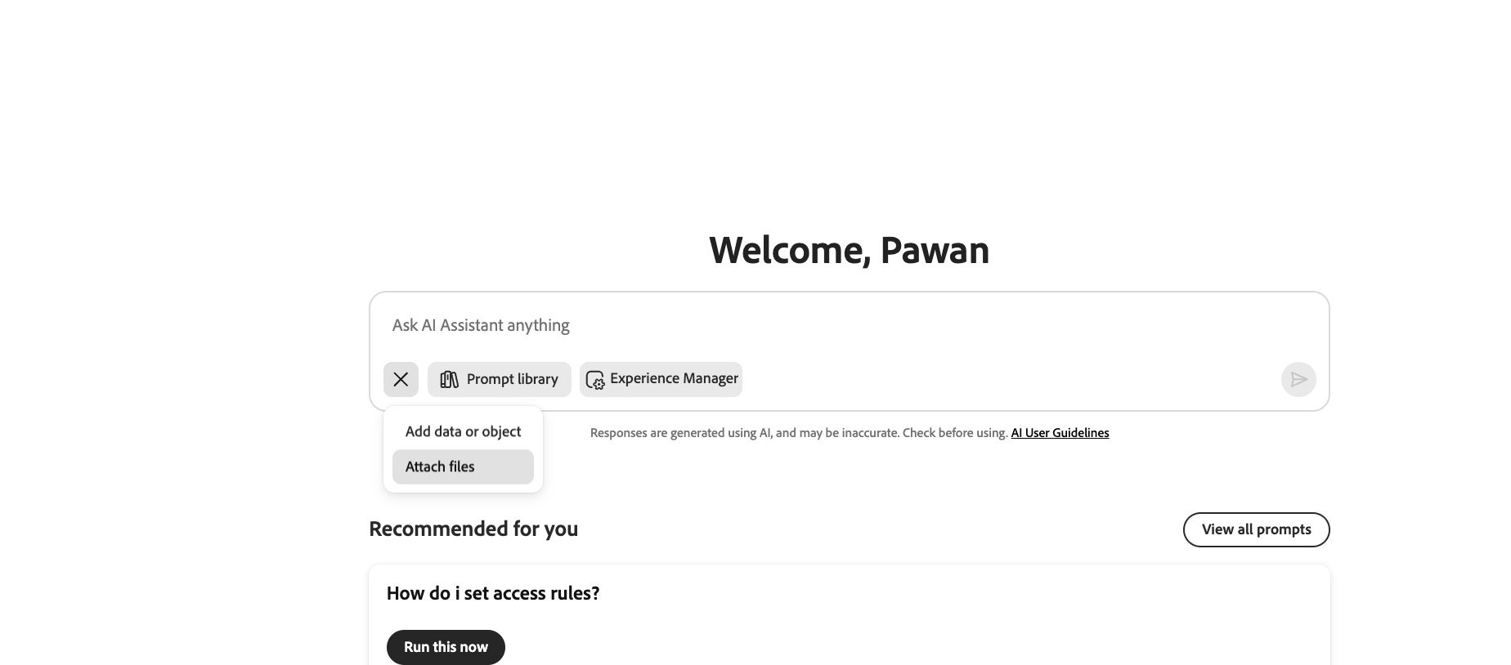
Attach files via the + button
- Attach the downloaded PDF via file browse or drag & drop.
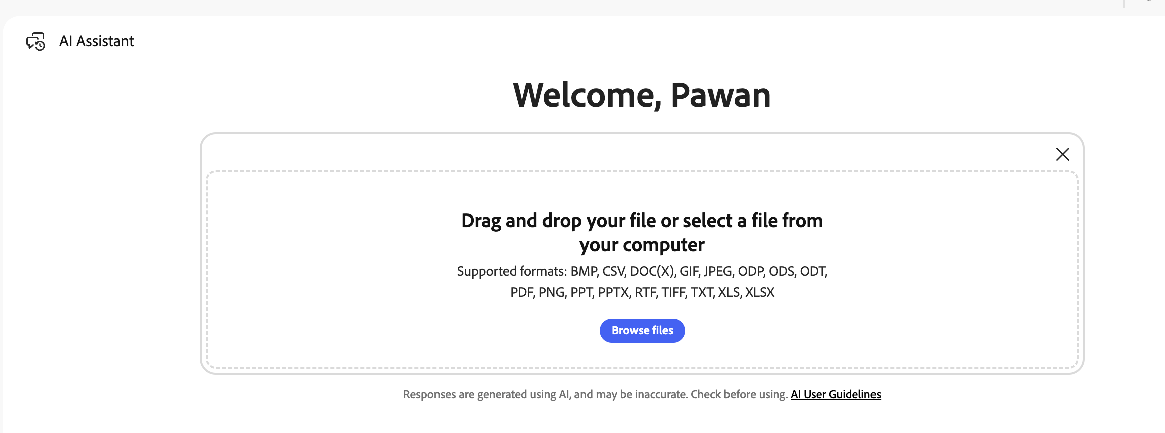
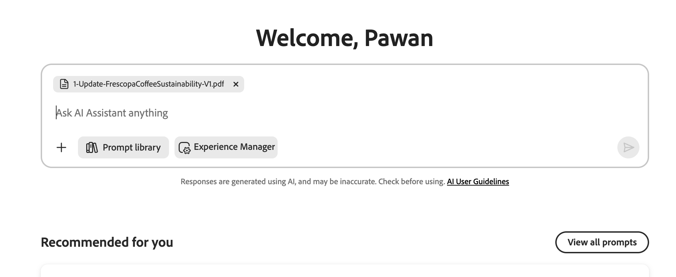
PDF attached to the prompt
- Enter the following prompt:

💬 Prompt
On https://main--{siteName}--aemsitestrial.aem.live/sustainability make changes based on the attached

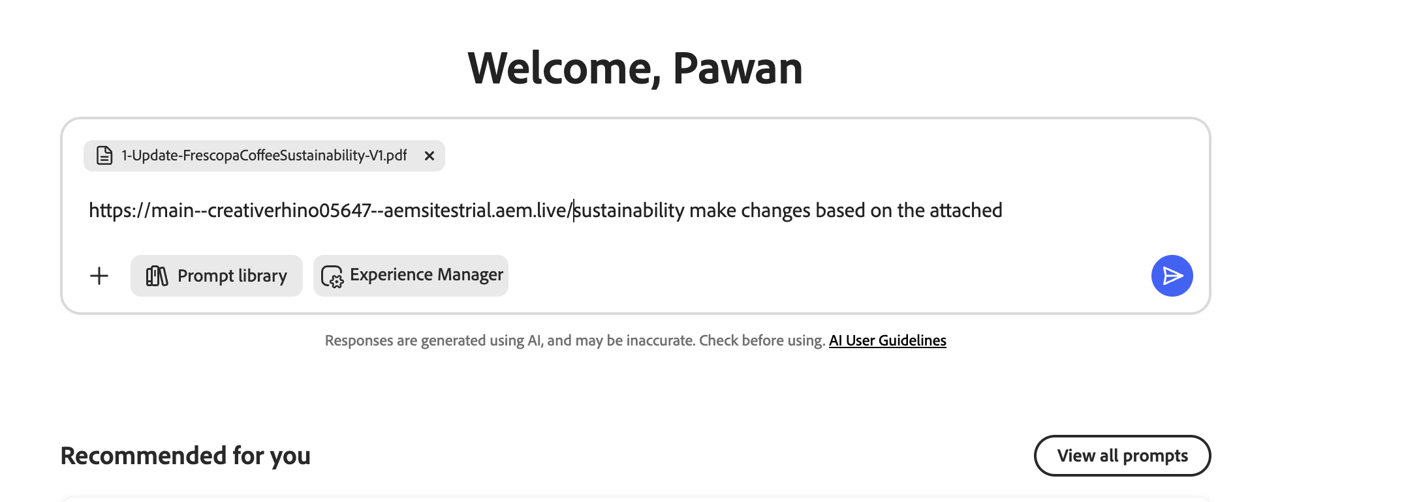
Submitting the prompt with the attached PDF
- Click the blue icon to submit. The agent will create a plan.
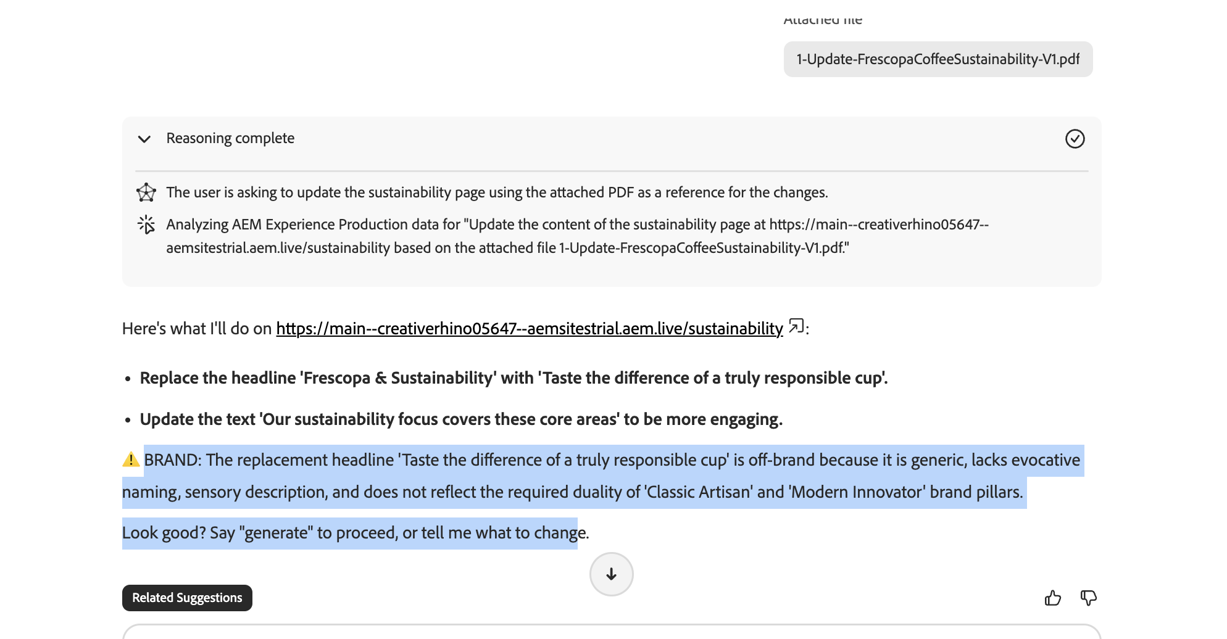
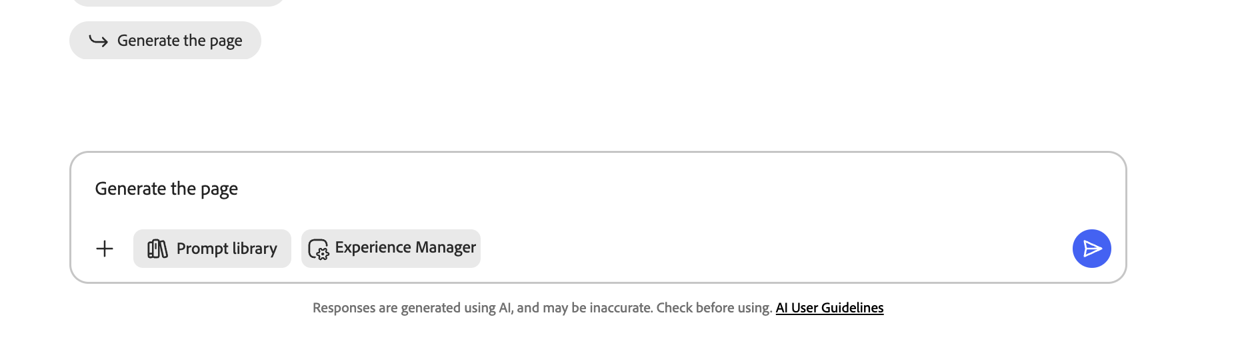
Agent creates and presents a plan based on the annotated PDF
- Review the plan, select Generate the page, and submit.
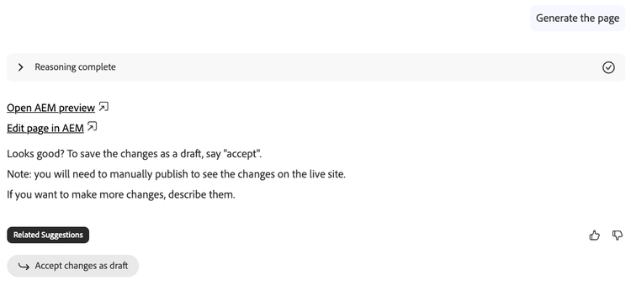
Generating the page
- Once done, select Preview Page to inspect the result.
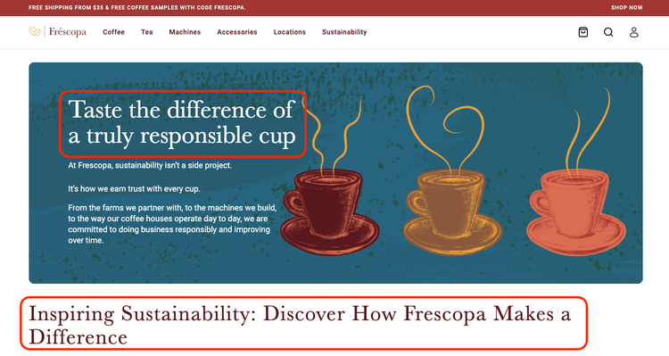
Previewing the updated page
- If satisfied, close the preview and select Accept changes as draft.
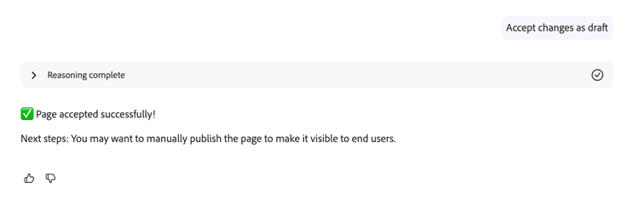
Accepting changes as a draft

✅ What You Achieved
✓ Updated a page using an annotated PDF
✓ Accepted the changes and updated the original page

Exercise 4 | Generate a New Page Based on a Brief and Template

Generate a brand-new web page by providing a content brief and selecting an AEM template.

- In the lab folder, download and review 3-FrescopaCoffee-AprilBlog.docx — the brief that guides the agent.
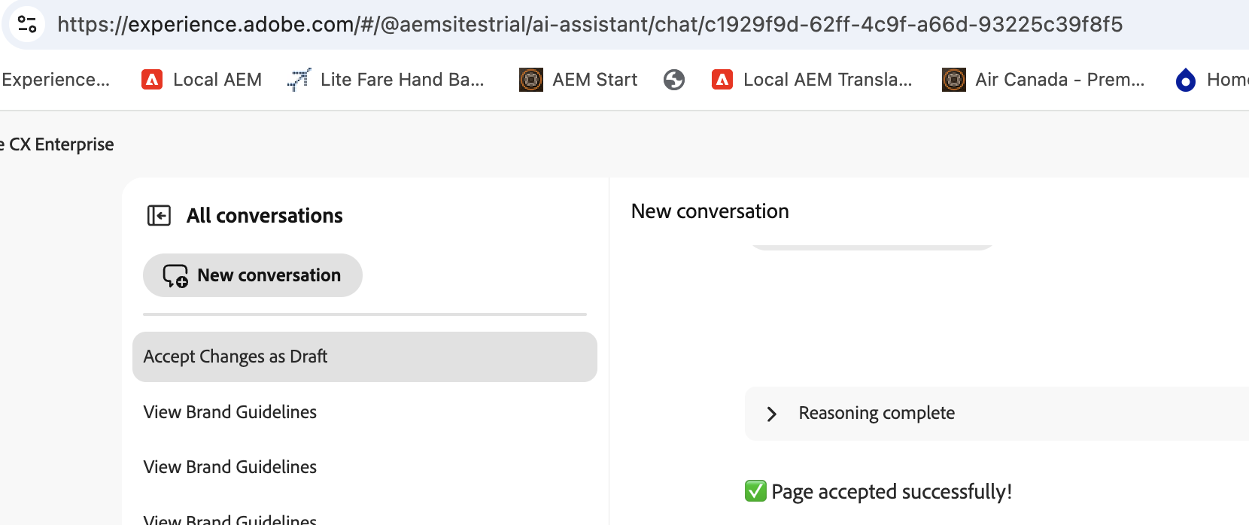
Content brief file: 3-FrescopaCoffee-AprilBlog.docx
📝 | The brief doesn't need a specific structure. Items that help agents produce high-quality output include: goals, audience, and topics.

- In AI Assistant, select New conversation.

Starting a new conversation
- Click + and attach 3-FrescopaCoffee-AprilBlog.docx.
- Enter the following prompt:

💬 Prompt
Create a new page based on the attached brief at https://main--{siteName}--aemsitestrial.aem.live/coffee-bean-types

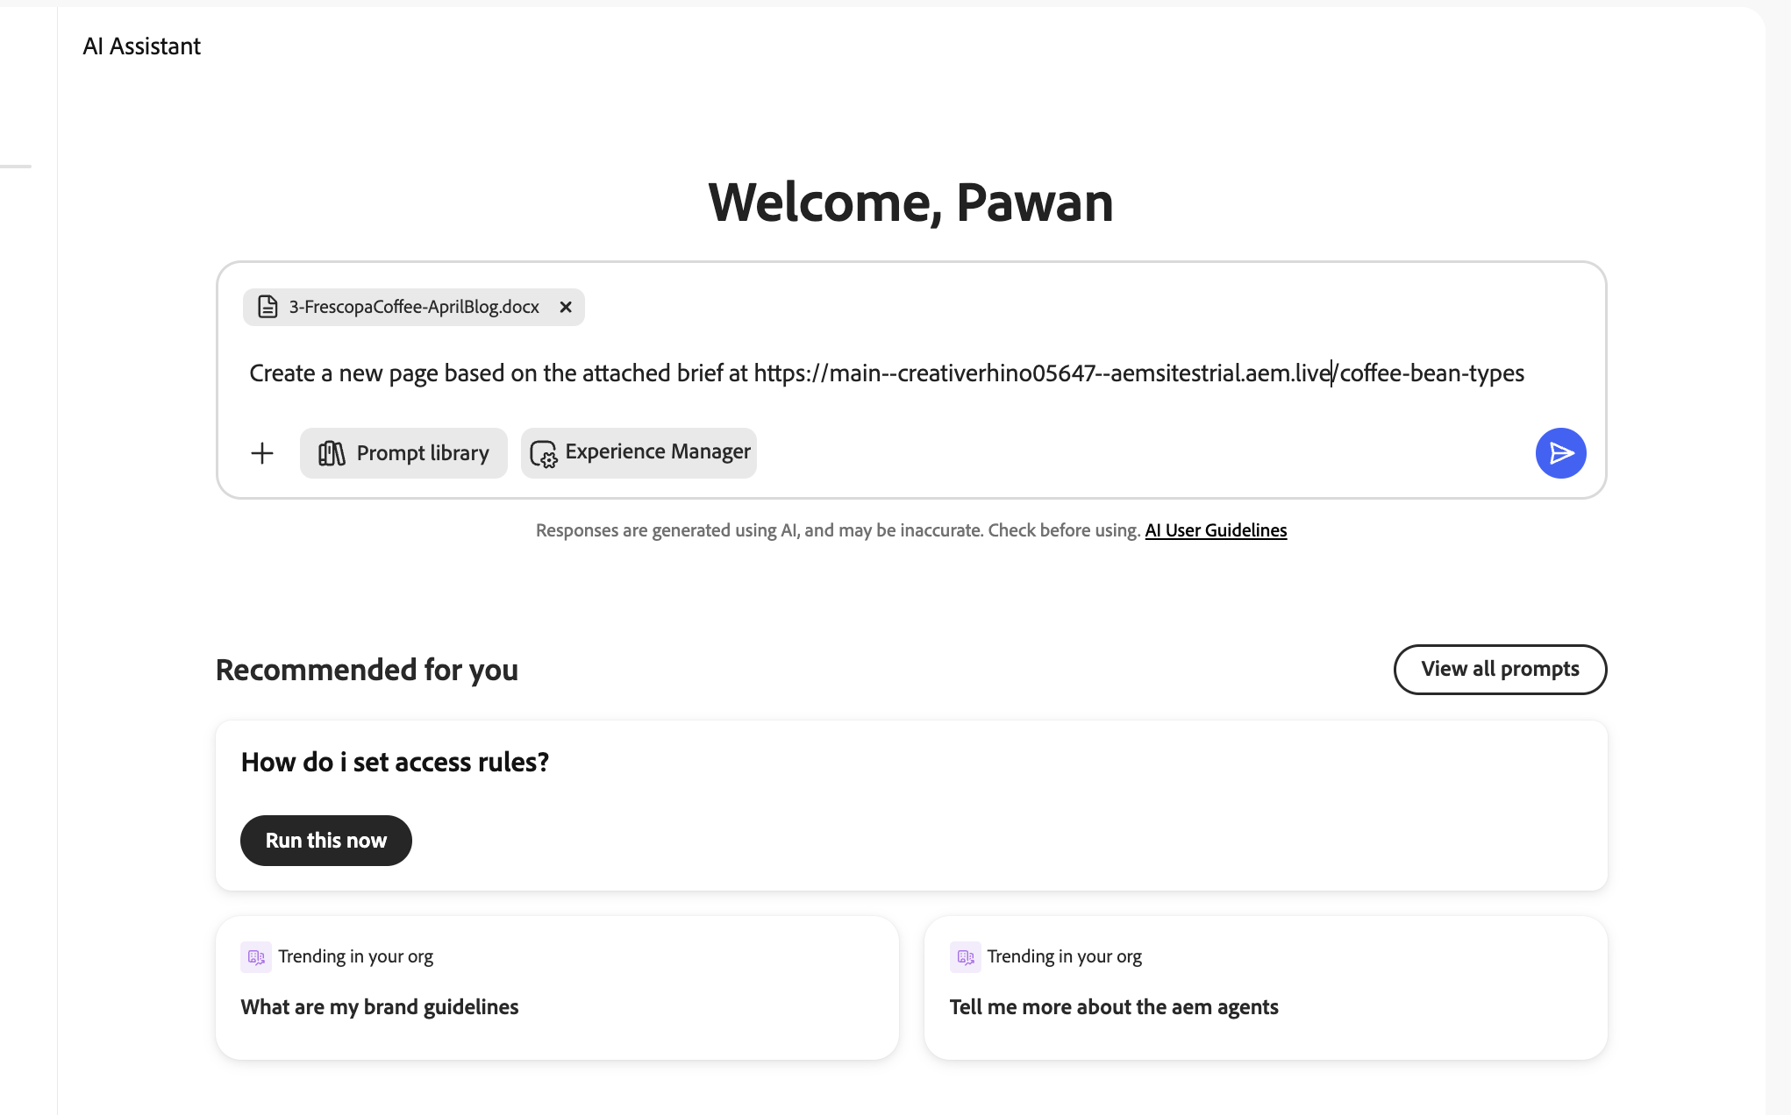
Entering the brief prompt with attachment
- When prompted to select a template, choose Blog – Step by Step, then submit.
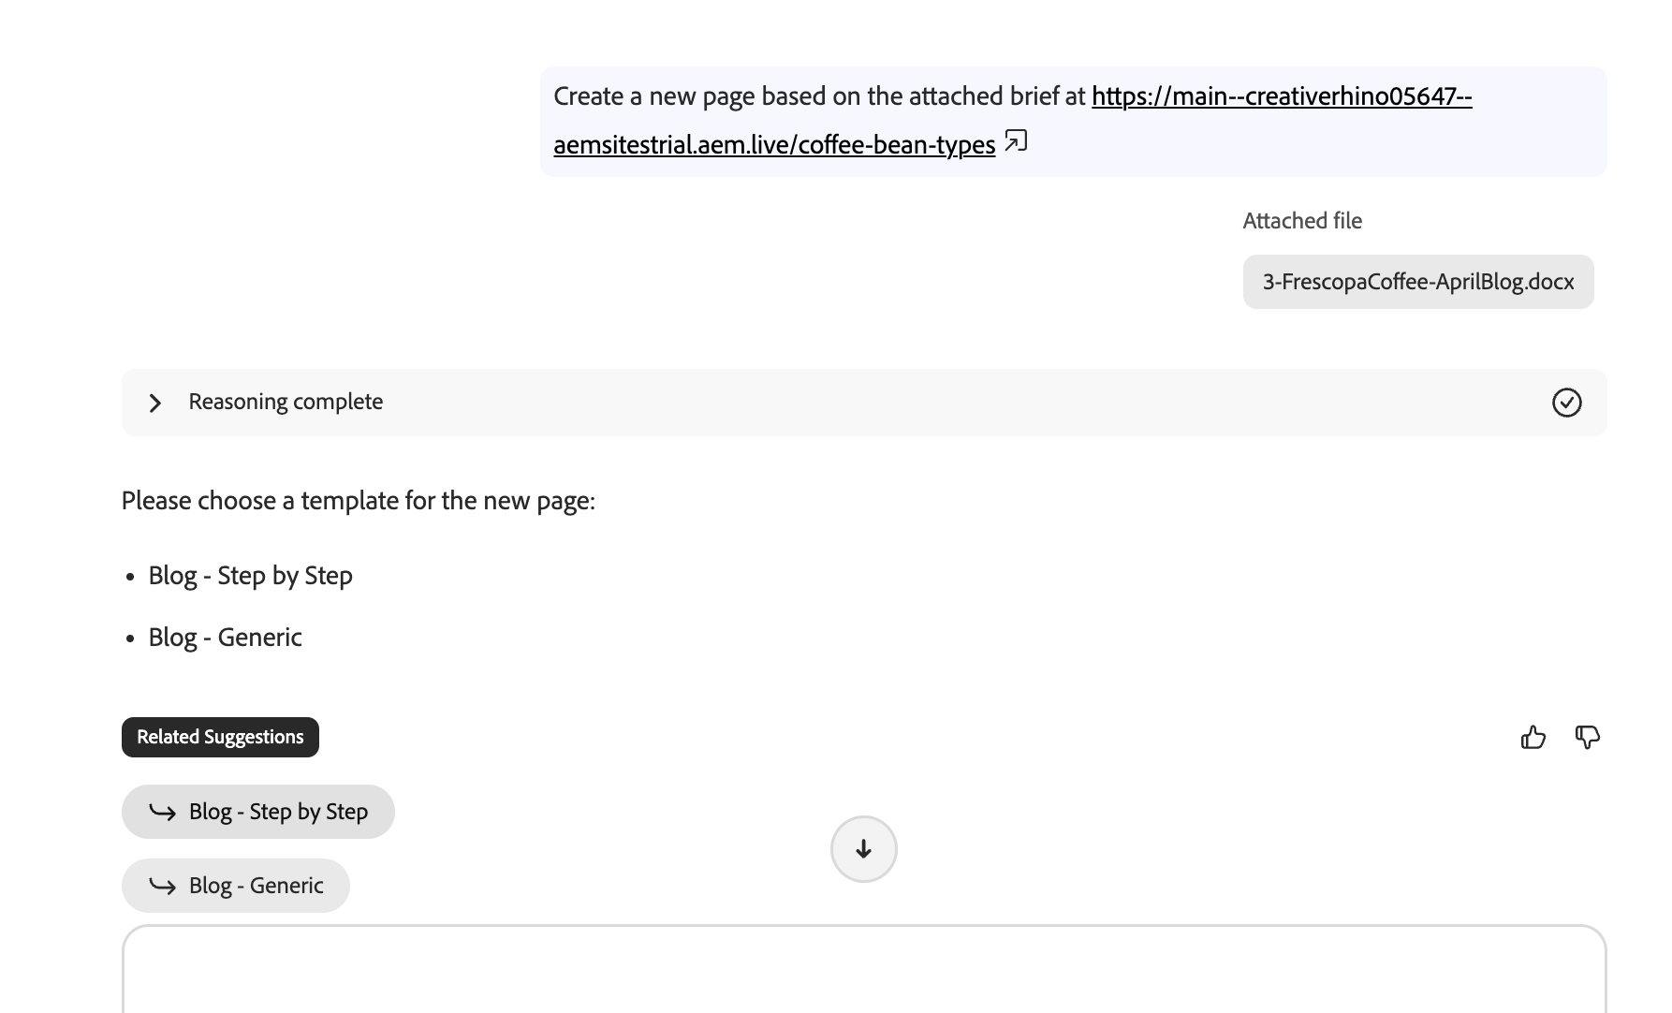
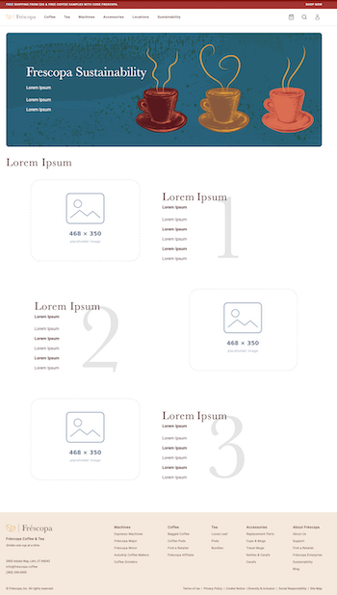
Selecting the Blog – Step by Step template
- Review the agent's plan and select Proceed, then submit.
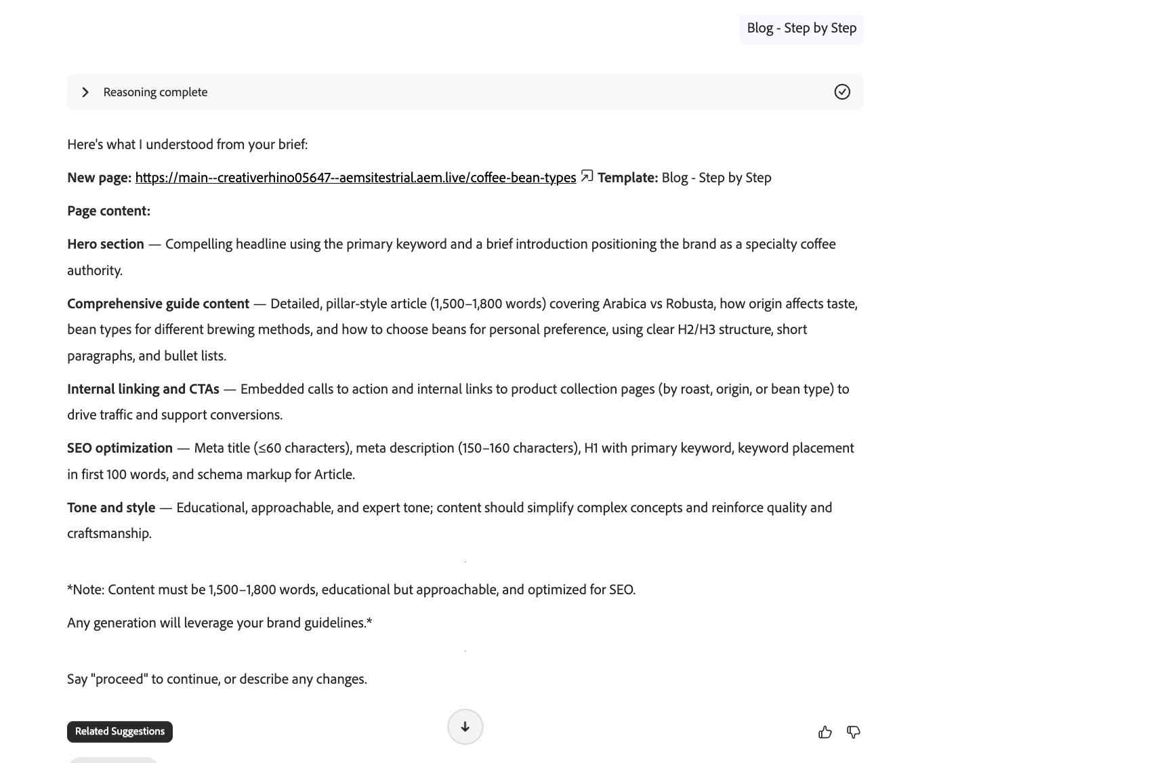
Agent conforming content to the selected template layout
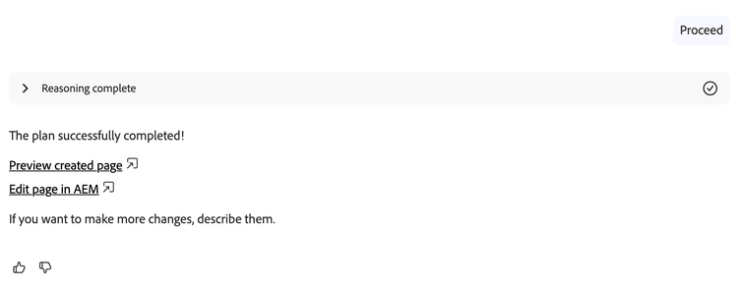
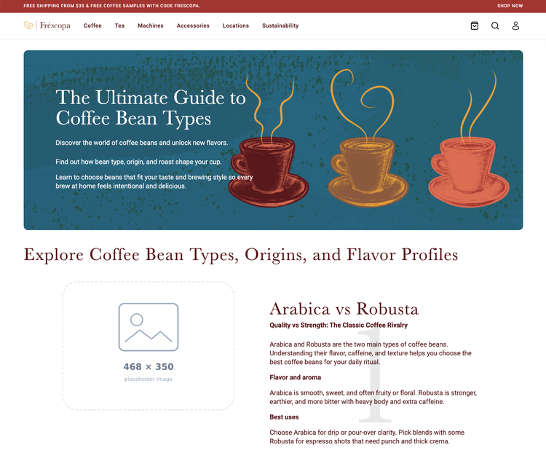
Generated page preview — content created from the brief

✅ What You Achieved
✓ Submitted a prompt and brief to generate a new web page
✓ Selected an AEM template to define the page layout
✓ Used brand guidelines to ensure brand compliance
✓ Viewed the newly generated page

Exercise 5 | Update Image Placeholders

Replace image placeholders on the page generated in Exercise 4 using the Discovery Agent.

- Select the first image placeholder on the generated page.
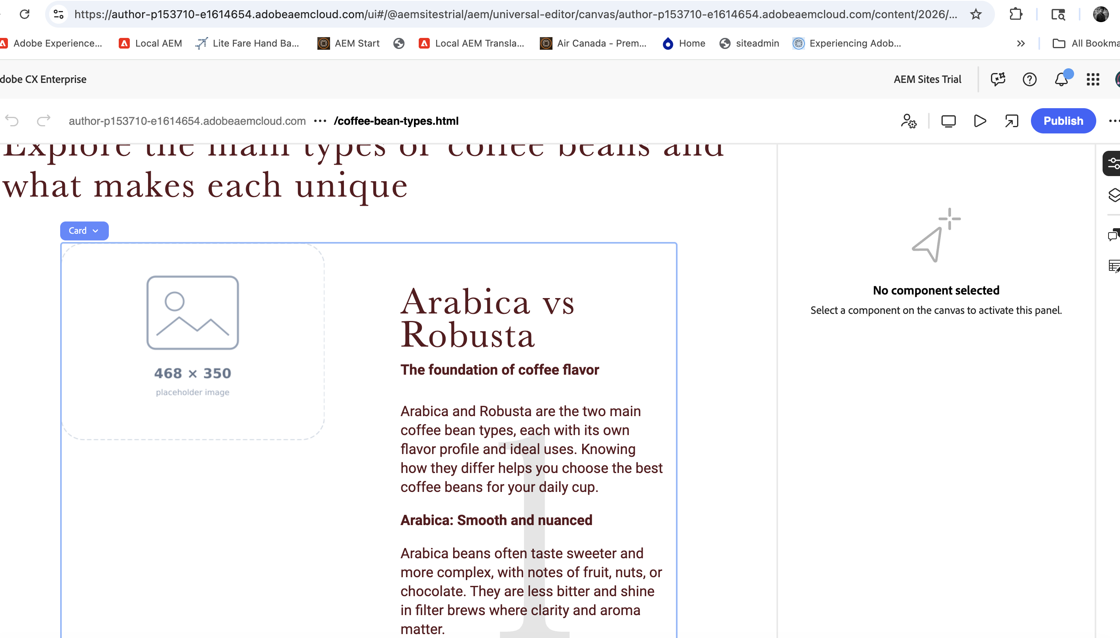
Image placeholder selected on the generated page
- Click AI Assistant at the top of the page.
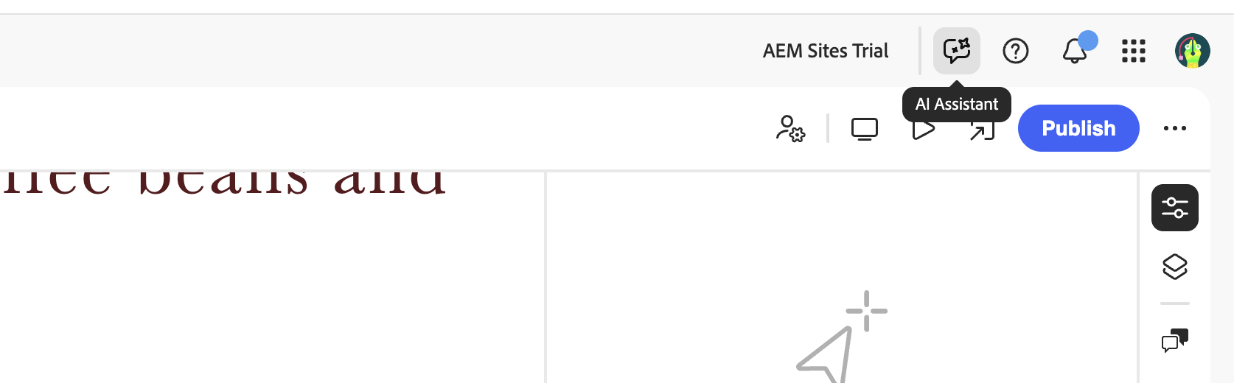
AI Assistant button at the top of Universal Editor
- Enter the following prompt:

💬 Prompt
Show me 5 approved assets with coffee beans and coffee cups

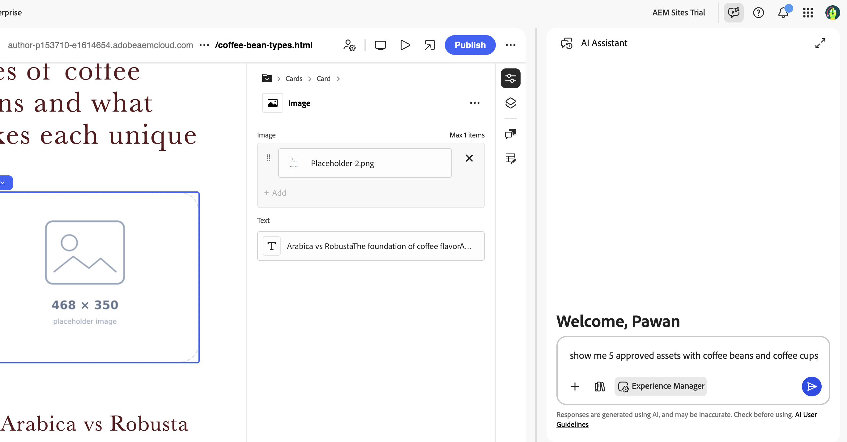
Discovery Agent uses semantic search to find matching assets
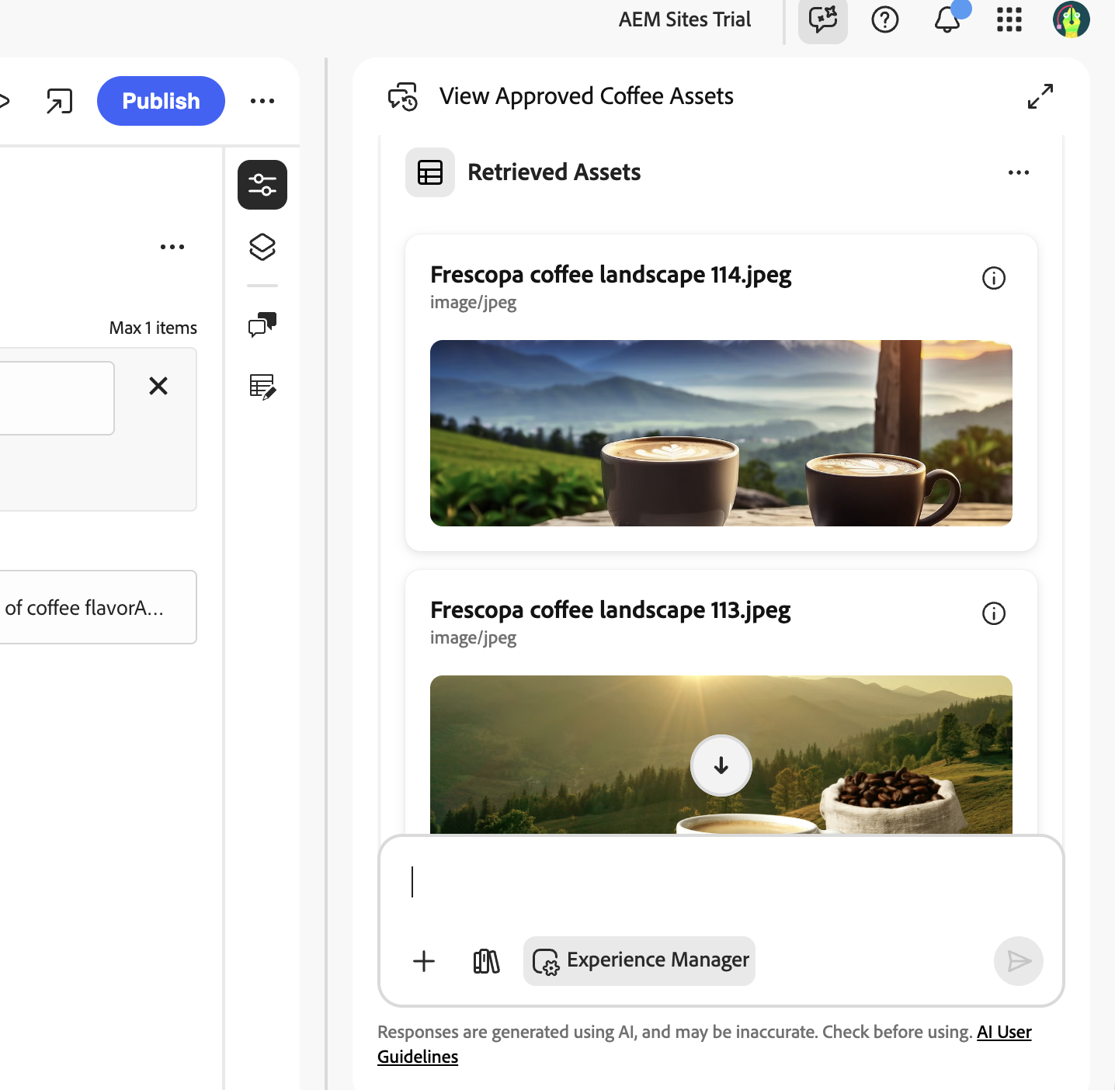
Asset results returned by the Discovery Agent
- Choose an image from the results and apply it:

💬 Prompt
Update with image 1

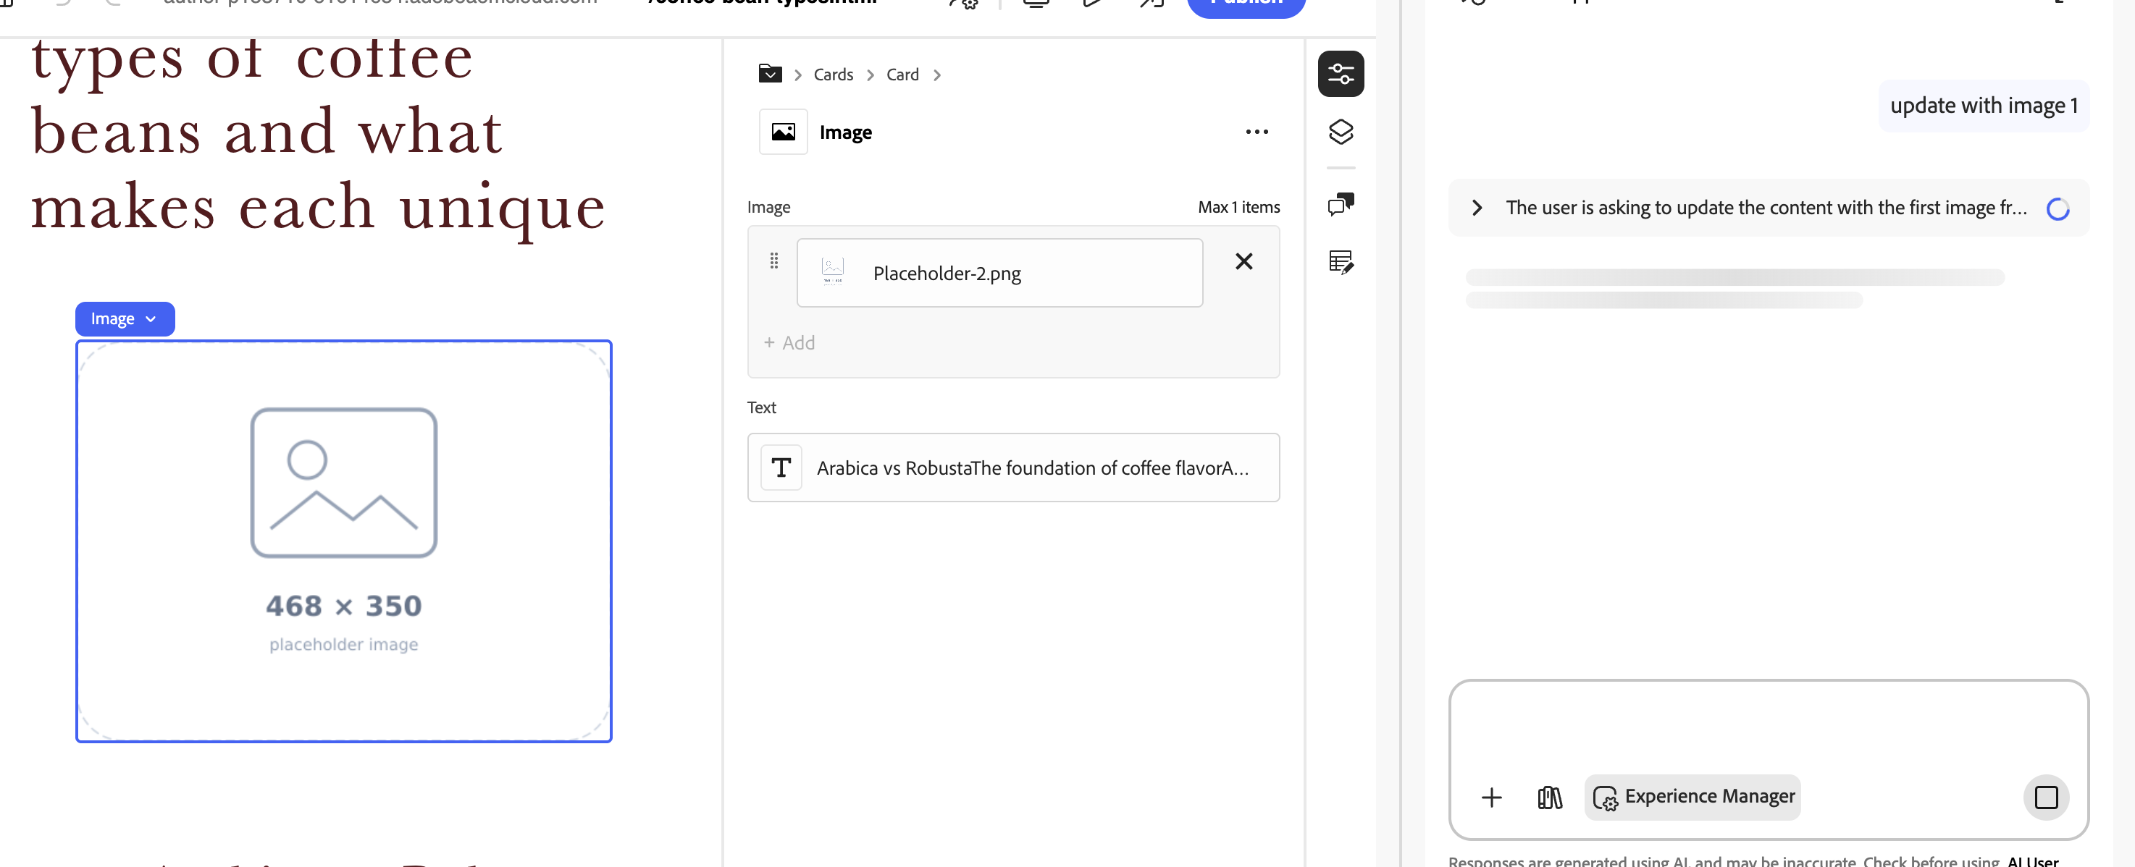
Selecting image 1 from the discovery results
- Select Apply Changes to see the update applied in real time.
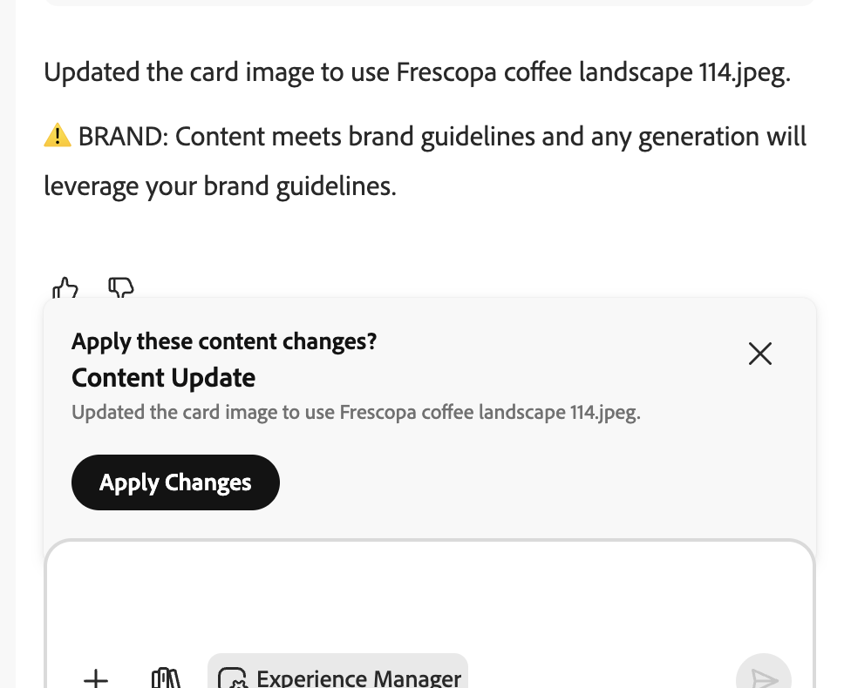
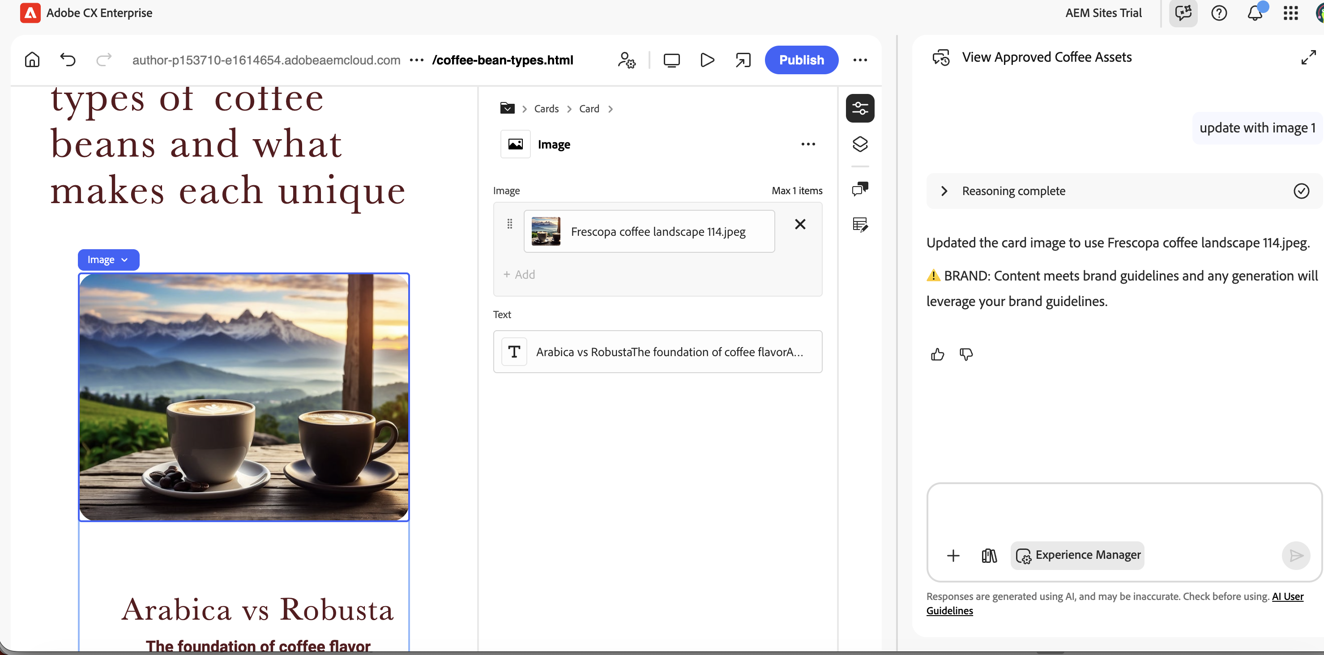
Image placeholder replaced with the selected on-brand asset
- Repeat for each remaining image placeholder.

✅ What You Achieved
✓ Updated copy using agents directly within Universal Editor
✓ Replaced image placeholders with on-brand assets using the Discovery Agent

Exercise 6 | Content Optimisation — Social Media Formats

Goal: Generate multiple social media renditions from a single asset using the AI Assistant.

- Run a discovery prompt to return at least three images from /content/dam/skillup-nz/.
- Identify an image you would like to use for a social media campaign.
- Prompt the agent to generate renditions for these formats:

Platform | Dimensions | Format
Instagram | 1080 × 1920 px | Portrait / Story
Facebook | 1200 × 630 px | Landscape
Twitter / X | 1200 × 675 px | Landscape

- Note how the agent is context-aware — you can say "the third image" without re-specifying the asset.
- Expand the Reasoning section to see the Agent Orchestrator switch to the Content Optimisation Agent.
- Review the smart crop links — these are live Dynamic Media URLs ready for use.

Sample prompts:
- "Generate Instagram 1080x1920, Facebook 1200x630, and Twitter 1200x675 formats for the second image"
- "Create social media crops for my jane-doe-hero asset"

Exercise 7 | AI Content Visibility Chrome Extension

Install the AI Content Visibility Checker extension to analyze your website's AI discoverability.

- Install the Chrome extension:
- AI Content Visibility Checker
- Open your Fréscopa site and activate the extension.
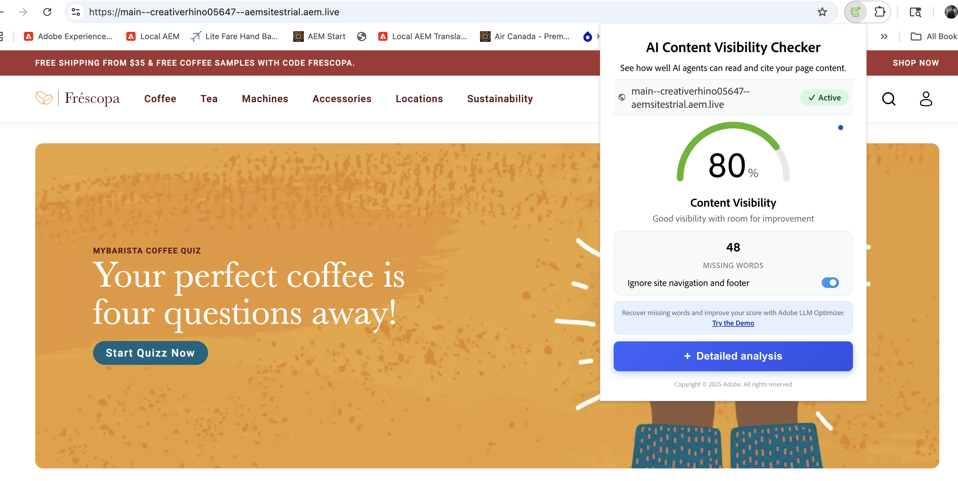
AI Content Visibility Checker showing 80% content visibility score

Exercise 8 | Check Brand Visibility with LLMO

Use the LLMO tool to check how visible your brand is to AI language models.

- Log in to one of the LLMO portals:
- https://play.llmo.now/
- https://llmo.now/
- Search for your domain to check your brand's current AI visibility and discoverability.
📝 | Your domain must already be onboarded for visibility data to appear.

Adobe Experience Manager · Hands-On Lab Guide · Confidential

