EDS Exercise Activity

Objective:
This activity will help you:
1. Evaluate the performance of an AEM Edge Delivery Services (EDS) website using Google Lighthouse.
2. Create and customize a personal brand/profile page in AEM under the given hierarchy and edit it in Universal Editor by adding custom blocks.

Part 1 – Website Performance Evaluation
Website Information:
- The website is built using Edge Delivery Services with Universal Editor-based authoring.
- URL: https://main--aem-skill-up--guptapawan86.aem.live/
You can choose either Option 1 (Web Tool) or Option 2 (Chrome DevTools) to run Lighthouse tests.
Option 1 – Using Page Speed Insights
- Open PageSpeed Insights.
- Enter the site URL: https://main--aem-skill-up--guptapawan86.aem.live/
- Run the analysis for Desktop.
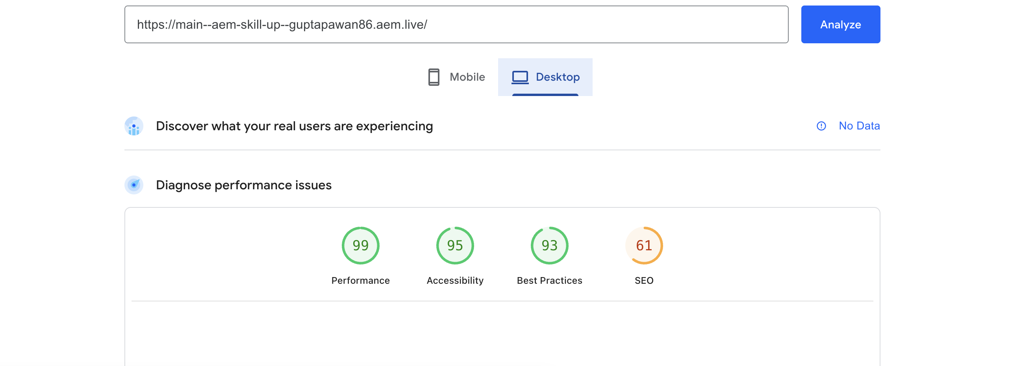
Option 2 – Using Chrome DevTools
- Open Google Chrome.
- Navigate to the website URL https://main--aem-skill-up--guptapawan86.aem.live/
- Open Chrome DevTools: Press F12 or Right-click → Inspect.
- Go to the Lighthouse tab.
- Configure the report:
- Mode: Desktop (as required)
- Categories: Performance (uncheck others for now)
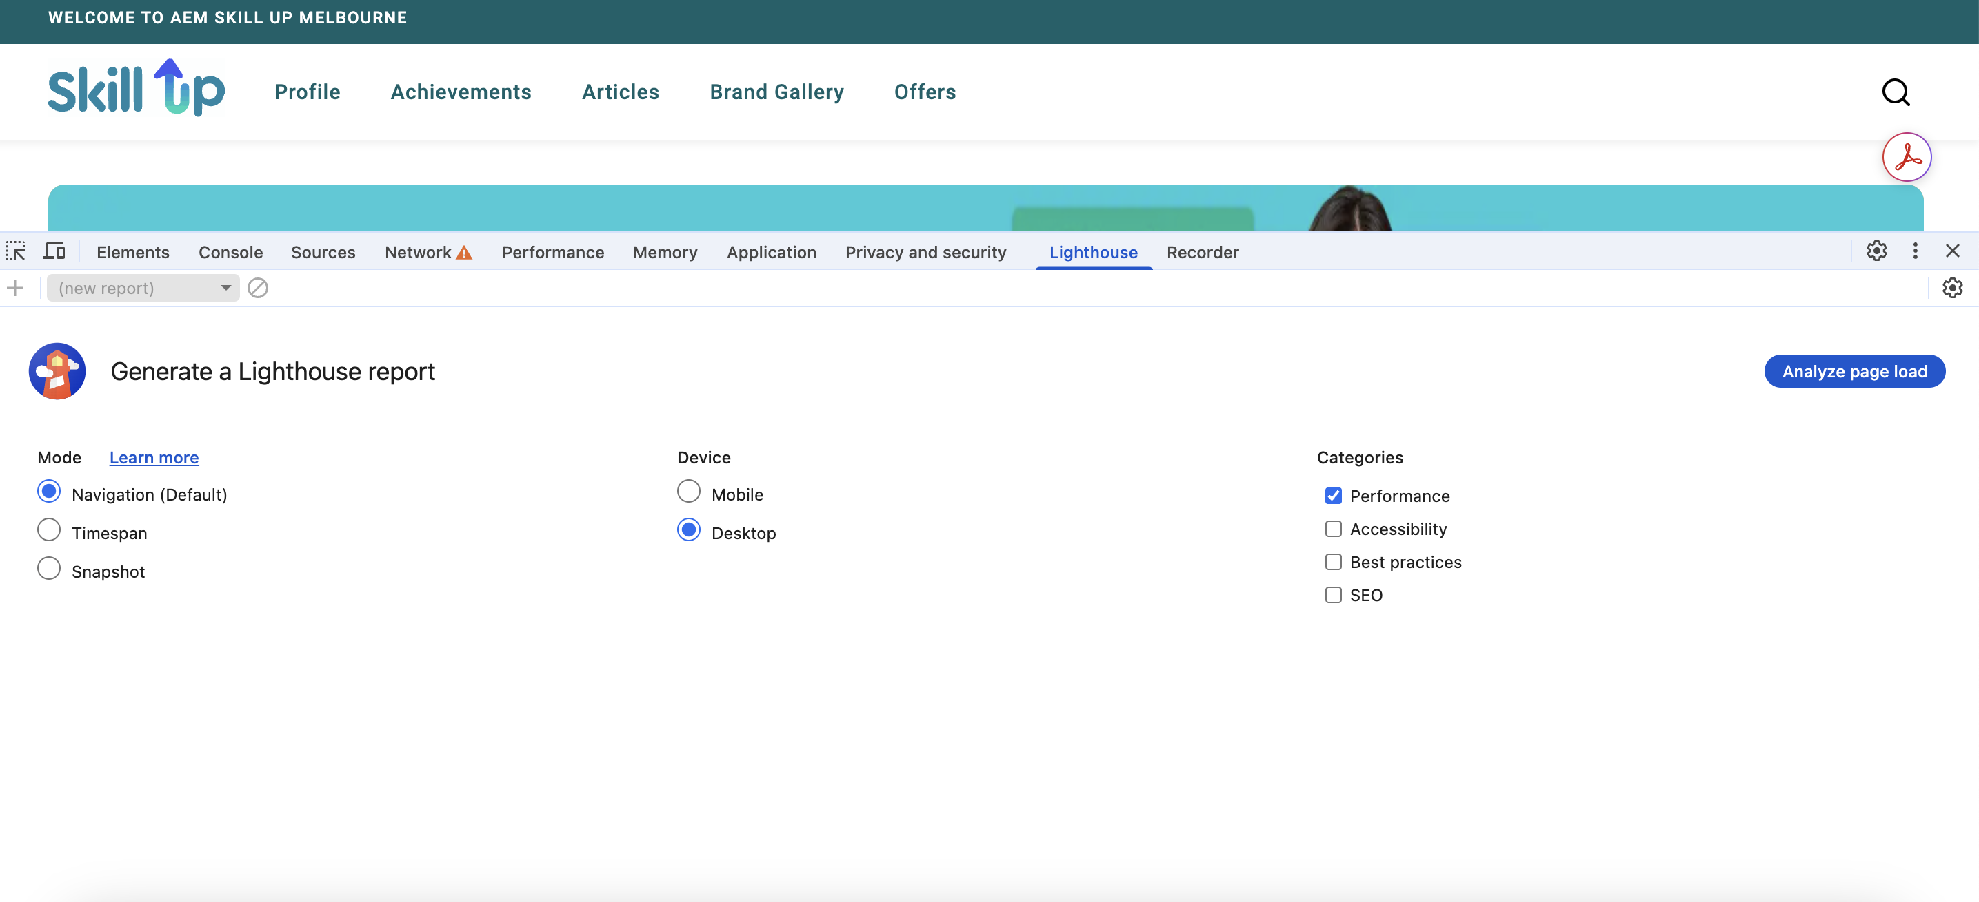
- Click Analyze page load to generate the Lighthouse report.
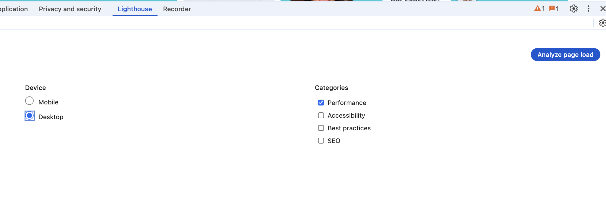
- Review the Performance score and key metrics:
- Largest Contentful Paint (LCP)
- First Input Delay (FID)
- Cumulative Layout Shift (CLS)

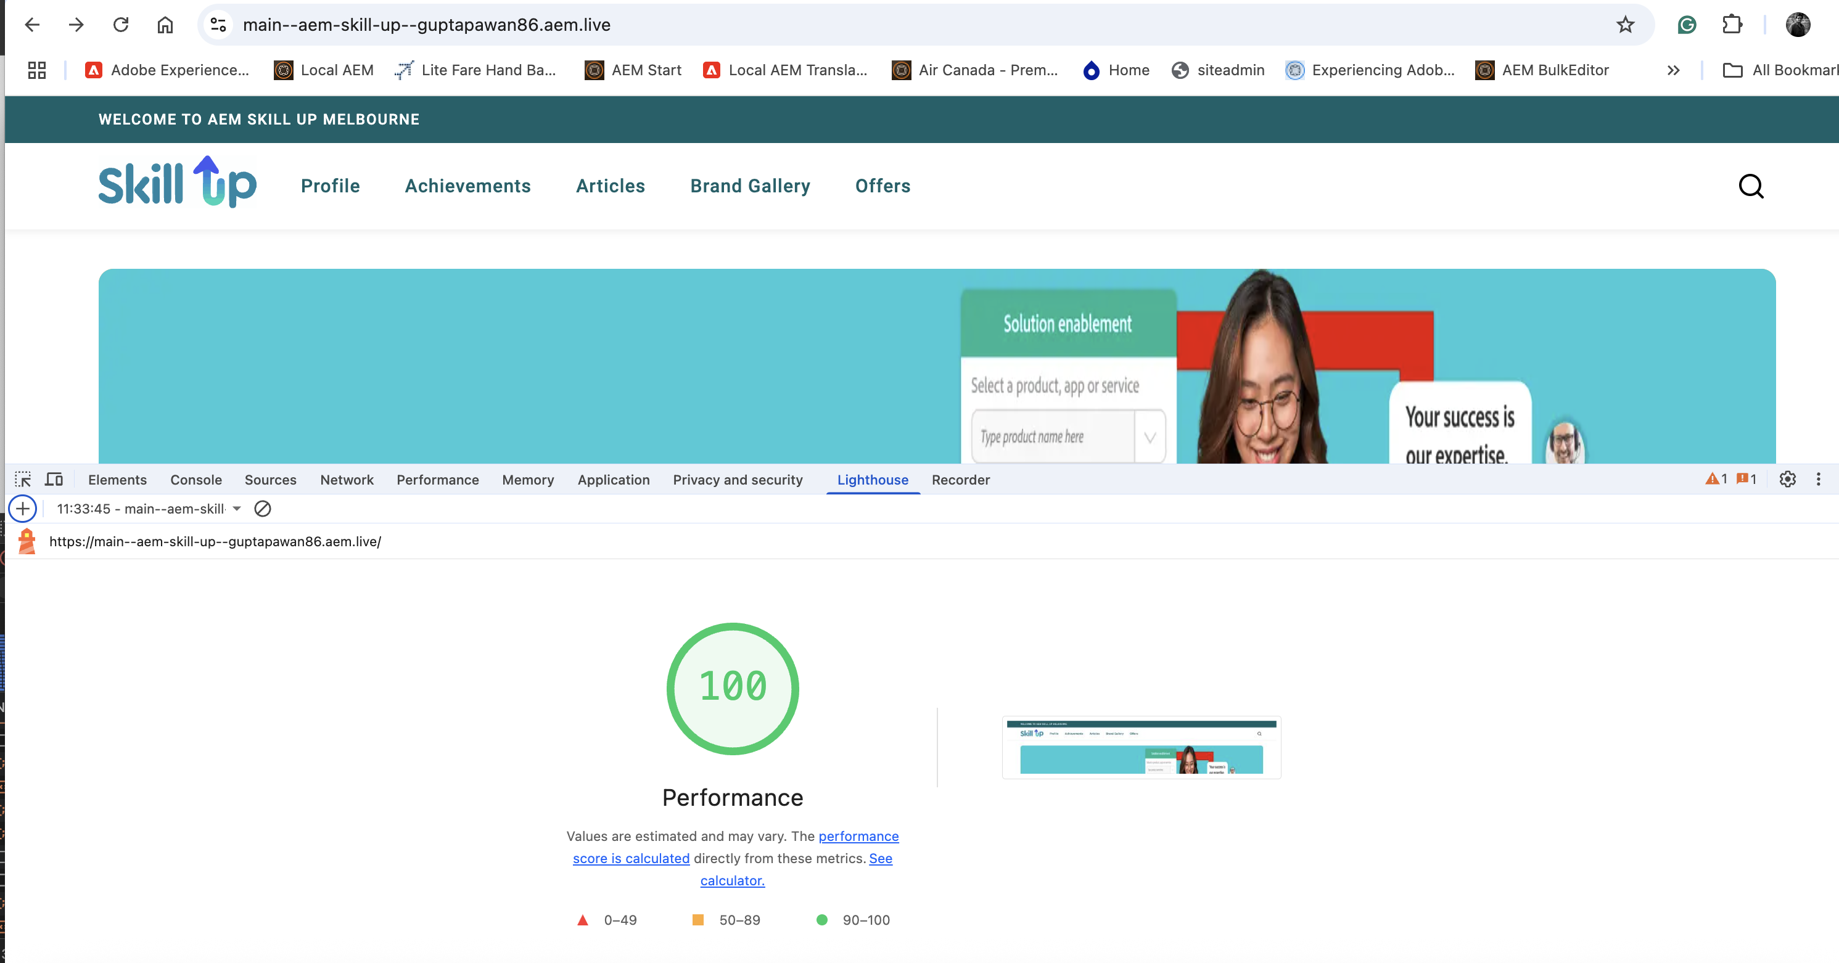

Part 2 – Create and Edit a Personal Brand/Profile Page in AEM
1. Login to AEM Author: AEM Author Instance
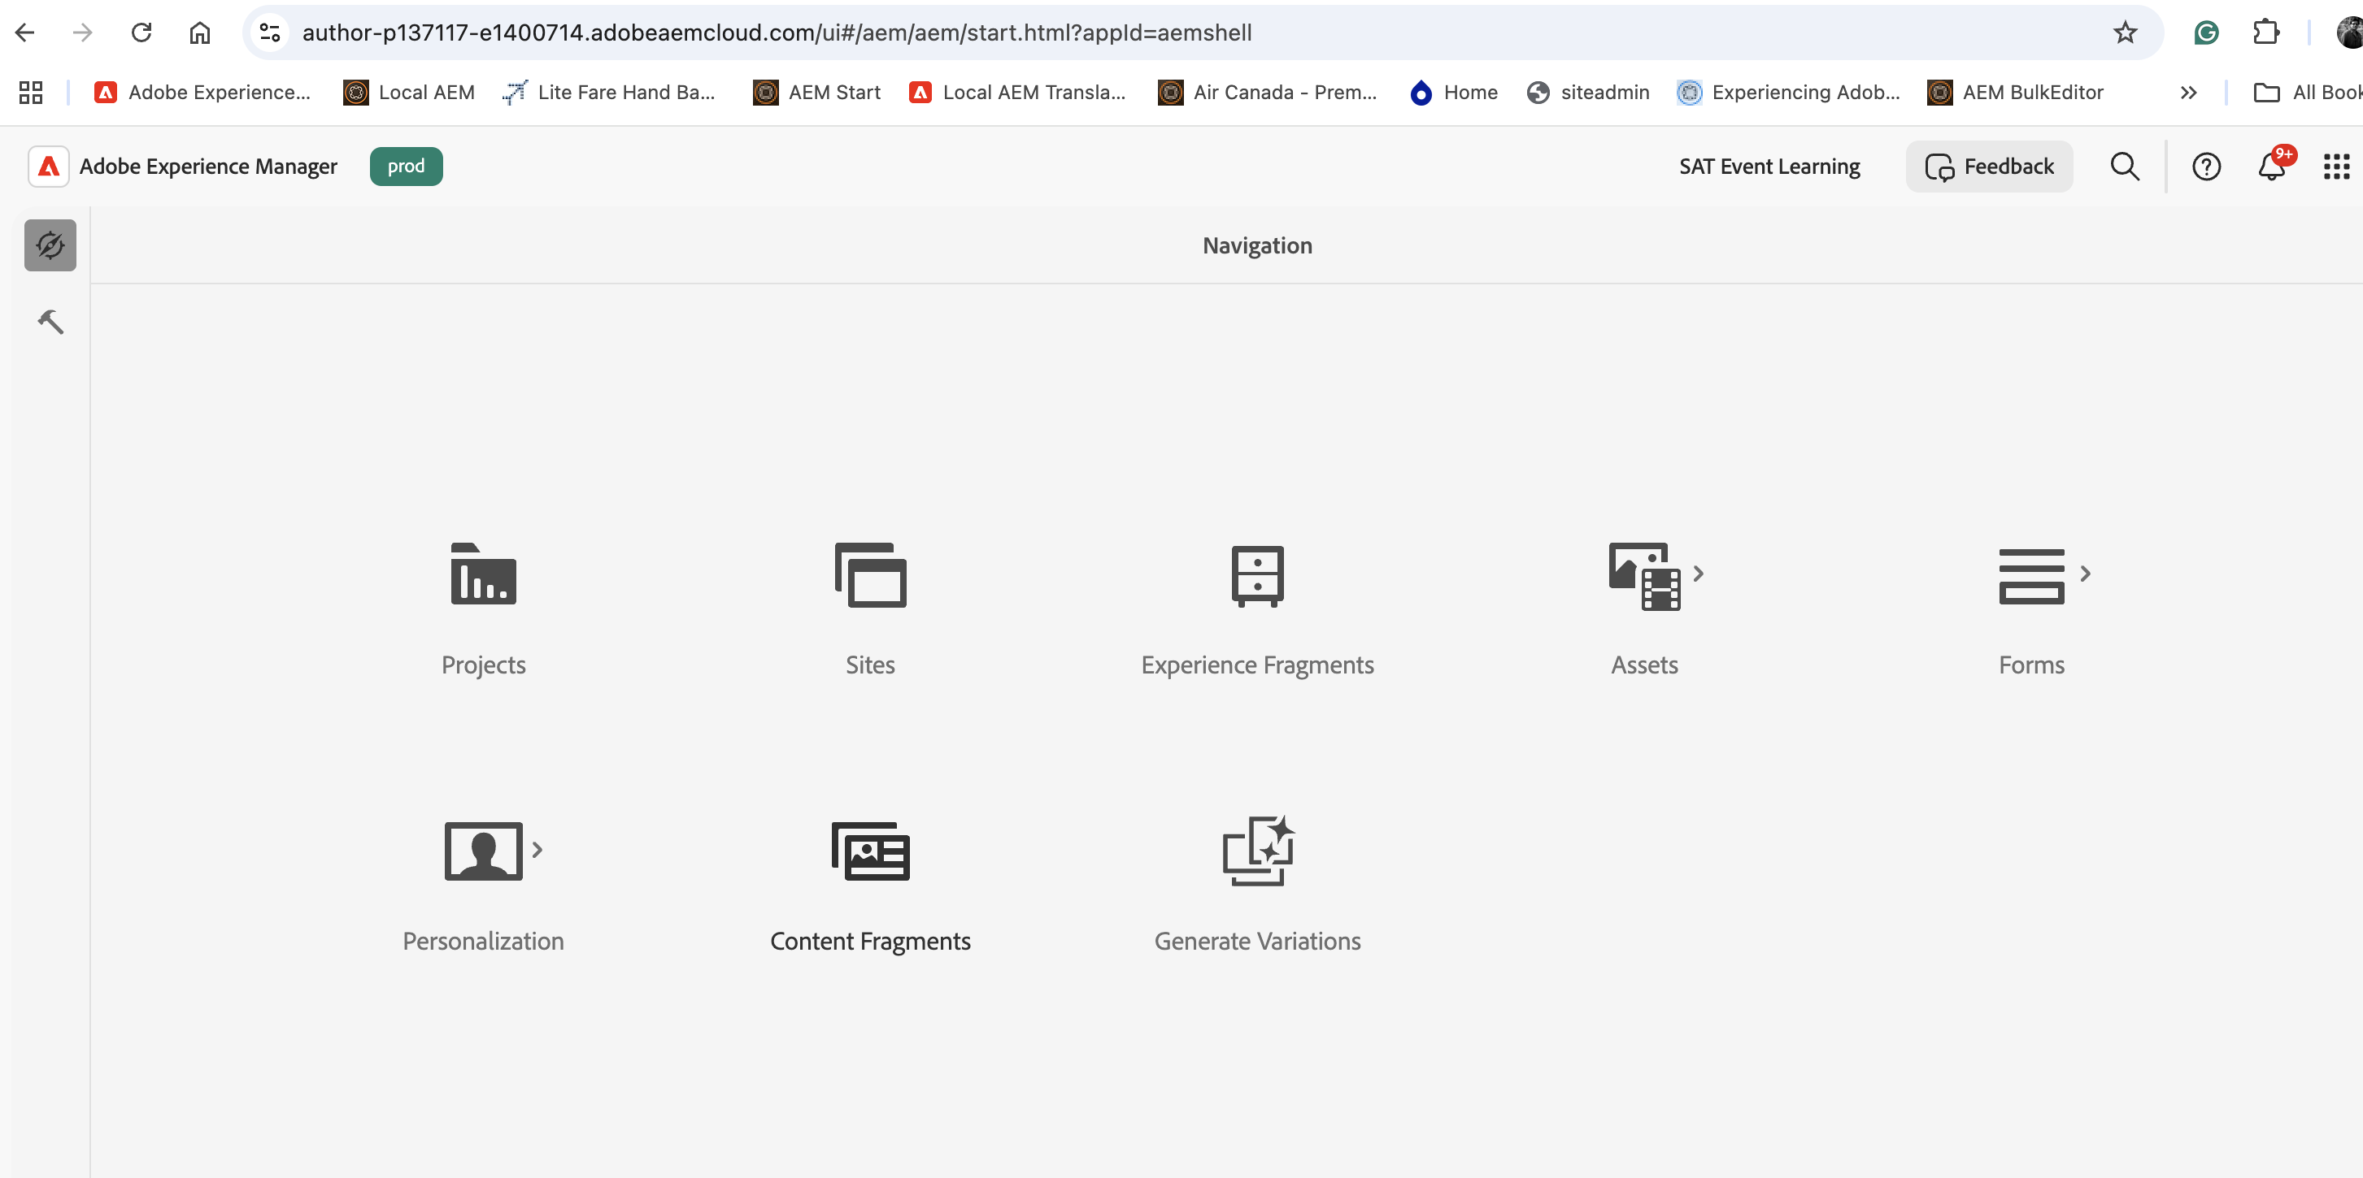
2. Go to Sites → Path:
/content/aem-skill-up/en/brand-gallery or use this link.
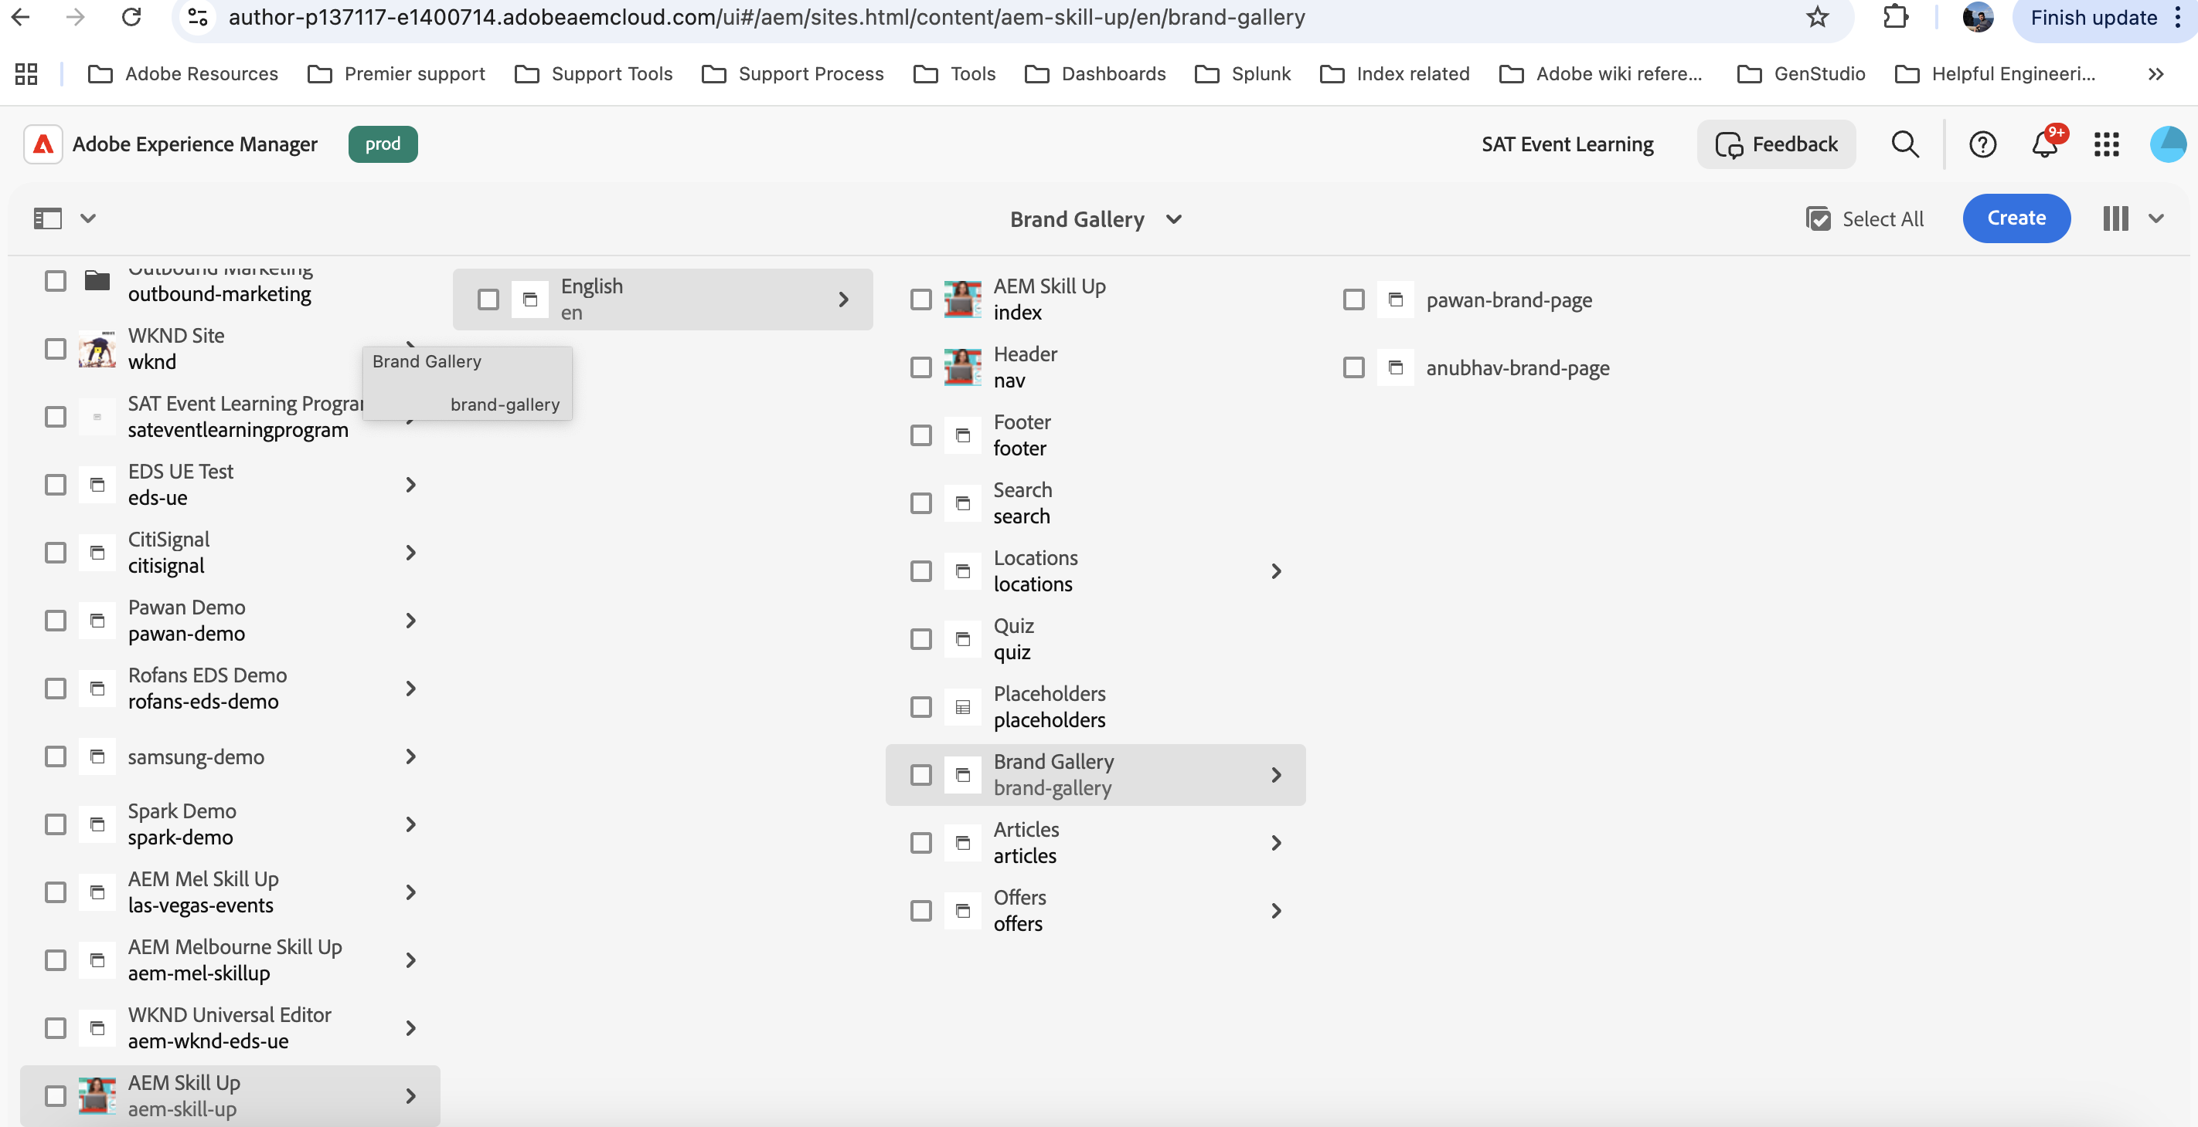
3. Locate the page Sample Profile.
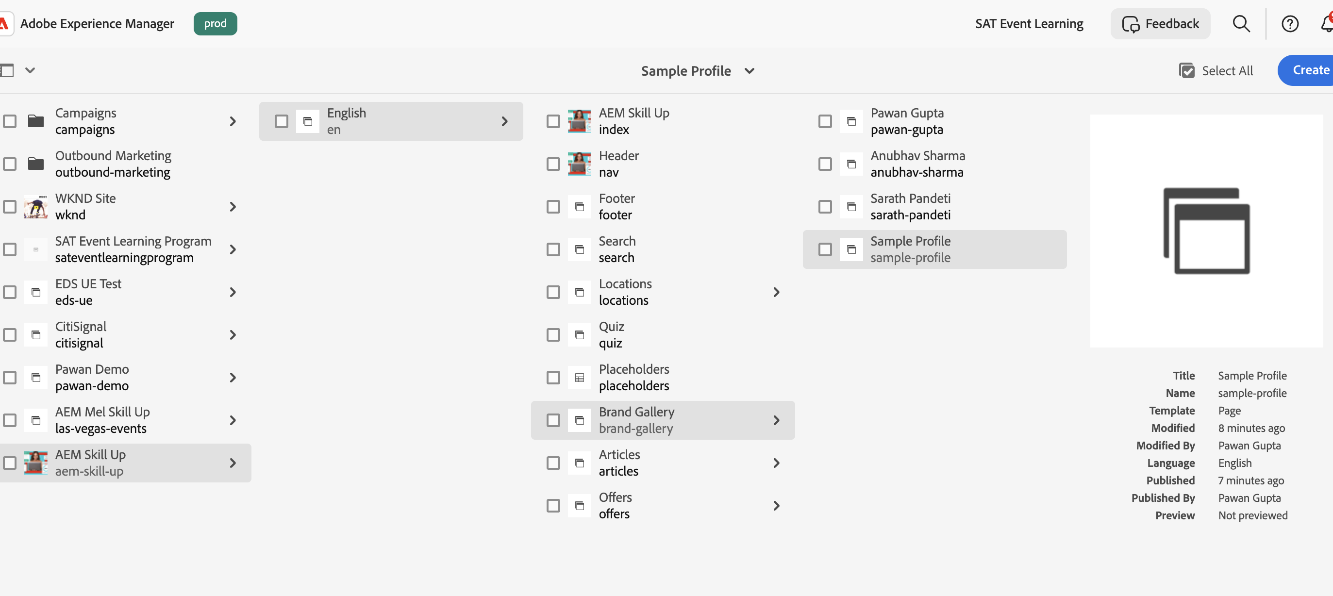

4. Select the page → Click Copy [use the copy option from the tool bar properties]

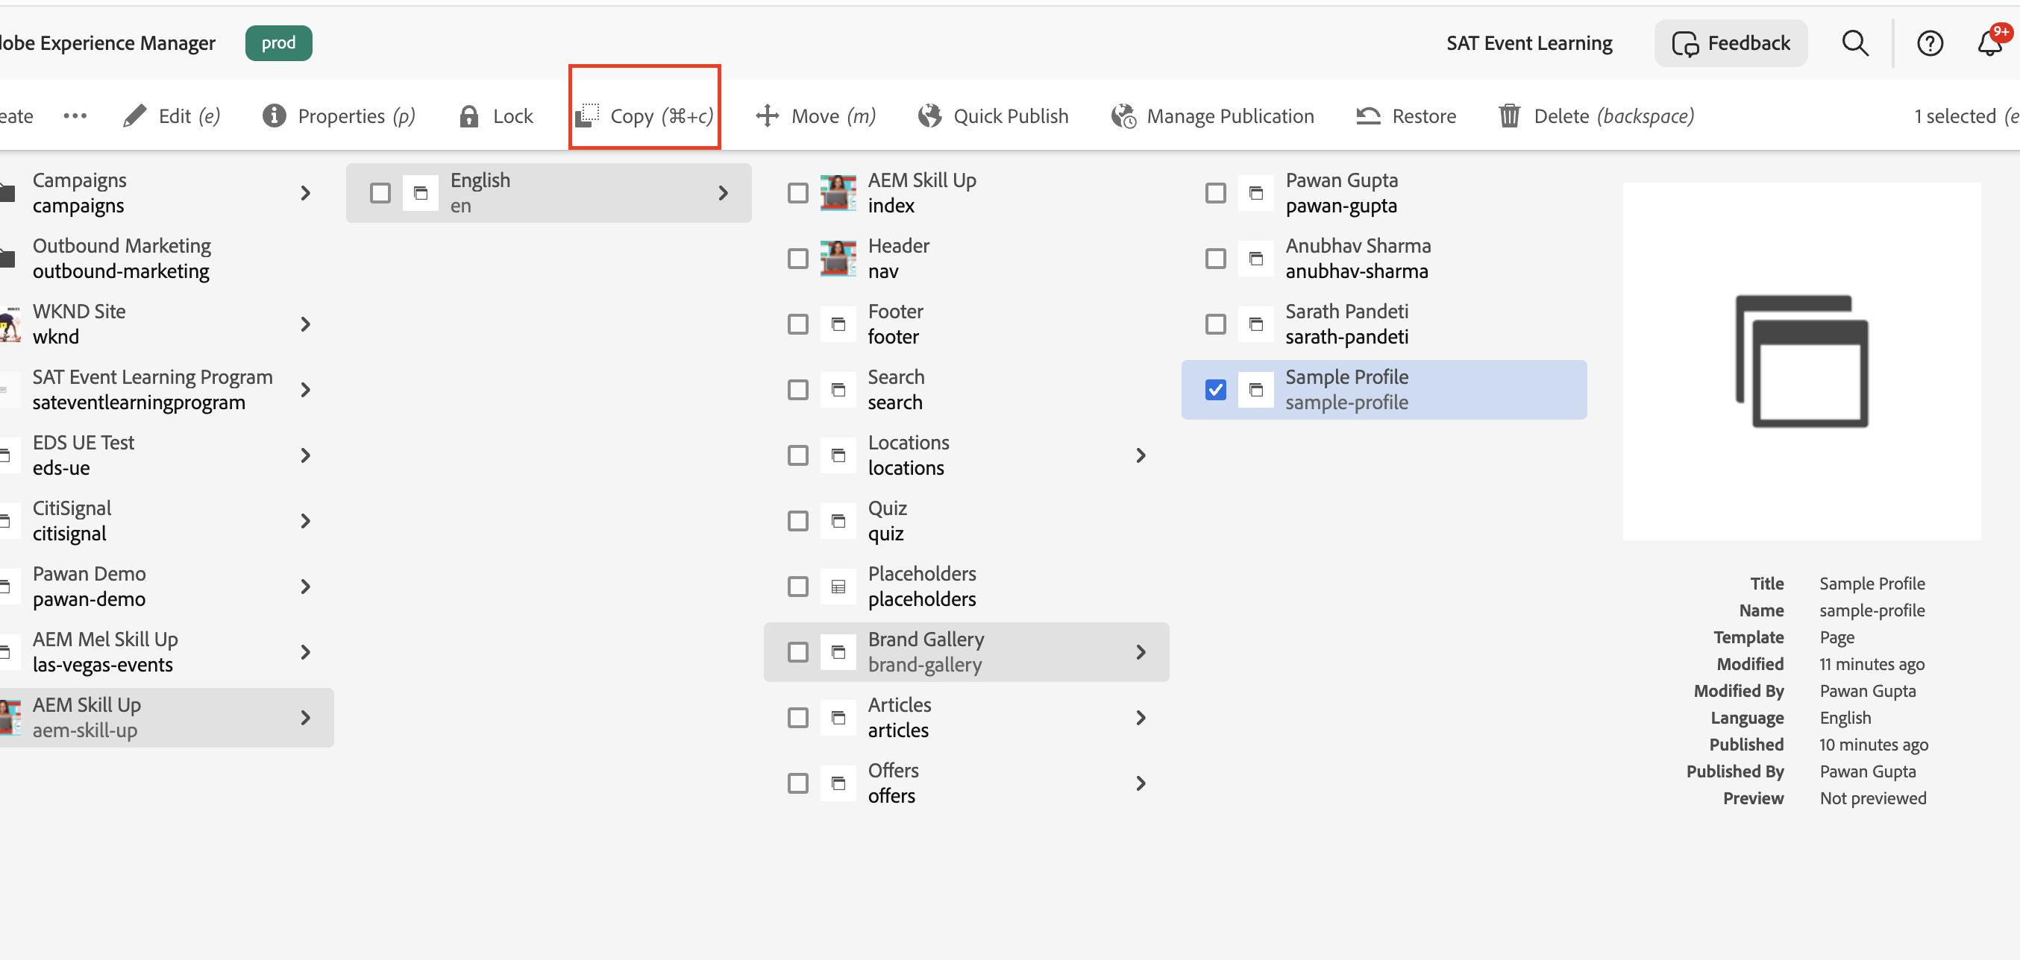
5. Paste it under the same /brand-gallery hierarchy.
- Set New Site Name as your name (fistname-lastname)[e.g., pawan-gupta]
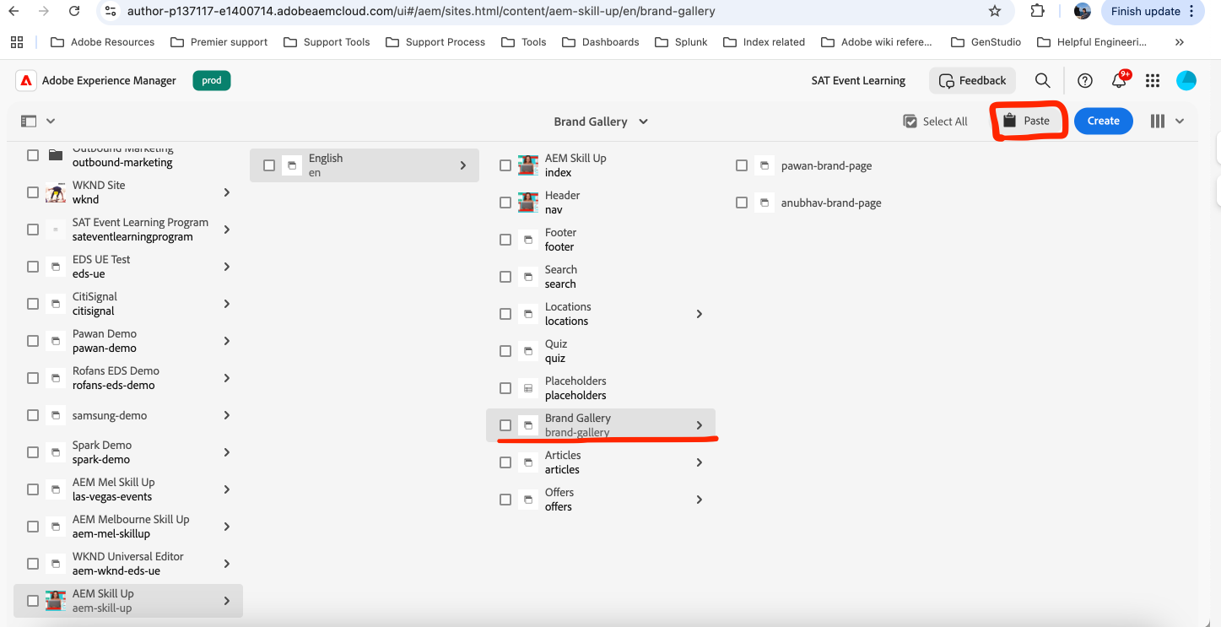
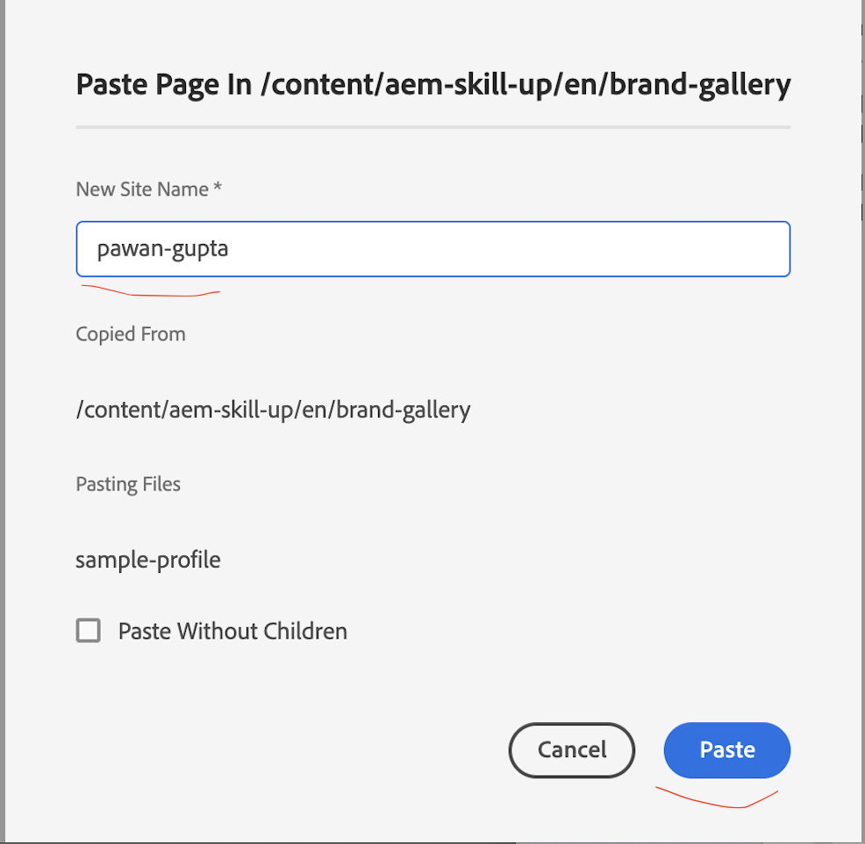
Click Paste

6. Open Properties of the newly created page and update the Title (e.g., Pawan Gupta).
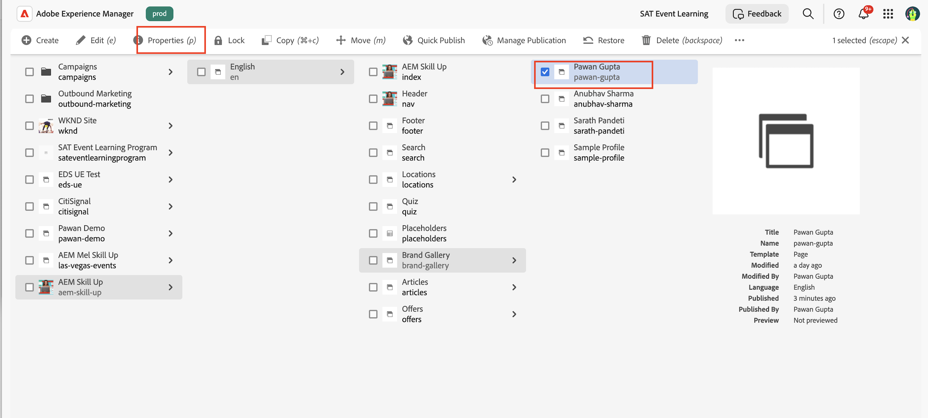
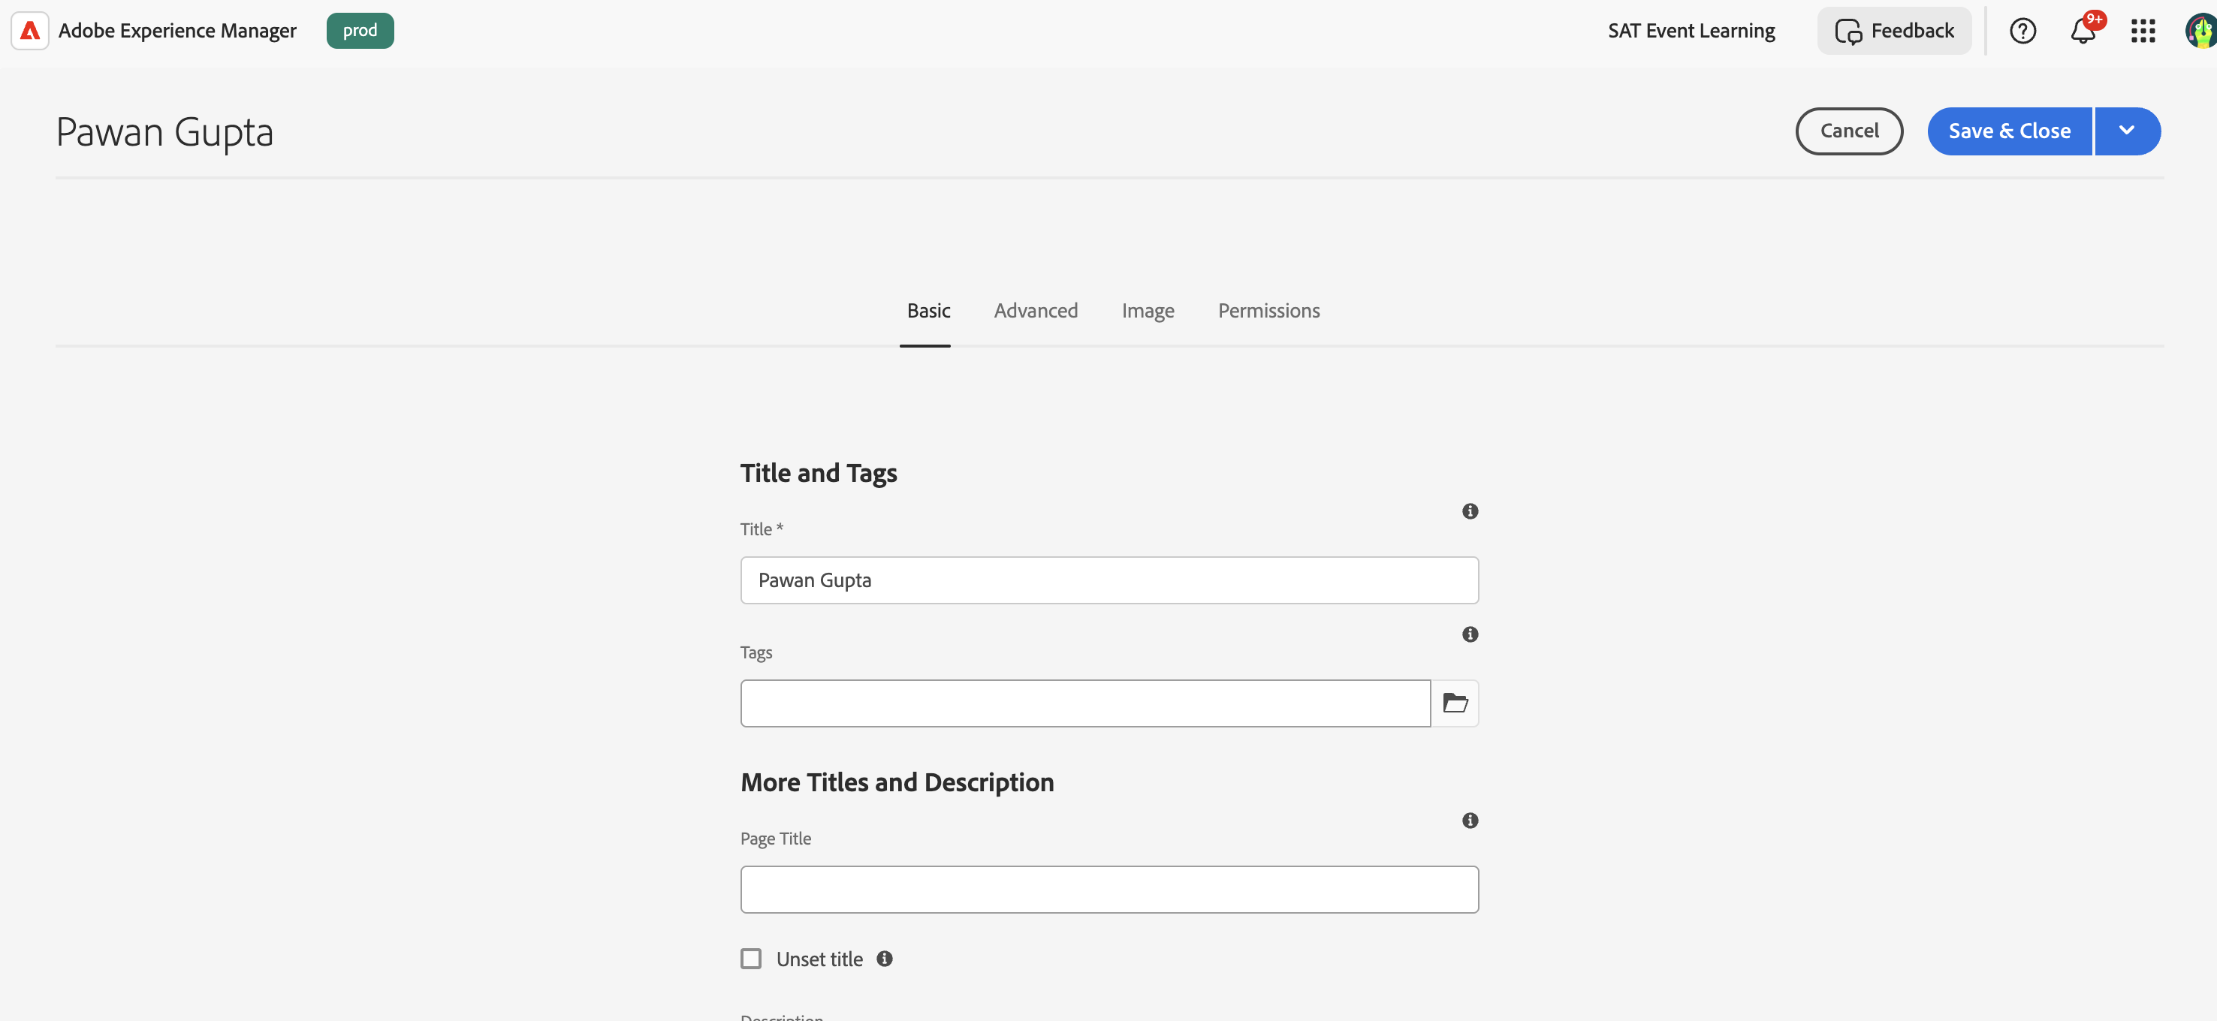
Click save and close.
7. Select your page → Click Edit to open it in Universal Editor.
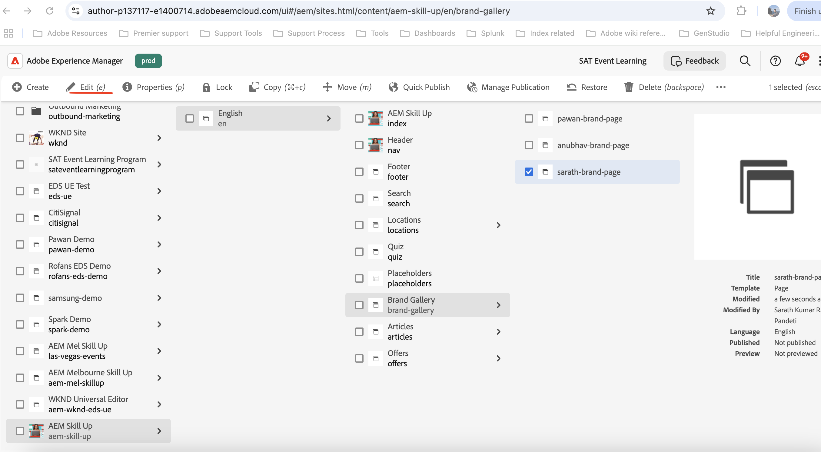

Editing Content

Editing About Me Section
1. Click on the Open the Content Tree on the right side. It will list out sections in the page and corresponding included block/component
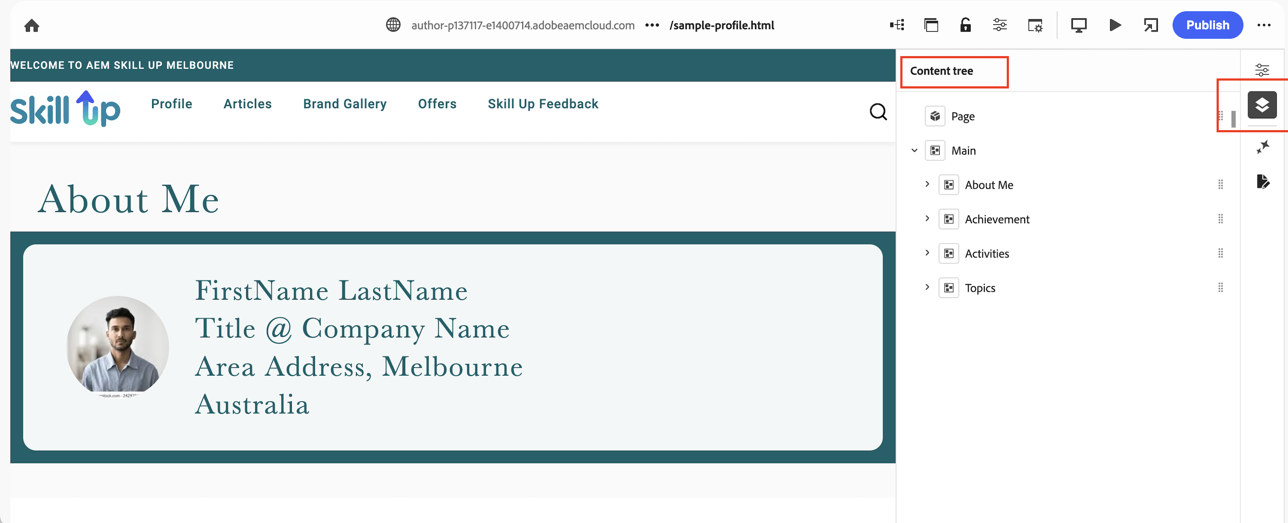
2. Expand About Me → Select Hero Block
3. Update the text/image by clicking Properties to edit it.
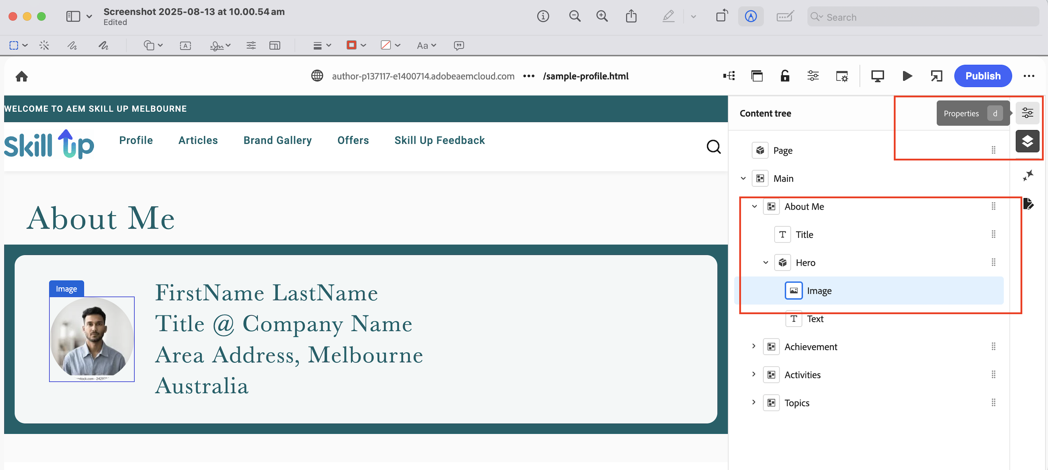
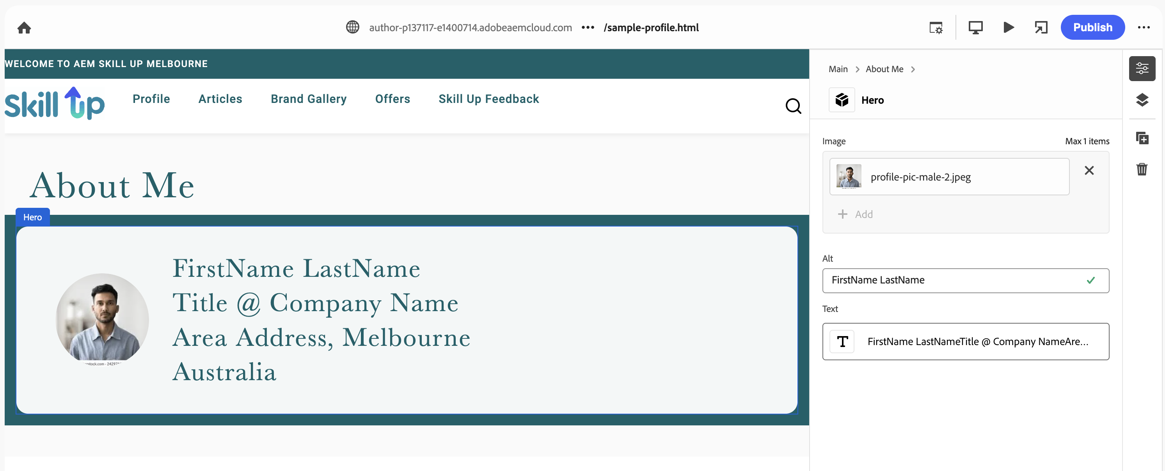
Note: To upload any image to be used on the page, please open to below URL in the new tab
To upload an image:
- Go to Assets → Exercise Folder.
- Create a folder with your name (firstname-lastname) (e.g., pawan-gupta).
- Upload your images there and publish it
- In case you want to use the existing the image, navigate to folder named sample (sample images) to pick the default images.
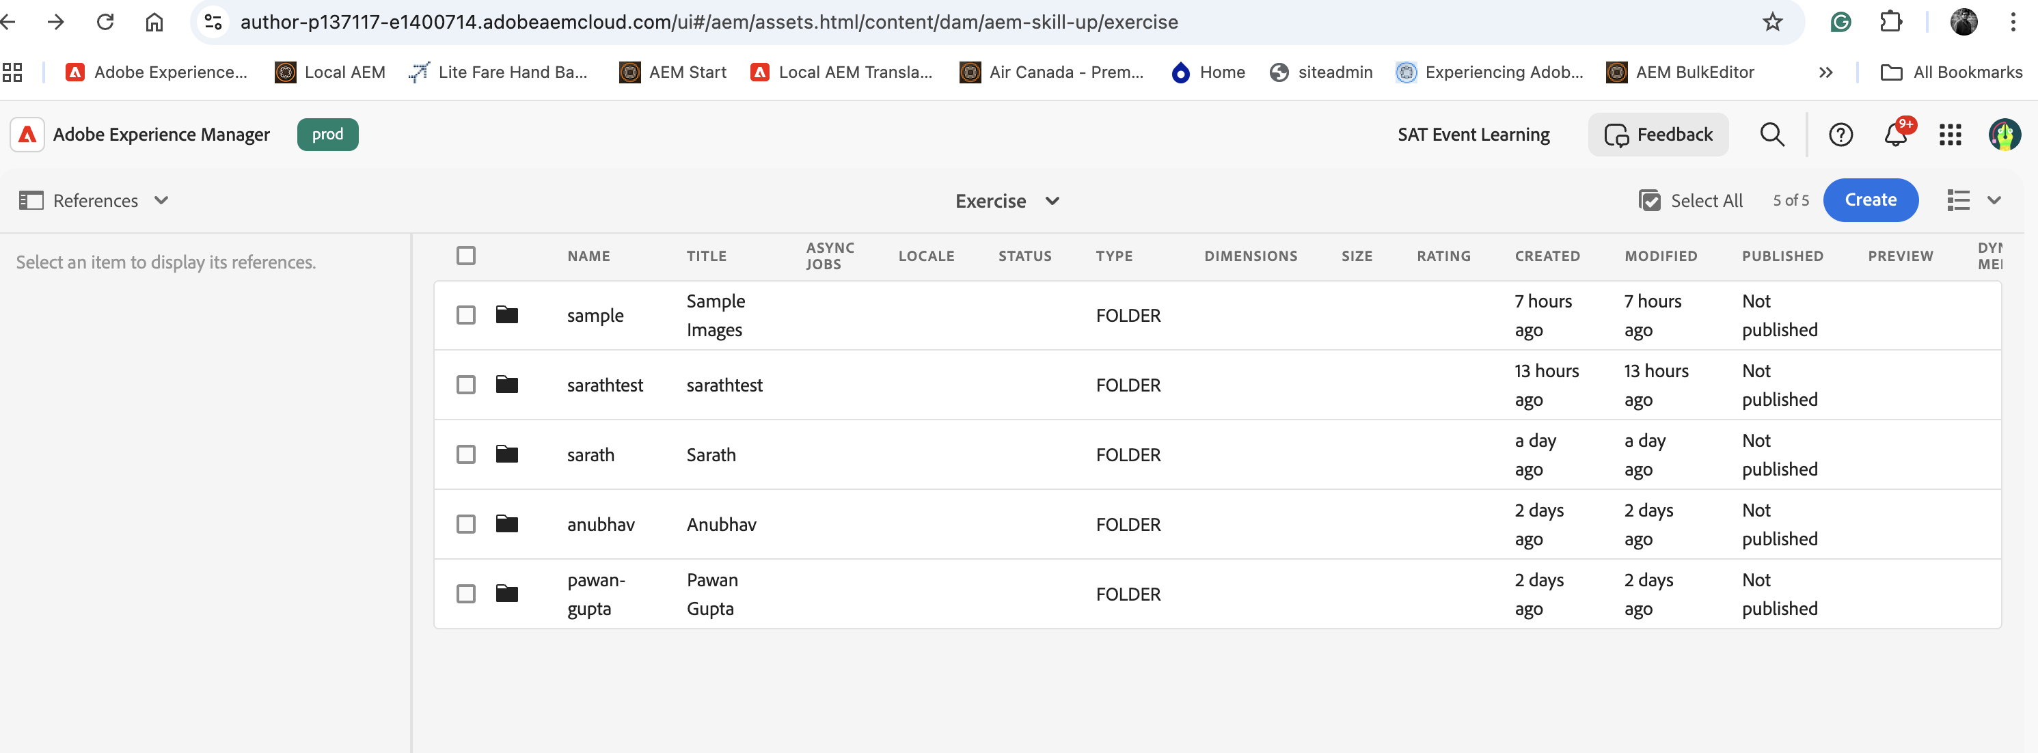

Editing Achievements Section
This section uses Content Fragments to display the data.
To create your achievement ->
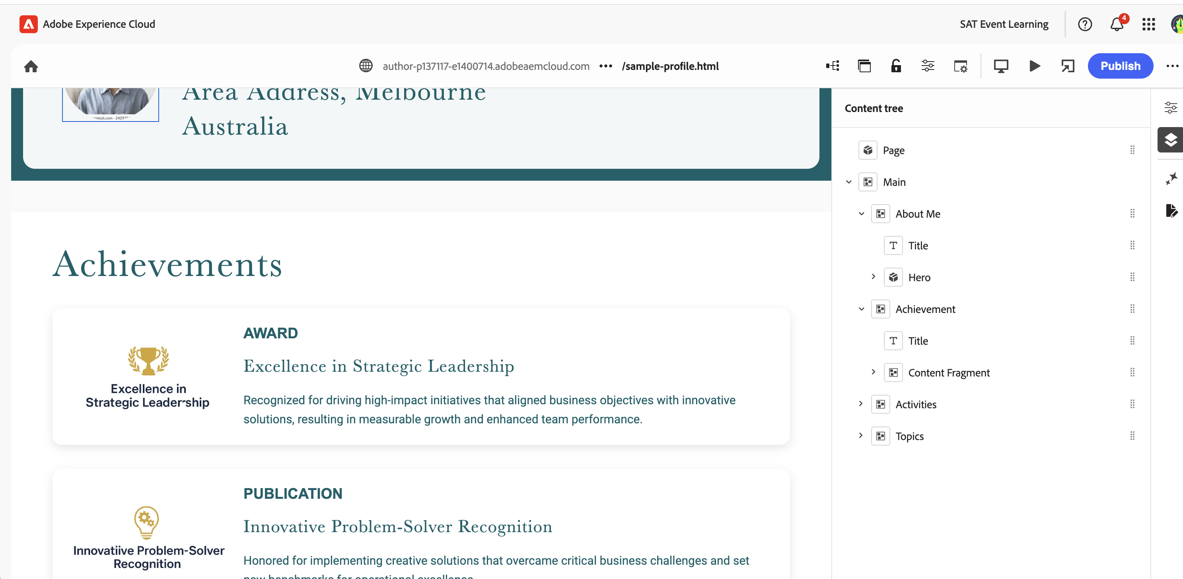
- Go to Assets → Exercise Folder and navigate to your asset folder (e.g., pawan-gupta).
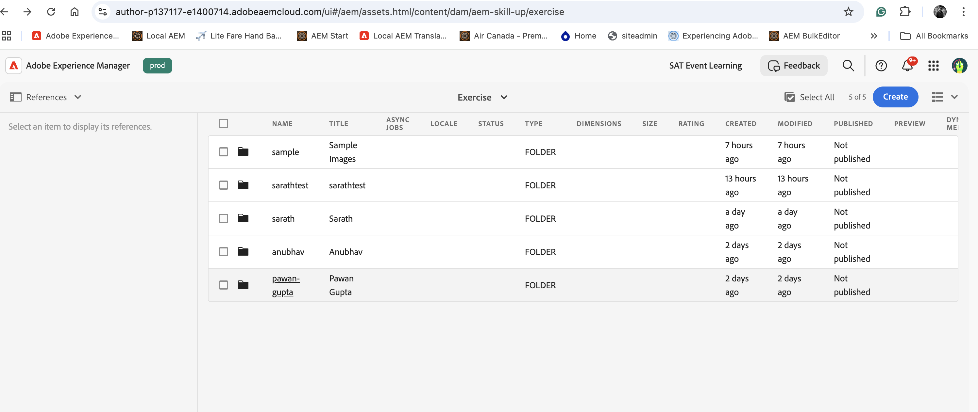

- Click Create → Content Fragment.
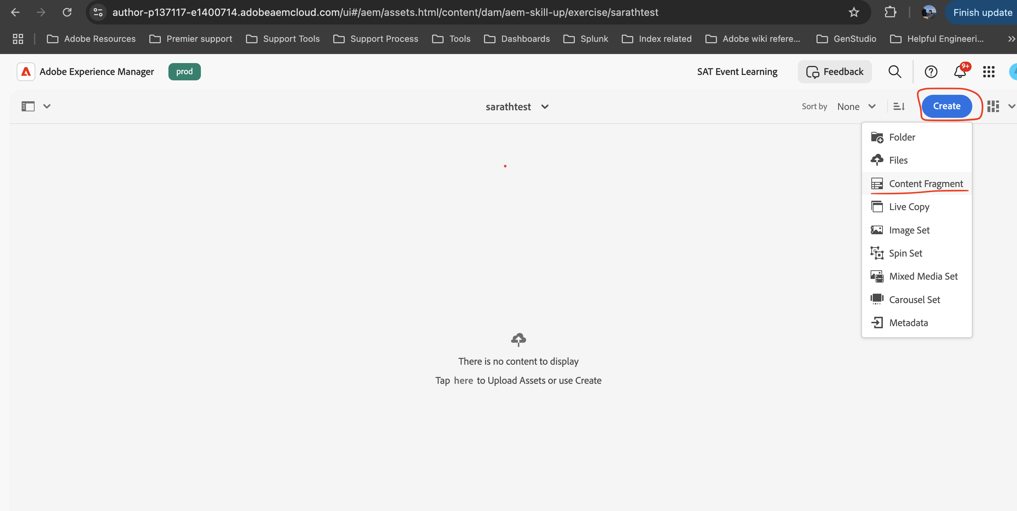
2. Select Achievement Model → Enter title (e.g., Pawan Gupta Achievement).
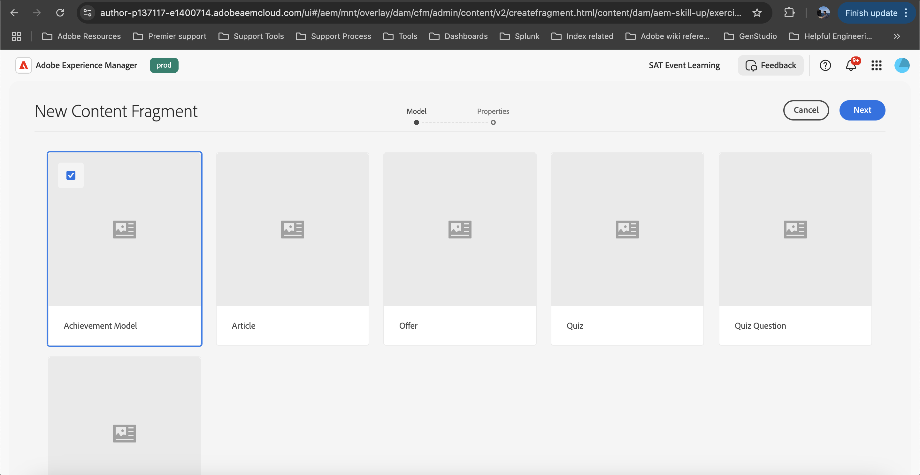
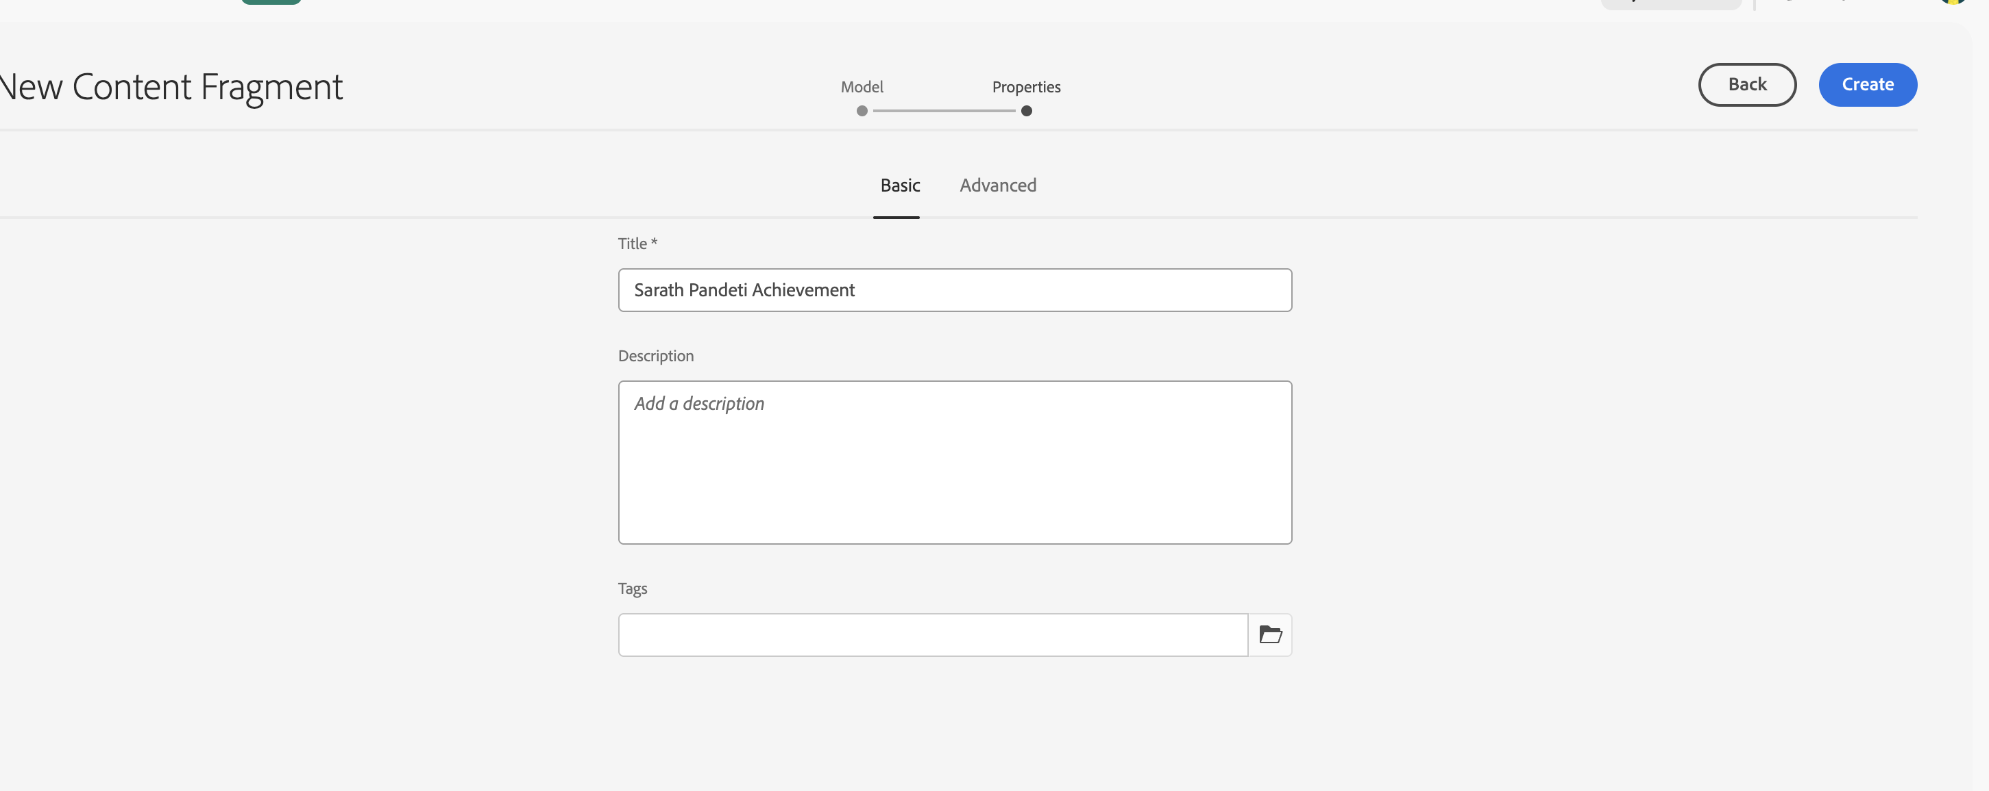
3. A Success popup will appear; select "open" to view the content model in a new tab.
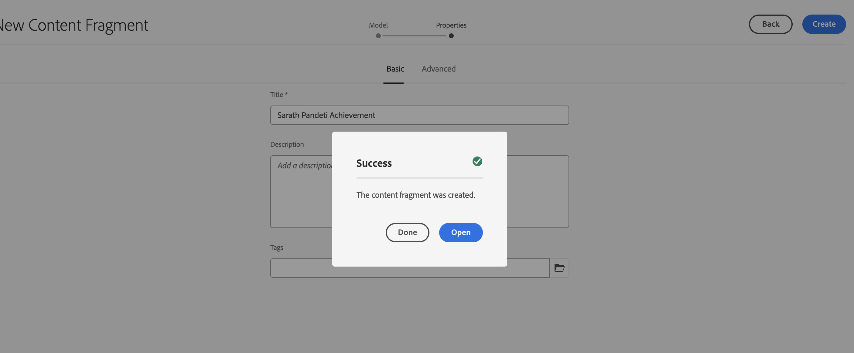
4. Fill in:
- Title
- Description
- Achievement Image (Use images present in achievement folder under sample folder.).
Sample content for title and description field or create your own content
Title: Your Name - Excellence in Solution Delivery
Description: {Your name} demonstrated exceptional expertise in delivering complex, high-value digital solutions on time and with outstanding quality. His ability to collaborate with cross-functional teams, anticipate challenges, and implement innovative approaches has significantly contributed to business success and client satisfaction. This achievement reflects not only technical proficiency but also leadership in driving impactful results.
Category: Select any category from the dropdown field. Image : Select any image present in achievement folder under sample folder
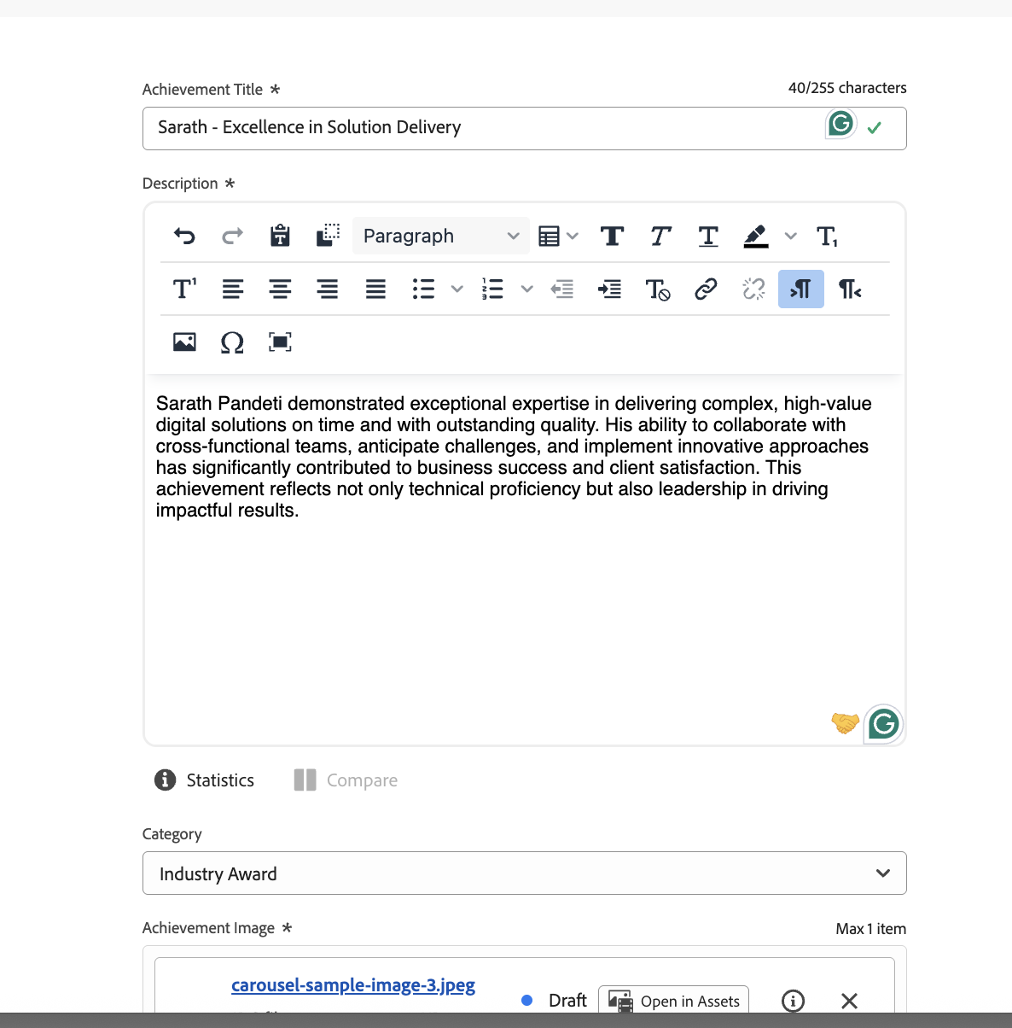
5. Save → Click Publish to publish the content fragment

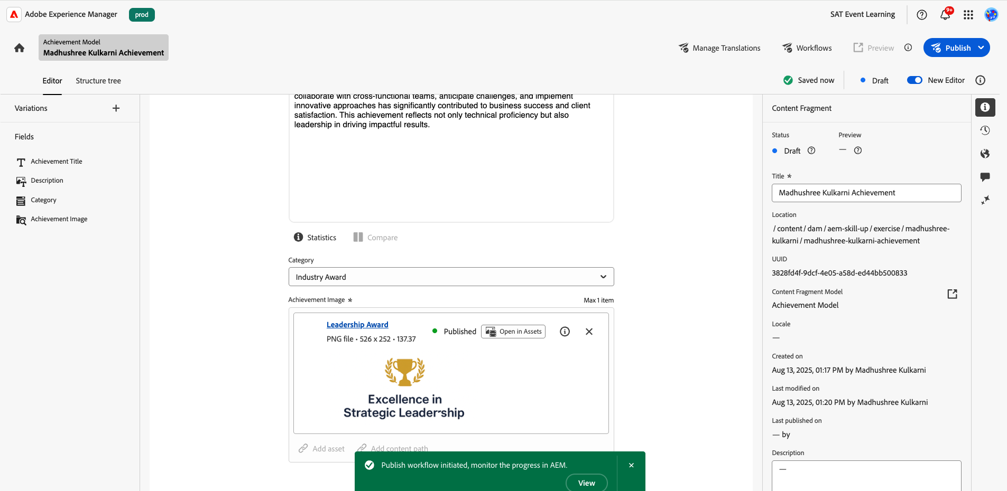
6. Refresh your EDS page or Open page created by you to reflect the new achievement record which you have created.
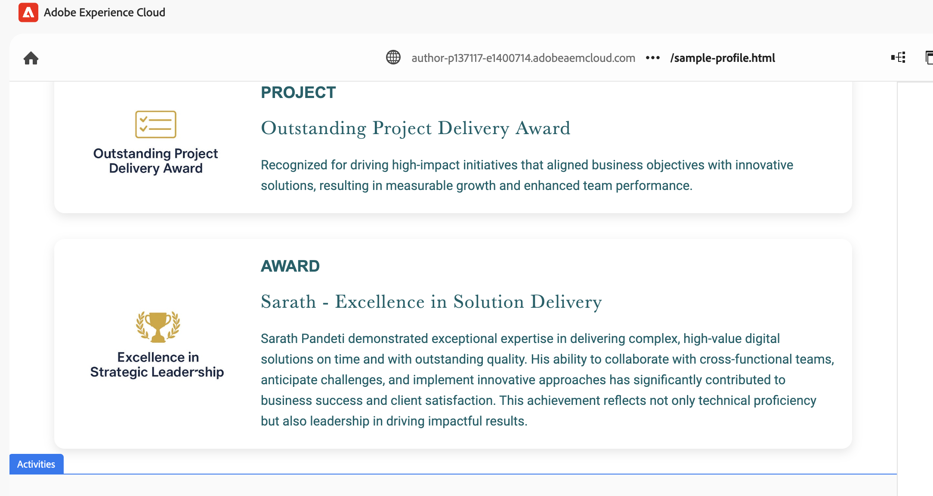
Editing Activities Section (Carousel)
- Expand the Activities section by expanding the activities section.
- Select a carousel slide → Click Properties to edit.
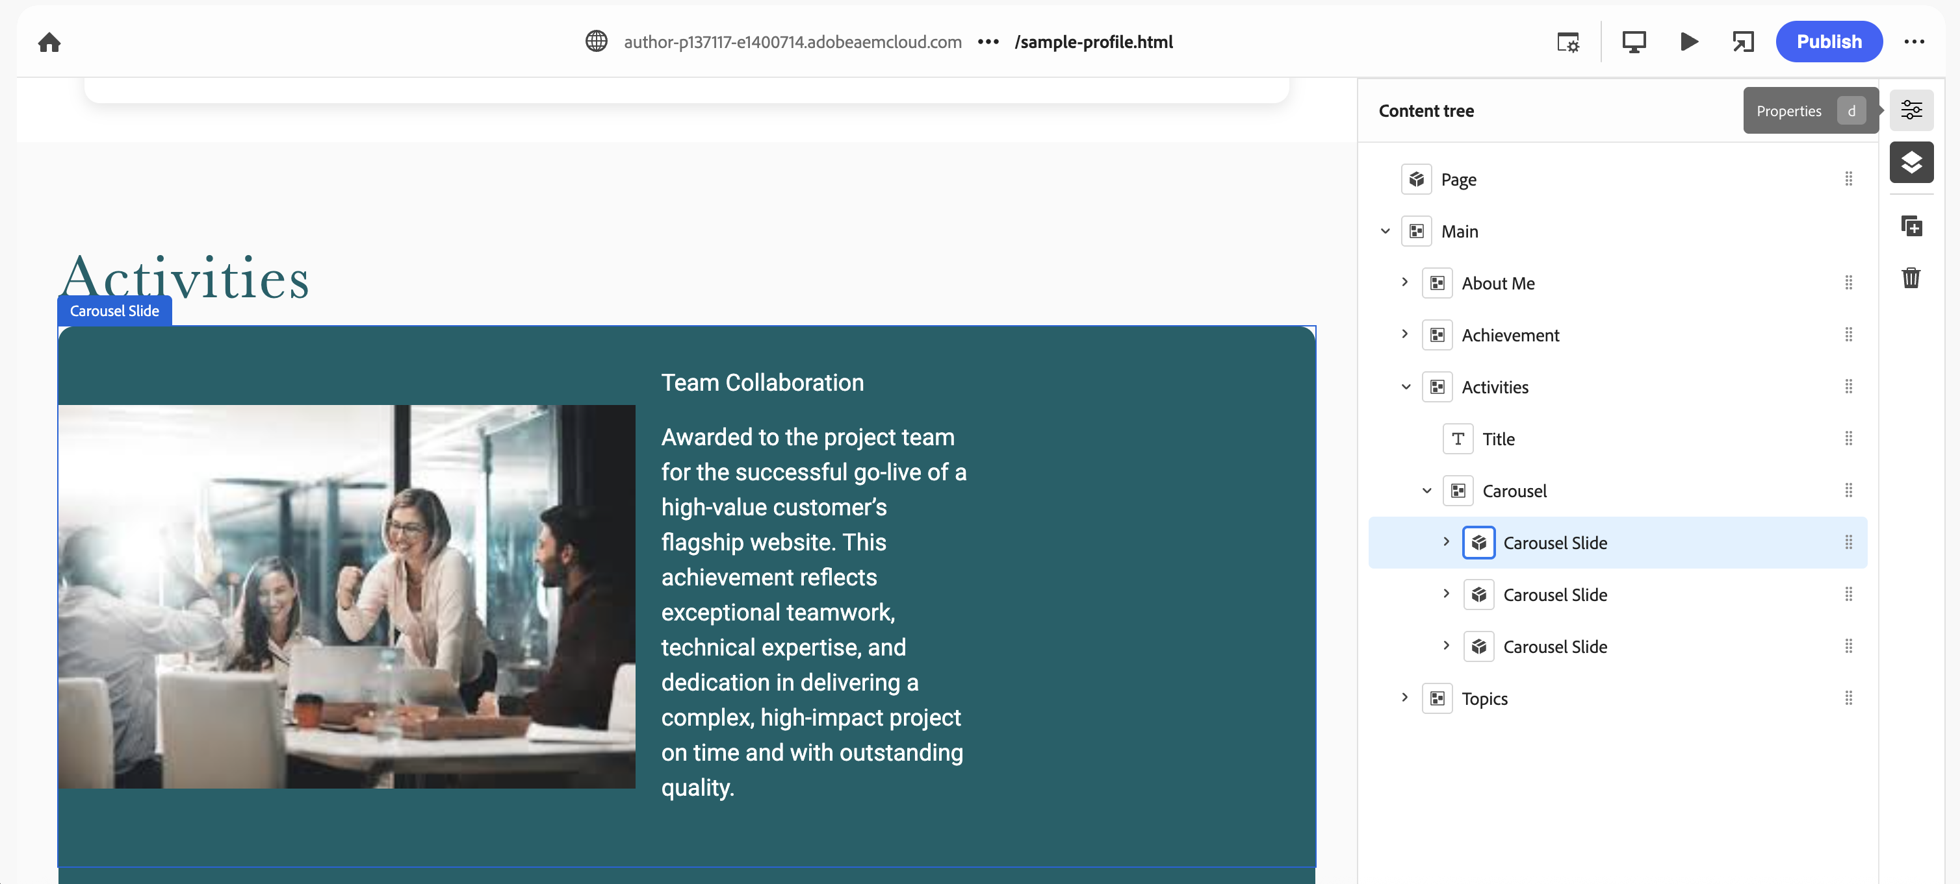
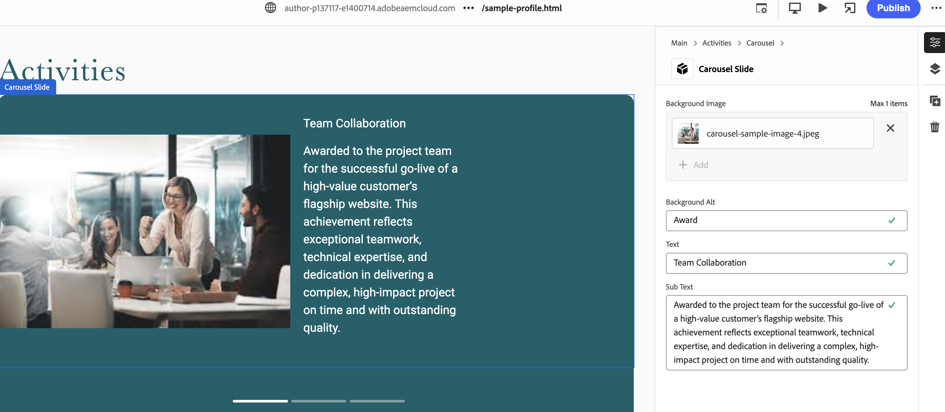

- To add a new slide, please select the Carousel and click on + Add icon on the right navigation bar.
- For image on your new Carousel slide, either select Carousel folder under sample folder or feel free to upload your own images and use it.
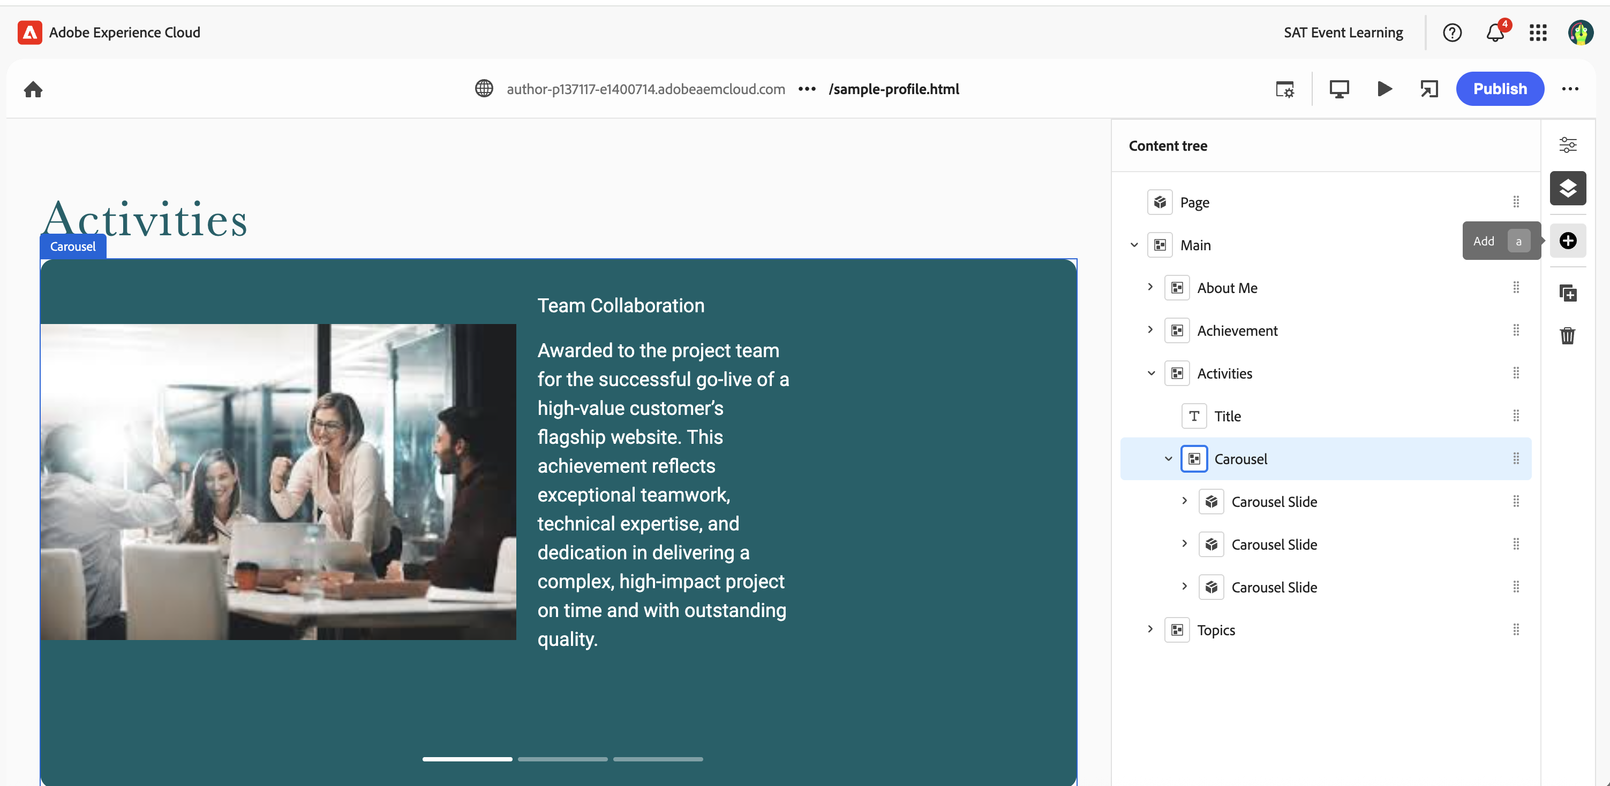

Editing Topics & My View Section (FAQ)
- Expand Topic & My View section
- Select a FAQ → Click Properties to edit/update.
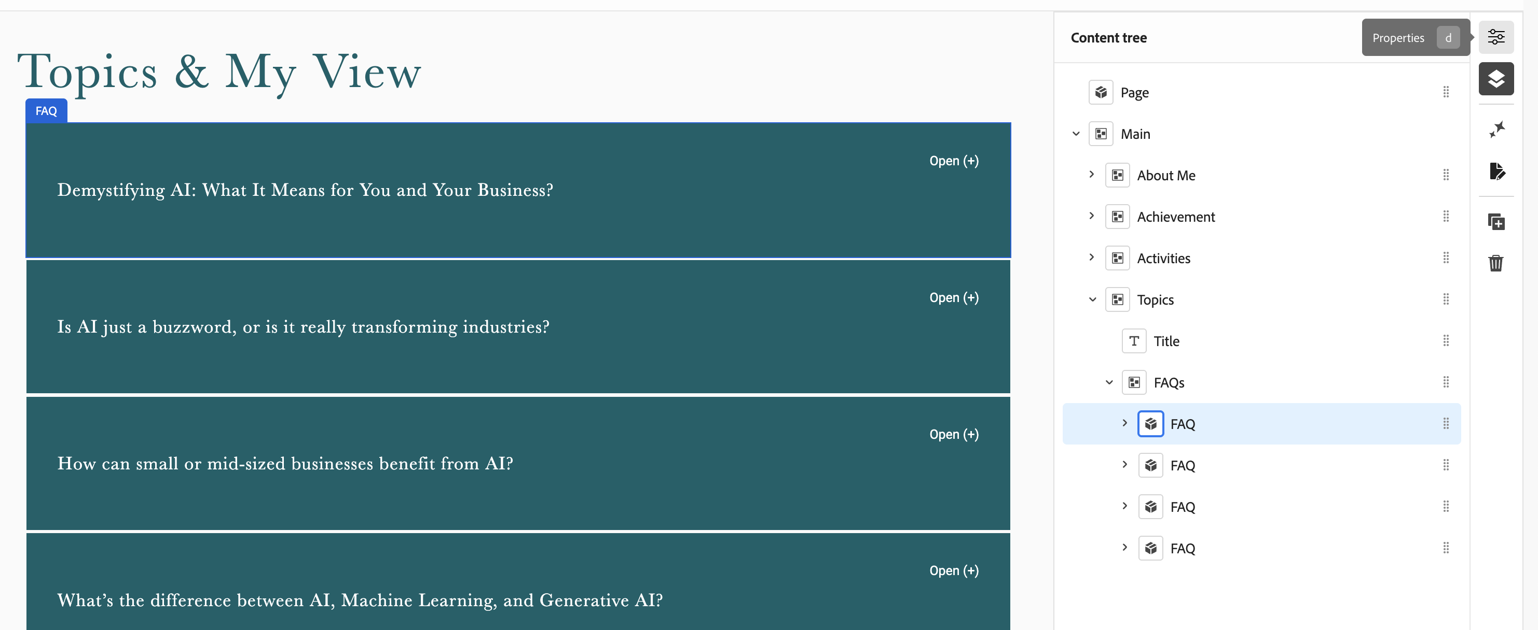

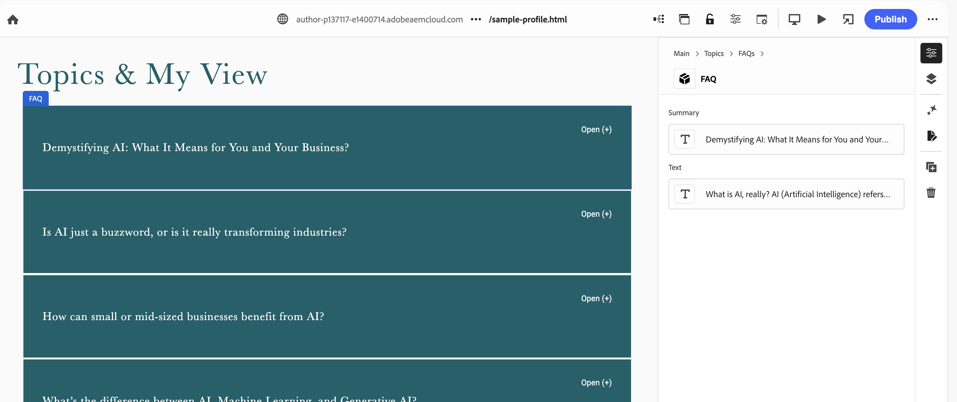
- To add a new slide, please select the FAQ’S and click on + Add icon on the right navigation bar.
- Update the content of Question/Answer and adjust styling as required.
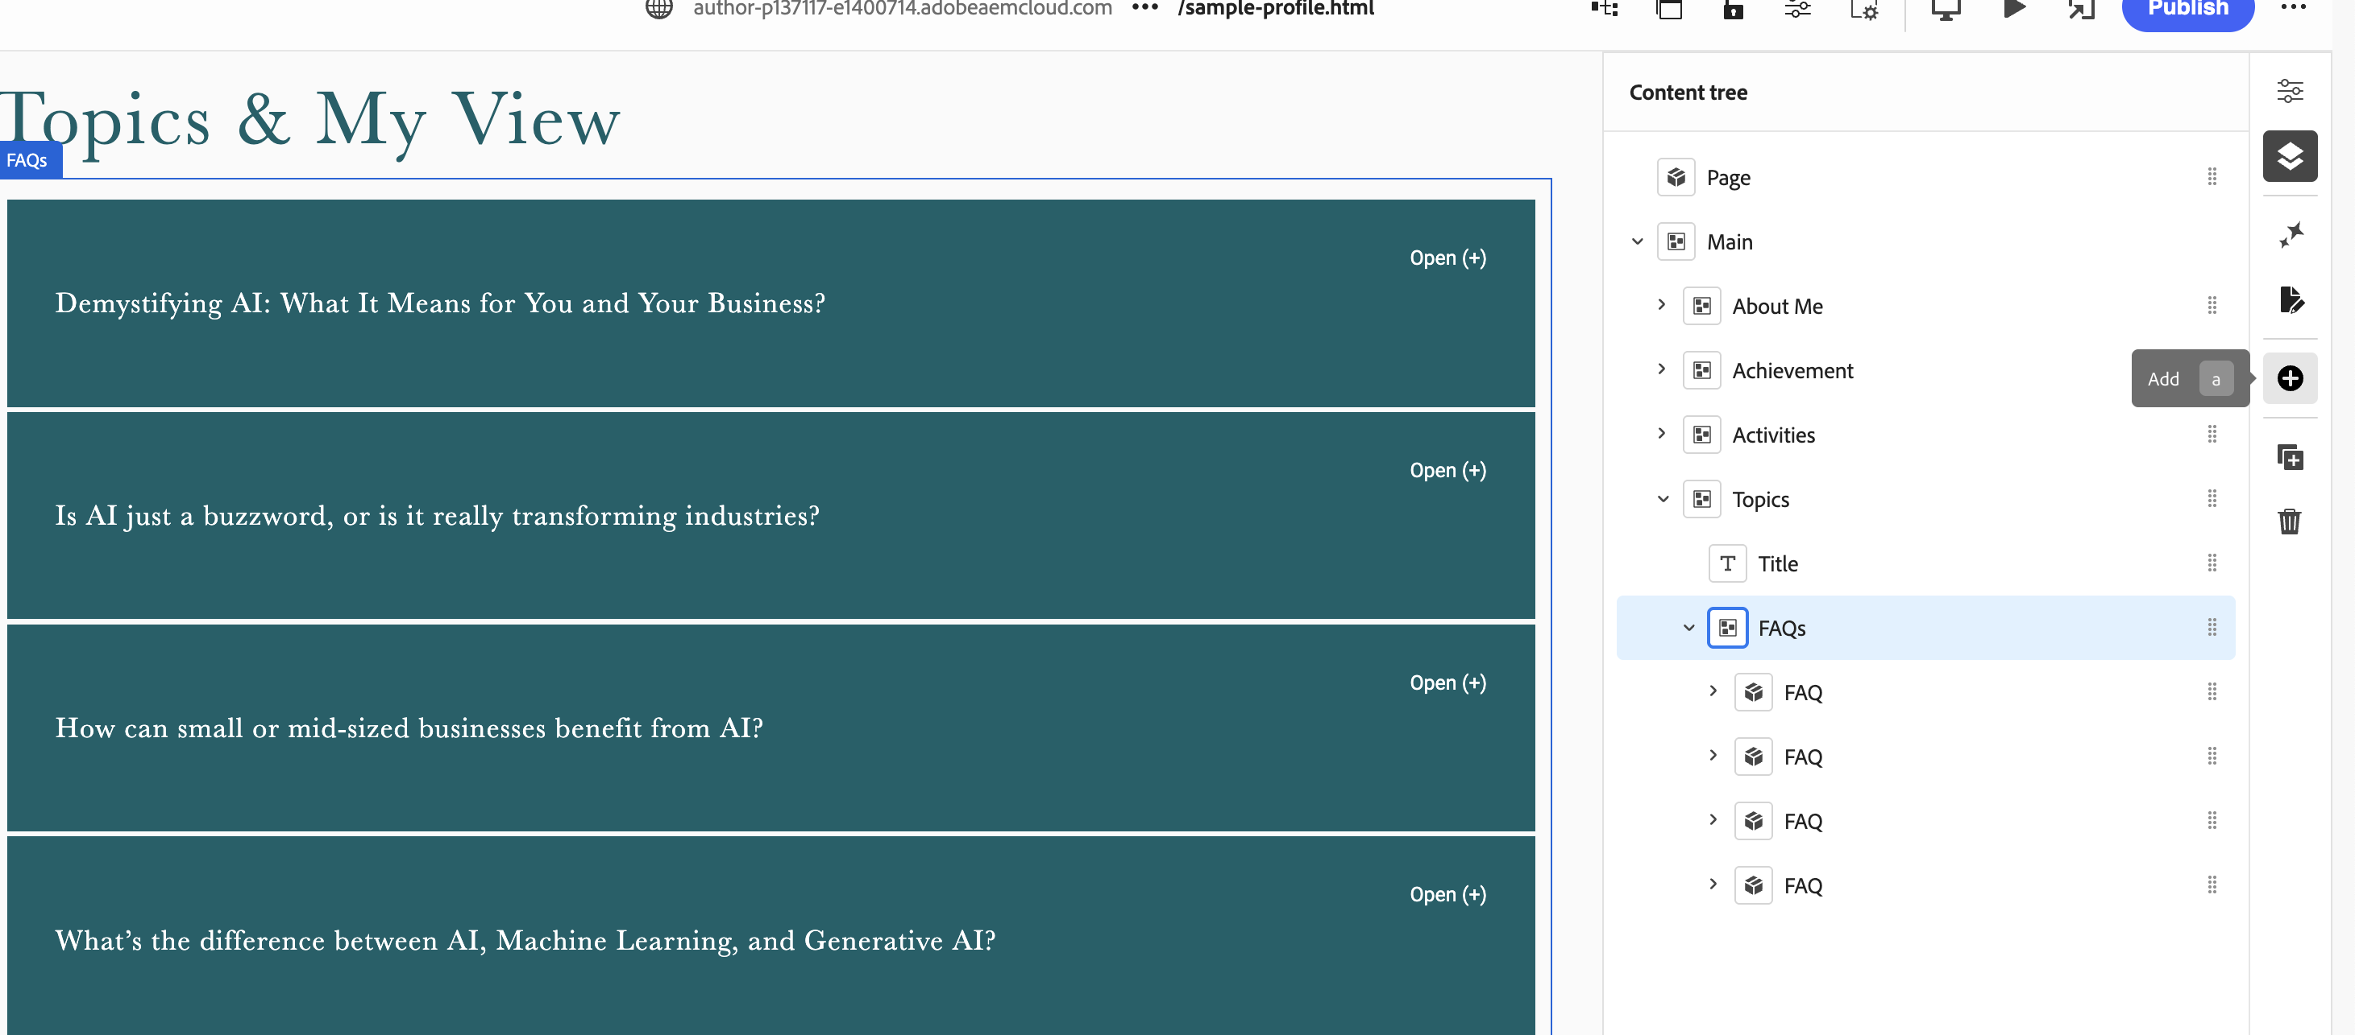

Part E – Review and Publish
1. Publish the EDS page either through publish button on the page or via AEM Sites Console
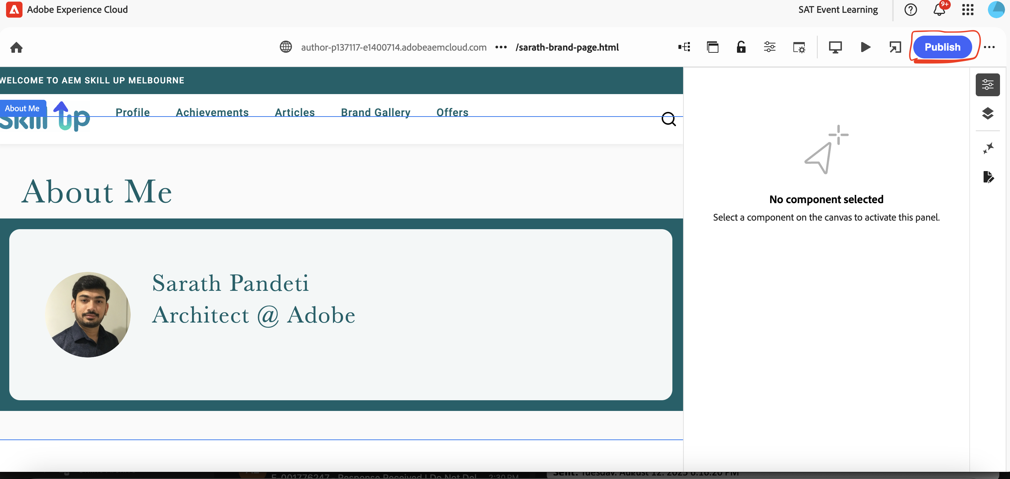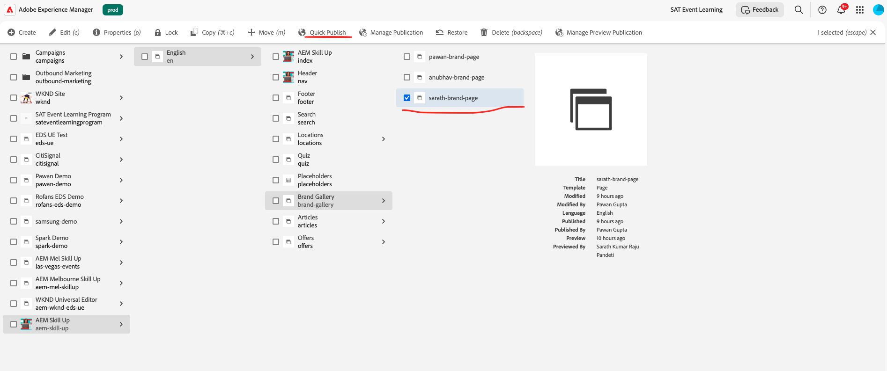

- View your published page at
https://main--aem-skill-up--guptapawan86.aem.live/brand-gallery/pawan-gupta
(Replace pawan-gupta with your page name)
Refer to the site page and use the hyphen name tag.

- Run the Google Lighthouse on your new created page
- Navigate back to Brand Gallery to confirm your profile appears with others.
Note: If you are unable to view your profile using the above link, please open the link in Incognito mode.

Example
Asset Upload Instructions:
1. Click on Assets icon from start screen and navigate to “/content/dam/aem-skill-up/exercise” folder.
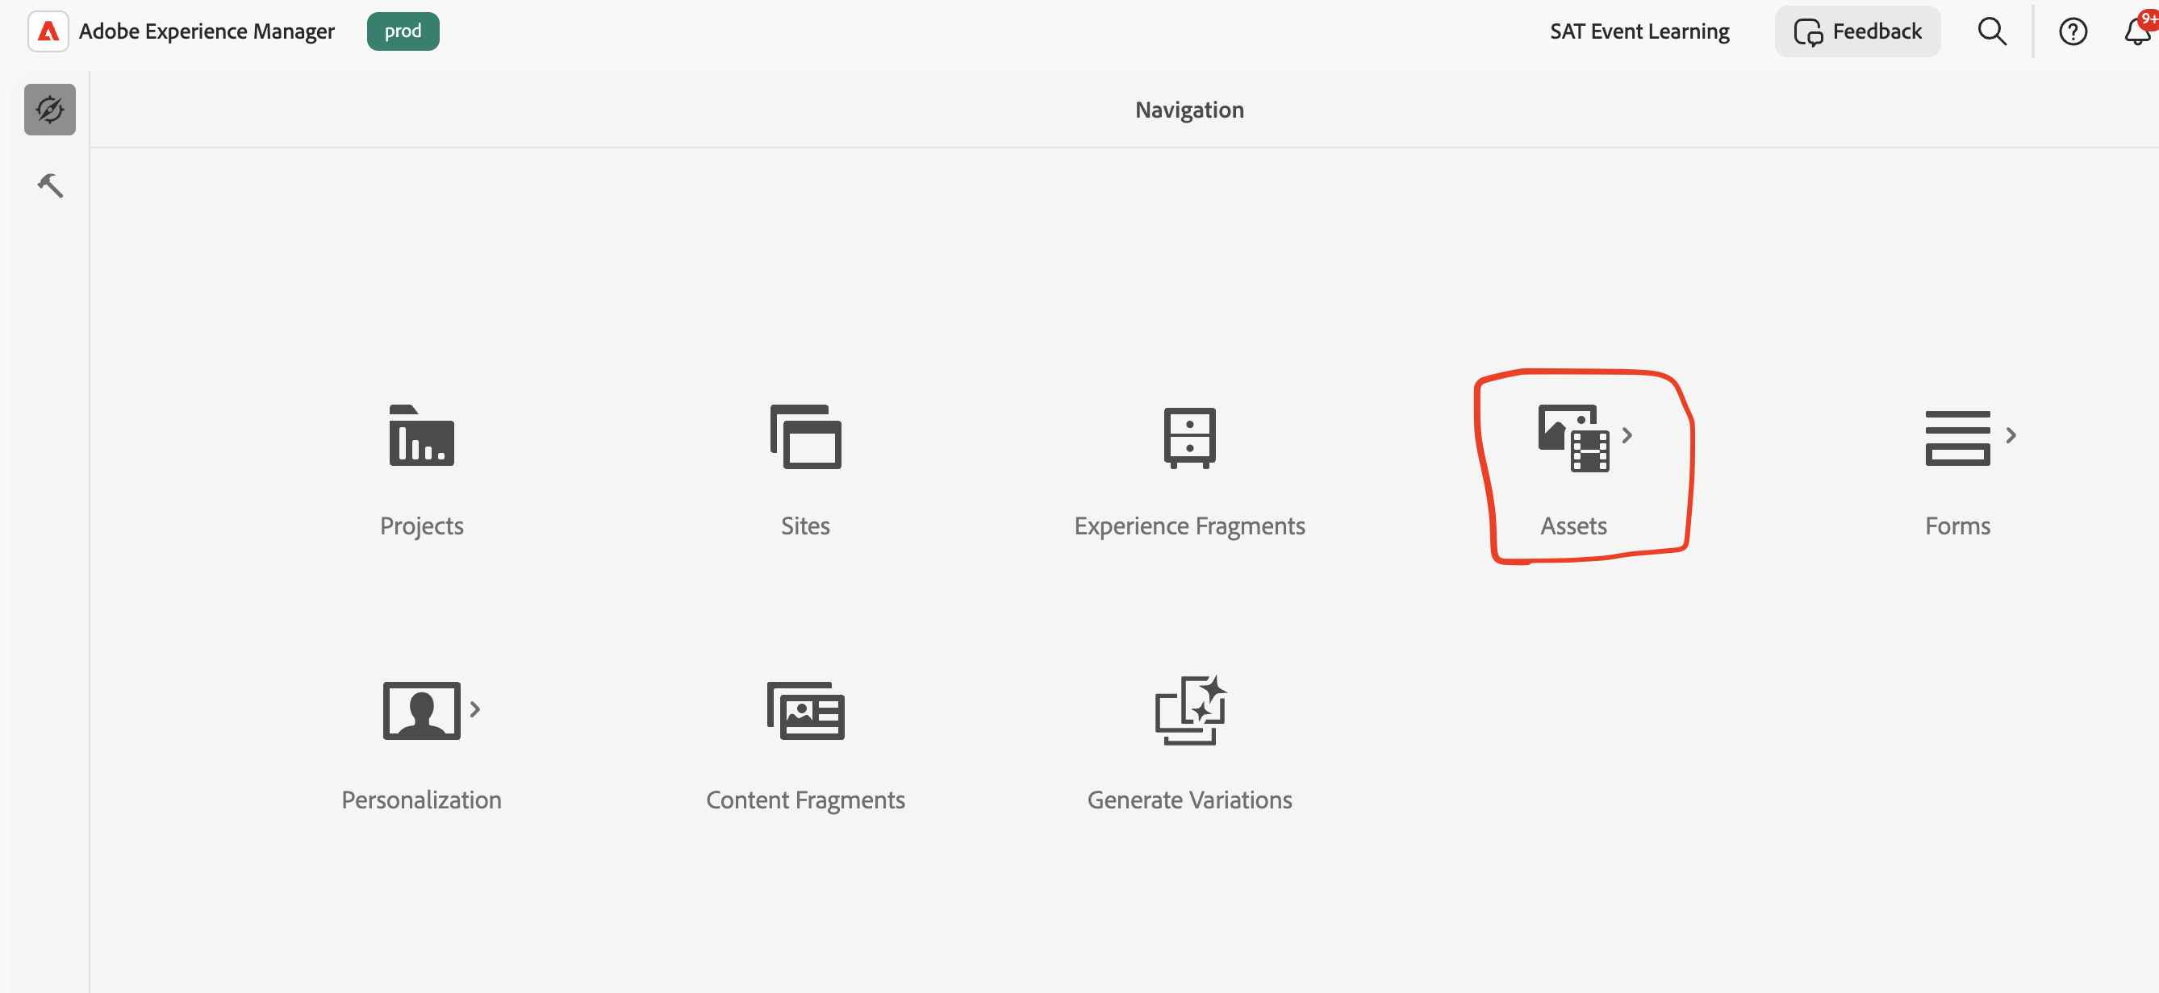
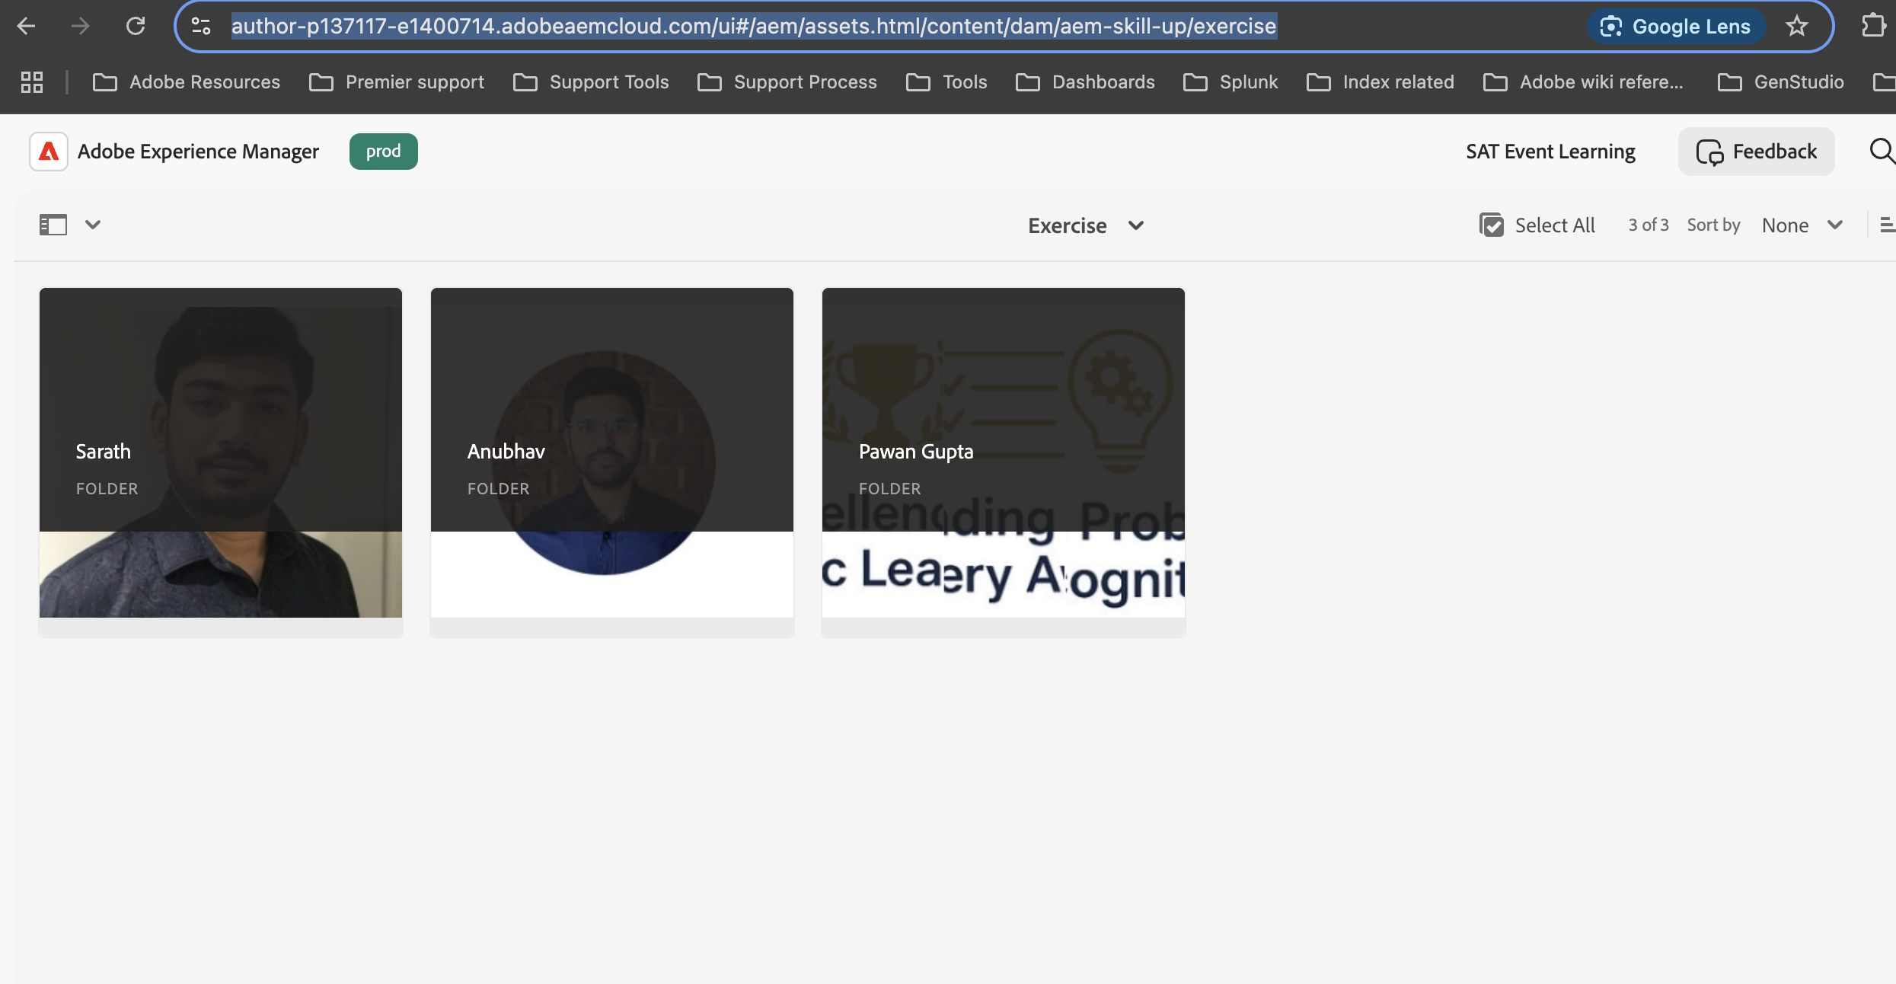
2. Create new folder and name your folder name.
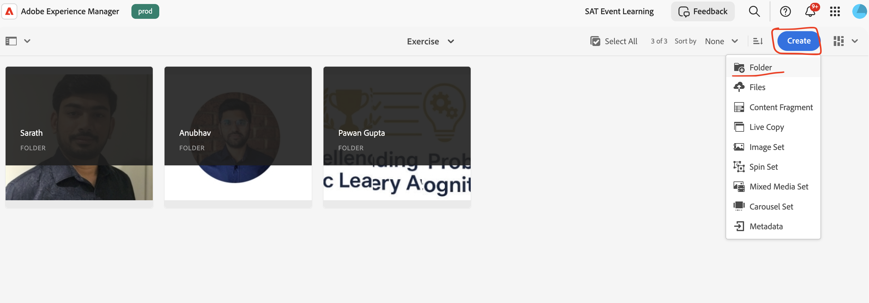
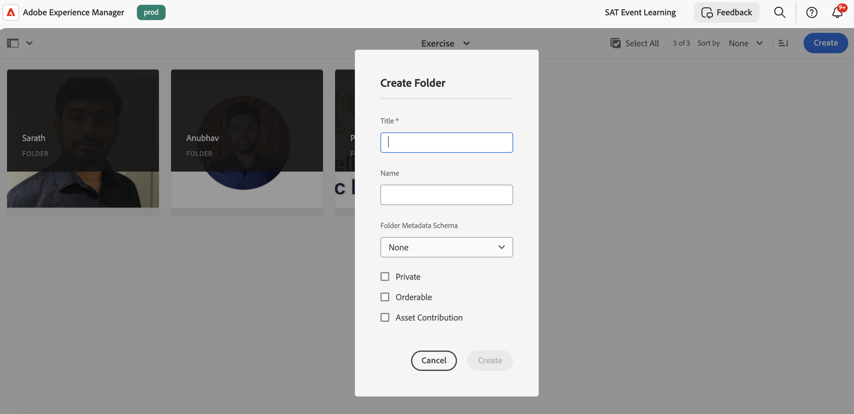
3. Upload the assets inside your folder by clicking create -> Files or using the upload option
