Section Metadata
style | article-header

4 minutes to read

Why technology supply chains remain under pressure
Global demand for AI and data infrastructure is putting lasting pressure on technology supply chains, making forward planning, flexibility and resilience increasingly important across the world today.

Datacom
---
Section Metadata
style | full-width

Industrial docklands skyline at dusk on the Yarra river, Melbourne.
---
Section Metadata
style | article-body

- Global demand for AI, cloud and data-intensive infrastructure is creating structural pressure on technology supply chains, affecting pricing, availability and lead times.
- Forward planning and procurement visibility are increasingly important, giving organisations more opportunities to secure supply and adapt to changing market conditions.
- Flexible, resilient infrastructure strategies can help organisations manage supply chain uncertainty while supporting future growth and technology requirements.
Technology supply chains may no longer be dominating the headlines, but many of the conditions affecting pricing, availability and procurement planning remain firmly in place.
That’s because a number of the pressures shaping today's market are increasingly structural rather than temporary. Rapid growth in AI infrastructure, rising demand for data-intensive workloads, geopolitical disruption and global competition for critical components continue to reshape technology supply chains and procurement strategies worldwide.
Recent discussions at Datacom's Buyers Group highlighted how quickly the market is evolving. One theme emerged consistently from vendors, distributors and technology partners: organisations are no longer operating in a market where supply is determined primarily by local demand.
Instead, New Zealand organisations are increasingly affected by global investment cycles and infrastructure demand far beyond their local market.

The rise of global competition for infrastructure
Around the world, organisations are investing heavily in AI platforms, cloud services, analytics environments and high-performance computing infrastructure. These technologies rely on the same underlying components that support enterprise infrastructure, particularly memory, storage and server platforms.
The challenge is that demand can accelerate much faster than supply. As discussed during the recent Buyers Group session, bringing new memory manufacturing capacity online is a long-term undertaking. New fabrication facilities can take between five and seven years to progress from planning through to full production. By contrast, AI-related infrastructure demand has accelerated dramatically in just a few years.
This mismatch is creating what many in the industry increasingly view as a structural supply gap. Demand continues to grow, while the industry's ability to rapidly increase production remains limited.
For organisations planning infrastructure investments, this doesn't always translate into widespread shortages. Instead, it often appears as higher pricing, longer lead times, reduced configuration flexibility and increased competition for specific products and components.
Global demand patterns can also influence where inventory is allocated. As large-scale infrastructure programmes absorb increasing volumes of memory, storage and server capacity, smaller markets such as New Zealand can experience reduced availability and increased competition for supply.

Why planning matters more than urgency
One of the biggest misconceptions about constrained supply markets is that success comes from moving faster.
In reality, the organisations achieving the best outcomes are usually the ones planning further ahead.
When businesses have visibility of upcoming refresh cycles, growth initiatives and infrastructure projects, they create more opportunities to secure supply, evaluate alternatives and make informed purchasing decisions. Conversely, projects that enter procurement late often have fewer options available and greater exposure to shifting pricing or lead times.
"We've seen a noticeable shift in how organisations approach infrastructure procurement,” says Mark Hardie, Director of Datacom’s Product Solutions Group (PSG). “The most successful projects aren't necessarily the ones that move fastest. They're the ones that understand their future requirements early and build procurement planning into broader technology and business planning."
Flexibility is proving increasingly important as well. Organisations that remain open to alternative configurations, vendors or deployment approaches are often better positioned to navigate market fluctuations than those relying on a single product specification or supply path.
Mark Hardie, Director of Product Solutions Group and Strategic Partnerships at Datacom, mid body shot standing in the street with office buildings blurred in the background, wearing a navy blue suit and light blue shirt
Mark Hardie, Datacom’s Director of Product and Onsite Solutions Group, says understanding procurement planning can contribute to organisational success.

Supply chain planning is becoming a resilience conversation
Technology procurement is also becoming more closely connected to broader conversations about operational resilience.
Infrastructure decisions made today influence not only cost and availability, but also disaster recovery capabilities, data strategy, business continuity and future technology and business requirements. As organisations modernise environments and prepare for increasing compute and storage requirements, infrastructure planning is becoming a strategic consideration rather than a procurement exercise.
PSG Associate Director James David says organisations are increasingly recognising that infrastructure availability and resilience are closely linked.
"The conversation has evolved beyond simply securing hardware. Customers are looking at how procurement decisions support long-term resilience, future growth and emerging technology priorities. Supply chain planning is now part of a much bigger business discussion."

Looking ahead
While no one can predict exactly how supply and demand dynamics will evolve over the next few years, current market indicators suggest that infrastructure availability, particularly across memory, storage and AI-related technologies, will remain under pressure.
For organisations, the lesson is not to react with urgency, but to plan with greater visibility.
Understanding future demand, engaging early with technology partners and building flexibility into procurement decisions can help reduce risk and create greater certainty in an increasingly competitive global market.
Through initiatives such as the Datacom Buyers Group, which brings together customer demand, vendor expertise and market intelligence to improve purchasing leverage and supply certainty, Datacom continues to help customers navigate changing market conditions with greater confidence.
In an environment where supply chain pressures are becoming increasingly structural, visibility, flexibility and forward planning remain the strongest tools organisations have available.
Cards Related Tags

Related industries
Technology
Transportation & logistics

Related solutions
Artificial intelligence
Hardware & licences
Software management and licensing
Managed IT services

---
Section Metadata
style | dark

Discover more
Cards Articles
 | Transportation & logistics  Building resilience amid a disrupted supply chain  AI-driven demand and Middle East instability are straining hardware supply chains for years ahead, however, organisations that plan early and partner wisely will be best placed to manage the pressure.
 | Education  Why technology supply chains need optimising  With the rise of SaaS and PaaS models, it is easy to think of technology as 'weightless' but the devices that our organisations rely on each day need proactive supply chain and lifecycle management.
 | Agriculture  Optimised licensing streamlines costs for Tegel  Datacom has helped Tegel cut cost increases for its software licensing using savvy consultancy, smart negotiation and an optimisation tool to measure existing license use among Tegel team members.

---
Metadata
Title | Why technology supply chains remain under pressure
Description | AI-driven demand is reshaping technology supply chains, increasing pressure on pricing, availability and lead times as competition for infrastructure grows.
Image | 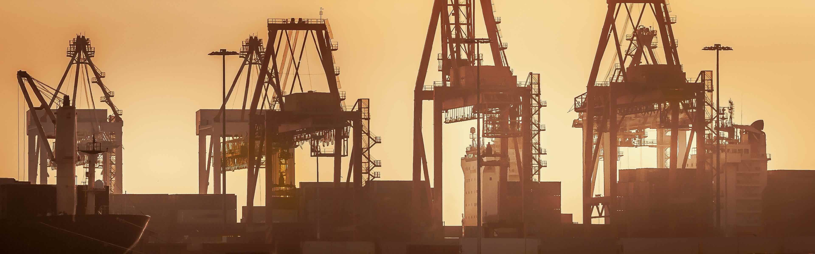
og:title | Why supply chain risk hasn't gone away

