We're currently updating our website to improve your experience. During this time, you may encounter temporary issues or incomplete content. Thank you for your patience while we complete the upgrade.
---

https://main--my-eds-site--guptapawan86.aem.page/au/en
---
- Solutions
  - Application services
    - Application services

Adapt, innovate and thrive with enterprise application development services.
    - 
https://main--my-eds-site--guptapawan86.aem.page/au/en/solutions/application-services/business-platforms
Business platforms
Build customer relationships, foster collaboration and optimise your assets.
    - 
https://main--my-eds-site--guptapawan86.aem.page/au/en/solutions/application-services/data-intelligence-and-process-optimisation
Data intelligence and process optimisation
Shape a smarter, more efficient and successful future for your business.
    - 
https://main--my-eds-site--guptapawan86.aem.page/au/en/solutions/application-services/software-engineering
Software engineering
Support your development teams to build faster, smarter, and with confidence.
    - 
https://main--my-eds-site--guptapawan86.aem.page/au/en/solutions/application-services/ai-powered-engineering
AI-powered engineering
Reimagine how you build, assure and optimise apps.
    - 
https://main--my-eds-site--guptapawan86.aem.page/au/en/solutions/application-services/digital-experience
Digital experience
Imagine and build omnichannel digital customer experiences.
  - Artificial intelligence
    - Artificial intelligence

Harness the power of artificial intelligence (AI) to enhance human capability and reshape the way you work.
    - 
https://main--my-eds-site--guptapawan86.aem.page/au/en/solutions/artificial-intelligence/ai-foundations
AI foundations
Build strong AI foundations to scale with confidence.
    - 
https://main--my-eds-site--guptapawan86.aem.page/au/en/solutions/artificial-intelligence/ai-for-productivity
AI for productivity
Increase efficiency with AI-driven automation to augment human capabilities.
    - 
https://datacom.com/au/en/solutions/application-services/ai-powered-engineering/ai-application-modernisation
AI application modernisation
Modernising businesses from legacy to leadership.
    - 
https://main--my-eds-site--guptapawan86.aem.page/au/en/products/datapay/payroll-assistant
Payroll Assistant
    - 
https://main--my-eds-site--guptapawan86.aem.page/au/en/solutions/artificial-intelligence/ai-sandpit
Learn, experiment and scale AI safely
Datacom's AI Sandpit provides a safer path to AI for organisations, enabling on-premises or hybrid deployments from pilots to production.
  - Cloud
    - Cloud

Your success, our expertise: smart cloud solutions.
    - 
https://main--my-eds-site--guptapawan86.aem.page/au/en/solutions/cloud/hybrid-and-private
Hybrid & private cloud
Cloud solutions that balance flexibility, compliance and control.
    - 
https://main--my-eds-site--guptapawan86.aem.page/au/en/solutions/cloud/public
Public cloud
Secure, flexible foundations built to accelerate cloud transformation.
    - 
https://datacom.com/nz/en/solutions/application-services/software-engineering/application-modernisation
Application modernisation
Datacom supports Australian businesses with secure, tailored application modernisation services.
    - 
https://main--my-eds-site--guptapawan86.aem.page/au/en/solutions/cloud/connectivity
Cloud connectivity
Improve agility, reduce risk and cut IT costs. A fast, secure foundation for hybrid and multi-cloud success for Australian businesses.
    - 
https://main--my-eds-site--guptapawan86.aem.page/au/en/solutions/cloud/financial-operations
Cloud FinOps
Helping businesses across Australia maximise business value from every cloud dollar.
    - 
https://main--my-eds-site--guptapawan86.aem.page/au/en/solutions/cloud/innovation
Innovation
As your trusted multi-cloud, zero-trust security partner, we take the complexity out of cloud security.
    - 
https://main--my-eds-site--guptapawan86.aem.page/au/en/solutions/cloud/migration
Cloud migration & modernisation
Trusted cloud migration and modernisation tailored for Australian organisations.
    - 
https://main--my-eds-site--guptapawan86.aem.page/au/en/solutions/cloud/operations
Cloud operations & optimisation
Helping businesses across Australia keep critical workloads running securely and efficiently — anytime, anywhere.
    - 
https://main--my-eds-site--guptapawan86.aem.page/au/en/solutions/cloud/data-protection
Data protection
Safeguarding the data of Australian organisations against today’s risks, and preparing them for tomorrow’s challenges.
    - 
https://datacom.com/au/en/offerings?&contentTypesList=offering&solutionsList=cloud
Programs & offerings
Explore our programs and offerings that can help transform your cloud infrastructure.
  - Customer experience & service transformation
    - Customer experience & service transformation

Connect strategy, digital platforms, customer service and data to deliver AI-enabled customer experiences.
    - 
https://main--my-eds-site--guptapawan86.aem.page/au/en/solutions/customer-experience-and-service-transformation/strategy-and-design
Customer experience strategy & design
Customer experiences grounded in real needs, supported by strategy, service design and delivery.
    - 
https://main--my-eds-site--guptapawan86.aem.page/au/en/solutions/customer-experience-and-service-transformation/digital-experience
Digital experience and platforms
Design, build and manage digital platforms that create connected experiences.
    - 
https://main--my-eds-site--guptapawan86.aem.page/au/en/solutions/customer-experience-and-service-transformation/customer-service
Customer service and contact centre
Design, modernise and run customer service and contact centre operations.
    - 
https://main--my-eds-site--guptapawan86.aem.page/au/en/solutions/customer-experience-and-service-transformation/customer-data-and-personalisation
Customer data and personalisation
Use customer data, CRM, analytics and personalisation for relevant experiences.
  - Managed IT services
    - Managed IT services

Leverage technology to transform the way you do business.
    - 
https://main--my-eds-site--guptapawan86.aem.page/au/en/solutions/managed-it-services/it-support-services
IT support services
Free up your team's time so they can focus on what they do best.
    - 
https://main--my-eds-site--guptapawan86.aem.page/au/en/solutions/managed-it-services/service-operations
Service operations
Streamline business process, bridge the gaps between IT and business development.
    - 
https://main--my-eds-site--guptapawan86.aem.page/au/en/solutions/managed-it-services/technology-lifecycle-services
Technology lifecycle services
Unlock more life from the IT asset lifecycle.
  - Network services
    - 
https://main--my-eds-site--guptapawan86.aem.page/au/en/solutions/network-services/managed-lan-services
Managed LAN services
Ensure the stability and performance of all business applications.
    - 
https://main--my-eds-site--guptapawan86.aem.page/au/en/solutions/network-services/managed-wan-services
Managed WAN services
Get fast, secure, and resilient WAN connectivity backed by 24/7 expert support.
  - Security
    - Security

Move faster with less risk. Protect your people, assets, and data.
    - 
https://main--my-eds-site--guptapawan86.aem.page/au/en/solutions/security/cybersecurity
Cybersecurity
From culture change to reducing risks, we improve the first act of your defence.
    - 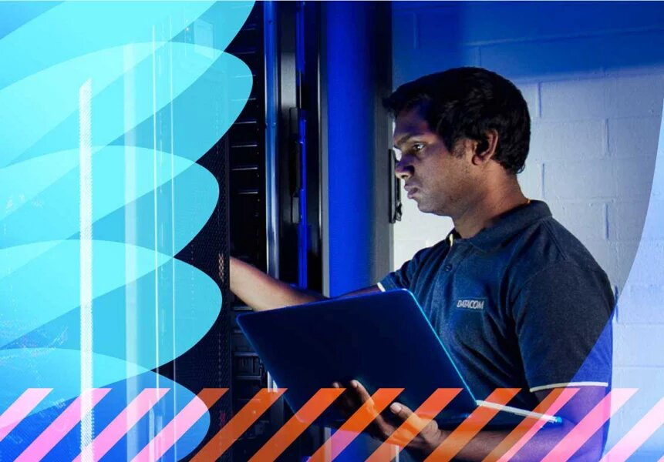
https://main--my-eds-site--guptapawan86.aem.page/au/en/solutions/security/protective-services
Protective services
Protect your people and business from harm, loss, and reputational damage.
  - Software management & licensing
    - Software management & licensing

Simplify software and licensing with tailored solutions that meet your business needs.
    - 
https://main--my-eds-site--guptapawan86.aem.page/au/en/solutions/software-management-and-licensing/software-asset-management
Software Asset Management
Control costs, support compliance, and maximise the value of your software.
    - 
https://main--my-eds-site--guptapawan86.aem.page/au/en/solutions/software-management-and-licensing/licensing-consultancy-services
Licensing consultancy services
Navigate the intricacies of software licensing with expert guidance.
    - 
https://datacom.com/au/en/solutions/asset-lifecycle-services/vendor-relationship-management
Vendor relationship management
Resilient supply chains through expert supplier relationship management.
  - Technology lifecycle services
    - Technology lifecycle services

Unlock the greatest value from your IT assets; optimising people, performance and planet.
    - 
https://main--my-eds-site--guptapawan86.aem.page/au/en/solutions/asset-lifecycle-services/procurement
Procurement
Streamline your asset procurement strategy with Datacom.
    - 
https://main--my-eds-site--guptapawan86.aem.page/au/en/solutions/asset-lifecycle-services/hardware-and-device-management
Hardware and device management
End-to-end hardware and device management solutions.
    - 
https://main--my-eds-site--guptapawan86.aem.page/au/en/solutions/asset-lifecycle-services/warehousing-and-logistics
Integration and logistics
Secure, comprehensive warehousing and logistics services in Australia.
    - https://main--my-eds-site--guptapawan86.aem.page/au/en/solutions/asset-lifecycle-services/vendor-relationship-management
Vendor partner relationship management
Resilient supply chains through expert supplier relationship management.
    - https://datacom.com/au/en/solutions/artificial-intelligence/ai-sandpit
AI Sandpit
Datacom's AI Sandpit provides a safer path to AI for organisations, enabling on-premises or hybrid deployments from pilots to production.
- Products
  - Data centres
    - Data centres

Secure, scalable and award-winning data centre solutions for your vital IT infrastructure.
    - 
https://main--my-eds-site--guptapawan86.aem.page/au/en/products/data-centres/enterprise-solutions
Data centre solutions for enterprises
Move your equipment to our certified, resilient data centre.
    - 
https://main--my-eds-site--guptapawan86.aem.page/au/en/products/data-centres/it-solution-aggregators
Data centre solutions for IT aggregators
Take advantage of our proven and trusted reseller model.
    - 
https://main--my-eds-site--guptapawan86.aem.page/au/en/products/data-centres/saas-and-cloud
SaaS and cloud provider data centre solutions
Have full confidence that your business is in safe hands with our 100% uptime.
    - 
https://main--my-eds-site--guptapawan86.aem.page/au/en/products/data-centres/high-density-and-power
Data centres for high-density AI workloads
Support your AI workload with our high-density secure data centre hub.
    - 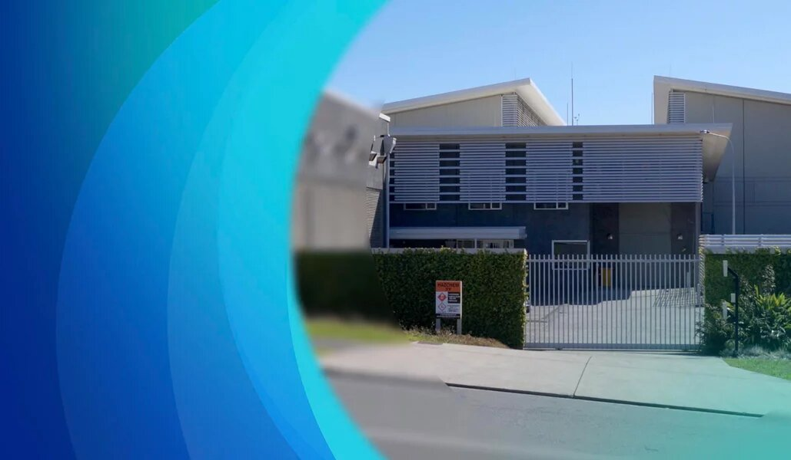
https://main--my-eds-site--guptapawan86.aem.page/au/en/products/data-centres/locations
Our data centre locations
Full service, high-density data centres managed and operated to the highest standards.
    - 
https://main--my-eds-site--guptapawan86.aem.page/au/en/products/data-centres/global-growth
Enterprise data centers for global growth
Keep your data safe, scalable and supported in our enterprise-grade colocation data centers for global growth.
  - Datapay
    - Datapay

A modern, cloud-based payroll service for Australia and New Zealand.
    - 
https://main--my-eds-site--guptapawan86.aem.page/au/en/products/datapay/managed-payroll
Managed Payroll
Our payroll consulting team help you deliver effective and efficient payroll solutions.
    - 
https://main--my-eds-site--guptapawan86.aem.page/au/en/products/datapay/mypay
MyPay
Engage and empower your staff with Datacom's on-the-go MyPay payroll app.
    - 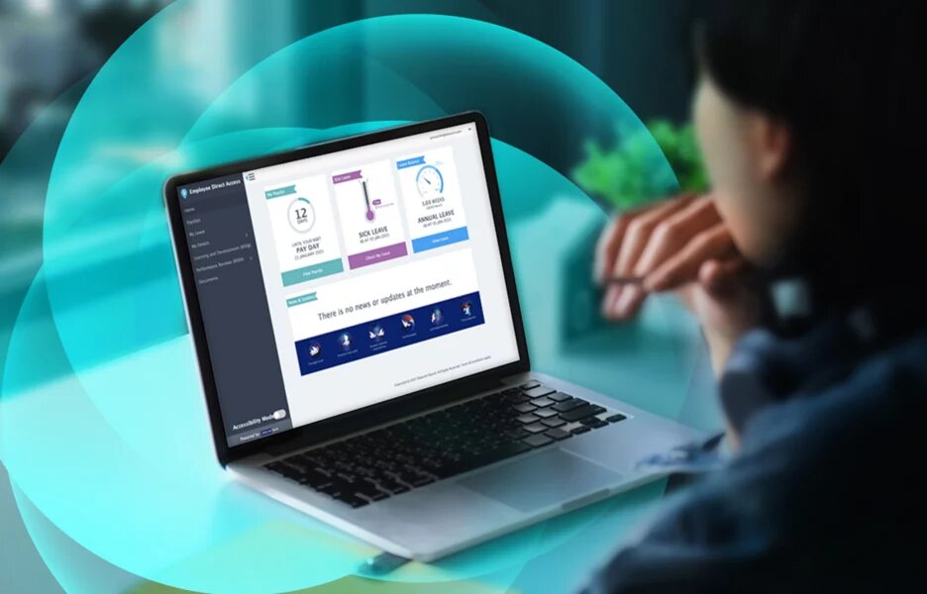
https://main--my-eds-site--guptapawan86.aem.page/au/en/products/datapay/direct-access
Direct Access
Datapay's employee self-service payroll portal.
    - 
https://main--my-eds-site--guptapawan86.aem.page/au/en/products/datapay/payroll-compliance
Payroll compliance
Support better payroll compliance and avoid costly errors with Datapay.
    - 
https://main--my-eds-site--guptapawan86.aem.page/au/en/products/datapay/integrations
Payroll integrations
Explore our payroll integration capability.
    - 
https://main--my-eds-site--guptapawan86.aem.page/au/en/products/datapay/payroll-implementation
Payroll implementation
Our payroll consulting team help you deliver effective and efficient payroll solutions.
    - 
https://main--my-eds-site--guptapawan86.aem.page/au/en/products/datapay/payroll-security
Payroll security
Protect your payroll and employee data with security features and protocols.
    - https://main--my-eds-site--guptapawan86.aem.page/au/en/products/datapay/payroll-assistant
Payroll Assistant
  - Datascape
    - Datascape

Datascape integrates rates, CRM, community engagement and regulatory compliance for Australian councils.
    - 
https://main--my-eds-site--guptapawan86.aem.page/au/en/products/datascape/antenno
Antenno
Antenno is a two-way mobile application connecting councils and communities, purpose-built for Australian local government.
    - 
https://main--my-eds-site--guptapawan86.aem.page/au/en/products/datascape/bookings
Bookings
Bookings is Datacom's council facility booking software for local government across Australia.
    - 
https://main--my-eds-site--guptapawan86.aem.page/au/en/products/datascape/crm
Datascape CRM
Datascape CRM software for local government tracks every request, interaction and outcome unifying community interactions for Australian councils.
    - 
https://main--my-eds-site--guptapawan86.aem.page/au/en/products/datascape/fieldwork
Mobile fieldwork
Streamline council field operations with mobile inspection software for Australian councils, delivering services to communities faster by working remotely.
    - 
https://main--my-eds-site--guptapawan86.aem.page/au/en/products/datascape/financials
Financials
Datascape Financial is local government financial software that automates budgets, spending and reporting for Australian councils.
    - 
https://main--my-eds-site--guptapawan86.aem.page/au/en/products/datascape/my-datascape
MyDatascape
MyDatascape is a purpose-built local government portal providing 24/7 access to council forms, payments and request tracking for Australian citizens.
    - 
https://main--my-eds-site--guptapawan86.aem.page/au/en/products/datascape/property-and-rating
Property & rating
Support sustainable revenue generation through automated property records & rates management. Built for Australian local government to manage rates revenue with accuracy, compliance and transparency.
    - 
https://main--my-eds-site--guptapawan86.aem.page/au/en/products/datascape/regulatory-and-compliance
Regulatory & compliance
As regulatory reporting software, Australian councils can unify development applications, planning, licensing and more with Datascape Regulatory & Compliance.
    - 
https://main--my-eds-site--guptapawan86.aem.page/au/en/products/datascape/websites
Websites
Datascape Websites enable local government to deliver engaging digital experiences for customers and communities across Australia.
  - Gateway
    - Gateway

Gateway incorporates two products - for payments and sending messages, with different features and customer bases.
    - 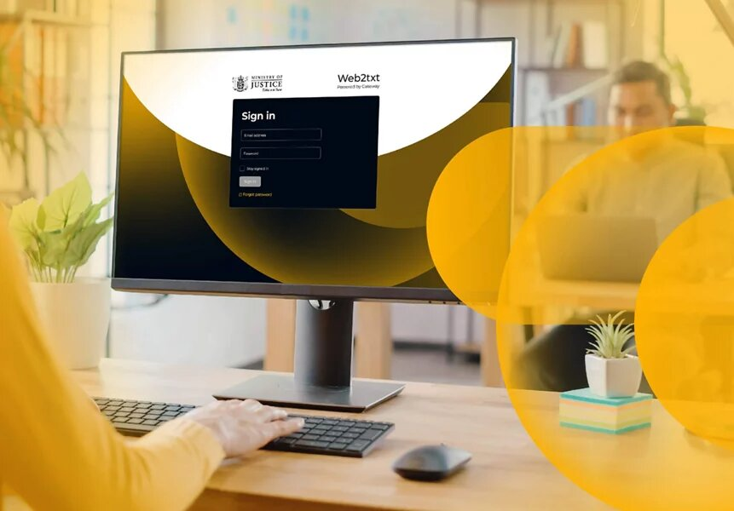
https://main--my-eds-site--guptapawan86.aem.page/au/en/products/gateway/datacom-message-manager
Datacom Message Manager
Communicate with your customers anywhere, any time.
    - 
https://main--my-eds-site--guptapawan86.aem.page/au/en/products/gateway/payment-gateway
Payment gateway
Give your business secure payment innovation and reliable processing services.
  - Timpani
    - Timpani

The event management platform made for transport and logistics networks of any scale.
    - 
https://main--my-eds-site--guptapawan86.aem.page/au/en/industries/transportation-and-logistics
Transportation & logistics
Managed IT services for logistics to improve automation, safeguard operations and support process optimisation.
    - 
https://main--my-eds-site--guptapawan86.aem.page/au/en/products/timpani/digital-supply-chain
Digital supply chain
Get real time visibility and integration across your network.
- Industries
  - 
https://main--my-eds-site--guptapawan86.aem.page/au/en/industries/agriculture
Agriculture
Harvest the benefits of modern technologies and grow your business.
  - 
https://main--my-eds-site--guptapawan86.aem.page/au/en/industries/education
Education
Shaping a digitally-driven future to impact today's students for their tomorrow.
  - 
https://main--my-eds-site--guptapawan86.aem.page/au/en/industries/energy-and-utilities
Energy & utilities
Supply consistent, sustainable, and safe energy and utilities with technology.
  - 
https://main--my-eds-site--guptapawan86.aem.page/au/en/industries/engineering-and-construction
Engineering & construction
Streamline processes, remove manual pain points, and build for the future.
  - 
https://main--my-eds-site--guptapawan86.aem.page/au/en/industries/financial-services
Financial services
From AI to business processes, get better value for money and improved CX.
  - 
https://main--my-eds-site--guptapawan86.aem.page/au/en/industries/fmcg-and-retail
Fast moving consumer goods & retail
Get future-ready digital solutions to enhance customer service and loyalty.
  - 
https://main--my-eds-site--guptapawan86.aem.page/au/en/industries/healthcare
Healthcare
Maximise patient care and empower staff with automation and next-gen tech.
  - 
https://main--my-eds-site--guptapawan86.aem.page/au/en/industries/manufacturing
Manufacturing
Use smart technology to connect systems seamlessly and improve communication.
  - 
Public sector
From regional to national, we help connect and empower communities and citizens.
    - 
https://main--my-eds-site--guptapawan86.aem.page/au/en/industries/public-sector/local-government
Local government
Connect and engage communities with purpose-built local government software solutions.
    - https://main--my-eds-site--guptapawan86.aem.page/au/en/industries/public-sector/federal-government
Federal government
We’re a trusted government partner and help to support its essential services.
    - 
https://main--my-eds-site--guptapawan86.aem.page/au/en/industries/public-sector/state-government
State government
We support state government with digital platforms, AI-driven tools, and secure infrastructure.
  - 
https://main--my-eds-site--guptapawan86.aem.page/au/en/industries/media-entertainment-and-telecoms
Media, entertainment & telecoms
Adopt newsworthy tech to provide thoughtful and engaging customer experiences.
  - 
https://main--my-eds-site--guptapawan86.aem.page/au/en/industries/professional-services
Professional services
Automate your processes and use your specialist skills to grow your business.
  - 
https://main--my-eds-site--guptapawan86.aem.page/au/en/industries/tourism-and-hospitality
Tourism & hospitality
Enhance customer experiences with emerging technologies and mobile integration.
  - https://main--my-eds-site--guptapawan86.aem.page/au/en/industries/transportation-and-logistics
Transportation & logistics
Managed IT services for logistics to improve automation, safeguard operations and support process optimisation.
- Insights
- About Us
  - 
https://main--my-eds-site--guptapawan86.aem.page/au/en/about-us/who-we-are
Who we are
Datacom helps customers use the power of tech to make a difference in people's lives.
  - 
https://main--my-eds-site--guptapawan86.aem.page/au/en/about-us/our-team
Our team
Meet our leadership team and board and learn more about their roles.
  - 
https://main--my-eds-site--guptapawan86.aem.page/au/en/about-us/sustainability
Our sustainability journey
We're working with our customers and partners to create a more sustainable future.
  - 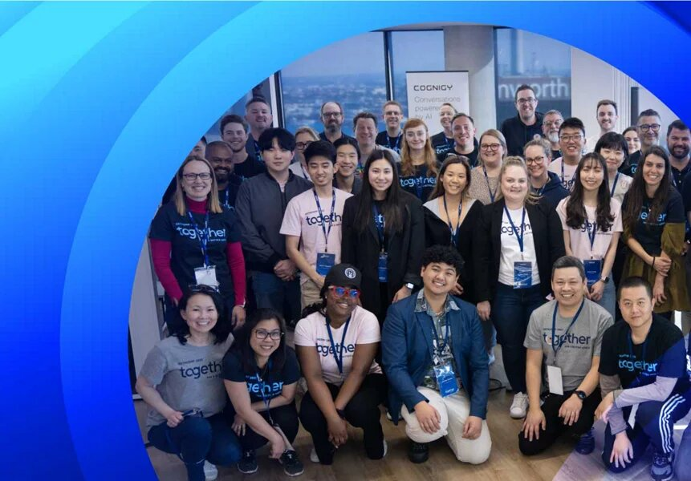
https://main--my-eds-site--guptapawan86.aem.page/au/en/about-us/our-communities
Our communities
Datacom values making a contribution to the communities where we live and work.
  - 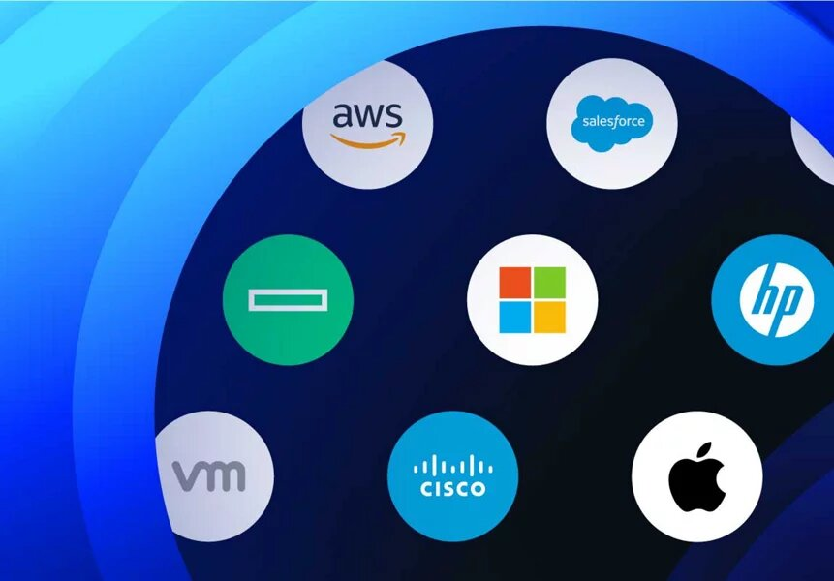
https://main--my-eds-site--guptapawan86.aem.page/au/en/about-us/partners
Partners
Explore our valued partnerships with the world’s most innovative tech providers.
  - 
https://main--my-eds-site--guptapawan86.aem.page/au/en/about-us/awards
Awards
See the awards we're honoured to receive and the stories behind our work.
  - 
https://main--my-eds-site--guptapawan86.aem.page/au/en/about-us/year-in-review
Year in Review
Explore our annual highlights and how we connect people and technology.
  - 
https://datacom.com/au/en/contact-us
Our locations
Find one of our global offices and contact information for each one.
- Careers
  - Careers at Datacom

Join a community of innovators and create the future of technology.
  - 
https://main--my-eds-site--guptapawan86.aem.page/au/en/careers/experienced-professionals
Experienced professionals
Learn new skills, add to your wealth of experience, and achieve new goals.
  - 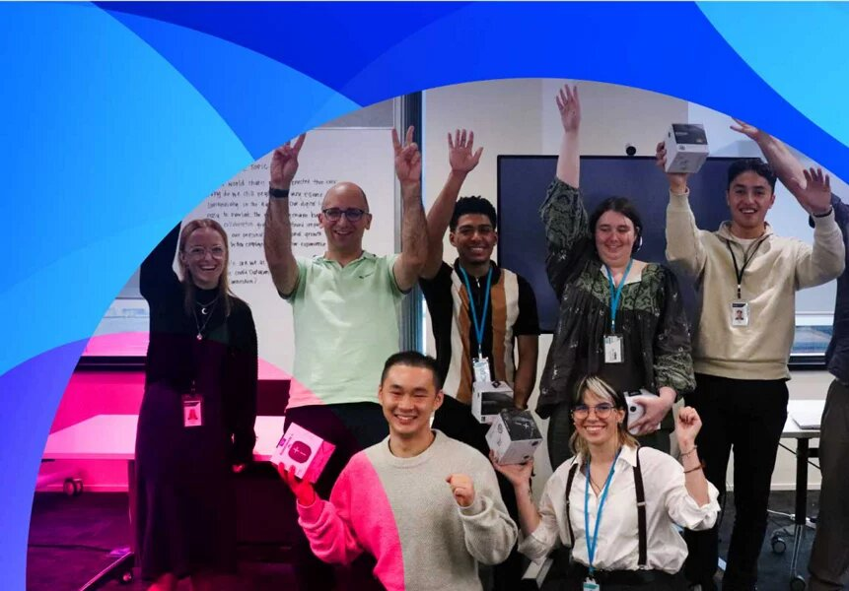
https://main--my-eds-site--guptapawan86.aem.page/au/en/careers/graduates
Early careers
Begin your career with one of Australia's top 100 graduate employers.
  - 
https://main--my-eds-site--guptapawan86.aem.page/au/en/careers/contact-centre-representatives
Contact centre and service desk
Kick start your career and shape your own future with Datacom.
  - 
https://main--my-eds-site--guptapawan86.aem.page/au/en/careers/why-datacom
Why Datacom?
Explore our values and inclusivity and how our people make the difference.
  - 
https://main--my-eds-site--guptapawan86.aem.page/au/en/careers/search
Search
From grad opportunities to new beginnings and challenges, find your next role.
---
Sign in
---
Search datacom.com
Quick links
- Insights — Customer Stories, Ebooks, Video & Resources
- Our communities
- Our sustainability journey
- Two in three Australian organisations to appoint CAIO: 2027
- 2025 Annual Cloud & Infrastructure Report

