**AEM Skill Up – Content Fragment [CF] Hands on Activities**

**Objective:**

Create a structured web FAQ section using AEM Content Fragments and link it to the Card Section for display.

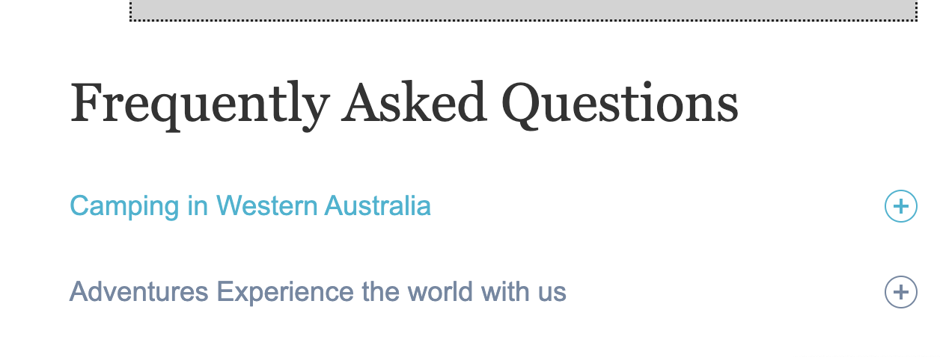

**Prerequisites:**

* Access to AEM Author instance.
  + https://author-p137117-e1400714.adobeaemcloud.com
* Basic understanding of AEM Sites and Content Fragments.
* AEM Content Fragment Models have been enabled in your instance.

**Step-by-Step Guide**

**Step 1: Create a Content Fragment Model**

1. **Navigate to AEM Start**:
   * Go to **Tools** > **General** > **Content Fragment Models**.



https://author-p137117-e1400714.adobeaemcloud.com/ui#/aem/libs/dam/cfm/models/console/content/models.html/conf



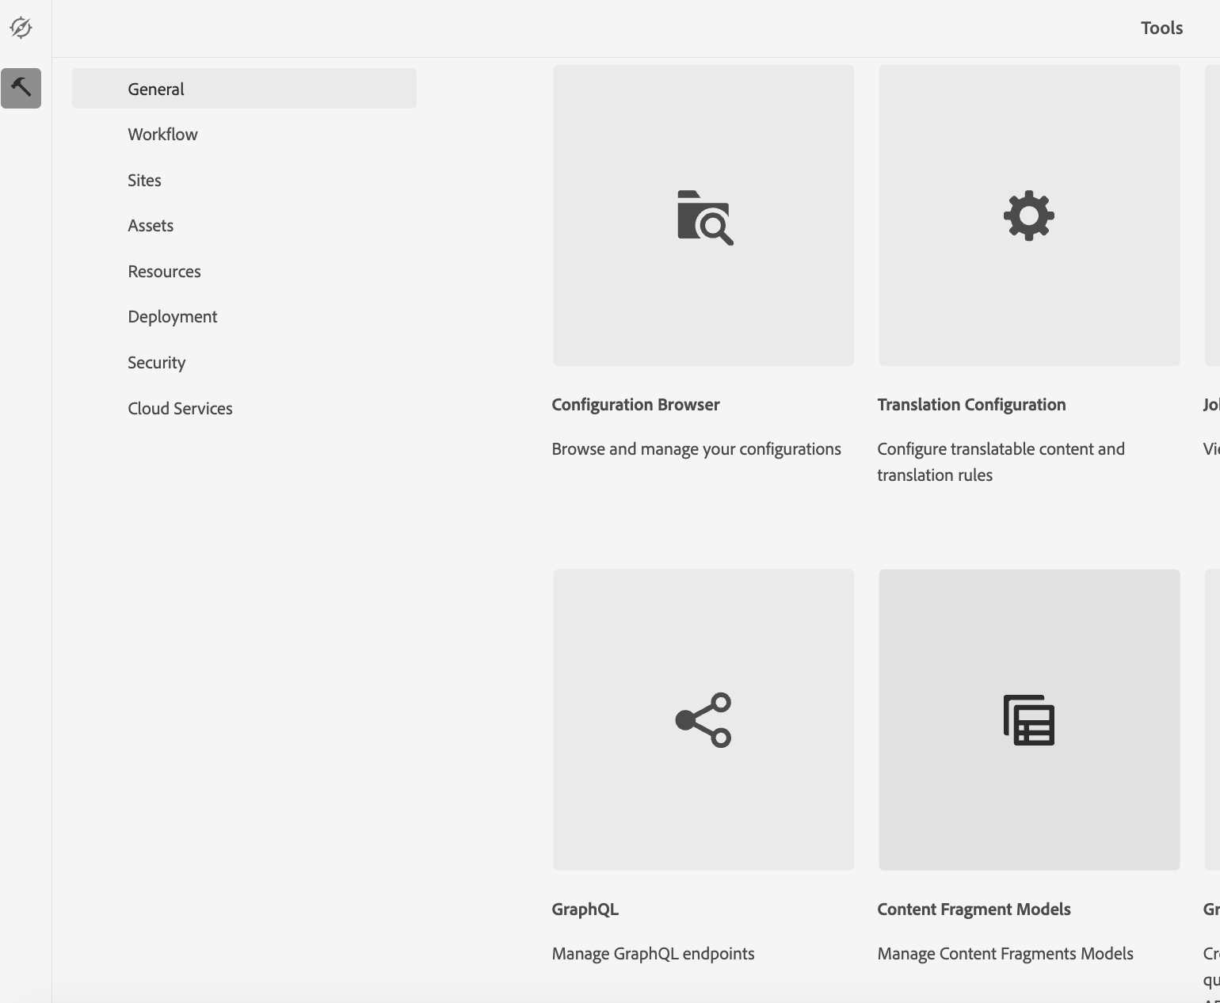



1. **Navigate to the “SAT Event Learning Program” Folder by clicking on it.**

https://author-p137117-e1400714.adobeaemcloud.com/ui#/aem/libs/dam/cfm/models/console/content/models.html/conf/sateventlearningprogram

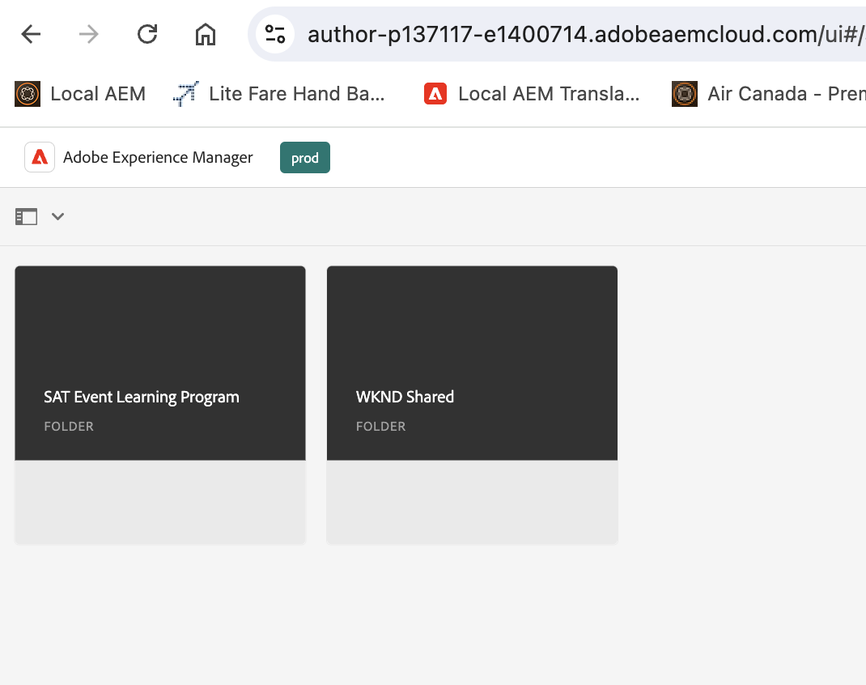

1. **Create a New Model by clicking on Create Button**
   * Click on **Create** > **Content Fragment Model**.
   * Enter a **Title** ( **FAQ Model – Your Name Ex. FAQ Model - Pawan**) and click **Create**.

1. **Define the Model**:
   * Open the newly created model ( **FAQ – Your Name).**
   * Add fields to your model. For an FAQ, Drag and drop these fields from the side panel into the model editor.
     + **Single Line Text** for the Question (Provide Field Label as Question and Property Name as question.

**Field Label: Question**

**Property Name: question**

* + - **Multi-line text** for the answer. Provide Field Label as Answer and Property Name as answer).

Field Label: Answer

Property Name: answer

1. **Save and Enable the Model**:
   * Click **Save** and then **Enable**.

**Step 2: Create Content Fragments [FAQ] Using the “FAQ- Your Name” Model**

1. **Navigate to AEM Start**:
   * Go to **Assets** > **Files > Sat Event Learning Program**

<https://experience.adobe.com/?repo=author-p137117-e1400714.adobeaemcloud.com#/@sateventlearning/aem/cf/admin/content/dam/sateventlearningprogram?appId=aem-cf-admin> [ New CF UI]

<https://author-p137117-e1400714.adobeaemcloud.com/ui#/aem/assets.html/content/dam/sateventlearningprogram> [ Old CF UI]

1. **Create a Folder for FAQs**:
   * Click on **Create** > **Folder**.
   * Enter a **Title** (e.g., FAQ – Your Name) and click **Create**.

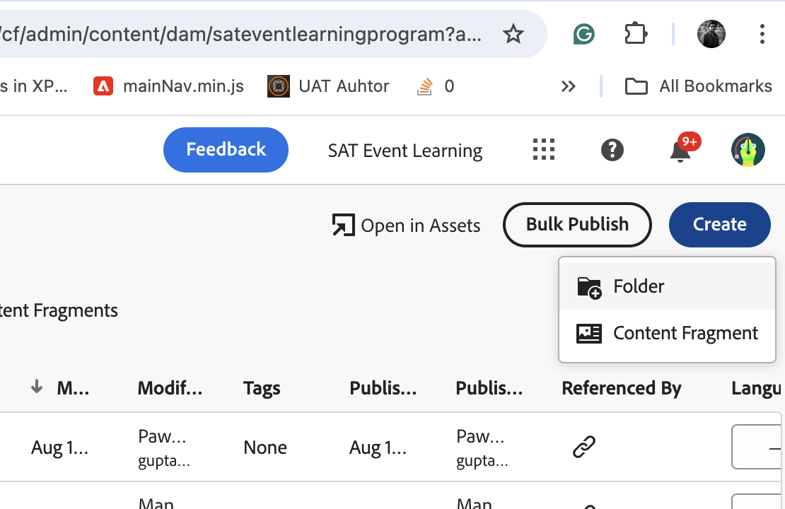

1. **Create Content Fragments**:
   * Navigate into the newly created folder [FAQ – Your Name]
   * Click on **Create** > **Content Fragment**.
   * Select the [ **FAQ Model - Your Name ]** and click **Next**.
   * Enter a **Title** for the content fragment (e.g., FAQ and click **Create & Open**.

1. **Enter FAQ Content**:
   * Open the newly created content fragment.
   * Fill in the fields with your FAQ data, for example:
     + **Question**: **Your Name** - What is a credit card?
     + **Answer**: **Your Name -** A credit card is a financial tool issued by banks that allows you to borrow up to a specific limit to make purchases, pay bills, or withdraw cash. Depending on the card's terms, the borrowed amount must be repaid, often with interest.
   * Click **Save**.
2. **Repeat** for additional FAQs ( create 3-4 Faqs in similar ways) :
   * Create more content fragments for each FAQ using the same process.

**Step 3: Create a Page to Display FAQs**

1. **Navigate to AEM Sites**:
   * Go to **Sites** and Navigate to SAT Event Learning Program -> US -> EN -> FAQ Exercise

<https://author-p137117-e1400714.adobeaemcloud.com/ui#/aem/sites.html/content/sateventlearningprogram/us/en/faq-exercise>

1. **Create a New Page**:
   * Navigate to the location mentioned above and create the FAQ page.
   * Click on **Create** > **Page**.
   * Select a template (e.g., **Content Page**) and click **Next**.
   * Enter a **Title** (e.g., FAQ – Your Name) and click **Create**.
2. **Edit the Page**:
   * Open the newly created page [ FAQ – Your name]
   * Drag and drop the **Content Fragment List** component from the side panel onto the page.

1. **Configure the Component**:
   * Select the **Content Fragment List** component on the page.
   * Click on the **wrench icon** to configure it.
   * Select the model value as  **FAQ – Your Name Model**
   * Click **Done**.

1. Your FAQ Data will be displayed in the Raw Format.

1. **Publish the Page**:
   * To make the page live, click **Publish Page**.

**Step 4: Verify the FAQ Page**

1. **Preview the Page**:
   * Please navigate the FAQ page URL to preview its appearance and ensure all content fragments are displayed correctly.
2. **Edit and Update as Needed**:
3. Make any necessary adjustments

Now, the presenter will cover the section below.

1. **Style the FAQ Section** and link it to the Card Model.

.