### **AEM Skill Up – Experience Fragment [XF] Hands-on Activities**

### **Activity Overview**

* **Objective**: Create an Experience Fragment for a credit card promotion that can be reused across multiple channels (web, email, mobile) and pages.

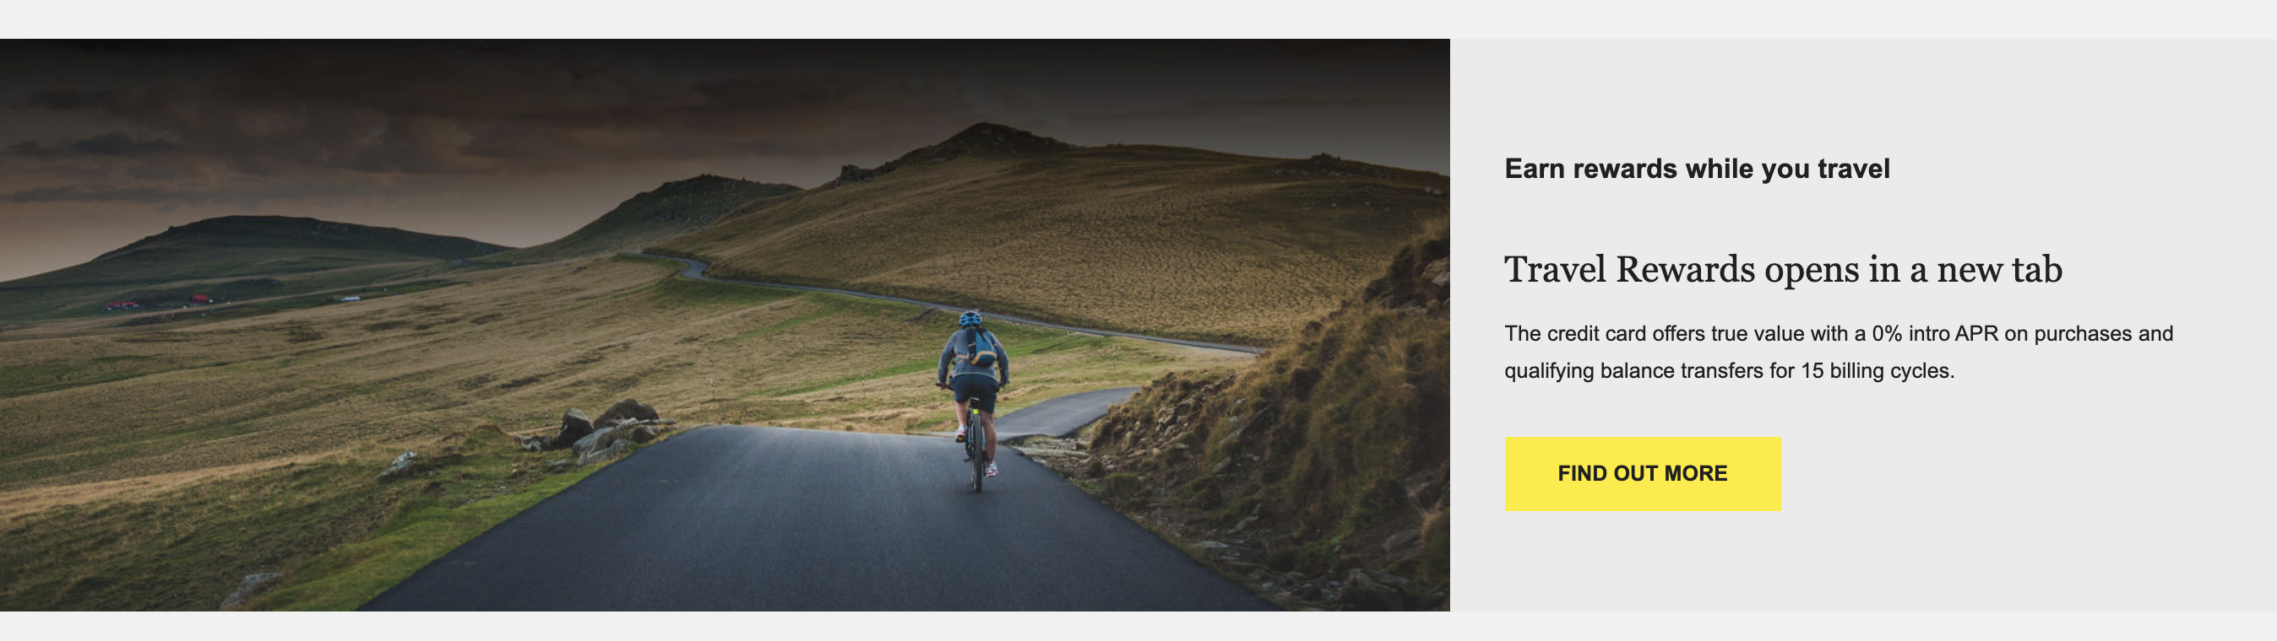

* **Prerequisites**: Access to AEM, a basic understanding of AEM components and templates, and experience with fragment
* Access to AEM Author instance.
  + [https://author-p137117-e1400714.adobeaemcloud.com/](https://author-p137117-e1400714.adobeaemcloud.com/ui#/aem/aem/start.html)

### **Step-by-Step Guide**

#### **Step 1: Access AEM and Navigate to Experience Fragments**

1. **Log in to AEM**:
   * Open your web browser and log in to AEM.

[https://author-p137117-e1400714.adobeaemcloud.com/](https://author-p137117-e1400714.adobeaemcloud.com/ui#/aem/aem/start.html)

* + Navigate to the AEM homepage.

1. **Navigate to Experience Fragments**:
   * Go to **Experience Fragments** by clicking on **Sites** from the AEM homepage.
   * In the left-hand navigation panel, find and click on **Experience Fragments**.
   * Navigate to content > experience fragments > SAT Event Learning Program > us > en > Banking > Promotion

<https://author-p137117-e1400714.adobeaemcloud.com/ui#/aem/aem/experience-fragments.html/content/experience-fragments/sateventlearningprogram/us/en/banking/promotion>

#### **Step 2: Create a New Experience Fragment**

1. **Create a New XF**:
   * Click the **Create** button in the top right corner.
   * Select **Experience Fragment** from the dropdown menu.
2. **Choose a Template**:
   * You’ll be prompted to choose a template. Select a template “Web-Variation.”

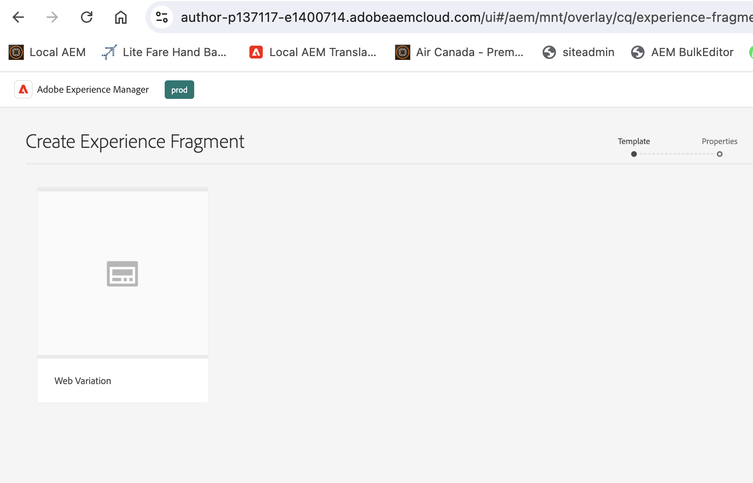

* + Click **Next**.

1. **Name Your Experience Fragment**:
   * Provide a name, e.g., "Credit Card Promo – Your Name."
   * Optionally, add a description to help identify the XF's purpose.
   * Click **Create**, then click **Open**.

#### **Step 3: Add Content to the Experience Fragment**

1. **Add Components**:
   * Drag and drop components like **Text**, **Images, and Buttons or Teaser Components** onto the canvas.

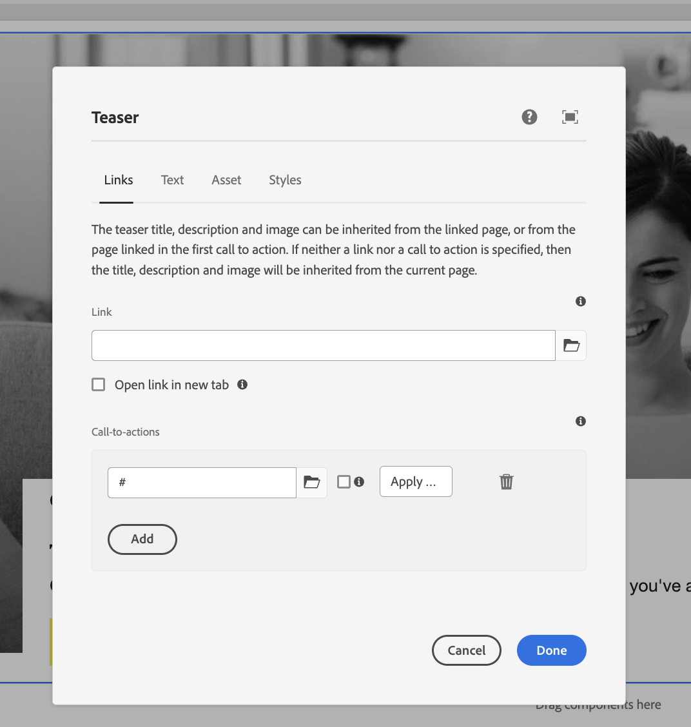

* + For example:
    - **Text**: Add a headline like "Get Your New Platinum Credit Card Today! - Your Name"
    - **Image**: Add a relevant image of the credit card.
    - **Button**: Add a button with a credit card application page link.

1. **Edit Content**:
   * Click on each component to edit its content.
   * For the **Text** component, add a brief description of the card's benefits.
   * For the button, set the label to "Apply Now" and link it to the relevant landing page.

#### **Step 4: Preview and Save the Experience Fragment**

1. **Preview Your XF**:
   * Click the **Preview** button to see how the Experience Fragment looks on different devices (desktop, tablet, mobile).
   * Ensure the layout is responsive and that content displays correctly on all devices.
2. **Save Your Work**:
   * Click **Save** to ensure all your changes are saved.

#### **Step 5: Use the Experience Fragment Across Channels**

1. **Embed in a Web Page**:
   * Open a FAQ page created in CF Activity in AEM where you want to include the XF.

<https://author-p137117-e1400714.adobeaemcloud.com/ui#/aem/sites.html/content/sateventlearningprogram/us/en/faq-exercise>

* + Drag the XF component onto the page and select the "Credit Card Promo XF – Your Name" from the list.
  + Click Done

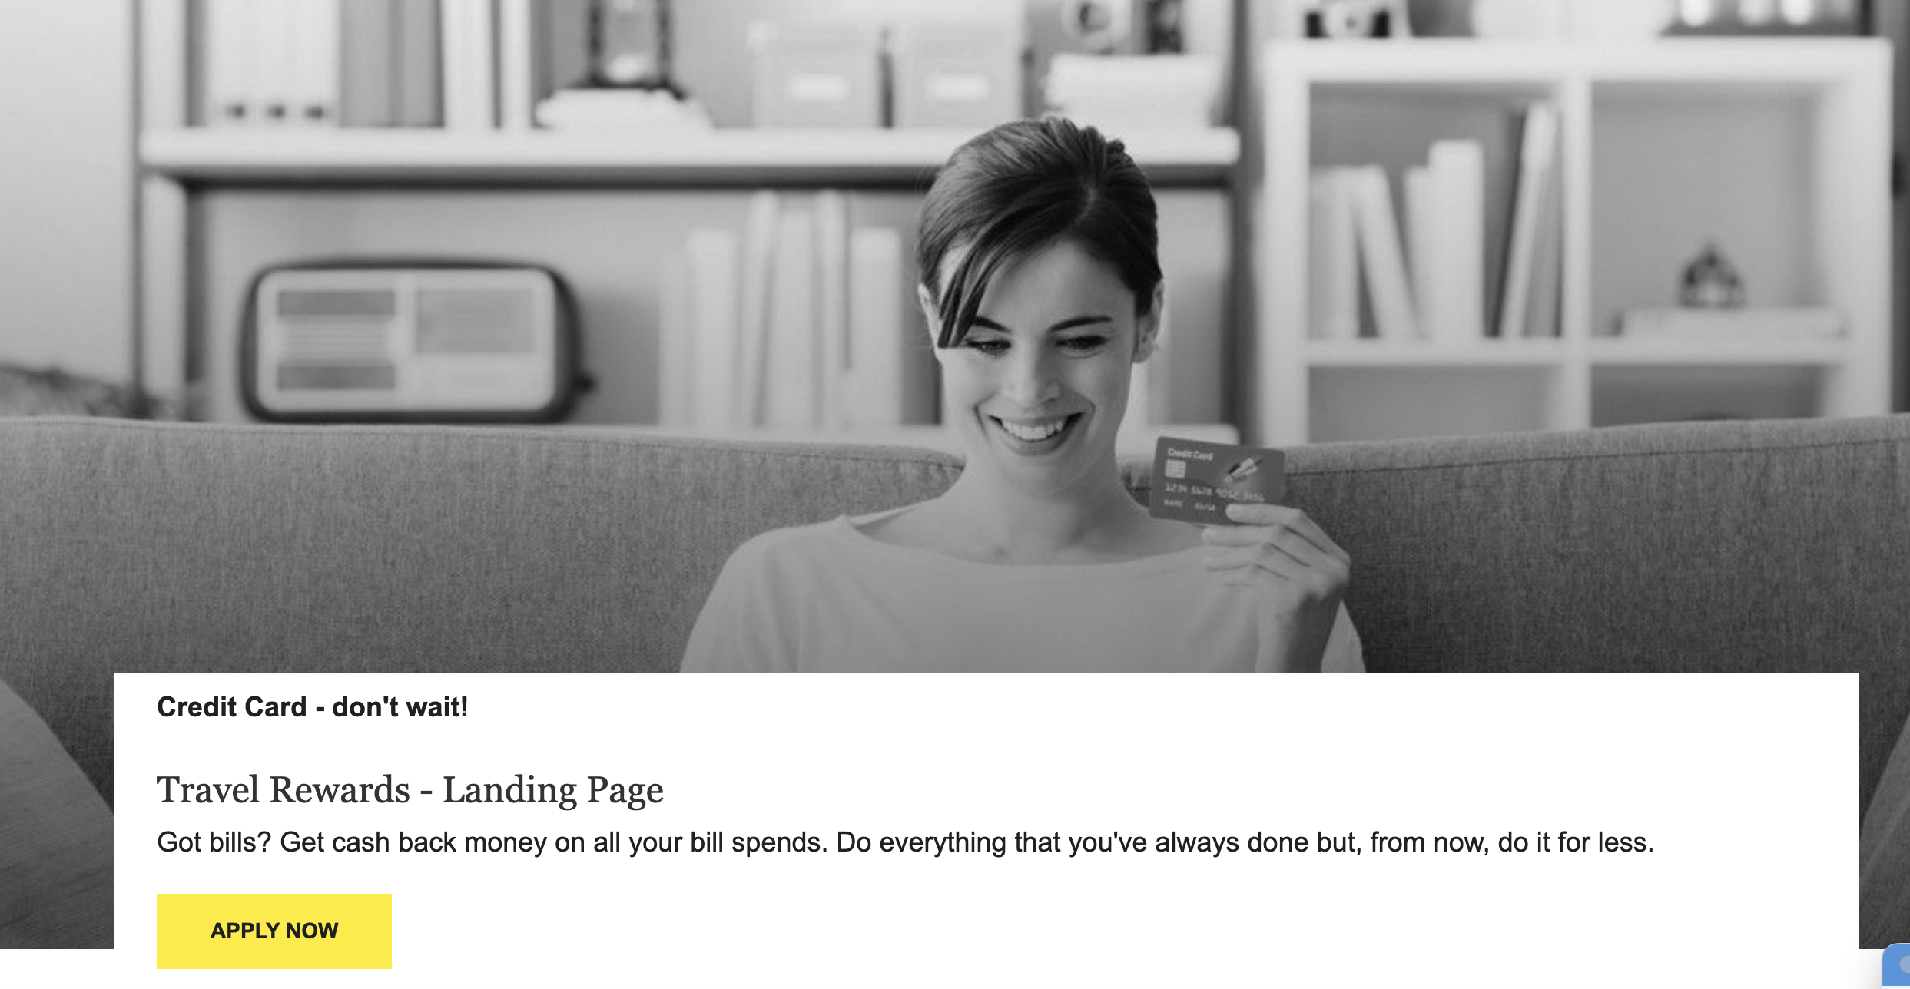

Create a couple more AEM pages and repeat **step 10** to see the same XF displayed on the other pages.

1. Publish the XF and pages.

Note: Whenever you update the content in XF, it will be reflected across all the pages where the XF is being referenced.