**Software Development Life Cycle (SDLC) Overview**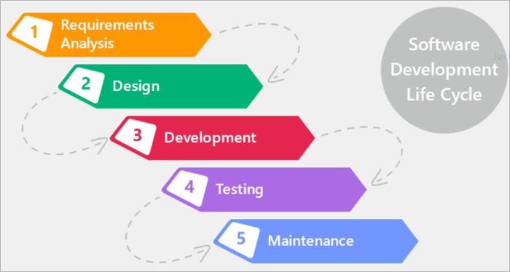

**1. Requirements**

Identify the wishes and expectations of stakeholders. Define the scope, desires, and functionalities of the software. Establish clear and measurable goals.

**2. Design**

Create an in depth blueprint of the software program structure. Design person interfaces and gadget functionalities. Determine the generation stack and assets required.

**3. Implementation**

Translate design into code. Develop and combine software components. Write smooth, maintainable, and green code.

**4. Testing**

Verify that the software meets the required requirements. Identify and attach defects and bugs. Conduct various types of testing (unit, integration, device, popularity).

**5. Deployment**

Release the software program to users or clients. Install and configure the software within the production surroundings. Provide schooling and support for cease-customers.

**Interconnection of Phases:**

* Requirements pressure layout and implementation.
* Design guides the development process.
* Implementation is primarily based on design specifications.
* Testing ensures the best and capability of the applied software program.
* Deployment grants the finalized product to customers.