Assignment 1: Create an infographic illustrating the Test-Driven Development (TDD) process. Highlight steps like writing tests before code, benefits such as bug reduction, and how it fosters software reliability

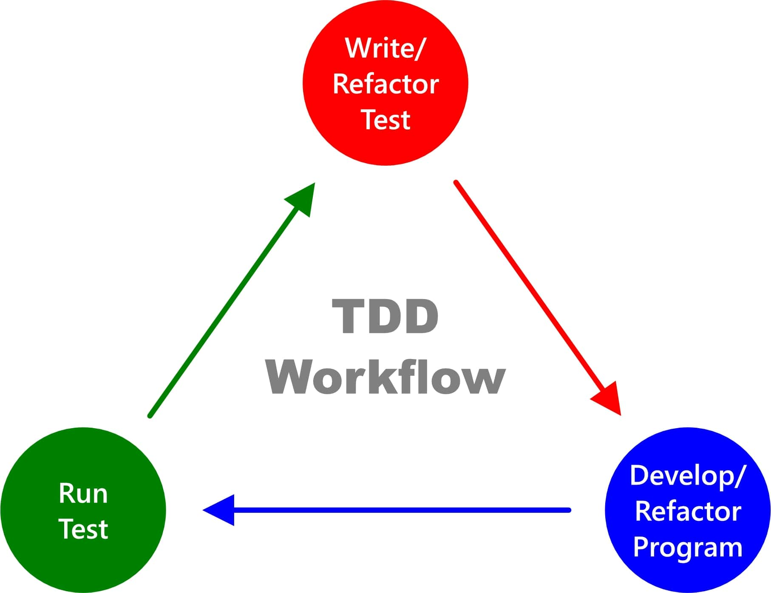

**1. Write a Test:**

• Visual of a developer writing a test case before writing any code.

• Caption: "Start by writing a test that defines the desired behavior of the feature."

**2. Run the Test:**

• Image of running the test and showing it fail.

• Caption: "Run the test and witness it fail, as expected since no code has been implemented yet."

**3. Write Code:**

• Illustration of a developer writing code to make the test pass.

• Caption: "Write the minimum amount of code necessary to make the test pass."

**4. Run Tests:**

• Visual representation of running all tests, including the new one.

• Caption: "Run all tests to ensure that the new test passes without breaking existing functionality."

**5. Refactor Code:**

• Image of a developer refactoring the code without changing its functionality.

• Caption: "Refactor the code to improve its design without altering its behavior."

**Benefits of TDD:**

• Icon or illustration representing each benefit:

• Bug Reduction: A magnifying glass over a bug-free code.

• Improved Code Quality: A graph showing code quality improvement over time.

• Faster Development: A stopwatch with an arrow pointing downwards, indicating reduced development time.

• Enhanced Software Reliability: A shield protecting a computer, symbolizing software reliability.

**Conclusion:**

• Summary statement emphasizing the importance of TDD in building reliable and bug-free software.