Deadlock Prevention in the Ambulance Dispatch System
Coffman conditions, resource allocation graph and lock ordering

1. Overview
The dispatch system runs four worker threads that handle emergencies at the same time. To assign an ambulance, a worker locks up to five candidate ambulance rows in the database using SELECT ... FOR UPDATE. If two workers lock the same rows in different orders, each can end up waiting for the other forever, which is a deadlock.
We prevent this by making every worker lock rows in the same order: ascending primary key. The sections below explain why this works.

2. Coffman Conditions
A deadlock needs all four Coffman conditions to be true at the same time. Breaking any one of them prevents deadlock.
Condition | Meaning | In our project
Mutual exclusion | A resource can be used by only one transaction at a time. | A row locked with FOR UPDATE cannot be locked by another worker.
Hold and wait | A transaction keeps its locks while waiting for more. | A worker holds row 3 while waiting for row 7.
No preemption | A lock cannot be taken away from its owner. | MySQL (InnoDB) releases a lock only at COMMIT or ROLLBACK.
Circular wait | A cycle of transactions, each waiting for the next. | Prevented by locking rows in ascending id order.

The first three conditions cannot be avoided, because rows must be locked exclusively to stop two emergencies from getting the same ambulance. So our project breaks the fourth condition, circular wait.

3. Resource Allocation Graph
In the graphs below, a circle is a transaction (worker) and a square is a row (resource). A solid arrow means the transaction holds the row lock. A dashed arrow means the transaction is waiting for that row.
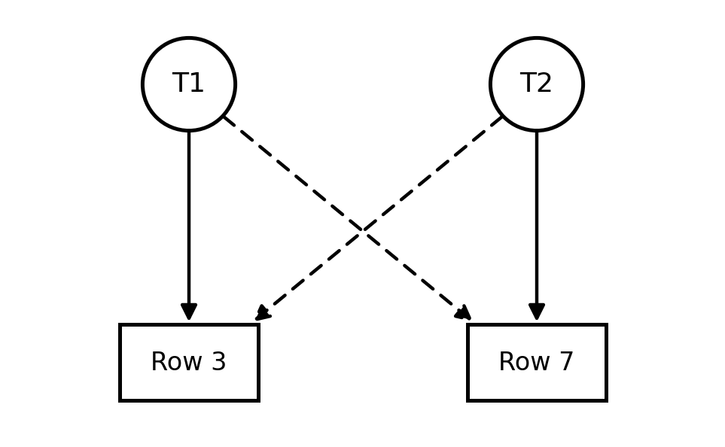
Figure 1: Without ordering. T1 holds row 3 and wants row 7; T2 holds row 7 and wants row 3. The arrows form a cycle, so this is a deadlock.
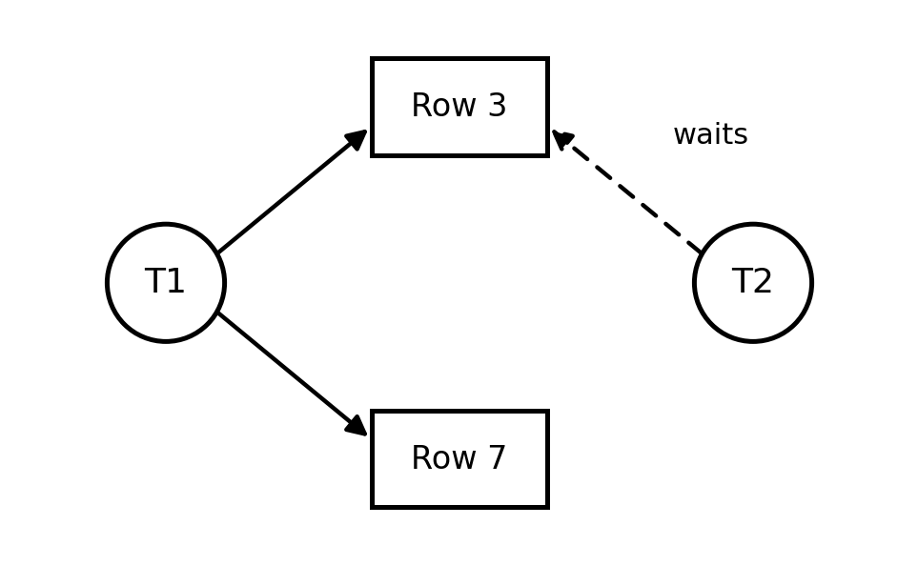
Figure 2: With ascending primary-key order. Both transactions lock row 3 first, so T2 simply waits for T1. There is no cycle, so it is safe.

4. Lock Ordering
Theorem. If every transaction acquires locks in the same total order, no deadlock cycle can form.
In the project (allocation.py), the candidate ambulances are sorted by id before they are locked:
mav_sorted = sorted(mav_candidates, key=lambda c: c[0])
ORDER BY id ASC
FOR UPDATE

Worked example. The candidate rows are 3, 7 and 9. Both transactions follow ascending order.
Step | T1 (first) | T2 (second)
1 | Lock row 3 | Wait for row 3
2 | Lock row 7 | Still waiting
3 | Commit (releases locks) | Lock row 3
4 | - | Row 7 is already assigned, skip
5 | - | Lock row 9 (available)
6 | - | Commit

Rule. Candidate rows must always be locked in ascending primary-key order. This total ordering is our deadlock prevention, so it must not be changed.
Trade-off. Locking with FOR UPDATE causes occasional lock waits (median 97 ms), but all 12 vehicles can be used and no ambulance was double-booked in 40 simultaneous calls. SKIP LOCKED waits only 0.8 ms, but only 9 of 12 vehicles get used.

