Step 1) Git already installed

Step 2) cloning project from GitHub

Cloned successfully

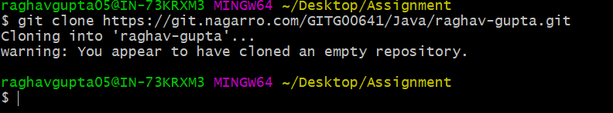

Step3) Creating a folder GitAssignments



Step4) Storing Screenshot on GitAssignments folder

Step 5) Checking Status of current directory

Step 6) Adding file to git project



committing GitASsignment



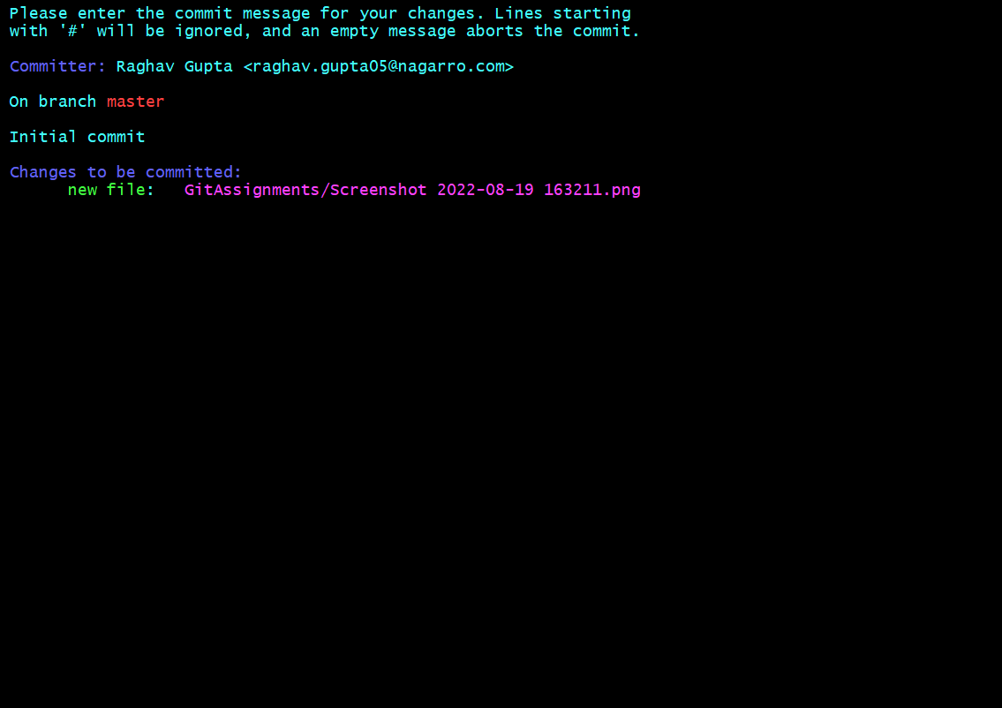

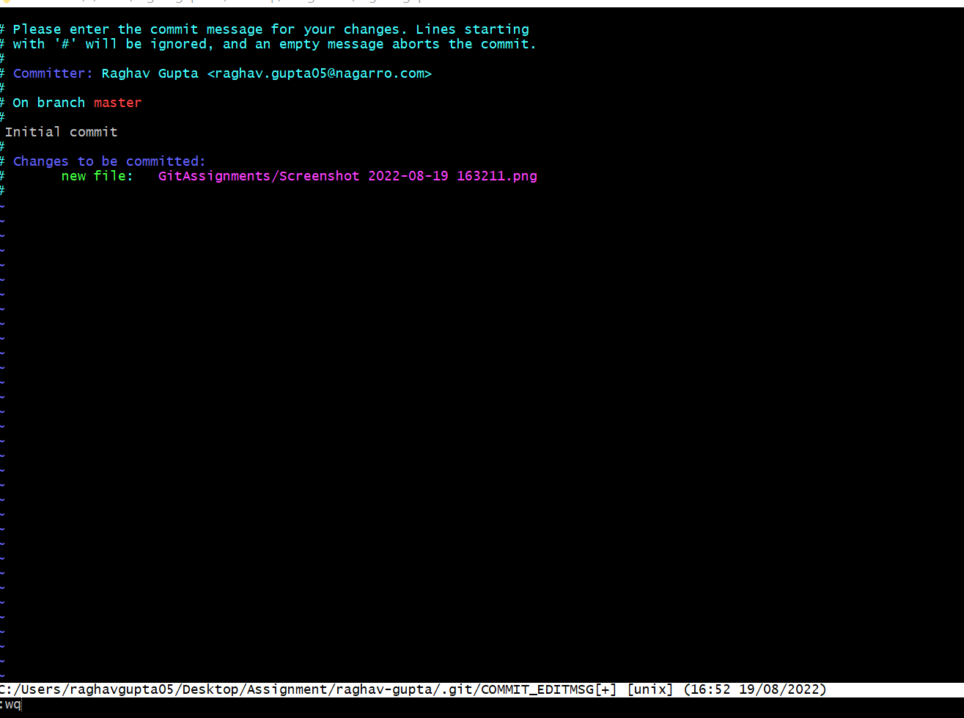

Verification

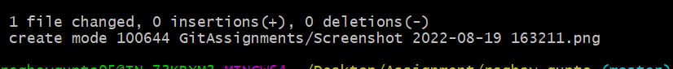

Step 8) Pushing to remote

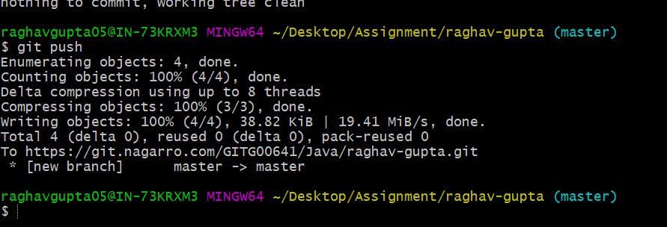

Step 9) Creating new Branch GitlabFiles





Step 10) Showing current active branch (Highlighted green)



Step 11&12) Pushing all files and screen shots to the folder

Step 13) Merging GitlabFiles with master

url= <https://git.nagarro.com/GITG00641/Java/raghav-gupta/merge_requests/1>

Step14&15)

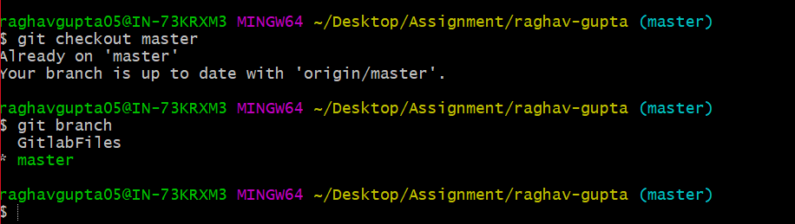

Step 16)

Step 19)

