Step 2) cloning project from github

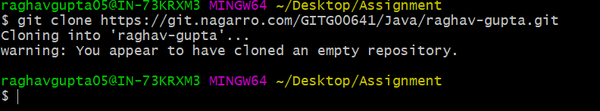

Step3)creating a folder



Step 5)

Step 6)Adding file to git project



committing Gitassignment



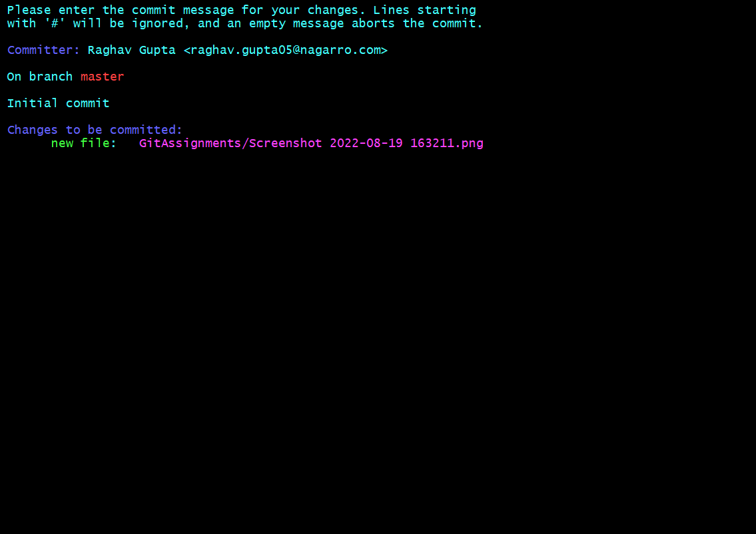

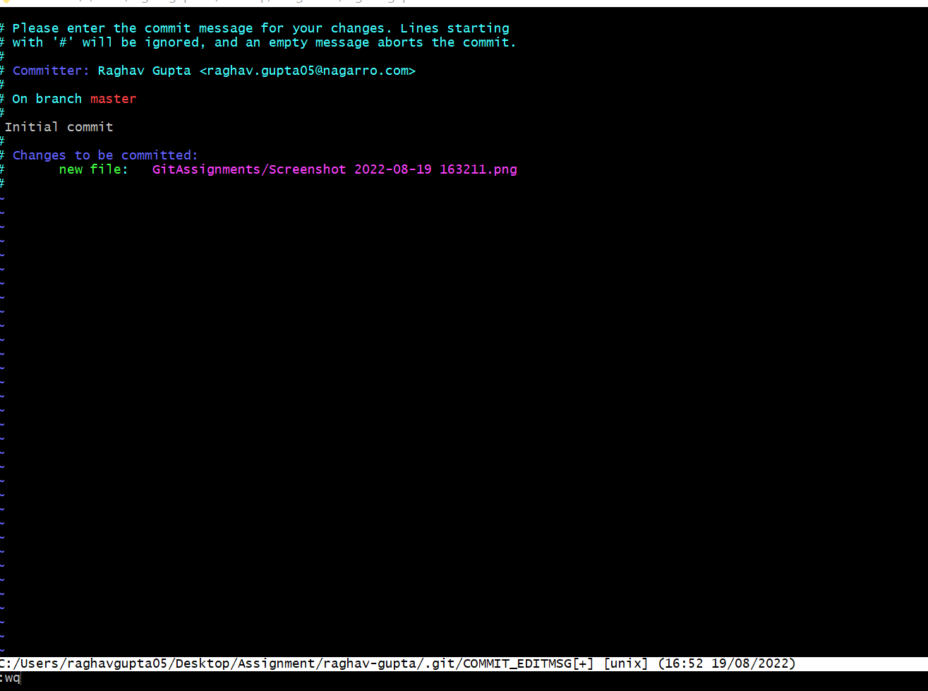

Verification

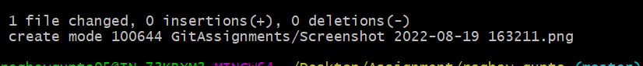

Step 8)pushing to remote

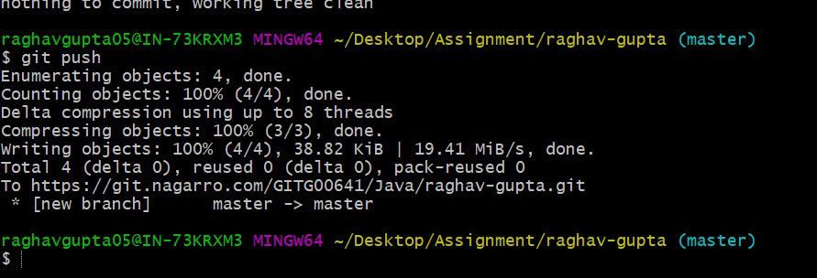

Step 9)





Step 10)



Step 11)

Step 13)url= <https://git.nagarro.com/GITG00641/Java/raghav-gupta/merge_requests/1>

Step14)

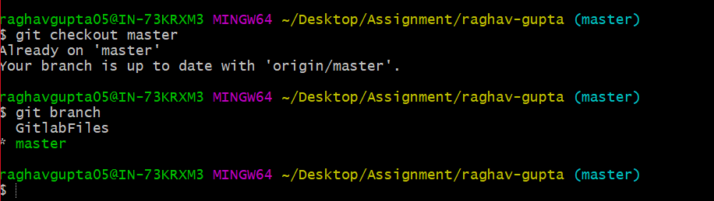

Step 16)

Step 19)

