Document Processing UI
Each page below is the ASP.NET Core MVC screen served at http://localhost:5280. The same service also exposes the API used by Postman.

Dashboard
The dashboard shows how many documents are in each workflow status. Each count opens the document list already filtered to that status. The activity list is the latest audit rows, with the agent that wrote them and a link to that document's history.

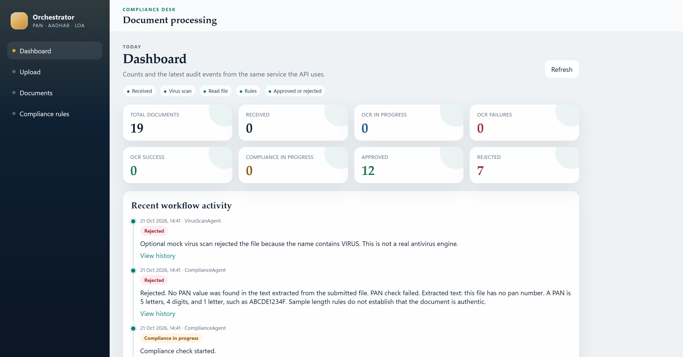

Upload
Upload accepts a customer id, a document type of PAN, AADHAR, or LOA, and a file up to 5 MB. A text file is read directly. An image is read with Windows OCR. After upload, the details page opens and refreshes until the workflow finishes.

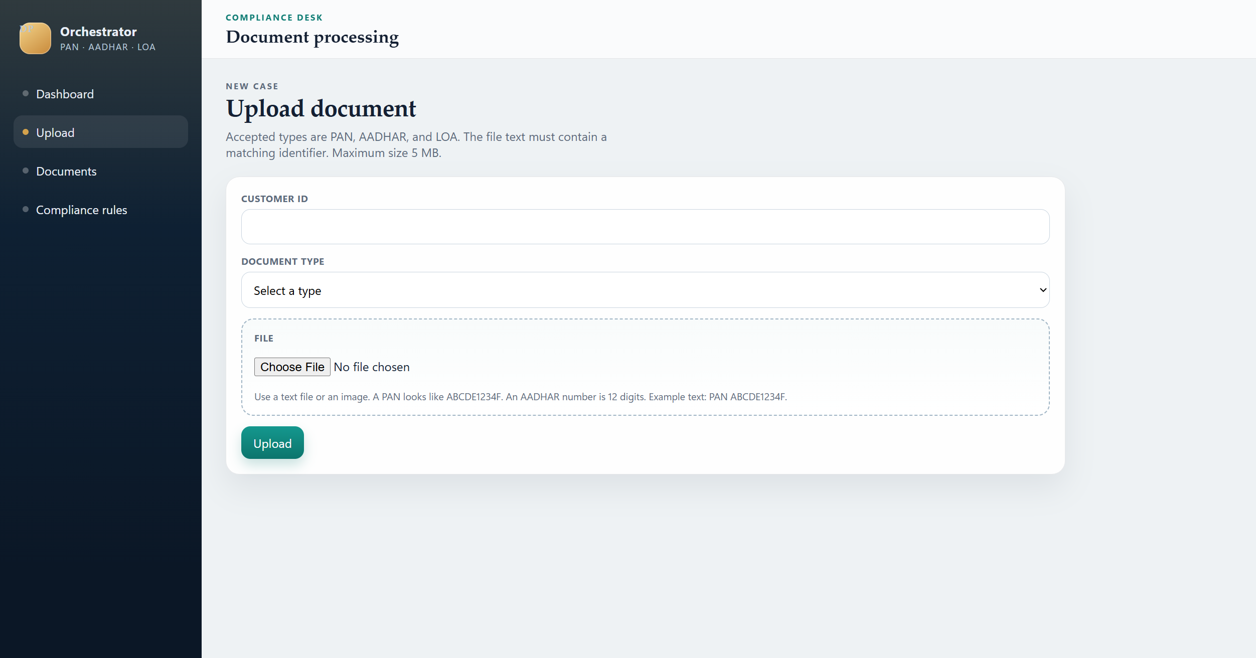

Documents
The document list can be searched by customer, file name, or id, and filtered by status and type. Each row shows the short id, the current status, and the latest audit message. View opens the details page.

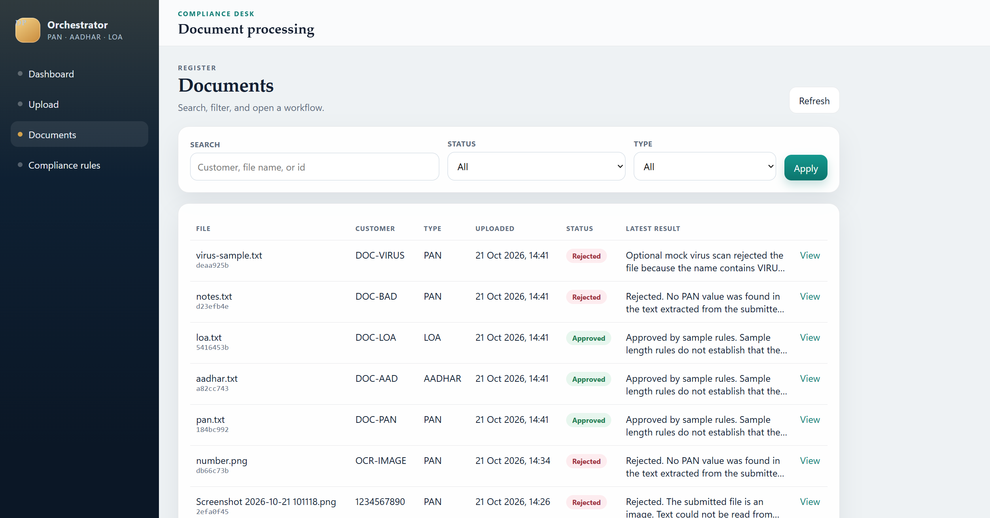

Document details
Details shows the customer, type, file name, and upload time. The status badge is the current SQL status. The page also shows the extracted identifier, the text that was read, and the approval or rejection remarks. A document that is not finished can be resumed from here.

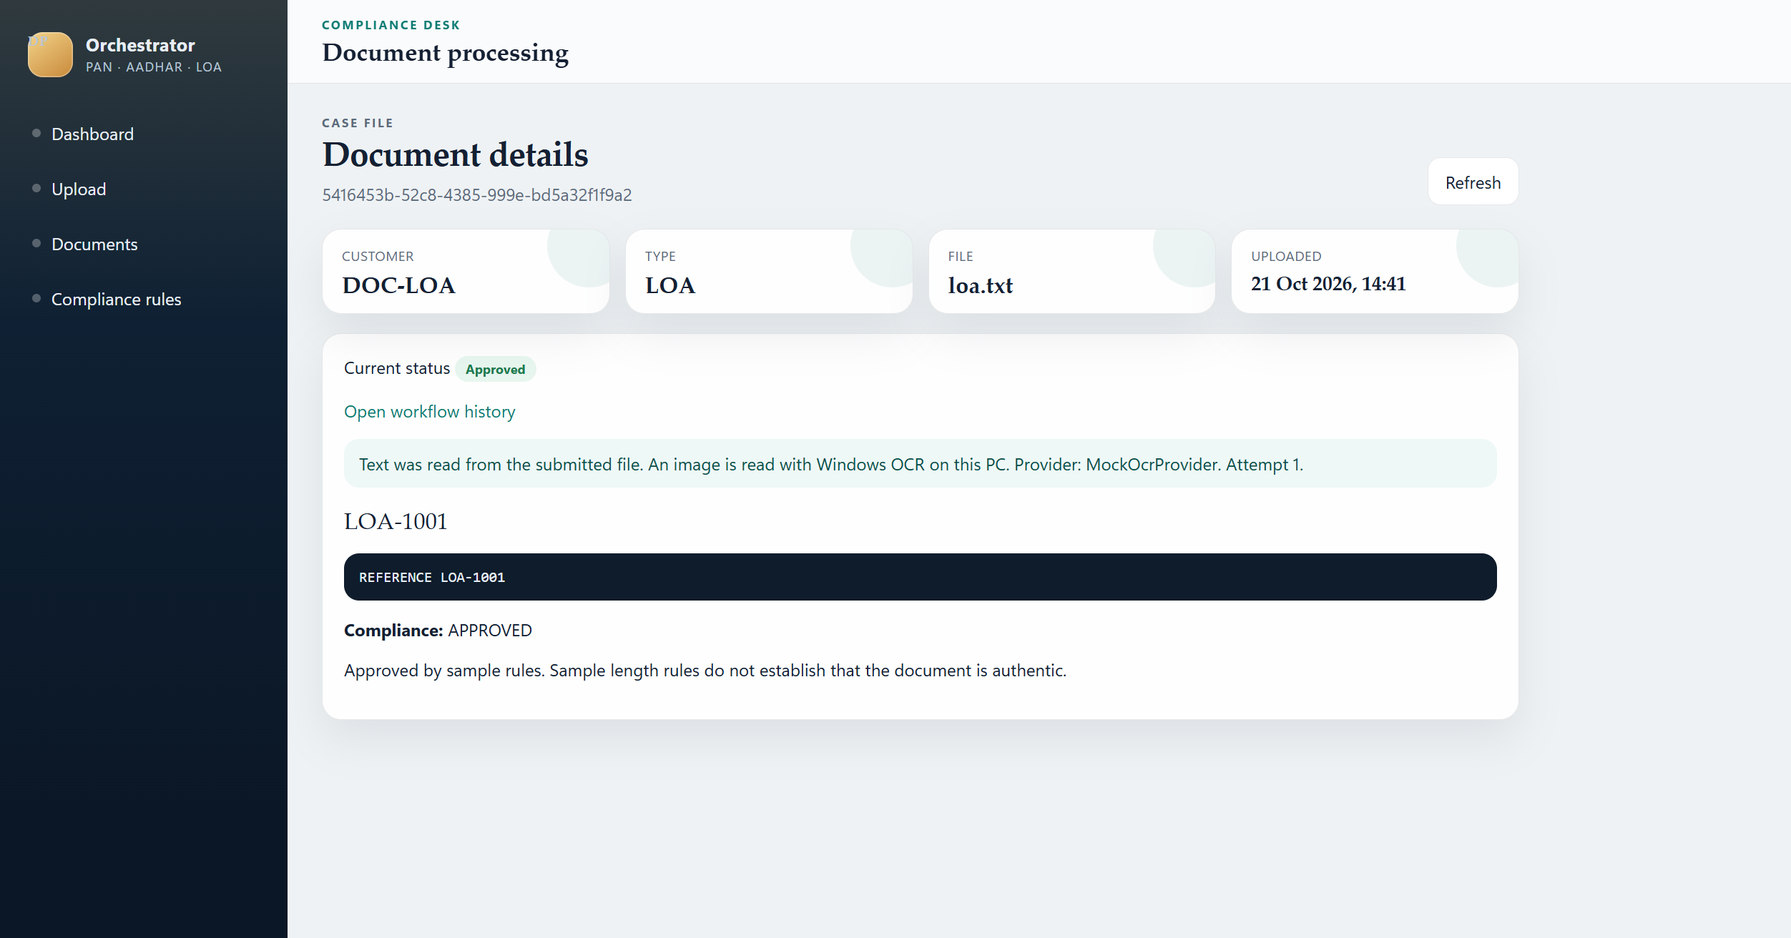

Workflow history
History is the audit trail for one document, oldest first. Each step shows the status, the message, the agent, the tool, the attempt, and how long the step took. This is the same data stored in DocumentWorkflowStatus.

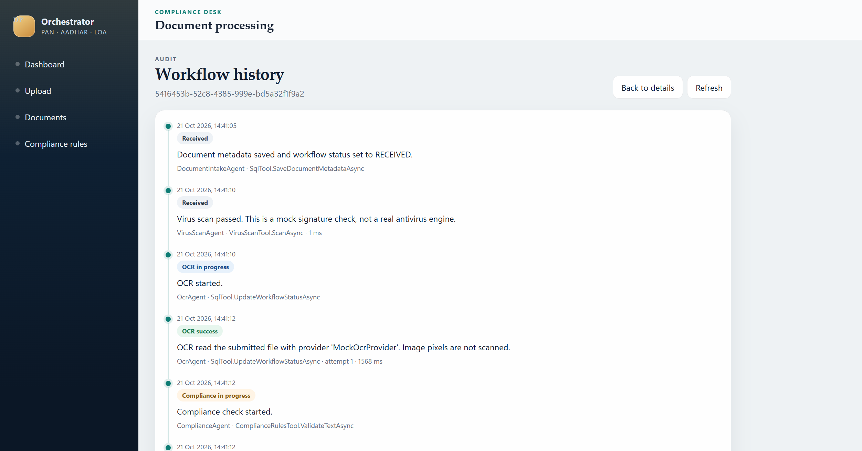

Compliance rules
This page lists the active rules from SQL Server. PAN must be 10 characters, AADHAR must be 12 digits, and an LOA reference must be at least 6 characters. The rules can be viewed here. They cannot be edited from the page.

