1. Sequence, flow chart
2. Variable
3. Box, assign
4. Loop

flow Decision,

if,

while,

do while,

for each – example array, Folder

1. random Number example in flow chart and sequence
2. Data manipulation

Split

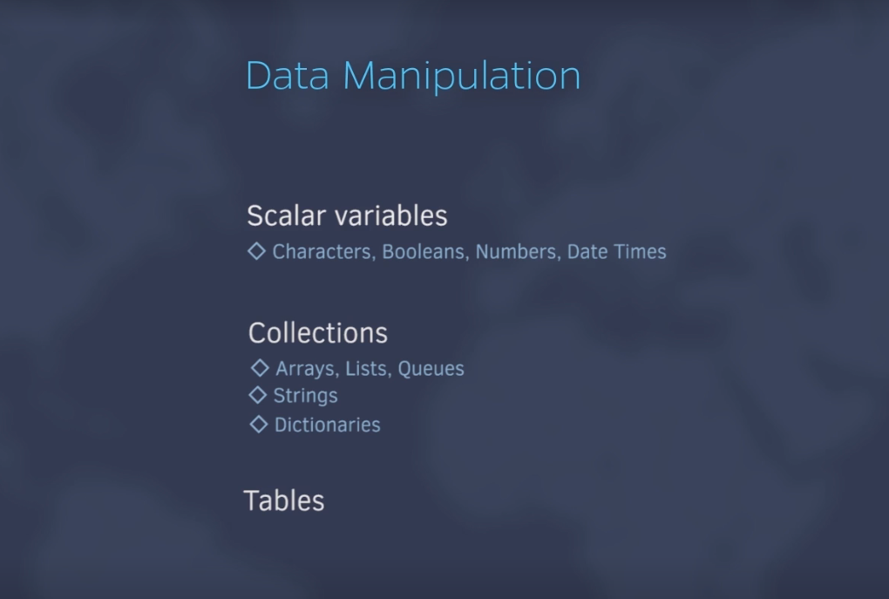

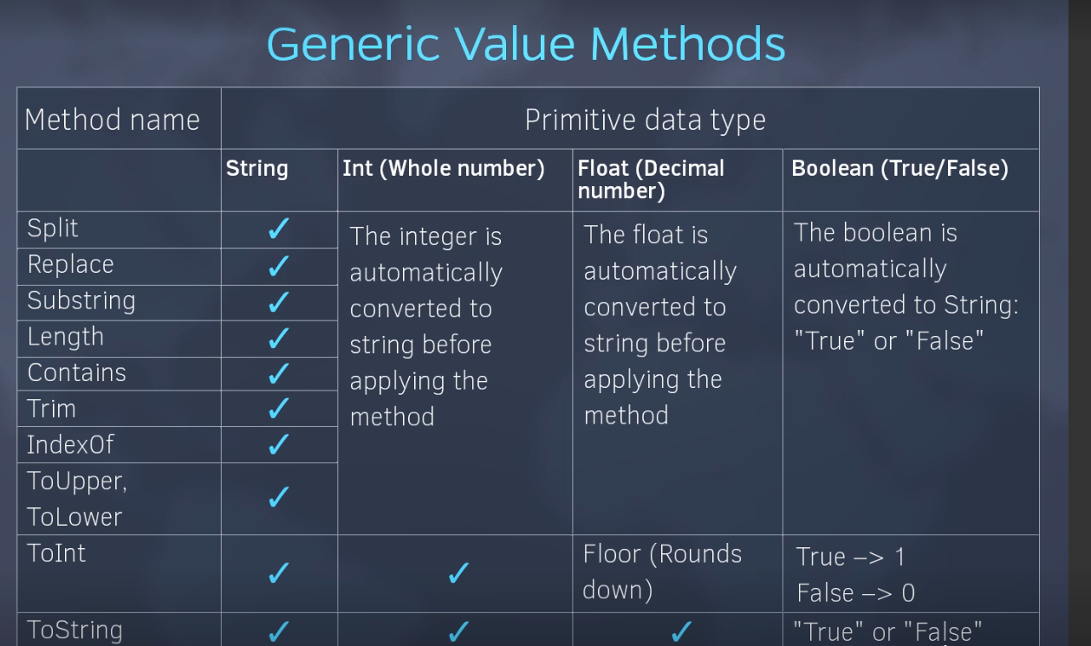

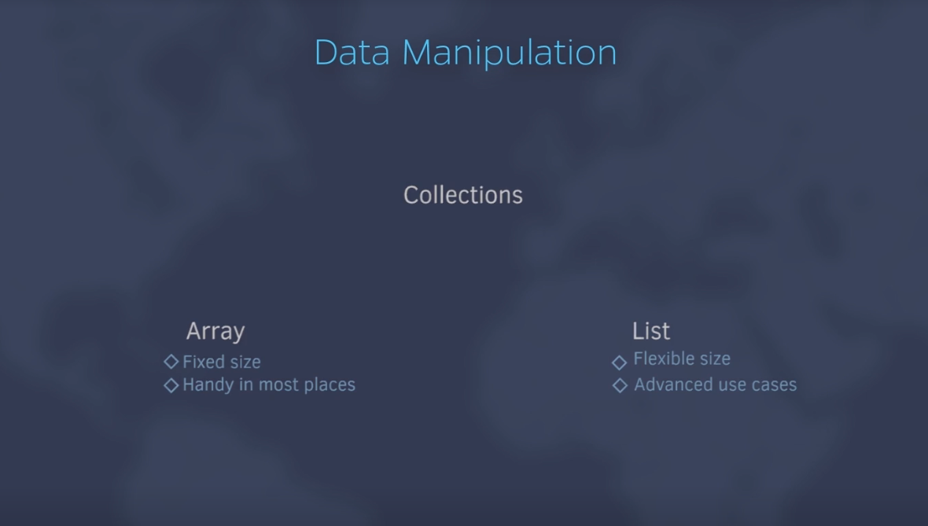

Array:

Store similar kind of data. {}

Fixed in size.

Default value

retrieve particular value

retrieve entire value

few operation like – Sum, Avg

check value exits or not

length of array

List:

dynamic in size

Add to collection

Clear collection

exits in collection

remove from collection

get particular item

get all items

Dictionary –

1. install activity.microsoft
2. Can not have duplicate
3. case sensitive
4. Key value paid