1. Sequence, flow chart
2. Variable
3. Box, assign
4. Loop

flow Decision,

if,

while,

do while,

for each – example array, Folder

1. random Number example in flow chart and sequence
2. Data manipulation

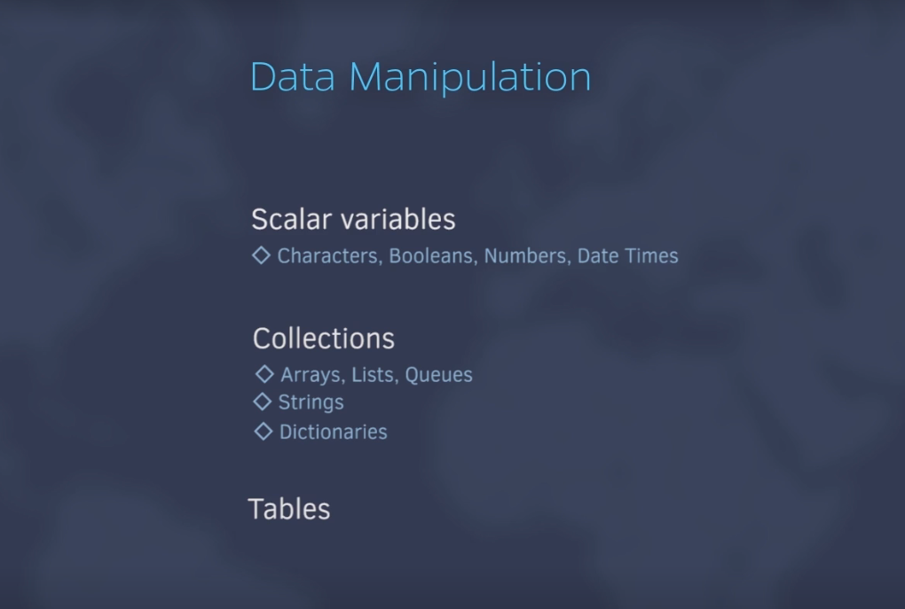

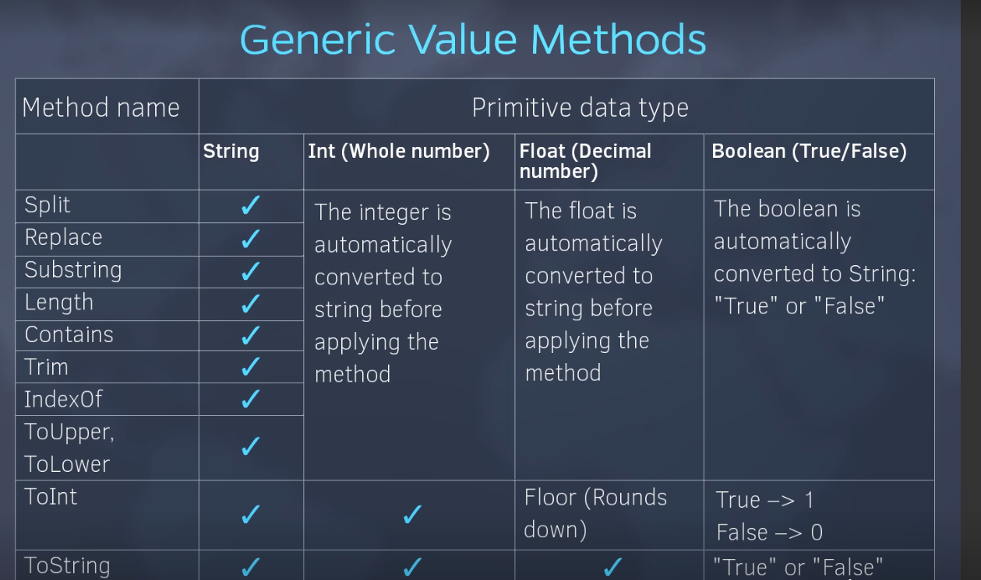

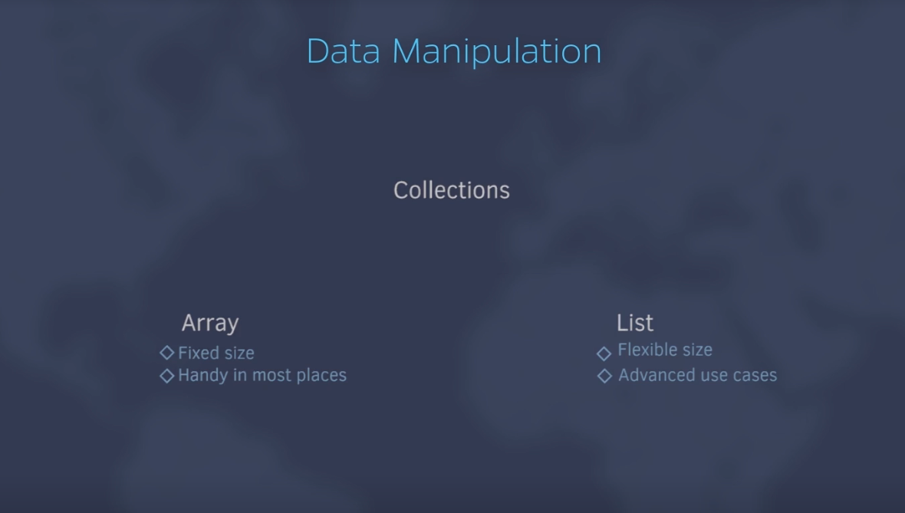

Dictionary