**File Management**

**Ctrl + Shift + N** - Creates a new **Blank Process**.

Crtl+N – new sequence

CRTL+0 – open

+s – Save

+Shift+S – Save all

+Tab - switch between workflow

+L – Open Log

+D – Disable

+E – Enable

F5 –Run

F12- Stop

F8 – Check for error

F7- Run in debug mode

F9 – Breakpoint

Shift+F9 – remove breakpoint

**Ctrl + O** - Enables you to open a previously created workflow, either the .xaml or project.json file.

**Ctrl + L** - Opens the folder where the Log files are stored.

**Ctrl + S** - Saves the currently opened workflow.

**Ctrl + Shift + S** - Saves all the workflows that are currently open.

**Ctrl + Tab** - Moves focus between workflows opened in the **Designer** panel. Upon pressing the shortcut, the following window appears, allowing you to select between active files and panels in Studio.

[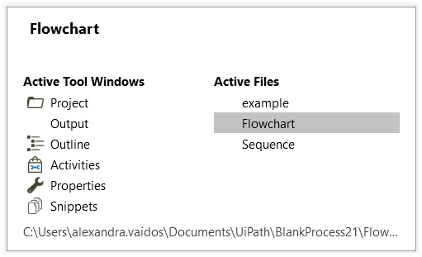](https://files.readme.io/9f12fbc-crtlTab.png)

**Comment**

**Ctrl + D** - Ignores the activity that is currently selected by placing it into a **Comment Out**container.

**Ctrl + E** - Removes the activity from the **Comment Out** container it was placed in.

**Debugging**

**F7** - Runs the currently opened workflow in debug mode.

**F8** - Checks the currently opened workflow for validation errors.

**F9** - Marks the selected activity with a breakpoint.

**Shift + F9** - Removes all the breakpoints in the currently opened workflow.

**F11** - When debugging, enables you to step into a block of activities and executes the first one.

**Shift + F11** - When debugging, steps over the execution of a block of activities in the currently selected workflow.

**Recording**

**Alt + Ctrl + W** - Opens the **Web Recording** toolbar.

**Alt + Ctrl + B** - Opens the **Basic Recording** toolbar.

**Alt + Ctrl + C** - Opens the **Citrix Recording** toolbar.

**Alt + Ctrl + D** - Opens the **Desktop Recording** toolbar.

**F2** - Adds delay during a recording activity.

**F3** - Lets you specify a custom recording region.

**F4** - Lets you choose the UI Framework to record, which can be **Default, AA,** and **UIA**.

**Workflow Execution**

**F5** - Runs the workflow that is currently open.

**Pause** - Pauses the execution of the current workflow, in both normal and debug mode.

**F12** - Stops the execution of the current workflow, in both normal and debug mode.

**Selected Activity**

**Ctrl + T** - Places the activity inside the **Try** section of a **Try Catch** activity.

**Ctrl + N** - Creates a new **Sequence Diagram** in the current project.

**Ctrl + C** - Copies the selected activity or activities to the clipboard.

**Ctrl + V** - Pastes the copied activity or activities inside the selected item.

**Ctrl + K** - Creates an variable of the same type as the required type of the activity.

**Ctrl + M** - Creates an **In** argument of the same type as the required type of the activity.

**Ctrl + Shift + M** - Creates an **Out** argument of the same type as the required type of the activity.

**Ctrl + Space** - Opens the IntelliPrompt window.

**Miscellaneous**

**F1** - Enables you to access a help topic associated with the currently selected element.

**Ctrl + Alt + F** - Sets the focus to the search box in the **Activities** panel to search for an activity.

**Ctrl + P** - Opens the **Manage Packages** window.

**Esc** - Closes the **Publish**, **Manage Packages**, **File Diff** windows.