Prototype Documentation
Leave Management System(LMS)

Contents

1. Introduction.................................................................................2
1.1. Purpose...................................................................................2
1.2. Abbreviations...........................................................................2
1.3. Summary.................................................................................3
2. System Overview..........................................................................3
3. Design Considerations..................................................................3
3.1. Assumptions and Dependencies..................................................3
3.1.1. Related software and hardware………………………………………………….3
3.1.2. End-user characteristics………..……………………………………………………3
3.1.3. Possible and/or probable changes in functionality...................3
3.2. General Constraints……..……………………………………………………………………..4
3.3. Goals and Guidelines……………………………………………………………………………4
3.4 Architectural Strategies……………………………………………………………………….5
4. System Architecture…………………………………………………………………………………5
4.1. Sub-System architecture…………………………………………………………….8 5. Policies and Tactics.....……………………………………………………………………………9
6. UML Diagrams………….…………………………...………………………………………………..9
7.1 Class Diagram……………………………………………………………………………………….9
7.2 Sequence Diagram……..………………………………………………………………………11
7.3 Entity Relationship Diagram.………………………………………………………………12

- Introductions
  - Purposes
The objective of the proposed System is to automate Leave management. With the help of this system users can apply leave online, manager can approve or reject leaves, and one can view updated leave status online. The users can see the status of all Leave Transactions and their Leave Balances from this system. The work flow is designed in such a way the Leave System generates email messages as alerts to respective users, and managers to enable them to act upon.

  - Abbreviations
- LMS – Leave Management System
- SRS – Software requirements specification
- PC – Personal Computer
- HDD - Hard Disc Drive
- RAM – Random Access Memory
- IE – Microsoft Internet Explorer
- PSE – Payment System Engine
- UIE – User Interface Engine
- SQL – Structured Query Language
- RD – Requirements Documentation
- DD – Design Documentation

  - Summary
This version of design document consist next parts:
Design Considerations – general description of the software system including its functionality and matters related to the overall system.
Architectural Strategies – this part describe design decisions and strategies that affect the overall organization of the system and its higher-level structures.
System Architecture – this part gives high-level overview of how the functionality and responsibilities of system were partitioned and then assigned to subsystems.
Policies and Tactics – in this part of design document we describes design policies and tactics which affect on details of the interface and implementation of various aspects of the system.

- System Overview
The project Leave Management System's software will reflect all the requirements defined by the Manager.
Leave Management System will allow to perform all necessary procedures for company employees. According to employees requirements the software to be developed will consist of three databases:
- Manager's_database (manager_id,account number, name, address, phone number etc)
- Employee's_database (employee name, branch, city, state, address, phone number, current balance etc)
LMS will also provide all necessary services for databases such as creating, deleting, updating and searching information. Employee will be able to access to the Online Leave Management Portal through the Internet or through LAN-connected computers, scattered throughout, receiving information about current leave status, leaves applied in the past, and futrure leaves. Employee interface will be easy-to-use.

3. Design Considerations
3.1 Assumptions and Dependencies
3.1.1 Related software, hardware and operating system:
Leave Management System will be executed on Intell/AMD based platoforms and under following system:- Windows .
3.1.2 End-user characteristics:
There is no special requirements for users because LMS system will be quite easy in application and use. Only knowledge of English (all interface is going to be represented in this language) and ordinary skill ,login details and beneficiary details are required.

3.2 General constraints
Next items must be used to verify software:
    - For user home PC and Company's PC’s
Hardware
- IBM-compatible PC with PentiumΙ processor and higher
- 50MB free space on HDD
- 32MB RAM
- Internet connection
Software
- Windows

- For Server
Hardware
- IBM-compatible PC with Pentium ΙΙΙ and higher
- 256MB RAM or higher
- 80GB free space on HDD
3) For LMS’s interface
- Interface will be implemented in English
- Simple design
- Good GUI

3.3 Goals and guidelines
Main principle of creating LMS sytem is according to it's customer’s requirements.Design of LMS system will be very simple because of two reasons:
    - LMS’s interface has to be similar to ordinary search systems in Internet.
    - Implentation is also quite compact.

3.4 Architectural Strategies
- All data (employees details, address, current leave status, and any leaves for future) will be stored in a database (ORACLE server will be used for storing data).
- User Interface Engine will provide interaction of LMS with user through Internet.
- LMS database management (updating leave status) is carried out by Leave Management System.
- All components of LMS system easily can be modified so it is possible to extend developing system in future.
- Administrator will have all necessary functions and instructions for controlling the database.
- Also, there will be smart calendar which will display employee leaves for 3 years(last year, present year, upcoming year) and it will also display weekends and holidays present in a particular month.
- There will be 3 types of leaves for which employees can apply: Sick Leave, Casual Leave, Earn Leave
- System will communicate with employees and managers, through the interfaces.
- Administrator can modify information about employee accounts, change passwords and additional information in database.

- System Architecture
LM System has three main components:
  - Database for storing different types of data such as employees, managers etc which are managed by an SQL database server.
  - Leave Management Portal (main core of LMS implemented in Java).
  - Employee Interface Engine (by means of this server user interact with database through the web).

i) EMPLOYEE VIEW-
Users have three Menu Options in Leave Module.
- Apply
Apply for new leaves along with the leave type
- Leave Transaction
Shows the leave record for the particular user.
- List
Provide a list of available leaves for the user.
ii) MANAGER VIEW-
Leave applications management-
Can accept or reject leaves of employees under him.
b) Apply
c) Leave Transaction
d) List

Database



SQL server
Leave Management Functions

Windows Applications
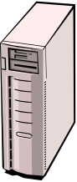





Leave Management Portal
Employee's View

Manager's View

Figure 1

Above there is description of main components of LMS system represented on fig. 1.
Database. Database is intended for storing different types of data such as employee details, manager details etc.

Oracle server. This server is intended for Database management. It receives commands from Leave Management Portal and accordingly takes data from the database.

Leave Management Portal. This is the core of LMS system. It is intended for processing of client’s inquires and has standard library of functions. By means of this functions LMS connects to database server (Oracle server) and generate requests for data issue, data renew, deleting data, etc from database. Requests are made on standard language named Structured Query Language (SQL). LMS can be implemented by different ways. In this LMS system it will be implemented in Java.

User Interface Engine (UIE). UIE allows to work with LMS. The Project is made in Java using JSP & Servlets.

Windows Application. This allows to work with LM System directly without applying web browser on basis of Windows operation system.
LMSystem can be divided into two main parts. The first part is User side and the second is a Server side.
User side usually consist from personal computer with the Web-Browser connected to Internet (if user apply LMS by means of Internet) or PC with installed LMS software connected to Leave Management Portal. According to Login data user can see his/her leave details and can further apply for leave. LMS provides users with next possible actions.

Employee as User can perform following actions:
- Login to the system
- Search for account details
- View the information about his/her current leave status as well as for the past applied leaves and for future leaves.
- Enter Beneficiary Details
- Apply for Leave.

4.1 Subsystem Architecture
LMS database will have the following structure: there are will be 2 or more tables for storing different kinds of data.
First table will store information about Employee's details.
Table1 (user)
Field name | Data type | Description
Emp_id | Char(10) | Id assigned by company
Emp_role | Varchar(20) | Employee's role in the company
Emp_name | Varchar(20) | employee name
Emp_address | Varchar(50) | employee address
Emp_phone | Char(12) | employee Phone No.
Emp_leave | Varchar(20) | Current leaves available for the employee
Emp_salary | Char(10) | Employee's current salary

Second table will store information about banks.
Table2 (server)
Field Name | Data type | Description
Manager_Name | Varchar(20) | Name of Manager
Manager_Phone | Varchar(20) | Phone no. of Manager
Manager_address | Varchar(50) | Address of Manager
Manager_id | Char(10) | Manager id assigned by company

6. Policies and Tactics
LMS system is developing according to requirements. Main functionality and logic of system are provided by Web Server and SQL server. LMS provides end users with friendly interface and company's manager with easy installation methods.
After it will be implemented it’s going to be tested by tester. In initial stage of LMS using system will be serviced by our team. If some problems occur during software application manager should address to technical support service.

UML DIAGRAMS:

1. CLASS DIAGRAM

Class diagram is the main building block of any object oriented solution. It shows the classes in a system, attributes and operations of each class and the relationship between each class. The following diagram shows the classes along with its attributes and operations or methods.

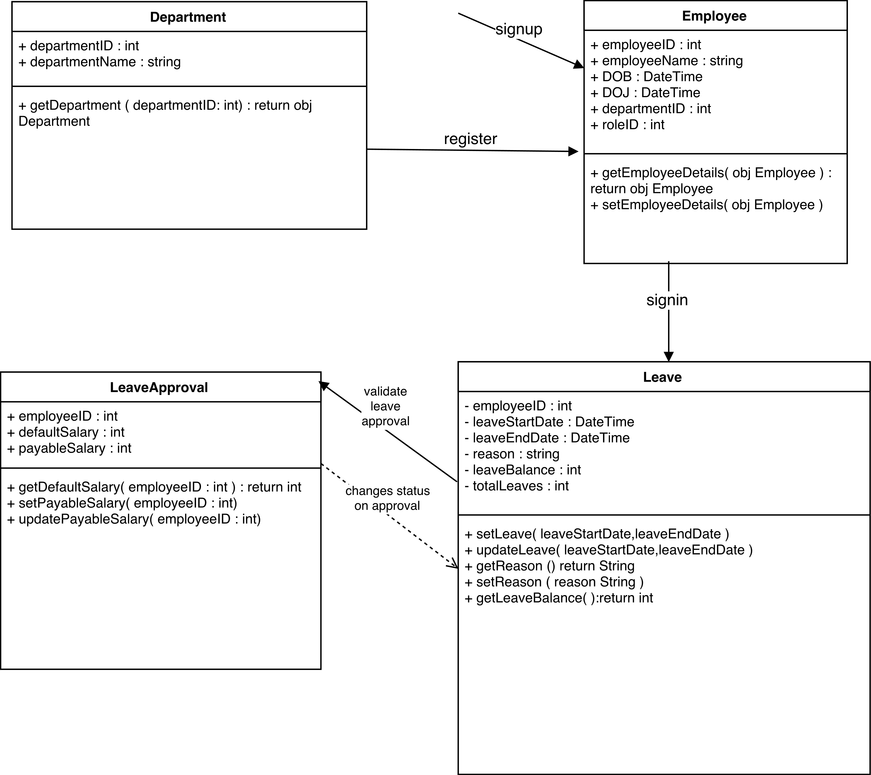
Figure 2: Class Diagram

2. SEQUENCE DIAGRAM:
Sequence diagrams in UML show how objects interact with each other and the order those interactions occur. The following diagram gives the message and return call among the various objects of the system. It provides us with the typical sequence of events during a user session.

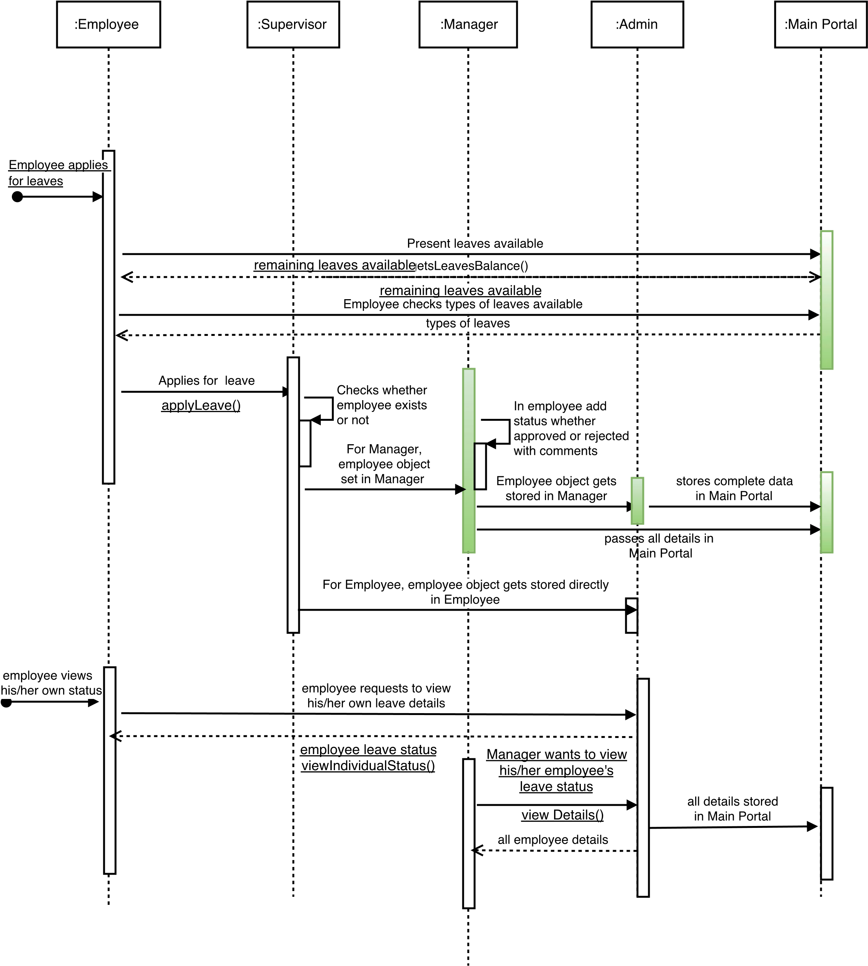

Figure 3: Sequence Diagram

3. ENTITY RELATIONSHIP DIAGRAM:
An entity relationship diagram (ERD) shows the relationships of entity sets stored in a database. An entity in this context is a component of data. The following diagram shows the existing entities in the system along with their attributes.

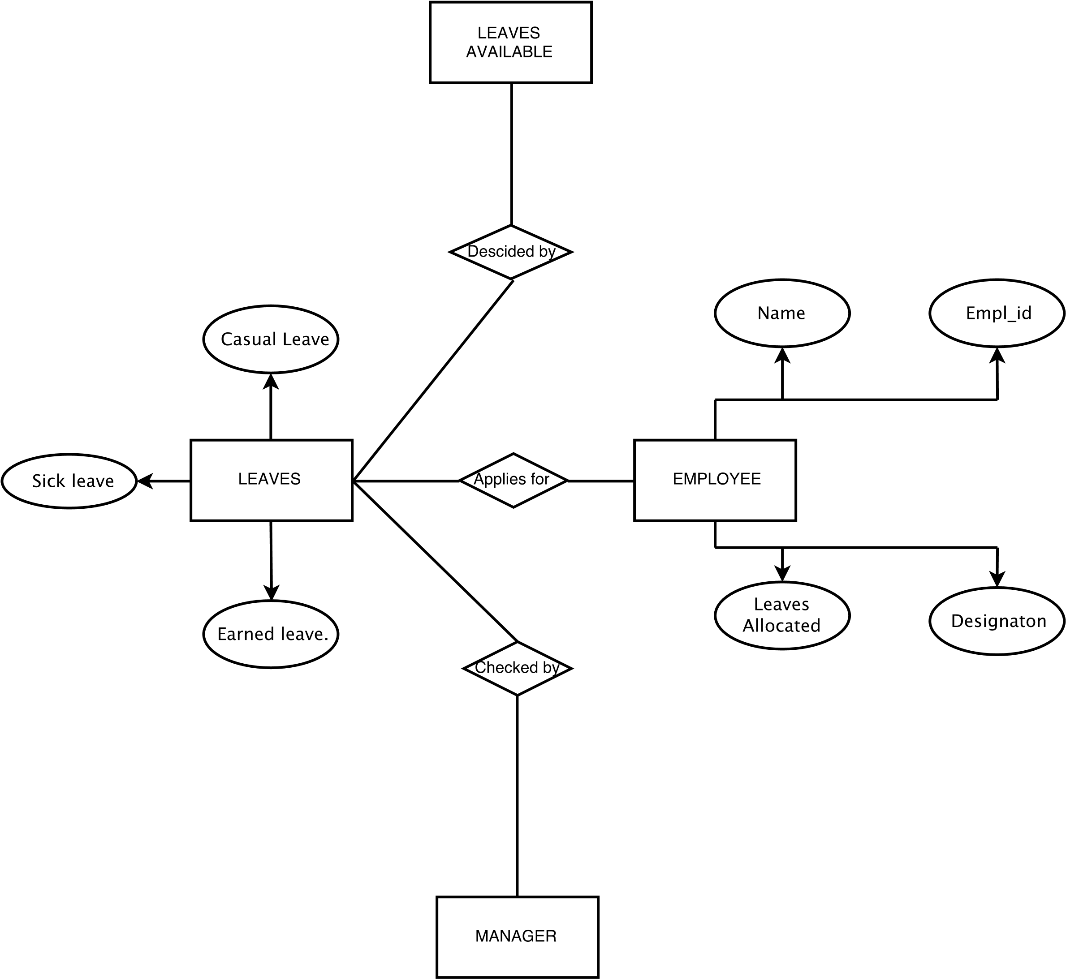

Figure 4: Entity Relationship Diagram

