

Self Learning Micro Project Report
Stage – 3: Analysis and Report
First Year
Semester -2
Subject: DEMI

Topic: Use of Numerical Integration Methods in Network Traffic Analysis

Submitted by

Name – Sargam Gupta Roll No.19


SHAH AND ANCHOR KUTCHHI ENGINEERING COLLEGE

CASE STUDY REPORT

Use of Numerical Integration Methods in Network Traffic Analysis

Abstract
Modern computer networks experience continuously varying data traffic due to fluctuating user demand and application usage. Network engineers must estimate total data transfer accurately to design efficient communication systems and ensure reliable performance. Since network traffic measurements are obtained at discrete time intervals rather than as continuous mathematical functions, analytical integration methods cannot be applied directly.

This case study demonstrates the application of numerical integration techniques, specifically the Trapezoidal Rule and Simpson’s 1/3 Rule, for estimating total network data transfer. The study explains how these numerical methods assist engineers in bandwidth planning, server capacity evaluation, and network performance optimization. A comparative analysis of both methods highlights their accuracy and engineering significance in real-world network management.

Introduction
Engineering design frequently involves decision-making based on measured data rather than exact mathematical models. In computer networking, traffic flow varies dynamically depending on user activity, system load, and application demand. Engineers monitor network traffic periodically to understand system performance and future infrastructure requirements.

Because traffic measurements are collected at fixed sampling intervals, engineers obtain discrete datasets instead of continuous functions. Determining cumulative data transfer from such datasets requires numerical integration techniques.

Numerical integration converts sampled measurements into meaningful engineering quantities such as total data usage, allowing engineers to evaluate system efficiency and make informed design decisions.

Engineering Background
In a communication network, data traffic represents the rate at which information passes through routers, switches, or servers. Traffic rate is typically expressed in megabytes per second (MB/s) or gigabits per second (Gbps).

Network monitoring systems record traffic values at regular time intervals. These values indicate instantaneous transmission rates but do not directly provide the total amount of data transferred during a period.

For network planning and performance evaluation, engineers must determine cumulative data transfer over time. This requirement forms the engineering problem addressed in this study.

Problem Statement
Network administrators often possess only sampled traffic-rate measurements taken at regular time intervals. The absence of a continuous mathematical model prevents direct analytical calculation of total data transferred.

The engineering problem is therefore defined as:
To estimate total network data usage from discrete traffic measurements using numerical integration methods in order to support network design and capacity planning.

Mathematical Modeling
Let R(t) represent the network traffic rate at time t.

Total Data = Integral R(t) dt

Since the exact function R(t) is unknown and only sampled observations are available, numerical integration techniques are employed to approximate the integral.

Graphically, total data transfer corresponds to the area under the Traffic Rate versus Time curve.

Numerical Integration Methods

Trapezoidal Rule
The Trapezoidal Rule approximates the area under a curve by dividing it into trapezoidal sections formed between consecutive data points. Each interval assumes linear variation of traffic rate between measurements.

Engineering Advantages:
- Simple computational procedure
- Suitable for real-time monitoring systems
- Effective when rapid estimation is required

Limitations:
Accuracy decreases when traffic variation is highly nonlinear.

Simpson’s 1/3 Rule
Simpson’s Rule improves accuracy by approximating the curve using quadratic segments instead of straight lines. This method models realistic traffic behavior more effectively because network usage typically changes smoothly rather than linearly.

Engineering Advantages:
- Higher computational accuracy
- Better representation of real network traffic patterns
- Suitable for planning and analytical evaluation

Limitations:
Requires evenly spaced data samples and an even number of intervals.

Engineering Application
Network Traffic Analysis

In modern organizations, servers and communication networks must handle unpredictable workloads generated by users, cloud services, video streaming, and online applications. Engineers continuously monitor traffic rates to evaluate whether existing infrastructure can sustain operational demand.

By applying numerical integration to traffic measurements, engineers determine the total data transferred over a specified duration.

This information is critical for:
- Bandwidth allocation and upgrade planning
- Server capacity estimation
- Network congestion prevention
- Cloud resource management
- Performance optimization of communication systems

Engineering Workflow

1.Data Collection:
Network monitoring tools record traffic rate values at uniform time intervals.

2.Data Visualization:
Traffic rate is plotted against time to identify usage trends and peak demand periods.

3.Numerical Integration:
Trapezoidal Rule and Simpson’s Rule are applied to estimate cumulative data transfer.

4.Analysis and Decision Making:
Engineers compare calculated results with system capacity limits to determine whether infrastructure modification is required.

Result Interpretation
Both numerical methods provide approximations of total network data usage. The Trapezoidal Rule offers a quick estimate suitable for operational monitoring, while Simpson’s Rule generally produces a more accurate result due to improved curve approximation.

If calculated total data exceeds the designed bandwidth capacity, engineers may decide to:
- Upgrade network bandwidth
- Deploy additional servers
- Implement load balancing strategies
- Optimize traffic routing

Comparison of Methods
Trapezoidal Rule: | Simpson’s 1/3 Rule:
Curve Approximation – Linear | Curve Approximation – Parabolic
Accuracy – Moderate | Accuracy – High
Computational Effort – Low | Computational Effort – Moderate
Engineering Use – Real-time estimation | Engineering Use – Detailed analysis

Code
clc;
clear;
close all;
% Time interval (minutes)
t = [0 10 20 30 40 50];
% Network Traffic Rate (MB/s)
R = [5 8 12 15 11 7];
% Step size
h = t(2) - t(1);
%% -------------------------------
% Trapezoidal Rule
%% -------------------------------
n = length(R);
trap_result = (h/2) * (R(1) + 2*sum(R(2:n-1)) + R(n));
%% -------------------------------
% Simpson's 1/3 Rule
%% -------------------------------
if mod(n-1,2) ~= 0
error('Simpson rule requires even number of intervals');
end
odd_sum = sum(R(2:2:n-1));
even_sum = sum(R(3:2:n-2));
simp_result = (h/3) * (R(1) + R(n) + 4*odd_sum + 2*even_sum);
%% -------------------------------
% Display Results
%% -------------------------------
fprintf('Total Data using Trapezoidal Rule = %.2f MB\n', trap_result);
fprintf('Total Data using Simpson''s Rule = %.2f MB\n', simp_result);
%% -------------------------------
% Plot Graph
%% -------------------------------
figure;
plot(t, R, 'o-', 'LineWidth',2);
xlabel('Time (minutes)');
ylabel('Traffic Rate (MB/s)');
title('Network Traffic Rate vs Time');
grid on;
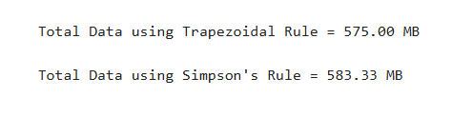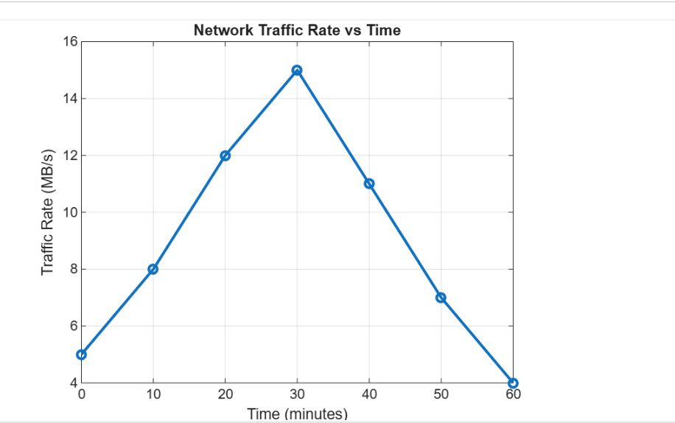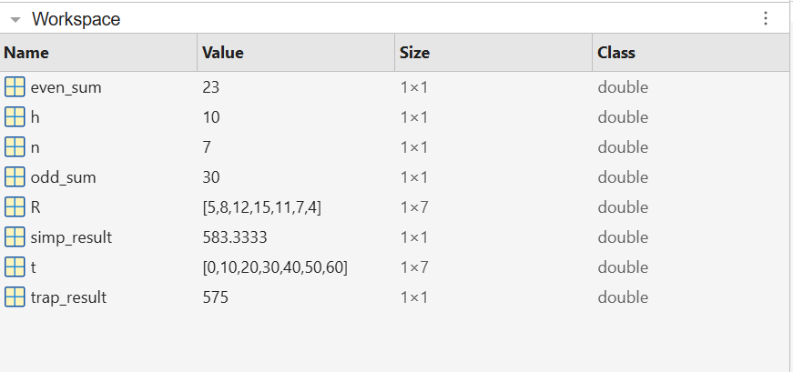
Engineering Significance
Numerical integration methods play an essential role in data-driven engineering environments. In network engineering, these techniques enable accurate estimation of cumulative system behavior from sampled measurements.

Without numerical integration, engineers would be unable to convert monitoring data into actionable design information. The methods therefore support efficient infrastructure planning, cost reduction, and reliable system operation.

Conclusion
This case study demonstrates that numerical integration methods are powerful tools for solving practical engineering problems involving discrete datasets. The Trapezoidal Rule and Simpson’s 1/3 Rule successfully estimate total network data transfer from sampled traffic measurements.

While the Trapezoidal Rule provides rapid approximation suitable for monitoring applications, Simpson’s Rule offers improved accuracy for engineering analysis and capacity planning. The study highlights how mathematical techniques translate directly into engineering decisions that enhance network reliability and performance.

