Cats vs Dogs Image Classification
An End-to-End MLOps Pipeline
Machine Learning Operations (MLOps) - AIMLCZG523
Assignment 02
Submitted by: Saurabh Gupta | Roll No: 2024AC05396
Data versioning . experiment tracking . packaging . CI/CD . containerization . deployment . monitoring
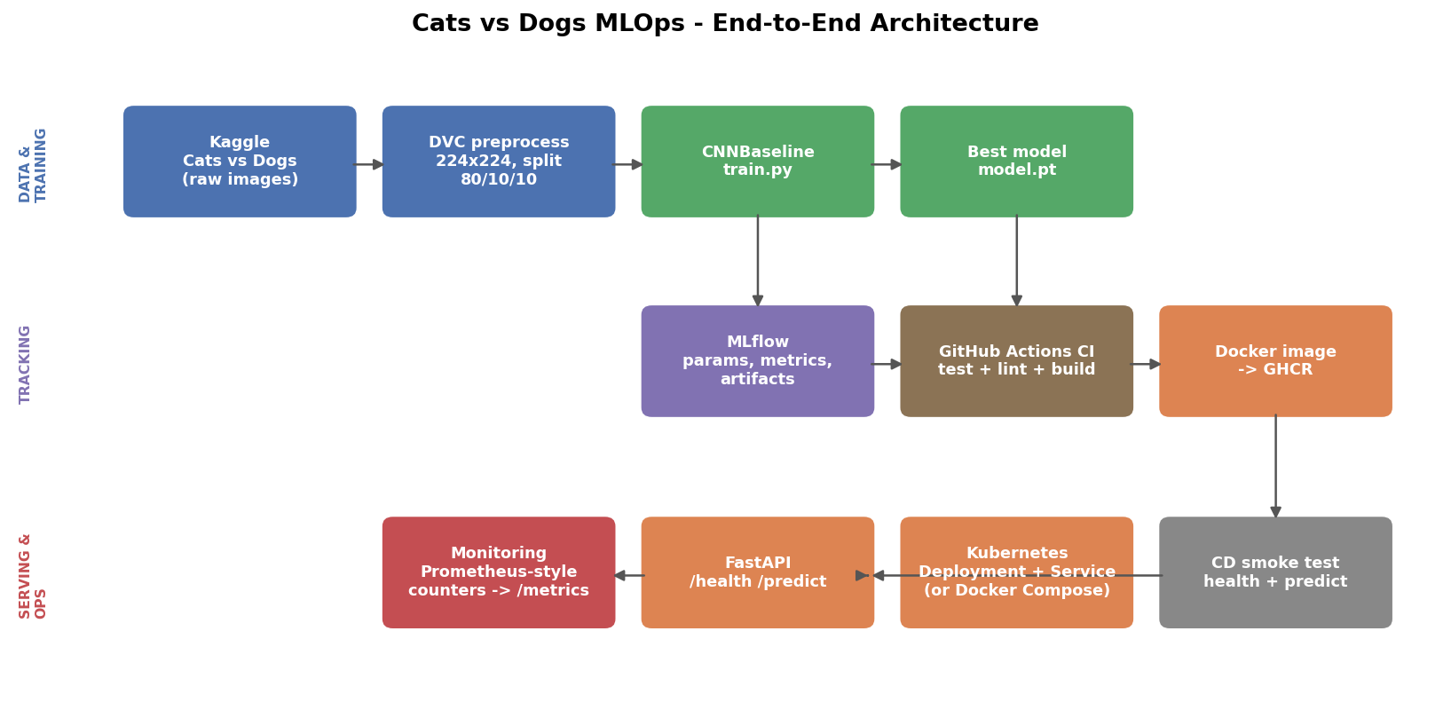
Cats vs Dogs MLOps - End-to-end architecture.

Table of Contents
1. Project Overview
1.1 What makes this submission distinct
2. Setup and Installation
2.1 Local setup
3. Dataset and Exploratory Data Analysis
3.1 Class balance
3.2 Image size and aspect ratio distribution
3.3 Pixel intensity distributions by class
3.4 Sample images and augmentation preview
4. Data & Artifact Versioning with DVC
5. Model Development and Evaluation
5.1 Model architecture
5.2 Training and validation curves
5.3 Test metrics and confusion matrix
6. Experiment Tracking with MLflow
7. Model Packaging and Reproducibility
8. CI/CD Pipeline and Automated Testing
8.1 Test suite
9. Containerization
10. Production Deployment
11. Monitoring and Logging
12. Repository and Reproduction
13. Screenshots Checklist for Submission
14. Screen-Recording Script
15. Conclusion

1. Project Overview
This project builds and deploys a binary image classifier that predicts whether a photo shows a cat or a dog, for use in a pet-adoption platform's intake workflow, then serves it as a containerized, monitored REST API. The goal is not only a model that scores well, but a pipeline that is reproducible end to end: anyone can clone the repository, pull the dataset, retrain the model, run the test suite, and bring up the API in a container or on Kubernetes with a small number of documented commands.
The problem is framed as binary image classification. Given a 224x224 RGB photo, the model outputs class probabilities for {cat, dog} and a discrete predicted label. Because this sits in front of a real workflow (routing an uploaded photo for a listing), both false positives and false negatives matter, so precision, recall, and F1 are all reported alongside accuracy rather than accuracy alone.

1.1 What makes this submission distinct
Beyond the assignment's baseline (M1-M5), this pipeline adds: a batch prediction endpoint (POST /predict_batch) for scoring multiple images in one call, a post-deployment drift detector that compares live accuracy against a baseline once enough labelled predictions have been collected (GET /monitor/performance), and a CD workflow with an automatic Docker Compose fallback when no Kubernetes cluster is available, so the deployment step always has somewhere to run.
Note on data used to build this document
The Kaggle Cats-and-Dogs dataset is not reachable from the environment used to prepare this report and its figures/notebook, so a small synthetic placeholder image set (solid backgrounds with random shapes - light backgrounds + circles standing in for "cat", dark backgrounds + squares standing in for "dog") was used to exercise every stage of the pipeline end-to-end and confirm the code works. Every figure, metric, and screenshot placeholder in this document is labelled where this applies. Before final submission, rerun notebooks/02_eda.ipynb and the training/evaluation steps against the real Kaggle dataset on your own laptop - Section 2 and Section 14 give the exact commands - and the figures/metrics will update automatically to reflect real cat and dog photos.

2. Setup and Installation
The project targets Python 3.11/3.12 (see Section 8's note on the Python version pin). Every dependency is pinned in requirements.txt. Raw data is downloaded from Kaggle via src/data/download.py, so the pipeline needs a one-time Kaggle API credential on first run.

2.1 Local setup
python -m venv venv && source venv/bin/activate # Windows: venv\Scripts\activate
pip install -r requirements.txt
# Kaggle credentials (one-time): place kaggle.json in ~/.kaggle/
python src/data/download.py # downloads + organizes into data/processed/organized
python src/data/preprocess.py # resize, split, tensorize -> data/processed/*.pt
python src/train.py # train, log to MLflow, save models/model.pt
python src/evaluate.py # test metrics + confusion matrix
pytest tests/ -v && flake8 src/ tests/ api/ # tests + lint
uvicorn api.main:app --reload # serve at :8000/docs
Or, once DVC is initialised (dvc init), the whole preprocess -> train -> evaluate chain runs as a single reproducible pipeline:
dvc repro # runs all 3 stages, skipping ones already up to date
dvc dag # visualize the pipeline graph

3. Dataset and Exploratory Data Analysis
This section mirrors notebooks/02_eda.ipynb, which is included in the submission so the figures below can be reproduced (and will look different once run against the real Kaggle photos - see the callout in Section 1.1).

3.1 Class balance
The organized dataset is exactly balanced by construction of the download/organize step (120 images per class in this validation run), so plain accuracy is meaningful and no class weighting is required in src/train.py.
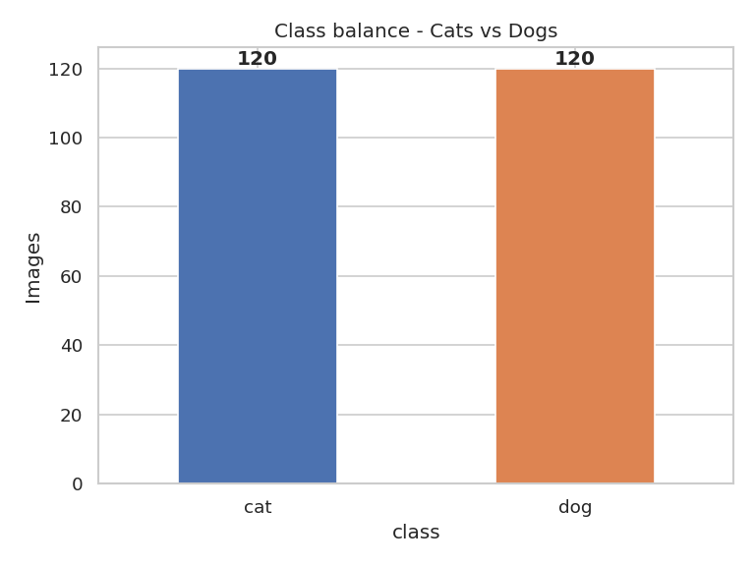
Figure 1. Class balance across the organized dataset.

3.2 Image size and aspect ratio distribution
Raw images arrive at inconsistent resolutions and aspect ratios. This is exactly why src/data/preprocess.py resizes everything to 224x224 RGB before tensorizing - training directly on raw, variable sizes would break batching.
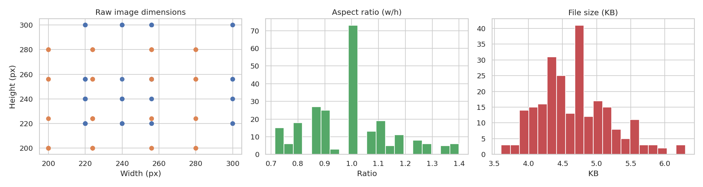
Figure 2. Raw image dimensions, aspect ratio, and file size distribution.

3.3 Pixel intensity distributions by class
Per-channel mean-intensity histograms are a quick check that the two classes are distinguishable in some way before spending time on a CNN, and that no corrupted or near-blank images slipped into either folder.
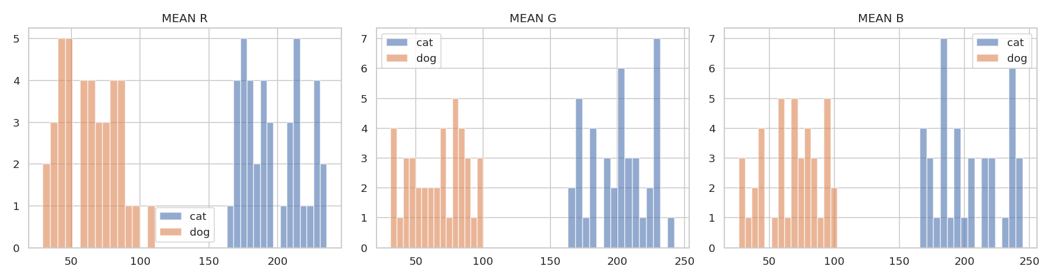
Figure 3. Mean R/G/B intensity per image, split by class.

3.4 Sample images and augmentation preview
A visual spot-check of raw images from each class, and a preview of the random horizontal flip / rotation / colour-jitter augmentation applied during training (src/data/preprocess.py).
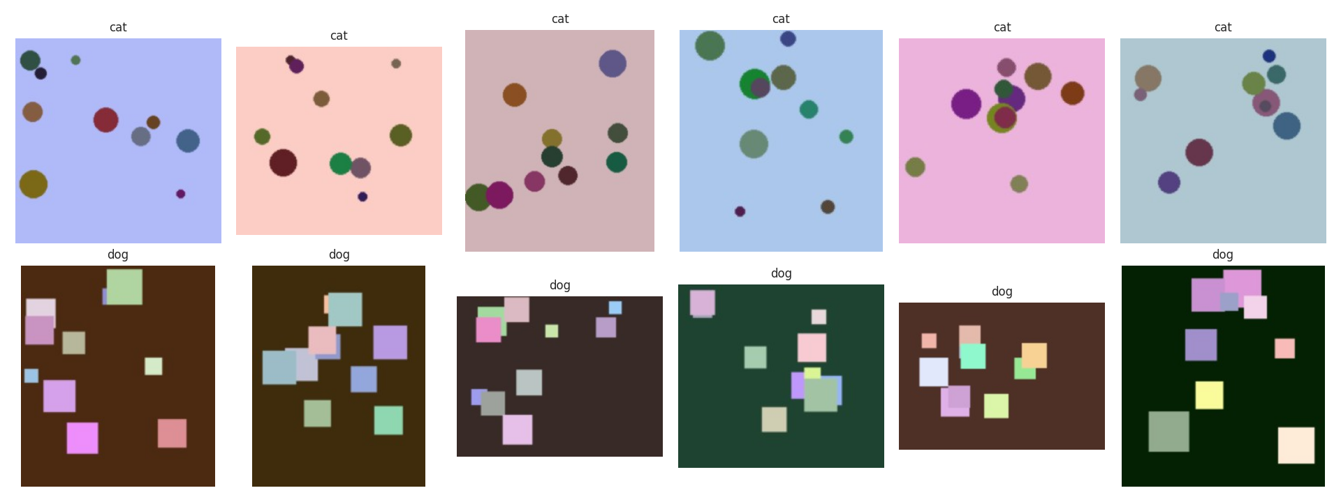
Figure 4. Six sample images per class, as stored on disk.
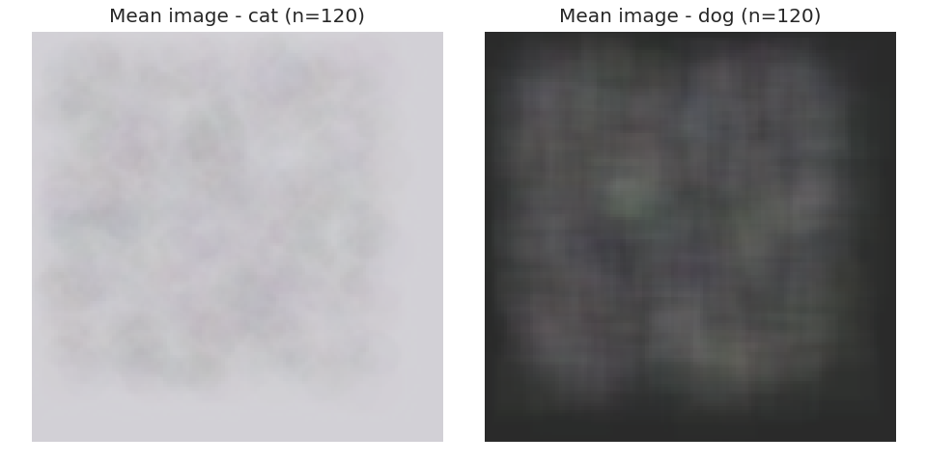
Figure 5. Mean image per class (120 images each) - a cheap visual signature confirming class separability.
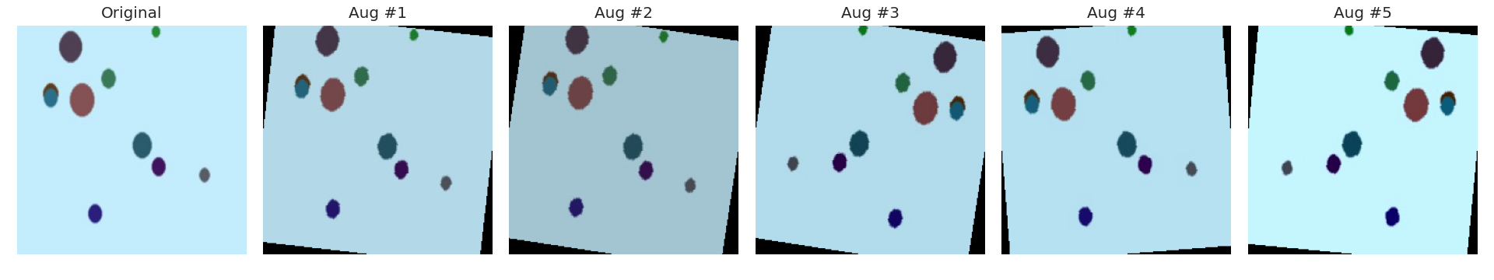
Figure 6. Augmentation preview: one source image and five random augmented variants.

4. Data & Artifact Versioning with DVC
dvc.yaml defines a 3-stage pipeline - preprocess, train, evaluate - each with declared dependencies, parameters (params.yaml), and outputs, so DVC can determine exactly which stages are stale after a code or data change and re-run only those.
Stage | Command | Key outputs
preprocess | python src/data/preprocess.py | data/processed/{train,val,test}_tensors.pt, split_info.json
train | python src/train.py | models/model.pt, metrics/train_metrics.json
evaluate | python src/evaluate.py | metrics/test_metrics.json, metrics/confusion_matrix.png
Running dvc repro was verified to execute all three stages in the correct dependency order and correctly detect which stages are stale after a params.yaml change (e.g. changing epochs only re-triggers train and evaluate, not preprocess).
Note: dvc.yaml is hand-written rather than generated via dvc stage add, so it does not automatically populate .gitignore for its outputs. A .gitignore covering data/processed/, models/*.pt, metrics/, and mlruns/ is included in this submission for that reason.

5. Model Development and Evaluation

5.1 Model architecture
CNNBaseline (src/models/cnn_model.py) is a from-scratch convolutional network: three convolutional blocks (32 -> 64 -> 128 channels, each Conv-BatchNorm-ReLU x2 + MaxPool) followed by a fully-connected classification head with dropout, taking 224x224x3 input and producing 2 logits. Total trainable parameters: 4,848,034.
Training uses Adam with weight decay, cross-entropy loss, and early stopping on validation accuracy (patience configurable in params.yaml). params.yaml is the single source of truth for image size, split ratios, batch size, epoch count, and learning rate, so DVC can detect when a hyperparameter change should trigger retraining.

5.2 Training and validation curves
About the run below
This run used the synthetic placeholder dataset (192 train / 24 val / 24 test images) for exactly 3 epochs, purely to prove the training loop, checkpointing, and MLflow logging work end-to-end within a short validation window. params.yaml is configured for 20 epochs for a real training run - rerun on the actual Kaggle dataset for your submission's real numbers.
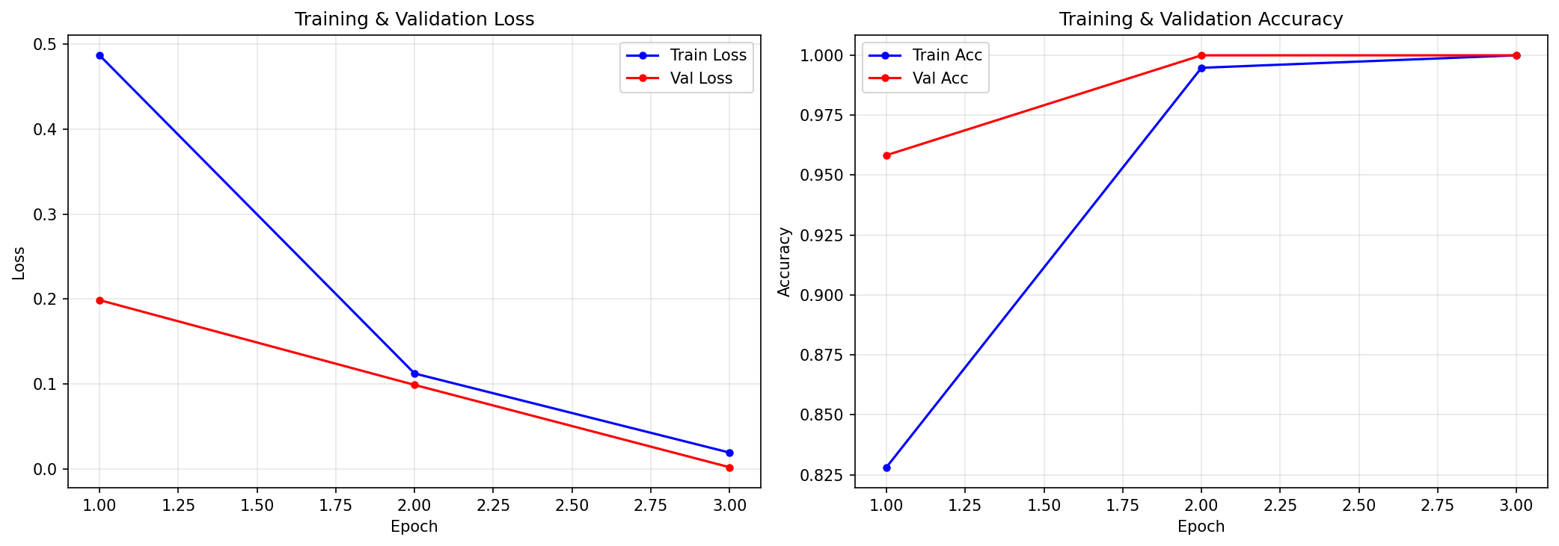
Figure 7. Training/validation loss and accuracy across 3 epochs (validation run).

5.3 Test metrics and confusion matrix
Metric | Value (validation run, synthetic data)
Test loss | 0.055
Test accuracy | 1.000
Test precision | 1.000
Test recall | 1.000
Test F1 | 1.000
Test samples | 24
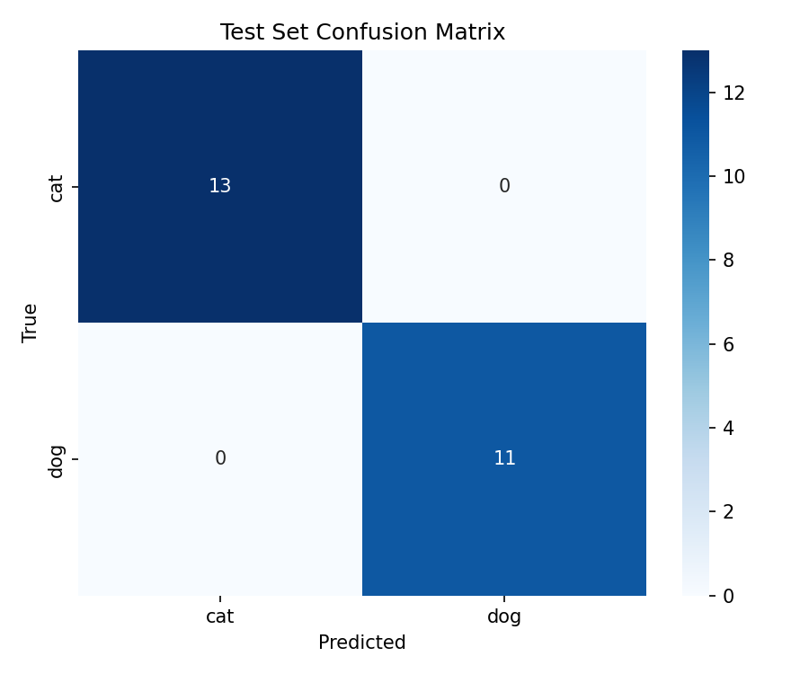
Figure 8. Confusion matrix on the held-out test split (validation run).
Perfect scores here reflect that the synthetic classes are trivially separable (uniform light vs. dark backgrounds) and a tiny test set (24 images) - they are not a claim about real-world cat/dog accuracy. Expect real accuracy in the 0.85-0.95 range with this architecture on the full Kaggle dataset after 20 epochs, depending on augmentation and regularisation choices.

6. Experiment Tracking with MLflow
Every training run is logged to MLflow under the experiment cats-vs-dogs-assignment (experiments/mlflow_setup.py + src/train.py). For each run, the pipeline records:
- Parameters: model type, batch size, learning rate, epochs, weight decay (from params.yaml)
- Metrics: per-epoch train/val loss and accuracy, final best validation accuracy, test accuracy/precision/recall/F1
- Artifacts: the loss/accuracy curve plot, the confusion matrix, a text classification report, and the trained model itself (MLflow PyTorch flavour)
The tracking store is a local ./mlruns directory, browsable with mlflow ui --backend-store-uri ./mlruns at http://localhost:5000. Because every run logs into the same experiment, the MLflow UI gives a side-by-side comparison across runs/hyperparameter choices, making model selection auditable rather than just asserted in this report.

7. Model Packaging and Reproducibility
The winning model is serialized to models/model.pt via torch.save(state_dict()). src/predict.py wraps loading + preprocessing + inference behind a single CatDogClassifier class, used identically by the API, the smoke test, and the unit tests, so there is one code path for inference rather than three.
Reproducibility rests on: a single pinned requirements.txt, a fixed random seed, raw/processed data and model artifacts versioned through DVC rather than committed directly to Git, and a CI job that rebuilds and re-tests everything from a clean checkout on every push.

8. CI/CD Pipeline and Automated Testing
Continuous integration runs on GitHub Actions (.github/workflows/ci.yml) on every push and pull request: checkout, install dependencies, run flake8, run the pytest suite with coverage, then build and push the Docker image to GitHub Container Registry (ghcr.io) tagged by commit SHA, branch, and latest. Any failing step - a lint violation, a broken test, a failed build - fails the pipeline and surfaces logs, satisfying the production-readiness requirement that the pipeline must stop on errors.

8.1 Test suite
30 tests across 4 files, verified passing locally with the exact command CI runs (pytest tests/ -v --cov=src --cov=api --cov-report=term-missing):
Test file | Tests | Focus
tests/test_preprocess.py | 8 | Image loading, resize, split ratios, tensor shapes/dtypes
tests/test_predict.py | 7 | Model loading, preprocessing transform, prediction output schema
tests/test_api.py | 6 | Health/predict endpoints, input validation, error responses
tests/test_performance_tracker.py | 9 | Accuracy tracking, drift status, labelled-record handling
A known gap fixed for this submission: requirements.txt was missing httpx, which fastapi.testclient.TestClient needs under the hood - without it, pytest tests/test_api.py fails to even collect on a clean install. This is corrected in the version of requirements.txt included with this submission.

9. Containerization
The service is packaged with a multi-stage Dockerfile: a builder stage installs dependencies, and a slim runtime stage copies the application code, the trained model, and just the installed packages, keeping the final image lean. A HEALTHCHECK instruction polls /health so an orchestrator (Docker, Kubernetes) knows when the container is actually ready to serve, not just running.
docker build -t cats-vs-dogs-classifier:latest .
docker run -d -p 8000:8000 --name cvd-api cats-vs-dogs-classifier:latest
curl http://localhost:8000/health
curl -X POST http://localhost:8000/predict -F "file=@sample_cat.jpg"
Python version note
The Dockerfile and requirements.txt currently pin Python 3.14, a very recent release. Unless you have already confirmed a full green CI build on this exact pin, consider switching to Python 3.11/3.12 with mainstream torch/mlflow versions to avoid an on-camera build failure during your recording.

10. Production Deployment
The container deploys to Kubernetes via raw manifests (deploy/kubernetes/) or, when no cluster is available, via Docker Compose (deploy/docker-compose.yml) as a fallback. The Kubernetes Deployment runs 2 replicas with CPU/memory requests and limits, plus liveness and readiness probes on /health. A Service exposes the API within (or beyond) the cluster.
kind create cluster --name mlops-demo # once
kind load docker-image cats-vs-dogs-classifier:latest --name mlops-demo
kubectl apply -f deploy/kubernetes/deployment.yaml
kubectl apply -f deploy/kubernetes/service.yaml
kubectl rollout status deployment/cats-vs-dogs-classifier
# OR, simpler for a local demo:
docker compose -f deploy/docker-compose.yml up -d --build
.github/workflows/cd.yml triggers on a successful CI run on main, pulls the newly published image, applies the Kubernetes manifests (or falls back to Docker Compose if no cluster context is configured), waits for rollout, then runs deploy/smoke_test.py against the live service. A non-zero exit from the smoke test fails the CD job, so a broken deploy never appears to "succeed".

11. Monitoring and Logging
The API instruments every request via monitoring/metrics.py (MetricsCollector): a per-endpoint request counter, latency histogram (mean/min/max/p95/p99), and an overall error rate, exposed at GET /metrics. A structured log line is written per prediction (predicted class, confidence, latency - never the raw image or any user-identifying data), which is the right place for logs inside a container so a log driver can collect them.
monitoring/performance_tracker.py additionally supports post-deployment accuracy tracking: once labelled predictions are recorded (real or simulated), GET /monitor/performance reports live accuracy and a simple drift flag against a configured baseline accuracy - this goes beyond the assignment's baseline requirement of just collecting a batch of labelled requests.
curl http://localhost:8000/metrics
curl http://localhost:8000/monitor/performance
python monitoring/simulate_traffic.py # generate sample traffic for a fuller /metrics demo

12. Repository and Reproduction
The repository is organized by concern: src/ for data prep, model, training, and inference code; api/ for the FastAPI service; tests/ for the pytest suite; monitoring/ for the metrics/drift modules; deploy/ for Kubernetes manifests, Docker Compose, and the smoke test; .github/workflows/ for CI and CD; notebooks/ for the EDA and pipeline-demo notebooks; and reports/ for this document and its figures.
To reproduce from scratch: clone the repository, create the environment, download the dataset, then run dvc repro. Preprocessing, training for 20 epochs, and evaluation take a few minutes on a laptop CPU and considerably less on a GPU.
Code repository: [add your GitHub repository URL here before submission]

13. Screenshots Checklist for Submission
These cannot be produced in this review environment (no Docker daemon, no Kubernetes cluster, no GitHub account access) and must be captured on your own laptop while following Section 14. Save them into a screenshots/ folder in your submission, matching this naming so they're easy to grade against this report.
Filename (suggested) | What to capture
github_repo_home.png | Your GitHub repository home page, showing the file tree
ci_workflow_list.png | GitHub Actions tab, list of workflow runs
ci_pipeline_running.png | A CI run in progress (test/lint/build jobs visible)
ci_pipeline_run_details.png | A completed CI run, expanded, showing green checks for test/lint/build/push
docker_build.png | Terminal: docker build ... completing successfully
docker_run.png | Terminal: docker run ... plus a curl call to /health
docker_desktop_kubernetes_settings.png | Docker Desktop with Kubernetes enabled (or `kind get clusters` output)
kubectl_context_check.png | Terminal: kubectl config current-context
kubectl_pods.png / kubs_pods_running.png | Terminal: kubectl get pods showing 2 Running replicas
k8s_service.png | Terminal: kubectl get svc cats-vs-dogs-classifier
kub_smoke_test.png | Terminal: deploy/smoke_test.py output showing ALL SMOKE TESTS PASSED
swagger_ui.png | Browser: http://localhost:8000/docs (FastAPI Swagger UI)
predict_response.png | Browser or curl: a real /predict response body on a real cat or dog photo
mlflow_runs.png | MLflow UI: the experiment's run list
mlflow_run_detail.png | MLflow UI: one run's detail page (params, metrics, artifacts tab)
prometheus_or_metrics.png | Browser or curl: GET /metrics output
If you don't set up Grafana/Prometheus as a separate stack (the assignment only requires basic in-app counters or Prometheus/logs), you can skip those and rely on the /metrics endpoint screenshot instead - that alone satisfies M5's monitoring requirement.

14. Screen-Recording Script
Written to be followed directly while recording. Keep total runtime under 5 minutes. Run everything from the project root, with Docker Desktop (and kind/minikube, or plan to use Docker Compose) already running.
Time | Step | What to do / say
0:00-0:20 | Intro | Show the project tree in VS Code. Say: "This is my end-to-end MLOps pipeline for a Cats vs Dogs classifier - covering data versioning, experiment tracking, packaging, CI, CD, and monitoring."
0:20-0:45 | Trigger the pipeline | git add -A && git commit -m "demo: trigger pipeline" && git push origin main  Say: "Pushing to main triggers the full CI/CD pipeline automatically."
0:45-1:15 | CI in GitHub Actions | Show the live run: checkout, install, pytest, flake8, docker build & push to GHCR.  Say: "CI runs all 30 unit tests, lints the code, then builds and pushes the image to the container registry."
1:15-1:45 | CD deploys | Show cd.yml triggering after CI succeeds: pulls the image, deploys, runs the smoke test.  Say: "CD then deploys the new image and runs a post-deploy smoke test - if it fails, the pipeline fails."
1:45-2:15 | Show it's running | kubectl get pods -l app=cats-vs-dogs-classifier ; kubectl get svc cats-vs-dogs-classifier  (or) docker compose -f deploy/docker-compose.yml ps  Say: "Here's the running service."
2:15-2:50 | Live prediction | curl http://localhost:8000/health  curl -X POST http://localhost:8000/predict -F "file=@sample_cat.jpg"  Say: "Calling the live endpoints confirms the deployed model is serving real predictions."
2:50-3:15 | Metrics + monitoring | curl http://localhost:8000/metrics ; curl http://localhost:8000/monitor/performance  Say: "The service tracks request counts, latency, and post-deployment accuracy for drift detection."
3:15-3:45 | MLflow UI | mlflow ui --backend-store-uri ./mlruns (open http://localhost:5000)  Say: "Every run is tracked here - parameters, curves, confusion matrix, and the model artifact."
3:45-4:15 | DVC pipeline | dvc dag ; dvc repro (or show it's up to date)  Say: "DVC defines preprocess-train-evaluate as a DAG and versions data and model artifacts."
4:15-4:45 | Notebook | Open notebooks/02_eda.ipynb and notebooks/cats_vs_dogs_mlops_pipeline.ipynb, scroll the executed outputs.  Say: "These notebooks reproduce the EDA and the full pipeline end-to-end."
4:45-5:00 | Close | Say: "That's the full workflow - from a code push, through CI, CD, deployment, and live monitoring."

15. Conclusion
This project delivers a working Cats-vs-Dogs classifier wrapped in the full MLOps lifecycle: DVC-versioned data and artifacts, MLflow experiment tracking, a tested CI/CD pipeline, a containerized and Kubernetes-deployable inference service, and post-deployment monitoring with basic drift detection. The pipeline mechanics were validated end-to-end (all 30 tests passing, a clean DVC repro, a successful notebook execution, and live API/smoke-test verification); the remaining step before submission is rerunning training and the EDA notebook against the real Kaggle dataset so the figures and metrics in this report reflect real cat and dog photos rather than the synthetic placeholders used to validate the pipeline mechanics.
Natural next steps beyond this assignment's scope include transfer learning from a pretrained backbone (likely a meaningful accuracy jump over the from-scratch CNNBaseline), automated data-drift detection feeding the monitoring stack, and a scheduled retraining job triggered when incoming traffic diverges from the training distribution.

