Job Portal Presentation (Text Only)

Slide 2
“Home Page, User and Admin Registration and Login”

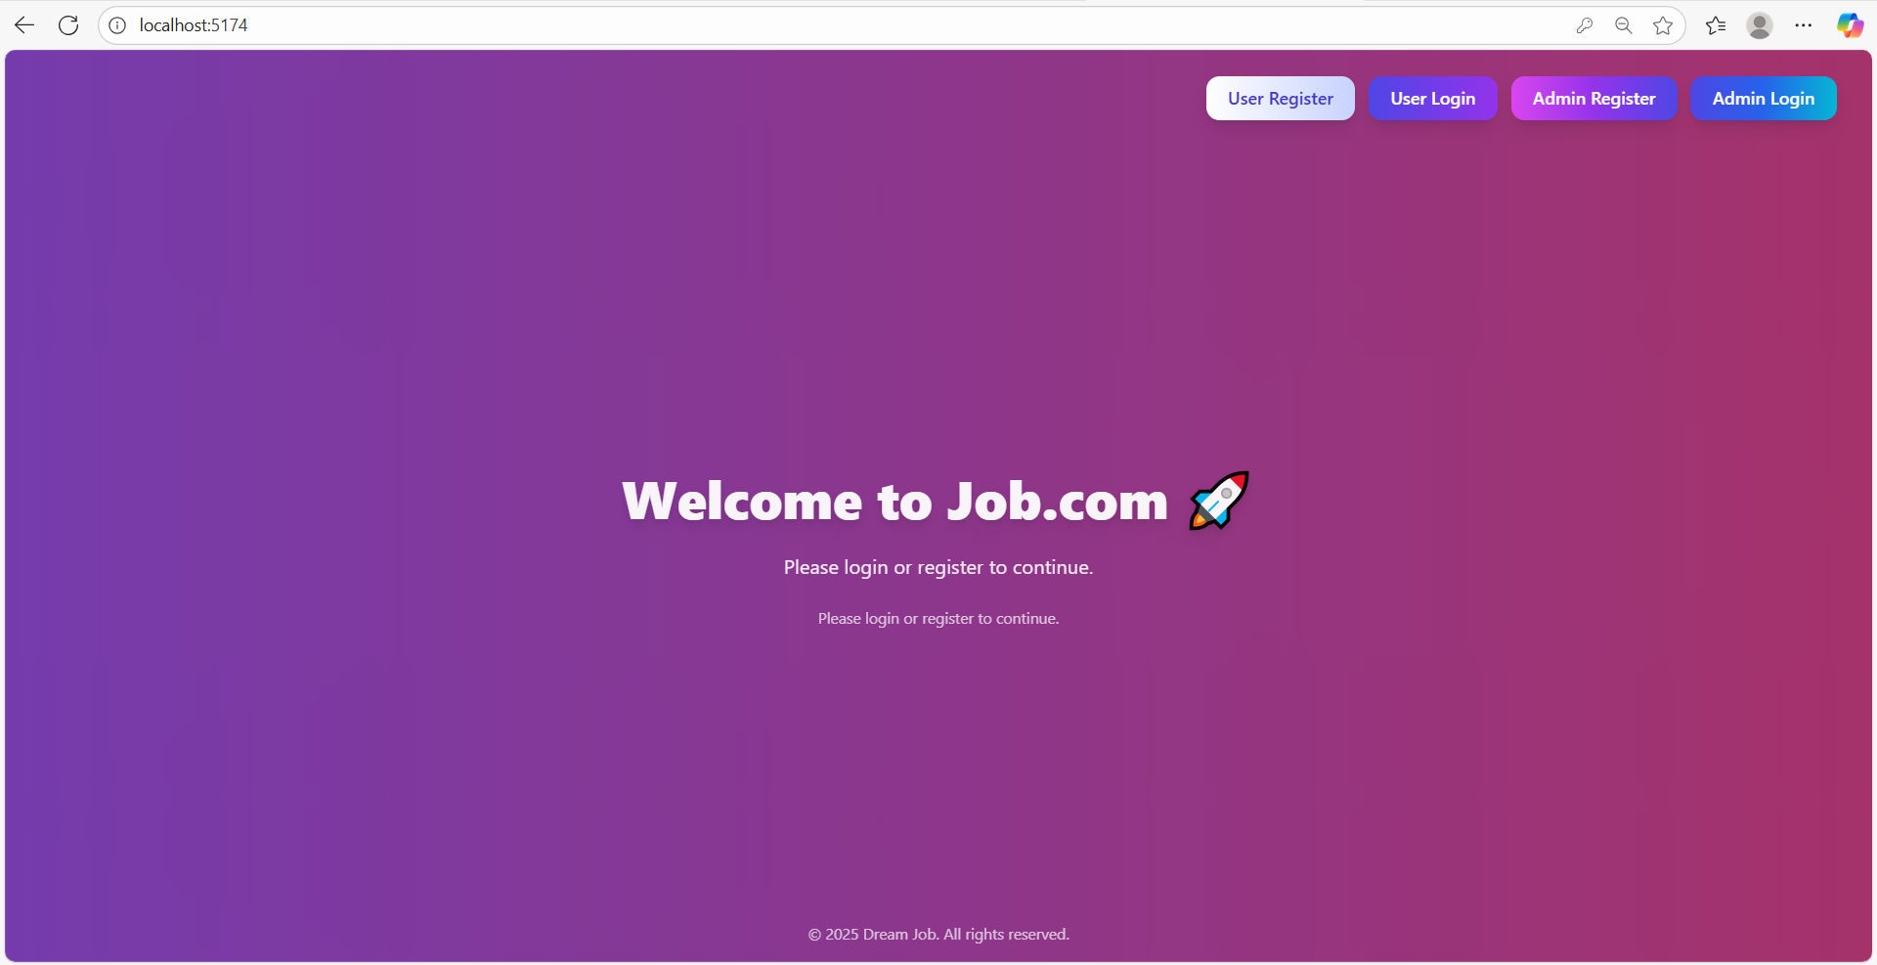

Slide 3
User Register And Login
User Register
User login
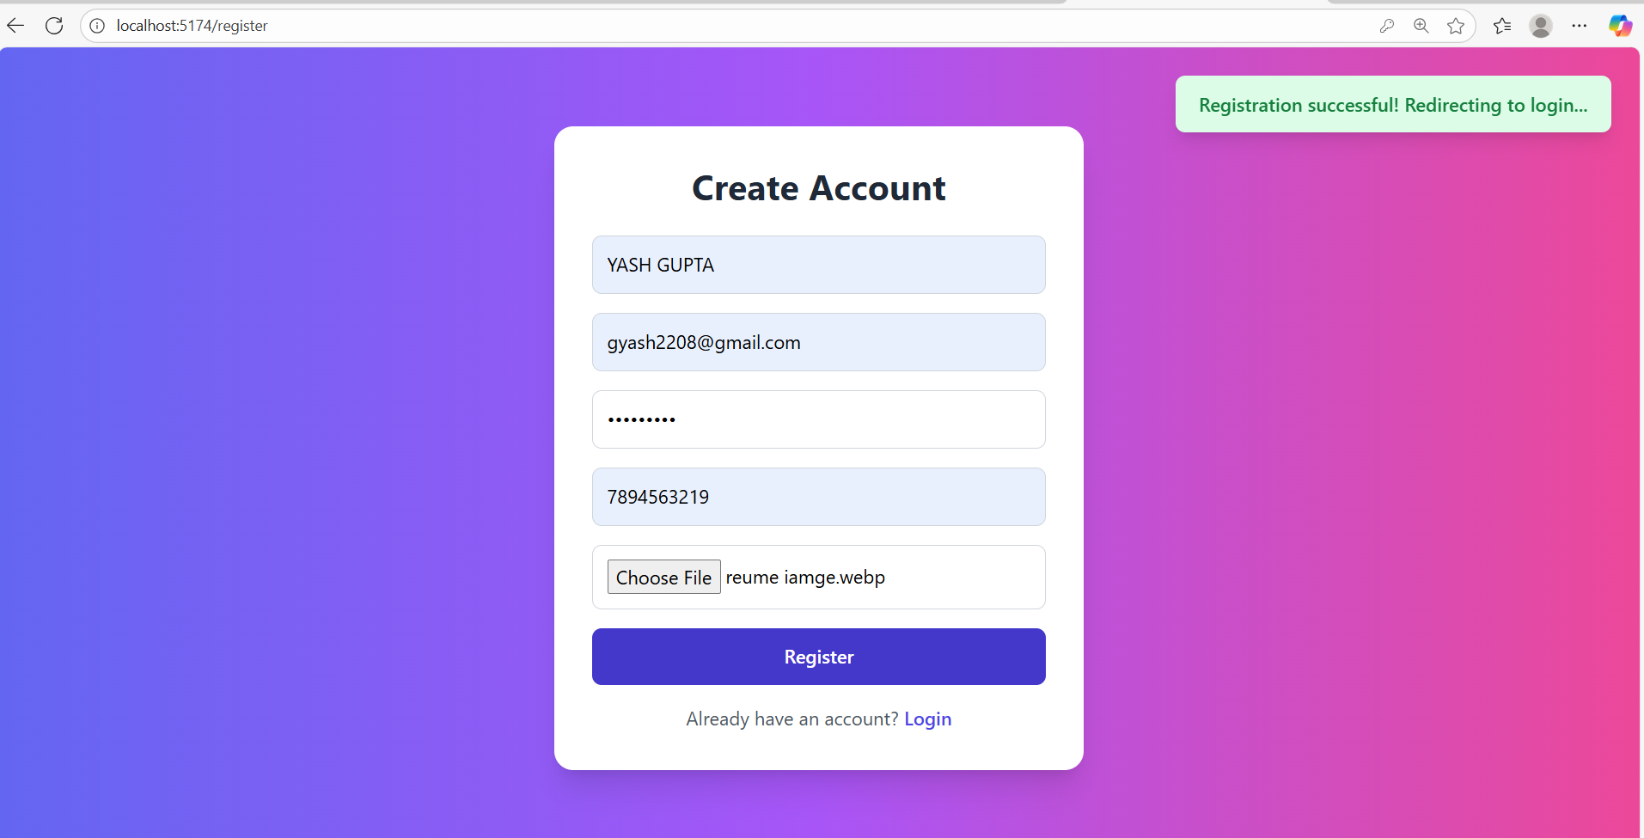

Slide 4
After User Login
We can see Heading
User Personal Info
User Profile
Show Job Detail
Track Job
Logout
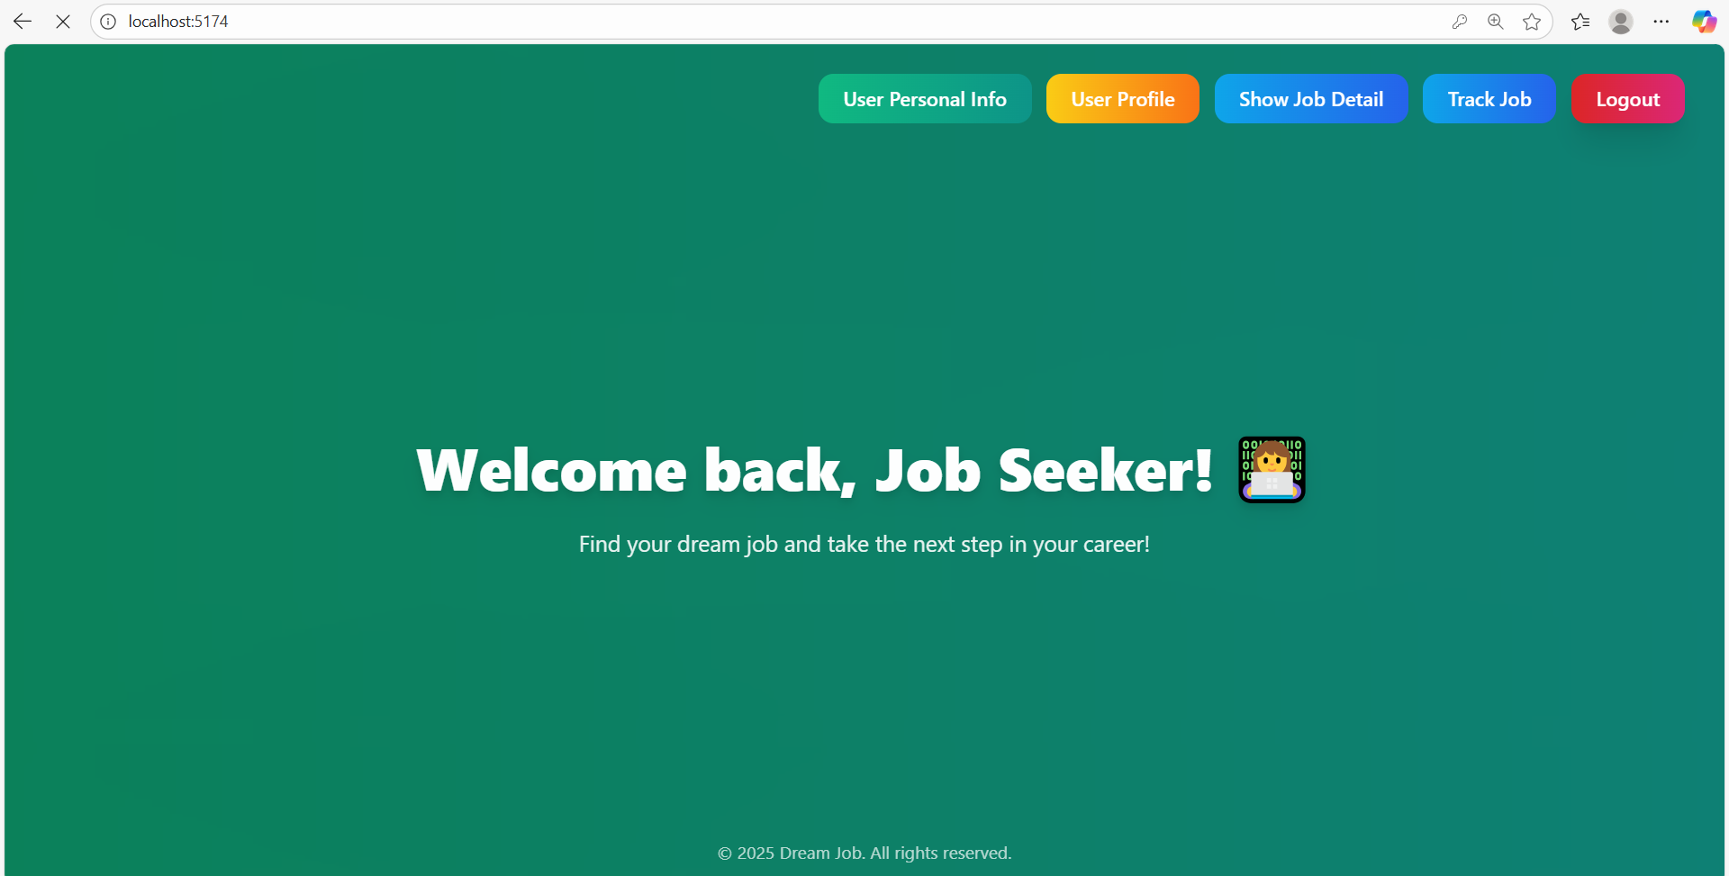

Slide 5
In User Profile
The user profile section allows users to view their details and profile picture, and provides an option to update them.
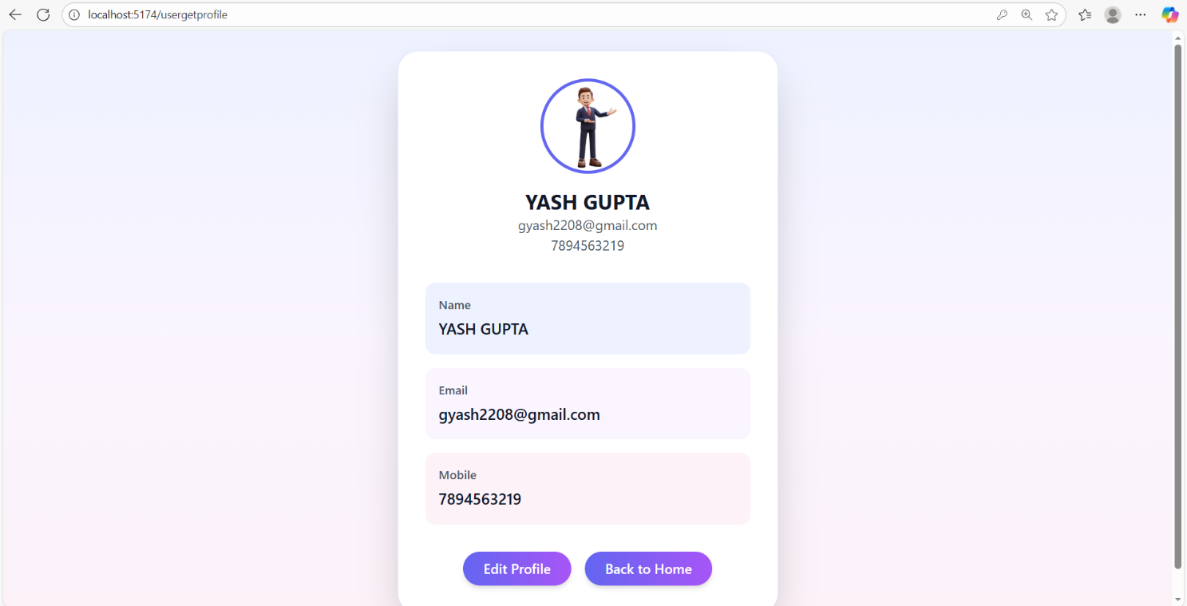

Slide 6
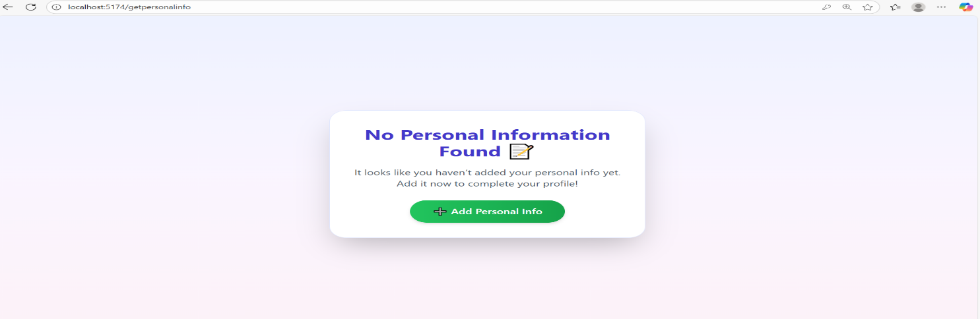
User Personal Info
The user can add and update their personal information through add and edit option.

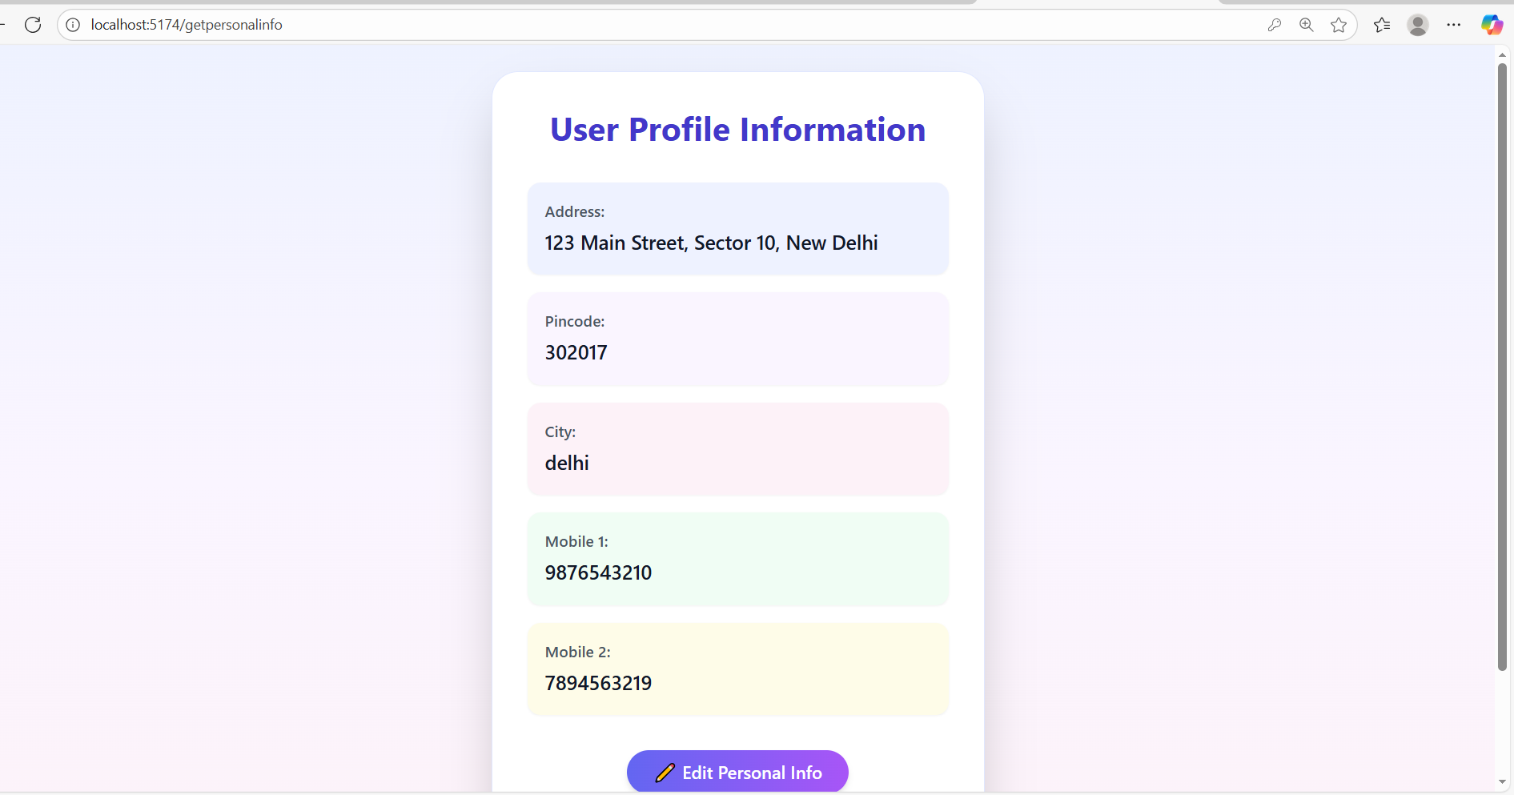

Slide 7
Show Job Detail
Users can browse and search for available job listings and apply for suitable positions directly through the system.
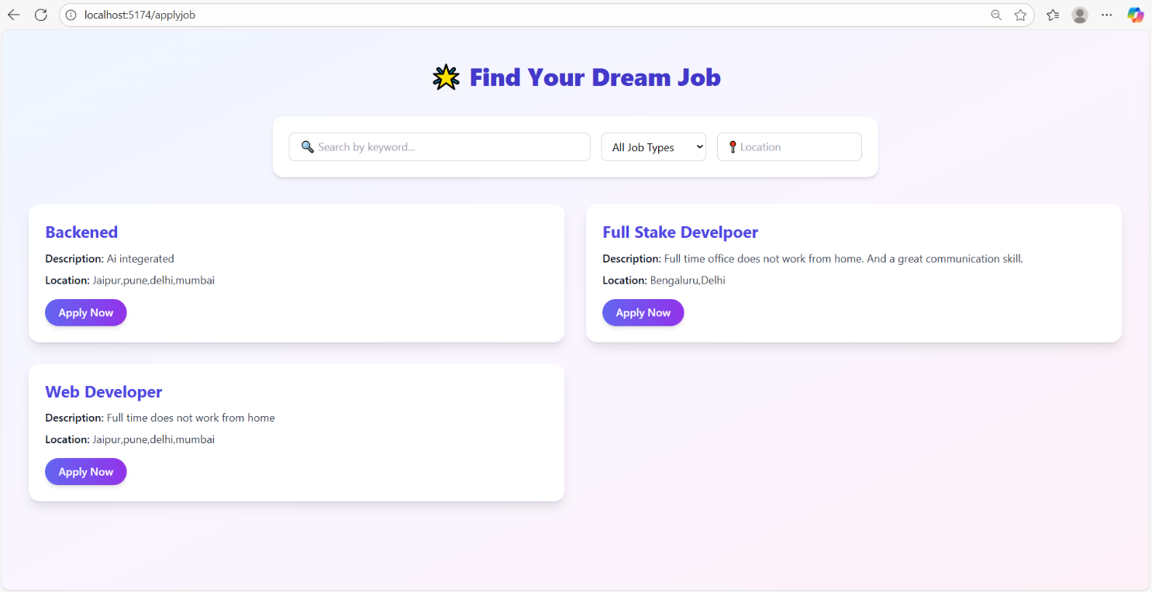

Slide 8
User apply Job
Allows users to upload their resume and
apply for desired job postings.

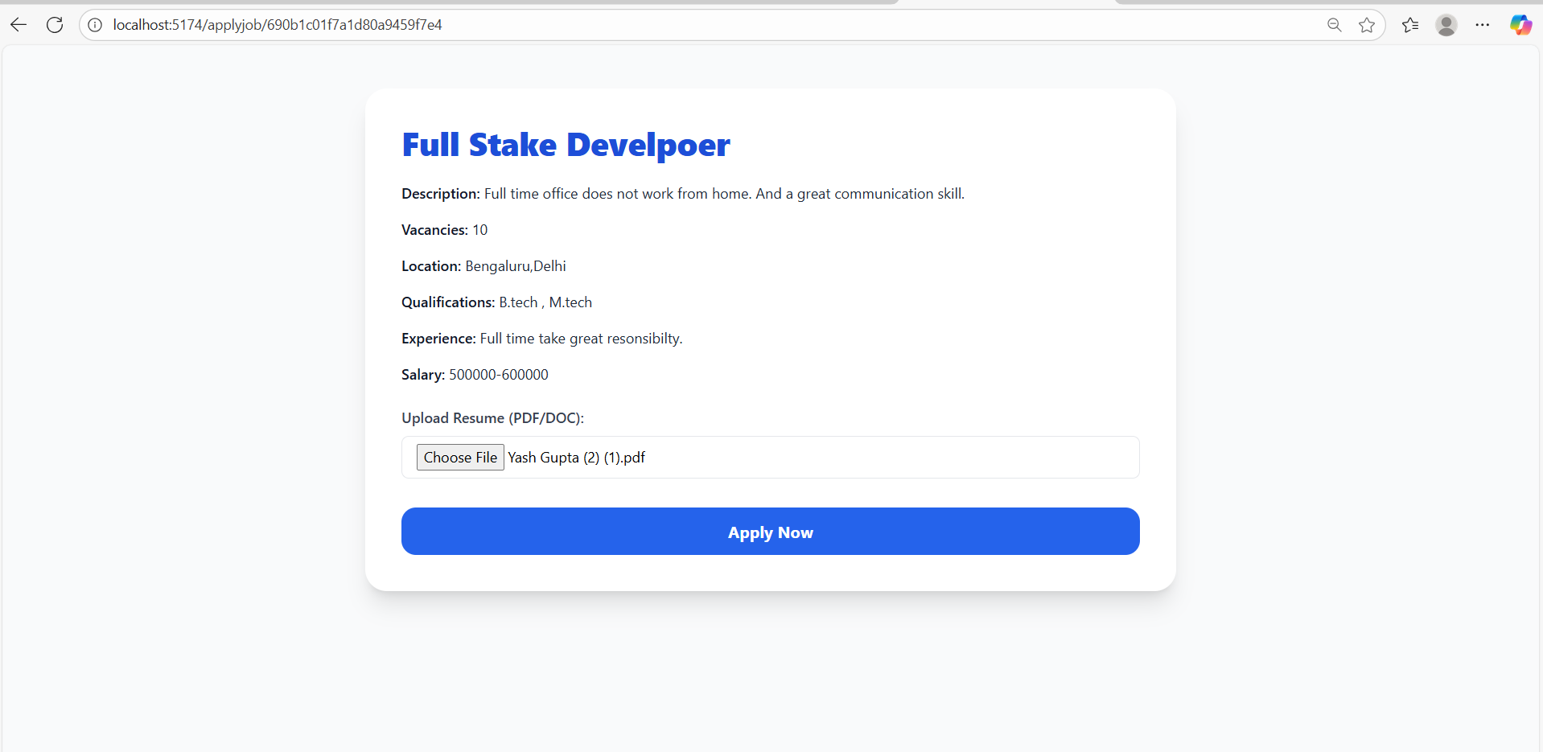

Slide 9
User Can Track Job
