Performance Results with Test Scenarios

## Lakshmi Narasimha Guptha Munuhur Rajagopal

There are a few things that can be varied in the program.

1. The number of pigs can be modified by changing the number of entries in the file called portConfig.
2. The chances of a coordinator being alive at the start of each bird launch can be adjusted using the macro COORD_ALIVE_CHANCE
3. The probability that a pig is successfully notified by the coordinator about an impending bird launch can be varied using the macro PIG_NOTIFY_CHANCE
4. The number of positions on the grid can be varied by setting the value of the macro MAX_POSN

# The Test Scenarios

For validating correctness, the number of “I was hit” messages by the individual pigs was compared with the actual scores reported by the coordinators and the bird. The position of the bird and that of the pigs which claim to be affected were cross verified. It was verified that coordinators go down and that the other coordinator seamlessly takes over. Further, it is verified that the database entries about dead pigs are read in by the coordinator that is alive. All this has been verified to the extent possible over plenty of games.

For each scenario, there were a minimum of 100 rounds of the game, with each game having 10 launches. This leads to a total of 1000 launches for each scenario. The scores were determined over 100 games in order to give an accurate picture that is free of bias due to the randomization employed in the program.

First, for 6 pigs, the COORD_ALIVE_CHANCE was varied from 10 to 6 and then to 3. The greater the COORD_ALIVE_CHANCE, the better is the chance of a coordinator staying alive at the start of each launch. Now, this should not have any impact on the bird hit rate, because the other coordinator should seamlessly be able to take over.

Secondly, PIG_NOTIFY_CHANCE is varied – takes the values 2, 4 and 6. The higher the PIG_NOTIFY_CHANCE, the greater is the possibility for a pig to escape from being hit when it is targeted.

Thirdly, for each variation in PIG_NOTIFY_CHANCE, the maximum number of positions on the grid is varied – 5, 8 and 10. When the maximum positions increases, the probability of a bird launch affecting a pig decreases.

Finally, the number of pigs is increased from 6 to 8. This leads to a denser grid, and an increase in the number of hits. In essence, the earlier graphs shift upwards.

The actual performance numbers are presented in the file called records, in the birdypigs3 directory. Here are three graphs that represent the performance measures:

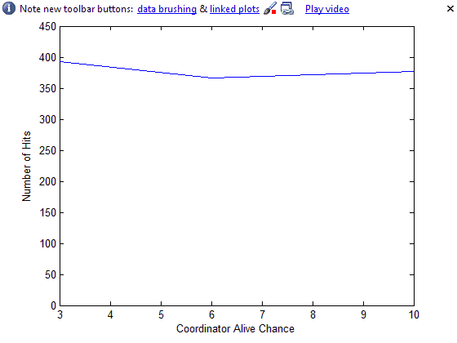

6 Pigs – Fairly constant as expected

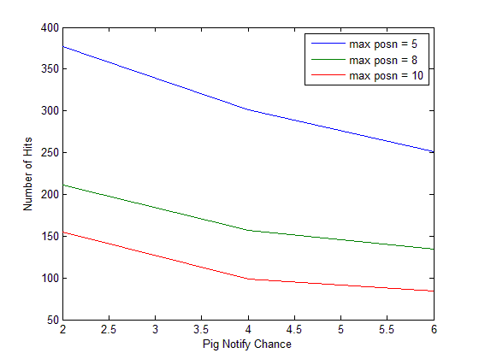

6 Pigs – Decreases with increase in Pig Notify Chance

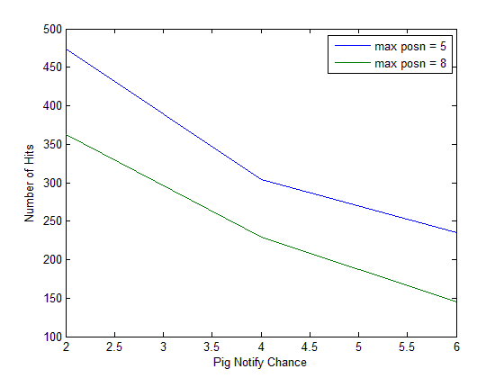

8 Pigs - Decreases with increase in Pig Notify Chance