CONDENSED COMPANION · V1.0 · SEPT–OCT 2026

SAP Migration — Field Pocket Reference
The one document to carry into a cutover bridge: the sequence, the checks, the return codes and the decision gates. Full rationale, theory and evidence strategy live in the SAP Migration Training Handbook v1.0 — this card deck does not replace it.
Field | Value
Document ID | SAP-MIG-TRN-PR-001
Companion to | SAP-MIG-TRN-HB-001 v1.0 (Training Handbook)
Owner | Amit Prajapati — primary trainer
Use | Cutover bridge, validation desks, hypercare desk
Status | Issued with handbook v1.0

THREE RULES THAT OVERRIDE EVERYTHING ELSE ON THESE PAGES
1. Nothing advances past a gate without evidence and a named approval.
2. The source stays available until the required final backup activity succeeds.
3. If R3trans -d is not 0000, SAP does not start.

POCKET REFERENCE · SECTION 1

1 Cutover run-card
Four lanes, one direction of travel. Each handover is announced on the bridge and recorded in the change log with a timestamp.
LANE SEQUENCE
APPLICATION | DBA | BASIS / MIGRATION | FUNCTIONAL + PMO
1 Cooldown / ramp-up complete 2 Application + web services stopped 3 Handover to DBA confirmed | 4 Final backup + AWS snapshot 5 Switchover or HANA recovery 6 DBVERIFY, RMAN, DB validation | 7 rsync global directory; clean host/IPAM 8 Profile parameters, kernel permissions, root scripts 9 R3trans -d must return 0000 10 Start SAP; validate SNC/SSO, Gateway, RFC | 11 Business transaction tests, interfaces, printers, evidence

# the gate before SAP start
su - &lt;sid&gt;adm
R3trans -d # expect: R3trans finished (0000)
cat trans.log # first place to look if not 0000
# instance state without the GUI
sapcontrol -nr <nn> -function GetProcessList
sapcontrol -nr <nn> -function GetSystemInstanceList
GO/NO-GO GATE INPUTS
Go/No-Go input | Must be true to vote Go
Technical validation | Module 4 + Module 6 checks complete, or formally deferred with owner, impact, date
Functional validation | Named business transactions passed by the functional team
Evidence | Source and target captured, compared, attached to the change record
Rollback readiness | Snapshot / final backup verified; DNS rollback path defined; owner on the bridge
Approvals | Basis, application, functional, system owner, PMO — recorded by name
Open risks | Every item classified; no unexplained critical
Support readiness | Hypercare roster, escalation path, ticket routing live

ROLLBACK PATH (EXECUTED ON NO-GO OR AN UNSAFE CUTOVER)
▪ Restore the snapshot or recover the source; revert DNS/CNAME to the source.
▪ Restart source database and SAP; re-validate connectivity (R3trans -d).
▪ Announce decision, time and reason on the bridge; record evidence of the attempt.
▪ Confirm with the business what data (if any) was created on the target.

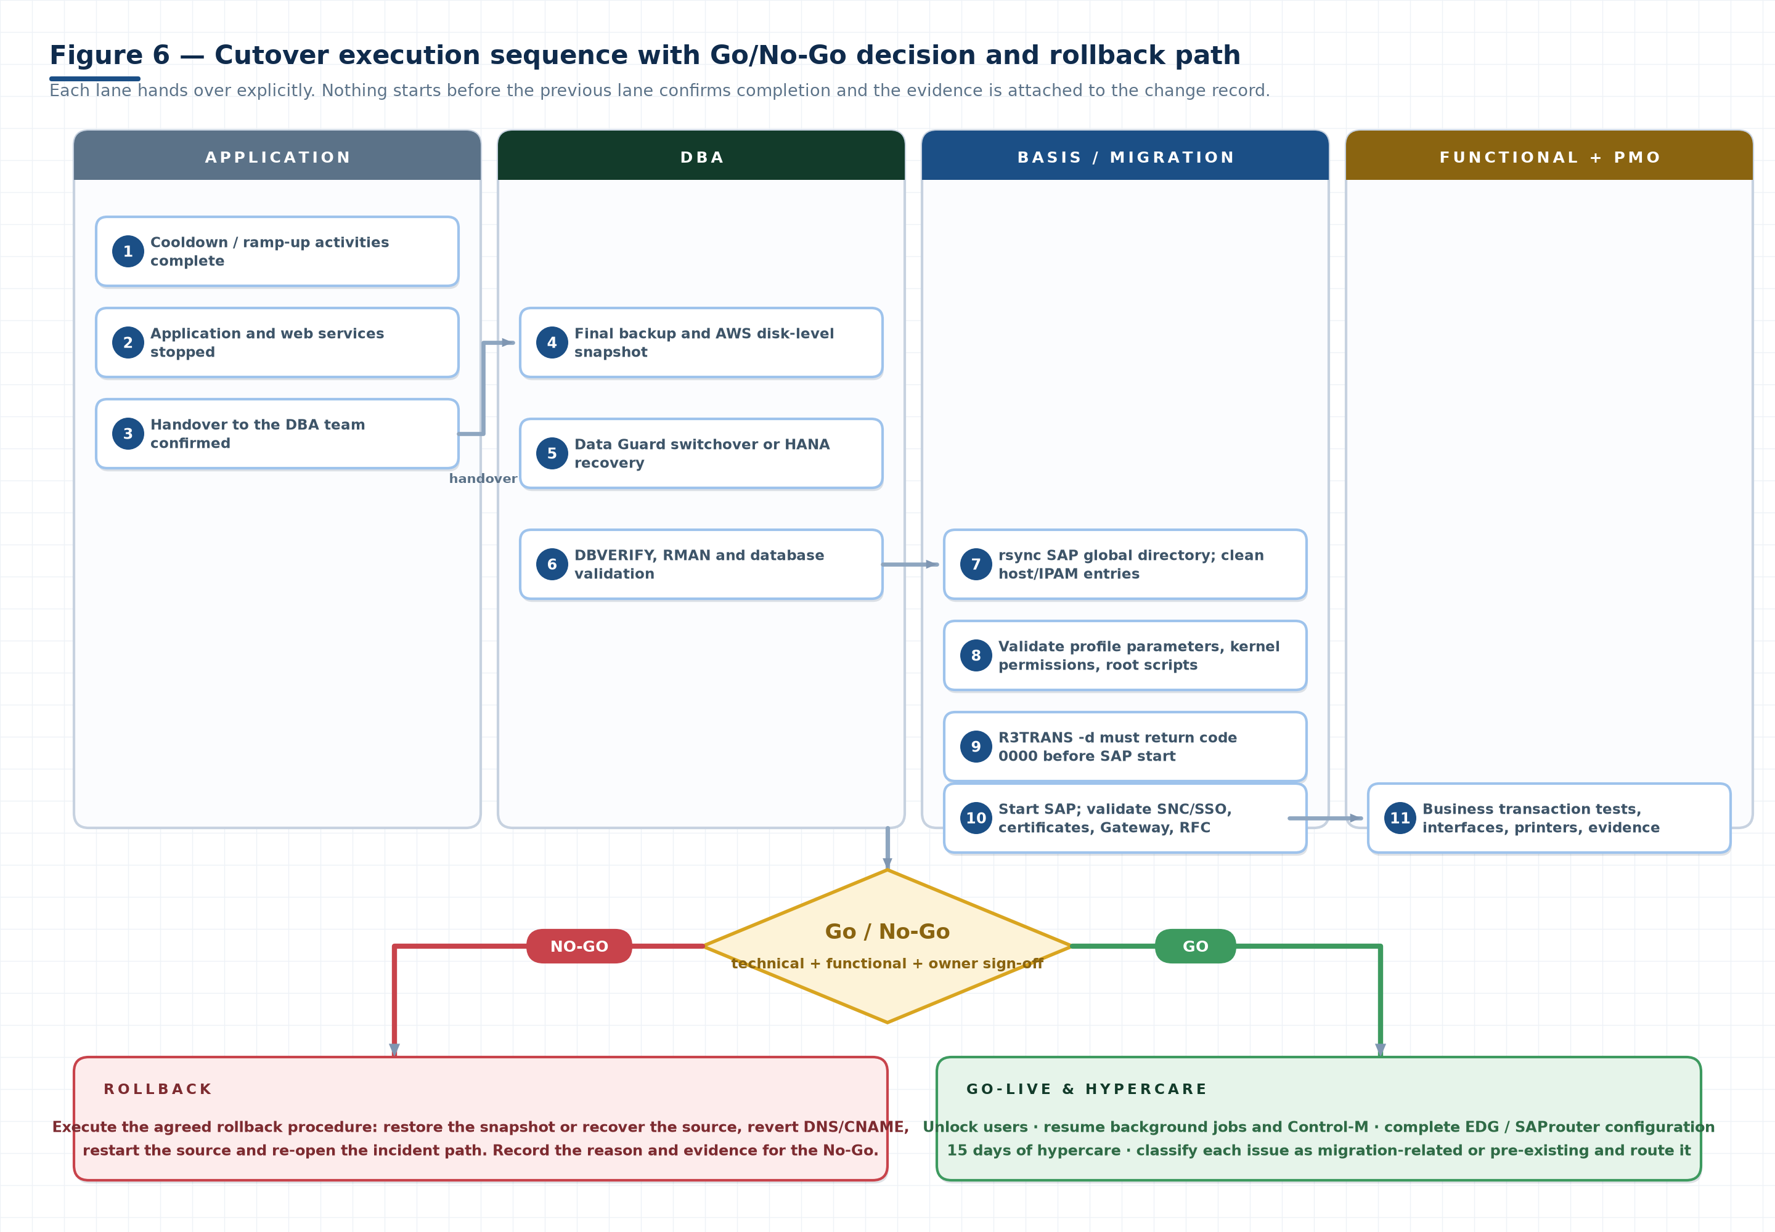
Figure 6. Cutover execution sequence with the Go/No-Go decision and rollback path (from the handbook).

POCKET REFERENCE · SECTION 2

2 Validation checklists — field copy
Tick, status, evidence reference. Transfer results into the change record before sign-off; an unexplained N/A is an audit finding.

2.1 OS
☐ | Check | Status | Evidence / remarks
☐ | File systems / mount points | Not Started
☐ | CPU | Not Started
☐ | RAM | Not Started
☐ | Swap | Not Started
☐ | OS version | Not Started
☐ | Kernel version | Not Started
☐ | UID/GID | Not Started
☐ | Libraries | Not Started
☐ | FTP users | Not Started
☐ | OS groups | Not Started
☐ | IP addresses | Not Started
☐ | Hostnames | Not Started
☐ | /etc/hosts | Not Started
☐ | /etc/services | Not Started
☐ | SAP directories | Not Started
☐ | Permissions | Not Started

2.2 SAP
☐ | Check | Status | Evidence / remarks
☐ | SAP services active | Not Started
☐ | Auto-start tested (real reboot) | Not Started
☐ | SAP processes green | Not Started
☐ | Application servers available | Not Started
☐ | SM51 | Not Started
☐ | SMGW | Not Started
☐ | SM59 | Not Started
☐ | RFC report | Not Started
☐ | SNC | Not Started
☐ | STMS | Not Started
☐ | Transport directory | Not Started
☐ | AL11 | Not Started
☐ | Printers | Not Started
☐ | Spool | Not Started
☐ | SMICM | Not Started
☐ | SSL/TLS certificates | Not Started
☐ | SAP license | Not Started

2.3 Database
☐ | Check | Status | Evidence / remarks
☐ | DB status | Not Started
☐ | DB02 | Not Started
☐ | Storage utilization | Not Started
☐ | Tablespaces | Not Started
☐ | Database growth | Not Started
☐ | Latest backup | Not Started
☐ | Backup status | Not Started
☐ | Redo/archive logs | Not Started
☐ | Recovery requirements | Not Started

2.4 Performance
☐ | Check | Status | Evidence / remarks
☐ | ST02 memory | Not Started
☐ | Extended memory | Not Started
☐ | Heap/private memory | Not Started
☐ | Buffer utilization | Not Started
☐ | ST03N workload | Not Started
☐ | Response time | Not Started
☐ | Wait time | Not Started
☐ | DB request time | Not Started
☐ | CPU time | Not Started
☐ | Performance trends | Not Started

2.5 Cutover readiness
☐ | Check | Status | Evidence / remarks
☐ | Application shutdown confirmed | Not Started
☐ | DBA handover confirmed | Not Started
☐ | Source/target synchronization confirmed | Not Started
☐ | Snapshot/backup confirmed | Not Started
☐ | DNS/IPAM plan confirmed | Not Started
☐ | Evidence captured | Not Started
☐ | Technical validation complete | Not Started
☐ | Functional validation complete | Not Started
☐ | Approvals complete | Not Started
☐ | Rollback ready | Not Started
☐ | Go/No-Go decision recorded | Not Started

POCKET REFERENCE · SECTION 3

3 Transactions, commands and files
What each item proves. A screenshot you cannot interpret is not evidence.
SAP TRANSACTION QUICK REFERENCE
T-code | Proves | T-code | Proves
SM51 | All planned instances active and registered | ST02 | EM, heap/private, roll, paging, buffer hit ratio
SM59 | RFC destinations exist and connect | ST03/ST03N | Response/DB/CPU/wait time and workload trend
SMGW | Gateway status and connections | STAD | The individual slow records behind the aggregates
SMICM | ICM HTTP/HTTPS services and ports | RZ10 / RZ11 | Persistent profile change / dynamic runtime change
STMS | Domain, systems, routes, transport directory | DB02 | Space, tablespaces, growth, backup status
AL11 | SAP directories, content, permissions | SPAD / SP01 | Output devices and spool requests
STRUST | Certificates: validity, chain, hostname | SLICENSE | License valid for the new hardware key
ST22 / SM37 | New dumps / job status after go-live | SM13 / SM12 | Update errors / lock entries

OS COMMAND QUICK REFERENCE
Command | Validates
df -h, mount, lsblk | File systems, mounts, sizes, options
lscpu, free -g, swapon -s | CPU, RAM, swap versus build sheet
id, getent passwd, getent group | Numeric UID/GID consistency
ip a, ip r, hostname -f | IPs, routes, hostname/FQDN
getent hosts, nslookup | Resolution — run from the SAP host, not a laptop
uname -r, /etc/os-release | Kernel and OS version
systemctl status / show | Service state, Result and exit code
sapcontrol -nr <nn> -function GetProcessList | Instance process state from the OS
R3trans -d | SAP-to-database connectivity (expect 0000)
rsync -avn (dry run first) | Global directory synchronisation

FILES THAT DECIDE WHETHER A CUTOVER WORKS
File / location | Why it decides the cutover
/etc/hosts | A stale entry silently overrides DNS and reconnects you to the source
/etc/services | sapdp<nn> / sapgw<nn> port definitions
/etc/fstab | A missing or misordered mount breaks SAP at boot
SAP work/log dirs | dev_w*, dev_disp, dev_ms explain start failures
trans.log | First place to look when R3trans -d ≠ 0000
HANA INI files | global.ini, nameserver.ini drive recovery
Oracle network files | listener.ora, tnsnames.ora, sqlnet.ora

POCKET REFERENCE · SECTION 4

4 Return codes and first diagnostics
Diagnose before you retry, and never raise a memory parameter before finding what consumes the memory.
CODES YOU WILL ACTUALLY SEE
Code | Meaning | First actions
Service 0 | Success | Still confirm instances in SM51 — zero exit ≠ usable SAP
Service 127 | Command or shared library not found | ExecStart path, <sid>adm environment, LD_LIBRARY_PATH, migrated libraries
Service 255 | Generic start-script/SAP failure | Service journal, dev_disp, dev_ms, dev_w0, DB connect trace
R3trans 0000 | SAP ↔ database connectivity OK | Proceed to SAP start
R3trans 0012 | Database connect failed | DB open? listener? DB host entry in profile and /etc/hosts?
R3trans 0018 | DB authorisation / credentials | User, password, wallet/keystore, credentials handover

Confirm code meanings against the release and platform in use; treat as a starting point.
MEMORY AND PERFORMANCE SYMPTOM MAP
Symptom | Investigate first | Owner
Processes in PRIVATE mode | EM under-sized, long transactions, memory-heavy custom code | Basis + ABAP
High paging / swaps | Paging area too small, context held too long | Basis
Low buffer hit ratio | Buffer sizing or access patterns bypassing buffers | Basis + DBA
High DB time | Access path, statistics, SQL, app-to-DB latency, storage throughput | DBA
High CPU time | Custom code, data volume, under-sized instance type | ABAP
High wait time | Memory, enqueue, RFC destinations, dispatcher | Basis + interface owner
Slow only at peak | Work process saturation, DB contention | Basis + DBA

THRESHOLD CAUTION
≈1200 ms response time and ≈40% average DB request time are discussion values from the training. Validate against the client baseline and the measured source performance before using them as alerting thresholds.

POCKET REFERENCE · SECTION 5

5 Oracle switchover and HANA recovery cards
Planned switchover only — a failover is disaster recovery and is not reversible in the same way.
ORACLE DATA GUARD SWITCHOVER SEQUENCE
# | Step | Evidence to capture
1 | Pre-checks: listener, SQL*Net, DG parameters, SID, Broker, observer, patch alignment | Config outputs
2 | Review log switching and apply lag (zero gap) | v$managed_standby
3 | Compare source and target SCN | v$database.current_scn both sides
4 | Attach evidence to Jira/change; obtain approval | Ticket reference
5 | AWS disk-level snapshot of the target (rollback point) | Snapshot ID + timestamp
6 | Application shutdown confirmed; DBA handover accepted | Bridge log
7 | Close source primary; switchover; open new primary | Command output
8 | Validate new primary; DBVERIFY; RMAN backup; OEM agent | DBVERIFY + RMAN logs

NAME RESOLUTION AFTER THE ROLE CHANGE
DNS / IPAM after switchover | Rule
Virtual hostname | Unchanged — SAP keeps addressing the same name
Target IP | Updated in DNS/IPAM
CNAME | Repointed to the target environment
Resolution | Verified from every consumer with getent hosts + a real R3trans -d
Host files | Obsolete entries cleaned — they override DNS

Source backup → Configuration file → S3 backend → Target configuration → Recovery → Validation
HANA CONTAINER MODEL IN ONE LINE
SystemDB = central management, monitoring and the backup catalogue; TenantDB = the application workload. Separate logins; both can live on one host; neither is HA — HA is HSR plus cluster/storage design.
CUTOVER RULE
Test backup and recovery before cutover. During cutover: final backup → validate it → only then stop the source. The source stays available until that backup succeeds; it is also your rollback anchor.

POCKET REFERENCE · SECTION 6

6 Evidence, hypercare and escalation
Working before migration should work after migration — evidence is what makes that provable at 02:00 on a bridge call.
&lt;SID&gt;_&lt;PHASE&gt;_&lt;CHECK&gt;_&lt;SOURCE|TARGET&gt;_&lt;YYYYMMDD-HHMM&gt;.&lt;ext&gt;
# examples
PRD_PRECUT_SM59_SOURCE_20261002-1015.pdf
PRD_CUTOVER_R3TRANS_TARGET_20261005-0212.log
PRD_CUTOVER_SCN_BOTH_20261005-0140.png
CLASSIFYING A FAILURE IN HYPERCARE
Before vs after | Classification | Route
Working → failing | Migration-related | Owning team corrects, retests, re-captures evidence
Failing → failing | Pre-existing condition | Document it; route to BAU with baseline evidence
Failing → working | Improvement | Record it so it is not rolled back later
No baseline | Unclassifiable | Escalate — you cannot prove what you did not record

HYPERCARE MONITORING SET (15 DAYS)
Watch daily | Source | Bad trend looks like
Short dumps | ST22 | New dump types or a rising count
Failed jobs | SM37 / Control-M | Jobs cancelled that previously succeeded
Interfaces / IDocs | SM59, WE02 | Rising error status, retries not clearing
Response time | ST03N | Sustained rise over baseline, same period type
Memory | ST02 | PRIVATE mode, rising paging or swaps
Database | DB02, alert log | Growth beyond forecast, archive filling, backup failures
Updates / locks | SM13, SM12 | Stuck updates, growing lock entries
Certificates | STRUST | Expiry approaching, SNC handshake failures

ESCALATION MODEL
Severity | Definition | Route
S1 Critical | Cutover blocked, system down, data at risk, rollback decision | Bridge → module owner → programme lead → stakeholders now
S2 High | Gate cannot pass; validation failure without workaround | Module owner → team lead; in the change record
S3 Medium | Deviation with workaround; deferrable | Owning team; deviation log; before next gate
S4 Low | Cosmetic / documentation | Deviation log; closed in hypercare

OWNERSHIP PRINCIPLE
One accountable owner per assigned SID, one named guide per owner, controlled change. Multiple engineers must not independently modify the same system.

