CONSOLIDATED TRAINING MATERIAL · 2026
SAP Migration
Training Handbook

A single, evidence-driven reference for engineers executing SAP-to-AWS migrations: preparation and source baselining, target architecture and AWS build validation, SAP HANA MDC backup and recovery, Basis post-migration validation, performance troubleshooting, Oracle Data Guard switchover, cutover, Go/No-Go governance, rollback and hypercare.
SAP → AWS Migration · SAP HANA MDC · Oracle Data Guard · Basis Validation · Cutover & Go/No-Go · Hypercare · Evidence Model
DOCUMENT CONTROL
Field | Value
Document title | SAP Migration Training Handbook
Document ID | SAP-MIG-TRN-HB-001
Version | 1.0 — vetted release
Status | Issued for training delivery
Document type | Consolidated training & knowledge-transfer handbook
Training scope | SAP migration planning, build readiness, validation, troubleshooting, cutover
Training period | September – October 2026
Primary trainer | Amit Prajapati
Prepared from | Consolidated training / MOM source document
Applies to | SAP → AWS migrations on SAP HANA and Oracle, including Basis validation, cutover and hypercare
Classification | Internal — project and training use
Retention | Per programme record-retention standard

Source basis. This handbook consolidates the supplied training/MOM material. It preserves the source terminology and practical guidance, and it does not replace approved project runbooks, architecture baselines or change-management procedures. Where the source material was ambiguous or client-specific, the item is flagged rather than silently rewritten — see Appendix D: Technical review and vetting notes.

Table of contents
Word populates this table of contents on open (it will offer to update fields). If it does not, select this line and press F9.
All headings carry Word outline levels, so the field above resolves to a live, page-numbered, hyperlinked table of contents. The figure index and the detailed contents live in the “Contents and figure index” section of the handbook itself.

FRONT MATTER

How to use this handbook
This is a working document, not a read-once handout. Use it to prepare for a migration, to run a training session, and as the index that points you to the right project runbook at cutover.

0.1 Reading paths by role
SUGGESTED READING ORDER
Role | Read first | Then | Use at cutover
Basis / migration engineer | Sections 1–3, Modules 1–4 | Modules 5, 7 and Section 15 | Sections 10, 12, 16
DBA (Oracle / HANA) | Section 3, Module 3 | Module 6 | Sections 10, 12.3, 12.5
Automation / cloud engineer | Section 3, Module 2 | Section 14 | Section 10.2
Linux / OS engineer | Module 1, Section 7.2 | Section 14 | Sections 10, 12.1
Network / DNS / IPAM | Module 1, Section 9.5 | Module 2 | Section 10.2
Application / functional lead | Sections 1–3, Module 7 | Sections 13, 14 | Sections 10.4, 10.6
Project manager / stakeholder | Sections 1–3 | Sections 13, 14, 16 | Section 10.5

0.2 Conventions used in this handbook
LEGEND
Convention | Meaning
MUST Gate | Mandatory step or formal gate. Work does not proceed without it and without recorded evidence.
SHOULD | Strongly recommended practice. Deviation needs a recorded reason and the accountable owner's agreement.
MAY | Optional, context-dependent, or dependent on the customer's design.
Source term | Terminology taken verbatim from the supplied training/MOM material. It may be client-specific — confirm it against the project standard before use.
Validate | Assumption from the source material that must be verified against the applicable SAP, AWS or client baseline before it is relied on.

0.3 Checklist behaviour
▪ Every checklist in Section 12 is interactive: tick a check, choose a status and add an evidence reference. Progress is saved in your browser (local storage only — nothing leaves the device).
▪ Checklists are training and readiness aids. The authoritative record is the project's validation workbook or change ticket; transfer your results there before sign-off.
▪ Use Print / save as PDF to produce a static copy. Printing expands all knowledge-check answers and renders each section on its own page.
▪ Figures are vector diagrams. They can be lifted from assets/ as standalone SVG files for slides or runbooks.
SCOPE LIMITATION
This handbook teaches the method and the checks. It is not a runbook, not an approved architecture, and not a substitute for the customer's change-management process. Command syntax, parameter names, thresholds and instance types must always be taken from the approved project documentation for the specific system, release and landscape you are working on.

FRONT MATTER

Document control, revision history and approval

0.4 Revision history

REVISION HISTORY
Version | Date | Author / editor | Description of change | Reviewed by | Status
0.1 | Sep 2026 | Amit Prajapati | Initial consolidation of training sessions and MOM notes into a single draft. | — | Draft
0.2 | Sep 2026 | Amit Prajapati | Modules reorganised into the migration lifecycle; checklists and evidence model added. | Delivery team | Draft
0.9 | Oct 2026 | Amit Prajapati | Figures 1–8 added; source terminology cross-checked; open items flagged. | Basis + DBA leads | In review
1.0 | Oct 2026 | Amit Prajapati | Professional review and vetting pass: technical corrections, glossary, troubleshooting playbook, Appendix D review notes. | Programme lead | Issued

0.5 Approval and distribution
APPROVAL RECORD
Role | Name | Responsibility for this document | Signature | Date
Primary trainer / author | Amit Prajapati | Content accuracy, delivery, consolidation of MOM material
Technical reviewer — Basis |  | SAP validation, monitoring and cutover content
Technical reviewer — DBA |  | Oracle Data Guard and HANA backup/recovery content
Programme / project manager |  | Approval, distribution list, version control
Client system owner (per SID) |  | Confirmation that the material matches the approved landscape

INTENDED DISTRIBUTION
Distribution | Purpose
Migration / Basis delivery team | Primary audience — training and execution reference
DBA, Linux, network, security and automation teams | Interface and responsibility clarity
Application / functional leads | Validation and Go/No-Go participation
PMO and stakeholders | Governance, approvals and hypercare oversight
New joiners to the programme | Onboarding and knowledge transfer

DISCLAIMER
SAP, SAP HANA, ABAP, NetWeaver and the transaction codes referenced here are trademarks of SAP SE. AWS, Amazon S3, Amazon EFS, Route 53 and EC2 are trademarks of Amazon.com, Inc. or its affiliates. Oracle is a trademark of Oracle Corporation. Other product names (Control-M, NetBackup, Chef, ServiceNow, webMethods, MuleSoft) belong to their respective owners.
This handbook is internal training material. It carries no warranty for production use, and every technical value it quotes must be validated against the applicable vendor documentation, SAP Note, and the customer's approved design before being applied to a live system.

FRONT MATTER

Contents and figure index

Figures
FIGURE INDEX
# | Figure | Section
1 | End-to-end SAP-to-AWS migration lifecycle | 3
2 | Responsibility split across the migration lifecycle | 5.4
3 | Target AWS reference architecture | 5.1
4 | HANA MDC architecture, S3 backup backend and recovery flow | 6
5 | Oracle Data Guard switchover, SCN synchronisation and rollback | 9
6 | Cutover execution sequence with Go/No-Go and rollback | 10
7 | Performance monitoring, memory escalation and troubleshooting path | 8
8 | Evidence lifecycle | 13

SECTION 1

1 Executive training overview
The consolidated training focused on the practical execution of SAP migration activities, with emphasis on moving SAP workloads to AWS and validating the target environment. Sessions covered discovery, source baselining, sizing, architecture, AWS infrastructure readiness, SAP/HANA and Oracle considerations, post-migration validation, monitoring, troubleshooting, cutover, rollback, go-live and hypercare.
lifecycle stages 10
Scope through to hypercare, each with entry and exit criteria
vector figures 8
Architecture, flows, decision gates and troubleshooting paths
live checklists 5
OS, SAP, database, performance and cutover readiness
days of hypercare 15
Stated post-go-live support period in the source training
CORE OPERATING PRINCIPLE
A migration is not simply a technical copy. The process begins with scope, discovery, inventory and dependency analysis, followed by sizing, architecture, build, validation, migration and controlled handover. Every stage produces evidence that the next stage consumes.
BASELINE PRINCIPLE
Working before migration should work after migration. If something was already failing before migration, it is documented as a pre-existing condition — not absorbed as a migration defect, and not quietly fixed without a record.

1.1 Training coverage at a glance
COVERAGE MAP
Area | Training focus | Where it is covered
Preparation | Scope, access, CMDB, IP analysis, source parameters | Module 1 (Section 4)
Discovery | Sizing, workload, interfaces, external agents, NFS, AL11 | Module 1 (Section 4)
Target readiness | AWS account, VPC, subnets, DNS, S3, build sheet | Module 2 (Section 5)
SAP / HANA | MDC, SystemDB/TenantDB, backup, recovery, HA | Module 3 (Section 6)
SAP validation | OS, services, STMS, RFC, Gateway, SNC, certificates | Module 4 (Section 7)
Performance | ST02, ST03/ST03N, STAD, response-time analysis | Module 5 (Section 8)
Oracle | Data Guard, SCN, snapshots, DBVERIFY, RMAN | Module 6 (Section 9)
Cutover | Shutdown, switchover/recovery, validation, Go/No-Go | Module 7 (Section 10)
After go-live | Hypercare, evidence, issue classification and support | Module 7 (Section 10)

1.2 What good looks like at the end of a migration
Technically identical where it matters
OS, SAP and database parameters, UIDs/GIDs, directories, interfaces and certificates match the approved target design — and every difference from source is explained, not discovered later.
Provably working
Auto-start has been proven through a real reboot, backup and recovery have been tested, and RFC, Gateway, STMS, spool and SNC connectivity have each been exercised, not assumed.
Evidence at every gate
Source and target evidence is captured, compared and attached to the change record before the next gate opens.
Clear accountability
One owner per system, one guide per owner, and no uncoordinated parallel changes to the same SID.
Controlled handover
Users unlocked, jobs and Control-M resumed with the owning teams, hypercare running, and issues classified against the pre-migration baseline.
Rollback still possible
Until the migration is declared safe, the snapshot, source system and DNS rollback path remain available and tested.

SECTION 2

2 Training objectives and learning outcomes
Ten objectives define what a trained engineer must be able to do. Each one maps to a module and to the evidence that proves the skill in practice.
TRAINING OBJECTIVES
# | Learning objective | Module | Observable evidence of competence
1 | Understand the end-to-end migration lifecycle and the dependency between phases. | 3 | Can explain why sizing precedes build, and why validation precedes cutover.
2 | Build a reliable source baseline before migration so target validation is evidence-based. | 4 | Produces a source evidence pack with interfaces, directories and known failures recorded.
3 | Understand the role of the approved build sheet and CMDB in target provisioning. | 5 | Reviews a build sheet, completes peer review, and validates the build against it.
4 | Validate AWS infrastructure delivered by the automation team against approved requirements. | 5 | Checks VPC, subnets, IPs, DNS, S3 and permissions rather than accepting the automation output.
5 | Understand HANA SystemDB/TenantDB architecture and the backup/recovery sequence. | 6 | Explains the container model, configures the backup destination and tests recovery.
6 | Perform SAP Basis post-migration validation across OS, SAP, database, interfaces and security. | 7 | Completes all four validation domains and records deviations with owners.
7 | Use core SAP transactions for structured validation and troubleshooting. | 8, 11 | Navigates ST02, ST03N, STAD, SM51, SM59, SMGW, SMICM, STMS, DB02, AL11, SPAD, RZ10/RZ11.
8 | Understand Oracle Data Guard switchover, SCN synchronization, snapshot and rollback concepts. | 9 | Verifies synchronisation, confirms the rollback point, validates the new primary.
9 | Execute a controlled cutover with evidence, approvals and Go/No-Go gates. | 10 | Runs the lane sequence, presents evidence at the gate, respects the decision.
10 | Support post-go-live hypercare and distinguish migration-related issues from pre-existing issues. | 10, 13 | Classifies each ticket against the baseline and routes it to the owning team.

EXPECTED CAPABILITY AFTER TRAINING
A trained migration/Basis engineer should be able to take an approved migration package, understand the source baseline, validate the target build, execute the defined technical checks, capture evidence, identify deviations, coordinate with specialist teams, and support cutover and hypercare — without bypassing the approved change and ownership model.

2.1 Prerequisites assumed by this training
▪ Working knowledge of SAP Basis administration in at least one landscape (start/stop, profiles, transports, monitoring).
▪ Basic Linux/Unix administration: file systems, permissions, services, users and groups, log inspection.
▪ Basic relational database concepts and, for Module 6, exposure to Oracle administration.
▪ Familiarity with cloud infrastructure concepts: accounts, networks, subnets, DNS, object and file storage.
▪ Ability to read a change record and work inside an approval and evidence process.

2.2 How the modules build on each other
Module 1 baseline → Module 2 target build → Module 3 HANA data → Module 4 SAP validation → Module 5 performance → Module 6 Oracle switchover → Module 7 cutover + hypercare
Modules 1 and 2 create the conditions for everything else: without a source baseline and a validated target, the validation modules have nothing to compare against. Modules 3 to 6 are the technical depth, and Module 7 is where that depth is exercised under time pressure with a decision gate at the end.

SECTION 3

3 End-to-end SAP-to-AWS migration lifecycle
Ten stages, three formal gates. The lifecycle is sequential by design: each stage consumes the evidence produced by the one before it, and skipping a stage converts a planned risk into an unplanned incident.

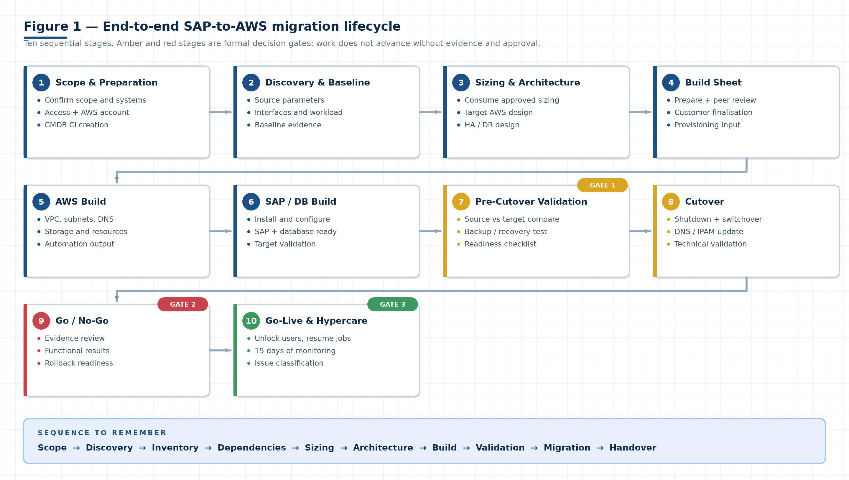
Figure 1. The migration lifecycle from scope to hypercare. Amber and red stages are decision gates — stage 7 (pre-cutover validation), stage 9 (Go/No-Go) and stage 10 (release to hypercare). A gate does not open on assertion; it opens on evidence and named approval.

3.1 Stage table with entry and exit criteria
LIFECYCLE STAGE TABLE
# | Stage | Purpose | Entry criteria | Exit criteria / evidence
1 | Scope &amp; Preparation | Confirm scope, systems, access, AWS account and customer expectations. | Customer request and system list | Signed scope, named systems, access granted, AWS account verified
2 | Discovery &amp; Baseline | Collect source configuration, interfaces, workload, dependencies, inventory and evidence. | Scope and access | Source baseline pack: parameters, interfaces, NFS, AL11, known failures
3 | Sizing &amp; Architecture | Consume approved sizing; confirm target AWS architecture, HA/DR and connectivity. | Source baseline | Approved sizing report and target architecture agreed with the customer
4 | Build Sheet | Finalise the technical input used for provisioning and customer review. | Architecture agreement | Peer-reviewed build sheet finalised with the customer
5 | AWS Build | Provision infrastructure through automation; validate VPC, subnets, DNS, storage and resources. | Approved build sheet | Validated infrastructure, CMDB CIs deployed and matching the inventory
6 | SAP / DB Build | Install and configure SAP and database components; validate target readiness. | Validated infrastructure | SAP and database installed, configured and reachable; pre-checks passed
7 | Pre-Cutover Validation GATE 1 | Complete source/target comparisons, backup/recovery testing and readiness checks. | Target build complete | All checklist items closed or formally deferred with an owner and a date
8 | Cutover | Execute shutdown, database migration/switchover or recovery, network updates and technical validation. | Gate 1 approval and a booked window | Target system technically validated; R3TRANS -d returns 0000; SAP started
9 | Go / No-Go GATE 2 | Review evidence, approvals, functional results and rollback readiness. | Technical and functional evidence | Recorded Go or No-Go decision with named approvers
10 | Go-Live & Hypercare GATE 3 | Unlock users, resume jobs, monitor the system and resolve migration-related issues. | Go decision | System released, jobs resumed, hypercare running for 15 days, handover complete

THE THREE GATES
▪ Gate 1 — Pre-cutover validation. Nothing enters a cutover window with an untested backup/recovery path or an open critical checklist item.
▪ Gate 2 — Go/No-Go. Technical, functional and system-owner sign-off plus confirmed rollback readiness. A No-Go is a successful outcome of this gate when the evidence does not support release.
▪ Gate 3 — Release to hypercare. Users unlocked and jobs resumed only after the Go decision is recorded, with the hypercare roster and escalation path live.

3.2 Sequence to remember
Scope → Discovery → Inventory → Dependencies → Sizing → Architecture → Build → Validation → Migration → Handover
If a project is in trouble, it is almost always because one of these was skipped or compressed: discovery (unknown interfaces and agents surface at cutover), dependencies (third-party credentials arrive late), or validation (the target is assumed correct because automation produced it).

3.3 Where each team enters the lifecycle

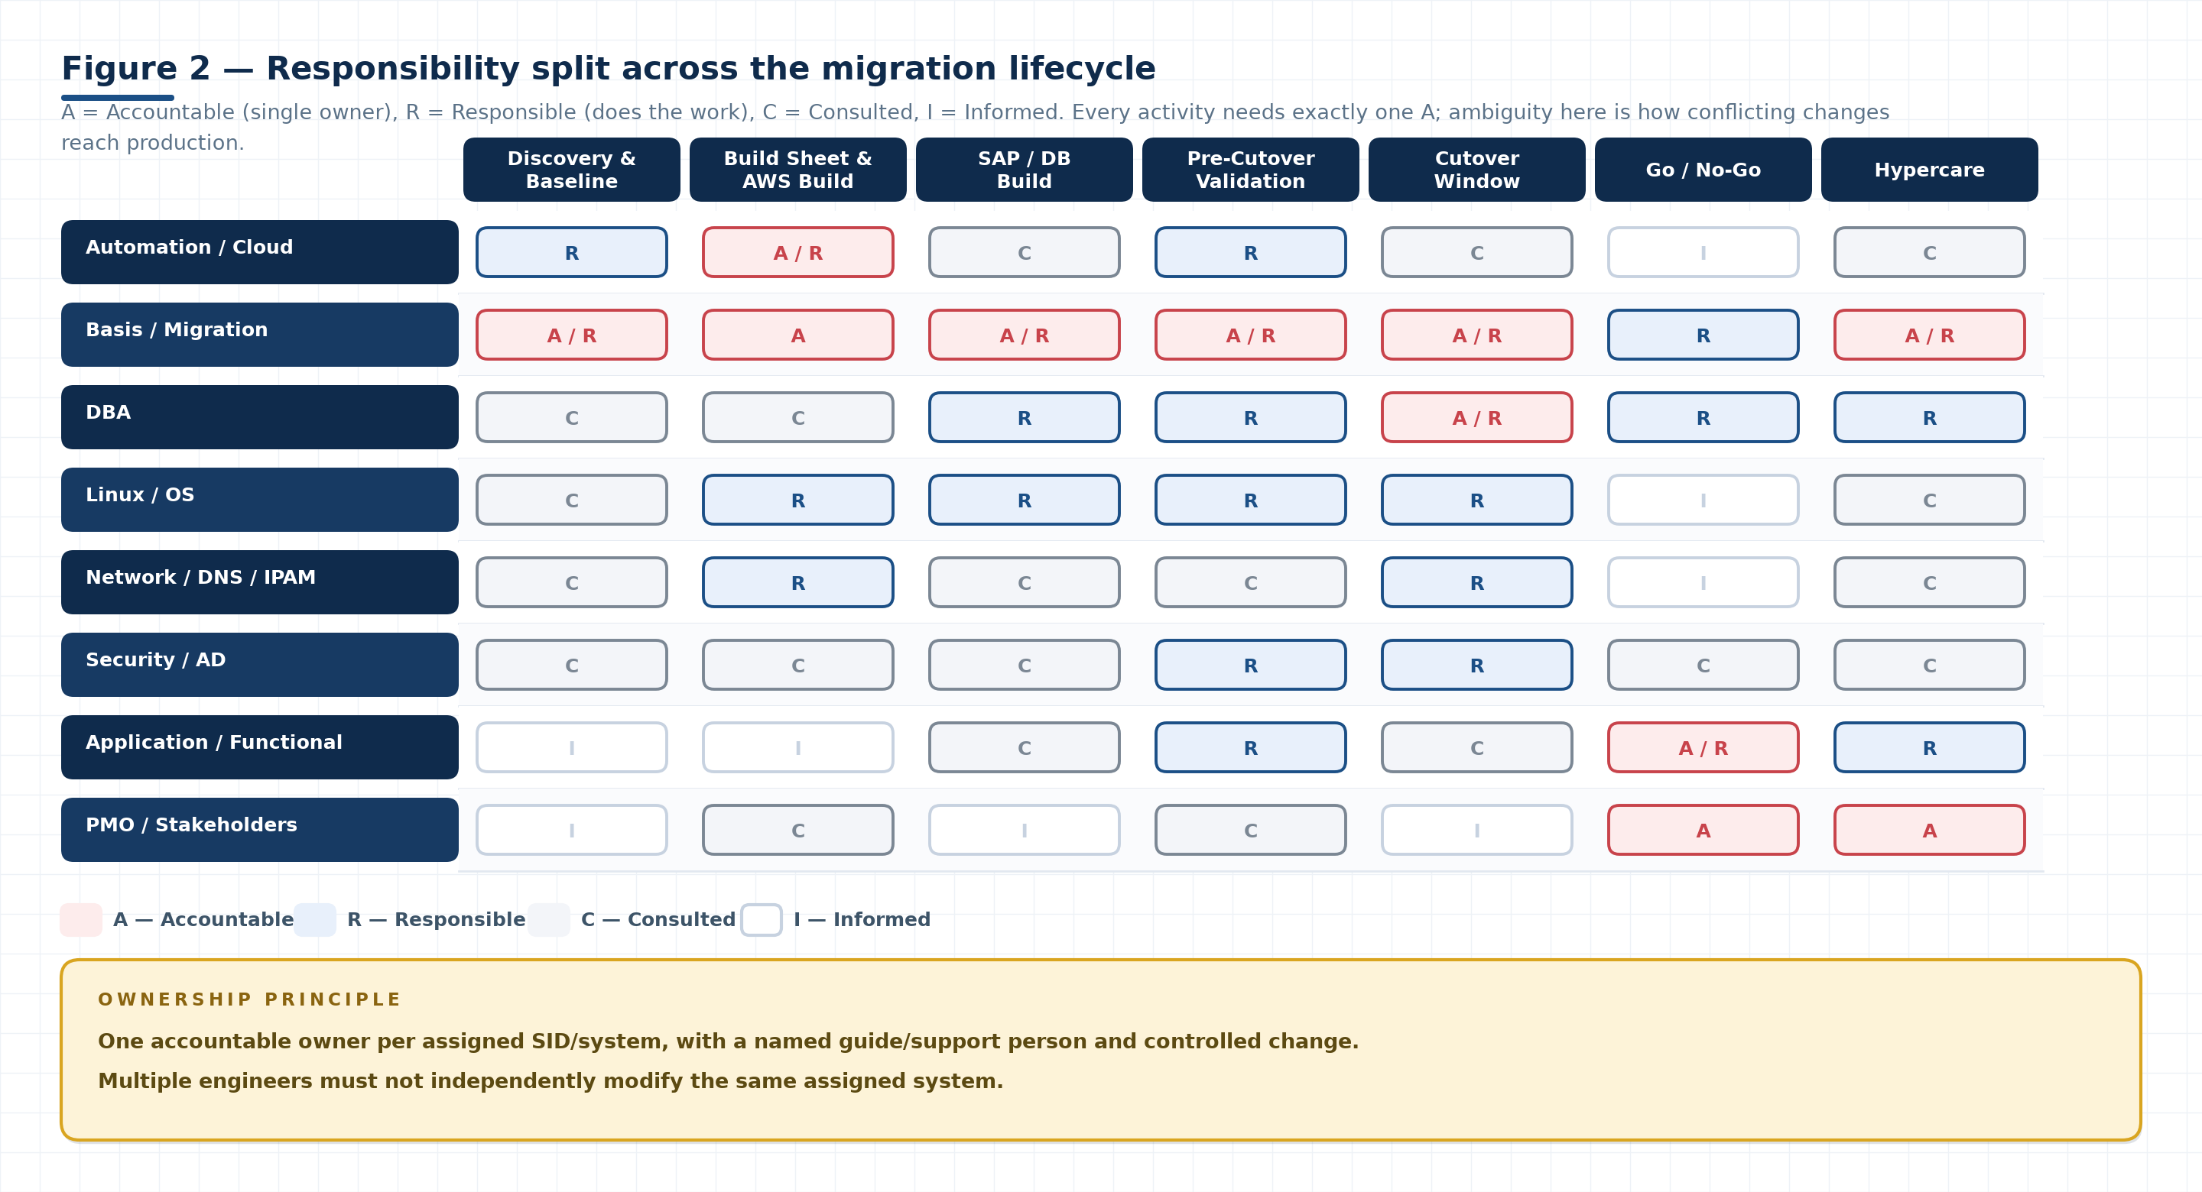
Figure 2. Responsibility split. Read the matrix by row when you need to know what your team owns, and by column when you need to know who to call at a given stage. Two teams can share work (A · R), but only one can be accountable.

MODULE 1 · SECTION 4

4 Module 1 — Preparation, discovery and source baseline
Everything validated later is validated against what is recorded here. A weak baseline produces a cutover full of unanswerable questions; a strong baseline turns every deviation into a five-minute lookup.

4.1 Preparation and discovery
1. Finalise the migration scope with the customer, in writing.
2. Identify the systems included in the migration (SIDs, landscape role, environment).
3. Verify AWS account availability and the target region.
4. Create or validate ServiceNow CMDB configuration items for each system.
5. Perform IP address analysis: current addressing, subnets, overlaps, static entries, host-file records.
6. Confirm SAP, OS/DB and AWS access for every engineer who will execute work — including privileged and third-party access.
7. Collect source system and database parameters.
ACCESS IS THE MOST COMMON SILENT DELAY
Access requests that are raised in the cutover week arrive after the window. Raise SAP, OS, database, AWS, middleware and third-party interface credentials during preparation, and confirm each one by actually logging in — not by receiving a ticket closure.

4.2 Source sizing and workload
▪ Sizing considers CPU, memory, server configuration, instance type and source-to-target mapping.
▪ The migration team consumes the approved sizing report for target planning and validation — it does not create or re-derive it.
▪ ST03 / ST03N is used for workload analysis, particularly for production systems.
▪ Workload information provides the context for post-migration performance comparison: without it, “the system feels slower” cannot be resolved.
SIZING INPUTS CONSUMED BY THE MIGRATION TEAM
Sizing input | What to capture | Why it matters later
CPU and memory | Current configuration, peak and average utilisation | Confirms the target instance type is not undersized
Server configuration | Host type, physical or virtual, cluster membership | Drives HA design and licensing implications
Instance type mapping | Source host → target EC2/instance type | Becomes the build sheet and the validation reference
Database size and growth | Data, log, archive, backup volumes and growth rate | Sizes storage, snapshots and backup windows
Workload (ST03N) | Dialog, batch and interface load by hour/day | Sets the performance baseline for comparison after migration
Peak patterns | Month-end, batch windows, integration peaks | Determines when cutover is safe and what to re-measure

4.3 Inventory and external dependencies
SOURCE INVENTORY CONTENT
Inventory item | Detail to record
Identity | Hostname, IP address, CMDB CI number, SID, environment
Software | Kernel version and patch level, database type and version, NetWeaver / SAP_BASIS release, SP level
External agents | Control-M, NetBackup, OEM/OBM and any other monitoring, scheduling or backup agent installed on the host
Credentials | OS, database, Oracle and Oracle Wallet credentials identified through approved processes (never shared by email or chat)
NFS dependencies | Every NFS mount: export host, path, purpose, consumer. Decide per share whether it is maintained/copied or migrated to AWS EFS
AL11 directories | Directory state before migration — which SAP directories exist, what they contain, which are custom
Certificates and keys | SNC, SSL/TLS, PSE files, keystores, wallet locations and expiry dates
Jobs and scheduling | Background jobs, job schedulers, batch windows, and which are controlled externally

EXTERNAL AGENTS ARE THE CLASSIC CUTOVER SURPRISE
Agents installed by other teams (backup, scheduling, monitoring, security) are frequently missing from the source inventory because no one on the migration team installed them. Enumerate them from the host, not from memory: compare installed packages, running services and cron entries on source and target.

4.4 Interface and connectivity baseline
▪ Identify SAP-to-SAP interfaces, external applications, middleware, RFCs and network dependencies.
▪ Validate SSO dependencies and the authentication path for each user group.
▪ Use SM59 to identify RFC destinations and connection types; record each destination, its target and its status.
▪ Record whether each interface is working before migration — success or failure, with a timestamp.
▪ Treat pre-existing failures as baseline conditions rather than migration defects.
INTERFACE BASELINE
Interface category | How to enumerate | Baseline evidence
SAP ↔ SAP (RFC) | SM59 destinations by type; connection test per destination | Destination list + test result, with failures annotated
Middleware / ESB | webMethods, MuleSoft, MBox and other documented integrations source term | Interface inventory with owning team and credentials status
External applications | Interface documentation, port and firewall rules, partner contacts | Connectivity matrix: source host/port → target host/port
File-based interfaces | AL11 directories, NFS mounts, scheduled transfers | Directory listing before migration and the transfer schedule
Authentication / SSO | SNC configuration, certificates, SSO provider dependencies | Certificate validity, SNC users, SSO test result
Gateway traffic | SMGW connections and gateway parameters | Connection list and gateway status
HTTP(S) traffic | SMICM ICM services and endpoints | Service list, ports, certificate binding

PRACTICAL RULE
If an interface or directory was not working before migration, capture the evidence. The migration team should not silently convert a pre-existing issue into a migration defect — and equally should not silently fix one without recording it, because an unrecorded fix becomes an unapproved change.

4.5 Building the source baseline pack
The output of this module is a single, indexed evidence pack per system. It is the reference used at every later gate and during hypercare triage.
CONTENTS OF THE SOURCE BASELINE PACK
Baseline artefact | Typical source | Used again at
OS parameter sheet | uname, /etc/os-release, kernel, swap, file systems, UID/GID | Section 7.2 OS validation
SAP parameter sheet | Profile parameters (RZ10/RZ11), instance list (SM51) | Section 7.3 SAP validation
Database parameter sheet | DB02, DB parameters, tablespace list and sizes | Section 7.4 database validation
Interface list | SM59, SMGW, SMICM, middleware inventory | Section 10.3 functional validation
Directory list | AL11, NFS mounts, custom directories and permissions | Section 10.2 post-processing
Workload snapshot | ST03/ST03N daily/weekly/monthly, STAD samples | Module 5 performance comparison
Memory and buffer snapshot | ST02 | Module 5 performance comparison
Backup status | Last successful backup, backup history, log/archive status | Section 6.4, Section 9.4
Known issues | Open tickets, failing interfaces, failing jobs, missing directories | Hypercare triage (Section 10.6)
Transport landscape | STMS domain, systems, routes, transport directory | Section 7.3, Section 10.3

4.6 Module 1 readiness checklist
☐ | Check | Status | Evidence / remarks
☐ | Migration scope finalised and documented with the customer | Not Started
☐ | Systems in scope identified (SID, environment, landscape role) | Not Started
☐ | AWS account availability verified; target region confirmed | Not Started
☐ | ServiceNow CMDB CIs created or validated for each system | Not Started
☐ | IP address analysis completed (addressing, overlaps, static entries) | Not Started
☐ | SAP, OS/DB and AWS access confirmed by successful login for every engineer | Not Started
☐ | Third-party and middleware credentials requested through approved processes | Not Started
☐ | Source system and database parameters collected | Not Started
☐ | Approved sizing report received and consumed (not re-derived) | Not Started
☐ | ST03/ST03N workload snapshot captured for production systems | Not Started
☐ | Host inventory complete: hostname, IP, CI, kernel, DB, NetWeaver release | Not Started
☐ | External agents identified (Control-M, NetBackup, OEM/OBM, others) | Not Started
☐ | NFS dependencies listed with a decision per share (maintain/copy vs EFS) | Not Started
☐ | AL11 directory state captured before migration | Not Started
☐ | SAP-to-SAP, external, middleware and RFC interfaces identified | Not Started
☐ | SSO and SNC dependencies validated | Not Started
☐ | SM59 destinations exported with connection test results | Not Started
☐ | SMGW and SMICM connection/service baseline captured | Not Started
☐ | Working vs failing state recorded for every interface | Not Started
☐ | Pre-existing failures documented as baseline conditions with evidence | Not Started
☐ | Baseline evidence pack indexed and stored per retention rules | Not Started

MODULE 2 · SECTION 5

5 Module 2 — Target architecture, AWS readiness and build
The automation team builds the target; the migration team proves it is right. Validating someone else's output is not a lack of trust — it is the control that keeps an infrastructure defect out of a production cutover.

5.1 Target architecture
▪ Confirm customer agreement with the proposed AWS target configuration and instance type.
▪ Architecture diagrams should show AWS Region, Availability Zones, SAP servers, database servers, ASCS/ERS where applicable, major infrastructure components and high-level connectivity.
▪ HA/DR discussions may include ASCS, ERS/CRS, Oracle, secondary/standby systems and failover architecture.
▪ Record the agreed RPO/RTO and the failover mechanism — an HA design nobody can describe under pressure is not an HA design.

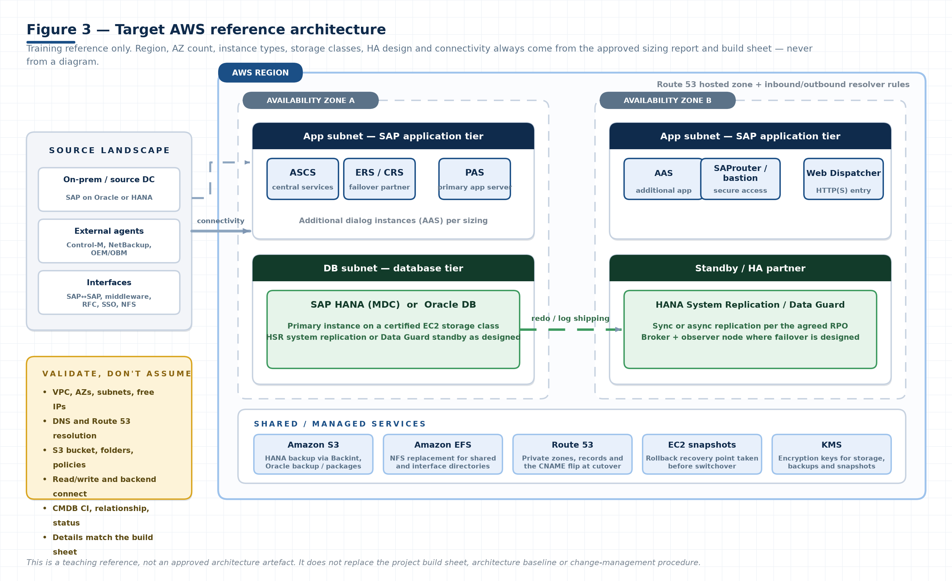
Figure 3. Target AWS reference architecture used for training. It shows the shape of a typical SAP-on-AWS landing zone — two AZs, application and database subnets, an HA partner, and the shared services the migration depends on (S3, EFS, Route 53, snapshots, KMS). Instance types, AZ count and HA mechanism always come from the approved sizing report and build sheet.

ARCHITECTURE CONTENT THAT MUST BE EXPLICIT
Architecture element | What must be agreed and recorded
Region and AZs | Target region, number of AZs, and which component sits in which AZ
SAP servers | ASCS/ERS (or CRS), PAS, AAS count and sizing per instance
Database servers | HANA or Oracle, instance/storage class, HA mechanism (HSR, Data Guard, cluster)
Network | VPC, subnets and their purpose, route tables, security groups / NACLs, inter-AZ latency
Connectivity | On-premises connectivity method, SAProuter, jump/bastion access, DNS resolution path
Storage | Root, SAP data/log volumes, shared file systems, backup targets, snapshot policy
Security | Encryption at rest and in transit, key management, privileged access path, audit logging
Observability | Monitoring agents, log forwarding, alerting ownership

5.2 Build sheet
1. Prepare the build sheet from the approved sizing report and architecture.
2. Perform peer review — a second engineer checks every field against the source documents.
3. Finalise the information with the customer and obtain their confirmation.
4. Use only the approved information for target provisioning.
5. Validate the provisioned environment against the build sheet, field by field.
BUILD SHEET CONTENT AND HOW EACH GROUP IS VALIDATED
Build sheet field group | Examples | Validation method after build
Identity | Hostname, SID, instance number, domain, environment | Compare with hostname, SAP profile, CMDB CI
Compute | Instance type, vCPU, RAM, AZ, placement | AWS console/CLI describe-instance versus build sheet
Network | VPC, subnet, private/public IP, security groups, routes | Interface attachment, IP, and reachability tests
Storage | Volume types and sizes, mount points, shared file systems | df -h, lsblk, /etc/fstab
OS | Distribution, version, kernel, packages, tuning parameters | /etc/os-release, uname -r, package list
Users and groups | UID/GID for sapadm, <sid>adm, DB users, groups | id, getent passwd/group
Database | Engine, version, SID, memory allocation, parameters | DB status, parameter export
SAP | Kernel/patch level, instance profile parameters, services | SM51, RZ10, service status
Backup | Backup tool, target bucket/path, retention | Test backup job and verify the object exists
Access and agents | Bastion/SAProuter, monitoring, backup and scheduling agents | Agent status and version check

PEER REVIEW IS THE CHEAPEST CONTROL IN THE PROGRAMME
Most provisioning defects found after build (wrong subnet, missing mount, UID mismatch, absent security-group rule) would have been caught by a second pair of eyes reading the build sheet against the sizing report. Build the review into the schedule; do not treat it as optional when the timeline tightens.

5.3 AWS bootstrapping and infrastructure validation
▪ Validate VPC, Availability Zones, subnets and available IP addresses.
▪ Validate the required AWS resources (compute, storage, network, security, backup).
▪ Validate DNS configuration and Route 53 where applicable — forward, reverse, and the private-zone resolution path used by SAP.
▪ Validate S3 bucket and folder requirements for Oracle backup and package use cases.
▪ Validate required read/write permissions and backend connectivity from the servers that will use them.
▪ Confirm tagging, inventory and CMDB automation produced correct records.
INFRASTRUCTURE VALIDATION MATRIX
Validation | What a pass looks like | Common failure
VPC and subnets | CIDRs, AZ placement and route tables match the build sheet | Subnet in the wrong AZ; free-IP exhaustion
IP address availability | Enough free addresses for all planned interfaces, including HA and future growth | Overlap with source addressing; static entries missed
DNS / Route 53 | Forward and reverse resolution correct from every subnet; private zones associated | Resolver rule missing; reverse lookup absent
S3 bucket and folders | Bucket exists, folder structure correct, versioning/encryption as designed | Folder path differs from the backup configuration
S3 permissions | The instance role/user can read and write the intended prefix, and nothing broader | Policy too narrow (backup fails) or too broad (audit finding)
Backend connectivity | Backup agent or HANA reaches the endpoint over the intended path | Endpoint or proxy not permitted in the security group
EFS / shared storage | Mounted, correct permissions, and reachable from every consumer | Mount missing on the secondary node; wrong UID/GID owner
Snapshots and backup policy | Policy attached, retention correct, restore path tested at least once | Policy attached to the wrong volume set
Tagging and CMDB | Tags present, CI created, relationships and status correct | CI created with source details, or left in “planned”

5.4 Responsibility split
RESPONSIBILITY SPLIT (SUMMARY — FULL MATRIX IN FIGURE 2)
Role | Primary responsibilities
Automation team | AWS provisioning, server creation, automated build, DNS provisioning, tagging, Chef/configuration management, inventory and CMDB automation.
Basis / migration team | Build-sheet input, target validation, SAP-specific activities, SAP/database configuration validation, migration checks and handover.
Specialist teams | DBA, Linux, network, security, application, interface and DR teams support their respective specialist areas.

WHERE THE SPLIT BREAKS IN PRACTICE
▪ DNS. Automation provisions records; Basis validates resolution from the SAP host. If neither owns the private-zone association, name resolution fails at cutover.
▪ File systems. Linux mounts the file systems; Basis validates that SAP directories and permissions are correct. Ownership of the mount options must be explicit.
▪ Credentials. Security/AD issues them; Basis and DBA consume them. Requests must be raised early and tracked, not escalated on cutover day.
▪ Agents. Automation installs platform agents; the owning team installs application agents (backup, scheduling, monitoring). Both lists must be reconciled against the source.

5.5 CMDB validation after build
☐ | Check | Status | Evidence / remarks
☐ | CI exists for every new server in ServiceNow | Not Started
☐ | CI relationship is correct (host → application → database) | Not Started
☐ | Application / DB relationship is correct for each SID | Not Started
☐ | CI status is deployed / operational (not planned or in build) | Not Started
☐ | Target server details match the inventory and the build sheet | Not Started
☐ | Hostname, IP, environment and owning team are correct on the CI | Not Started
☐ | Old source CIs flagged for retirement at the correct date | Not Started
☐ | Tags on AWS resources match the CMDB and cost-allocation standard | Not Started

5.6 Module 2 readiness checklist
☐ | Check | Status | Evidence / remarks
☐ | Customer agreement recorded for target configuration and instance type | Not Started
☐ | Architecture diagram covers region, AZs, SAP, DB, ASCS/ERS and connectivity | Not Started
☐ | HA/DR design documented (ASCS, ERS/CRS, standby database, failover) | Not Started
☐ | RPO/RTO and failover mechanism agreed with the customer | Not Started
☐ | Build sheet prepared from approved sizing and architecture | Not Started
☐ | Build sheet peer-reviewed by a second engineer | Not Started
☐ | Build sheet finalised and confirmed with the customer | Not Started
☐ | Provisioning used only approved build-sheet information | Not Started
☐ | VPC, AZs, subnets and free IP availability validated | Not Started
☐ | Required AWS resources validated against the build sheet | Not Started
☐ | DNS and Route 53 configuration validated (forward and reverse) | Not Started
☐ | S3 buckets and folders validated for backup and package use cases | Not Started
☐ | S3 read/write permissions and backend connectivity validated | Not Started
☐ | EFS / shared file systems mounted with correct ownership and permissions | Not Started
☐ | Snapshot and backup policies attached and a restore path tested | Not Started
☐ | Provisioned environment validated field-by-field against the build sheet | Not Started
☐ | Deviations logged with an owner and a resolution date | Not Started

MODULE 3 · SECTION 6

6 Module 3 — SAP HANA MDC, backup and recovery
HANA migration succeeds or fails on the backup and recovery path. Understand the container model, prove the backend works, and never stop the source before the final backup is validated.

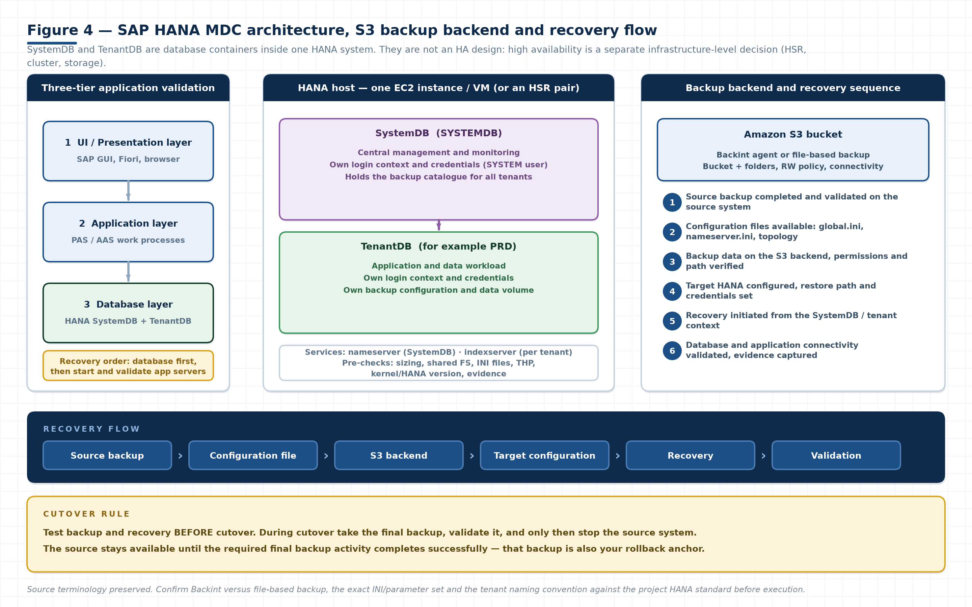
Figure 4. HANA MDC containers inside one HANA system, the S3 backup backend, and the six-step recovery sequence. Note the separation on the left: the three tiers are validated bottom-up — the database is recovered first, then the application servers are started against it.

6.1 HANA MDC architecture
▪ SystemDB provides central management and monitoring capabilities for the whole HANA system.
▪ TenantDB contains the application and data workload for a specific SAP system.
▪ SystemDB and TenantDB have separate login contexts and credentials — connecting to the wrong context is a common operator error.
▪ SystemDB/TenantDB should not be confused with HA server architecture.
▪ SystemDB and TenantDB can reside within the same HANA server/VM; HA is a separate infrastructure/system-level design.
SYSTEMDB VERSUS TENANTDB
Aspect | SystemDB | TenantDB
Purpose | Central management and monitoring of the HANA system | Hosts the application and data workload
Contains | System-wide configuration, nameserver, backup catalogue | Application tables, tenant services, tenant configuration
Login context | Own context and credentials (for example the SYSTEM user) | Own context and credentials, separate from SystemDB
Backup | Holds the backup catalogue for the system | Has its own backup configuration and data volume
Recovery | Recovered/restored first so tenants can be recovered | Recovered after the system context is available
HA relationship | Not an HA component — a database container | Not an HA component — a database container

THE MOST COMMON HANA CONCEPTUAL ERROR
Treating SystemDB/TenantDB as a primary/standby pair. They are containers within one HANA system. High availability is achieved by a different mechanism (system replication plus clustering or failover tooling, with storage and network design), and it is decided at infrastructure level.

6.2 HANA pre-checks
☐ | Check | Status | Evidence / remarks
☐ | Database / EC2 sizing confirmed against the approved sizing report | Not Started
☐ | Shared file system sizing confirmed | Not Started
☐ | Required INI files and HANA configuration present and consistent | Not Started
☐ | S3 bucket and backend configuration validated | Not Started
☐ | HANA DB server status checked (services running, no failed units) | Not Started
☐ | Transparent Huge Pages (THP) configuration checked against the SAP requirement | Not Started
☐ | Kernel and HANA version confirmed against the target design | Not Started
☐ | Global INI and relevant service configuration reviewed | Not Started
☐ | Index server and name server configuration reviewed | Not Started
☐ | OS prerequisites verified: hugepages, shared memory, limits, scheduler tuning | Not Started
☐ | Evidence for every pre-check captured and stored | Not Started

Pre-check output should be retained even when everything passes. A clean pre-check record is what allows you to say later that a problem was introduced by the migration rather than carried into it.

6.3 AWS S3 backup backend
☐ | Check | Status | Evidence / remarks
☐ | S3 bucket availability confirmed in the correct region | Not Started
☐ | Required bucket and folder structure created | Not Started
☐ | Read/write policies and permissions validated for the backup identity | Not Started
☐ | Backup path configuration validated in HANA | Not Started
☐ | Backend connectivity from the HANA host validated (endpoint, DNS, proxy, security group) | Not Started
☐ | Encryption and key management confirmed | Not Started
☐ | Required configuration / INI files available and consistent with the backup setup | Not Started
☐ | A real backup has been written to the backend and the objects verified | Not Started
☐ | Retention and lifecycle rules match the project standard | Not Started

BACKINT VERSUS FILE-BASED BACKUP
The source training refers to an S3 backup backend without naming the mechanism. In practice this is either a certified Backint agent for S3 or a file-based backup to a mounted/S3-synced target. Confirm which one the project uses, because the configuration files, permissions, log locations and restore syntax differ. Validate

6.4 Backup and recovery sequence
1. Configure the backup destination on the source.
2. Validate S3/backend connectivity end to end (write and read).
3. Test backup and recovery before cutover, on a target that mirrors production.
4. Verify recovered data consistency (row counts, key tables, application logon, no failed recovery steps in the log).
5. Capture evidence of the successful test: backup log, recovery log, timestamps, verification output.
6. During cutover, execute the final backup.
7. Complete final backup validation before source shutdown.
8. Stop the source system only after the required backup activity has succeeded.
9. Configure the target and initiate recovery.
10. Validate database and application connectivity after recovery.
Source backup → Configuration file → S3 backend → Target configuration → Recovery → Validation
SEQUENCING RULE THAT PROTECTS THE PROGRAMME
Keep the source available until the required final backup activity is successfully completed. Stopping the source first removes the rollback option and turns a routine recovery into an incident.

6.5 Three-tier application validation
THREE-TIER VALIDATION ORDER
Layer | What is validated | Order
UI / presentation layer | SAP GUI or Fiori connectivity, login, transaction rendering, timeout behaviour | 3rd
Application layer | Work processes, instance start, RFC and Gateway connectivity, spool, ICM services | 2nd
Database layer | HANA services, tenant status, connectivity from the application, data retrieval and updates | 1st

Database recovery is completed first; application servers are then started and validated against the recovered HANA database. Validate application processing, data retrieval, updates and database connectivity — not just “the instance is green”.

6.6 Module 3 readiness checklist
☐ | Check | Status | Evidence / remarks
☐ | SystemDB and TenantDB roles understood and documented for this system | Not Started
☐ | SystemDB/TenantDB not confused with the HA design in project documentation | Not Started
☐ | HANA pre-checks executed with all output retained | Not Started
☐ | S3 backup backend configured and connectivity proven | Not Started
☐ | Backup tested successfully to the S3 backend | Not Started
☐ | Recovery tested successfully on a non-production target | Not Started
☐ | Recovered data consistency verified | Not Started
☐ | Backup/recovery evidence pack complete | Not Started
☐ | Cutover backup window and duration estimated from the test | Not Started
☐ | Rollback anchor defined (final backup plus snapshot) | Not Started
☐ | Three-tier validation performed in the correct order after recovery | Not Started

MODULE 4 · SECTION 7

7 Module 4 — SAP post-migration validation
Validation is comparison, not inspection. Every check in this module answers one question: does the target match the approved design and the source baseline, and if not, is the difference explained?

7.1 Auto-start validation
1. Check the configured SAP service (the init/systemd unit that starts SAP at boot).
2. Verify the service status is Active.
3. Verify the service return code.
4. Stop the required SAP instances cleanly.
5. Coordinate the server reboot with the Linux team (and with any cluster or HA manager).
6. After reboot, verify automatic SAP startup without manual intervention.
7. Confirm SAP availability: instances registered, work processes running, logon possible.
8. Capture evidence: service status, return code, instance list before and after, timestamps.
NEVER ASSUME AUTO-START WORKS. TEST IT THROUGH AN ACTUAL REBOOT.
A service that is enabled and active can still fail at boot because of ordering: a file system that mounts late, a network interface that is not yet up, a cluster resource that owns the virtual IP, or a dependency on the database host. Only a real reboot proves the sequence.
SERVICE RETURN CODES DISCUSSED IN THE TRAINING
Return code | Interpretation | First actions
0 | Success. The expected result after reboot. | Confirm instances are actually registered in SM51 — a zero exit code is not proof that SAP is usable.
127 | Command or shared library not found: missing executable, wrong path, or an unresolved library dependency. | Check the service ExecStart path, the <sid>adm environment, LD_LIBRARY_PATH, and that the kernel and shared libraries were migrated with correct permissions.
255 | Generic/unknown failure returned by the start script or SAP program. | Read the actual logs: service journal, startsap/SAPControl output, dev_w0, dev_disp, dev_ms, and the database connection trace.
Other non-zero | Script- or component-specific failure. | Map the code against the start script and SAP component logs; do not retry until the cause is known.

Codes 127 and 255 were cited in the source training as indicators requiring troubleshooting. Treat the mapping above as a diagnostic starting point and confirm against the platform and SAP start mechanism used in the project.
# Service state and exit code (example — adapt to the project's unit naming)
systemctl status SAP<SID>_<NR>.service # expect: Active: active (exited/running)
systemctl show -p ExecMainStatus,ExecMainCode,Result SAP<SID>_<NR>.service
# expect: ExecMainStatus=0 Result=success
# Instance state without the SAP GUI
sapcontrol -nr <instance-number> -function GetSystemInstanceList
sapcontrol -nr <instance-number> -function GetProcessList
# then confirm in SM51 that every instance is active and registered

7.2 OS validation
OS VALIDATION DETAIL
Check | What to compare | Typical commands / sources
File systems and mount points | Every mount present, correct size, type, options and owner | df -h, mount, /etc/fstab, lsblk
CPU | Core count and architecture match the approved sizing | lscpu, nproc
RAM | Total memory matches the build sheet; HANA/DB allocation as designed | free -g, /proc/meminfo
Swap | Swap size and swappiness per the SAP/DB requirement | swapon -s, sysctl vm.swappiness
OS and kernel versions | Distribution, release and kernel match the target design | /etc/os-release, uname -r
UID/GID | sapadm, <sid>adm, DB users and groups identical to source/design | id, getent passwd, getent group
Libraries | Required shared libraries present at the expected versions | ldd on key binaries, package list comparison
FTP users and OS groups | Service accounts and group memberships migrated correctly | getent passwd, getent group, FTP/SFTP config
Physical and virtual IPs | Both present, bound to the right interfaces, correct netmask/gateway | ip a, ip r
Physical and virtual hostnames | Hostname, FQDN and virtual hostname resolve as designed | hostname, hostname -f, getent hosts
/etc/services and /etc/hosts | SAP service ports (sapdp/sapgw), sapdbhost entries, no stale source IPs | grep sap /etc/services, /etc/hosts
SAP directories and permissions | Kernel, profile, work, log, transport, interface directories present with correct ownership | ls -ld per directory, compare with the source listing
OS tuning | Hugepages, THP, semaphores, shared memory, file limits, scheduler | sysctl -a subset, /proc/meminfo, ulimit -a

UID/GID MISMATCHES ARE QUIET AND EXPENSIVE
A different UID for <sid>adm on the target makes files look correctly named but wrongly owned. The symptoms appear later and elsewhere: SAP start failures, permission denied on the transport or interface directory, NFS squash problems, or inter-server communication failures. Compare numeric IDs, not just names.

7.3 SAP application validation
SAP APPLICATION VALIDATION
Area | Transaction / tool | What a pass looks like
SAP services and processes | OS service, sapcontrol | Service active, return code 0, all processes green
Application servers | SM51 | Every planned instance listed, active, with the expected work process configuration
Gateway | SMGW | Gateway running, expected connections present, no unexplained external registrations
RFC destinations | SM59 | Each destination from the baseline exists and its connection test succeeds (or matches a documented pre-existing failure)
RFC connectivity report | SA38 / project report | Bulk test result matches the baseline interface list
Transport landscape | STMS | Domain, systems, routes and transport directory correct; import works end to end
Directories | AL11 | All baseline directories present with correct permissions and content
Printers and spool | SPAD, SP01 | Device types and output devices correct; test page prints; spool processes run
ICM / HTTP(S) | SMICM | ICM services active on the expected ports; HTTPS endpoints answer with the right certificate
SNC and secure communication | SNC configuration, PSE/keystore | SNC enabled where designed, correct users, valid PSE, no handshake errors
Certificates | STRUST | Certificates valid, correct hostname/domain, chain complete, expiry dates acceptable
SAP license | SLICENSE | Correct license installed for the new hardware key; temporary license not left to expire

HARDWARE KEY AND LICENSE
A migration normally changes the hardware key, which invalidates the permanent SAP license. Install the correct license (or a valid temporary one) during cutover and record the expiry date so it is replaced before it lapses. This is a go-live blocker that is easy to overlook because the system works without it for a while.

7.4 Database validation
DATABASE VALIDATION
Check | Detail to record | Tool
DB status | Instance up, services/processes running, no failed components | DB02, DB-specific console
Space utilisation | Data, log, archive, backup area; percent used and absolute free | DB02
Tablespaces | Each tablespace size, free space, autoextend setting, largest objects | DB02
Growth | Growth rate compared with the source baseline and the sizing assumption | DB02, historical reports
Latest successful backup | Timestamp, type, duration, size, and that it is on the intended target | Backup tool / DB02
Backup history | Sequence complete, no gaps, retention as designed | Backup catalogue
Redo / archive log status | Archive destination reachable, no log-switch stalls, archiver running | DB log mode and archive status
Recovery considerations | Point-in-time recovery possible; restore path and required files verified | Recovery test record

A GREEN DATABASE IS NOT A VALIDATED DATABASE
Compare sizes and object counts with the source baseline. A recovery that completes but silently misses a tablespace, or a log archive destination that is full, will not show up as an error at start-up — it shows up as an incident two weeks into hypercare.

7.5 Handling deviations found during validation
1. Record the deviation immediately: what was expected, what was found, and the evidence for both.
2. Classify it: configuration drift, migration defect, pre-existing condition, or an intentional approved difference.
3. Assign it to the responsible team and owner — do not carry an unowned deviation into the cutover gate.
4. Correct it through the approved change route.
5. Retest the specific check, not just the fix.
6. Re-capture the evidence and close the item with a reference to the change record.

MODULE 5 · SECTION 8

8 Module 5 — Performance monitoring and troubleshooting
Performance work after a migration is comparison work. The pre-migration baseline turns a subjective complaint into a measurable delta, and the triage path keeps you from changing parameters before you understand the cause.

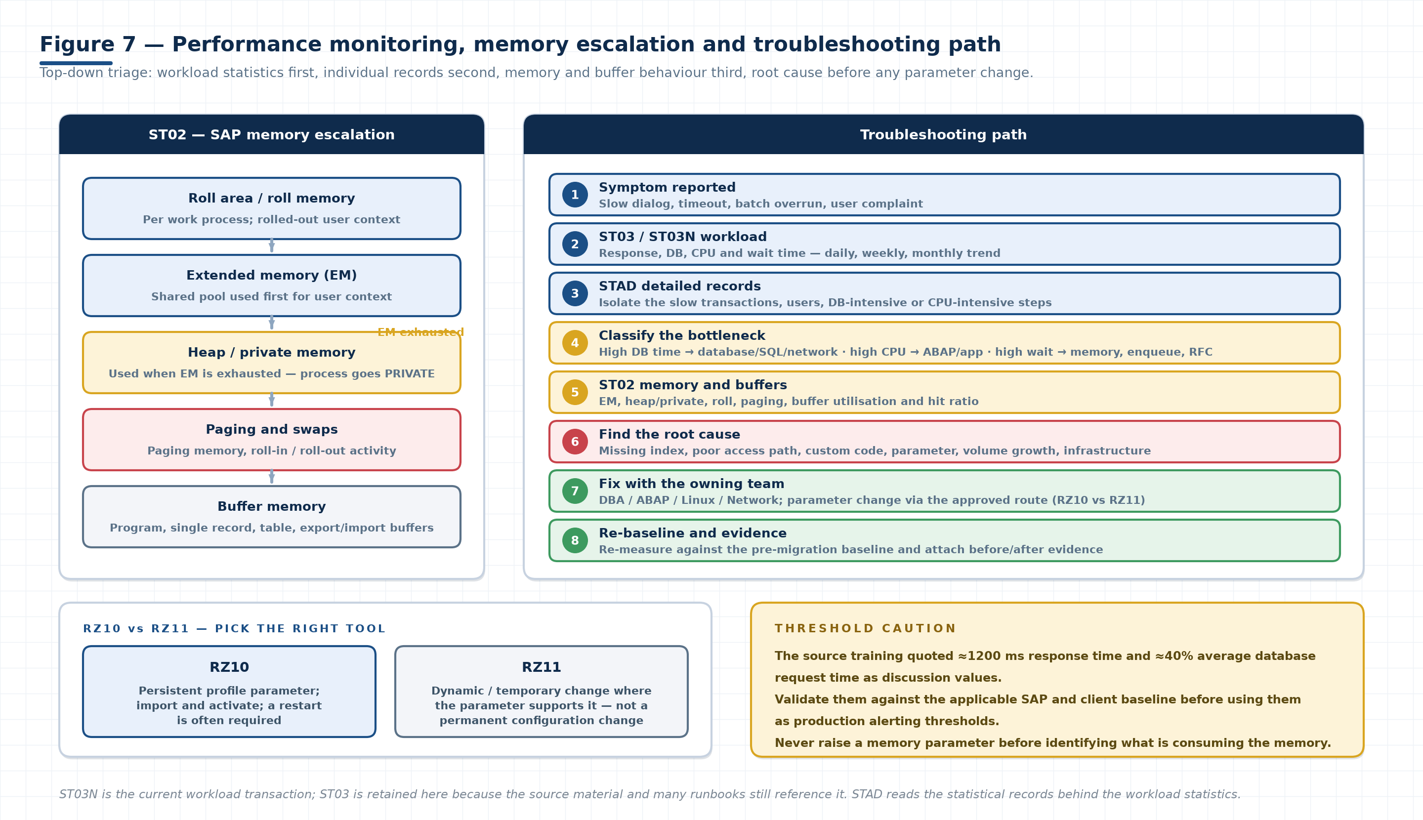
Figure 7. Left: the SAP memory escalation described in the training — extended memory is consumed first, and when it is exhausted work processes move into heap/private memory. Right: the top-down triage path from workload statistics to a root-cause fix with the owning team.

8.1 ST02 — memory monitoring
ST02 MEMORY AREAS
Memory area | What it is | What to watch
Extended memory (EM) | Shared memory used first for user context; allocated per instance | Max, used and free; whether processes are being pushed out of EM
Heap / private memory | Process-private memory used when EM is exhausted; the process mode becomes PRIVATE | Frequency and duration of PRIVATE mode — a strong signal of under-allocation or a memory leak
Roll memory / roll area | Per work process area holding rolled user context | Roll-in/roll-out activity and whether the roll area is a bottleneck
Paging memory | Paged user context (paging area / swaps) | Swaps and paging rate; high paging means context is being thrown away and rebuilt
Buffer memory | Program buffer, single record buffer, table buffer, export/import buffer | Utilisation and hit ratio per buffer; low hit ratio with high reads means sizing or access-pattern problems

For each area record available, used and free, plus buffer utilisation and hit ratio, so the target can be compared with the source snapshot rather than judged in isolation.
MEMORY TROUBLESHOOTING PRINCIPLE
The training described the general relationship as: Extended Memory → if exhausted → Heap/Private Memory. Investigate the cause rather than simply increasing memory. A parameter increase hides the symptom and can move the failure somewhere worse — for example into OS swapping or an OOM condition.
MEMORY SYMPTOM TABLE
Symptom | Likely causes to investigate first | Do not do this
Work processes frequently in PRIVATE mode | EM under-sized for the workload, long-running transactions, high dialog step counts, memory-consuming custom code | Raise ztta/roll_area/EM parameters before measuring actual consumption
High paging / swap rate | Paging area too small for the number of users, or context held too long | Add OS swap to “fix” an SAP memory design issue
Low table-buffer hit ratio | Buffer sizing, or access patterns that bypass the buffer (non-key reads, generic selects) | Enlarge buffers without checking whether the code can use them
Growing heap over days | Memory leak in custom code, unfreed internal tables, session accumulation | Schedule restarts as a permanent workaround
Slow response only at peak | Work process saturation, DB contention, enqueue or RFC waits | Tune a parameter that is not the constraint

8.2 RZ10 versus RZ11
RZ10 VERSUS RZ11
Transaction | Nature | Persistence | Restart | Use when
RZ10 | Profile parameter maintenance (instance, default and start profiles) | Persistent — written to the profile and activated | Required for many parameters; some take effect at the next instance start | The change must survive a restart and be part of the configuration baseline
RZ11 | Runtime parameter display and change where the parameter is dynamically switchable | Temporary — lost at restart unless also set in the profile | Not required for dynamic parameters | Testing a value, or applying a supported dynamic change within an approved window

PROFILE DISCIPLINE DURING MIGRATION
▪ Any RZ11 change made to get through a cutover must be followed by a matching RZ10 entry, or the fix disappears at the next restart.
▪ Profile changes are configuration changes: they need the same approval, documentation and transport/record discipline as any other change.
▪ Compare the source and target profile parameter sets explicitly after migration — parameters that no longer exist, or that were silently defaulted, are a frequent cause of post-migration behavioural differences.

8.3 ST03 / ST03N — workload analysis
WORKLOAD METRICS
Metric | Definition | How to use it in a migration
Response time | Total time from dialog step start to end, as experienced by the user | Compare target against the source baseline for the same period type (business hours, month-end)
Database time | Time spent in database requests | The single most useful split: high DB time points to the database, network or SQL, not to ABAP
CPU time | Time spent executing on the application server CPU | High CPU time with normal DB time points to code, volume or under-sized compute
Wait time | Time waiting for resources: roll, paging, enqueue, RFC, dispatcher | High wait time is a resource or dependency problem — check memory and external systems
Workload / steps | Number of dialog steps, background and RFC steps | Confirms you are comparing equivalent load, not a quiet day against a peak day
User activity | Active users and their distribution | Explains load differences and identifies who to interview about slowness

▪ Analyse daily, weekly and monthly views: a single day is noise, a month shows the trend and the peaks.
▪ Compare like with like — same day type, same time window, same workload mix.
▪ Record the top transactions by response time and by total load; they become your re-test list after any change.
▪ ST03N is the current workload transaction; ST03 is retained here because the source material and many runbooks still reference it.

8.4 STAD — detailed statistical records
Where ST03/ST03N gives you aggregates, STAD gives you the individual statistical records behind them. Use it to answer “which specific step, for which user, at which time, and where did the time go?”
STAD ANALYSIS TARGETS
Analysis goal | What to look for in STAD
Slow transactions | Records with the highest response time, grouped by transaction code
Long response times | Distribution of response time — a few extreme records or a general shift
Database-intensive activity | High DB time relative to response time; number of DB requests per step; sequential reads
CPU-intensive activity | High CPU time relative to response time, often with low DB time
User-specific workload | Records by user — identifies a single heavy session, a broken client, or a report run ad hoc
Performance bottlenecks | Roll/wait time, enqueue time, RFC time, and spool time as separate components

THRESHOLD CAUTION
The source training referenced approximately 1200 ms response time and 40% average database request time as discussion/reference values. These are teaching aids, not standards. Validate them against the applicable SAP and client baseline — and against the measured source performance for the same system — before using them as production alerting thresholds. Validate

8.5 Triage path
1. Reproduce or evidence the symptom: which transaction, which user, which time window, how often.
2. Check the aggregate view in ST03/ST03N and compare it with the pre-migration baseline for the same period type.
3. Split the time: database, CPU, wait, roll, RFC. This decides which team owns the investigation.
4. Drill into STAD for the specific slow records.
5. If memory is implicated, check ST02: EM, heap/private, roll, paging, buffer hit ratios.
6. Check the non-SAP layer when the split points there: database statistics and SQL, network latency to the DB, storage throughput, host CPU and memory pressure.
7. Identify the root cause and agree the fix with the owning team (DBA, ABAP, Linux, network).
8. Apply the fix through the approved change route, then re-measure against the baseline.
9. Record before/after evidence and close the item.
FROM SYMPTOM TO OWNER
Time component dominates | Look at | Usual owner
Database time | SQL and access path, missing or stale statistics/indexes, DB parameters, network latency to the DB, storage throughput | DBA (with ABAP for access paths)
CPU time | Custom code, volume of data processed, loop and internal-table behaviour, under-sized instance type | ABAP / application team
Wait time | Roll and paging behaviour, EM/heap configuration, enqueue contention, slow RFC destinations | Basis (with the interface owner)
Roll time | Roll area sizing, number of dialog steps, context size | Basis
RFC / external time | Destination response, middleware, partner system, network path | Interface owner + network
Spool time | Spool server, device type, output volume, printer availability | Basis

8.6 Module 5 readiness checklist
☐ | Check | Status | Evidence / remarks
☐ | ST02 captured on source and target: EM, heap/private, roll, paging | Not Started
☐ | Buffer utilisation and hit ratio recorded for each buffer | Not Started
☐ | ST03/ST03N daily, weekly and monthly views captured on source and target | Not Started
☐ | Response, DB, CPU and wait times compared with the baseline | Not Started
☐ | STAD samples captured for the slowest transactions | Not Started
☐ | Top transactions by response time and total load listed | Not Started
☐ | Bottleneck classified by dominant time component | Not Started
☐ | Root cause identified with the owning team (not a parameter guess) | Not Started
☐ | Any RZ11 runtime change mirrored in RZ10 or formally withdrawn | Not Started
☐ | Profile parameter sets compared between source and target | Not Started
☐ | Reference thresholds validated against the client baseline before alerting use | Not Started
☐ | Before/after evidence attached to the change record | Not Started

MODULE 6 · SECTION 9

9 Module 6 — Oracle database migration and switchover
The Oracle scenario covered in the training moves the database by building a standby in AWS, synchronising it with Data Guard, then performing a planned switchover during the cutover window.

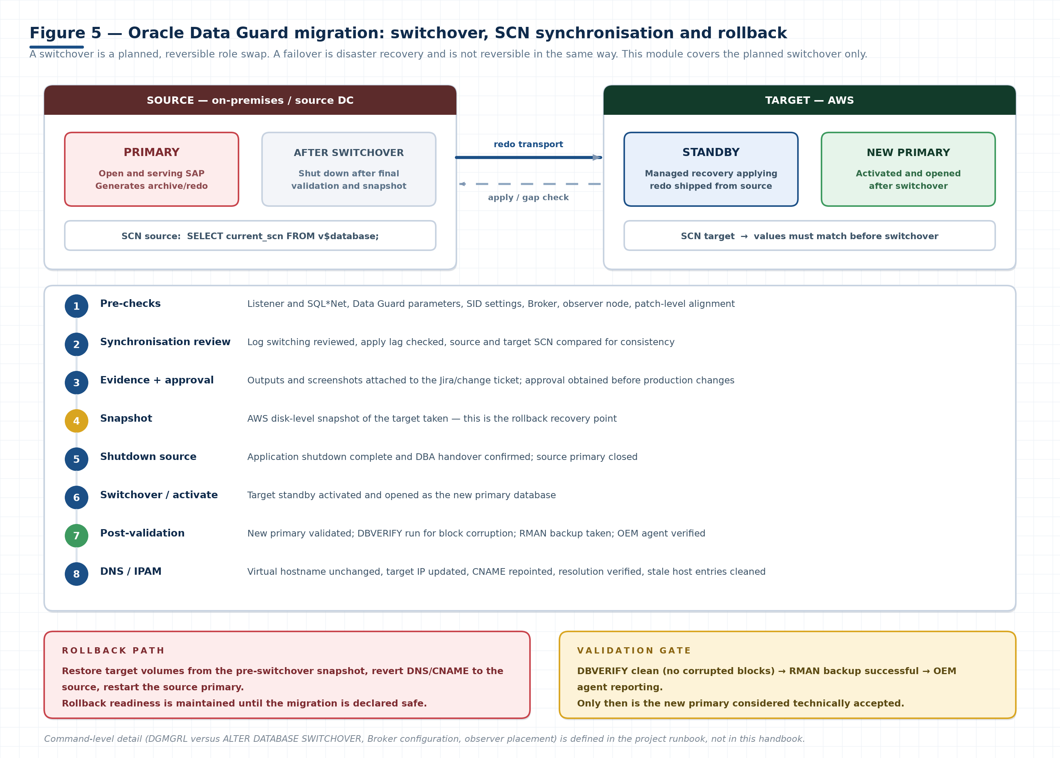
Figure 5. Data Guard switchover sequence. Redo flows from the source primary to the target standby throughout the project; SCN values are compared to prove synchronisation; a snapshot creates the rollback point; the roles are swapped only after evidence and approval; and the new primary is validated with DBVERIFY, RMAN and the OEM agent before it is accepted.

9.1 Oracle Data Guard in the migration scenario
▪ Source primary and target standby are synchronized using Oracle Data Guard.
▪ Log switching and synchronization are reviewed before switchover — apply lag must be zero (or within the agreed tolerance) at the moment of the change.
▪ Source and target System Change Number (SCN) values are compared to verify synchronization and data consistency.
▪ Evidence must be captured and attached to the relevant Jira/change ticket for approval.
▪ After successful validation, the source is shut down and the target standby is activated as the new primary.
DATA GUARD VOCABULARY
Concept | Meaning | Why it matters at cutover
Primary | The database that accepts writes and generates redo | The source is primary until the switchover moment
Physical standby | A copy of the primary kept current by applying shipped redo | The migration target during the project phase
Redo transport | Shipping of redo from primary to standby | A break here silently widens the gap between source and target
Managed recovery (apply) | Standby process applying received redo | Apply lag is the number to watch before switchover
SCN (System Change Number) | A logical point-in-time marker for the database | Comparing source and target SCN proves the data is consistent
Log switch / archive | Closing and archiving the current redo log | Forcing log switches confirms the pipeline is live, not stalled
Switchover | Planned, reversible role swap between primary and standby | The migration mechanism in this scenario
Failover | Unplanned promotion of the standby after a primary failure | Not reversible in the same way — this is DR, not migration
Data Guard Broker | Management layer that coordinates Data Guard configuration and operations | Simplifies and standardises the switchover where it is used
Observer node | Independent node that monitors the configuration (used with fast-start failover) | Required for HA environments where automatic failover is designed

SWITCHOVER VERSUS FAILOVER
A switchover is planned and reversible: both databases end the operation in a valid role, and you can switch back. A failover is a disaster-recovery action: the standby becomes primary and the old primary usually needs rebuilding. Migration uses switchover. Confusing the two in a runbook is how a reversible operation becomes an unrecoverable one.

9.2 Oracle configuration checks
☐ | Check | Status | Evidence / remarks
☐ | SQL*Net and listener configuration validated on source and target (tnsnames, listener.ora, service names) | Not Started
☐ | Listener registered services confirmed and reachable from the SAP application hosts | Not Started
☐ | Data Guard parameters validated (log archive destinations, transport/apply settings) | Not Started
☐ | SID-specific settings confirmed (SID, ORACLE_HOME, environment files, profile entries) | Not Started
☐ | Data Guard Broker configuration reviewed (where Broker is used) | Not Started
☐ | Observer-node configuration reviewed for HA environments | Not Started
☐ | Required source/target patch-level alignment confirmed | Not Started
☐ | Archive log mode and destination space validated on both sides | Not Started
☐ | Password files, wallets and credentials available to the DBA team | Not Started
☐ | Network path and latency between source and target measured and acceptable | Not Started
☐ | Character set, national character set and database options match | Not Started

9.3 Switchover sequence
1. Complete pre-checks: listener, SQL*Net, Data Guard parameters, SID settings, Broker, observer node, patch alignment.
2. Review log switching and apply status; confirm the standby is applying with no gap.
3. Compare source and target SCN values and record both.
4. Capture evidence and attach it to the Jira/change ticket; obtain approval.
5. Take the AWS disk-level snapshot of the target to establish the rollback recovery point.
6. Confirm application shutdown is complete and the DBA handover has been accepted.
7. Shut down / close the source primary as designed.
8. Perform the switchover and activate the target standby as the new primary.
9. Open the new primary and validate it: services registered, listener responding, SAP can connect.
10. Run DBVERIFY to check for database block corruption.
11. Take an Oracle RMAN backup after successful validation.
12. Install or verify the OEM agent in production where applicable.
13. Hand back to Basis for the DNS/IPAM update and SAP-side validation.
-- Synchronisation evidence typically captured before switchover (illustrative)
SELECT database_role, open_mode, current_scn FROM v$database;
-- run on BOTH source and target; compare current_scn
SELECT process, status, thread#, sequence#, block# FROM v$managed_standby;
-- confirm MRP0 is APPLYING_LOG and no gap remains
-- On the target after switchover: block integrity and backup
dbv file=<datafile> blocksize=<size> # expect: no corrupt blocks listed
rman target / → BACKUP DATABASE PLUS ARCHIVELOG;
-- Exact syntax (DGMGRL SWITCHOVER, ALTER DATABASE commands, Broker config)
-- comes from the project runbook and the Oracle version in use.
SNAPSHOT TIMING
The snapshot must be taken after the standby is fully synchronised and before the role change. Taken too early it is not a consistent recovery point; taken after the switchover it protects nothing. Also confirm whether the project requires an application-consistent snapshot (quiesced database) or accepts a crash-consistent one for this purpose — that decision belongs to the DBA lead and must be recorded. Validate

9.4 Backup and rollback protection
POST-SWITCHOVER PROTECTION SEQUENCE
Step | Purpose | Evidence
AWS disk-level snapshot before subsequent activities | Establishes the rollback recovery point | Snapshot ID, timestamp, volume list
Validate the new primary after switchover | Confirms the database is open, services are registered and SAP can connect | Listener/services output, connection test
Run Oracle DBVERIFY | Checks for database block corruption in datafiles | DBVERIFY output with no corrupted blocks
Take an Oracle RMAN backup | Creates the first backup of the new primary and a fresh recovery baseline | RMAN log, backup piece list, completion status
Install / verify the OEM agent in production | Restores monitoring and alerting coverage on the new primary | Agent status, target visible in the monitoring console

9.5 DNS and IPAM after database switchover
▪ The virtual hostname remains unchanged according to the migration design — SAP continues to address the database by the same name.
▪ The target IP is updated in DNS/IPAM.
▪ CNAME entries are updated to point to the correct target environment.
▪ Verify hostname and IP resolution from every consumer: SAP application hosts, interfaces, backup and monitoring systems.
▪ Clean obsolete host-file entries — a stale /etc/hosts line overrides DNS and silently reconnects you to the source.
# Resolution checks from an SAP application host
getent hosts <virtual-db-hostname> # must return the NEW target IP
nslookup <virtual-db-hostname> # confirm the CNAME chain
grep -n <virtual-db-hostname> /etc/hosts # must be empty or correct
# then prove the SAP side sees the same database
R3trans -d # expect return code 0000
CACHE AND CONNECTION POOLING
DNS TTL, name-service caching and pooled database connections can keep a system talking to the old IP after the record changes. Reduce TTL ahead of cutover as designed, restart the affected services, and verify with an actual connection test (R3trans -d) rather than by reading the DNS record.

9.6 Module 6 readiness checklist
☐ | Check | Status | Evidence / remarks
☐ | Data Guard configured and applying with zero gap | Not Started
☐ | Listener, SQL*Net and service names validated on both sides | Not Started
☐ | Data Guard parameters and Broker configuration reviewed | Not Started
☐ | Observer node configured for HA environments | Not Started
☐ | Source and target patch levels aligned as required | Not Started
☐ | Log switching tested and reviewed before switchover | Not Started
☐ | Source and target SCN compared and recorded | Not Started
☐ | Evidence attached to the Jira/change ticket | Not Started
☐ | Approval obtained before production changes | Not Started
☐ | AWS disk-level snapshot taken at the correct point | Not Started
☐ | Application shutdown and DBA handover confirmed | Not Started
☐ | Switchover executed and new primary validated | Not Started
☐ | DBVERIFY completed with no corruption found | Not Started
☐ | RMAN backup of the new primary completed successfully | Not Started
☐ | OEM agent installed/verified in production where applicable | Not Started
☐ | Virtual hostname unchanged; target IP and CNAME updated | Not Started
☐ | Resolution verified from every consumer host | Not Started
☐ | Obsolete host-file entries cleaned | Not Started
☐ | R3trans -d returns 0000 from the application host | Not Started
☐ | Rollback path tested or rehearsed and still available | Not Started

MODULE 7 · SECTION 10

10 Module 7 — Cutover, Go/No-Go, rollback and hypercare
Cutover is the execution of everything the previous modules prepared. It succeeds when the sequence is boring: no surprises, no improvisation, evidence at each handover, and a decision gate that is allowed to say no.

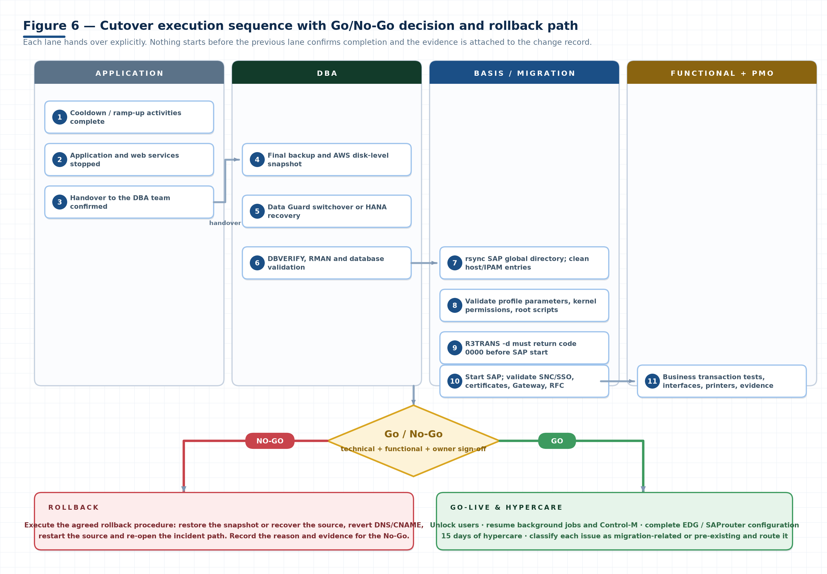
Figure 6. Cutover lane sequence. Application stops and hands over to the DBA; the DBA completes backup, snapshot, switchover or recovery and validation; Basis performs post-processing and starts SAP only after R3trans -d returns 0000; the functional team tests; and the Go/No-Go gate decides release or rollback.

10.1 Cooldown and cutover preparation
▪ Complete cooldown/ramp-up activities as defined by the project (for example reduced load, frozen changes, batch blackout).
▪ Shut down the application and associated web services as required.
▪ Hand over database-related activities to the DBA team after application shutdown, and get that handover acknowledged.
▪ Confirm all required evidence and approvals are ready before the window opens, not during it.
▪ Confirm the rollback point exists and the rollback owner is on the bridge.
▪ Confirm the window, the checkpoint times and the latest safe point-of-no-return.
DEFINE THE POINT OF NO RETURN
Every cutover has a moment after which rollback becomes expensive or impossible — typically after the source has been changed, decommissioned, or after new business data has been created on the target. Agree that point in advance, announce it on the bridge when you pass it, and make sure the Go/No-Go decision happens before it.

10.2 SAP Basis post-processing
BASIS POST-PROCESSING SEQUENCE
# | Activity | Detail and acceptance
1 | Synchronize the SAP global directory using rsync | Global directories (for example transport, interface and shared directories) copied and compared; permissions and ownership preserved
2 | Clean and validate host-file / IPAM entries | No stale source IPs; virtual hostname resolves to the new target; /etc/hosts and /etc/services correct
3 | Validate SAP profile parameters | Instance and default profiles match the target design; hostname, DB host, instance numbers and migration-specific parameters correct
4 | Validate webMethods / RFC connections | Each documented integration reachable and authenticated; middleware endpoints repointed where required
5 | Verify SAP kernel permissions and required SAP/Oracle root scripts | Kernel executable permissions correct; saproot.sh / Oracle root scripts executed as designed source term
6 | Run R3trans -d and confirm return code 0000 before starting SAP | The definitive SAP-to-database connectivity check. Any other code must be diagnosed before SAP is started
7 | Start SAP using the appropriate SAP utilities | sapstart/sapcontrol or the project's start mechanism; instances registered and work processes green
8 | Validate SNC / SSO and certificates | SNC handshake succeeds, SSO logon works, certificates valid for the new hostnames and domains
9 | Validate Gateway and external connectivity | SMGW connections as expected; external partners can reach the gateway as designed
10 | Import OS profiles through RZ10 where applicable | Profiles imported and activated; activation and restart behaviour understood

# The check that gates SAP start
su - &lt;sid&gt;adm
R3trans -d # expect: "R3trans finished (0000)"
# If it does not return 0000, read the trace before retrying:
cat trans.log # look for DB connect, auth or library errors
# Common non-zero codes to recognise (confirm against your release):
# 0000 success · 0004 general error · 0012 database connect failed
# 0018 no database authorization / wrong credentials
ORDER MATTERS
Starting SAP before R3trans -d returns 0000 produces a wall of secondary errors in the work process traces that hides the real cause, wastes window time, and can leave the system in a state that needs a clean restart. Diagnose the database connection first, every time.

10.3 Application and functional validation
▪ Validate RFC, webMethods, MuleSoft, MBox and other documented integrations source term.
▪ Verify inbound and outbound interfaces and application directories.
▪ Validate printers through SPAD (device type, output device, host printer, test page).
▪ The functional team executes business transaction tests and captures evidence — this is their call, not Basis's.
▪ Update Type 3 RFC passwords where required source term.
▪ Validate the ChaRM test cycle and transport-management functionality as applicable.
FUNCTIONAL VALIDATION OWNERSHIP
Validation area | Owner | Typical evidence
RFC and middleware interfaces | Basis + interface owner | SM59 test results, middleware logs, message flow screenshots
Inbound / outbound file interfaces | Application + Basis | AL11 listings, transferred file counts, timestamps
Printers and spool | Basis | SPAD configuration, test page output, SP01 spool requests
Business transactions | Functional team | Named test scripts with pass/fail per transaction and screenshot evidence
Transports / ChaRM | Basis + release manager | Successful test import, ChaRM cycle status, route validation
Authorisations and SSO | Security + Basis | Representative user logons per role, SSO success, SNC status
Background jobs | Basis + job owner | Job list with release status; a sample job run successfully
Interfaces to external partners | Interface owner | Partner confirmation or successful test exchange

10.4 Go/No-Go gate
1. Collect technical and functional evidence into one pack, indexed by checklist item.
2. Complete ADPU and relevant quality-assurance sign-offs source term.
3. Obtain confirmation from Basis, application, functional and system-owner teams — by name, not by silence.
4. Project management and stakeholders review the checklist, the open items and the rollback readiness.
5. Release the system only after the required approvals and an explicit Go decision.
GO/NO-GO INPUTS
Gate input | What must be true to vote Go
Technical validation | All Module 4 and Module 6 checks complete or formally deferred with an owner, impact and date
Functional validation | Named business transactions tested and passed by the functional team
Evidence | Source and target evidence captured, compared, and attached to the change record
Rollback readiness | Snapshot and/or final backup verified, DNS rollback path defined, rollback owner present
Approvals | Basis, application, functional, system owner, PMO — all recorded
Open risks | Every open item classified by severity with an agreed mitigation; no unexplained critical item
Support readiness | Hypercare roster, escalation path and ticket routing configured

A NO-GO IS A SUCCESS WHEN THE EVIDENCE SUPPORTS IT
The gate exists to protect the business, not to approve the project's schedule. Presenting a clean No-Go with documented reasons is professional execution. Presenting a Go with open critical items is how migrations become incidents.

10.5 Rollback
▪ If a No-Go decision is made, or a critical issue prevents safe cutover, execute the agreed rollback procedure — the one rehearsed before the window.
▪ Typical technical path: restore the snapshot or recover the source, revert DNS/CNAME to the source, restart the source database and SAP, re-validate connectivity, then re-open the incident path.
▪ Announce the decision, the time and the reason on the bridge and in the change record.
▪ Preserve all evidence from the failed attempt — it is the input to the next attempt.
▪ Confirm with the business which data (if any) was created on the target and how it will be handled.

10.6 Go-live and hypercare
1. Following Go, unlock users as required (and only the intended user population).
2. Resume background jobs and Control-M activities with the relevant teams — in the agreed order, not all at once.
3. Complete remaining EDG / SAProuter configuration as applicable source term.
4. Provide 15 days of hypercare, with a named roster and an escalation path.
5. Classify each issue as migration-related or pre-existing and route it to the responsible support team.
6. Monitor the leading indicators daily: short dumps, failed jobs, failed interfaces, response time versus baseline, memory, database growth, backup success.
7. Hold a daily hypercare call, track issues to closure, and report trend rather than incident count alone.
8. Close hypercare formally: exit criteria met, open items transferred to BAU support with owners, evidence archived.
DAILY HYPERCARE MONITORING SET
Hypercare indicator | Source | What a bad trend looks like
Short dumps and runtime errors | ST22 | New dump types appearing after go-live, or a rising count for a known dump
Failed background jobs | SM37, Control-M | Jobs cancelled that previously succeeded; jobs not scheduled at all
Failed interfaces / IDocs | SM59, WE02/BD87, middleware | Rising error status, retries not clearing, partner timeouts
Response time | ST03/ST03N | Sustained increase over the pre-migration baseline for the same period type
Memory behaviour | ST02 | Processes moving to PRIVATE mode, rising paging or swap counts
Database health | DB02, DB alert log | Tablespace growth beyond forecast, archive destination filling, backup failures
Update errors | SM13 | Update records stuck or failed — a business-visible data problem
Locks and enqueue | SM12 | Stale or growing lock entries after go-live
Security and certificates | STRUST, SNC | Certificate expiring soon, SNC handshake failures, SSO fallbacks
Backup success | Backup tool, DB02 | First backup on the target failing or running far longer than the test

ISSUE CLASSIFICATION DURING HYPERCARE
Compare each issue against the pre-migration baseline before assigning it. “Was this working before?” is answerable only if Module 1 recorded the answer. Migration-related issues go to the migration/owning team under the project process; pre-existing issues go to BAU support with the baseline evidence attached.

10.7 Cutover readiness checklist
This is the short list used on the bridge. The full consolidated version is in Section 12.5.
☐ | Check | Status | Evidence / remarks
☐ | Cooldown / ramp-up activities complete | Not Started
☐ | Application and web services shut down | Not Started
☐ | DBA handover acknowledged after application shutdown | Not Started
☐ | Final backup and snapshot completed and verified | Not Started
☐ | Source/target synchronization confirmed (SCN or equivalent) | Not Started
☐ | Switchover or recovery executed successfully | Not Started
☐ | DBVERIFY and RMAN completed (Oracle scenario) | Not Started
☐ | SAP global directory synchronized with rsync | Not Started
☐ | Host-file and IPAM entries cleaned and validated | Not Started
☐ | Profile parameters validated | Not Started
☐ | Kernel permissions and root scripts verified | Not Started
☐ | R3trans -d returns 0000 | Not Started
☐ | SAP started; instances registered and processes green | Not Started
☐ | SNC / SSO and certificates validated | Not Started
☐ | Gateway and external connectivity validated | Not Started
☐ | RFC, webMethods, MuleSoft, MBox interfaces validated | Not Started
☐ | Printers validated through SPAD | Not Started
☐ | Functional business transaction tests passed with evidence | Not Started
☐ | Type 3 RFC passwords updated where required | Not Started
☐ | ChaRM / transport management validated | Not Started
☐ | Go/No-Go inputs complete; decision recorded with named approvers | Not Started
☐ | Users unlocked after Go | Not Started
☐ | Background jobs and Control-M resumed with the owning teams | Not Started
☐ | EDG / SAProuter configuration completed | Not Started
☐ | Hypercare roster, escalation path and daily monitoring live | Not Started
☐ | Rollback path available until the migration is declared safe | Not Started

SECTION 11 · REFERENCE

11 SAP transaction and technology quick reference
The working vocabulary of a migration. Learn what each item proves — a transaction you cannot interpret produces a screenshot, not evidence.

11.1 SAP transactions
SAP TRANSACTION REFERENCE
Transaction | Purpose in this training | What you check | Module
ST03 / ST03N | Workload and performance analysis | Response, DB, CPU and wait time; steps and users; daily/weekly/monthly trend | 5
STAD | Detailed transaction and user-level performance analysis | Individual statistical records behind the aggregates: the slow steps and where the time went | 5
ST02 | SAP memory and buffer monitoring | Extended, heap/private, roll, paging; buffer utilisation and hit ratio | 5
AL11 | SAP directory analysis and interface/custom directory validation | Directory presence, content, permissions and changes versus the baseline | 1, 4
SM59 | RFC destination and connectivity validation | Destinations by type, connection test result, logon and authentication | 1, 4, 7
SMGW | SAP Gateway monitoring and troubleshooting | Gateway status, active connections, unexpected or missing registrations | 4, 7
SMICM | HTTP/HTTPS and ICM communication monitoring | ICM services and ports, URL handling, certificate binding, errors | 4, 7
SM51 | Application server status and availability | All planned instances active and registered; work process configuration | 4, 7
STMS / TMS | Transport landscape, domain, routes and transport directory | Domain controller, systems, routes, transport directory path, import test | 4, 7
RZ10 | Persistent profile parameter maintenance | Profile versions, imports, activation and the restart requirement per parameter | 5, 7
RZ11 | Dynamic/temporary parameter changes where supported | Current runtime value versus the profile value | 5
DB02 | Database status, storage and tablespace information | Space, tablespaces, growth, backup status (database-dependent views) | 4
SPAD | Printer configuration and spool validation | Output devices, device types, host printers, test page | 4, 7
SP01 | Spool requests | Spool output present, no stuck or failed requests | 4, 7
STRUST | Certificate and PSE management | Certificate validity, chain, hostname/domain match, expiry | 4, 7
SLICENSE | SAP license administration | Hardware key after migration, installed license, temporary-license expiry | 4
SA38 | ABAP report execution (used for RFC connectivity reports) | Running the project's RFC/interface test report | 1, 4
ST22 | ABAP runtime error analysis | New or rising dumps after go-live | 7
SM37 | Background job overview | Job status after cutover: released, running, cancelled | 7
SM13 | Update errors | Stuck or failed update records — business-visible data issues | 7
SM12 | Lock entries | Stale or growing locks after go-live | 7
WE02 / BD87 | IDoc monitoring and processing | Failed or stuck IDocs on interfaces | 7
Solution Manager / EarlyWatch | Central monitoring and SAP health information | Landscape health, configuration and performance reporting where available | 5

11.2 Database, platform and tooling reference
TECHNOLOGY REFERENCE
Technology | Purpose in this training | Module
Oracle Data Guard | Database replication and planned switchover mechanism in the discussed Oracle scenario | 6
Oracle DBVERIFY (dbv) | Block-level integrity check for database corruption after switchover | 6
Oracle RMAN | Backup and recovery of the new primary after successful validation | 6
Oracle OEM agent | Monitoring coverage restored on the new primary in production | 6
Oracle listener / SQL*Net | Database connectivity path validated from the SAP application hosts | 6
Data Guard Broker + observer node | Configuration management and independent monitoring for HA designs | 6
R3trans -d | SAP-to-database connectivity check; training expects return code 0000 | 7
sapcontrol / sapstart | Instance control and status from the OS, without the GUI | 4, 7
AWS Route 53 | DNS management: hosted zones, records and the cutover CNAME/IP change | 2, 6
AWS S3 | Object storage used as the backup backend (HANA, Oracle) and for packages | 2, 3
AWS EFS | Managed file service — an option when migrating NFS shares | 1, 2
EC2 snapshots | Disk-level rollback recovery point before risky cutover activities | 6, 7
AWS KMS | Encryption keys for storage, backups and snapshots | 2
Chef | OS and configuration management used by the automation team | 2
CMDB / ServiceNow | Configuration inventory, CIs, relationships and lifecycle status | 1, 2
Control-M | External job scheduling — resumed with the owning team after go-live | 1, 7
NetBackup | Backup agent that must be inventoried and re-pointed on the target | 1, 2
rsync | Synchronization of SAP global directories during post-processing | 7
systemd / SAP service | Service that must start SAP automatically after a reboot | 4

11.3 OS commands used during validation
COMMAND QUICK REFERENCE
Command | Validates | Section
df -h, mount, lsblk | File systems, mount points, sizes and options | 7.2
lscpu, nproc, free -g | CPU and memory versus the build sheet | 7.2
uname -r, /etc/os-release | Kernel and OS version | 7.2
id, getent passwd, getent group | UID/GID and group membership consistency | 7.2
ip a, ip r | Physical and virtual IPs, routes | 7.2
hostname -f, getent hosts, nslookup | Hostname and DNS resolution | 7.2, 9.5
swapon -s, sysctl vm.swappiness | Swap configuration | 7.2
grep -E 'sapdp|sapgw' /etc/services | SAP service port definitions | 7.2
ldd on key binaries | Shared library dependencies | 7.2
systemctl status / show | Service state, result and exit code | 7.1
sapcontrol -nr <nn> -function GetProcessList | Instance process state from the OS | 7.1
R3trans -d | SAP-to-database connectivity (expect 0000) | 10.2
rsync -avn (dry run first) | Global directory synchronization | 10.2

Command names and syntax differ by distribution, SAP release and project standard. These are the checks to perform, not copy-paste production commands.

11.4 Key files and locations
FILES THAT DECIDE WHETHER A CUTOVER WORKS
File / location | Relevance
/etc/hosts | Hostname and virtual-hostname resolution; stale entries silently override DNS
/etc/services | sapdp<nn> and sapgw<nn> port definitions used by SAP and the gateway
/etc/fstab | Mount definitions — a missing or misordered entry breaks SAP at boot
SAP profile directory | Instance and default profiles maintained via RZ10
SAP work / log directories | dev_w*, dev_disp, dev_ms traces used to diagnose start failures
SAP global directories | Transport, interface and shared directories synchronized with rsync
HANA INI files | global.ini, nameserver.ini and service configuration used in recovery
Oracle network files | listener.ora, tnsnames.ora, sqlnet.ora
Oracle wallet / PSE / keystore locations | Credentials and certificates for SNC, SSL and database authentication
R3trans trace (trans.log) | First place to look when R3trans -d does not return 0000

SECTION 12 · REFERENCE

12 Consolidated validation checklists
Five checklists covering the whole validation surface. They are interactive: tick a check, set a status, add the evidence reference. Progress persists in your browser and is printed as a static record.
HOW TO USE THESE CHECKLISTS IN ANGER
▪ Run them twice per system: once at pre-cutover validation (Gate 1) and once during the cutover window.
▪ Every item needs either a tick with evidence, or a recorded deferral with an owner, an impact statement and a date.
▪ “Not applicable” is a valid status — but write why. An unexplained N/A is an audit finding waiting to happen.
▪ Transfer the results into the project's validation workbook or change record before sign-off; the browser copy is a working aid, not the system of record.

12.1 OS validation
☐ | Check | Status | Evidence / remarks
☐ | File systems / mount points | Not Started
☐ | CPU | Not Started
☐ | RAM | Not Started
☐ | Swap | Not Started
☐ | OS version | Not Started
☐ | Kernel version | Not Started
☐ | UID/GID | Not Started
☐ | Libraries | Not Started
☐ | FTP users | Not Started
☐ | OS groups | Not Started
☐ | IP addresses | Not Started
☐ | Hostnames | Not Started
☐ | /etc/hosts | Not Started
☐ | /etc/services | Not Started
☐ | SAP directories | Not Started
☐ | Permissions | Not Started

12.2 SAP validation
☐ | Check | Status | Evidence / remarks
☐ | SAP services active | Not Started
☐ | Auto-start tested (real reboot) | Not Started
☐ | SAP processes green | Not Started
☐ | Application servers available | Not Started
☐ | SM51 | Not Started
☐ | SMGW | Not Started
☐ | SM59 | Not Started
☐ | RFC report | Not Started
☐ | SNC | Not Started
☐ | STMS | Not Started
☐ | Transport directory | Not Started
☐ | AL11 | Not Started
☐ | Printers | Not Started
☐ | Spool | Not Started
☐ | SMICM | Not Started
☐ | SSL/TLS certificates | Not Started
☐ | SAP license | Not Started

12.3 Database validation
☐ | Check | Status | Evidence / remarks
☐ | DB status | Not Started
☐ | DB02 | Not Started
☐ | Storage utilization | Not Started
☐ | Tablespaces | Not Started
☐ | Database growth | Not Started
☐ | Latest backup | Not Started
☐ | Backup status | Not Started
☐ | Redo/archive logs | Not Started
☐ | Recovery requirements | Not Started

12.4 Performance validation
☐ | Check | Status | Evidence / remarks
☐ | ST02 memory | Not Started
☐ | Extended memory | Not Started
☐ | Heap/private memory | Not Started
☐ | Buffer utilization | Not Started
☐ | ST03N workload | Not Started
☐ | Response time | Not Started
☐ | Wait time | Not Started
☐ | DB request time | Not Started
☐ | CPU time | Not Started
☐ | Performance trends | Not Started

12.5 Cutover readiness
☐ | Check | Status | Evidence / remarks
☐ | Application shutdown confirmed | Not Started
☐ | DBA handover confirmed | Not Started
☐ | Source/target synchronization confirmed | Not Started
☐ | Snapshot/backup confirmed | Not Started
☐ | DNS/IPAM plan confirmed | Not Started
☐ | Evidence captured | Not Started
☐ | Technical validation complete | Not Started
☐ | Functional validation complete | Not Started
☐ | Approvals complete | Not Started
☐ | Rollback ready | Not Started
☐ | Go/No-Go decision recorded | Not Started

12.6 Sign-off
VALIDATION SIGN-OFF RECORD
Validation domain | Validated by | Date | Deviations / deferrals | Reviewed by
OS validation
SAP validation
Database validation
Performance validation
Cutover readiness
Functional validation
Go/No-Go decision

SECTION 13 · REFERENCE

13 Evidence and documentation strategy
Evidence is the difference between “it works” and “it is proven to work, by these checks, at this time, compared with this baseline”. It is also the only defence against absorbing a pre-existing fault as a migration defect.

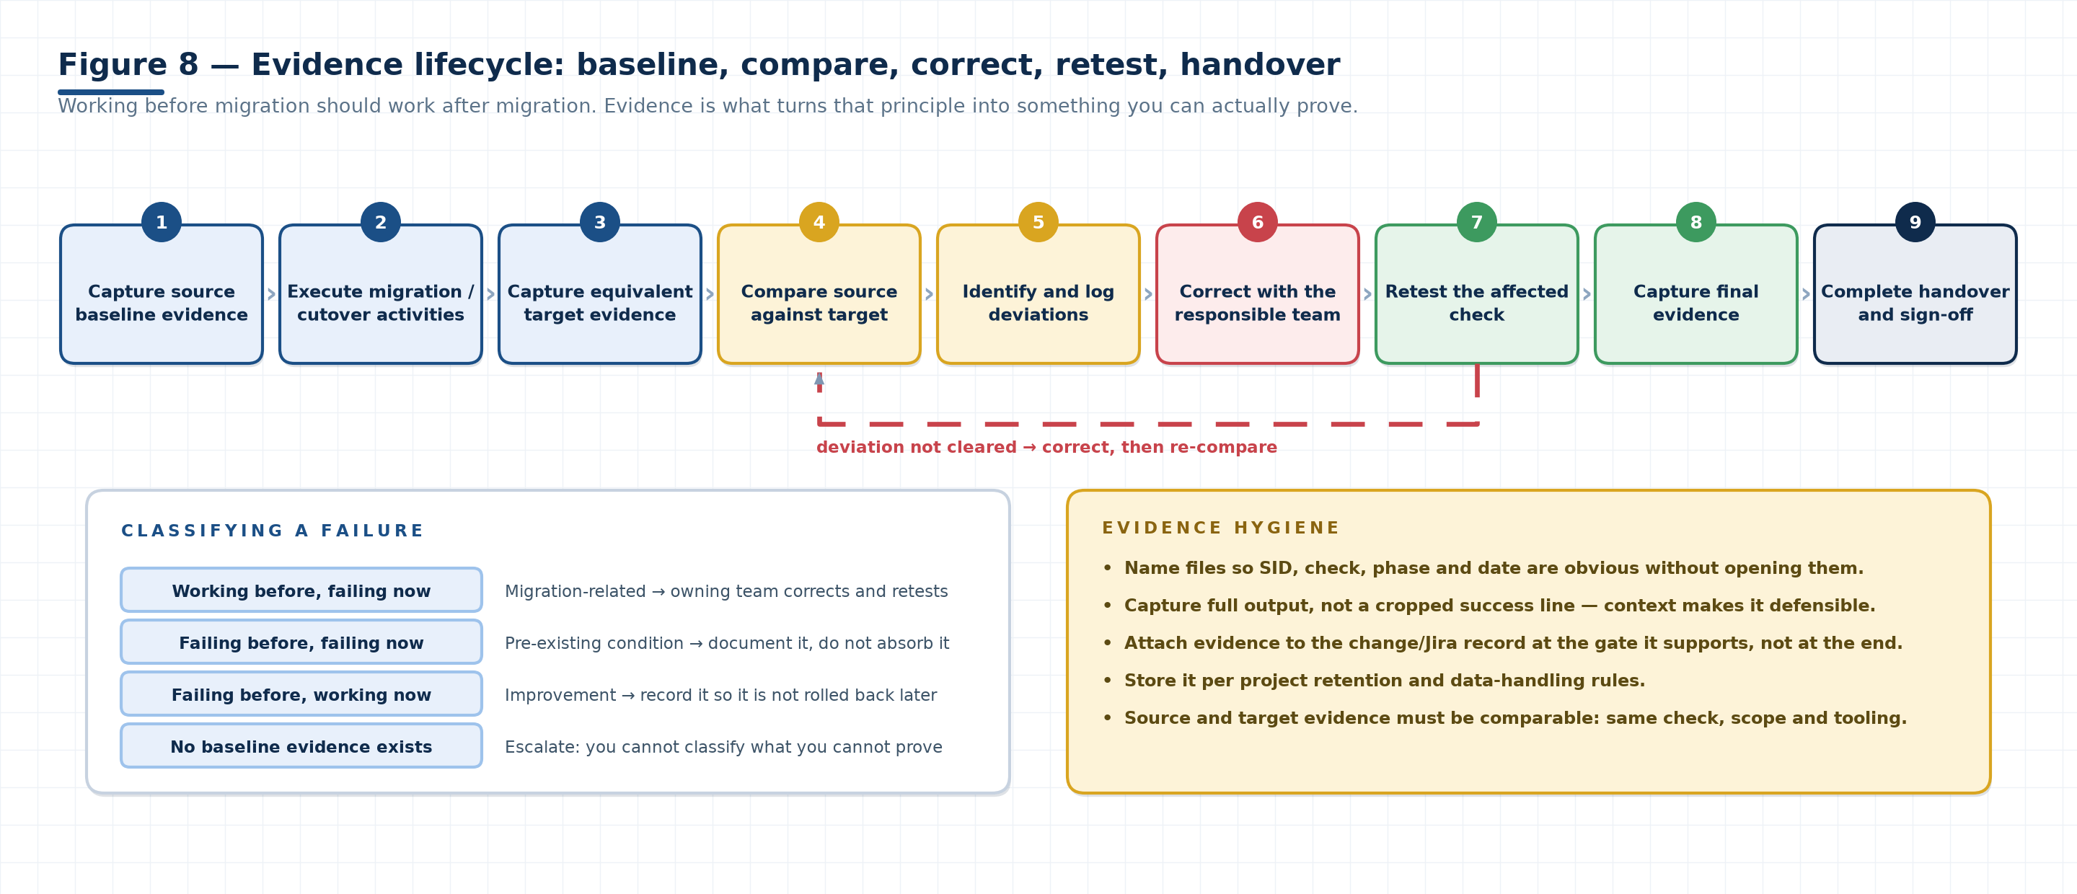
Figure 8. The evidence lifecycle. The loop from retest back to comparison is deliberate: a correction is not complete until the comparison has been re-run and re-recorded.

13.1 Evidence lifecycle
1. Capture source evidence before migration.
2. Execute migration/cutover activities.
3. Capture equivalent target evidence.
4. Compare source and target.
5. Identify deviations.
6. Correct issues with the responsible team.
7. Retest.
8. Capture final evidence.
9. Complete handover.
EQUIVALENT MEANS EQUIVALENT
A target screenshot of a different transaction, a different time window or a filtered view is not comparable evidence. Same check, same scope, same tooling, and — for performance — the same period type and load profile.

13.2 Evidence categories
OS configuration and file systems
CPU and memory
UID/GID
IP / hostname
SAP status and application servers
RFC and Gateway status
STMS
Database status and backup
Printers and AL11
SNC and certificates
Performance indicators
Backup/recovery evidence
Database synchronization/switchover evidence
Functional transaction evidence
Approvals and Go/No-Go decision

13.3 Recommended evidence record
EVIDENCE REGISTER TEMPLATE
ID | Validation area | Source evidence | Target evidence | Result / action
1
2
3
4
5
6
7
8

13.4 Naming and storage convention
Adopt one convention across the programme so that evidence can be found during a 02:00 cutover call without opening files:
&lt;SID&gt;_&lt;PHASE&gt;_&lt;CHECK&gt;_&lt;SOURCE|TARGET&gt;_&lt;YYYYMMDD-HHMM&gt;.&lt;ext&gt;
# examples
PRD_PRECUT_SM59_SOURCE_20261002-1015.pdf
PRD_CUTOVER_R3TRANS_TARGET_20261005-0212.log
PRD_CUTOVER_SCN_BOTH_20261005-0140.png
PRD_HYPER_ST03N_TARGET_20261007-0900.pdf
▪ Store per the project retention and data-handling rules — no production data in unapproved locations, personal drives or chat.
▪ Attach evidence to the change/Jira record at the gate it supports, not in a batch at the end.
▪ Capture full output. A cropped success line proves nothing about what else was on the screen.
▪ Where evidence contains credentials, secrets or personal data, redact before storing and note that redaction occurred.
▪ Keep the evidence pack indexed by checklist item so a reviewer can jump from “SNC” to the SNC proof in one step.

13.5 Documentation set produced by a migration
DOCUMENTATION SET
Document | Owner | Purpose
Source baseline pack | Basis / migration | Reference for every comparison and for hypercare triage
Build sheet (approved) | Basis + automation | The provisioning input and the validation reference
Infrastructure validation record | Basis / migration | Proof that what was built matches what was approved
Backup/recovery test record | Basis + DBA | Proof the recovery path works before it is needed
Validation workbooks (Sections 12) | Executing engineer | Check-by-check results with evidence references
Cutover runbook and log | Basis / migration + PMO | What was planned, what was done, at what time, by whom
Go/No-Go pack and decision record | PMO | The evidence set and the named approvals behind the decision
Hypercare issue log | Hypercare lead | Issues, classification (migration vs pre-existing), owners, closure
Handover pack to BAU | Basis / migration | Final state, known issues, deferred items, contacts, evidence archive

SECTION 14 · REFERENCE

14 Ownership and operating model
The training concluded with an ownership model intended to prevent conflicting changes and unclear accountability. Technology rarely fails a migration on its own; uncoordinated people do.

14.1 Ownership model
1. Complete the training and review the documentation.
2. Clear technical doubts before taking ownership — an unasked question becomes a cutover incident.
3. Assign individual SIDs/systems to owners.
4. Assign a guide/support person for each owner.
5. The assigned owner remains accountable for the system.
6. Avoid multiple people independently modifying the same assigned system.
7. Consolidate the training documentation/MOM after completion.
8. Circulate the finalized material after confirmation/sign-off.
OWNERSHIP PRINCIPLE
One accountable owner per assigned system, with a defined guide/support path and controlled changes. Accountability does not mean doing everything alone — it means being the person who knows the state of the system and who authorises changes to it.

14.2 System ownership register

OWNERSHIP REGISTER TEMPLATE
SID | System / description | Owner (accountable) | Guide / support | Backup owner | Status

14.3 Typical collaboration model
COLLABORATION MODEL
Team | Owns | Consulted on
Basis / migration | SAP validation, migration coordination and technical handover | Everything SAP-side; chairs the technical bridge
DBA | Database migration, synchronization, backup/recovery and database validation | Storage sizing, snapshot strategy, DB parameters
Linux | OS configuration, services, file systems, UID/GID and reboot coordination | Auto-start design, kernel tuning, reboot sequencing
Network / IPAM / DNS | IP changes, hostname resolution, CNAME and connectivity | TTL reduction, resolver design, firewall and security groups
Application / functional | Business transactions and application validation | Test scripts, data readiness, user communication
Automation / cloud | AWS infrastructure provisioning and configuration automation | Build-sheet feasibility, tagging, CMDB automation
Security / AD | Credentials, SSO/SNC/certificates and security dependencies | Certificate reissue, privileged access, audit requirements
Project management / stakeholders | Approvals, Go/No-Go and change governance | Window scheduling, risk acceptance, communication

14.4 Escalation path
ESCALATION MODEL
Severity | Definition | Route | Response expectation
S1 — Critical | Cutover blocked, system unavailable, data at risk, or rollback decision required | Bridge → module owner → programme lead → stakeholders immediately | Immediate; decision within the agreed checkpoint interval
S2 — High | A gate cannot be passed; a validation item fails with no workaround | Module owner → accountable team lead; logged in the change record | Same day, inside the window if one is open
S3 — Medium | Deviation with a workaround; deferrable to a later checkpoint | Owning team; tracked in the deviation log | Before the next gate
S4 — Low | Cosmetic, documentation, or non-blocking observation | Deviation log; closed during hypercare | Hypercare window

CHANGE CONTROL DOES NOT PAUSE FOR A MIGRATION
Every change made during build, validation and cutover is still a change: it needs an owner, a record and, where the process requires it, an approval. The cutover change record is the umbrella — but it must list what was done, not merely that a cutover happened.

SECTION 15 · REFERENCE

15 Troubleshooting playbook and common failure modes
The failures that recur across SAP migrations, with the first diagnostic question for each. Use this before changing anything: most of these are resolved by finding the cause, not by adjusting a parameter.
Q1. !
SYMPTOMS
▪ Service enabled but exit code non-zero (127 / 255 / other)
▪ SAP starts manually as <sid>adm but not from the service
▪ Instance starts but never registers in SM51
FIRST DIAGNOSTICS
▪ Read the service journal and the SAP start log before retrying.
▪ Check boot ordering: file systems mounted, network up, virtual IP owned, database reachable.
▪ For 127: path, environment and shared libraries. For 255: the SAP-side trace (dev_disp, dev_ms, dev_w0).
▪ Confirm the cluster/HA manager is not fighting the local service for the same resource.
PRACTICAL TIP
Coordinate the reboot with the Linux team, and rehearse it before cutover — never for the first time in the window.
Q1. !
SYMPTOMS
▪ Database not reachable or not open
▪ Wrong credentials, missing user, or wallet/keystore problem
▪ Library or DB client (for example the Oracle client / HANA client) mismatch
▪ /etc/hosts or /etc/services pointing at the source
▪ Database name or SID changed without updating SAP configuration
FIRST DIAGNOSTICS
▪ Read trans.log — it names the failing step.
▪ Test the DB connection independently of SAP (listener/service check, DB client connection).
▪ Verify the DB host entry and the SAP profile's database parameters.
▪ Confirm the DB client version and library path match the target design.
PRACTICAL TIP
Do not start SAP until this returns 0000; starting it first buries the real error under hundreds of secondary messages.
Q1. !
SYMPTOMS
▪ RFC destination points at an old hostname/IP
▪ Gateway or message-server connection blocked by a security group or firewall
▪ Certificate, SNC or credential change on either side
▪ Middleware endpoint not repointed
▪ The interface was already failing before migration (baseline)
FIRST DIAGNOSTICS
▪ Check the baseline record first: was it working before?
▪ Test the destination in SM59 and read the returned error class.
▪ Check SMGW for the connection and for missing registrations.
▪ Validate name resolution and the network path from the SAP host, not from your laptop.
PRACTICAL TIP
If the baseline shows it was already failing, classify it as a pre-existing condition and route it to BAU with the evidence.
Q1. !
SYMPTOMS
▪ UID/GID mismatch between source and target
▪ Ownership not preserved by the copy or the rsync
▪ NFS export with root-squash or a different owner mapping
▪ EFS mount with different default ownership
FIRST DIAGNOSTICS
▪ Compare numeric UID/GID, not just user names.
▪ Check the ownership of the parent directory and the mount options.
▪ For NFS/EFS, verify the export permission model and squashing behaviour.
PRACTICAL TIP
Fix the ID mapping rather than chmod-ing the symptom; a broad permission change creates a security finding.
Q1. !
SYMPTOMS
▪ Backup backend not reachable, or permissions insufficient
▪ Configuration files missing or inconsistent with the source topology
▪ Wrong recovery context (SystemDB versus tenant)
▪ Insufficient storage or memory on the target
▪ Log or data volume path mismatch
FIRST DIAGNOSTICS
▪ Read the recovery log and the nameserver/indexserver traces.
▪ Prove the S3/backend path with a manual read test before retrying.
▪ Confirm you are recovering the tenant from the correct system context.
▪ Verify the INI/topology files describe the target, not the source.
PRACTICAL TIP
This is why recovery is tested before cutover. A first-time recovery attempt during the window is a rollback decision waiting to happen.
Q1. !
SYMPTOMS
▪ Tablespace not recovered or not extended
▪ Archive/log volume difference after the migration
▪ Compression, storage class or block-size difference on the target
▪ Growth since the baseline was taken
FIRST DIAGNOSTICS
▪ Compare per tablespace, not only the total.
▪ Check the recovery log for skipped or truncated datafiles.
▪ Reconcile object counts for a sample of large tables.
PRACTICAL TIP
A total that looks plausible can hide a missing tablespace; compare the composition.
Q1. !
SYMPTOMS
▪ Different workload mix or period compared
▪ Stale database statistics or a changed access path
▪ Memory configuration not matching the target sizing
▪ Network latency between application and database hosts
▪ Storage throughput or IOPS below the sizing assumption
▪ Instance type smaller than the sizing report specified
FIRST DIAGNOSTICS
▪ Confirm you are comparing equivalent periods and load.
▪ Split the response time: DB, CPU, wait. Follow the dominant component.
▪ Measure app-to-DB latency and storage throughput against the design.
▪ Check whether database statistics were refreshed after the data move.
PRACTICAL TIP
Do not raise memory parameters first; find what is consuming the resource.
Q1. !
SYMPTOMS
▪ CNAME or A record not updated, or updated in the wrong zone
▪ Stale /etc/hosts entry overriding DNS
▪ TTL still high, or a caching resolver holding the old record
▪ Private zone not associated with the target VPC
FIRST DIAGNOSTICS
▪ Resolve from the affected host with getent hosts and nslookup.
▪ Check /etc/hosts explicitly.
▪ Verify which zone answers and whether the VPC association is correct.
▪ Prove it with a real connection test (R3trans -d), not by reading the record.
PRACTICAL TIP
Lower TTL ahead of cutover as designed, and clear the host-file entries as part of post-processing.
Q1. !
SYMPTOMS
▪ Certificate issued for the old hostname or domain
▪ Certificate expired during the project
▪ PSE/keystore not migrated, or migrated with wrong permissions
▪ SSO provider still pointing at the old URL
▪ SNC configuration mismatch between partners
FIRST DIAGNOSTICS
▪ Check validity and the hostname/domain match in STRUST.
▪ Verify the PSE/keystore files exist with correct ownership.
▪ Test SNC handshake and SSO logon with a representative user, not an administrator account.
▪ Confirm the partner side is configured for the new endpoint.
PRACTICAL TIP
Certificate reissue has lead time with the issuing authority — raise it during preparation.
Q1. !
SYMPTOMS
▪ Transport directory not synchronized, or permissions wrong
▪ Domain controller or route definition pointing at the old landscape
▪ TMS configuration not updated for the new hostnames
▪ ChaRM cycle state inconsistent after the move
FIRST DIAGNOSTICS
▪ Validate STMS: domain, systems, routes, transport directory.
▪ Run a test import through the full route.
▪ Check ownership and permissions on the transport directory on every host.
PRACTICAL TIP
A transport route that only works in one direction is a common half-migrated landscape symptom.
Q1. !
SYMPTOMS
▪ Bucket/path/policy not matching the backup configuration
▪ Agent not installed, not registered, or pointing at the old master server
▪ Credentials or IAM role missing on the new host
▪ Network path to the backup target blocked
FIRST DIAGNOSTICS
▪ Check the backup log for the exact failing operation.
▪ Verify the agent inventory and registration against the source baseline.
▪ Test the backend path manually with the same identity the backup uses.
PRACTICAL TIP
The first backup on the target must succeed before the system is handed to BAU — no exceptions.
Q1. !
SYMPTOMS
▪ Jobs not released after cutover
▪ Control-M agent not reinstalled or not re-pointed
▪ Job definitions referencing old hostnames or paths
▪ Dependencies resumed out of order
FIRST DIAGNOSTICS
▪ Compare the job list with the source baseline (SM37 plus the scheduler).
▪ Confirm the agent is registered with the correct control.
▪ Resume in the agreed order with the job owners on the call.
PRACTICAL TIP
Resuming everything at once creates a self-inflicted load spike on go-live day.
WHEN TO STOP AND ROLL BACK
▪ The database cannot be validated and the remaining window cannot absorb the diagnosis.
▪ The rollback point is about to expire or be invalidated by the next step.
▪ Data consistency cannot be proven (SCN mismatch, corruption found, missing tablespaces).
▪ A dependency outside the project's control will not be ready before the business deadline.
▪ The Go/No-Go gate lacks a required approval or an unexplained critical open item.

SECTION 16

16 Key lessons and practical guidance
Fifteen lessons carried out of the training sessions. Each one is short because the moment you need it will not be a comfortable one.
KEY LESSONS
# | Lesson | Where it applies
1 | Never assume auto-start works. Test it through an actual reboot. | 4, 7.1
2 | Always establish a source baseline before migration. | 4
3 | Use the approved build sheet as the central technical input. | 5.2
4 | Validate provisioned AWS infrastructure rather than assuming automation produced the expected result. | 5.3
5 | Keep CMDB, inventory and actual infrastructure aligned. | 5.5
6 | UID/GID mismatches can create permission and application issues. | 7.2
7 | Validate STMS, RFC, Gateway, certificates, printers and directories explicitly. | 7.3
8 | Obtain third-party RFC credentials before cutover when required. | 4.1, 10.3
9 | Test backup and recovery before the actual cutover. | 6.4
10 | Keep the source available until the required final backup activity is successfully completed. | 6.4
11 | Capture evidence at every important decision gate. | 13
12 | Do not classify a pre-existing source issue as a migration defect without evidence. | 4.4, 13
13 | Go/No-Go must be evidence-driven and supported by technical, functional and owner approvals. | 10.4
14 | Rollback readiness must be maintained until the migration is considered safe. | 9.3, 10.5
15 | During hypercare, compare actual issues with the pre-migration baseline. | 10.6

16.1 Anti-patterns the training warned against
Silent fixes
Repairing something during cutover without recording it. It becomes an unapproved change nobody can explain later.
Assertion instead of evidence
“It was working” with no timestamp, no output and no comparison to the baseline.
Automation absolution
Assuming the automated build is correct because it completed. Completion is not correctness.
Parameter-first troubleshooting
Raising memory, timeouts or buffer sizes before identifying what is consuming the resource.
Shared ownership
Three engineers making independent changes to one SID during validation.
Compressed discovery
Shortening discovery to protect the schedule, then paying for it in the cutover window.
Unrehearsed rollback
A rollback plan that exists in a document but has never been executed or timed.
Late credential requests
Third-party and middleware credentials requested in cutover week.
Cropped screenshots
Evidence that shows only the success line and none of the context around it.
Hypercare amnesia
Losing the baseline at go-live, so every pre-existing fault becomes a migration defect.

SECTION 17

17 Final knowledge check
Sixteen questions. The first twelve are from the source training; the last four were added during the professional review to cover points the modules rely on. Answers are hidden until opened — this is a self-test, not a reading exercise.
Q1. 1
It provides the evidence used for target comparison and it is what allows you to distinguish migration-related failures from pre-existing issues. Without a baseline, every post-migration problem is arguable: you cannot prove whether the migration caused it, and you cannot prove that a fix is needed. The baseline covers OS, SAP, database, interfaces, directories, workload, memory, backup status and known failures — each with a timestamp.
Q1. 2
It is the approved system information used for target provisioning and for validating what was provisioned. It is prepared from the sizing report and architecture, peer-reviewed, finalised with the customer, and then used twice: as the input to automation, and as the reference the migration team validates the built environment against.
Q1. 3
SystemDB provides central management and monitoring for the HANA system and holds the backup catalogue; TenantDB contains the application and data workload for a specific SAP system. They have separate login contexts and credentials, and both can reside on the same HANA server or VM. Neither is an HA component — high availability is a separate infrastructure-level design.
Q1. 4
To confirm that the backup destination, configuration, permissions and the recovery process actually work before they are needed under production pressure. The test also produces the evidence required at Gate 1 and gives you a realistic duration estimate for the cutover window.
Q1. 5
RFC destinations and their connectivity, including the relevant TCP/IP, HTTP and external connections. In a migration it is used twice: to enumerate the interface baseline before the move, and to prove each destination still works after it — compared against that baseline, so pre-existing failures are not mistaken for migration defects.
Q1. 6
Transport landscape management: the transport domain and its controller, the systems in the landscape, the routes between them, and the transport directory. After migration you validate all four and prove the route works with a test import — a landscape that only transports in one direction is a common half-migrated symptom.
Q1. 7
Because mismatches cause permission problems, inter-server communication issues, SAP file-access problems and application failures that appear far from their cause. Compare the numeric IDs for sapadm, <sid>adm, the database users and their groups — not just the names, which can be identical while the numbers differ.
Q1. 8
To verify synchronization and data consistency between the source primary and the target standby before the switchover. Matching SCN values (with no apply gap) are the evidence that no committed data will be lost when the roles are swapped, and they are attached to the change ticket for approval.
Q1. 9
It provides a rollback recovery point before subsequent migration activities. Taken after the standby is synchronized and before the role change, it lets you restore the target to a known consistent state if the switchover or the following validation fails.
Q1. 10
To ensure the system is released only after the required technical, functional and owner approvals are in place, with evidence and confirmed rollback readiness. It is a governance control, not a formality: a No-Go with documented reasons is a successful use of the gate.
Q1. 11
Execute the agreed rollback procedure — the one prepared and rehearsed before the window. Restore the snapshot or recover the source, revert DNS/CNAME, restart the source, re-validate connectivity, then record the reason, the evidence and the path back into the incident and change process.
Q1. 12
15 days after successful go-live. During that period, users are unlocked, background jobs and Control-M activities are resumed with the owning teams, remaining EDG/SAProuter configuration is completed, and every issue is classified as migration-related or pre-existing and routed to the responsible support team.
Q1. 13
Added during the review pass. Because it is the definitive SAP-to-database connectivity check. Starting SAP with a failing database connection generates hundreds of secondary errors in the work process and dispatcher traces that hide the real cause and consume window time; diagnosing trans.log first is faster and safer.
Q1. 14
Added during the review pass. An enabled, active service can still fail at boot because of dependency ordering — late-mounting file systems, network not yet up, a cluster-owned virtual IP, or an unreachable database. Only a reboot proves the sequence. A return code of 127 indicates a missing command or unresolved shared library (path, environment, library dependency); 255 is a generic failure from the start script or SAP program and must be diagnosed from the service journal and the SAP traces.
Q1. 15
Added during the review pass. A switchover is a planned, reversible role swap in which both databases end in valid roles and you can switch back; it is the migration mechanism. A failover is a disaster-recovery action taken when the primary is lost: the standby becomes primary and the old primary typically needs rebuilding. Migration runbooks must never describe a failover when they mean a switchover.
Q1. 16
Added during the review pass. Record it in the source baseline with evidence and a timestamp, classify it as a pre-existing condition, and route it to BAU support rather than absorbing it as a migration defect. If it is fixed during the migration, record the fix as a change — an unrecorded fix is an unapproved change that nobody can explain later.

17.1 Scoring guidance for trainers
SCORING BANDS
Score | Interpretation | Recommended action
14–16 | Ready to take ownership of a system in a migration wave. | Assign a SID and a guide; proceed to supervised execution.
11–13 | Sound understanding with gaps. | Re-read the modules behind the missed questions; re-test before assignment.
8–10 | Partial readiness. | Paired execution only, with the guide performing the validation and the trainee observing.
Below 8 | Not yet ready for independent migration work. | Repeat the training; focus on Modules 1, 4 and 7 and the evidence model.

PRACTICAL ASSESSMENT SUGGESTION
A written check tests recall; migration work tests judgement. Pair this quiz with a practical exercise: give the trainee a source baseline pack and a target system, and ask them to complete one Section 12 checklist, produce the evidence, classify three seeded deviations correctly, and present the result as if at a Go/No-Go gate.

APPENDIX A

A Appendix A — Source training coverage
The supplied consolidated material included multiple training/MOM sections. This handbook reorganises them into a reusable training format; the mapping below preserves traceability to the source.
SOURCE COVERAGE MAP
Source training / MOM section | Content covered | Mapped to
Final checklist session | Consolidated end-of-project checklist review and open items | Sections 10, 12
SAP-to-AWS migration checklist | Preparation, discovery, sizing, architecture, build and validation steps | Sections 3, 4, 5, 7
HANA MDC and recovery | SystemDB/TenantDB, pre-checks, S3 backup backend, recovery sequence | Section 6
SAP validation / monitoring / troubleshooting | OS, SAP and database validation; ST02, ST03/ST03N, STAD, RZ10/RZ11 | Sections 7, 8
Oracle migration and switchover | Data Guard, SCN, snapshot, DBVERIFY, RMAN, DNS/IPAM | Section 9
Cutover and go-live | Shutdown, post-processing, functional validation, Go/No-Go, rollback | Section 10
Ownership and evidence model | System ownership, guides, evidence lifecycle and categories | Sections 13, 14

WHAT CHANGED DURING CONSOLIDATION
▪ Material was re-sequenced to follow the migration lifecycle rather than the order in which sessions were delivered.
▪ Repeated content across MOM sections was merged, keeping the most complete version of each instruction.
▪ Implicit knowledge (why a step matters, what a failure looks like) was made explicit for a training audience.
▪ Source terminology was preserved verbatim, including client-specific terms, which are tagged source term throughout.
▪ No technical value from the source was silently altered. Corrections and clarifications are listed in Appendix D.

APPENDIX B

B Appendix B — Training completion record
One row per module per attendee. Sign-off means the attendee has completed the material and can answer the associated knowledge-check questions.
COMPLETION RECORD — ATTENDEE COPY
Module | Completed by | Date | Trainer sign-off | Knowledge check score
Preparation &amp; Discovery
AWS Build &amp; Architecture
HANA Backup &amp; Recovery
SAP Validation &amp; Monitoring
Performance &amp; Troubleshooting
Oracle &amp; Cutover
Go-Live &amp; Hypercare
Evidence &amp; Ownership model

B.1 Session register

SESSION REGISTER (MOM CONSOLIDATION SOURCE)
Session | Date | Duration | Trainer | Attendees | Topics covered | Actions from the session

B.2 Competency confirmation
PRACTICAL COMPETENCY CONFIRMATION
Competency | Assessed by | Result | Date
Can build and use a source baseline pack
Can validate a provisioned AWS target against a build sheet
Can perform SAP Basis post-migration validation end to end
Can execute and interpret the HANA backup/recovery test
Can support an Oracle Data Guard switchover and validate the new primary
Can perform cutover post-processing and interpret R3trans -d
Can triage a performance issue to the correct owning team
Can present evidence at a Go/No-Go gate
Can classify a hypercare issue against the baseline

APPENDIX C

C Appendix C — Glossary and acronyms
Terms used in this handbook. Client-specific terms carried over from the source material are marked and should be confirmed against the project glossary before use.

APPENDIX D

D Appendix D — Technical review and vetting notes
This handbook was reviewed for technical accuracy and professional consistency. Every editorial change and every flagged ambiguity is recorded here so a reviewer can see exactly what was preserved from the source and what was clarified.

D.1 Vetting summary
tables reviewed 67
Every table, checklist and statement checked for technical accuracy
corrections 12
Technical clarifications added where the source was imprecise
terms flagged 9
Client-specific or unverifiable terms retained but marked
quiz questions added 4
Review-pass questions covering points the modules rely on

D.2 Technical corrections and clarifications
CORRECTIONS AND CLARIFICATIONS
# | Source statement | Review finding | Action taken
1 | “Run R3TRANS -d and confirm return code 0000.” | Correct, but the source did not say what to do when the code is not 0000, nor which codes appear in practice. | Retained the 0000 requirement; added the diagnostic sequence (read trans.log, test the DB connection independently) and common non-zero codes with a note to confirm them against the release in use. Section 10.2.
2 | “Service status Active, return code 0 … return codes such as 127 or 255 were discussed.” | Accurate but incomplete: 127 and 255 are shell/service-level codes whose meaning depends on the start mechanism. | Presented as a diagnostic table (0 = success, 127 = command/library not found, 255 = generic failure) with the explicit caveat that the mapping is a starting point. Section 7.1.
3 | “STAD detailed analysis” listed alongside ST03/ST03N without distinction. | ST03/ST03N are aggregate workload statistics; STAD shows the individual statistical records behind them. Conflating them leads to wrong triage. | Added the aggregate-versus-record distinction and the drill-down path. Sections 8.3, 8.4.
4 | “ST03 is used for workload analysis.” | ST03N is the current workload transaction in modern releases; ST03 is legacy but still referenced in runbooks. | Both retained, with a footnote explaining the relationship so the source terminology stays recognisable. Sections 8.3, 11.1.
5 | “SystemDB and TenantDB … should not be confused with HA server architecture.” | Correct and important, but the source did not name the actual HA mechanism. | Added HANA System Replication (HSR) as the HA mechanism, clearly separated from the container model. Sections 6.1, Figure 4.
6 | S3 as the HANA backup backend, mechanism unnamed. | The mechanism (certified Backint agent versus file-based backup) changes the configuration, permissions, logs and restore syntax. | Flagged for confirmation with the project HANA standard; both options described. Section 6.3.
7 | “The target standby is activated as the new primary.” | Correct for the scenario, but the source used switchover and activation language interchangeably, and did not distinguish it from failover. | Added the switchover-versus-failover distinction and a vocabulary table; noted that command syntax belongs to the project runbook. Section 9.1, Figure 5.
8 | “Take the required AWS disk-level snapshot before subsequent activities.” | Correct, but timing and consistency type matter: a snapshot taken before synchronisation completes, or a crash-consistent snapshot where an application-consistent one is required, is not a reliable recovery point. | Specified the timing (after synchronisation, before role change) and flagged the consistency decision as a DBA-lead call. Section 9.3.
9 | “Extended Memory → if exhausted → Heap/Private Memory.” | Correct as a general relationship, but incomplete without roll area and paging, which is where the user-visible symptom often appears. | Extended the model to roll, EM, heap/private and paging, and added the “find the cause, don't raise the parameter” rule. Section 8.1, Figure 7.
10 | “Approximately 1200 ms response time and 40% average database request time.” | These are discussion values, not standards. Quoting them without qualification risks them being configured as production thresholds. | Retained verbatim with a prominent caution to validate against the applicable SAP and client baseline. Section 8.4.
11 | “Identify NFS dependencies and determine whether the share is maintained/copied or migrated to AWS EFS.” | Correct, but EFS is not always the right target for SAP NFS workloads; performance characteristics and NFS feature requirements may point elsewhere. | Added FSx for NetApp ONTAP as an alternative in the glossary and a note to confirm performance requirements per share. Sections 4.3, Appendix C.
12 | “Provide 15 days of hypercare.” | Client/programme-specific commitment rather than an industry standard. | Retained as stated, and labelled explicitly as the period stated in the source training. Sections 10.6, 17 (Q12).

D.3 Terms preserved but flagged for confirmation
FLAGGED TERMS
Term | Where used | Why it is flagged
ADPU | Section 10.4 | Sign-off step named in the source training; the exact expansion and scope are client-specific.
MBox | Section 10.3 | Integration component named in the source; not a generally documented product name in this context.
OEM / OBM | Sections 4.3, 9.3 | Used together in the source for external agents; OEM is most likely Oracle Enterprise Manager, OBM is unclear.
EDG | Section 10.6 | Post-go-live configuration item named in the source; expansion is client-specific.
Type 3 RFC passwords | Section 10.3 | Type 3 is the ABAP-to-ABAP RFC connection type; the password-update requirement depends on the project's credential handling.
saproot.sh / Oracle root scripts | Section 10.2 | Correct in principle; exact script names vary by database, platform and SAP release.
webMethods / MuleSoft | Sections 10.3, 13 | Named middleware in the source landscape; the applicable set is project-specific.
Chef | Sections 5.4, 11.2 | Configuration-management tool named in the source; the automation standard may differ by programme.
≈1200 ms / ≈40% DB time | Section 8.4 | Discussion values from the source training, not validated production thresholds.

OPEN ITEMS FOR THE PROGRAMME TO CLOSE
▪ Confirm the exact meaning of ADPU, MBox, EDG and OBM in the project glossary, then remove the flags.
▪ Confirm the HANA backup mechanism (Backint agent versus file-based) and record the configuration file set.
▪ Confirm whether the pre-switchover snapshot must be application-consistent, and record the decision.
▪ Validate the performance thresholds against the client baseline before they are used for alerting.
▪ Confirm the NFS target per share (EFS, FSx for NetApp ONTAP, or copy/maintain) against performance requirements.
▪ Confirm the SAP license reissue path and hardware-key change procedure for each migrated system.
▪ Replace the placeholder reviewer and approver names in Section 0.5 before the document is issued externally.

D.4 Review method
1. Structural review: re-sequenced the source material to follow the migration lifecycle and removed duplication across MOM sections.
2. Technical review: verified each transaction, command, concept and sequence against standard SAP Basis, HANA, Oracle and AWS practice; recorded findings in D.2.
3. Terminology review: preserved source wording, tagged client-specific terms, and added a glossary (Appendix C).
4. Consistency review: cross-checked every cross-reference, checklist item, figure and quiz question against the module text.
5. Usability review: added entry/exit criteria, role reading paths, expected outputs, a troubleshooting playbook and an escalation model.
6. Diagram review: each figure was generated programmatically and checked geometrically for text overflow and container fit before publication.

D.5 Quality-control results
QC RESULTS FOR THIS RELEASE
Control | Method | Result for v1.0
Diagram geometry | Every SVG text node measured against its container and the viewBox (training/tools/svg_qa.py) | 0 overflow issues across 8 figures
Markup integrity | HTML parsed and tag balance, duplicate ids and anchors verified at build time (build_handbook.py QC pass) | Clean: 0 broken anchors, 0 duplicate ids
Figure and table cross-references | All internal # anchors resolved programmatically | All resolve
Checklist integrity | Unique persisted ids, status capture and progress metering verified in the generated HTML | 15 checklists, 209 items
Source traceability | Every source training section mapped to a handbook section (Appendix A) | 7 of 7 mapped
Terminology consistency | Glossary coverage of the acronyms and terms used in the body (Appendix C) | 53 terms
Knowledge check | Questions verified against the module text; four review-pass questions added | 16 questions
Word version parity | DOCX rendered from the same HTML source; headings, tables, figures and checklists verified present | 26 top-level sections, 91 tables

APPENDIX E

E Appendix E — Version control and change requests
This handbook is a controlled document. Raise corrections and additions through the change-request record below so the next version reflects what the field actually learned.

CHANGE-REQUEST LOG
CR # | Raised by | Date | Section affected | Description of the requested change | Disposition | Closed in version

E.1 Review cycle
▪ Review this handbook after every migration wave, and at minimum every six months.
▪ Update it when a project runbook, SAP release, AWS service behaviour or client standard changes the guidance.
▪ Re-run the technical review (Appendix D method) whenever a module is materially changed.
▪ Retire superseded versions to the archive with their evidence packs; do not leave multiple live copies in circulation.
▪ Circulate the finalized material only after confirmation and sign-off, as required by the ownership model in Section 14.
END OF HANDBOOK
Consolidated Training Material · 2026 · SAP Migration Training Handbook · Version 1.0 · Internal — training use. Prepared from the consolidated training/MOM source document; primary trainer Amit Prajapati.

