EC2 - with PEM
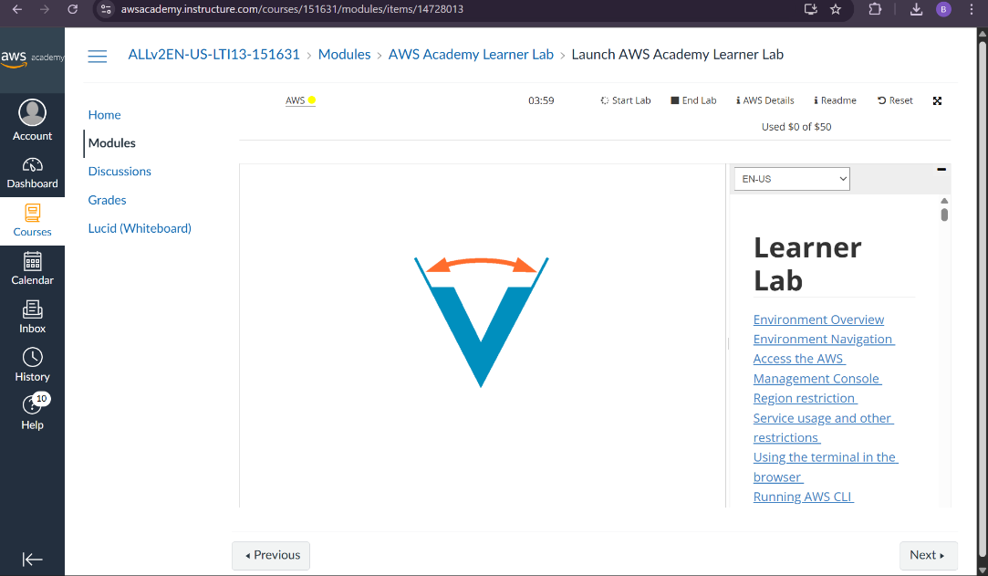
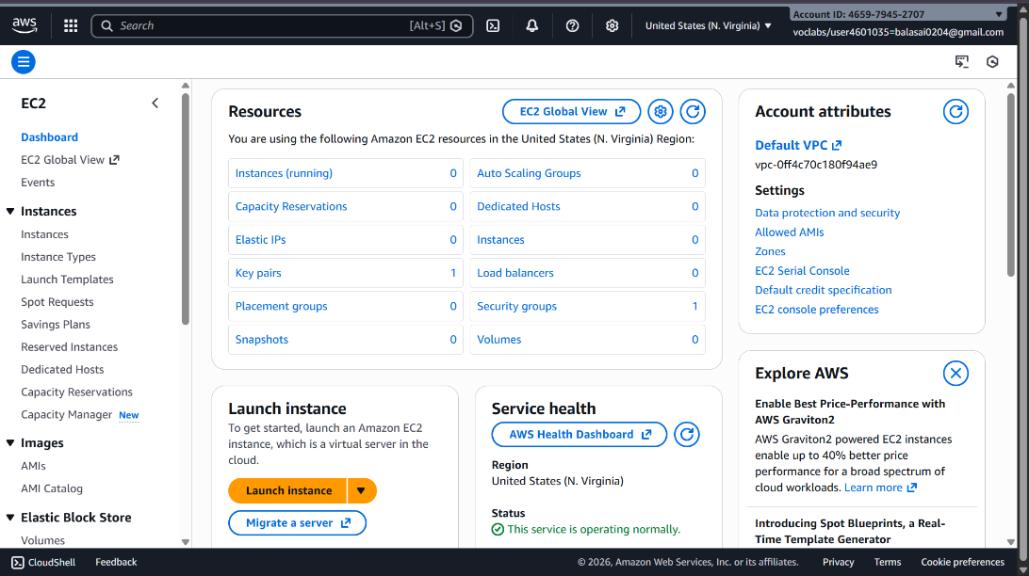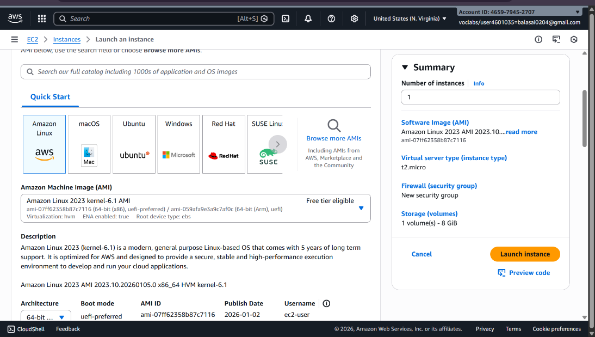

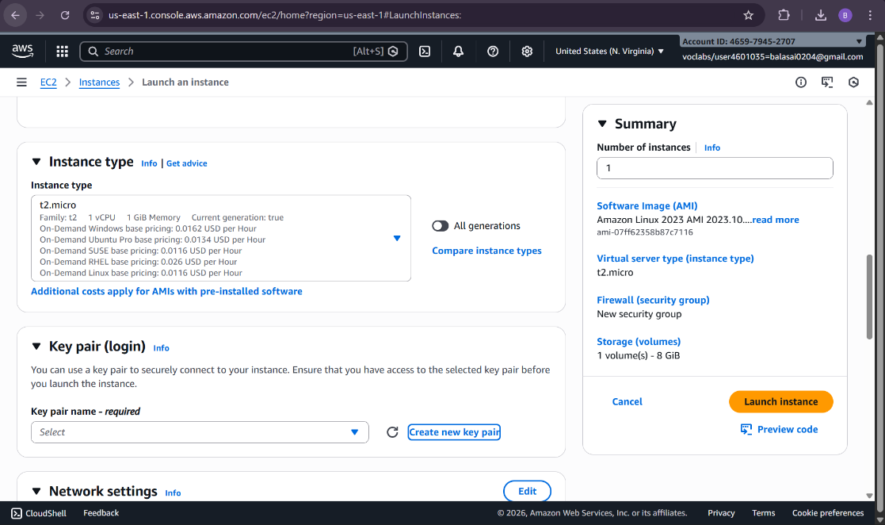
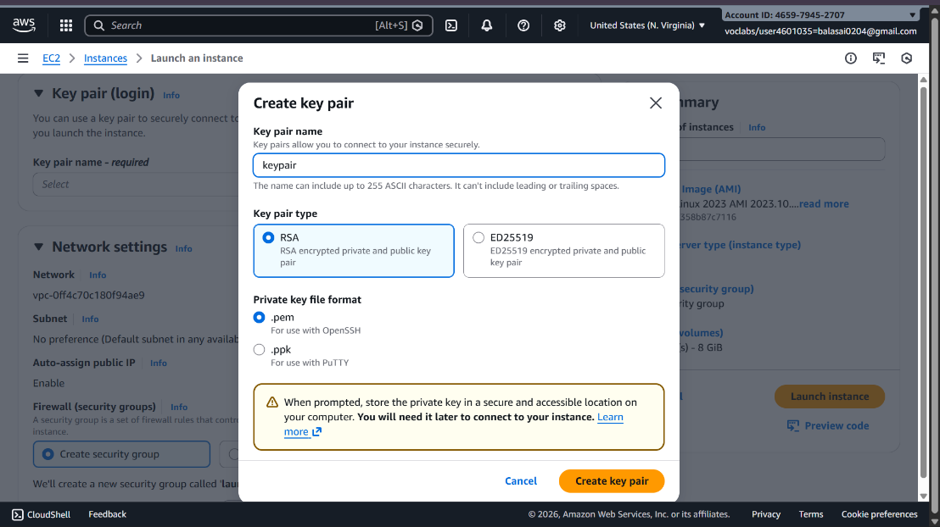
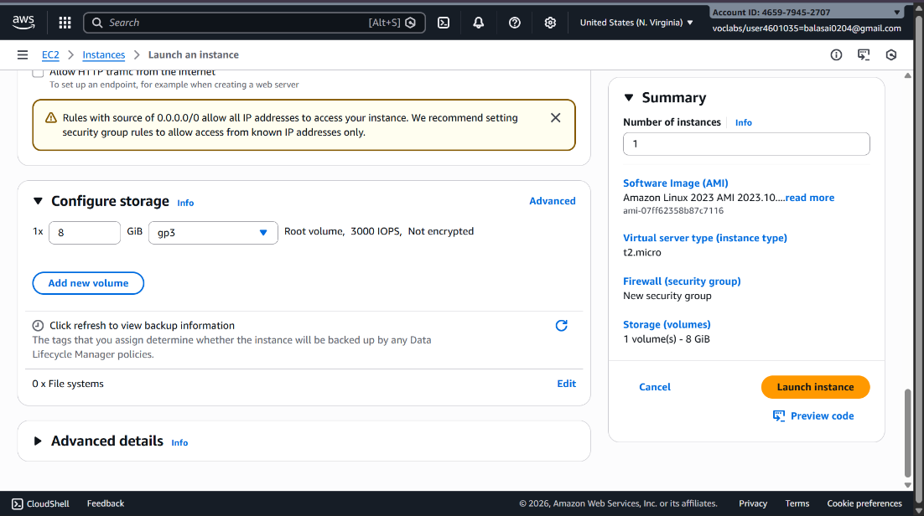

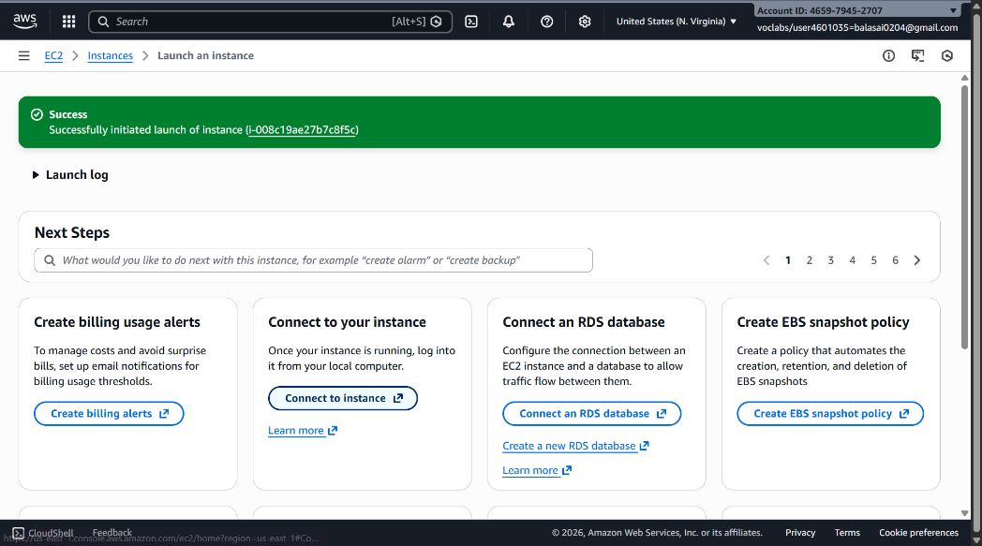
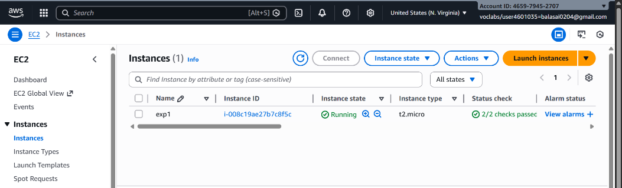
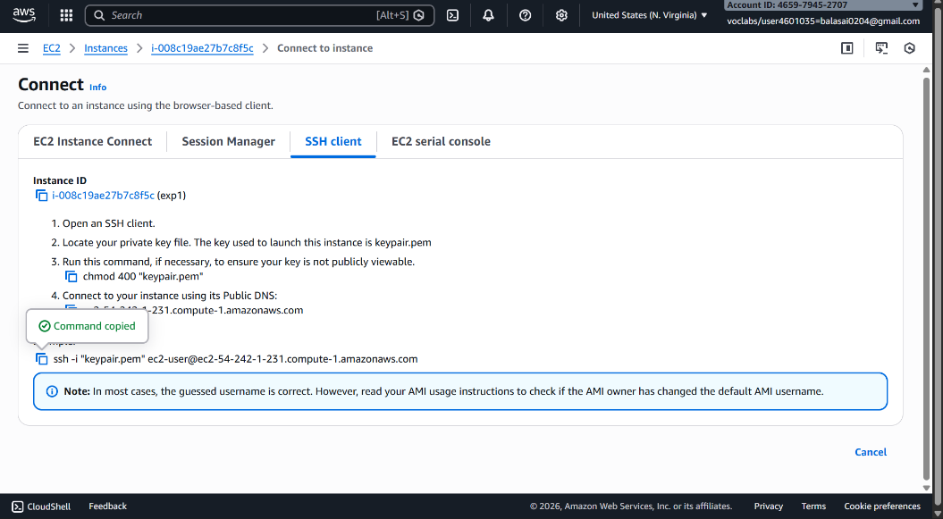
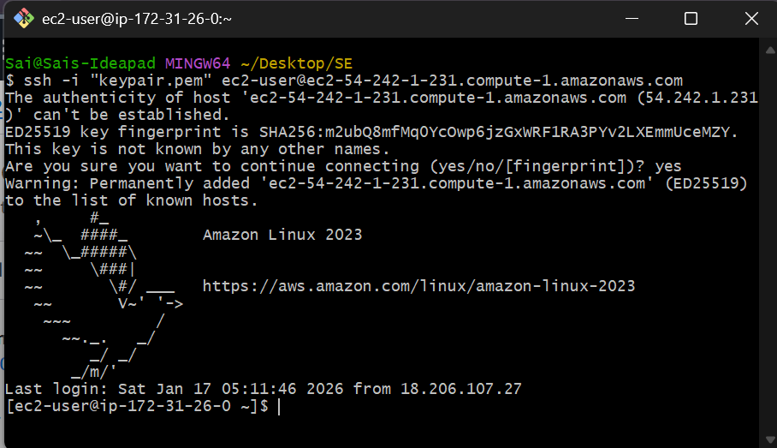

EC2 - with Putty
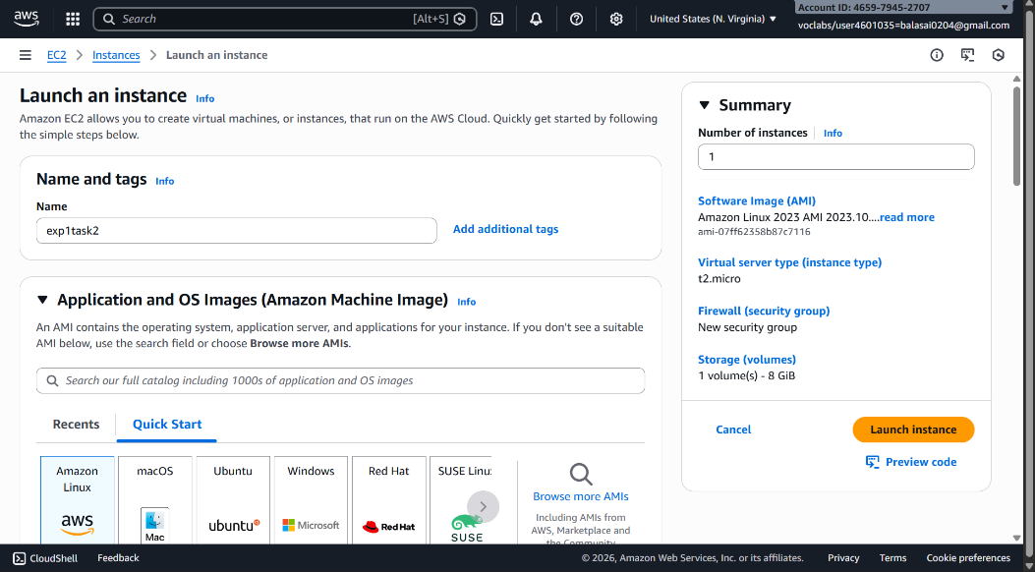
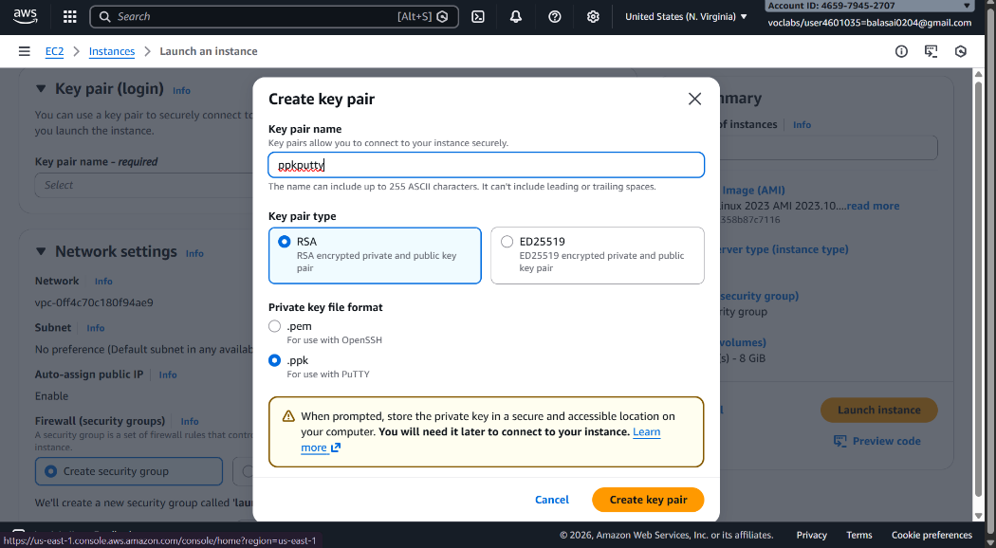
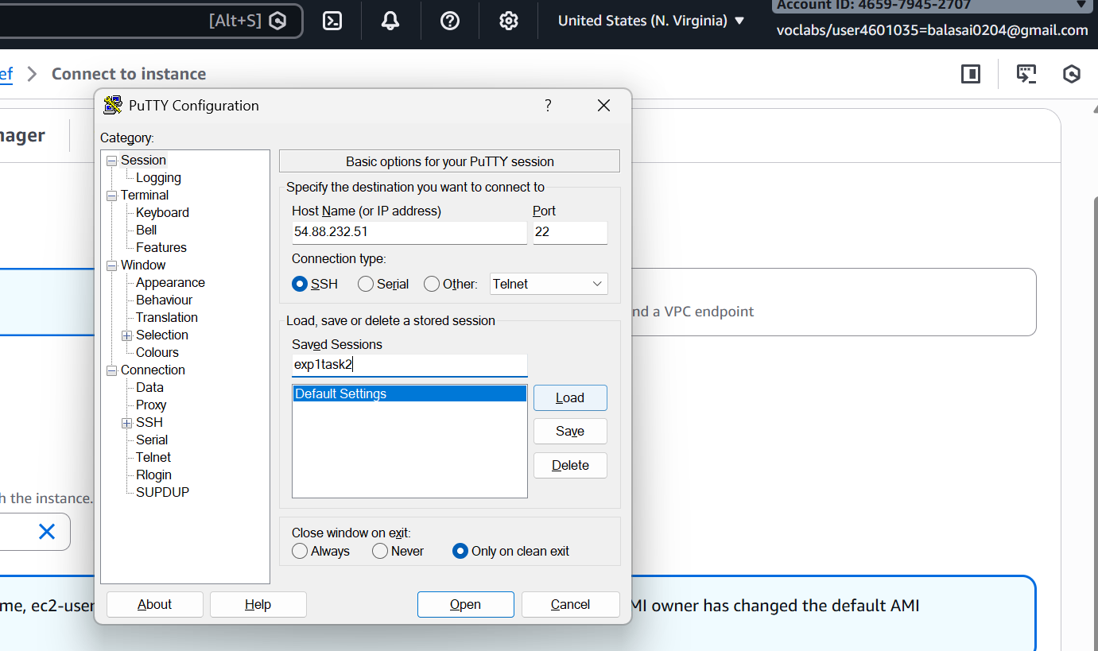

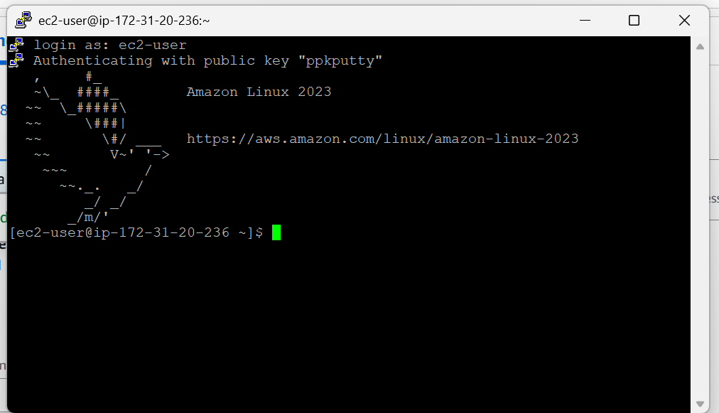

EC2 with RDP

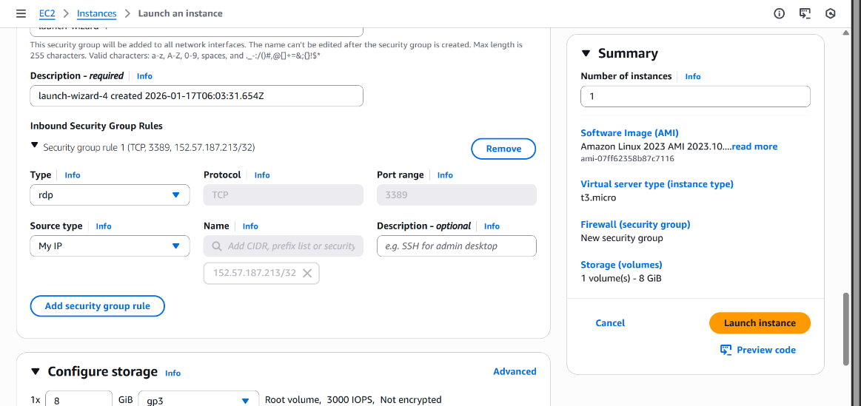

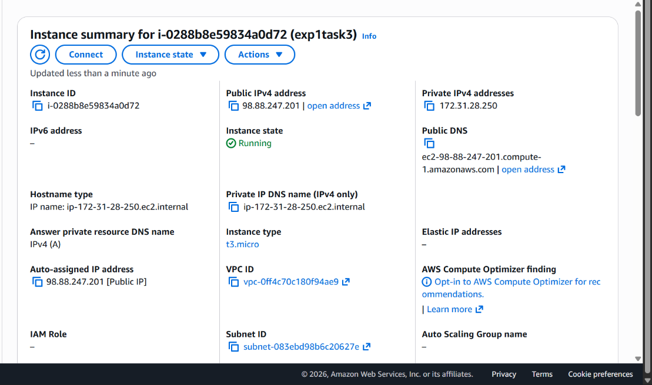
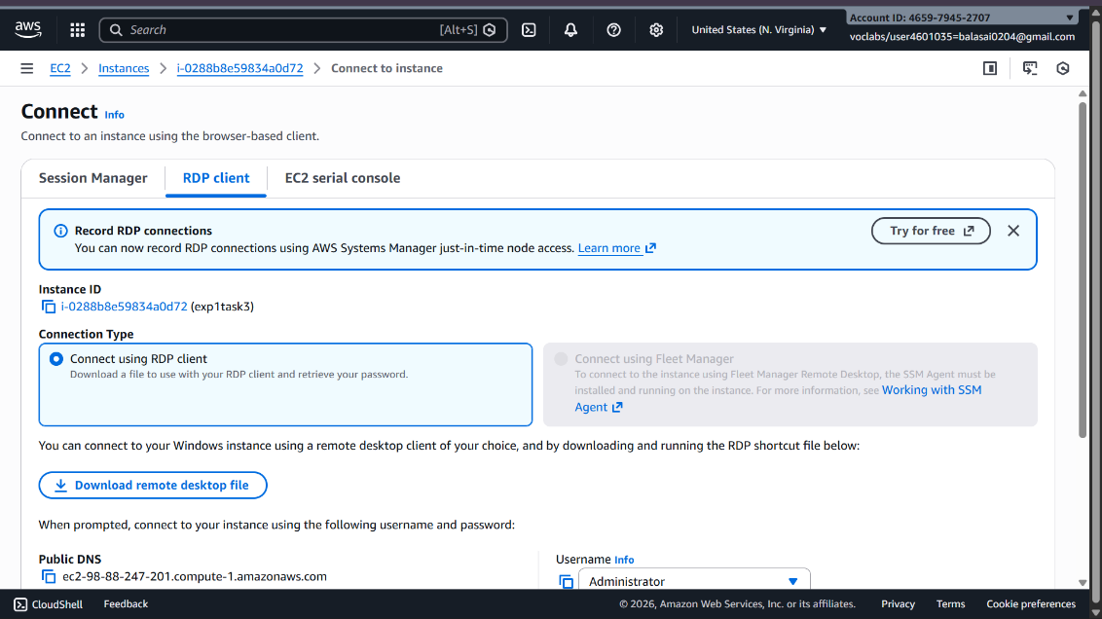
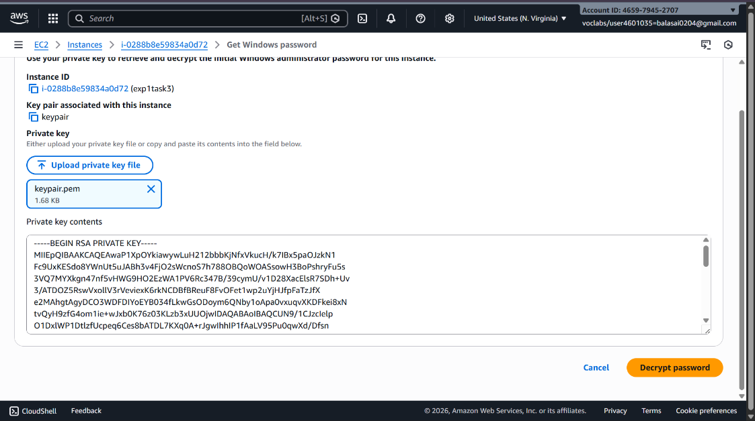

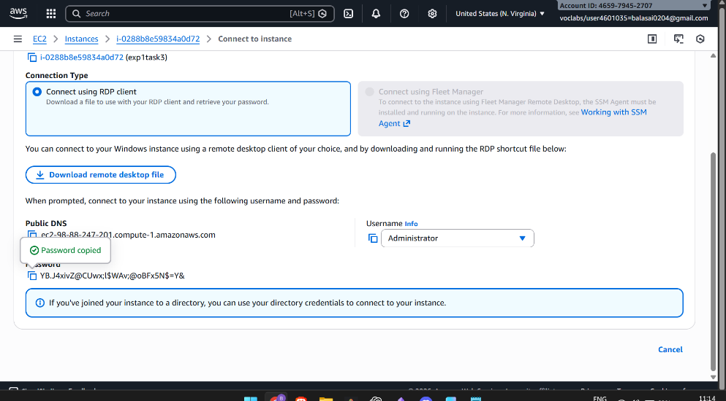
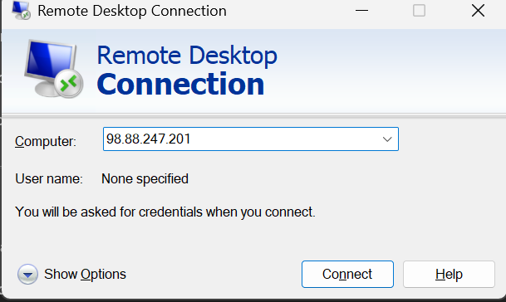
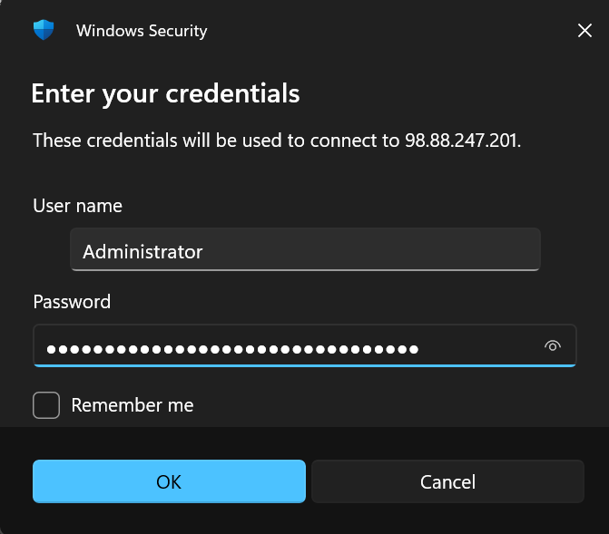

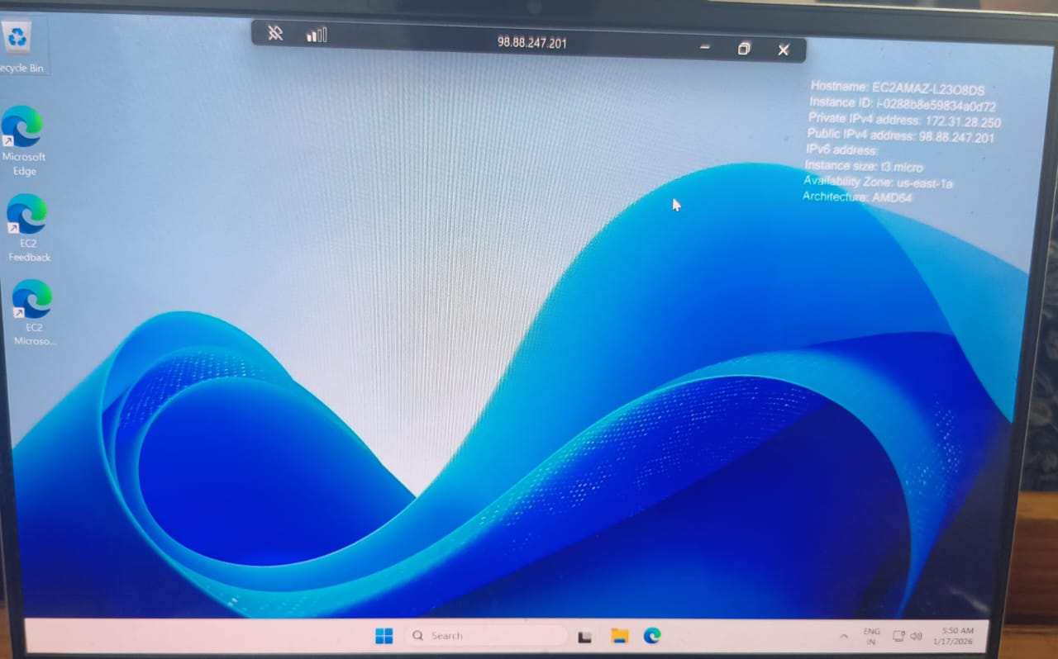

Viva Questions
WEEK 1 – AWS & EC2 BASICS
1. What is AWS?
Answer:
Amazon Web Services (AWS) is a cloud computing platform that provides on-demand IT resources such as servers, storage, databases, networking, and security over the internet on a pay-as-you-go basis.

2. What are the key components of an EC2 instance?
Answer:
Key components of an Amazon EC2 instance are:
- AMI (Amazon Machine Image) – OS + software template
- Instance Type – CPU, RAM, network capacity
- EBS Volumes – storage disks
- Security Groups – virtual firewall

3. How does EC2 work?
Answer:
- You select an AMI
- Choose an instance type
- Configure networking & security
- Attach EBS storage
- Launch → AWS provisions a virtual server
- You access it via SSH / RDP

4. What are the uses, advantages, and examples of EC2?
Answer:
Uses
- Hosting websites
- Running applications
Advantages
- Scalable
- Pay only for usage
Examples
- Hosting a Node.js backend
- Running a database server

