Elastic File Storage
Amazon Elastic File System (EFS) is a scalable and fully managed file storage service provided by Amazon Web Services (AWS). It allows you to create and configure file systems that can be accessed concurrently from multiple EC2 instances, providing a highly available and scalable storage solution for your applications and workloads.
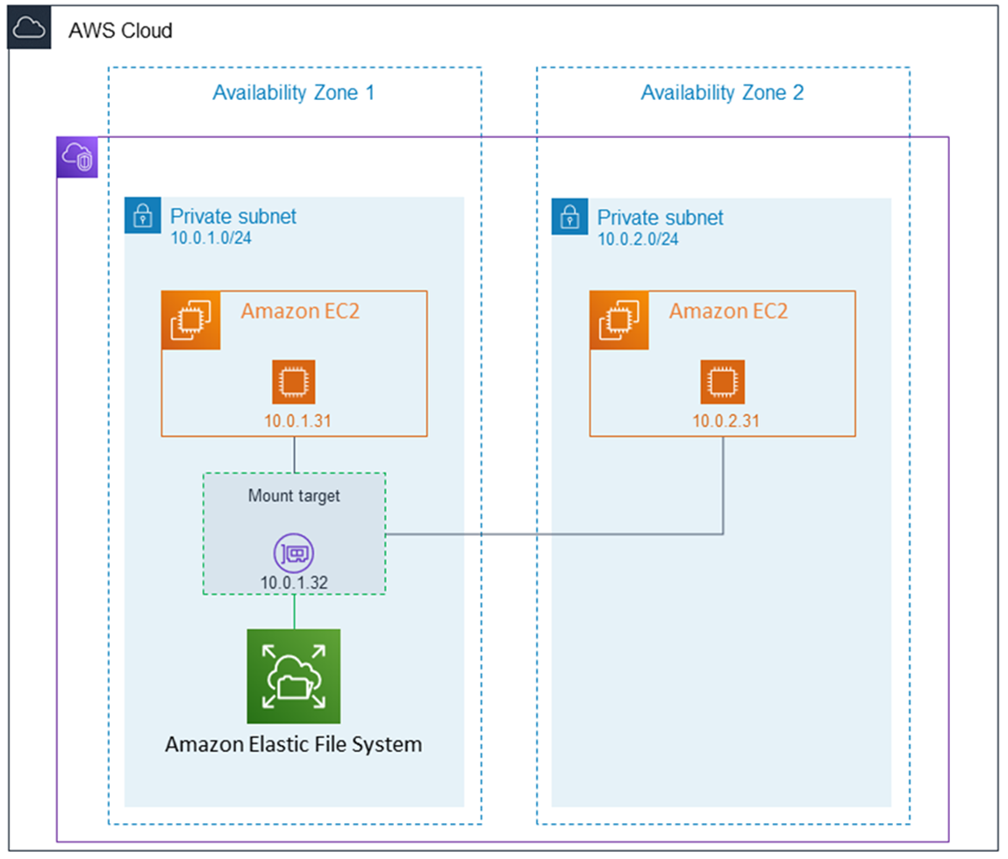
Amazon EFS supports for only Amazon Linux instance:
Step 1: Launching EC2 Instances
1. Sign in to AWS Management Console.
2. Go to the EC2 dashboard.
3. Click on "Launch Instance".
4. Configure instance details:
- Instance Name: EFS-1
5. Choose an Amazon Machine Image (AMI) for Linux.
6. Select instance type: t2.micro.
- Key Pair: EFS
- Network: Choose Subnet-1a
- Security Group: Create a new security group (SG) and add NFS and allow from anywhere.
7. Launch the instance.
8. Repeat the above steps to launch another instance named EFS-2 in Subnet-1b with the same configuration.
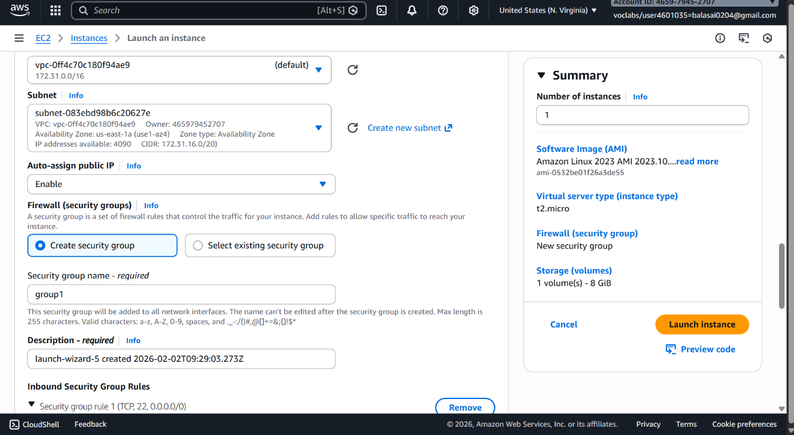
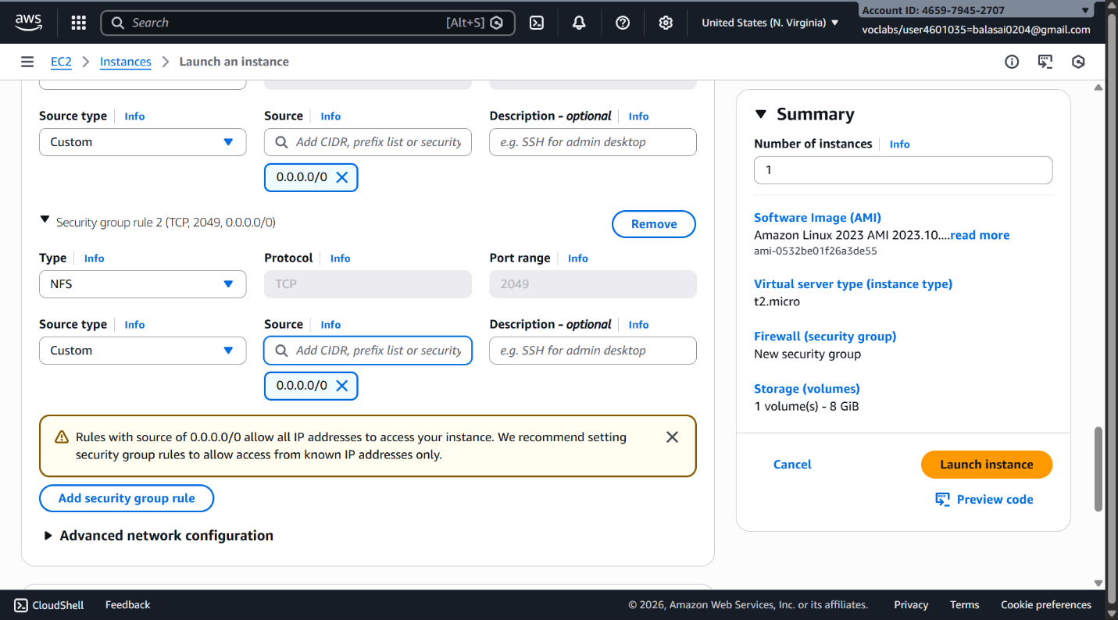
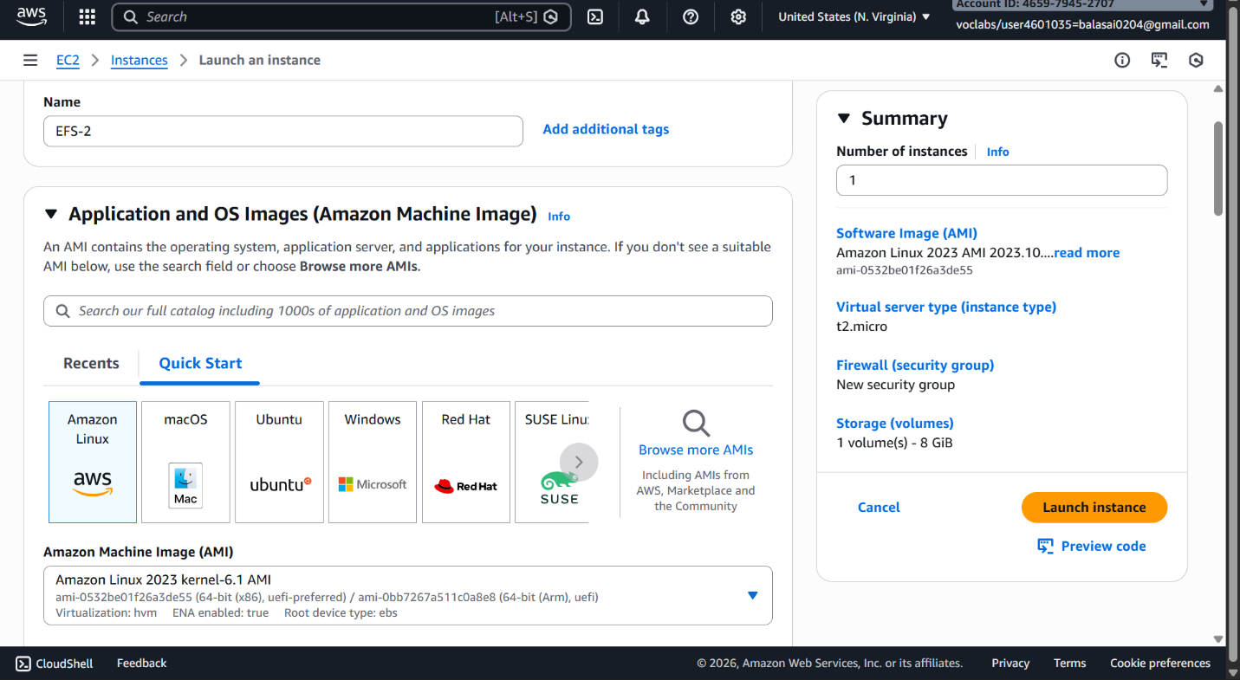
Step 2: Creating an EFS File System
1. Go to the EFS service in the AWS Management Console.
2. Click on "Create file system".
3. Specify details:
- Name: Optional
- VPC: Default
- Enable region button.
Click on "Next".
4. In the Network settings:
- Delete all security groups.
- Select the newly created security group (NFS).---which is created while creating instance
Click on "Next" and review the configuration.
Click on "Create file system".
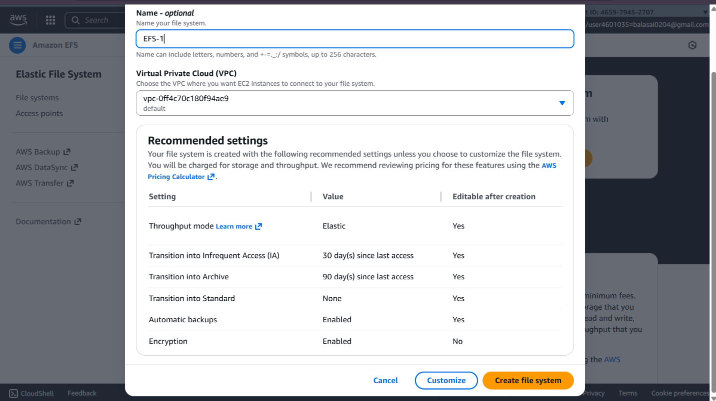
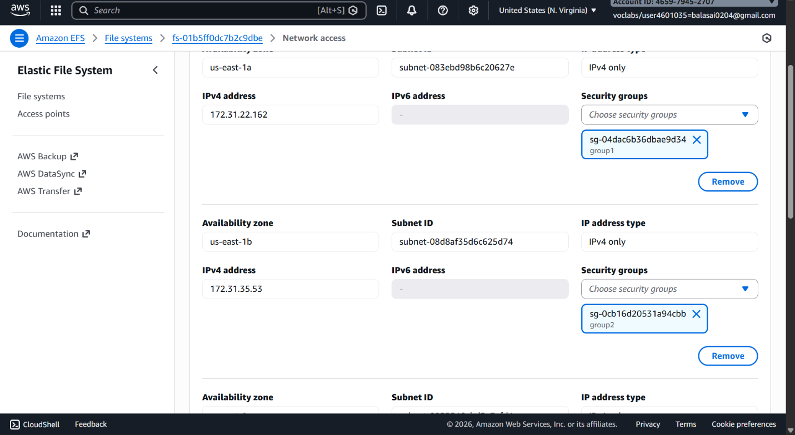
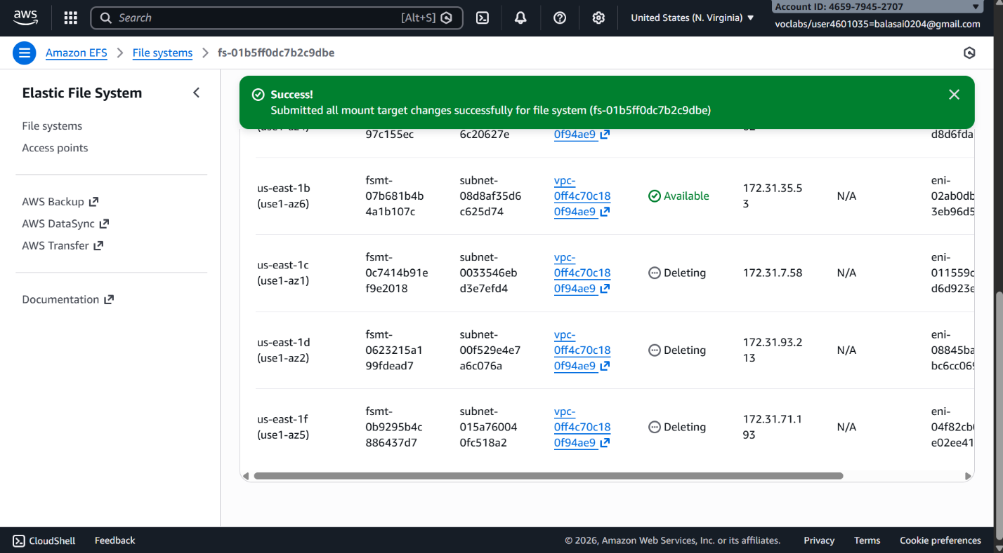
Step 3: Accessing the two EC2 instances named EFS-1 & EFS -2 in two different PowerShell sessions and performing the specified tasks:
Accessing EFS-1 Instances in Two Different PowerShell Sessions:
1. Open Two PowerShell Sessions:
- Open two separate PowerShell windows or tabs on your local machine.
For each Instance:
2. SSH into the Instance:
- Use the SSH command to connect to the EFS-1 instance
ssh -i [path-to-your-keypair.pem] ec2-user@[instance-public-ip]
3. Switch to Root User:
- Gain root access by executing the following command:
sudo su
4. Create a Directory:
- Make a directory named "efs" using the following command:
mkdir efs
5. Install Amazon EFS Utilities:
- Use yum package manager to install the Amazon EFS utilities:
yum install -y amazon-efs-utils
6. List Files:
- Execute the following command to list files in the current directory:
ls
7. Verify Installation (Optional):
- Optionally, you can verify the installation of the Amazon EFS utilities by checking the version:
efs-utils –version
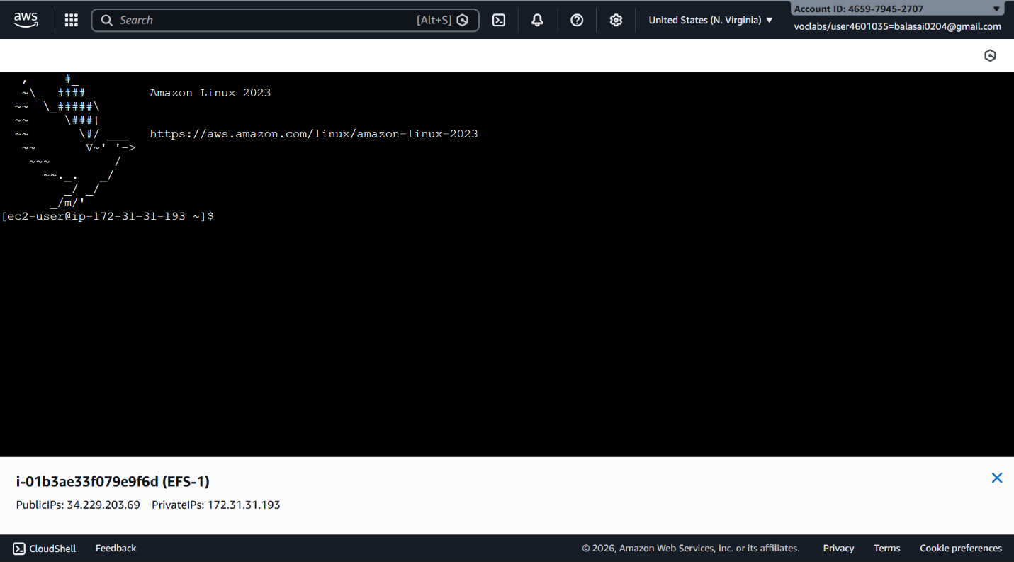
Repeat Steps 2-7 for ------------------------- EFS-2 Instance.
By following these steps, you'll have accessed each EFS-1 instance in separate PowerShell sessions, switched to the root user, created a directory named "efs," installed the Amazon EFS
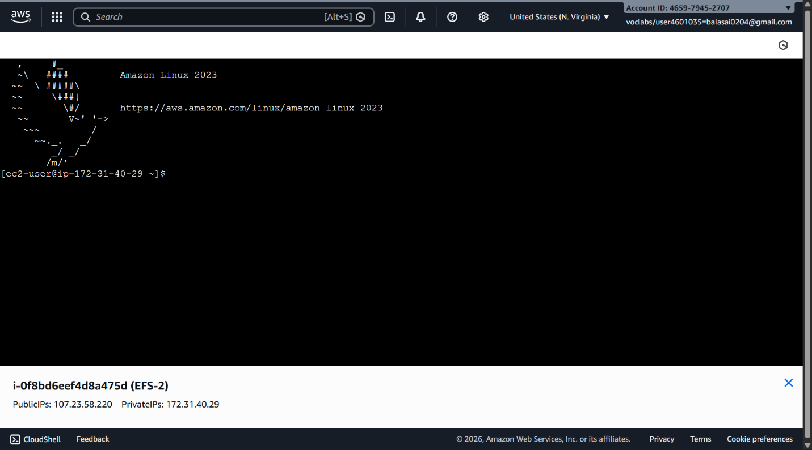
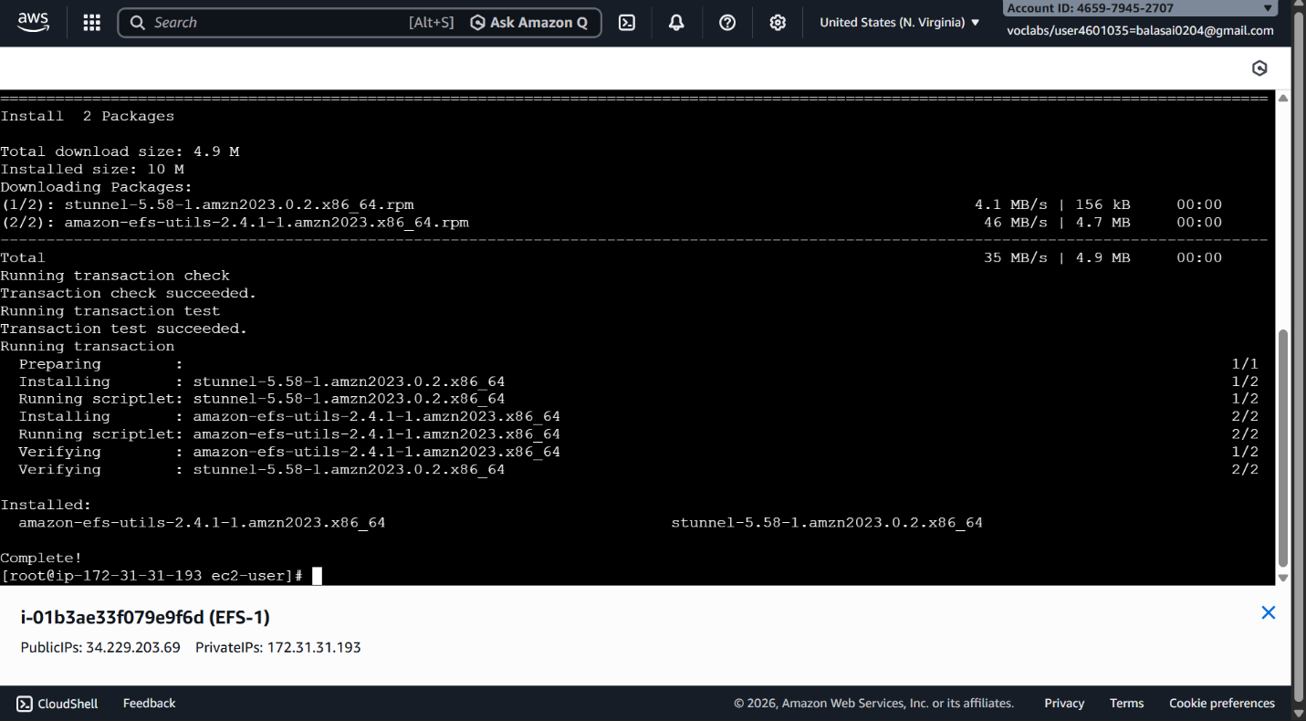
utilities, and listed files in the directory. This setup allows you to configure and manage each instance individually as needed.
Step 4: Attaching EFS to EC2 Instances
1. Go to the EFS service in the AWS Management Console.
2. Click on the target EFS file system.
3. Click on the "Attach" button.
4. Choose "Mount via DNS" option.
5. Copy the displayed command. ,on both ec2 instances(powershell)
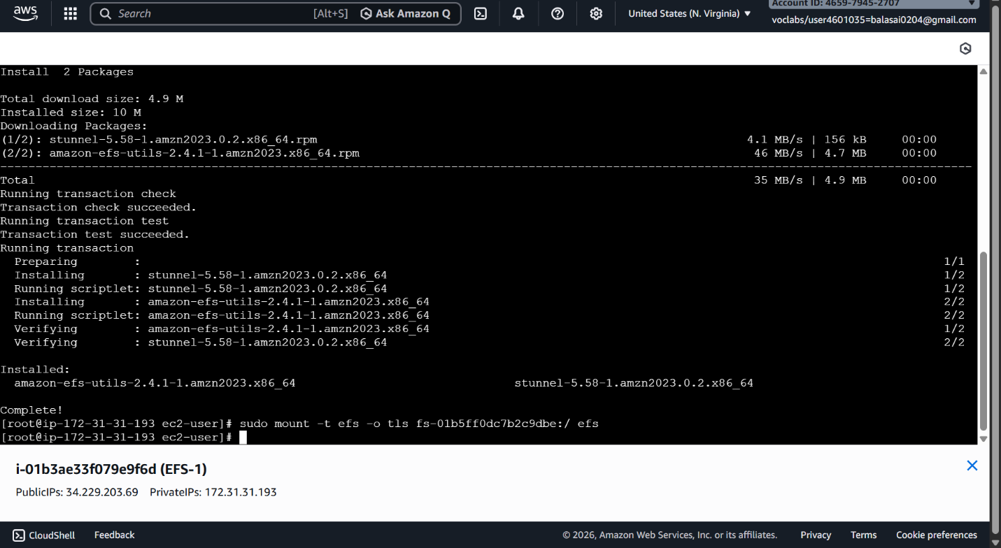
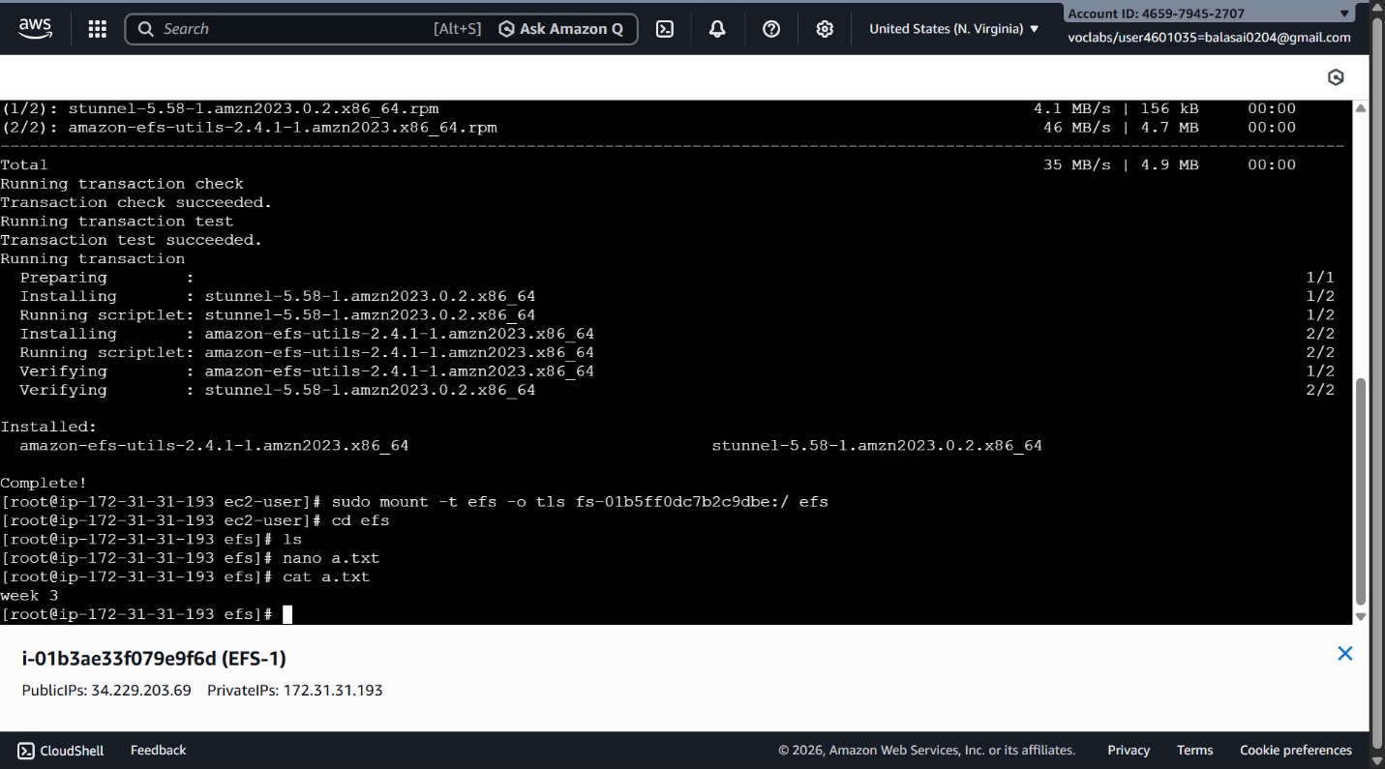
6. Paste and execute the copied command in the terminal to mount the EFS file system onto the instance.
Step 5: Verify and Test EFS
1. Change the directory to EFS on both instances.
2. Create a file on one instance.
3. Verify that the file automatically synchronizes and appears on the other instance.
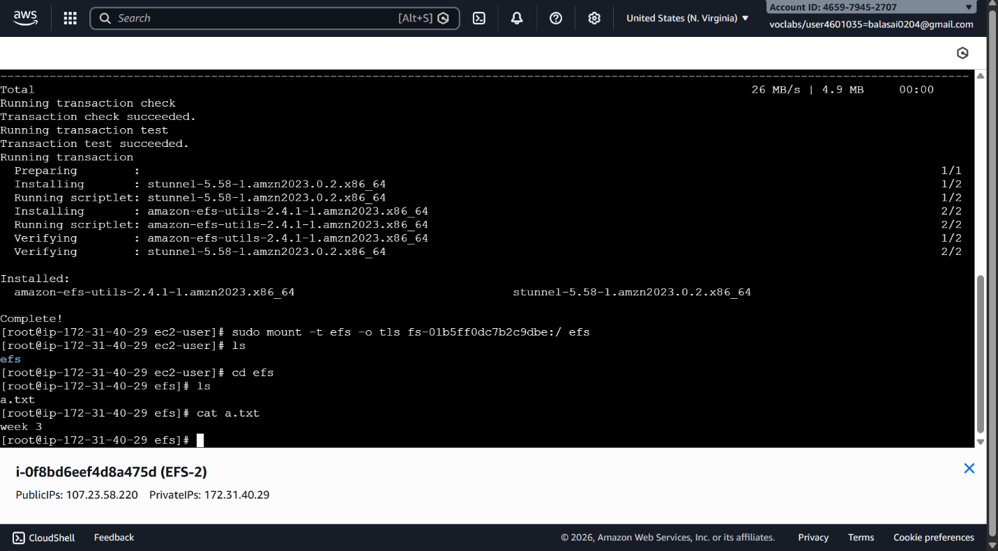

By above steps, we can successfully create EC2 instances, configured them, created an EFS file system, and attached it to the instances in the same availability zone in the Mumbai region. Now, the instances can seamlessly access and share files stored in the EFS file system.

Viva Questions
What is Elastic File Storage (EFS)?
Answer:
Amazon EFS is a fully managed, scalable, shared file system that allows multiple EC2 instances to read/write data simultaneously using NFS.

Scenario-Based Questions
1. Multiple EC2s across AZs need shared access. Which service and why?
Answer:
- EFS
- Supports multi-AZ, concurrent access

2. App in 3 AZs needs shared storage with low overhead. How does EFS help?
Answer:
- Auto-scaling storage
- No capacity planning
- Highly available across AZs

3. Can two EC2s modify the same file at once?
Answer:
- ✅ Yes
- EFS supports file locking via NFS

4. EFS mount timed out. What do you check first?
Answer:
- Security Groups (port 2049)
- Mount targets
- VPC networking

5. EC2 in private subnet cannot mount EFS. What’s missing?
Answer:
- EFS mount target in that AZ/subnet
- Proper route tables

6. No mount targets in some AZs. What happens?
Answer:
- EC2s in those AZs cannot access EFS

7. Why mount targets per AZ? What if one AZ fails?
Answer:
- Reduces latency
- If one AZ fails, others still access EFS

8. Two apps in different subnets need EFS access. How to configure?
Answer:
- Same VPC (or peered)
- Allow NFS (2049) in security groups

9. Restrict EFS access to specific EC2s
Answer:
- Use security groups
- Allow only required EC2 SGs

10. Why does EFS use NFS (-t nfs4)?
Answer:
- Standard file system protocol
- Supports concurrent access & locking

11. Why migrate from EBS to EFS?
Answer:
- EBS allows single-instance attachment
- EFS supports multi-instance access

12. High latency accessing EFS. What to check?
Answer:
- EC2 and EFS in same AZ?
- Network bandwidth
- Mount target placement

13. Can EFS be accessed from another VPC?
Answer:
Yes, using:
- VPC Peering
- Transit Gateway

