Week 5: VPC Creation and Ec2 Instance Connection

🔹 Step 1: Create the VPC
- Go to AWS Management Console → VPC
- Click Create VPC
- Choose VPC only
- Enter:
  - Name: Custom-VPC
  - IPv4 CIDR block: e.g. 10.0.0.0/16
- Click Create VPC
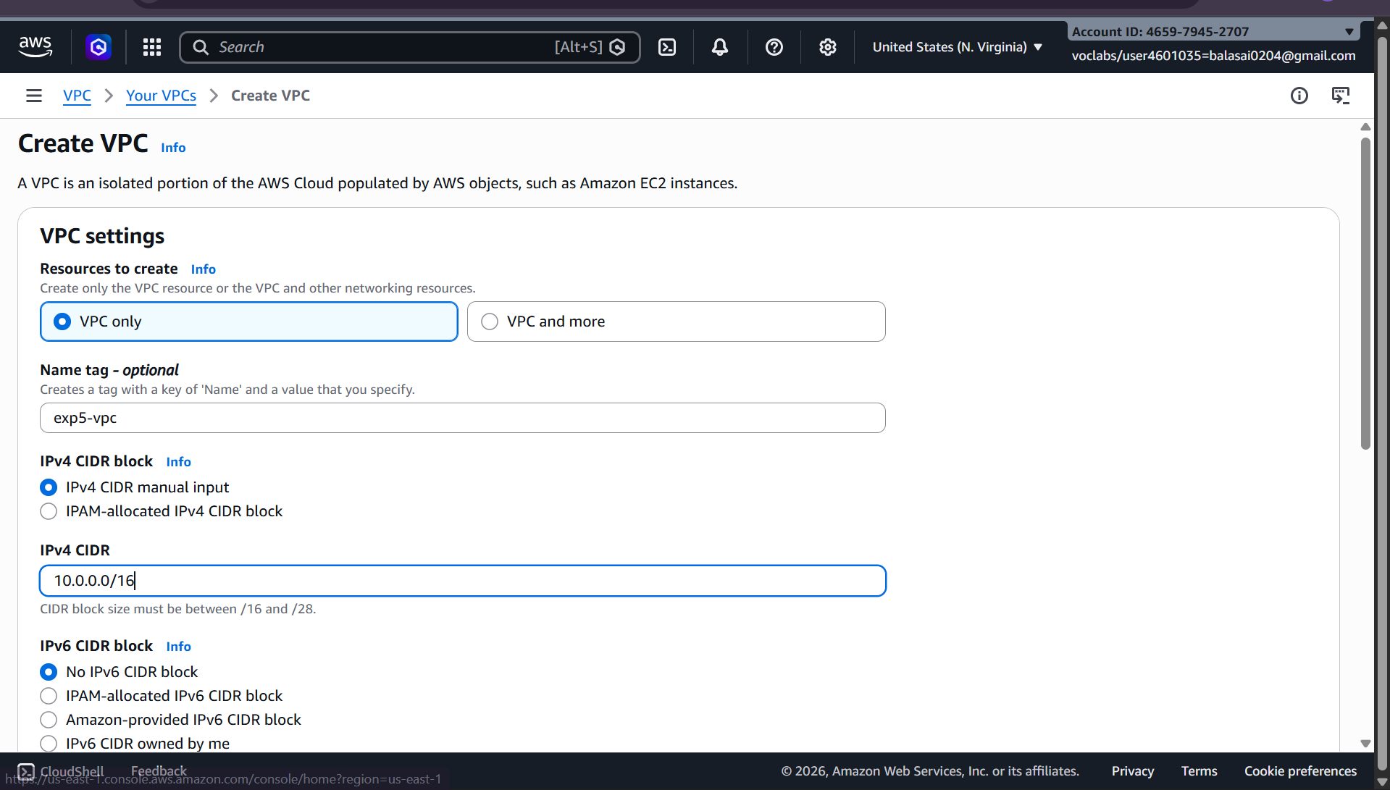

🔹 Step 2: Create Subnets (Public & Private)
Create subnets in same Availability Zones for high availability.

Example:
- Public Subnet: 10.0.1.0/24 (AZ-A)
- Private Subnet: 10.0.2.0/24 (AZ-A)

Public subnet
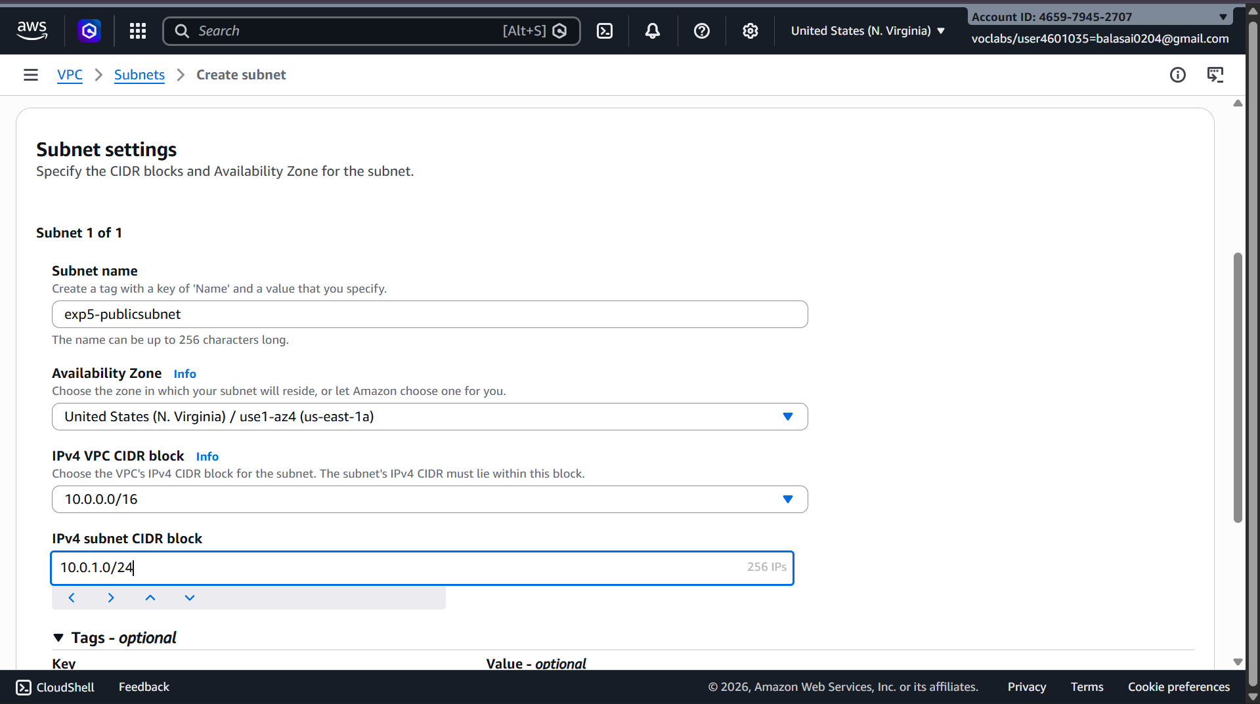
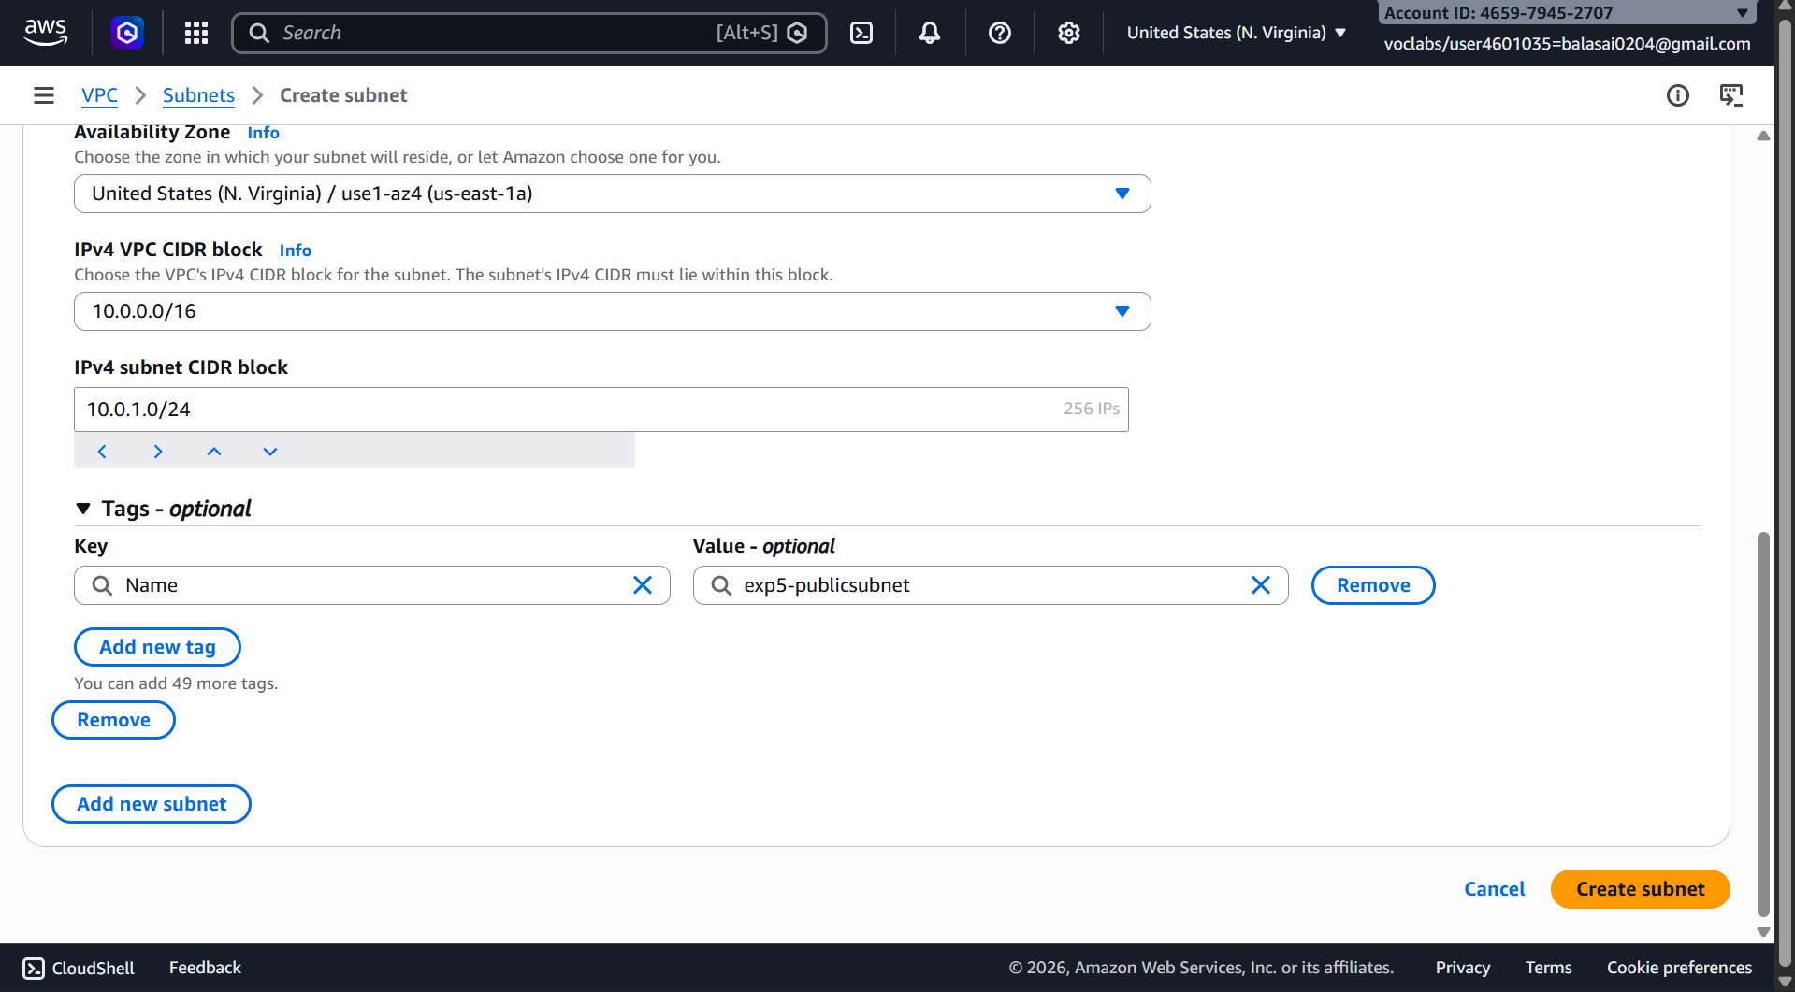
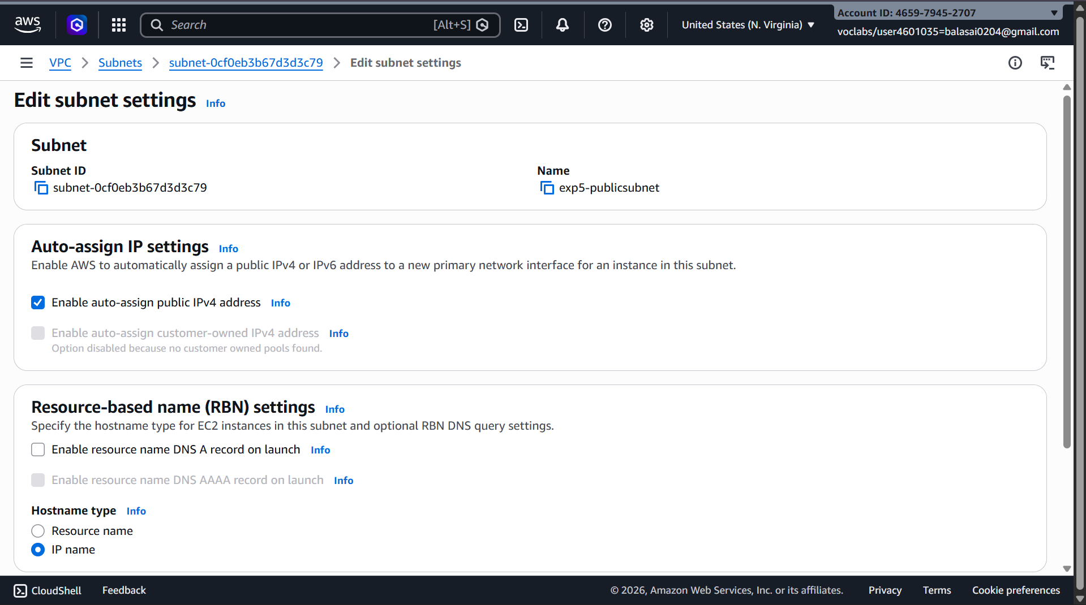

Private subnet
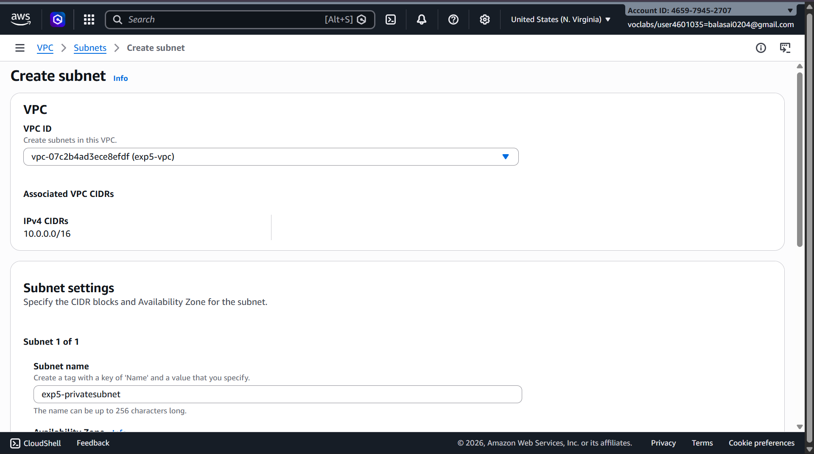
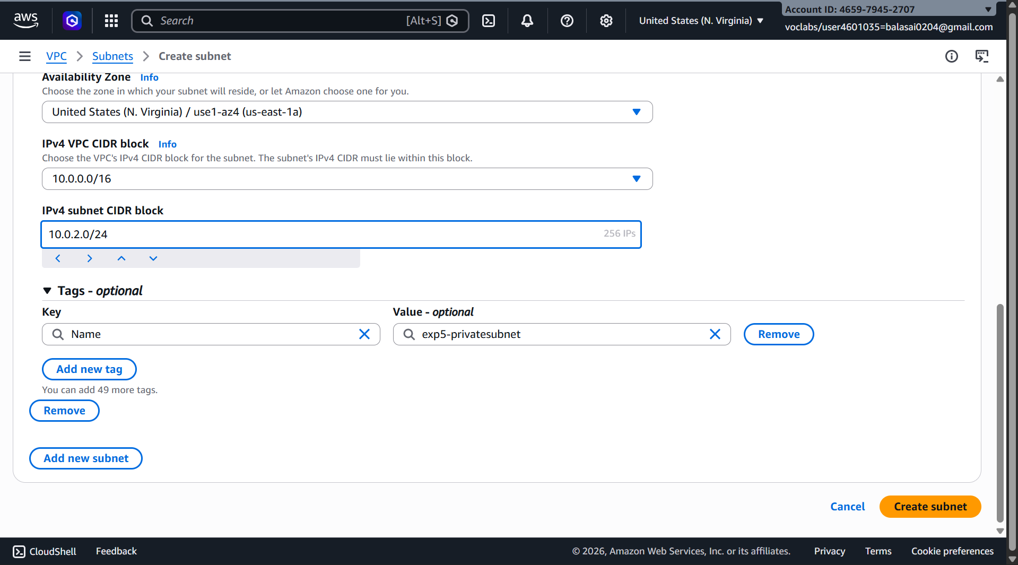

Steps:
- Go to Subnets → Create subnet
- Select your VPC
- Choose AZ
- Enter CIDR
- Create subnet

🔹 Step 3: Create an Internet Gateway (IGW)
- Go to Internet Gateways
- Click Create internet gateway
- Name it Custom-IGW
- Attach it to your VPC

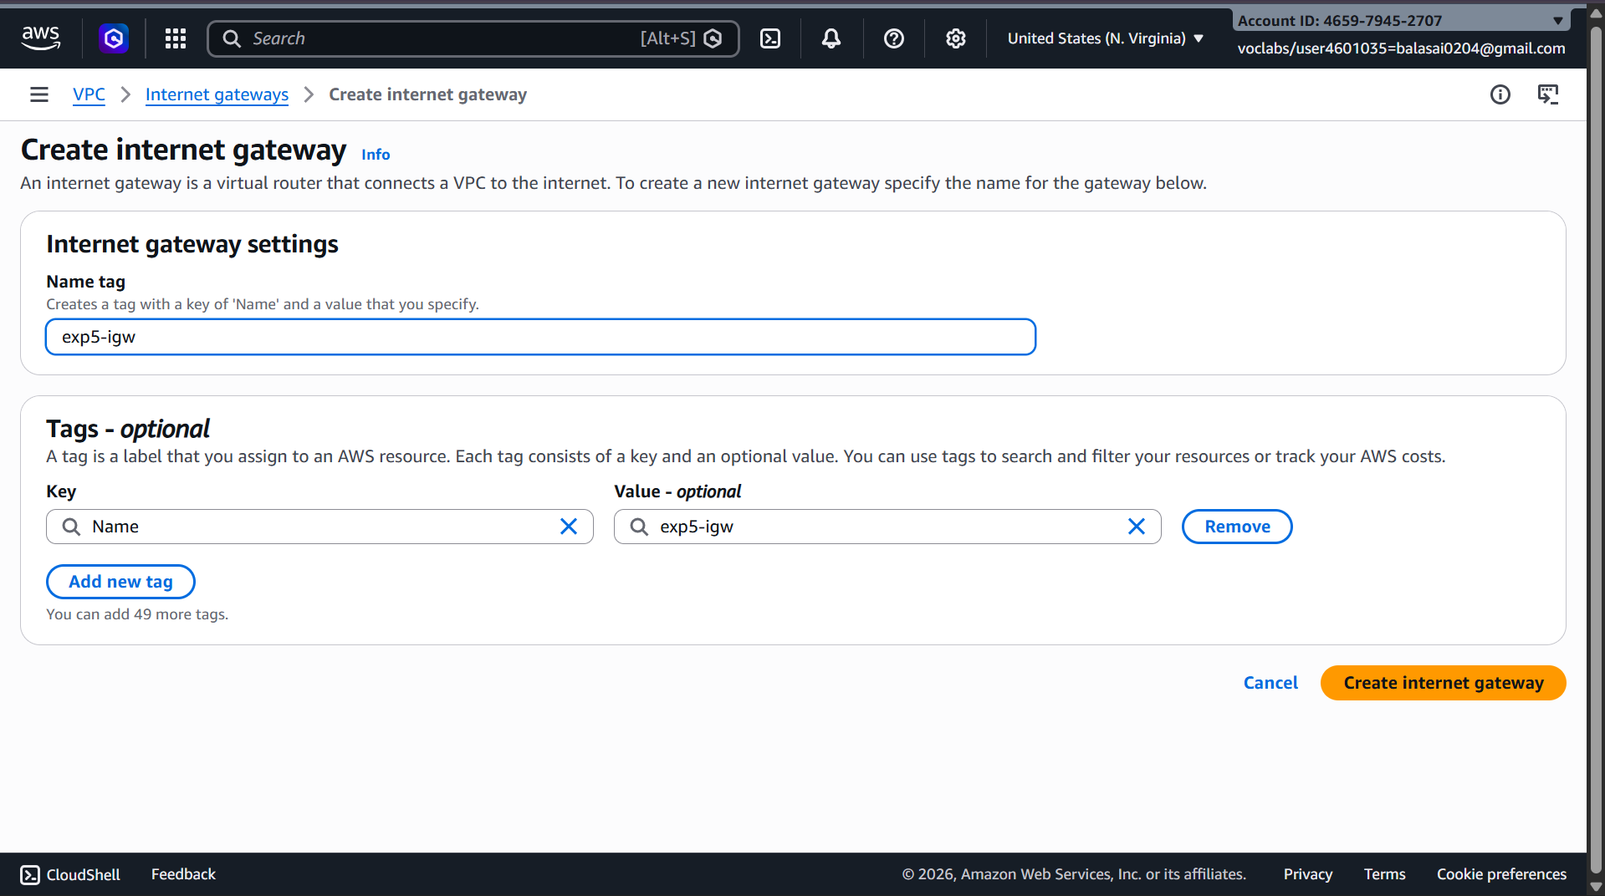

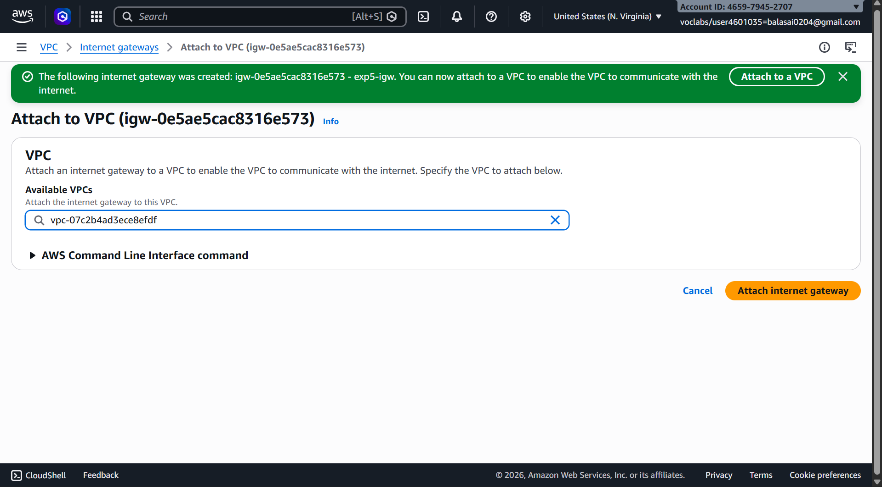

🔹 Step 4: Create Route Tables
You need separate route tables for public and private subnets.

Public Route Table
- Go to Route Tables → Create route table
- Select VPC
- Add route:
  - Destination: 0.0.0.0/0
  - Target: Internet Gateway
- Associate with public subnet
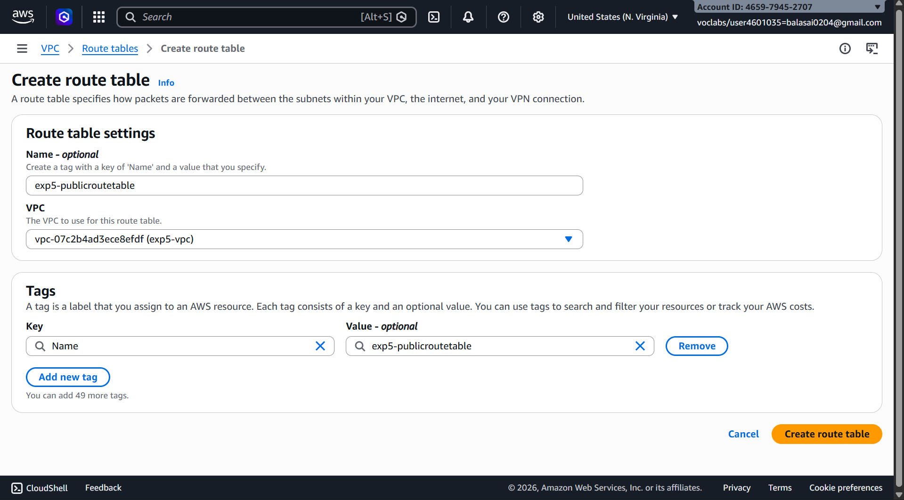
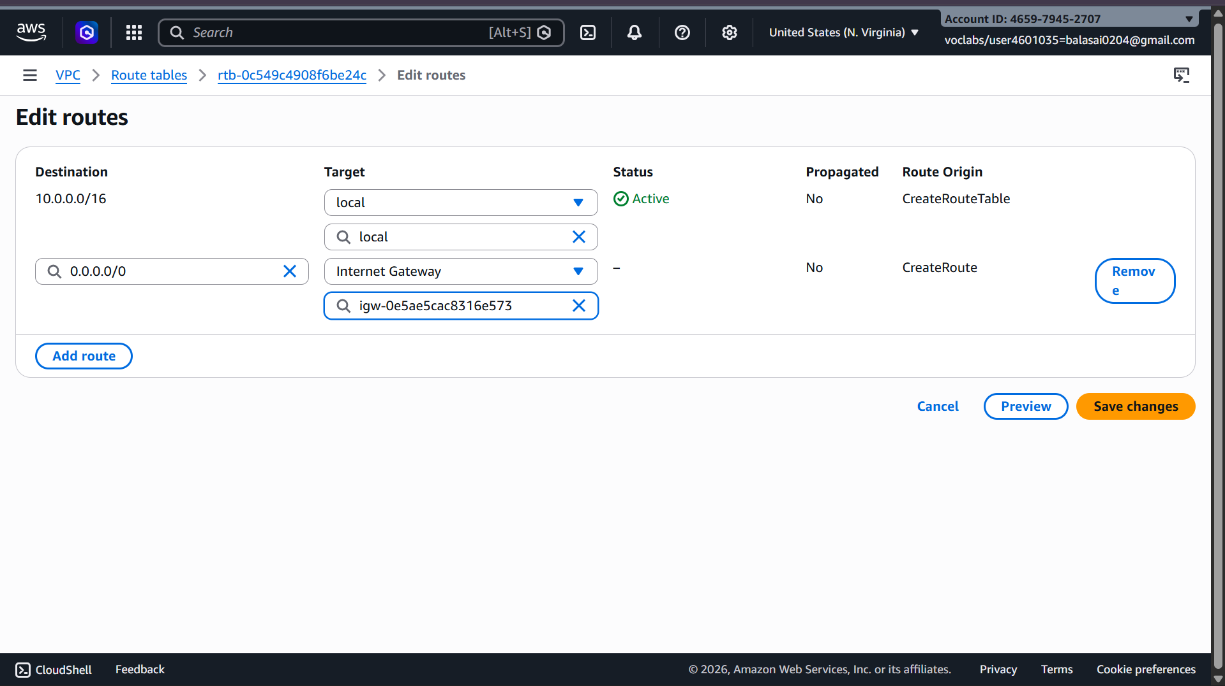
Attach route table
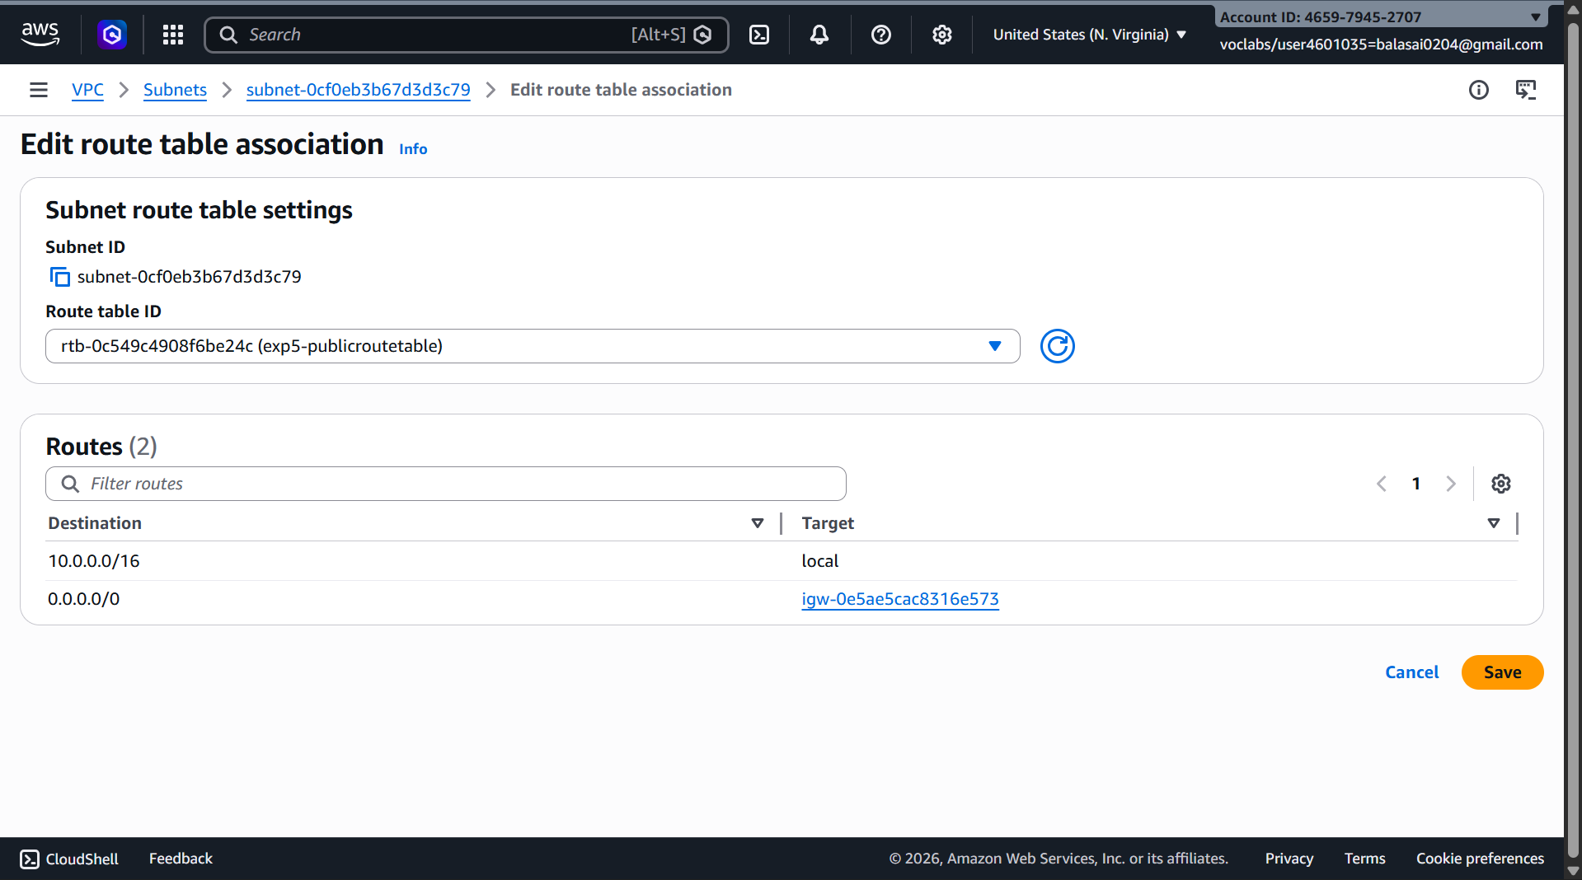

Private Route Table
- Keep default local route only (no IGW)
- Associate with private subnet
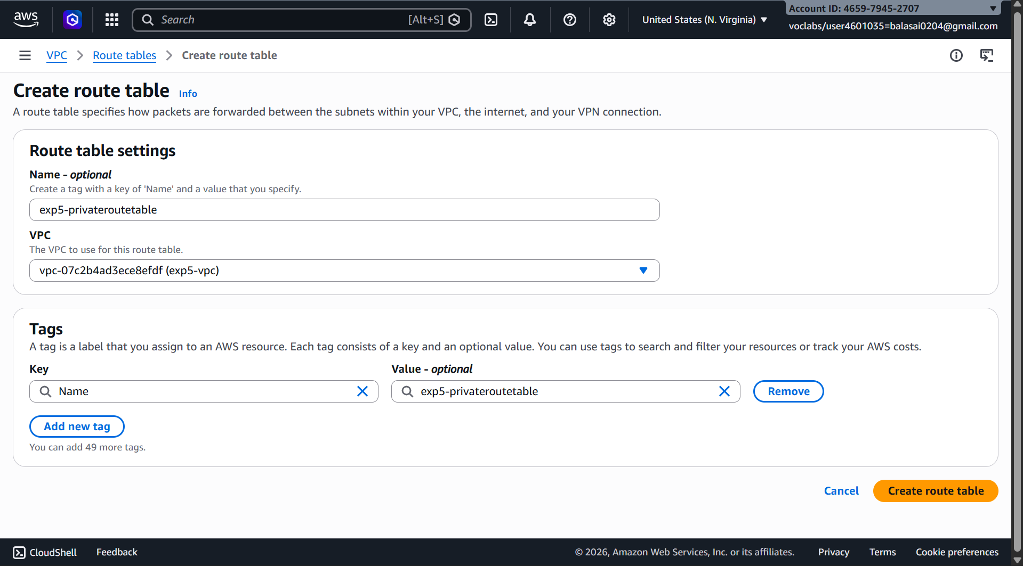
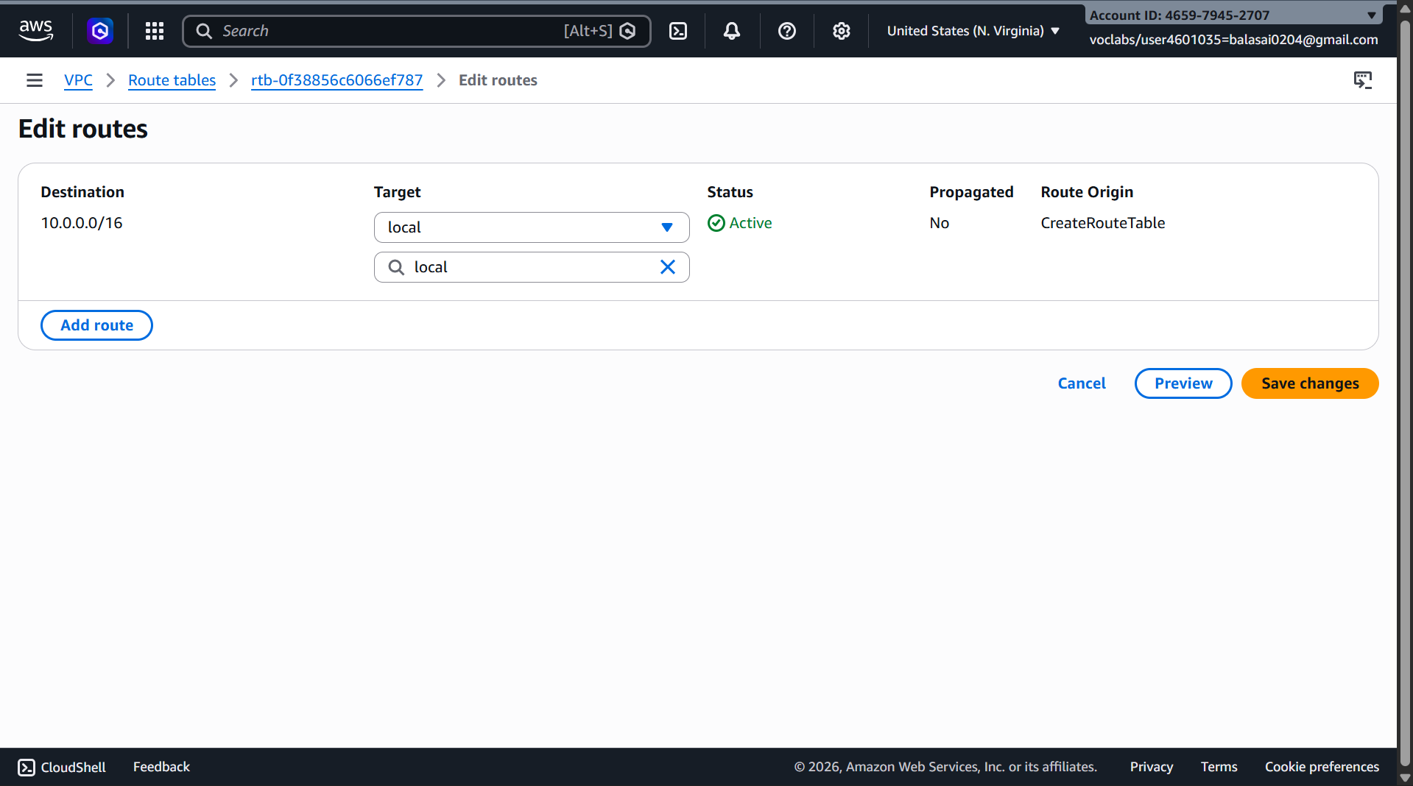

🔹 Step 5: Enable Auto-Assign Public IP (Public Subnet)
- Select Public Subnet
- Go to Edit subnet settings
- Enable Auto-assign public IPv4 address

🔹 Step 6: Configure Security Groups
- Create a Security Group
- Add inbound rules:
  - HTTP (80) / HTTPS (443)
  - SSH (22) from trusted IP
- Attach to EC2 instances
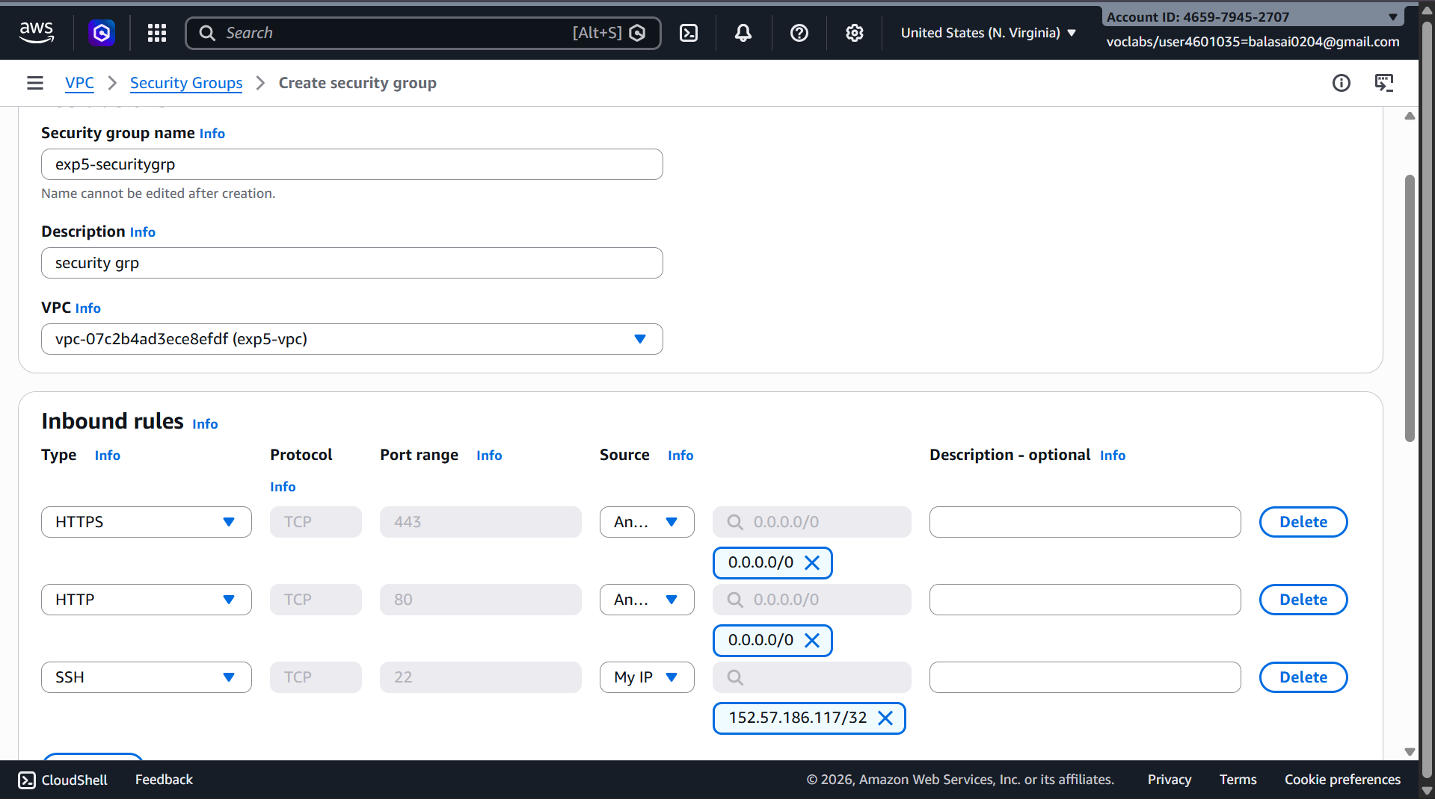

🔹 Step 7: Launch EC2 Instances
- Public EC2 → Public subnet
- Private EC2 → Private subnet –mysql/auroa
Attach correct security groups.

Public subnet ec2
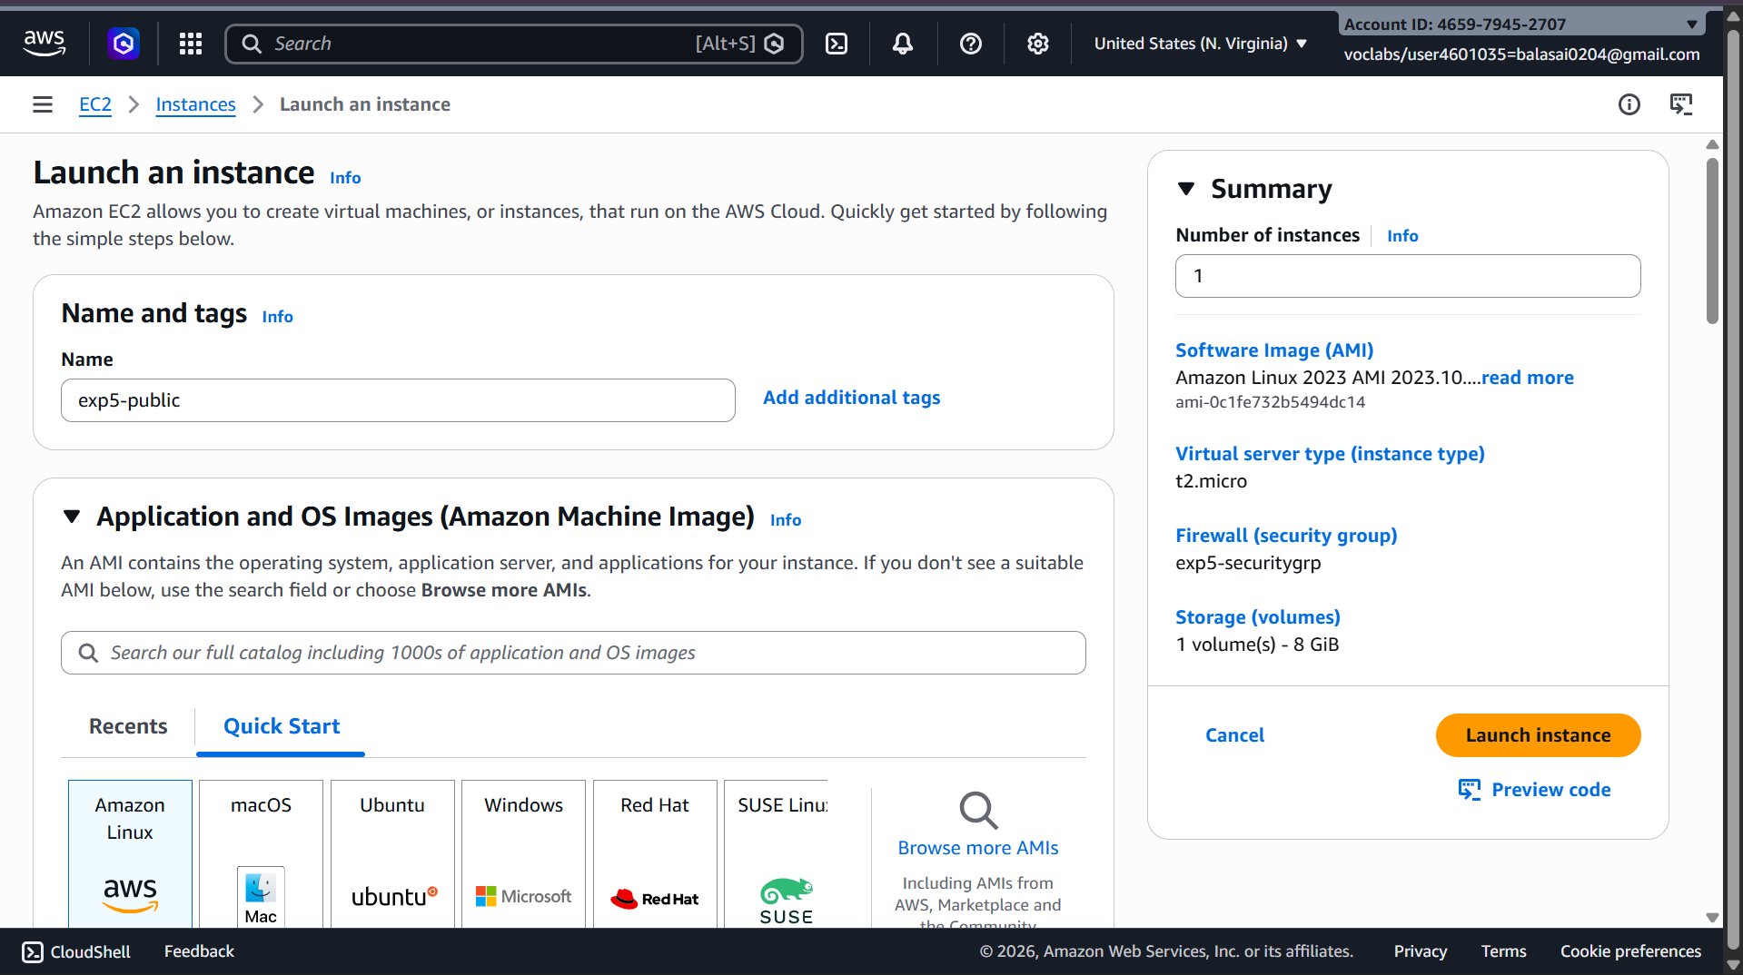
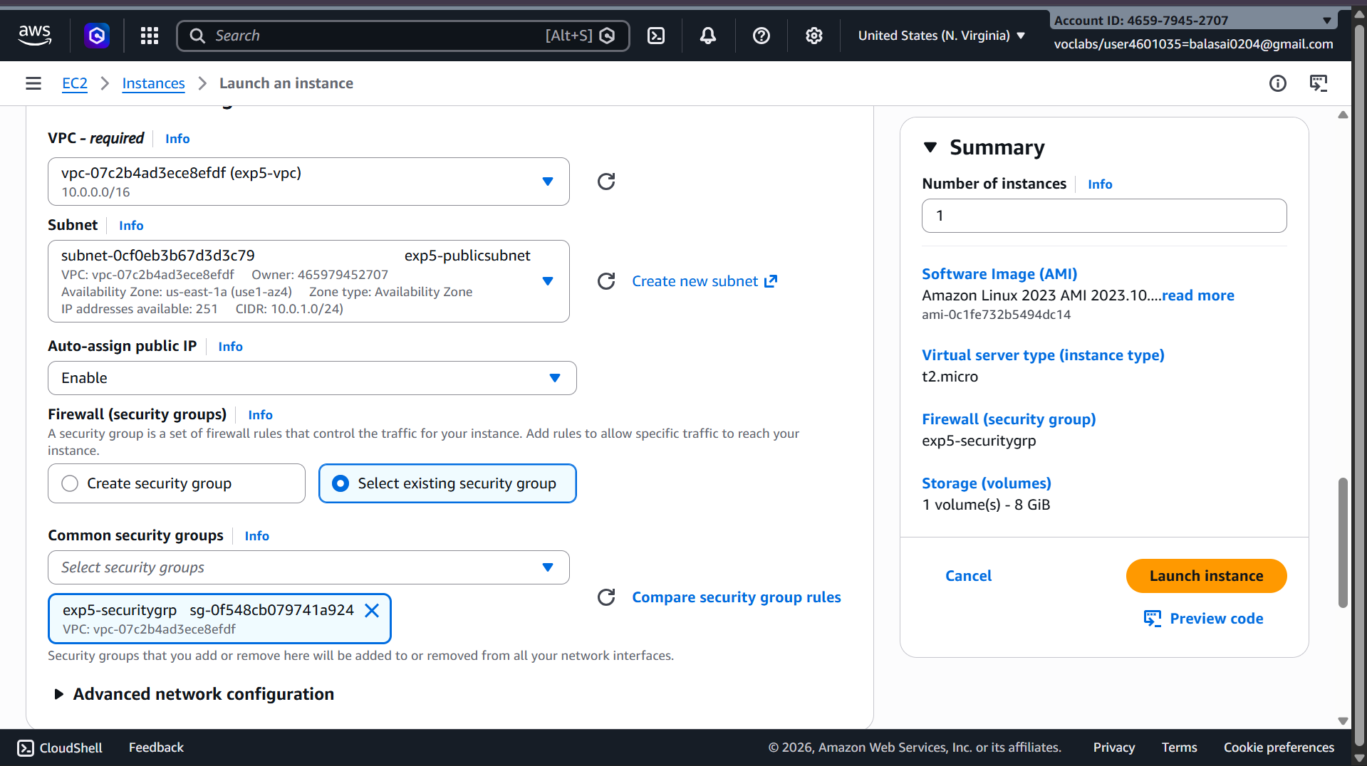

Private subnet ec2

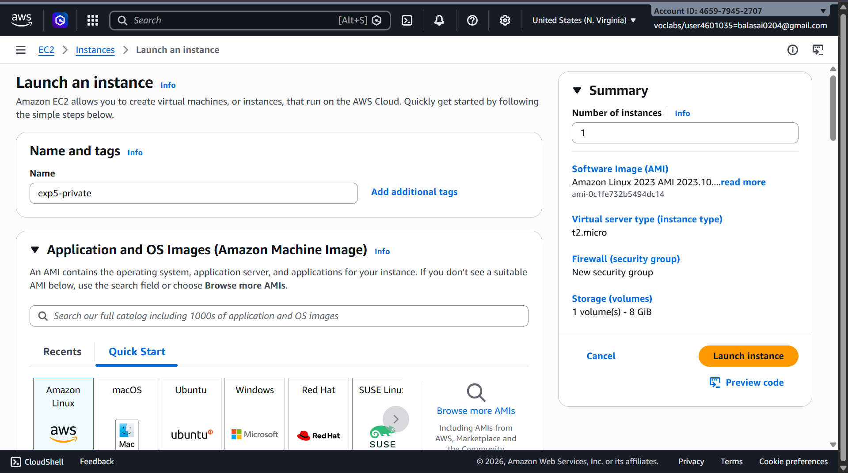

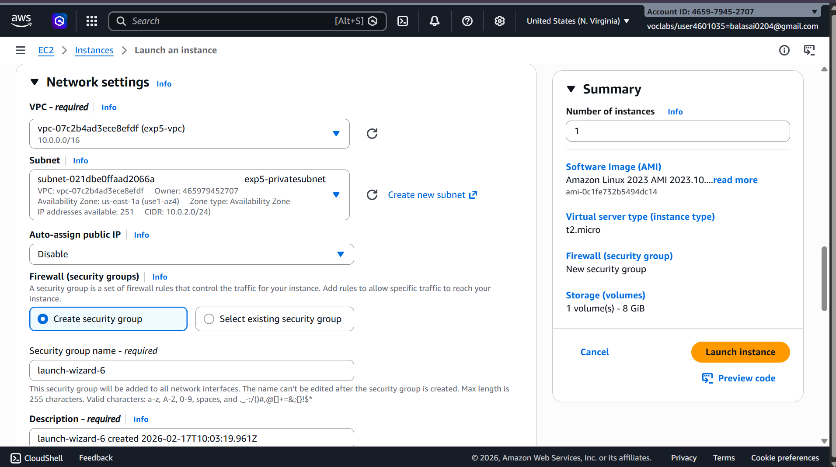

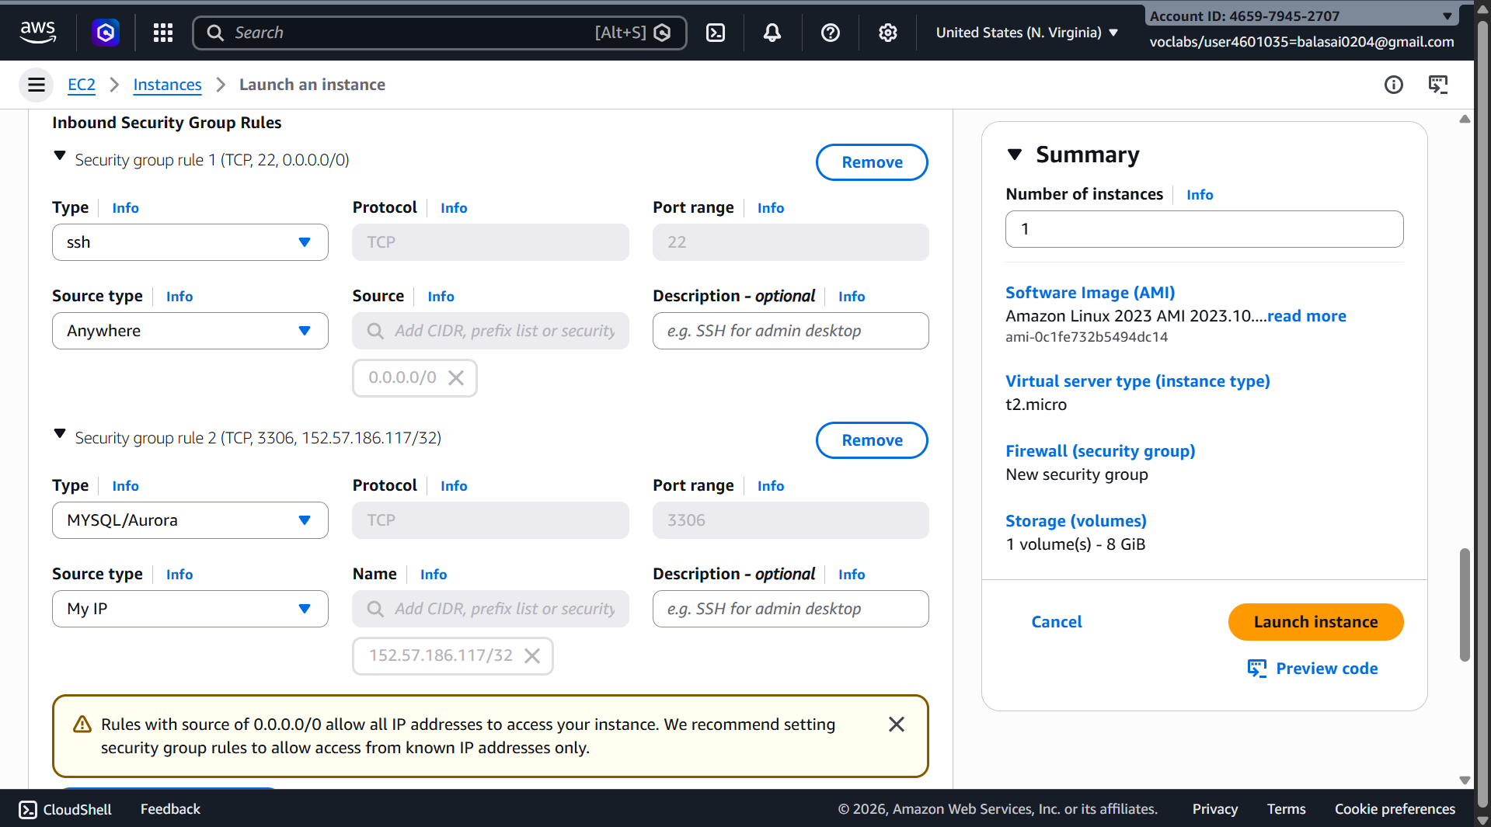

🔹 Step 8: Test the Setup
- Public EC2 → Internet access ✔
- Private EC2 → Internet via NAT ✔
- Private EC2 → No direct inbound access ✔

Private output – we cant connect
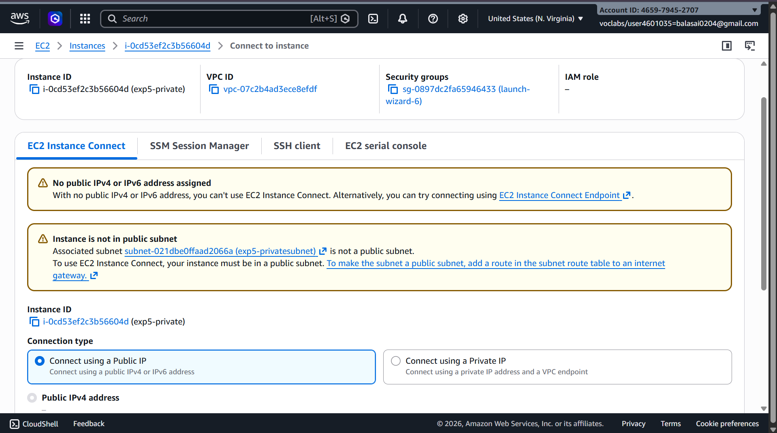

Public – can connect
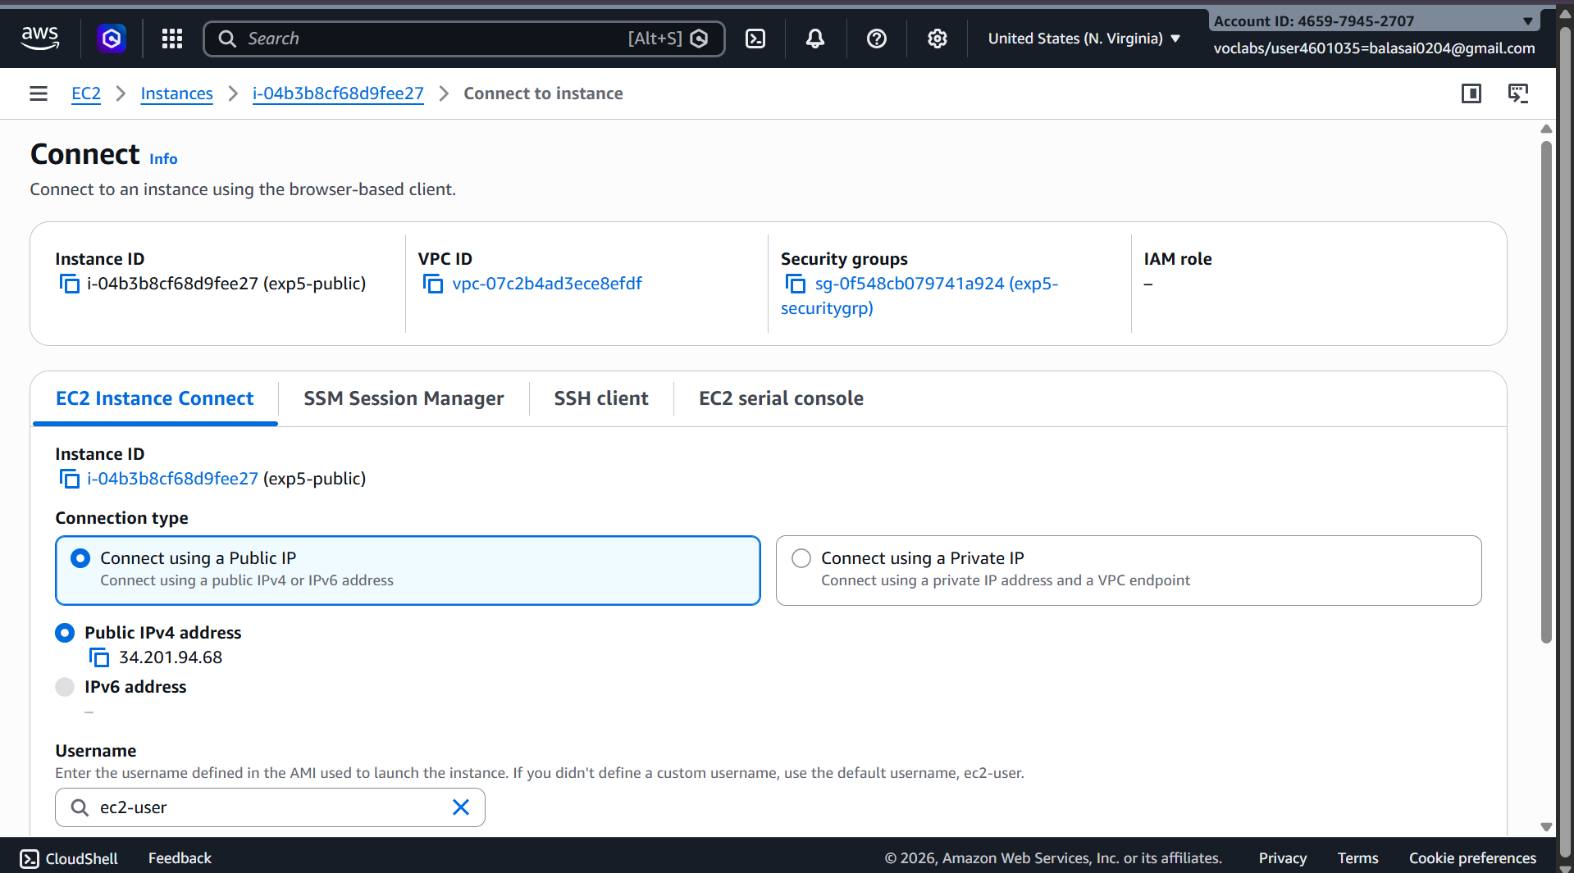

Scenario Based Questions:
1) You have a web application where users access a website, but the database should not be exposed to the internet. How would you design the VPC?
Answer:
Public subnet → Load Balancer, Bastion (optional web tier)
Private subnet → App servers, RDS
Flow: Internet → LB → App → DB
RDS has no public IP.

2) An EC2 instance in a public subnet cannot access the internet. What would you check?
Answer:
- IGW attached
- Route: 0.0.0.0/0 → IGW
- Public IP assigned
- Security group outbound open
- NACL not blocking

3) App server must connect securely to RDS. How configure?
Answer:
Both in private subnets.
RDS security group allows DB port from App SG only.
Disable public access.

4) VPC for 500 now, 2000 later — CIDR?
Answer:
Choose large range: 10.0.0.0/16 (or /20 minimum).
Prevents redesign later.

5) Secure on-premises connectivity — VPN vs Direct Connect?
Answer:
VPN → cheap, fast, encrypted internet
Direct Connect → dedicated, stable, low latency
Use DX for production heavy traffic.

6) Two VPCs use same CIDR — how connect?
Answer:
Peering fails.
Use NAT/PrivateLink/Transit Gateway or change CIDR.

7) Microservices in different subnets communicate securely?
Answer:
Use security group-to-security group rules.
No open CIDR ranges.
Routing is automatic inside VPC.

8) Design 3-tier VPC (Web, App, DB)
Answer:
Public → ALB, Bastion
Private App → App servers (via NAT)
Private DB → RDS only internal
IGW for public, NAT for private outbound.

9) Detect unusual VPC traffic?
Answer:
Enable VPC Flow Logs + CloudWatch + GuardDuty
(Optional: Traffic Mirroring)

10) Why private subnet cannot attach IGW directly?
Answer:
IGW attaches to VPC, not subnet.
Subnet becomes public only via route table.

11) If route tables misconfigured?
Answer:
Instances unreachable — no internet or internal connectivity.

12) Route table has no local route?
Answer:
Instances in same VPC cannot communicate.

13) Port 80 allowed but still blocked?
Answer:
Possible:
- NACL deny
- No public IP
- No IGW route
- OS firewall blocking

14) VPC for 1000+ instances multi-AZ — CIDR?
Answer:
Use /16 and divide into multiple subnets per AZ.

15) Only company IP can SSH?
Answer:
Security group rule:
SSH → Company_IP/32

16) Instance sends traffic but no response?
Answer:
NACL issue — stateless rules must allow ephemeral ports (1024-65535).

