VPC USING BASTION SERVER
- Inorder to connect to private subnets, we have an option called bastion server. So lets create an ec2 instance with the same name with .ppk keypair.
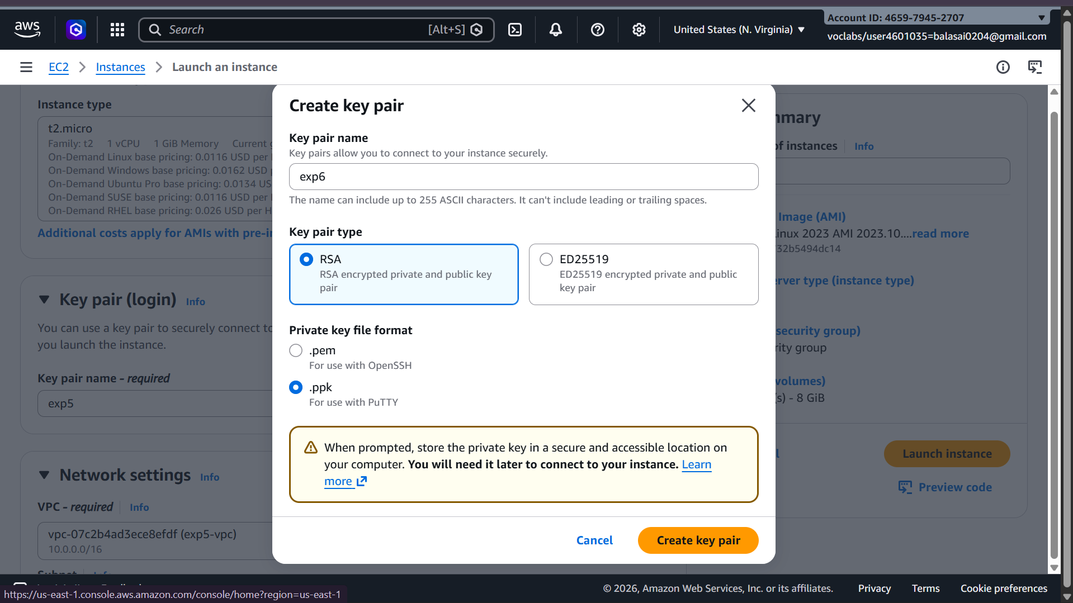
- Create the instance in public subnet, allow ssh and internet traffic along with this, add MYSQl/AURORA also.
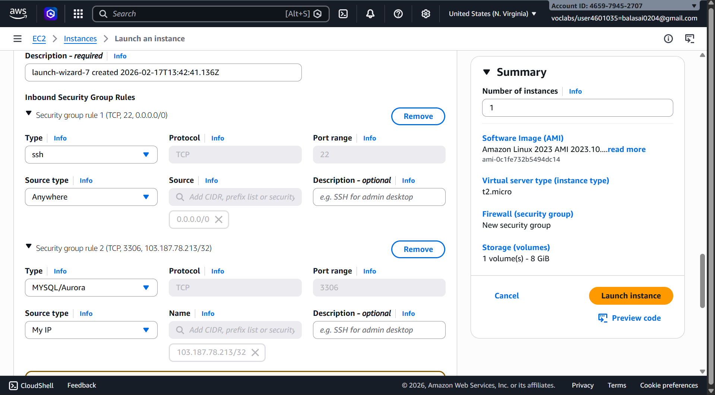

- Download Winscp software for windows from google and install in the computer
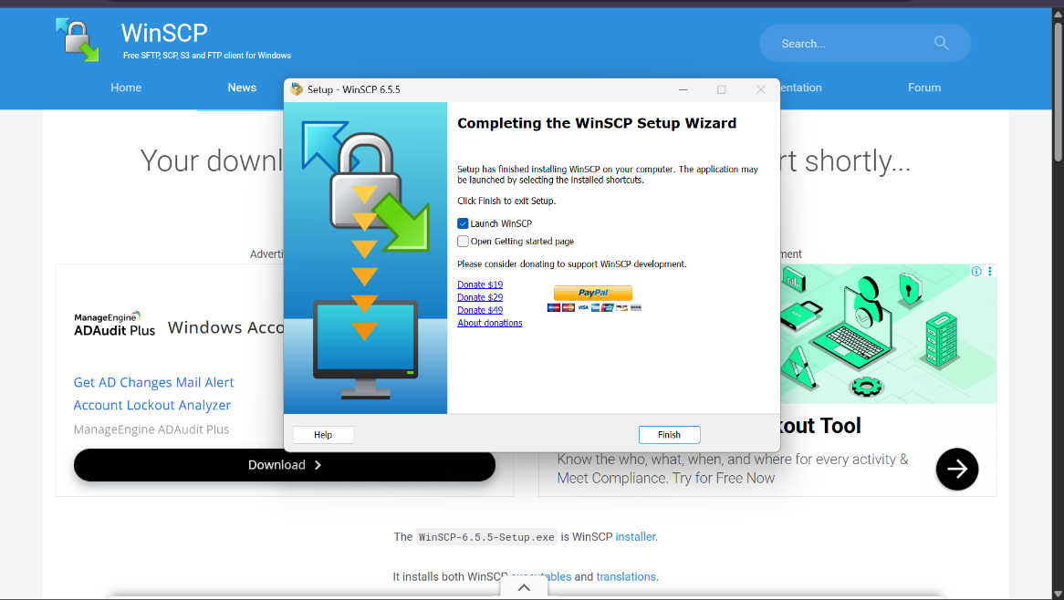

- Copy the public IP address of bastion server and open the winscp in our system.
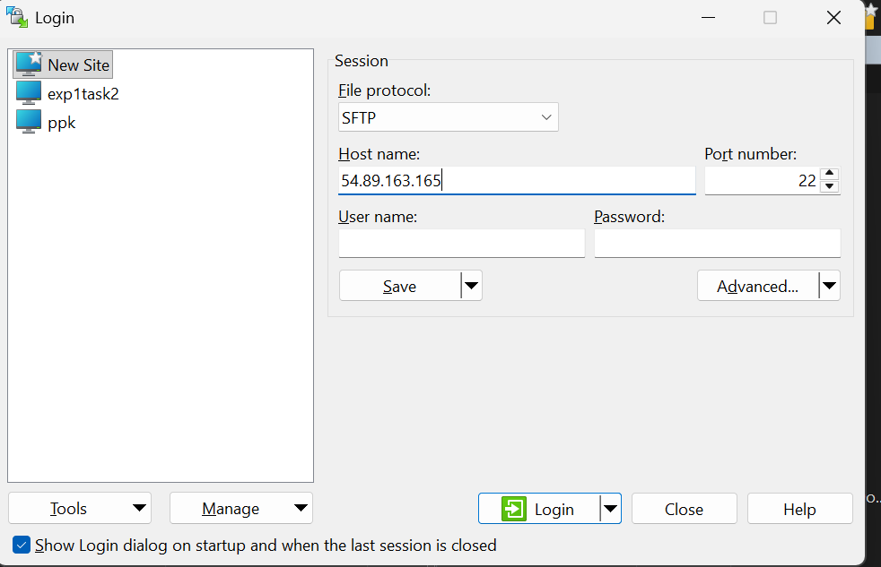

- Paste the public IP address in Host name and click on advanced.
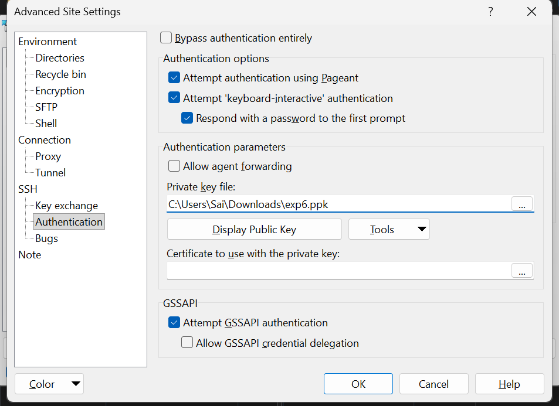

- In advanced, select authentication, click on browse and navigate to the folder where your .ppk is present and load that file, click on OK. And click on login. Accept the certificate. Give username as Ubuntu.

- Copy the .pem file from our desktop to the right side terminal. Just drag and drop.

- Now our private subnet is being accessed. Lets connect the bastion server using putty.

- After connecting through putty, give the commands Sudo su, give ls, check .pem file, give the ssh key of private instance as shown below.

- On successful connection, our private subnet 10.0.2.159 will be connected using successfully. And our ipv6 address will be shown in the command prompt.

VPC USING NAT GATEWAY

- In the above steps we only connected to private subnet with the help of bastion server. If we want to install or update anything in the instances present in private subnet we cannot do and get the warnings like failed to fetch because internet gateway is not attached to the private subnet as shown below.

- We can overcome this problem with the help of concept called, Network Address Translator (NAT Gateway). Goto NAT Gateway in the left side menu bar and click on create NAT gateway.

- Give the Nat gateway name, select your VPC, scroll down and clock create NAT gateway

- So Now lets create a rout for accessing NATGateway. Goto Route table click on create route table and give the route table name, along with it our customized vpc and click on create route.

- Click on actions, goto edit subnet associations and add private subnet to this bastion route.

- Again goto actions and click on edit routes, attach NAT Gateway and click on save changes.
- Now that all connections are established, we can install and update any files in the private subnet as given below.
This completes out VPC with NAT Gateway using Bastion Server inorder to connect and do operations in private subnet.

