Name : Deras Pangestu Gusti (08)
Class : SIB 1G
NIM : 254107060114

JOBSHEET

Double Linked Lists

Learning Objectives
After completing this practical session, students will be able to:
- Understand the double linked list algorithm.
- Create and declare the structure of a double linked list algorithm.
- Apply the double linked list algorithm in various case studies.

Experiment 1
    - Activity 1
In Experiment 1, a Student class, a Node class, and a DoubleLinkedList class will be created. These classes will include operations for adding data in multiple ways (from the front and the back of the linked list).
      - Observe the class diagram of Student, Node, and DoubleLinkedLists below. This class diagram will serve as a reference for writing the DoubleLinkedLists program code.

Student
nim: String name: String className: String
gpa: Double
Student(String nim, String name, String className, Double gpa)
print(): void

Node
data: Student
prev: Node next: Node
Node()
Node(data: Student)
Node(prev: Node, data: Student, next: Node)

DoubleLinkedLists
head: Node
tail : Node
DoubleLinkedLists() isEmpty(): boolean addFirst (): void addLast(): void
add(item: int, index:int): void print(): void
removeFirst(): void removeLast(): void
insertAfter: void

      - Create a new package named P13 or by using your preferred name
      - Create a class within the package named Student. In this class, declare the attributes according to the class diagram above. Also, add the constructor and methods as specified in the diagram.
package P13;

public class Student {
String nim, name, className; double gpa;

public Student(){
}
public Student(String nm, String nama, String kls, double ip){ nim = nm;
name = nama; className = kls; gpa = ip;
}
void print(){
System.out.println(nim+" - "+name+" - "+className+" - "+gpa);
}
}

      - Create a class within the package named Node. In this class, declare the attributes according to the class diagram above. Then, add the constructor as specified in the diagram.
public class Node {

Student data; Node prev; Node next;

Node(){
}
Node(Student data){ this.data = data; prev = null;
next = null;
}
Node(Node prev, Student data, Node next){ this.data = data;
this.prev = prev; this.next = next;
}
}

      - Create a new class named DoubleLinkedLists in the same package as Node. In the
DoubleLinkedLists class, declare the attributes according to the class diagram above.
public class DoubleLinkedLists {
Node head;
Node tail;

}

      - Add constructor to initialize head and tail attributes to be null;
DoubleLinkedLists(){
head = null; tail = null;
}

      - Create a new method isEmpty() that will return true in case the double linked list is still empty.
boolean isEmpty(){
return head==null;
}

      - Next, create the addFirst() method. This method will perform data insertion at the front of the linked list.
void addFirst(Student data){
Node newNode = new Node(data); if(isEmpty()){
head = tail = newNode;
}else{

newNode.next = head; head.prev = newNode; head = newNode;
}
}

      - In addition, create the addLast() method to insert data at the end of the linked list.
void addLast(Student data){
Node newNode = new Node(data); if(isEmpty()){
head = tail = newNode;
}else{
tail.next = newNode; newNode.prev = tail; tail = newNode;
}
}

      - To insert data after the node that contains the specified key, you can do it as follows.
void insertAfter(String key, Student data){
Node newNode = new Node(data); Node temp = head; while(temp!=null){
if(temp.data.nim.equalsIgnoreCase(key)){ if(temp == tail){
addLast(data);
}else{
newNode.next = temp.next; newNode.prev = temp; temp.next.prev = newNode; temp.next = newNode;
}
}
temp = temp.next;
}
if(temp == null){
System.out.println("Insertion failed. Data ("+key+") not
found!!");
}
}

      - To display the contents of the linked list, create a print() method. This method will print all elements in the linked list, regardless of its size.
void print(){
if(!isEmpty()){
Node temp = head; while(temp!=null){

temp.data.print(); temp = temp.next;
}
System.out.println("");
}else{
System.out.println("Double linked list is currently
empty!!");
}
}

      - Next, create the DoubleLinkedListsMain class to execute all the methods available in the
DoubleLinkedLists class.
public class DoubleLinkedListsMain {
public static void main(String[] args) { DoubleLinkedLists dll = new DoubleLinkedLists(); dll.print();
dll.addFirst(new Student("111", "Anton", "TI-1I", 3.57)); dll.print();
dll.addLast(new Student("112", "Prabowo", "TI-1I", 3.7)); dll.print();
dll.addFirst(new Student("113", "Herco", "TI-1I", 3.89)); dll.print();
dll.insertAfter("111", new Student("114", "Rizki", "TI-1I",
3.8));
dll.print();
dll.insertAfter("112", new Student("115", "Hanzel", "TI-1I",
3.6));
dll.print();
dll.insertAfter("120", new Student("116", "Eiyu", "TI-1I",
3.4));
dll.print();
}
}
      - Run and observe the output!
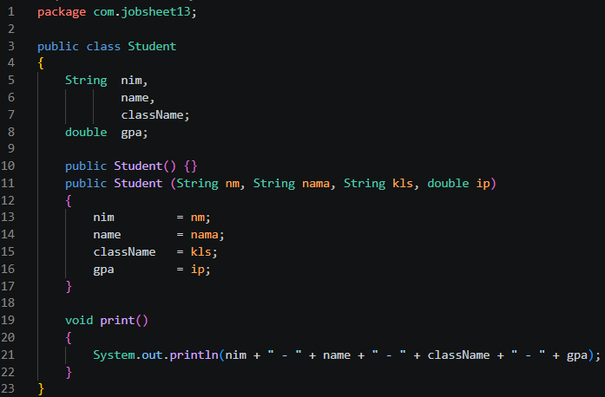
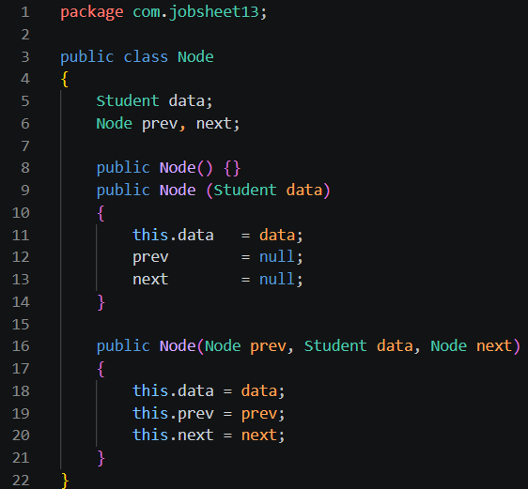
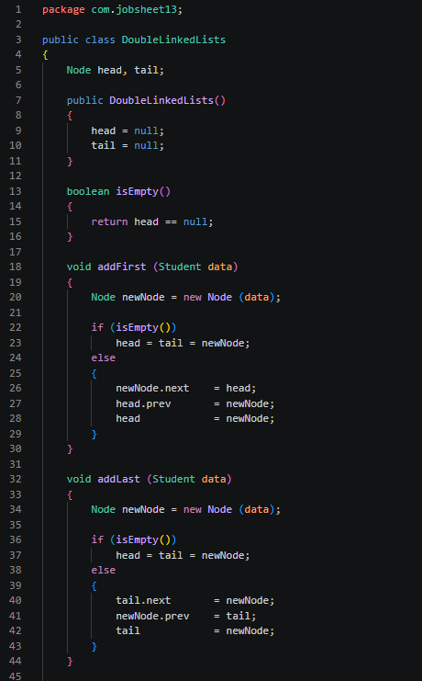
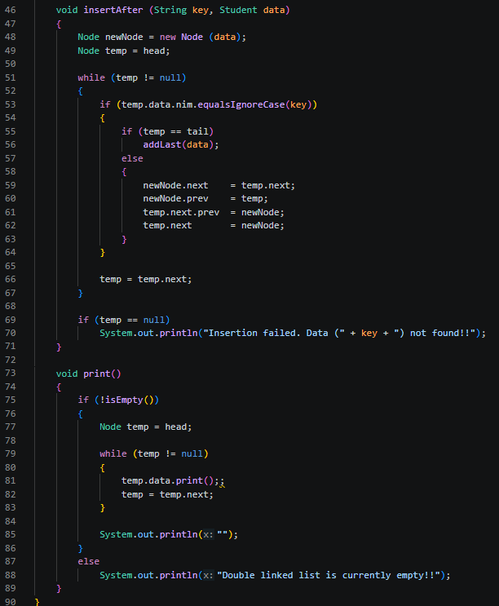
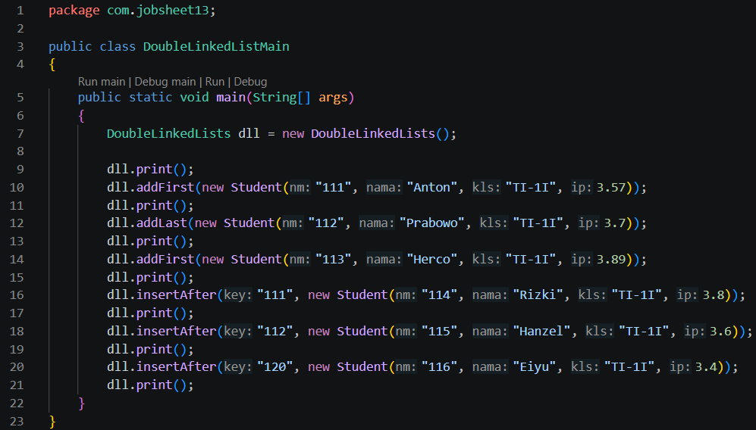
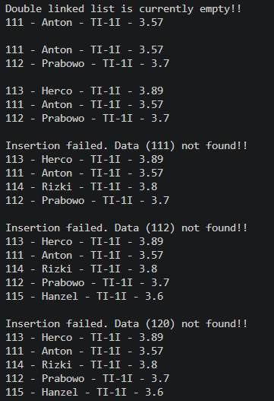

Output Verification
Verify your program’s compilation results using the following.
Double linked list is currently empty!!
111 - Anton - TI-1I - 3.57
Insertion failed. Data (111) not found!!
113 - Herco - TI-1I - 3.89
111 - Anton - TI-1I - 3.57

111 | - Anton - | TI-1I - | 3.57
112 | - Prabowo | - TI-1I | - 3.7
113 | - Herco - | TI-1I - | 3.89
111 | - Anton - | TI-1I - | 3.57
112 | - Prabowo | - TI-1I | - 3.7

114 - Rizki - TI-1I - 3.8
112 - Prabowo - TI-1I - 3.7

Insertion failed. Data (112) not found!!
113 - Herco - TI-1I - 3.89
111 - Anton - TI-1I - 3.57
114 - Rizki - TI-1I - 3.8
112 - Prabowo - TI-1I - 3.7
115 - Hanzel - TI-1I - 3.6
Insertion failed. Data (120) not found!!
113 - Herco - TI-1I - 3.89
111 - Anton - TI-1I - 3.57
114 - Rizki - TI-1I - 3.8
112 - Prabowo - TI-1I - 3.7
115 - Hanzel - TI-1I - 3.6

Questions
- Explain the difference between a singly linked list and a doubly linked list.
- Observe the Node class, which contains the attributes next and prev. What are the purposes of these attributes?
- Examine the constructor in the DoubleLinkedLists class. What is the purpose of this constructor?
DoubleLinkedLists(){ head = null; tail = null;
}
- In the addFirst() method, what is the meaning of the following code?
if(isEmpty()){
head = tail = newNode;
}
- In the addFirst() method, what does the statement head.prev = newNode mean?
- In the insertAfter() method, what is the meaning of current.next.prev = newNode?
- In the experiment 1 code, in which method the traversal process implemented? What is the meaning of temp = temp.next ?
- In the insertAfter() method, what is the following code for?
if(temp == tail){
addLast(data);
}
Do we have to implement it? What if we remove it?
- In the insertAfter() what is this statement if(temp.data.nim.equalsIgnoreCase(key)) for?
- In the above output, after inserting data after 111 and 112, an Insertion failed. Data (111) not found!! warning is displayed. It should be no warning message, since key 111 is found in the list. Explain the reason why it happens? And correct the code!

Experiment 2
    - Labs Activities

In this Experiment 2 several methods will be created to delete elements from the LinkedLists in the DoubleLinkedLists class. Deletion will be performed in three ways: at the front, at the end, and at a specified index within the linked list.

      - Create the removeFirst() method inside the DoubleLinkedLists class.
void removeFirst(){
if(isEmpty()){
System.out.println("Double linked list is currently
empty!!");
}else if(head == tail){ head = tail = null;
}else{
head = head.next; head.prev = null;
}
}

      - Create the removeLast() method inside the DoubleLinkedLists class.
void removeLast(){
if(isEmpty()){
System.out.println("Double linked list is currently
empty!!");
}else if(head == tail){ head = tail = null;
}else{
tail = tail.prev; tail.next = null;
}
}

      - Also, add the remove(int index) method to the DoubleLinkedLists class and observe the results.
void remove(int index){
if(isEmpty()){
System.out.println("Double linked list is currently
empty!!");
}else if(index == 0){
removeFirst();
}else{
Node temp = head;
for(int i=0; i<index; i++){ temp = temp.next;
}
if(temp == tail){
removeLast();
}else{
temp.prev.next = temp.next;

temp.next.prev = temp.prev;
}
}
      - Reopen the main method in the DoubleLinkedListsMain class and add the following statements to delete data:
dll.removeFirst(); dll.print(); dll.removeLast(); dll.print(); dll.remove(1);
dll.print();

      - Run and observe the output!

Output Verification
Verify your program’s compilation results using the following.
111 | - Anton - TI-1I - 3.57
114 | - Rizki - TI-1I - 3.8
112 | - Prabowo - TI-1I - 3.7
115 | - Hanzel - TI-1I - 3.6
111 | - Anton - TI-1I - 3.57
114 | - Rizki - TI-1I - 3.8
112 | - Prabowo - TI-1I - 3.7
111 | - Anton - TI-1I - 3.57
112 | - Prabowo - TI-1I - 3.7

Questions
      - What is the use of the following statement in the removeFirst() method?
head = head.next;
head.prev = null;
      - Why is it important to include conditions and processes like the ones below in both
removeFirst() and removeLast() methods? Explain!
else if(head == tail){ head = tail = null;
}
      - In the removeLast() method, if there is no tail attribute inside DoubleLinkedLists
class, what approach or changes need to be made to the code of the method?
      - What is the purpose of the initial if(isEmpty()) check in the remove(int index)
method?
      - Explain how the method handles the removal of a node at the beginning (index == 0) and at the end (temp == tail) of the linked list.
      - Describe how the method updates the links between nodes when removing a node from the middle of the linked list.

      - The remove(int index) method currently does not check for negative index or index that exceed the size of the DoubleLinkedLists. Please add statements to handle these cases.

--- *** ---

