Name: Deras Pangestu Gusti (08)
Class: SIB_1G
NIM: 254107060114

JOBSHEET III
ARRAY OF OBJE CTS

Objectives of the Practicum
After completing this practical material, students are able to:
- Understand and explain the function of arrays containing object variables.
- Students are able to implement instantiation of arrays of objects in Java.
- Students are able to perform operations on elements in an array of objects.

Creating an Array from Objects, Filling and Displaying
In this practical, we will practice how to create an array of objects, then fill and display the
array.

Experimental Steps
- Create a new folder with the name Praktikum03 .
- Create a class Student< Presence No > :
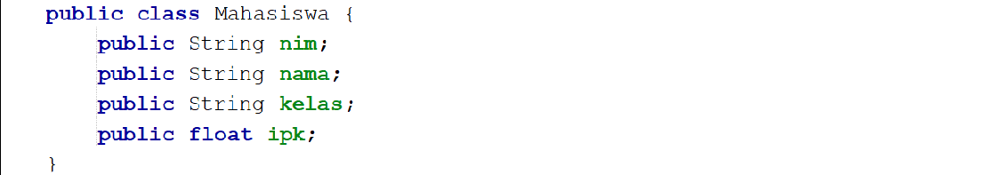

- Create a class MahasiswaDemo<NoPresensi> then add the main function as follows ;
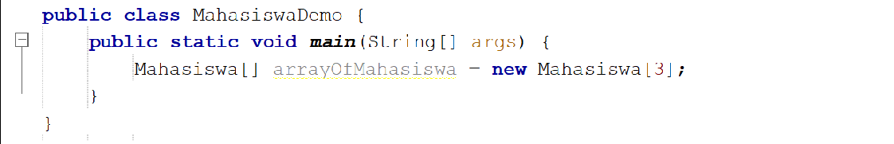

- Then fill in each attribute:
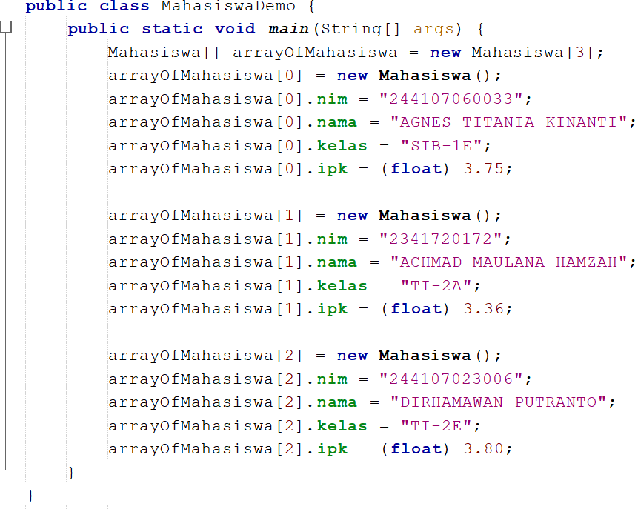
- Print to the screen all attributes of the arrayOfStudents object :
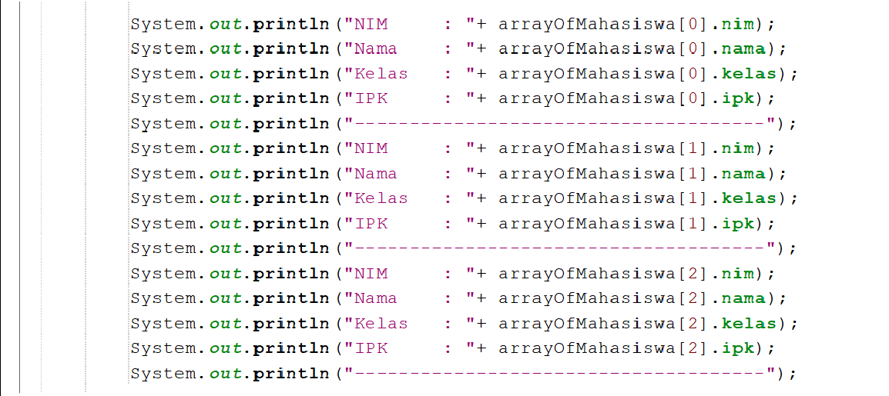
- Run the program and observe the results.

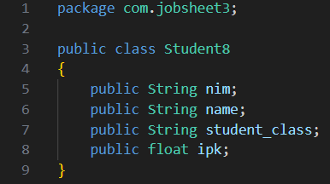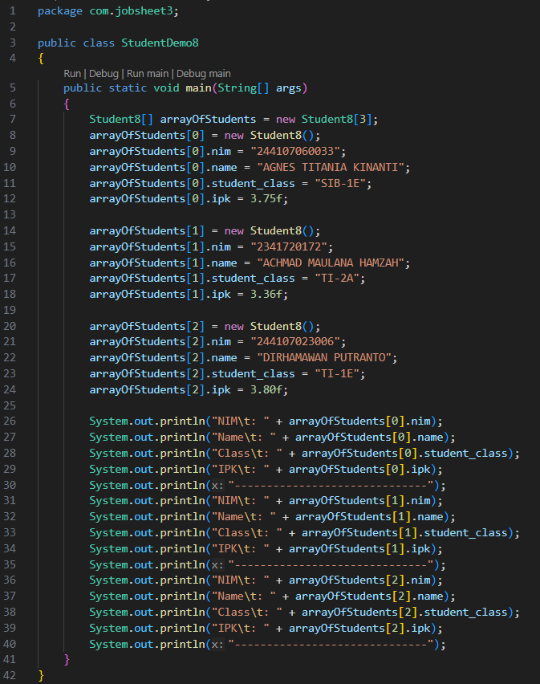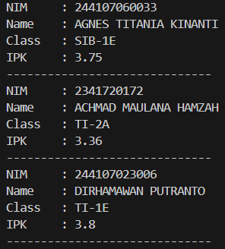

Verification of Experimental Results
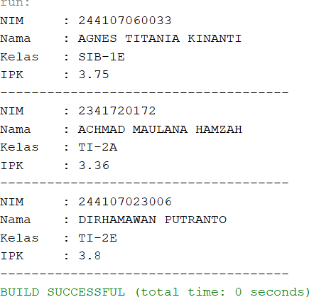
Match the results of compiling your program code with the following image.

Question
- Based on test 3.2, does a class that will create an array of objects always have to have both
attributes and methods ? Explain!
No, a class does not always have to have attributes and methods just because it will be used to create an array of objects.
- What does the following program code do?
Student declare an object array type where new Student[3] will create an array with a length of 3 elements with arrayOfStudents as the variable name.

- Does the Student class have a constructor? If not, why is the constructor called in the following line of the program?
No, because that line of code will automatically call the constructor to create a new object.
- What does the following program code do?
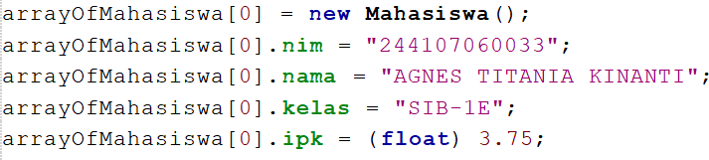
The first line will create a new object and store it in the first element of the array, then the following lines will fill in the values for each attribute.
- the Student and StudentDemo classes separated in test 3.2?

Yes, the two classes are in separate files.

Receiving Array Input Using Looping
In this practical we will change the program results from practical 3.2 so that the program can accept input and use looping to fill in the attributes of all Student objects.

Experimental Steps
- Import scanner in the MahasiswaDemo class .
Note: Place the import code below the package code (if any).
- In practical 3.2, point 4, modify the program code as follows. Create a Scanner object to receive input, then loop to retrieve the length and width information:
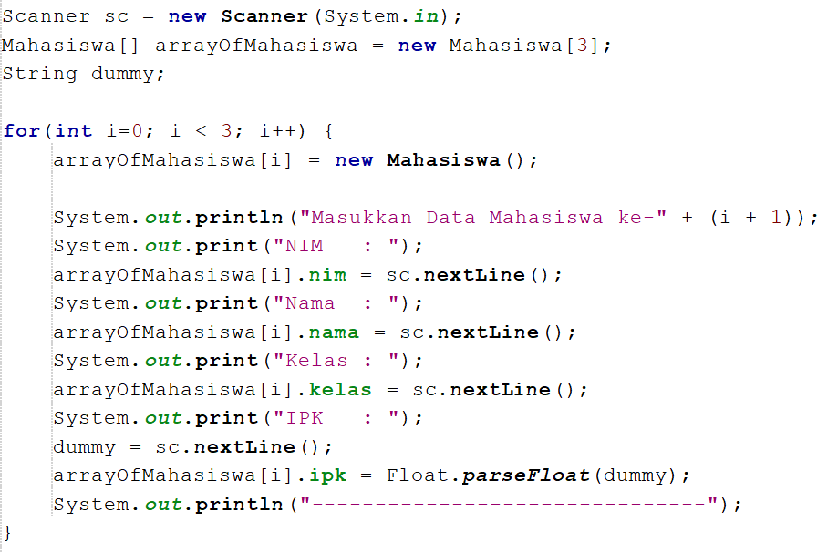
- In practical 3.2, point 5, modify the program code as follows. Loop through the array elements of
the student objects and display their information on the screen:
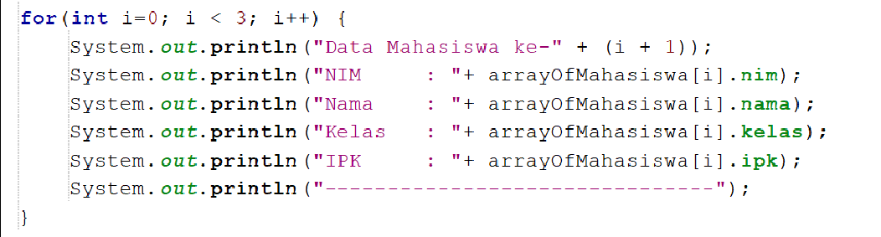
- Run the program and observe the results.
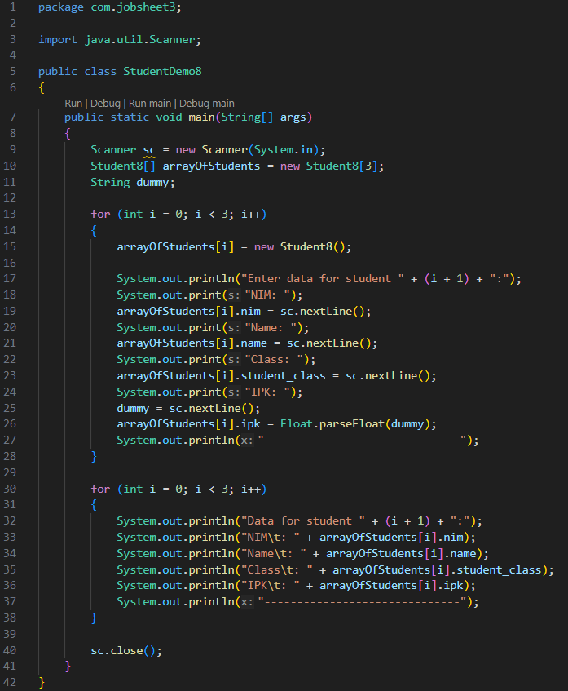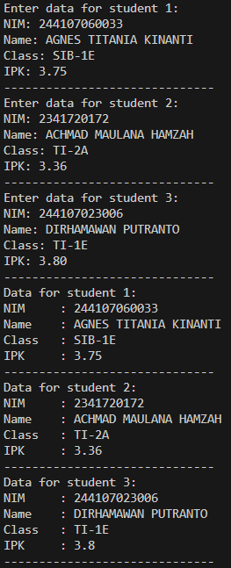

Verification of Experimental Results
Example of verification of the results of this experiment.
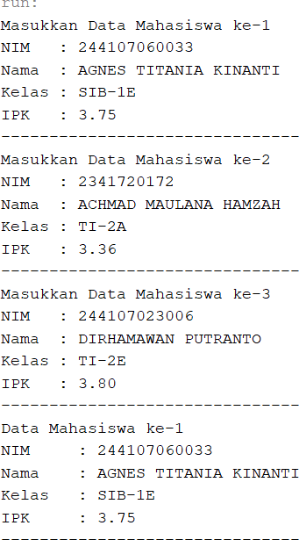
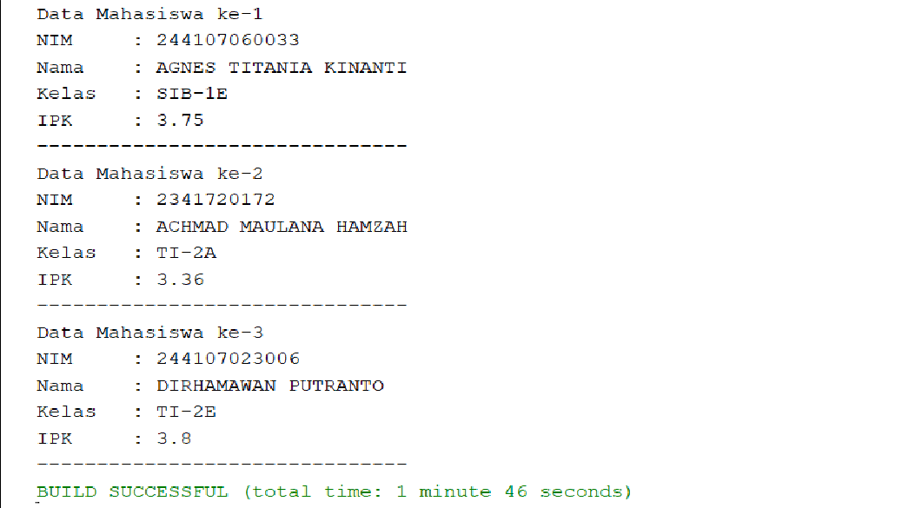

Question
- Add the printInfo() method to the Student class then modify the program code in step no. 3.
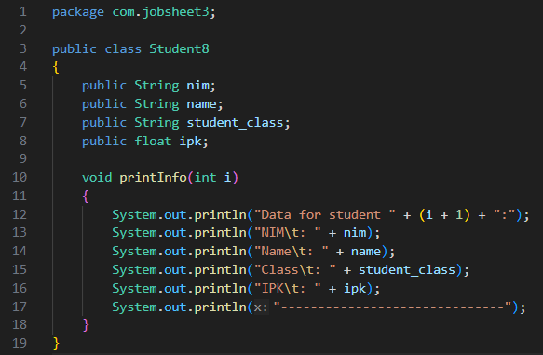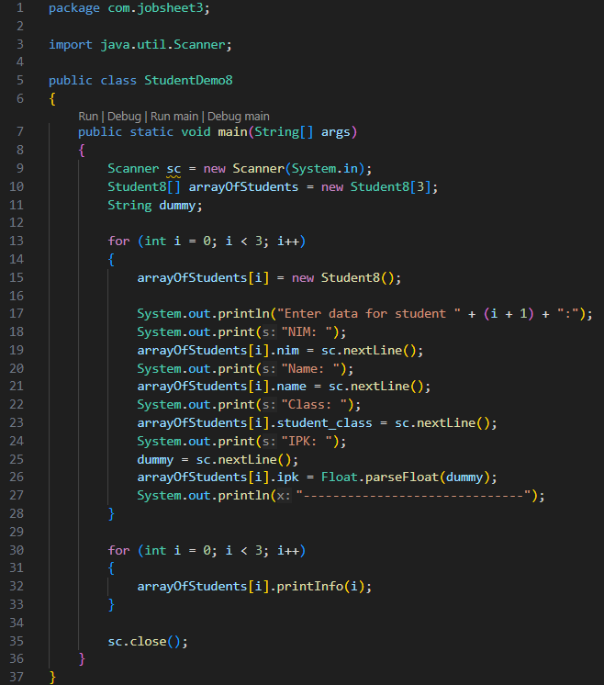






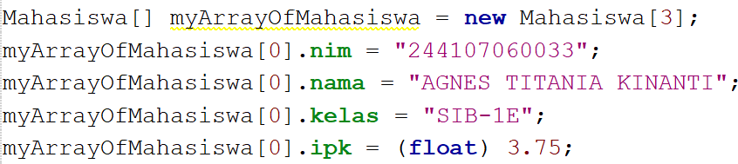
- Suppose you have a new array array of type Students named myArrayOfStudents . Why does the following code cause an error?
Because the newly created array only contains empty slots (null) and not Student8 objects.

Parameterized Constructor
In this practical, we will instantiate an array of objects using a parameterized
constructor .

Experimental Steps
- a new class with the name Matakuliah<NoPresensi> with a constructor with the following parameters;
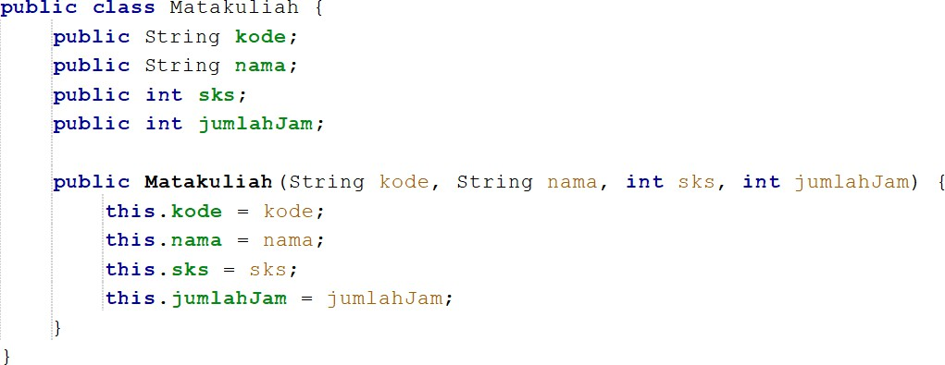
- a new class MatakuliahDemo<NoPresensi> and add the main() function. Then, instantiate
the Matakuliah object array using the following parameterized constructor ;
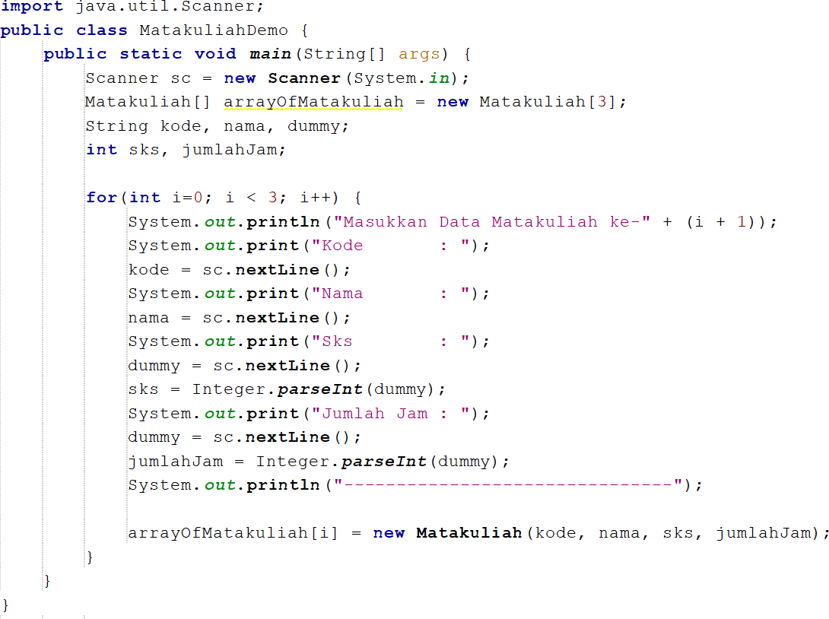
- Run the program then observe the results.

- Modify the MatakuliahDemo class so that it can display the input results of the variable
array of Matakuliah objects in the layer;
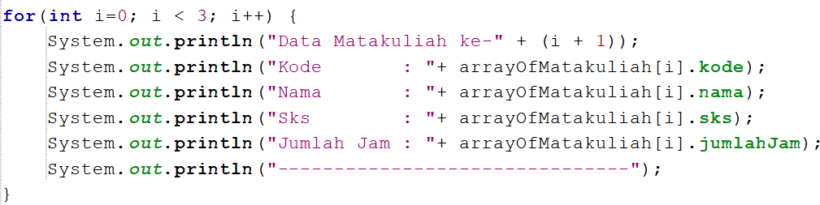
- Run the program and observe the results.
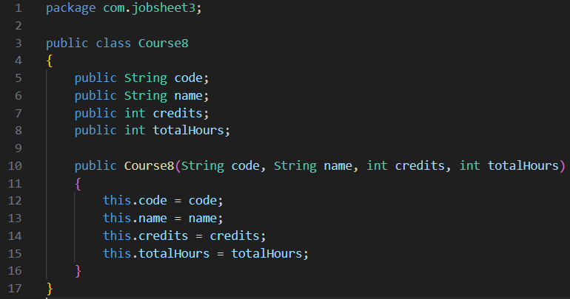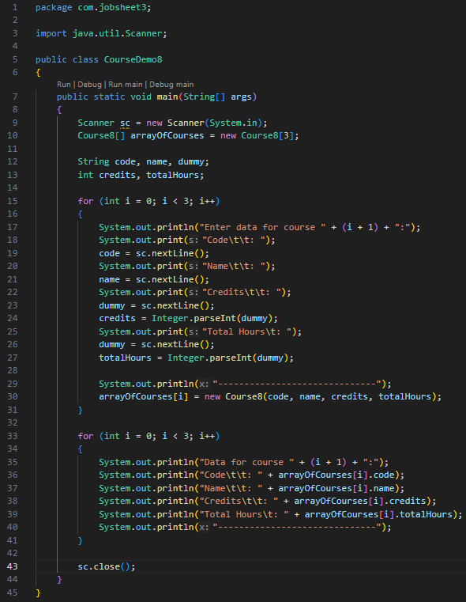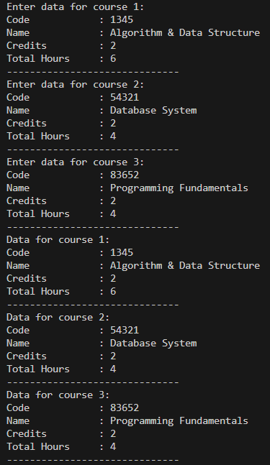

Verification of Experimental Results
Match the results of compiling your program code with the following image.
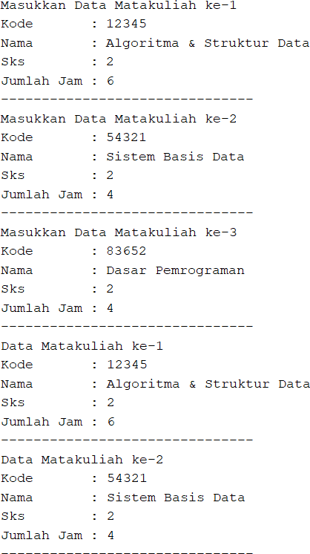
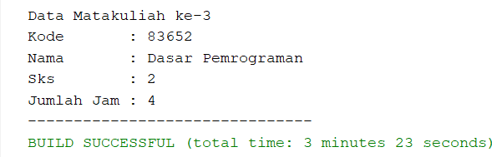

Question
      - Can a class have more than 1 constructor? If yes, give an example.
Yes, a class can have more than one constructor.
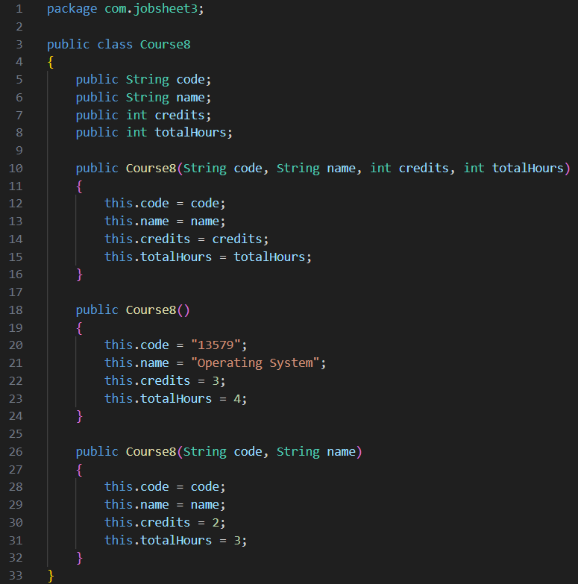
      - Add the addData() method to the Matakuliah class , then use this method in the MatakuliahDemo class to add Course data.
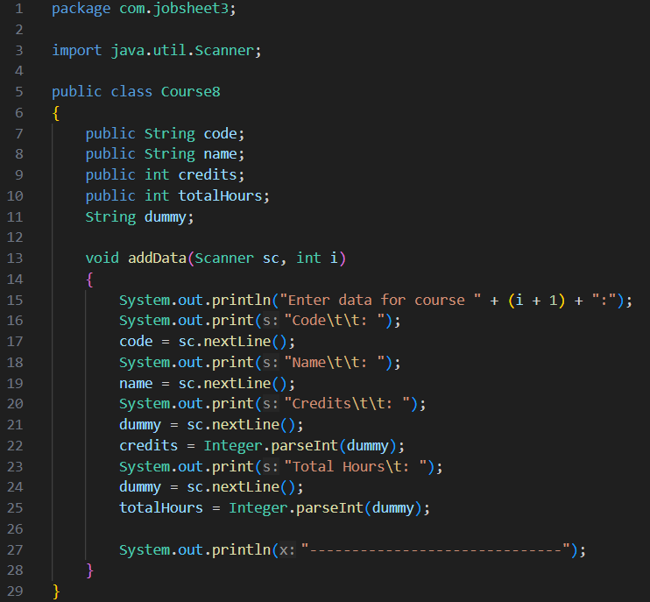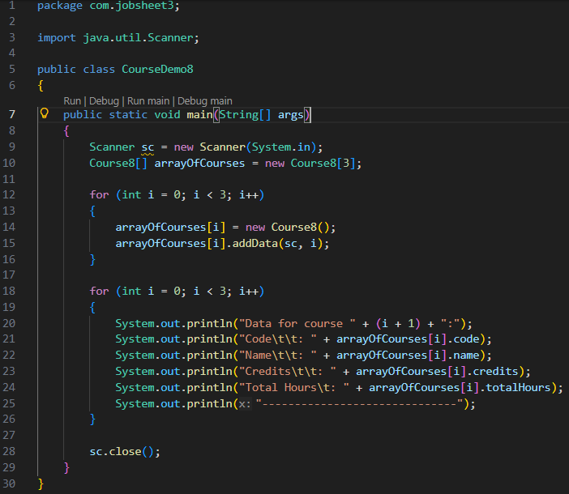
      - Add the printInfo() method to the Matakuliah class , then use this method in
the MatakuliahDemo class to display the input data on the screen.
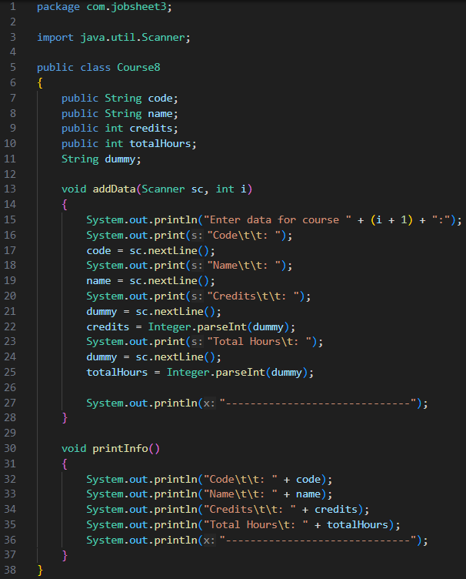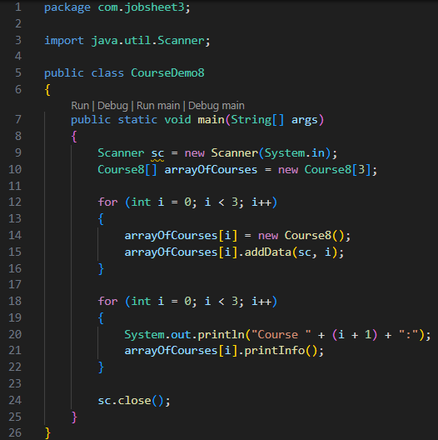
      - Modify the program code in the MatakuliahDemo class so that the length (number of elements) of the array of Matakuliah objects is determined by the user via input with Scanner
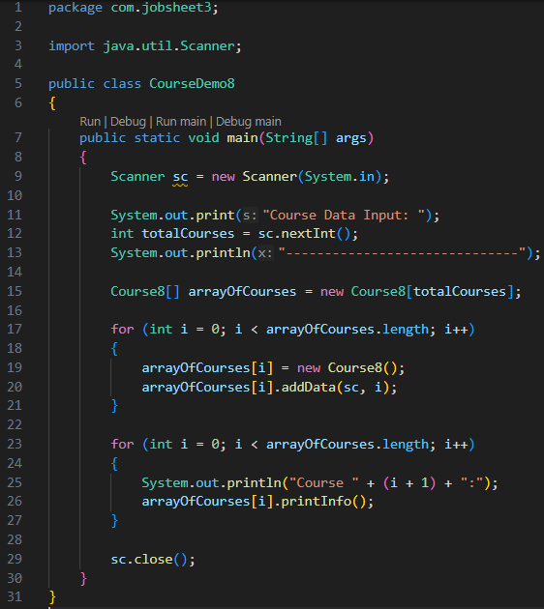

Task
- Create a program to display information about lecturers. The program can accept input of all lecturer-related information and display it back on the screen. This program consists of the Dosen<NoPresensi> class with the following attributes/properties:
Code string Name string Boolean gender int age
with the constructor method as follows;
public lecturer( String code, String name, Boolean gender, int age ) {
…………….;
…………….;
}
, create a class DosenDemo<NoPresensi> to process input and display data for several lecturers. Use a loop with FOR To create an array of objects , use FOREACH looping. to display data on the screen.

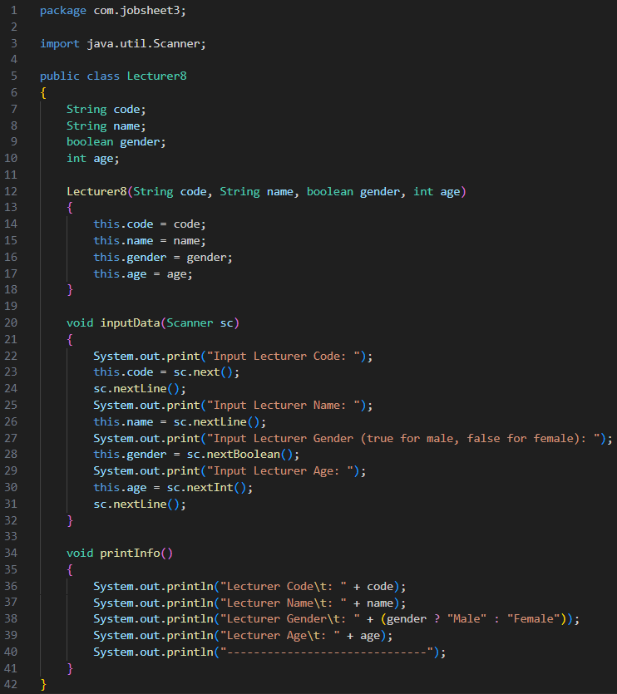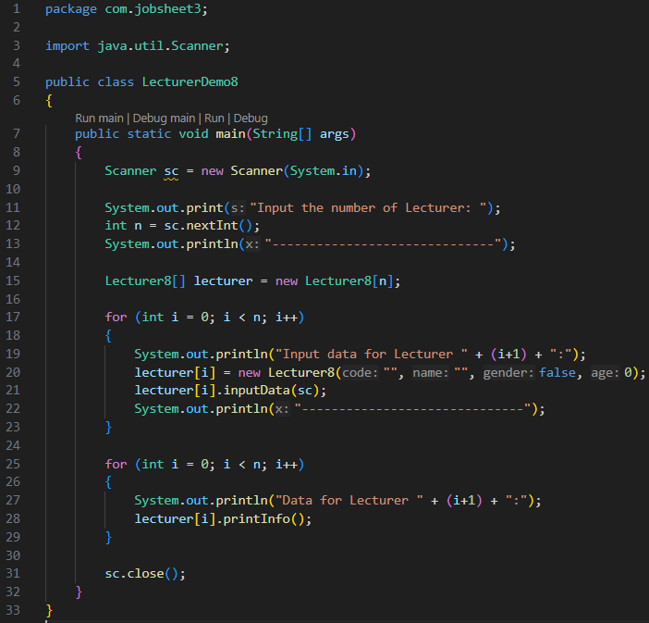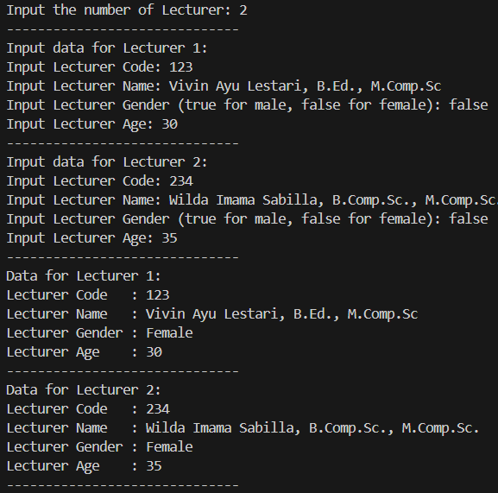
- Add a new class DataDosen<NoPresensi> with the following methods ;
  - dataAllDosen(Dosen[] arrayOfDosen) to display data for all lecturers
  - numberOfLecturersPerGender(Lecturers[] arrayOfLecturers) to display data on the number of lecturers per gender (Male / Female)
  - AverageAgeOfLecturersPerGender ( Lecturers[] arrayOfLecturers ) to display the average age of lecturers per gender (Male / Female)
  - infoDosenPalingTua ( Dosen[] arrayOfDosen ) to display the oldest lecturer data
  - infoDosenMostYoungest ( Dosen[] arrayOfDosen ) to display the youngest lecturer data
All these methods must be able to be called/tested from the DosenDemo class.
