Name: Deras Pangestu Gusti (08)
Class: SIB 1G
NIM: 254107060114

JOBSHEET XI LINKED LIST

Learning Objectives
After completing this practical session, students will be able to:
- Construct a linked list data structure
- Implement a linked list in a program
- Identify problems that can be effectively solved using a linked list

Labs Activities
  - Experiment 1: Implementing Single Linked List

Allocated times: 30 minutes
In this experiment, we will practice how to create a Single Linked List using Node-based data representation, access the linked list, and implement data insertion methods.
- In the project created for this semester, create a new package named week12.
- Create the following classes:
  - Student00.java
  - Node00.java
  - SingleLinkedList00.java
  - SLLMain00.java
Modify 00 with your number
- Implement Student following this class diagram:

Student
nim: String name: String className: String
gpa: double
Student()
Student (nm: String, name: String, kls: String, ip: double)
print(): void

- The following code is the Student class implementation
public class Student {
String nim, name, className; double gpa;

public Student(){
}
public Student(String nm, String nama, String kls, double ip){

nim = nm; name = nama;
className = kls; gpa = ip;
}
void print(){
System.out.println(nim+" - "+name+" - "+className+" - "+gpa);
}
}

- The following code snippet depicts the Node class implementation. Please make a note that the Node class manages the Student object data, that is why we create Student attribute within Node class. You will need to modify it based on the data type of data that you manage.
public class Node { Student data; Node next; public Node(){
}
public Node(Sudent data, Node next){ this.data = data;
this.next = next;
}
}

- Create a new class named SingleLinkedList
- Add head attributes within SingleLinkedList class
public class SingleLinkedList {
Node head;
Node tail;

}

- In the next step we will implement the basic method of single linked list
- Create a new method, isEmpty().
boolean isEmpty(){
return (head==null);
}

- Implement traversal process for displaying all data managed in the single linked list
void print(){
if(!isEmpty()){
Node tmp = head;

System.out.println("LinkedList Data:"); while(tmp!=null){
tmp.data.print(); tmp = tmp.next;
}
}else{
System.out.println("LinkedList is empty!!");
}
}

- Add addFirst() method as follows:
void addFirst(Student std){
Node newNode = new Node(std, null); if(isEmpty()){
head = newNode; tail = newNode;
}else{
newNode.next = head; head = newNode;
}
}

- Create a new method, addLast()as follows:
void addLast(Student std){
Node newNode = new Node(std, null); if(isEmpty()){
head = newNode; tail = newNode;
}else{
tail.next = newNode; tail = newNode;
}
}

- Add insertAfter(), to add a new student data after a key specified. In this example, we use student name as the key.
void insertAfter(Student std, String key){ Node newNode = new Node(std, null); Node temp = head;
do {
if (temp.data.name.equalsIgnoreCase(key)) { newNode.next = temp.next;
temp.next = newNode;
if (newNode.next == null) { tail = newNode;
}

break;
}
temp = temp.next;
} while (temp != null);
}

- Add these following codes to add a node based on defined index
public void insertAt(int index, Student std) { if (index < 0) {
System.out.println("Wrong index!!");
} else if (index == 0) {
addFirst(std);
} else {
Node temp = head;
for (int i = 0; i < index - 1; i++) { temp = temp.next;
}
temp.next = new Node(std, temp.next); if (temp.next.next == null) {
tail = temp.next;
}
}
}

- Create a new Main class, with a main method inside. Then create a SingleLinkedList object.
public static void main(String[] args) {
SingleLinkedList sll = new SingleLinkedList();

}

- Add 4 student objects, std1, std2, std3 and std4.
Student std1 = new Student("001", "Student 1", "TI-1I", 3.89); Student std2 = new Student("002", "Student 2", "TI-1I", 3.45); Student std3 = new Student("003", "Student 3", "TI-1I", 3.20);
Student std4 = new Student("004", "Student 4", "TI-1I", 3.00);

- Add the students object into SingleLinkedList object, following these scenarios:
sll.print(); sll.addFirst(std4); sll.print(); sll.addLast(std1); sll.print();
sll.insertAfter(std3, "Student 4");
sll.insertAt(2, std2); sll.print();

Output Verification
Observe the output of your program and compare it with the following output!
LinkedList is empty!! LinkedList Data:
004 - Student 4 - TI-1I - 3.0
LinkedList Data:
004 - Student 4 - TI-1I - 3.0
001 - Student 1 - TI-1I - 3.89
LinkedList Data:
004 - Student 4 - TI-1I - 3.0
003 - Student 3 - TI-1I - 3.2
002 - Student 2 - TI-1I - 3.45
001 - Student 1 - TI-1I - 3.89

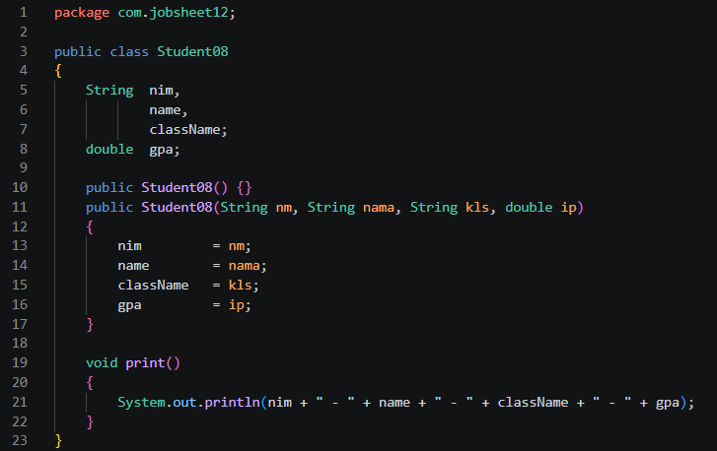
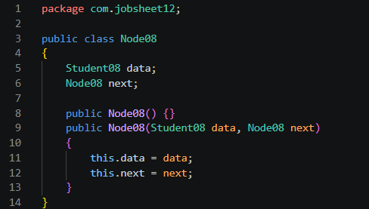
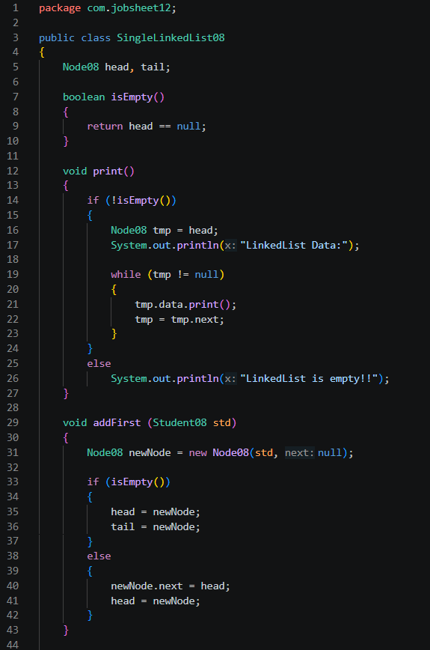
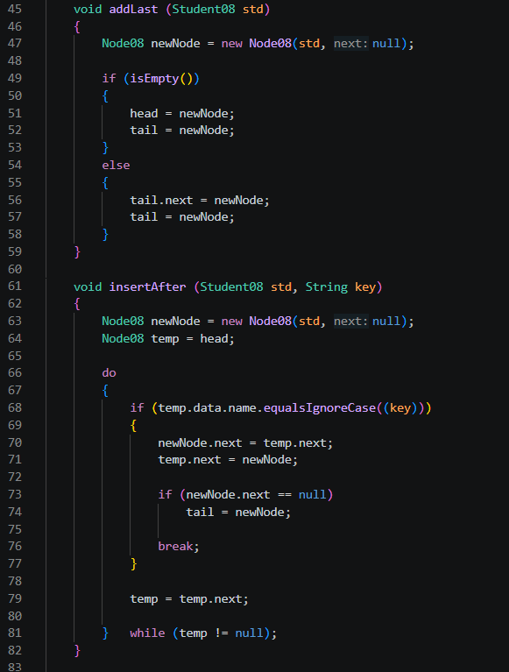\
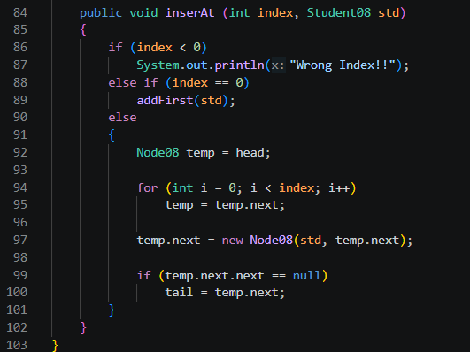
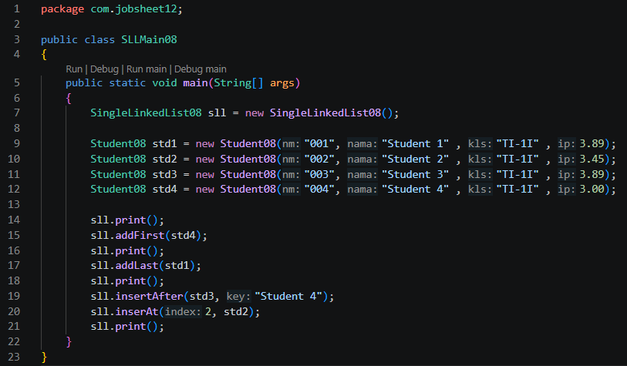
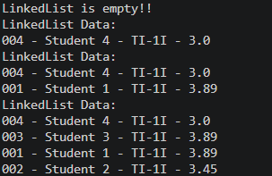

Questions!
      - Why does compiling the program code result in the message "Linked List is Empty" on the first line?
The message appears because, in the main method, the sll.print() method is invoked immediately after the SingleLinkedList object is instantiated. At this specific point in the execution, no student nodes have been added to the list yet. Consequently, the head attribute is still null, causing the isEmpty() check to return true and trigger the "LinkedList is empty!!" print statement.
      - Explain the general purpose of the variable temp in each method!
The variable temp (or tmp) serves as a temporary pointer or iterator used to traverse the linked list. Since a single linked list only provides a direct reference to the head, one must "walk" through the nodes by following the next references to reach a specific position or to display all data. Using temp allows the programme to navigate the list without losing the original reference to the head, which is vital for maintaining the list's structure.
      - Modify the code so that data can be added via keyboard input!
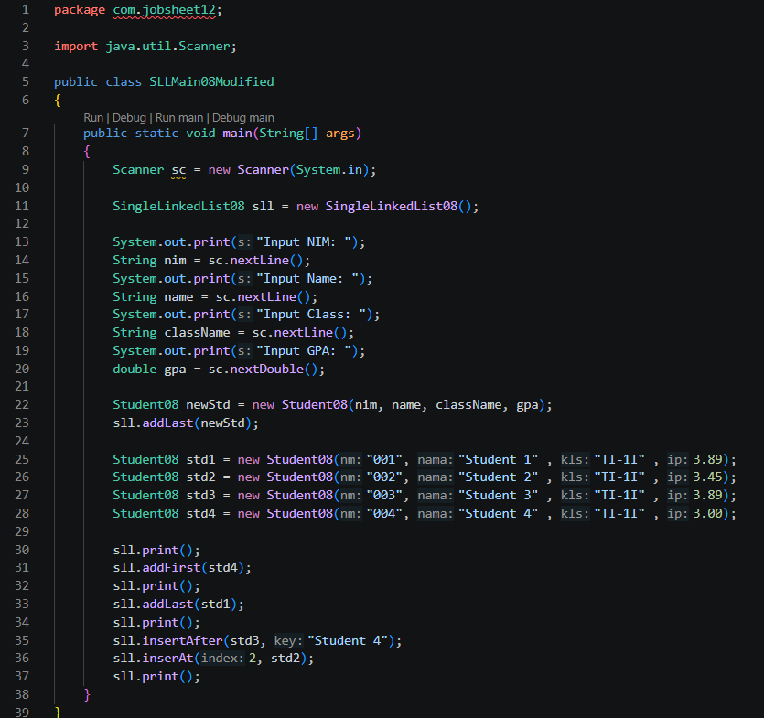
      - What would happen if we did not use the tail attribute? Would it affect the code implementation? Please explain.
Removing the tail attribute would not make the implementation impossible, but it would significantly decrease the efficiency of certain operations.
- Without a tail pointer: To perform an addLast() operation, the programme would have to start at the head and traverse the entire list until it reaches the final node. This changes the time complexity from $O(1)$ (constant time) to $O(n)$ (linear time).
- With a tail pointer: The programme has an immediate reference to the end of the list, allowing for an instantaneous addition of new nodes to the rear.

Experiment 2: Accessing Element in Single Linked List

Allocated time: 30 minutes
In this practical session, we will learn how to access elements, retrieve their index, and perform data deletion in a Single Linked List.

Experiment Steps
      - Open SingleLinkedList class that is already created in Experiment 1.
      - Add a getData() method to get data at a specific index in the SingleLinkedList class.
Student getData(int idx){ if(isEmpty()){
System.out.println("LinkedList is empty!!"); return null;
}
Node tmp = head; for(int i=0; i<idx;i++){
tmp = tmp.next;
}
return tmp.data;
}

      - Add a new method to get the index of a data specified. This method is named
indexOf().
int indexOf(String key){
if(isEmpty()){
System.out.println("LinkedList is empty!!"); return -1;
}
Node tmp = head; int idx = 0;
while(tmp != null && !tmp.data.name.equalsIgnoreCase(key)){ tmp = tmp.next;
idx++;
}
if(tmp == null){ return -1;
}else{
return idx;
}
}

      - Add a new mwthod named removeFirst() to remove the first element in single linked list object
void removeFirst(){
if(isEmpty()){
System.out.println("LinkedList is empty!!");
}else if(head==tail){ head = tail = null;
}else{
head = head.next;
}
}

      - Add a method to remove the last element in the SingleLinkedList class, named removelast()
void removeLast(){
if(isEmpty()){
System.out.println("LinkedList is empty!!");
}else if(head==tail){ head = tail = null;
}else{
Node tmp = head; while(tmp.next != tail){
tmp = tmp.next;
}
tmp.next = null; tail = tmp;
}

}

      - As the next step, the remove() method will be implemented.
public void remove(String key) { if (isEmpty()) {
System.out.println("LinkedList is empty!!");
} else {
Node temp = head; while (temp != null) {
if ((temp.data.name.equalsIgnoreCase(key)) && (temp ==
head)) {
removeFirst(); break;
} else if (temp.next.data.name.equalsIgnoreCase(key)) { temp.next = temp.next.next;
if (temp.next == null) { tail = temp;
}
break;
}
temp = temp.next;
}
}
}

      - Implement a method to removeAt() a node by a specified index.
public void removeAt(int index) { if (index == 0) {
removeFirst();
} else {
Node temp = head;
for (int i = 0; i < index - 1; i++) { temp = temp.next;
}
temp.next = temp.next.next; if (temp.next == null) {
tail = temp;
}
}
}

      - Next, try accessing and deleting data in the main method of the Main class by adding the following code.
System.out.println("Data at index 1 is:");
Student data = sll.getData(1); data.print();

int idx = sll.indexOf("Student 1");
System.out.println("Student 1 is located at index: "+idx);

sll.removeFirst(); sll.removeLast(); sll.print(); sll.removeAt(0);
sll.print();

      - Re-run the Main class

Output verification
Observe the output of your program and compare it with the following output!
Data at index 1 is:
003 - Student 3 - TI-1I - 3.2
Student 1 is located at index: 3 LinkedList Data:
003 - Student 3 - TI-1I - 3.2
002 - Student 2 - TI-1I - 3.45
LinkedList Data:
002 - Student 2 - TI-1I - 3.45

Questions
- Why is the break keyword used in the remove function? Explain!
- Explain the purpose of the code below in the remove method.
temp.next = temp.next.next; if (temp.next == null) {
tail = temp;
}

Assignments

Allocated times: 50 menit
Create a queue-based program for student service operations with the following requirements:
- Implement the queue using a Linked List-based Queue.
- The program should be a new project, not a modification of an existing example.
- When a student wants to join the queue, they must register their information.
- Include functions to check if the queue is empty, check if it is full, and clear the queue.
- Implement adding a student to the queue.
- Implement calling the next student in the queue.
- Display the first (front) and last (rear) student in the queue.
- Display the total number of students still in the queue.

