Name: Deras Pangestu Gusti (08)
Class: SIB 1G
NIM: 254107060114
JOBSHEET
Case Study 1

- Objective
  - Students are able to solve case study problems by applying the concepts of class, object, and array of objects.
  - Students are able to apply sorting and searching algorithms according to case studies.
- Practicum

Processing Time: 120 minutes

Work Instructions:
Each student will code a program based on a given case study. Ensure the program runs smoothly, implements all requested features, and is dynamic (using menus to select features).

Case Study Questions:
Case Study: JTI Reading Room Book Loan Management System
Students frequently borrow books from the JTI reading room for assignments or theses. The reading room administrator needs a simple system to record book, student, and loan transaction data. This system must also be able to automatically calculate late fees based on the length of the loan. The system must have the following features:
- Displays book and student data.
- Displays book borrowing data.
- Calculate the number of days late and the total fine.
- Sort loan data by the largest fine amount.
- Search for loan data based on student NIM. Provision:
- The maximum limit for borrowing books is 5 days.
- The late fee is Rp. 2,000 per day
- If not late, then the fine = 0
Create a Java program using the following class diagram:

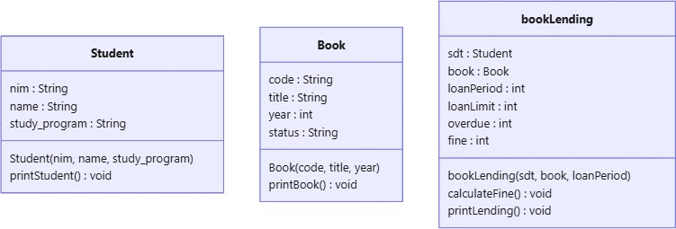

Use the class diagram above to create a book lending management system for the JTI reading room. You can add new classes, attributes, or methods to complete the case study.
The following data can be used as initial data in the program. All data is stored in the form of an array of objects and does not require user input.
- Student Data
NIM | Name | Study Program
22001 | Andi | Informatics Engineering
22002 | Budi | Informatics Engineering
22003 | Image | Business Information Systems
- Book Data
Code | Title | Year
B001 | Algorithm | 2020
B002 | Database | 2019
B003 | Programming | 2021
B004 | Physics | 2024
- Loan Data
NIM | Name | Book title | Loan Period (days)
22001 | Andi | Algorithm | 7
22002 | Budi | Database | 3
22003 | Image | Programming | 10
22003 | Image | Physics | 6
22001 | Andi | Database | 4
The following is an example of the results of running the program: Menu 1:

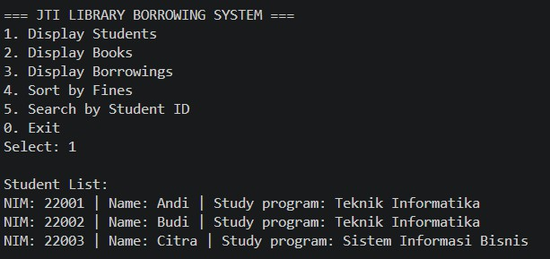
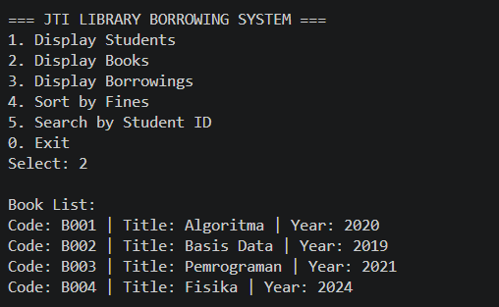
Menu 2:
Menu 3:
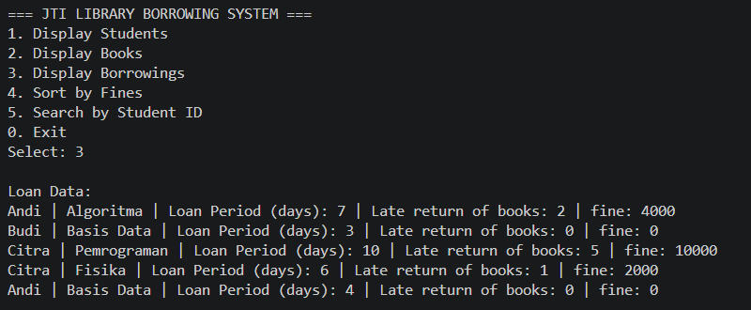

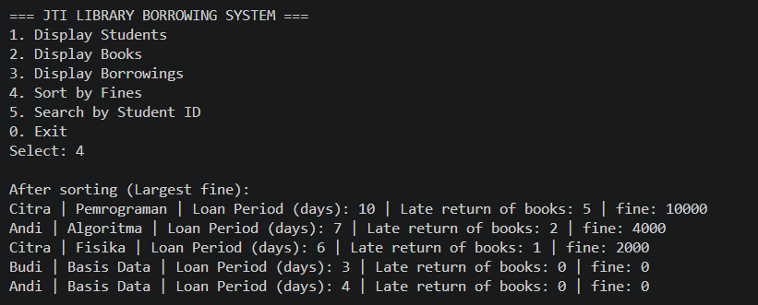
Menu 4:
Menu 5:
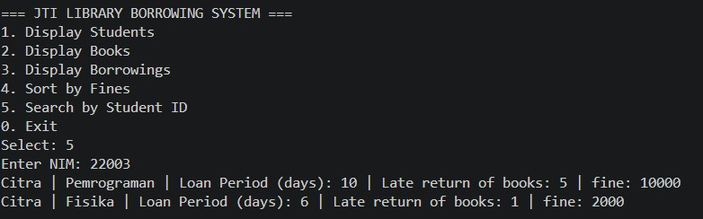

Assessment Rubric

Assessment Aspects | Max  Score | Score | Criteria
1. Class and Object Implementation (25%) | 25 | 20-25 | All classes (Student, Book, Loan) are complete (attributes, constructors, methods) and object  relationships are correct.
 |  | 10-19 | The class already exists but there are still deficiencies in the attributes/methods or the object relationships  are not quite right.
 |  | 0-9 | The class does not conform to the specification or  does not use the object concept correctly.
2. Array of Object Implementation (15%) | 15 | 12-15 | Arrays of objects are used correctly and the  relationships between objects are correct.
 |  | 6-11 | Using an array of objects but still has implementation  errors.
 |  | 0-5 | Not using array of objects or incorrect  implementation.
3. Implementation of Calculation Method (20%) | 20 | 16-20 | Calculation methods such as hitungDenda() are correct, the logic is correct, and the results are stored  in attributes.
 |  | 8-15 | The calculations exist but there are logical errors or  the results are inaccurate.

 |  | 0-7 | There is no calculation method or it is not running.
4. Sorting Implementation (20%)
a. Types of Algorithms | 5 | 5 | Using Insertion Sort
 |  | 4 | Using Selection Sort
 |  | 3 | Using Bubble Sort
 |  | 0 | No sorting
b. Sorting Truth | 15 | 12-15 | Data is sorted correctly according to criteria.
 |  | 6-11 | Partially sorted / there are minor errors.
 |  | 0-5 | Out of order or wrong.
5. Searching Implementation (20%)
a. Types of Algorithms | 5 | 5 | Using Binary Search
 |  | 3 | Using Sequential Search
 |  | 0 | No searching
b. Searching Truth | 15 | 12-15 | Search is always correct for all conditions (found &  not found).
 |  | 6-11 | The search is running but there are errors on some  conditions.
 |  | 0-5 | Search does not work or results are incorrect.
Total | 100

