Name: Deras Pangestu Gusti (08)
Class: SIB 1G
NIM: 254107060114

JOBSHEET X
STACK

Learning Objectives
After completing this session, students will be able to::
- Create a Stack data structure.
- Implement Stack algorithms in a Java program.

Labs Activities
  - Experiment 1: Assignment Submission

Allocated time : 90 Minutes
A number of students submit their assignment files by stacking them on the lecturer’s desk, applying the stack principle. The lecturer grades the assignments sequentially, starting from the top file. Refer to the following Student Class Diagram.
Student<AttendanceNumber>
nim: String
name: String
className: String
grade: int
Student<AttendanceNumber>()
Student<AttendanceNumber>(nim: | String, | name: | String,
className: String)
grading(grade: int)
Next, to manage the submission of assignment files, a StudentAssignmentStack class is needed, serving as a Stack to store student assignment data. The attributes and methods within the StudentAssignmentStack class represent data processing using the Stack structure. Refer to the following StudentAssignmentStack Class Diagram.
StudentAssignmentStack <AttendanceNumber>
stack: Student[] size: int
top: int
StudentAssignmentStack< AttendanceNumber >(size: int) isFull(): boolean
isEmpty(): boolean push(mhs): void pop(): Student peek():Student
print(): void

Note: The data type of the stack variable should be adjusted according to the type of data to be stored in the Stack. In this exercise, the data to be stored is an array of Student objects; therefore, the data type used is Student.

Experiment Steps
      - Student Class
- Create a new folder named, for example Jobsheet10 inside your repository. Then, create a new file and name it Student<AttendanceNumber>.java.
- Complete the Student class by adding the attributes shown in the Student class diagram, which include name, nim, className, and grade.
- Add a parameterized constructor to the Student class as specified in the Student class diagram. Set a default value of gade = -1 to indicate that the assignment has not yet been graded.
Student(String nim, String name, String className){ this.nim = nim;
this.name = name; this.className = className; this.grade = -1;
}

- Add a grading() method to the Student class, which is used to set the grade when a student's assignment is evaluated.
void grading(int grade){
this.grade = grade;
}

StudentAssignmentStack Class
- After creating the Student class, you will then create the StudentAssignmentStack
<AttendanceNumber>.java class to manage the stack of assignments. The
StudentAssignmentStack class is an implementation of the Stack data structure.
- Complete the StudentAssignmentStack class by adding the attributes shown in the
StudentAssignmentStack class diagram, which include stack, size, and top.
Student[] stack;
int top, size;
- Add a parameterized constructor to the StudentAssignmentStack class to initialize the maximum capacity of student assignment data that can be stored in the Stack, as well as to set the initial index of the top pointer.

StudentAssignmentStack(int size){ this.size = size;
top = -1;
stack = new Student[size];
}

- Next, create a boolean isFull method to check whether the stack of student assignments has reached its maximum capacity.
boolean isFull(){
if(top==size-1){ return true;
}else{
return false;
}
}

- Then, create another boolean isEmpty method to check whether the stack of assignments is empty.
boolean isEmpty(){
if(top==-1){
return true;
}else{
return false;
}
}

- To add assignment files to the Stack, create a push method. This method should accept a parameter std, which is an object of the Student class.
void push(Student std){
if(!isFull()){ top++; stack[top] = std;
}else{
System.out.println("Stack is already full!!");
}
}

- The grading of student assignments by the lecturer is done using the pop method to remove the assignment to be graded. This method does not accept any parameters but returns an object of the Student class.

Student pop(){
if(!isEmpty()){
Student std = stack[top]; top--;
return std;
}else{
System.out.println("There is no data in Stack!!"); return null;
}
}

Note: If information about the student data is required, the return type should be an object of the Student class. Conversely, a void return type can be used if the student data that is removed will not be processed or used again.

- Create a peek method to check the student assignment at the top of the stack.
Student peek(){
if(!isEmpty()){ return stack[top];
}else{
System.out.println("There is no data in Stack!!"); return null;
}
}

- Add a print method to display the entire list of student assignments in the Stack.
void print(){
for(int i=0;i<=top;i++){
System.out.println(stack[i].nim+"\t"+stack[i].name+"\t"
+stack[i].className);
}
System.out.println("");
}

Main Class
- Create a new main class named StudentDemo<AttendanceNumber>.java
- Add a new main() method
- Within main() method, instantiate a new object from StudentAssignmentStack class. Give the object name as stack and pass 5 as the parameter.
StudentAssignmentStack stack = new StudentAssignmentStack(5);

- Declare a Scanner object with the variable name scan and an int variable named choice.

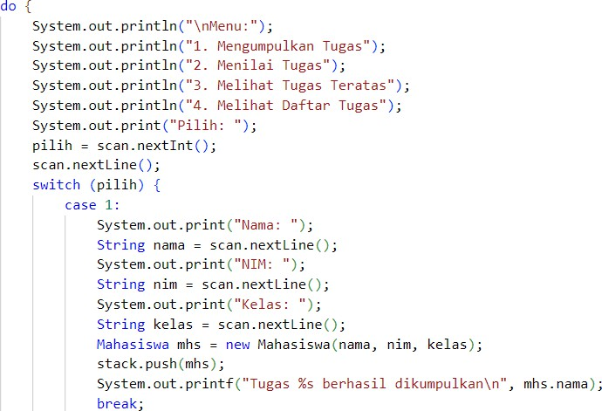
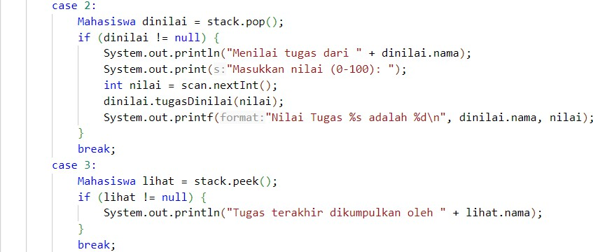
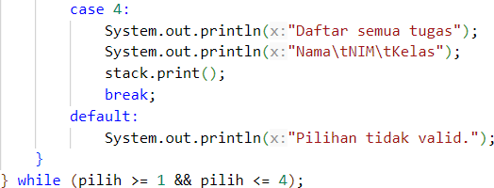
- Add a menu to allow users to choose Stack operations for managing student assignment data, using a do-while loop structure.

Commit and push your code to your Github repository
- Compile and run your program.
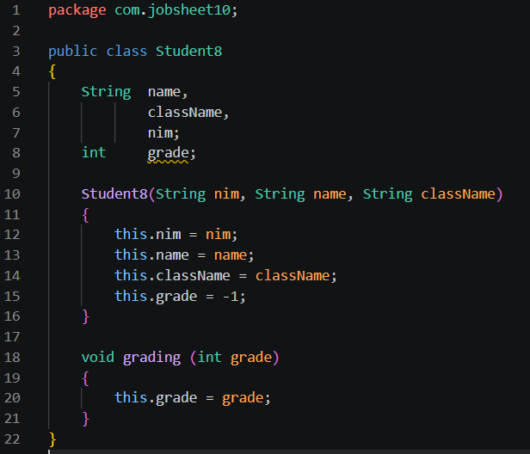
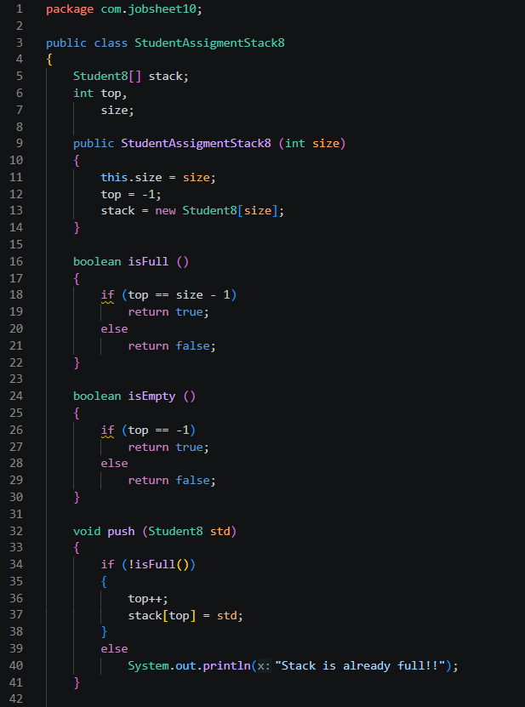
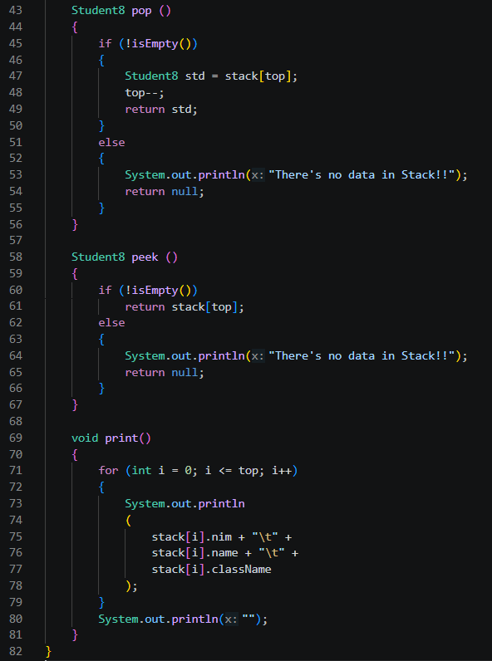
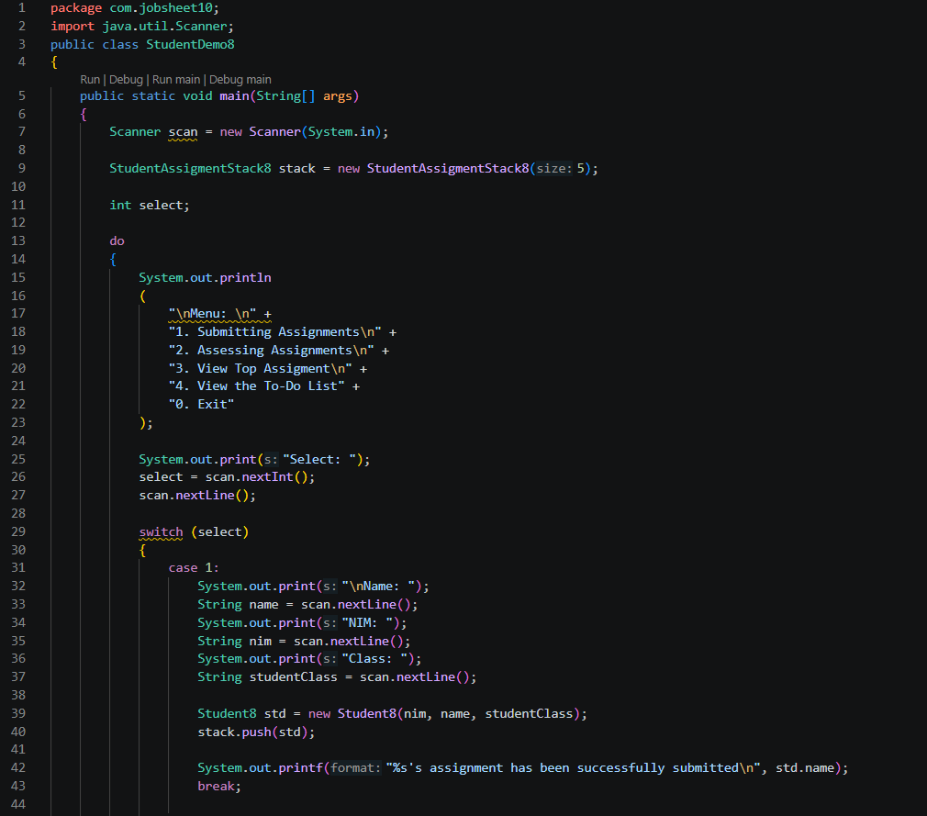
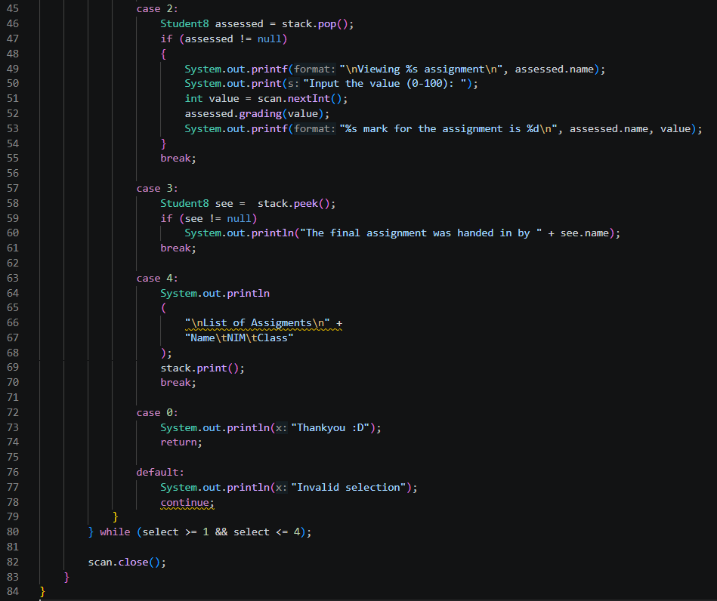
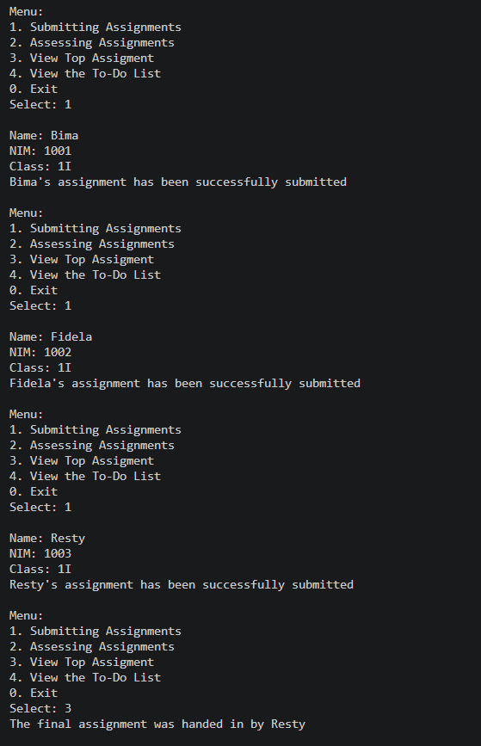
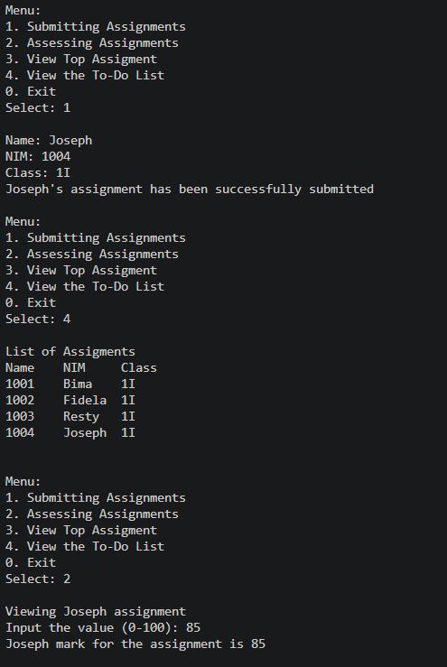
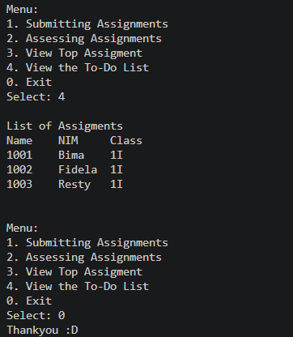

Verification
Compare the output of your compiled program with the following output.
Menu:

- Submit Assignment
- Grade Assignment
- View Top Assignment
- View All Assignments Choose a menu: 1
Name: Bima NIM: 1001
Class Name: 1I
Bima's assignment has been successfully submitted!!

Menu:
- Submit Assignment
- Grade Assignment
- View Top Assignment
- View All Assignments Choose a menu: 1
Name: Fidela NIM: 1002
Class Name: 1I
Fidela's assignment has been successfully submitted!!
Menu:
- Submit Assignment
- Grade Assignment
- View Top Assignment
- View All Assignments Choose a menu: 1
Name: Resty NIM: 1003
Class Name: 1I
Resty's assignment has been successfully submitted!!

Menu:
- Submit Assignment
- Grade Assignment
- View Top Assignment
- View All Assignments Choose a menu: 3
The last assignmentcomes from Resty

Menu:
- Submit Assignment
- Grade Assignment
- View Top Assignment
- View All Assignments Choose a menu: 1
Name: Joseph NIM: 1004
Class Name: 1I
Joseph's assignment has been successfully submitted!!

Menu:
- Submit Assignment
- Grade Assignment
- View Top Assignment
- View All Assignments Choose a menu: 4 Assignment list:
Name NIM Class Name
1001 | Bima 1I
1002 | Fidela 1I
1003 | Resty 1I
1004 | Joseph 1I
Menu:
- Submit Assignment
- Grade Assignment
- View Top Assignment

- View All Assignments Choose a menu: 2
Grading assignment from Joseph Input grade (0-100): 85 Assignment grade of Joseph is 85

Menu:
- Submit Assignment
- Grade Assignment
- View Top Assignment
- View All Assignments Choose a menu: 4 Assignment list:
Name | NIM | Class Name
1001 | Bima | 1I
1002 | Fidela | 1I
1003 | Resty | 1I

Menu:
- Submit Assignment
- Grade Assignment
- View Top Assignment
- View All Assignments Choose a menu:

Questions
- Explain the role of the stack data structure in the student assignment management system. Why was a stack used instead of another data structure (e.g., queue or list)?
The stack implements a Last In First Out mechanism so the most recently submitted assignment is assessed first. This matches a workflow where assessors pick the latest submission to mark immediately. A stack was chosen because the program needs LIFO behaviour rather than FIFO behaviour that a queue would provide. A simple list could store items but would require extra logic to enforce LIFO consistently.
- What is the difference between the push() and pop() methods in a stack, and how are they used in this program?
push() adds a Student8 object to the top of the stack. pop() removes and returns the object currently at the top. In this program push() is used when a student submits an assignment so their Student8 instance is placed on top. pop() is used when an assessor takes the next assignment to mark, removing that most recent submission from the stack.
- Why is it important to check the condition !isFull() before calling the push() method? What could go wrong if this check is removed?
Checking !isFull() prevents adding an element when the underlying array is already at capacity. Without that check the code would increment top beyond the array bounds and cause an ArrayIndexOutOfBoundsException or corrupt memory. The check ensures safe insertion and preserves program stability.
- How many student assignments can be stored in the current implementation of the stack? Provide the specific line of code or variable that determines this.
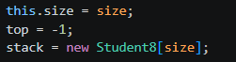
In the demo the stack is created with size 5 using new StudentAssignmentStack8(5) so the current implementation holds up to 5 assignments.
- Modify the existing stack implementation so that the system can also show the first student who submitted their assignment. Describe the changes you made in both StudentDemo and StudentAssignmentStack classes.
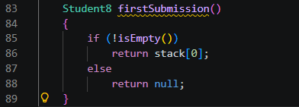
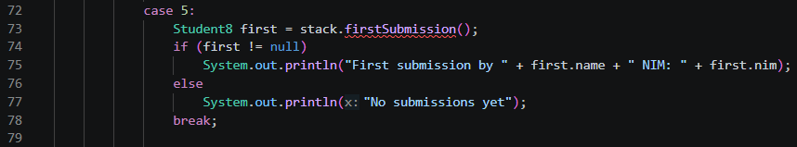
Add a method that returns the bottom element of the stack. The bottom element is at index 0 while top indicates the current top. If the stack is empty return null. Update the demo to call this method and print the result.
- Implement a method to count and return the number of assignments currently stored in the stack. Describe how your method works.
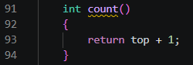
When the stack is empty top is -1 so top + 1 yields 0. Each push() increments top and each pop() decrements top, so top + 1 always reflects the current element count.
- What did you learn from this experiment about stack-based systems? Reflect on a real-world application where this kind of system might be useful.
This experiment highlights the simplicity and predictability of LIFO structures. Stacks are excellent when the most recent item must be handled first. They are memory efficient and easy to implement with an array and a single index. A real-world application is an undo system in text editors where the last action is reverted first. Other examples include browser history navigation, expression evaluation in compilers, and call stacks in program execution.
- Don’t forget to synchronize the changes you made from this questions into your repository!
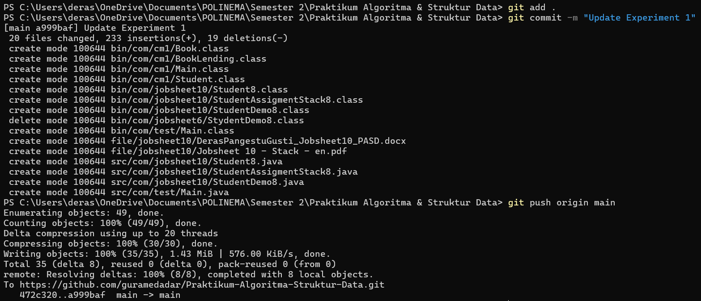

https://github.com/guramedadar/Praktikum-Algoritma-Struktur-Data/tree/main/src/com/jobsheet10

Experiment 2: Convert Assignment Grade to Binary

Time Allocated: 60 Minutes

In Experiment 2, a new method is added that functions to convert the task value of type int into
binary form after the task has been assigned a value and removed from the Stack.

Experiment Steps
- Re-open StudentAsignmentStack<AttendanceNumber>.java
- Create a new method named convertToBinary() with an int parameter grade
String convertToBinary(int grade){
ConversionStack stack = new ConversionStack(); while (grade > 0) {
int mod = grade % 2; stack.push(mod); grade = grade / 2;
}
String binary = "";
while (!stack.isEmpty()) { binary += stack.pop();
}
return binary;
}

In this method, the use of ConversionStack is implemented, which is similar to the StudentAssignmentStack class. The purpose of this is to differentiate the Stack used for students from the Stack used for binary data, as the data types involved are different. Therefore, create a new file named ConversionStack<AttendanceNumber>.java.
Note: It is important to remember that all Stack classes essentially have the same operations (methods). What distinguishes them is the specific activities that need to be performed, such as after adding or removing data.
public class ConversionStack { int[] binaryStack;
int size; int top;

public ConversionStack() { this.size = 32; //asumsi 32 bit binaryStack = new int[size]; top = -1;
}
public boolean isEmpty() { return top == -1;
}

public boolean isFull() { return top == size - 1;
}

public void push(int data) { if (isFull()) {
System.out.println("Stack is already full-filled!!");
} else {
top++;
binaryStack[top] = data;
}
}

public int pop() { if (isEmpty()) {
System.out.println("Stack is still empty!!"); return -1;
} else {
int data = binaryStack[top]; top--;
return data;
}
}
}

- To convert the student's assignment value into binary form after grading, add a line of code in StudentDemo class, specifically within case 2.
case 2:
Student graded = stack.pop(); if (graded != null) {
System.out.println("Grading assignment from " + graded.name);
System.out.print("Input grade (0-100): "); int grade = scan.nextInt(); graded.grading(grade);
System.out.printf("Assignment grade of %s is %d\n", graded.name,
grade);
}
break;
String binary = stack.convertToBinary(grade);
System.out.printf("Assignment grade in binary is %s\n", binary);

- Compile and run the program.

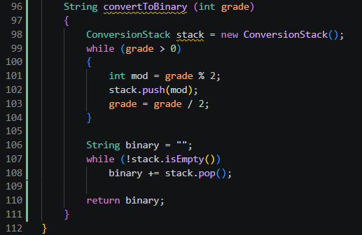
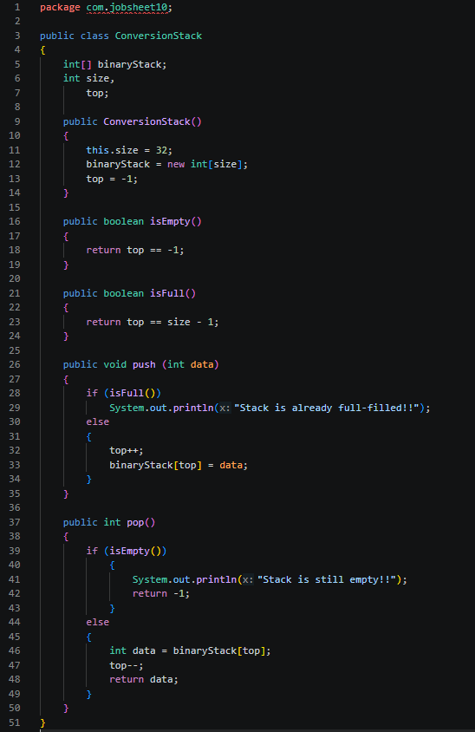
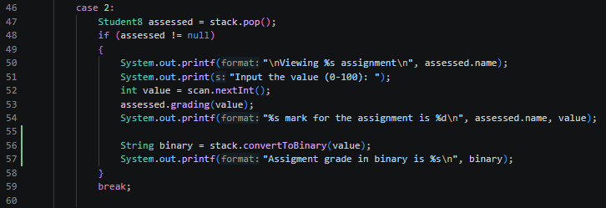
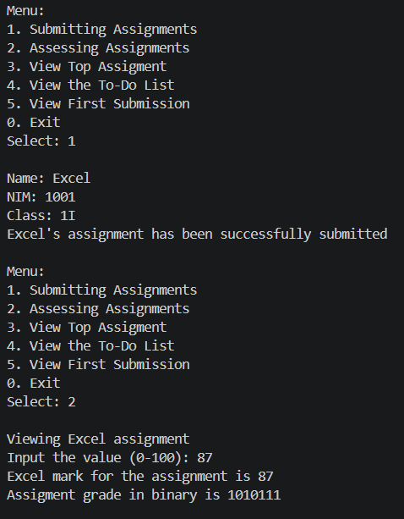

Commit and push the code to your Github repository.

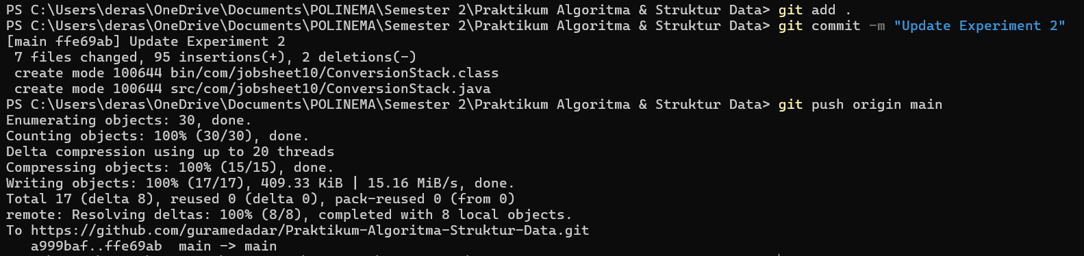

https://github.com/guramedadar/Praktikum-Algoritma-Struktur-Data/tree/main/src/com/jobsheet10

    - Verification
Compare the output of your compiled program with the following output.
Menu:
- Submit Assignment
- Grade Assignment

- View Top Assignment
- View All Assignments Choose a menu: 1
Name: Excel NIM: 1001
Class Name: 1I
Excel's assignment has been successfully submitted!!

Menu:
- Submit Assignment
- Grade Assignment
- View Top Assignment
- View All Assignments Choose a menu: 2
Grading assignment from Excel Input grade (0-100): 87 Assignment grade of Excel is 87
Assignment grade in binary is 1010111

Questions
- Explain the workflow of the convertToBinary() method.
- First, a ConversionStack object is created to store remainders.
- The method repeatedly divides the integer by 2, pushing the remainder (grade % 2) onto the stack. This ensures that the least significant bit is stored first.
- Once the integer becomes 0, the loop ends.
- Then, the method pops all elements from the stack one by one, appending them to a string. Because stacks are LIFO, this reverses the order of remainders, producing the correct binary sequence.
- Finally, the binary string is returned.
- In the convertToBinary() method, change the loop condition to while (grade != 0). What is the result? Explain the reason!
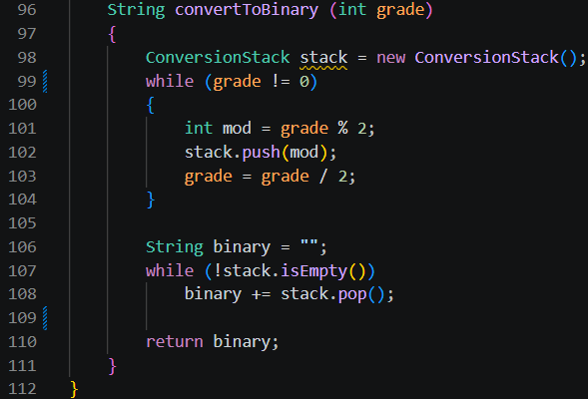
The result is essentially the same as while (grade > 0) because both conditions terminate when grade reaches 0.
With while (grade > 0), the loop only runs when the integer is positive. If grade is 0 at the start, the loop is skipped entirely, and the binary string remains empty. With while (grade != 0), the loop would also run for negative values, which is not intended in this context. Negative integers would cause an infinite loop because dividing by 2 never reaches exactly 0.

2.4 Assignment

Allocated Time : 90 Minutes
Students submit an excuse letter (due to illness or other reasons) each time they are absent from a lecture. The most recent letter submitted will be processed or validated first by the department administrator. Refer to the class diagram below.
ExcuseLetter<AttendanceNumber>
id: String name: String
className: String typeOfExcuse: char
duration: int
ExcuseLetter<AttendanceNumber>()
ExcuseLetter<AttendanceNumber>(id: String, name: String, className: String, type: char,
duration: int)

The typeOfExcuse attribute is used to store the type of student leave (S: Sick, or I: Other personal reasons), while the duration attribute stores the length of the leave period.
Based on the class diagram, implement a class named ExcuseLetter, and add a ExcuseLetterStack class to manage the collection of ExcuseLetter objects. In the class containing the main method, provide the following menu options:
- Submit Excuse Letter – to input new excuse letter data
- Process Excuse Letter – to process or verify the latest excuse letter

- View Latest Excuse Letter – to display the top letter in the stack
- Search for Letter – to search for the presence of a letter by the student's name

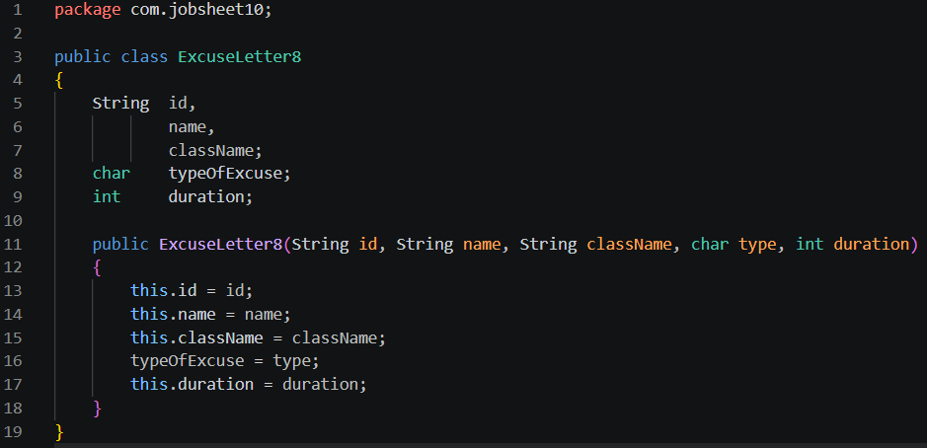
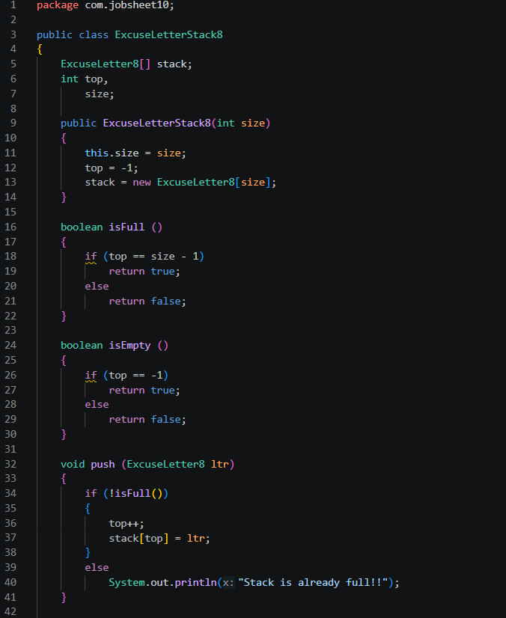
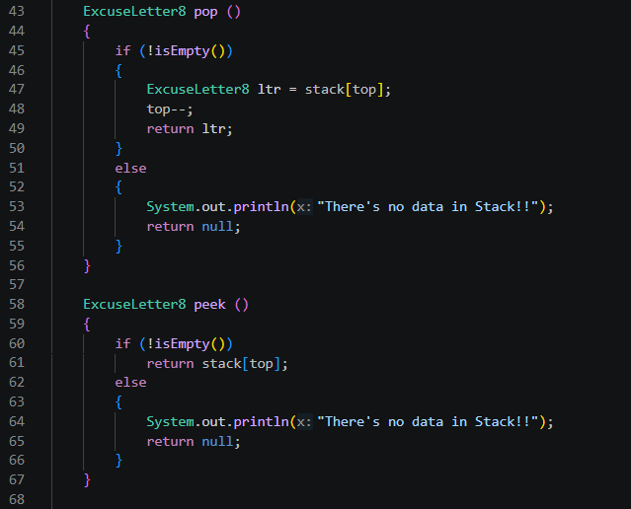
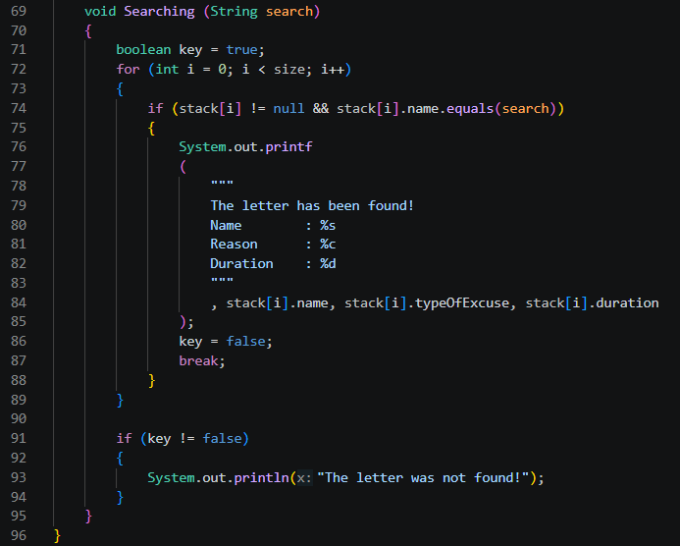
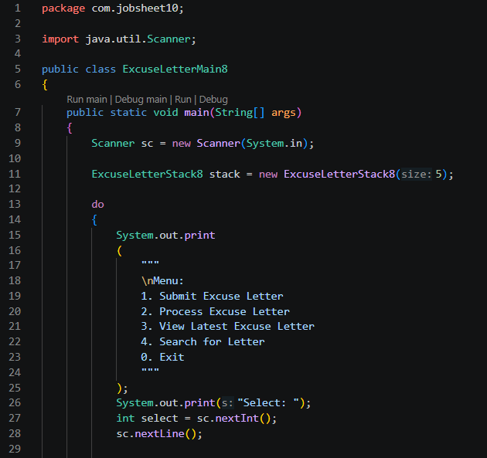
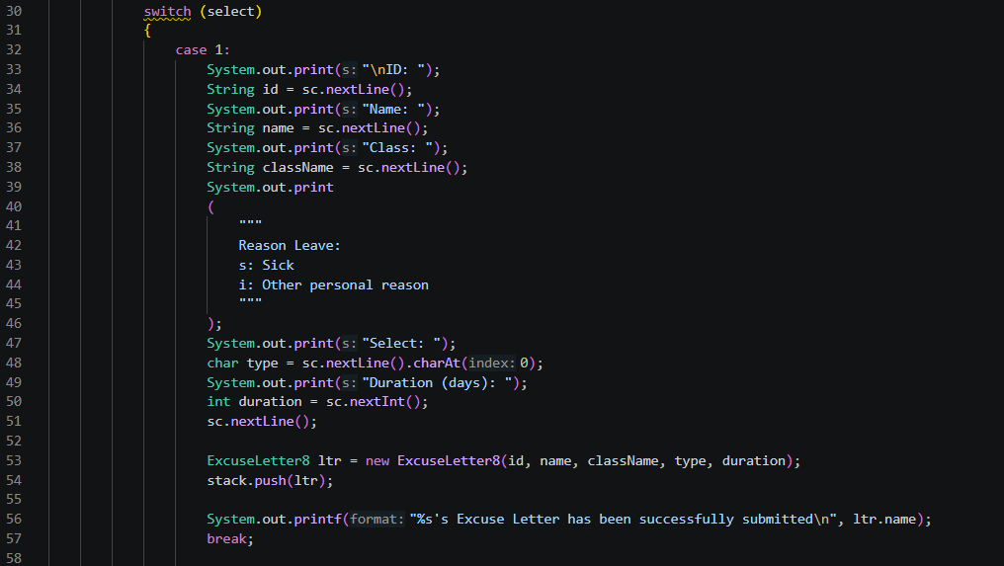
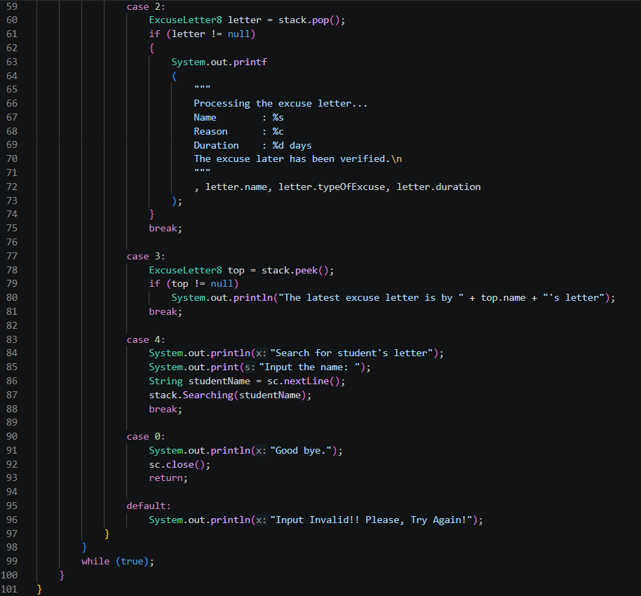
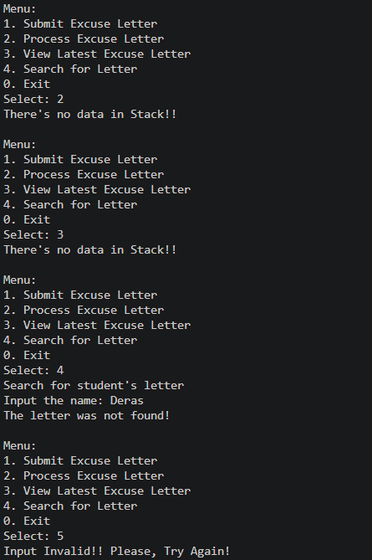
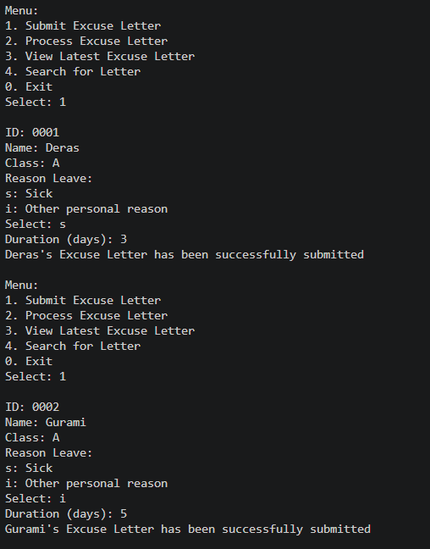
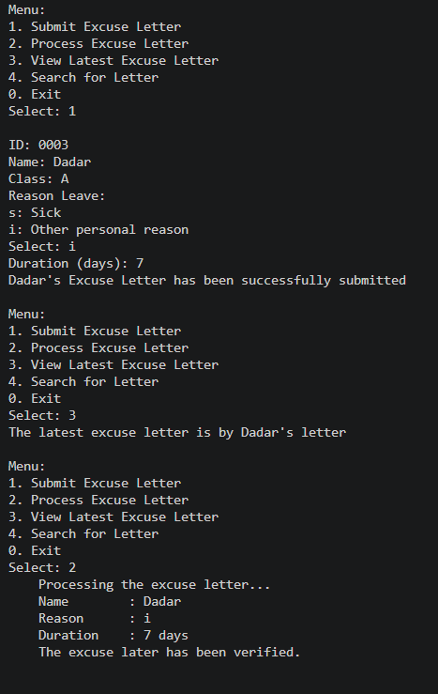
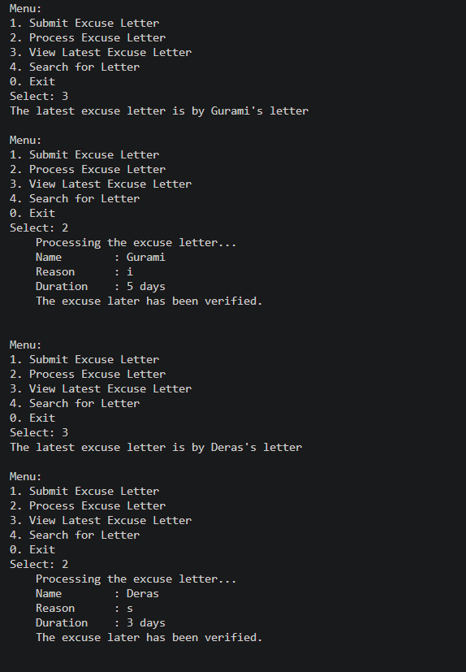
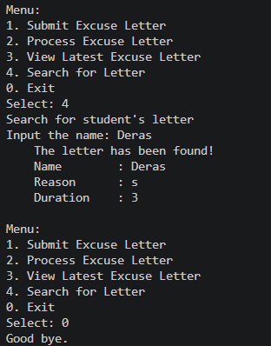

Github:
https://github.com/guramedadar/Praktikum-Algoritma-Struktur-Data/tree/main/src/com/jobsheet10

