Name: Deras Pangestu Gusti (08)
Class: SIB 1G
NIM: 254107060114

JOBSHEET XI QUEUE

Learning Objectives
After completing this practical session, students will be able to:
- Understand the structure and concept of the Queue data structure
- Create and declare a Queue data structure
- Implement Queue algorithms using arrays

Labs 1
  - Experiment 1 : Queue Basic Operations

Allocated Time : 90 minutes
In this experiment, we will implement the basic operations of the Queue algorithm. Take a look at the following Queue class diagram:
Queue
data: int[] front: int rear: int size: int
max: int
Queue(n: int) isFull(): boolean isEmpty(): boolean
enqueue(dt: int): void dequeue(): int
peek: void print(): void
clear(): void

The following steps will implement Java program from the above design.

Experiment Steps
- Create a new folder named P1Jobsheet11 or another prefered name, inside the Praktikum-ASD repository, then create a new class named Queue.
- Add the attributes of the Queue as shown in the class diagram, then add the constructor as described below:
int[] data;
int front, rear, size, max;

public Queue(int n){ max = n;

data = new int[max]; size = 0;
front = rear = -1;
}

- Create a boolean method named isEmpty to check whether the queue is empty.
boolean isEmpty(){
if(size == 0){ return true;
}else{
return false;
}
}

- Create a boolean method named isFull to check whether the queue is full.
boolean isFull(){
if(size == max){ return true;
}else{
return false;
}
}

- Create a void method named peek to display the element at the front of the queue.
void peek(){
if(!isEmpty()){
System.out.println("Front data: "+data[front]);
}else{
System.out.println("Queue is empty!!!");
}
}

- Create a void method named print to display all elements in the queue, from the front to the rear position.
void print(){
if(!isEmpty()){ int i = front;
while(i != rear){ System.out.print(data[i]+" "); i = (i+1)%max;
}
System.out.println(data[i]+" ");
System.out.println("Number of element: "+size);
}else{

System.out.println("Queue is empty!!!");
}
}

- Create a void method named clear to remove all elements from the queue.
void clear(){
if(!isEmpty()){
front = rear = -1; size = 0;
System.out.println("All data has been successfully
removed!");
}else{
System.out.println("Queue is already empty!!!");
}
}

- Create a void method named enqueue to add an element to the queue, using a parameter dt of type int.
void enqueue(int dt){
if(!isFull()){
if(isEmpty()){ front=rear=0;
}else{
if(rear==max-1){ rear=0;
}else{
rear++;
}
}
data[rear]=dt; size++;
System.out.printf("%d is successfully added at index %d\n",
dt, rear);
}else{
System.out.println("Queue is full!!!");
}
}

- Create an int method named dequeue to remove and return the data from the front position of the queue.
int dequeue(){
int dt = 0; if(!isEmpty()){
dt = data[front];
size--;

if(isEmpty()){ front=rear=-1;
}else{
if(front==max-1){ front=0;
}else{
front++;
}
}
}else{
System.out.println("Queue is empty!!!");
}
return dt;
}

- Next, create a new class named QueueMain. Create a void method named menu to display and handle the program's menu options during execution.
static void menu(){
System.out.println("Available menu:"); System.out.println("1. Enqueue"); System.out.println("2. Dequeue"); System.out.println("3. Print"); System.out.println("4. Peek"); System.out.println("5. Clear"); System.out.println("=======================");
}

- Create the main method, then declare a Scanner object named sc.
- Create a variable named n to store the user input representing the maximum number of elements that can be stored in the queue.
Scanner sc = new Scanner(System.in); System.out.print("Input maximum number of data: "); int n = sc.nextInt();
- Instantiate a Queue object named Q, passing n as the queue's element capacity.
Queue Q = new Queue(n);
- Declare an integer variable named choice to store the user's menu selection.
- Use a do-while loop to keep the program running based on user input. Inside the loop, use a switch-case statement to execute queue operations according to the user's menu selection.
public static void main(String[] args) {
Scanner sc = new Scanner(System.in); System.out.print("Input maximum number of data: "); int n = sc.nextInt();
Queue Q = new Queue(n);

int choice = -1; do {
menu();
choice = sc.nextInt(); switch (choice) {
case 1:
System.out.print("Input new data: "); int newData = sc.nextInt(); Q.enqueue(newData);
break; case 2:
int outData = Q.dequeue(); if (outData != 0) {
System.out.println("Removed data: " + outData); break;
}
case 3:
Q.print(); break;
case 4:
Q.peek(); break;
case 5:
Q.clear(); break;
}
} while (choice==1 || choice==2 || choice==3 || choice==4 || choice==5);
}

- Compile and run the QueueMain class, then observe the results.
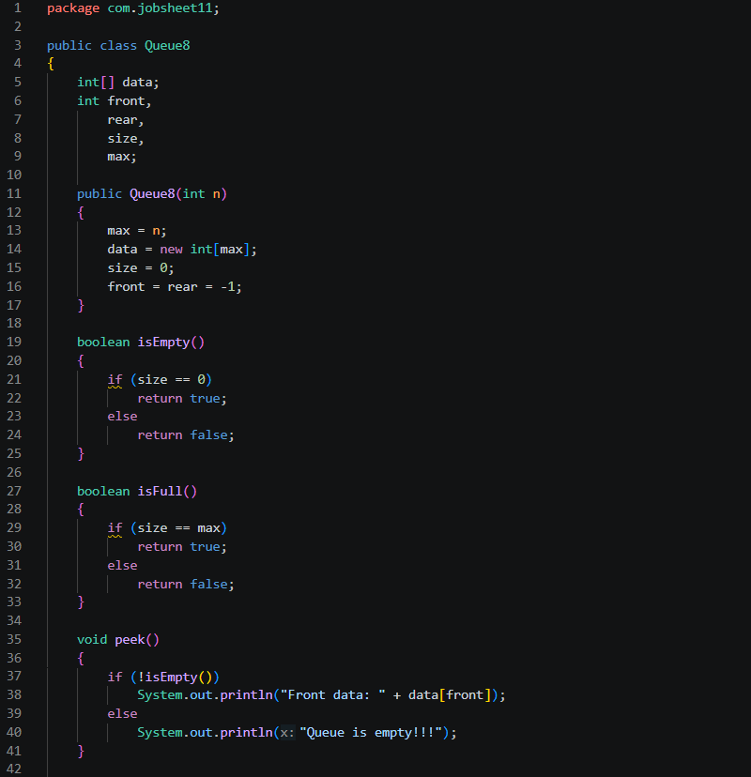
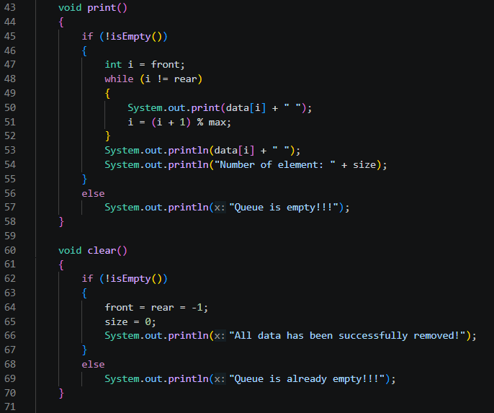
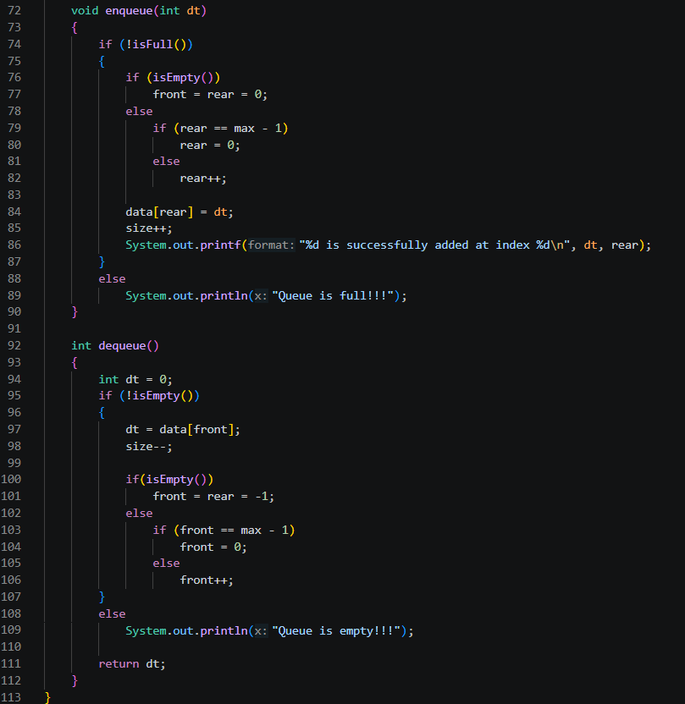
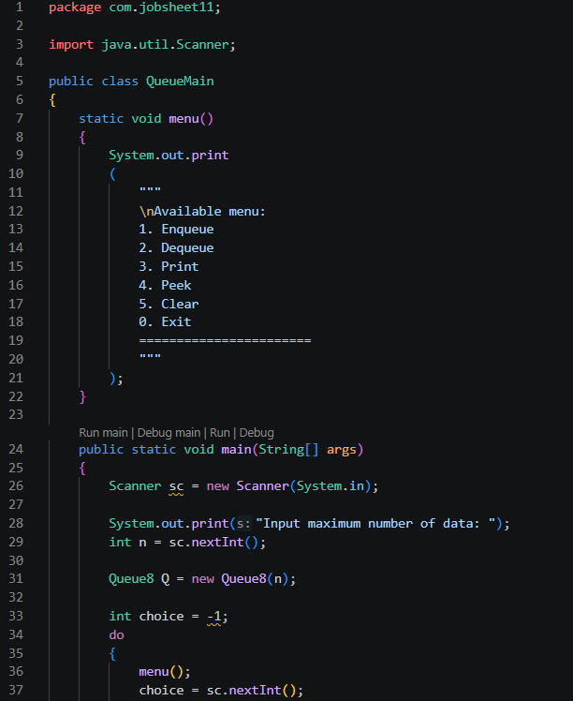
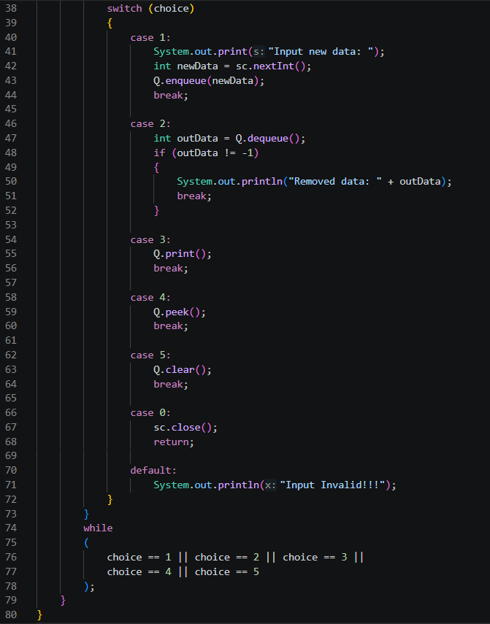
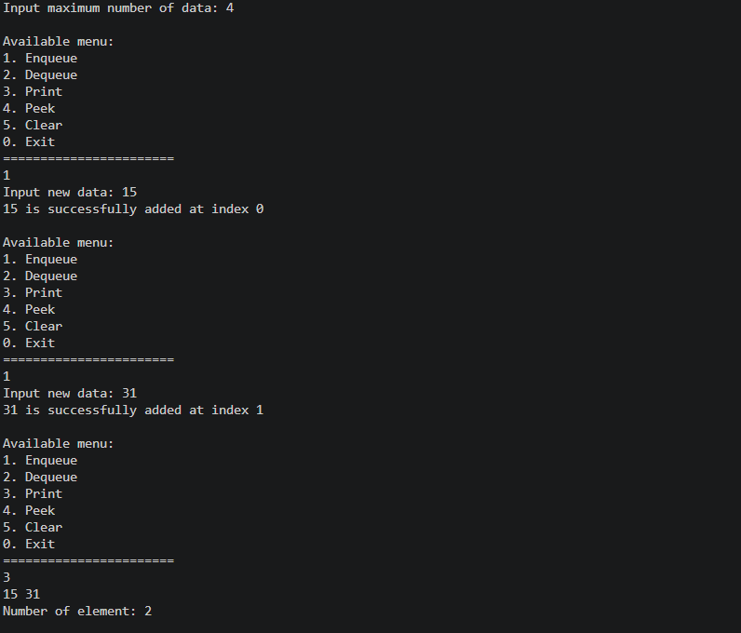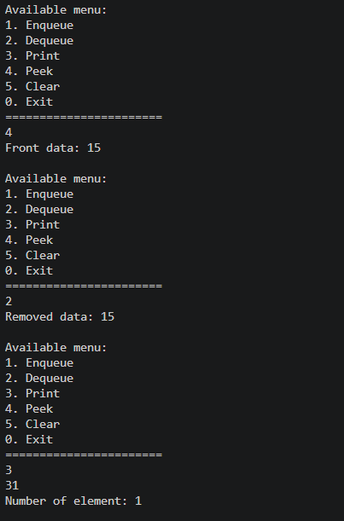

Output Verification
Verify the output with the following:
Input maximum number of data: 4 Available menu:
- Enqueue
- Dequeue
- Print
- Peek
- Clear
======================= 1
Input new data: 15
15 is successfully added at index 0 Available menu:
- Enqueue
- Dequeue
- Print
- Peek
- Clear

======================= 1
Input new data: 31
31 is successfully added at index 1 Available menu:
- Enqueue
- Dequeue
- Print
- Peek
- Clear
======================= 3
15 31
Number of element: 2 Available menu:
  - Enqueue
  - Dequeue
  - Print
  - Peek
  - Clear
======================= 4
Front data: 15 Available menu:
    - Enqueue
    - Dequeue
    - Print
    - Peek
    - Clear
======================= 2
Removed data: 15 Available menu:
      - Enqueue
      - Dequeue
      - Print
      - Peek
      - Clear
======================= 3
31
Number of element: 1 Available menu:
        - Enqueue
        - Dequeue
        - Print
        - Peek
        - Clear
=======================

Question
- In the constructor, why are the initial values of the front and rear attributes set to -1, while the size attribute is set to 0?
In the constructor, the attributes front and rear are set to -1 to indicate that the queue is initially empty and no valid index is being used. The size attribute is set to 0 to represent that there are no elements stored in the queue at the start. This combination clearly distinguishes the empty state from any valid occupied state.
- In the Enqueue method, explain the meaning and purpose of the following code snippet!
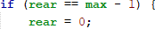
This code ensures the circular behaviour of the queue. When the rear pointer reaches the last index (max - 1), it wraps around to index 0. This allows the queue to reuse empty slots at the beginning of the array once elements have been dequeued, preventing wasted space and implementing a circular queue.
- In the Dequeue method, explain the meaning and purpose of the following code snippet!
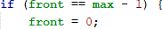

This code performs the same circular adjustment for the front pointer. When the front reaches the last index of the array, it wraps back to index 0. This ensures that the queue can continue to remove elements correctly even after the pointer has reached the end of the array, maintaining the circular structure.
- In the print method, why does the loop variable i start from front instead of 0 (i.e., int i = 0)?
The loop variable i starts from front instead of 0 because the queue does not necessarily begin at index 0. After several enqueue and dequeue operations, the logical start of the queue may be at a different position. Starting from front guarantees that the elements are printed in the correct logical order, not simply from the beginning of the array.
- Review the print method again, and explain the meaning of the following code snippet!
This expression increments the index i and uses the modulo operator to wrap it around when it reaches max. It ensures that the traversal continues correctly in a circular manner, moving from the end of the array back to the beginning without exceeding array bounds.
- Show the code snippet that represents a queue overflow!
- When a queue overflow or underflow occurs, the program continues to run and only displays informational text. Modify the program so that it stops when a queue overflow or underflow happens!
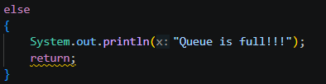
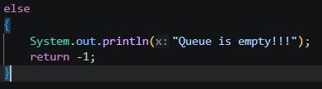

Experiment 2 : Academic Service Queue

Allocated Time : 90 minutes
In this experiment, we will create a program that illustrates the service provided by the Academic Admin. Please refer to the following class diagram:
Student
nim:String name: String
studyProgram: String
className: String
Student (nim: String, name: String, studyProgram: String, className: String)
void print()

Experiment Steps
Based on the class diagram, a Student class will be created in Java.
- Create a new class named Student
- Add the attributes as shown in the class diagram. Then, create the parametric constuctor as follows:
public Student(String nim, String name, String studyProgram, String
className){
this.nim = nim; this.name = name;
this.studyProgram = studyProgram; this.className = className;
}
Provide print() method to display the whole data of student.
void print(){
System.out.println(nim+" - "+name+" - "+studyProgram+" - "+className);
}

- Copy the Queue class code from Experiment 1 to be reused in this experiment, and rename the class to StudentQueue. Since in Experiment 1, the data stored in the queue was only an integer array, while in this experiment the data used is Student object, you will need to modify the StudentQueue class accordingly.
Student[] data;
int front, rear, size, max;

public StudentQueue(int n){ max = n;
data = new Student[max]; size = 0;
front = 0;
rear = -1;
}

- Modify the StudentQueue class by changing the type of the data array from int[] to Student[], since in this case the data to be stored consists of Student objects. The modifications should be applied to the attributes, the enqueue method, and the dequeue method.
void enqueue(Student dt){
if(isFull()){
System.out.println("Queue is full!!!"); return;
}
rear = (rear+1)%max; data[rear] = dt; size++;
System.out.printf("%s is successfully added at index %d\n", dt.name, rear);
}

Student dequeue(){
if(isEmpty()){
System.out.println("Queue is empty!!!"); return null;
}
Student dt = data[front]; front = (front+1)%max; size--;
return dt;
}

- Next, implement the peek and print methods to display the front-most data in the service queue and to display all the data in the service queue, respectively.
void peek(){

if(!isEmpty()){ System.out.println("Front data: "); data[front].print();
}else{
System.out.println("Queue is empty!!!");
}
}

void print(){
if(isEmpty()){
System.out.println("Queue is empty!!!"); return;
}
int i = front; while(i != rear){
data[i].print(); i = (i+1)%max;
}
data[i].print();
System.out.println("Number of element: "+size);
}

- Next, create a new class named StudentQueueMain within the same package. In this class, define the main function and declare a Scanner object with the name sc.
- Then, instantiate an StudentQueue object named queue with the parameter set to the maximum queue size (for example, 5).
- Declare an integer variable named choice to store the user's menu selection.
- Add the following code to loop through the menu options based on the input provided by the user:
public static void main(String[] args) {
Scanner sc = new Scanner(System.in); StudentQueue queue = new StudentQueue(5); int choice;
do {
System.out.println("\n=== Academic Service Menu ==="); System.out.println("1. Enqueue Student"); System.out.println("2. Dequeue Student"); System.out.println("3. Display Front"); System.out.println("4. Display All Data"); System.out.println("5. Queue Size"); System.out.println("0. Exit"); System.out.print("Choose a menu: ");
choice = sc.nextInt(); sc.nextLine();

switch (choice) { case 1:
System.out.print("NIM : "); String nim = sc.nextLine(); System.out.print("Name : "); String name = sc.nextLine();
System.out.print("Study Program : "); String studyProgram = sc.nextLine(); System.out.print("Class : ");
String className = sc.nextLine();
Student std = new Student(nim, name, studyProgram,
className);
queue.enqueue(std); break;
case 2:
Student studentBeingServed = queue.dequeue(); if (studentBeingServed != null) {
System.out.println("Student being served:"); studentBeingServed.print();
}
break; case 3:
queue.peek(); break;
case 4:
queue.print(); break;
case 5:
System.out.println("Queue size: " + queue.size); break;
case 0:
System.out.println("Thanks!!"); break;
default:
System.out.println("Invalid menu!!");
}
} while (choice != 0);
}

- Compile and run StudentQueueMain class and observe the result!
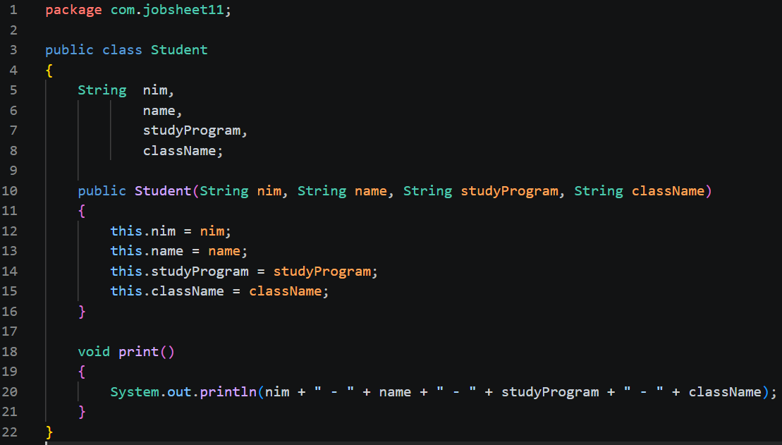
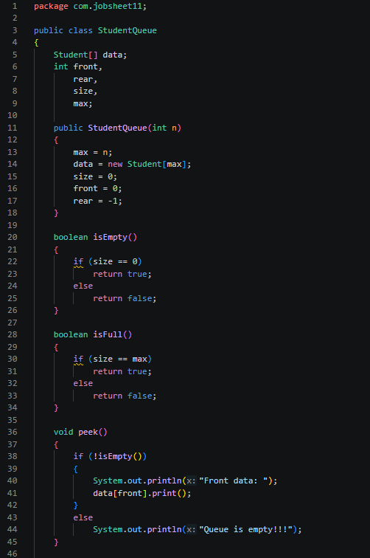
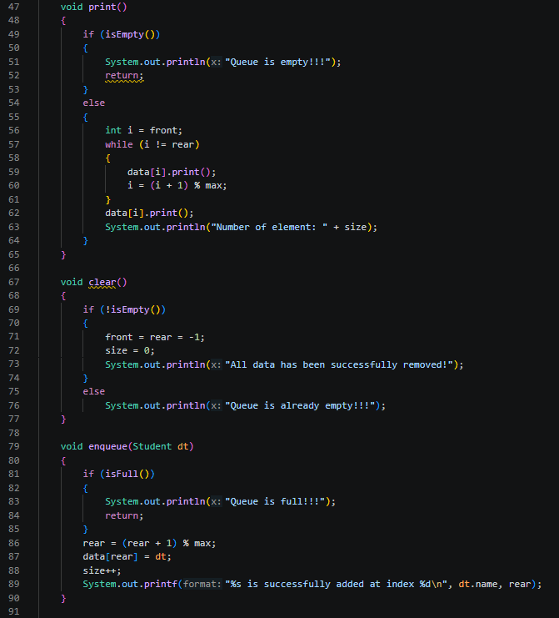
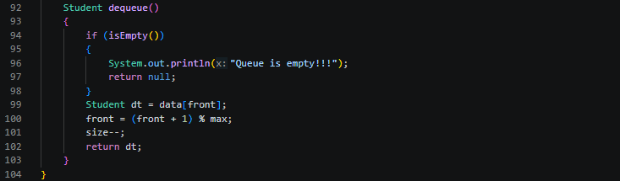
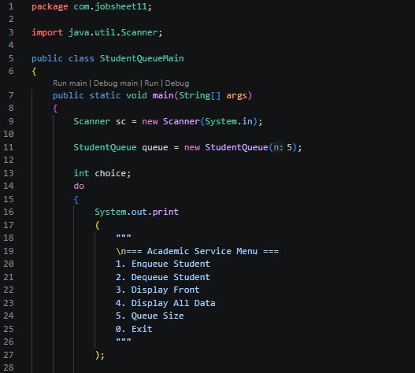
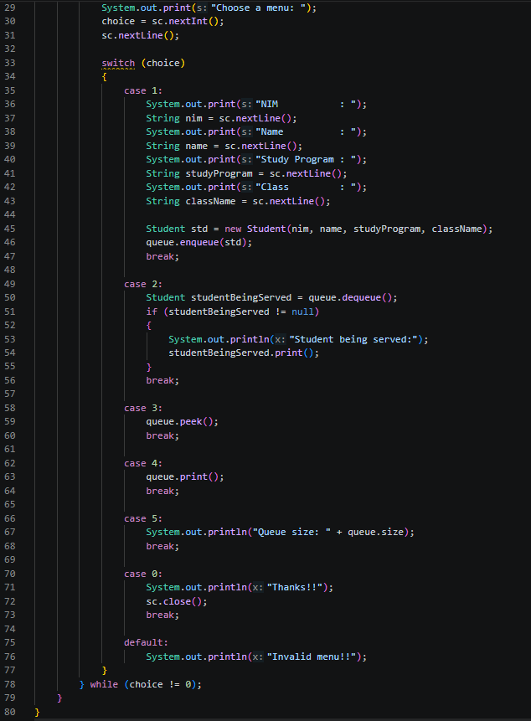
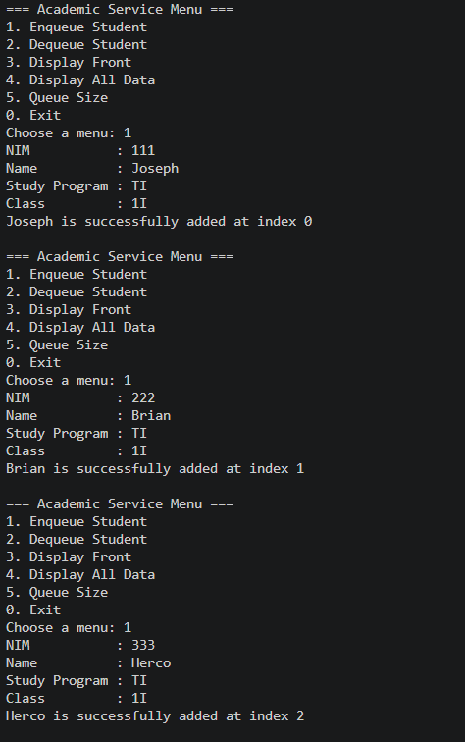
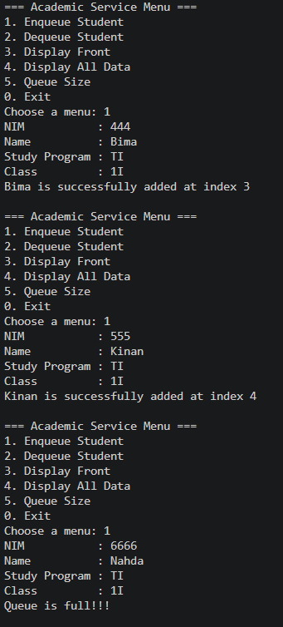
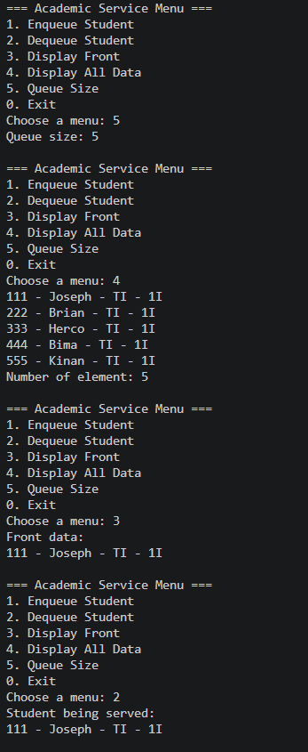
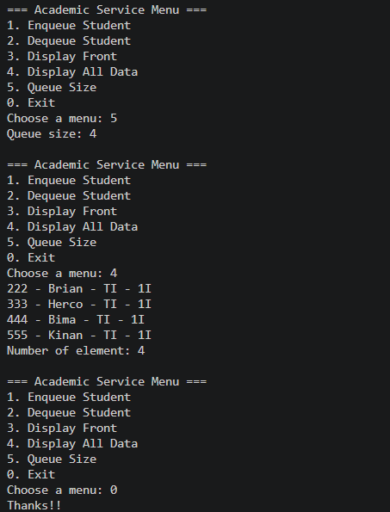

2.2.2 Result Verification
Verify the output with the following:
=== Academic Service Menu ===
- Enqueue Student
- Dequeue Student
- Display Front

- Display All Data
- Queue Size
- Exit
Choose a menu: 1 NIM : 111
Name : Joseph Study Program : TI Class : 1I
Joseph is successfully added at index 0

=== Academic Service Menu ===  - Enqueue Student  - Dequeue Student  - Display Front  - Display All Data  - Queue Size  0. Exit  Choose a menu: 1 NIM : 222  Name : Brian Study Program : TI Class : 1I  Brian is successfully added at | index | 1
=== Academic Service Menu ===  - Enqueue Student  - Dequeue Student  - Display Front  - Display All Data  - Queue Size  0. Exit  Choose a menu: 1 NIM : 333  Name : Herco Study Program : TI Class : 1I  Herco is successfully added at | index | 2
=== Academic Service Menu ===
- Enqueue Student
- Dequeue Student
- Display Front
- Display All Data
- Queue Size
- Exit
Choose a menu: 1 NIM : 444
Name : Bima
Study Program : TI Class : 1I
Bima is successfully added at index 3

=== Academic Service Menu ===
- Enqueue Student
- Dequeue Student
- Display Front
- Display All Data
- Queue Size
- Exit
Choose a menu: 1 NIM : 555
Name : Kinan Study Program : TI Class : 1I
Kinan is successfully added at index 4

=== Academic Service Menu ===

- Enqueue Student
- Dequeue Student
- Display Front
- Display All Data
- Queue Size
- Exit
Choose a menu: 1 NIM : 6666
Name : Nahda Study Program : TI Class : 1I
Queue is full!!!

=== Academic Service Menu ===
- Enqueue Student
- Dequeue Student
- Display Front
- Display All Data
- Queue Size
- Exit
Choose a menu: 5 Queue size: 5

=== Academic Service Menu ===
- Enqueue Student
- Dequeue Student
- Display Front
- Display All Data
- Queue Size
0. Exit
Choose a menu: 4
111 - Joseph - TI - 1I
222 - Brian - TI - 1I
333 - Herco - TI - 1I
444 - Bima - TI - 1I
555 - Kinan - TI - 1I
Number of element: 5
=== Academic Service Menu ===
- Enqueue Student
- Dequeue Student
- Display Front
- Display All Data
- Queue Size
0. Exit
Choose a menu: 3 Front data:
111 - Joseph - TI - 1I

=== Academic Service Menu ===
- Enqueue Student
- Dequeue Student
- Display Front
- Display All Data
- Queue Size
0. Exit
Choose a menu: 2 Student being served:
111 - Joseph - TI - 1I

=== Academic Service Menu ===
- Enqueue Student
- Dequeue Student
- Display Front
- Display All Data
- Queue Size
0. Exit

Choose a menu: 5 Queue size: 4
=== Academic Service Menu ===
- Enqueue Student
- Dequeue Student
- Display Front
- Display All Data
- Queue Size
0. Exit
Choose a menu: 4
222 - Brian - TI - 1I
333 - Herco - TI - 1I
444 - Bima - TI - 1I
555 - Kinan - TI - 1I
Number of element: 4

=== Academic Service Menu ===
- Enqueue Student
- Dequeue Student
- Display Front
- Display All Data
- Queue Size
0. Exit
Choose a menu:

2.2.3 Questions
- What is the main difference between the Queue (experiment 1) and StudentQueue classes in terms of the data type they manage? Why is this change in data type important?
- In the original Queue class, the queue stores primitive integers.
- In the StudentQueue class, the queue stores objects of type Student, which contain multiple attributes (nim, name, studyProgram, className).
This change is important because it allows the queue to handle complex data structures rather than simple numbers. It reflects a real-world scenario where queues often manage records or objects, not just primitive values.
- How do the enqueue and dequeue methods in StudentQueue differ from those in Queue?
- In the integer-based Queue, enqueue(int dt) and dequeue() work with primitive values, directly storing and returning integers.
- In StudentQueue, enqueue(Student dt) stores an entire Student object, and dequeue() returns a Student object.
- Examine the constructor of the StudentQueue class: why is the front attribute initialized to 0, whereas in the Queue class from Experiment 1, the front attribute is initialized to -1?
- In the original Queue, front was initialised to -1 to mark the queue as empty, with no valid index.
- In StudentQueue, front is initialised to 0. This is because the implementation assumes that the logical start of the queue is at index 0 and uses size to determine whether the queue is empty.
- Modify the program by adding a new method called viewRear() in the StudentQueue class to check the queue element at the rear position. Also, update the menu in the StudentQueueMain class by adding option 6: “Check rear of the queue,” so that the viewRear() method can be invoked.
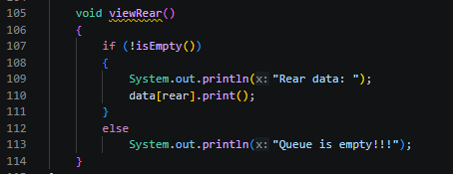
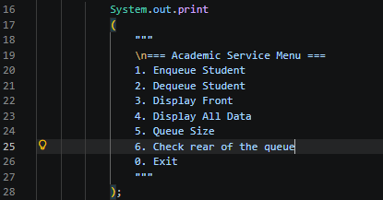
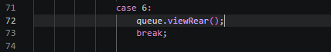

2.3 Assignment

Time : 120 minutes
Create a queue-based program to simulate the approval queue for Student Course Registration Forms (KRS) by Academic Advisors (DPA). When a student joins the queue, they must first register their personal data (as in Experiment 2). Use queue classes similar to those used in Experiment1 and 2, and implement the following methods:
- Check if the queue is empty, check if the queue is full, and clear the queue.
- Add a student to the queue (enqueue), and process the KRS approval (dequeue) – each approval session processes 2 students at a time (from the first two in the queue).

- Show all students in the queue, show the first two students in line, and show the last student in the queue.
- Print the total number of students in the queue, print the number of students who have completed the KRS approval process.
- The maximum queue size is 10, and each DPA can handle up to 30 students. Display the number of students who have not yet completed the KRS approval process.
Draw the class diagram for the queue structure and implement all the required methods through a menu-based interface in the main function.
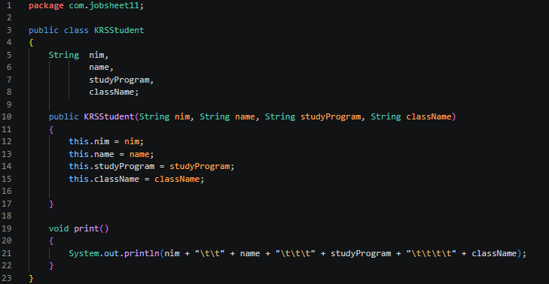
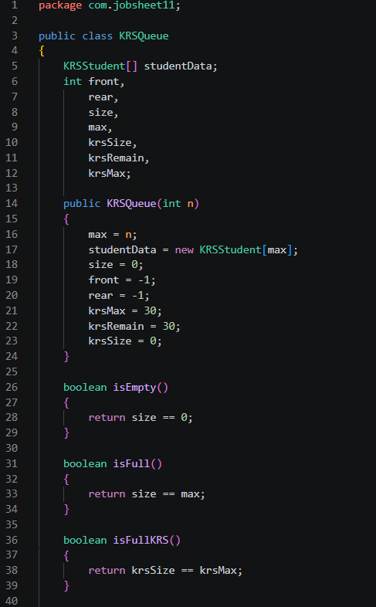
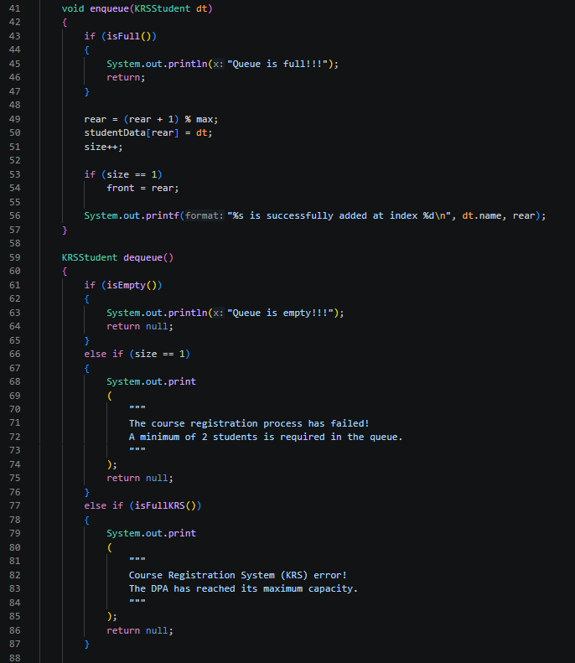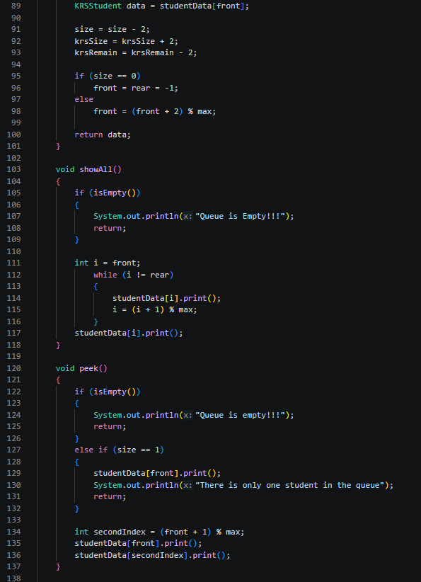
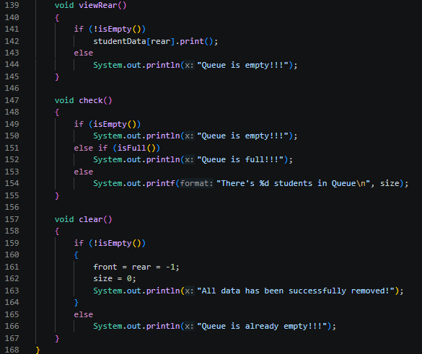
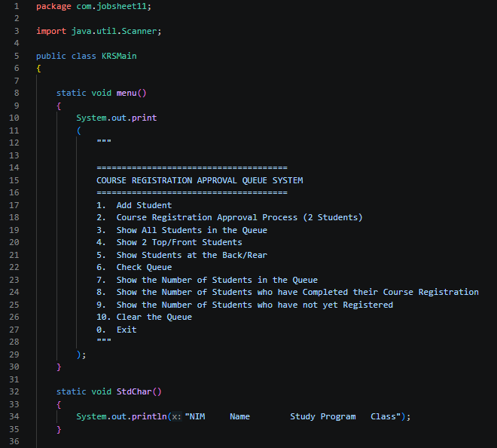
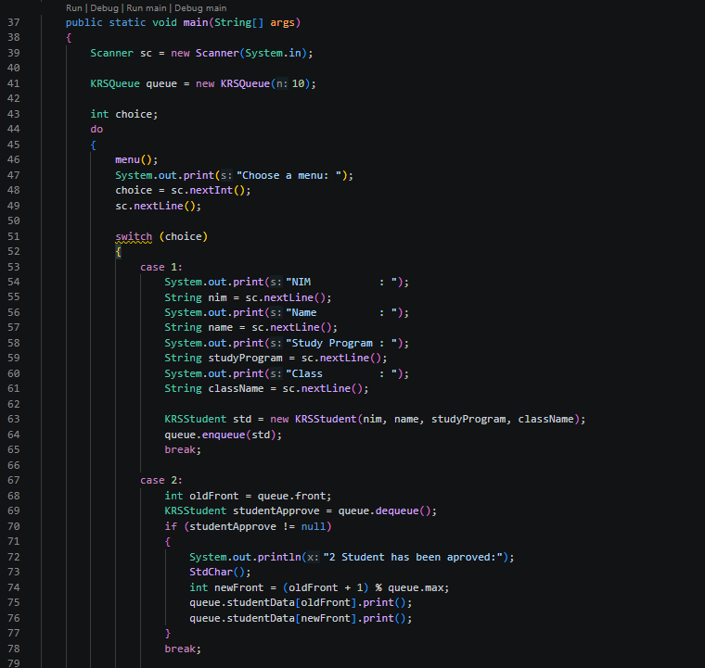
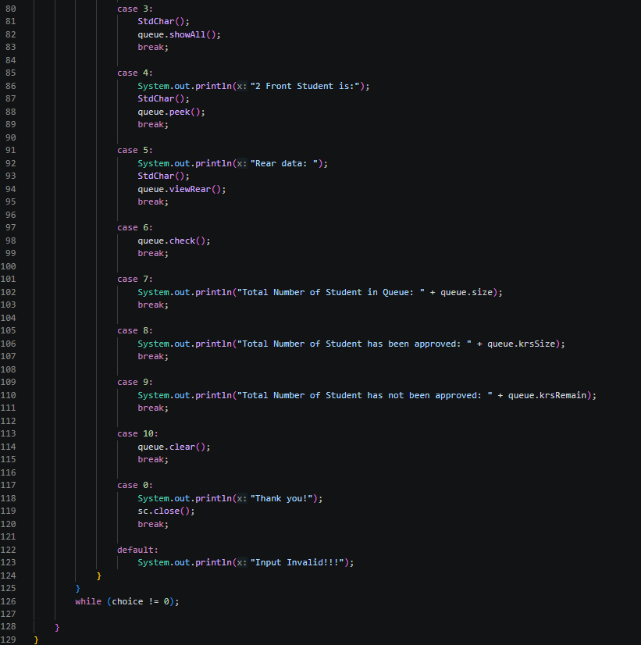
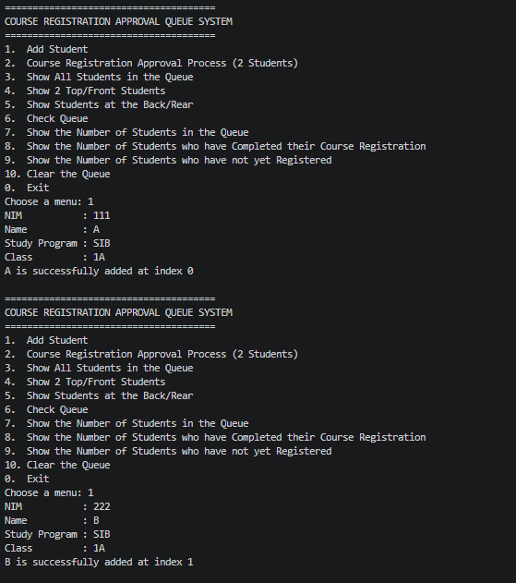
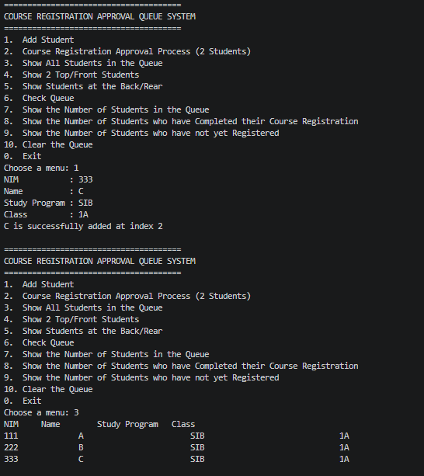
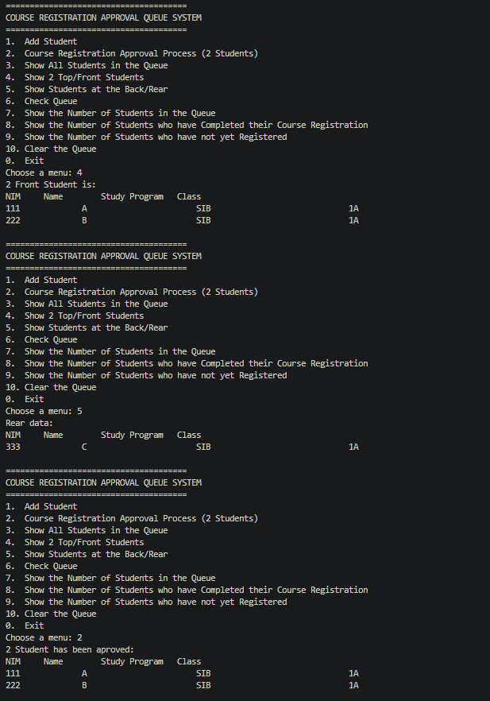
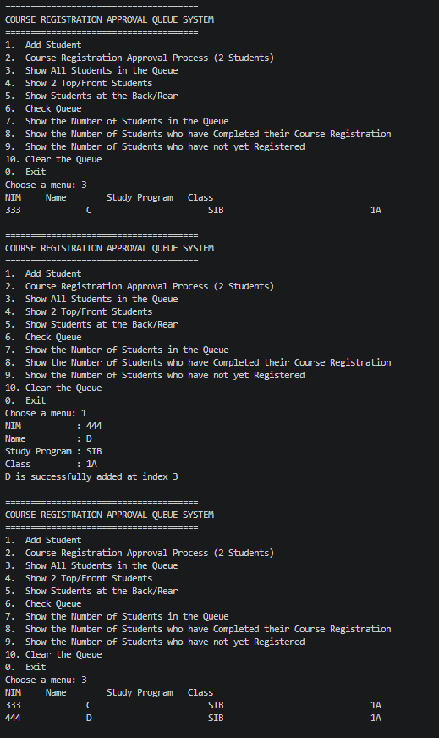
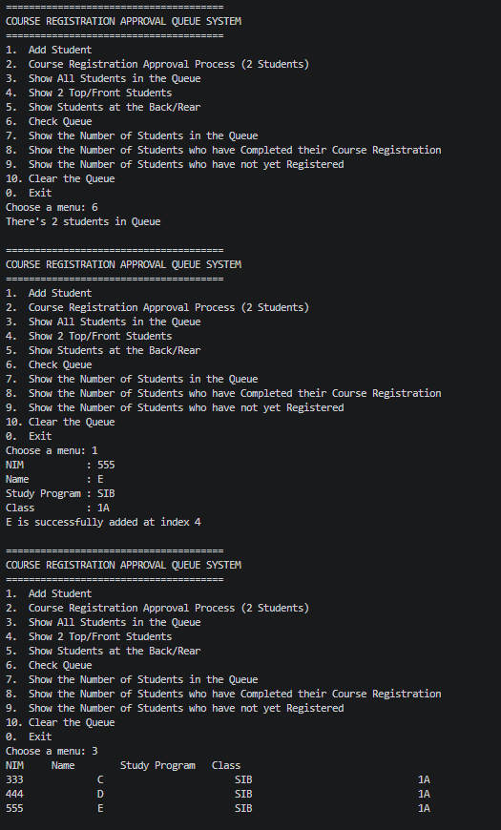
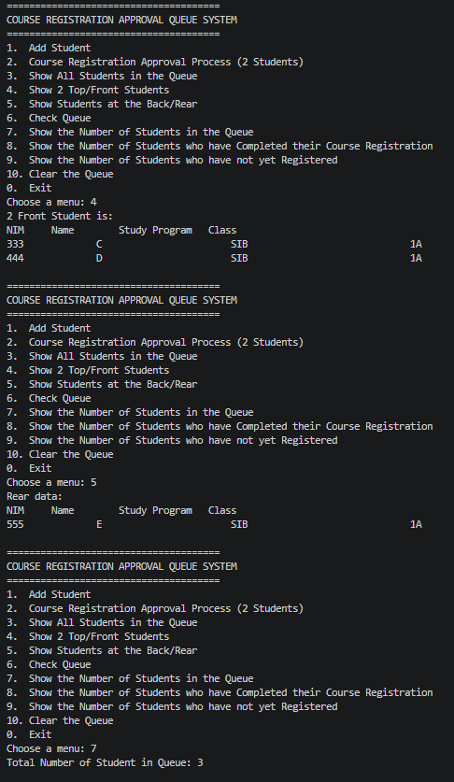
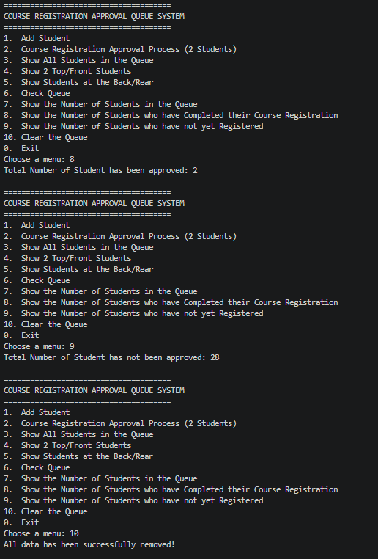
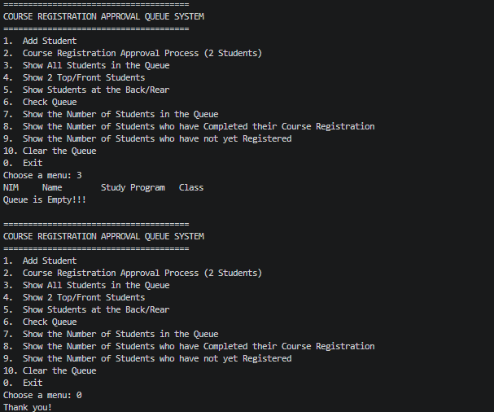

Github:

