Name: Deras Pangestu Gusti (08)
Class: SIB 1G
NIM: 254107060114

JOBSHEET VII SEARCHING

Learning Objective
After learning this practicum course, students will be able to:
- Define Searching algorithm
- Create and declare searching algorithm structure
- Implement searching algorithms

Sequential Search Method
Look at the following class diagram! Use this class diagram as blueprint of program code in
Students class

Students
Nim: int name: String age: int
gpa: double
Students (ni:int, nm: String, age: int, gpa: double)
display (): void

Create a Students class to make an instantiation process of Students class which will be added in an array. There is a constructor with parameter and display () method to print all attributes available in Students class

SearchStudent
listStd: Student [5]
idx: int
add (mhs: Mahasiswa): void display(): void findSeqSearch(int cari): int showPosition(int x,int pos): void
showData(int x,int pos) :void

Next, above class diagram will represents a class to manipulate array of objects instantiated from Students class. For example, adding a student, displaying all student’s information, to search by NIM, and to display searched student’s data later on

Steps
    - Open your project
    - Then, create a new package named week7.
    - Create new Students class, then declare following attributes:

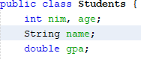
    - Create a constructor in Students class with parameters (int ni, String nm, int age, double gpa), as follows:
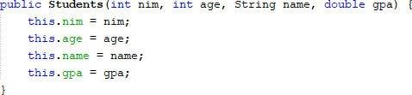

    - Create display() method with void as its return type
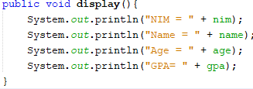

    - Create a new SearchStudent class as follows.
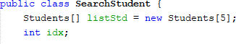

    - Create method add() at that class! This will be used for adding objects from Students
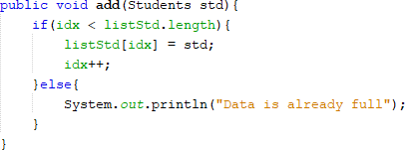
class to listStd attribute

    - Create method display() in class SearchStudent! This display() method will be used to print all student data available in this class. Pay attention on how we use for-loops differently (popularly known as foreach). Even so, the concepts are still the same

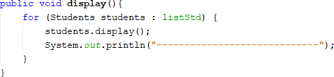
    - Create method findSeqSearch() with integer as its return type. Then fill in the function with sequential search algorithm.
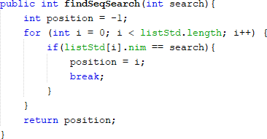
    - Create method showPosition() with void as its return type. And write the following code
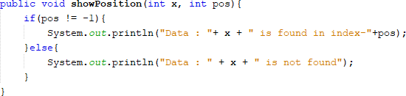
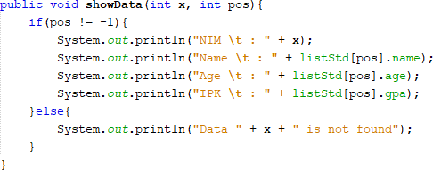
    - Create method showData() with void as its return type. And write the following code

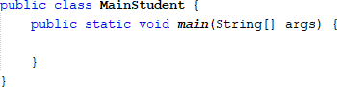
    - Create a main class named MainStudent and add main method as follows

    - In main method, instantiate an object in SearchStudent that consists of 5 Students,
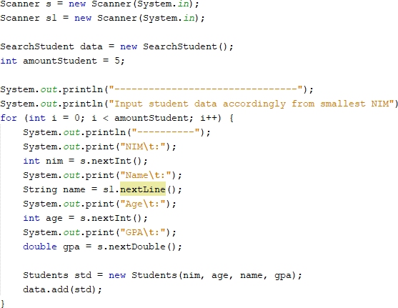
then add all students object by calling add() function in object SearchStudent

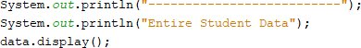
    - Add method display() to print all inserted data

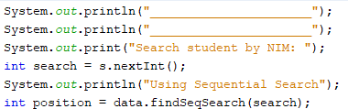
    - To search students by their NIM, create a search variable to hold input from user. Then call method findSeqSearch() with its parameter is the search variable we’ve declared before

    - Call method showPosition() from class SearchStudent.

    - Call method showData() from class SearchStudent

    - Run the program and see the result

Result
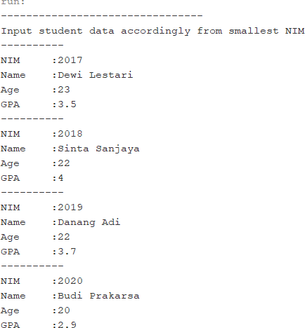
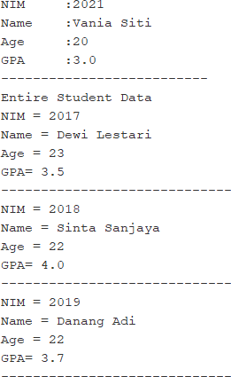
Match the output of your program code with following image

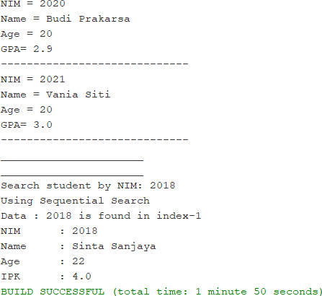
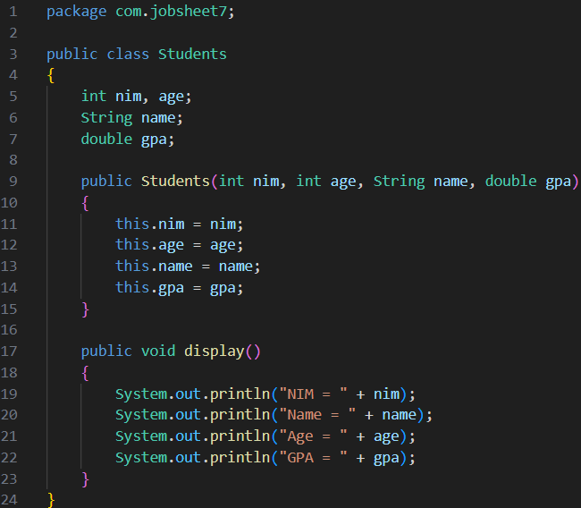
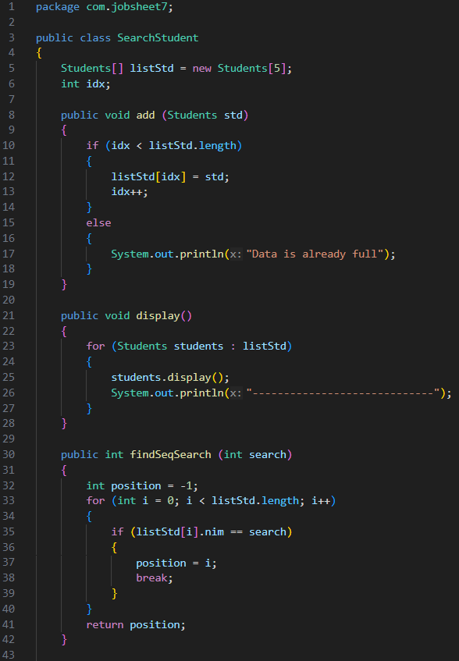
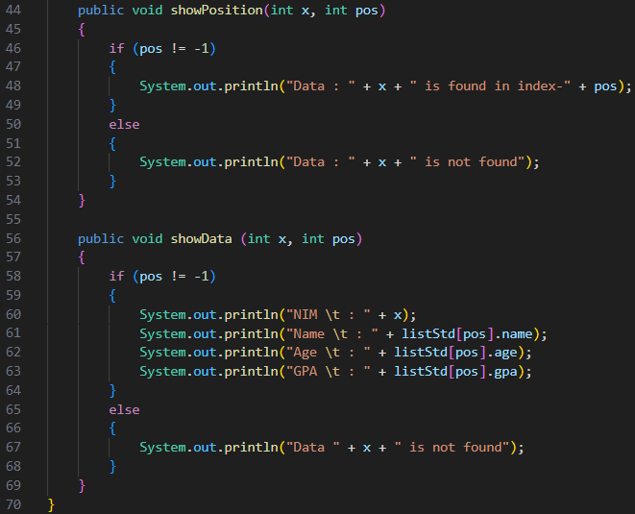
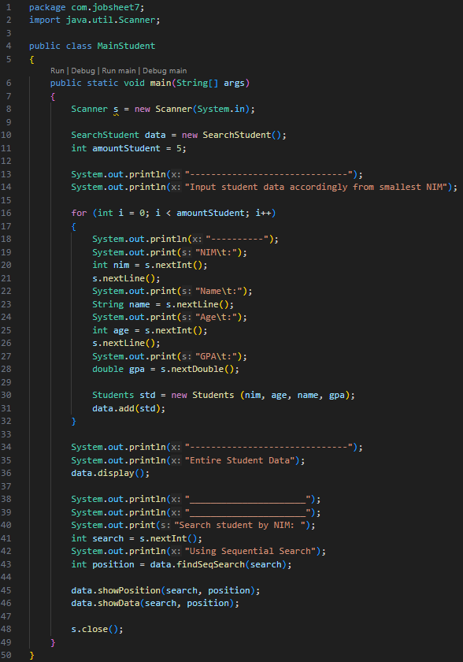
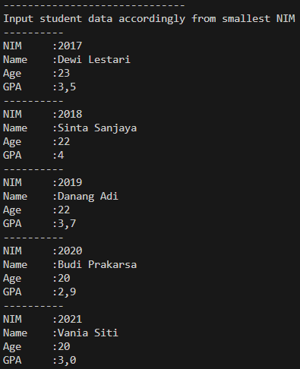
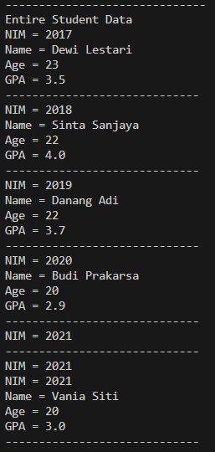
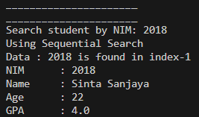

Question
    - What is the difference between the methods displayData and displayPosition in
StudentSearch class?
- displayData (showData) prints the full details of a student: NIM, name, age, and GPA.
- displayPosition (showPosition) only shows the location (index) of the student in the array.
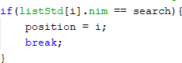
    - What is the function of break in this following program code?
The break statement immediately exits the loop once the student with the matching NIM is found.
    - If the NIM data inserted is not sorted from smallest to biggest value, will the program encounter an error? Is the result still correct? Why is that?
The program will not encounter an error because the search method used is sequential search, which does not require sorted data. The result will still be correct, because sequential search checks each element one by one until it finds a match.
    - Look at findSeqSearch method, why position is initialized by -1 instead of 0?
position = -1 is used as a sentinel value to indicate that the student was not found. If it were initialised to 0, the program might incorrectly assume that the student was found at index 0 even when no match exists.

Binary Search Method

Steps
      - Still in SearchStudent class, add a new method findBinarySearch() with integer as its data type. Then declare the content of method findBinarySearch with using binary search as its searching algorithm

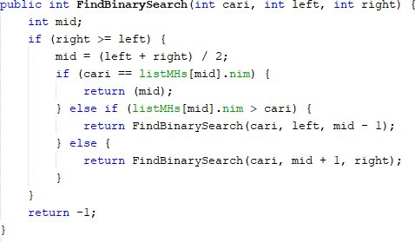
      - Call method findBinarySearch() from SearchStudent class in StudentsMain. Then call method

showPosition() and showData()
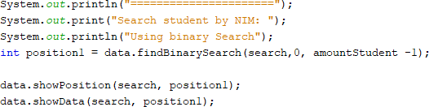
      - Run and see the result

Result
Match the output of your program code with following image

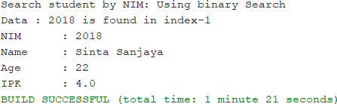





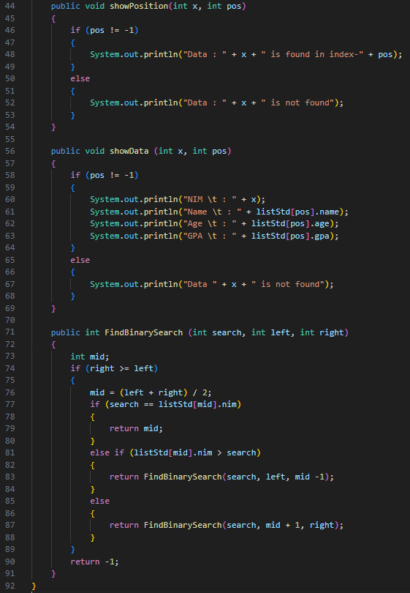

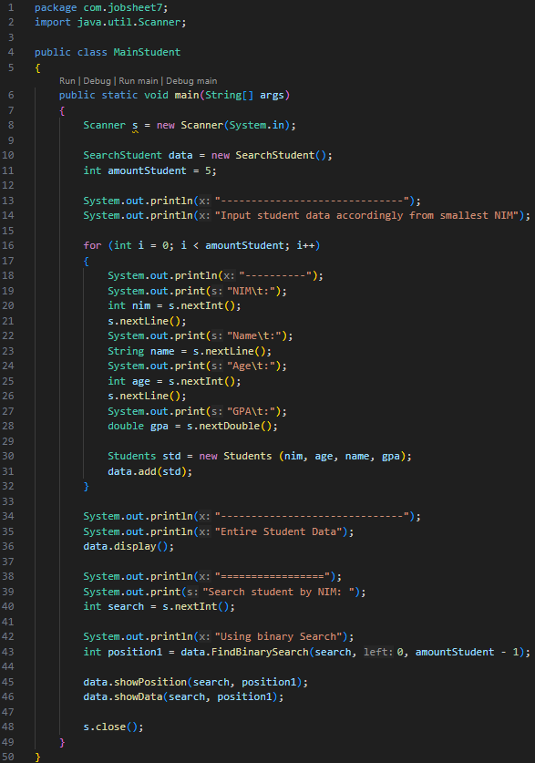
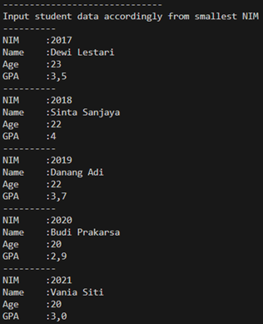



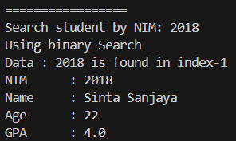

Question
- Show the program code in which runs the divide process!
- Show the program code in which runs the conquer process!
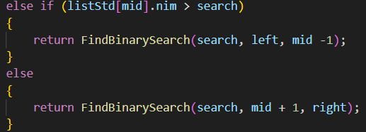
- If inserted NIM data is not sorted, will the program give the correct result? Why?
If inserted NIM data is sorted from largest to smallest value (e.g 20215, 20214 20212, 20211,20210) and element being searched is 20210. How is the result of binary search? does it return the correct one? if not, then change the code so that the binary search executed properly
- If the NIM data is not sorted, the binary search will not give the correct result. If the data is sorted in descending order (largest to smallest), the standard binary search will also fail, because the comparison logic assumes ascending order.
- If the array is [20215, 20214, 20212, 20211, 20210] and you search for 20210, the algorithm will not necessarily find it correctly.
- 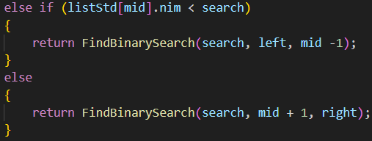
- Modify program above so that the students amount inserted is matched with user input
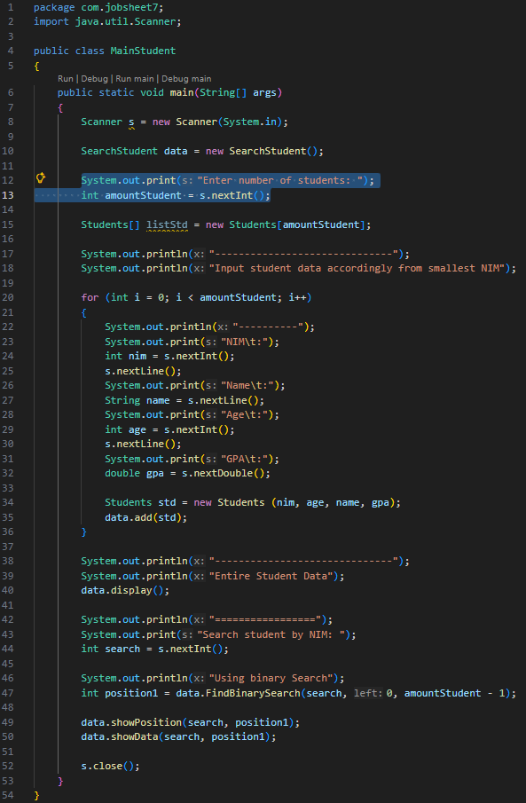

Review Divide and Conquer

Steps

      - Add a new class MergeSort
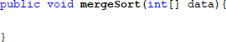
      - In this class, we will create method mergeSort() that receives an array in its parameter

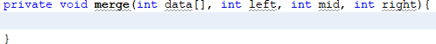
      - Create merge() method to do data merging process from left side to the right

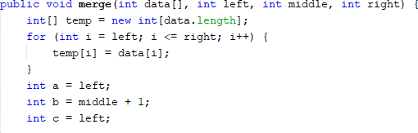
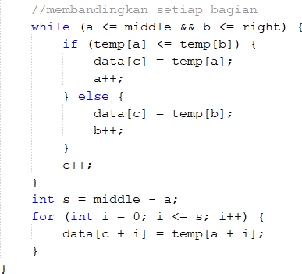
      - Implement merge() process as follows:

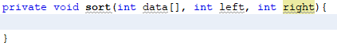
      - Create sort method

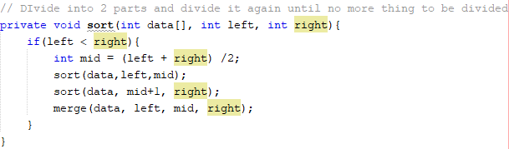
      - Implement these following codes in sort method

      - In method mergeSort, call method sort with the data that wants to be sorted and initial data range as its parameter
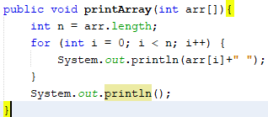
      - Add method printArray

      - Finally, declare the data to be sorted by using sorting process in SortMain class

7.2 Result
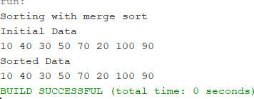
Match the output of your program code with following image
