Name: Deras Pangestu Gusti (08)

Class: SIB 1G

NIM: 254107060114

JOBSHEET - 6
SORTING (BUBBLE, SELECTION, DAN INSERTION SORT)

Course Leaning Outcome
After completing this practicum, students should be able to:
- Create sorting algorithms for bubble sort, selection sort, and insertion sort.
- Implement sorting algorithms (bubble sort, selection sort, and insertion sort) in a program.

Experiment 1 - Implementing Sorting Using Objects Duration : 60 minutes
    - Experiment Steps

SORTING – BUBBLE SORT
        - Create a new folder named week05.
        - Create a class Sorting<Attendance Number>, then add the following attributes:
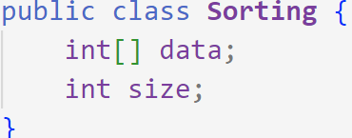
        - Create a constructor with parameters data[] and jmlDat.
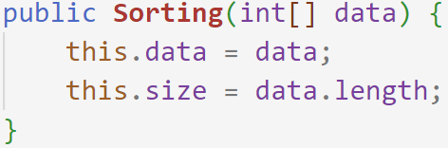
        - Create a bubbleSort method of type void and declare its contents using the Bubble Sort algorithm.
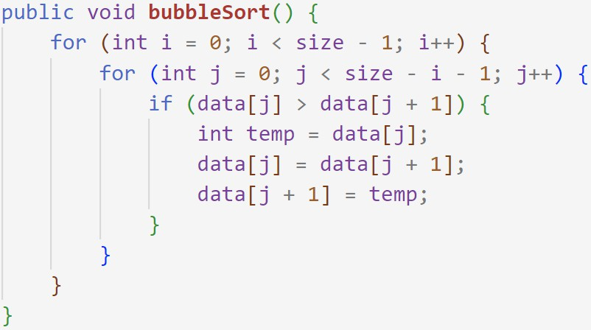

        - Create a print method of type void and declare the content of the method.
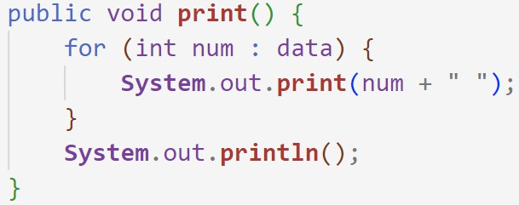
        - Create a class SortingMain<Attendance Number>, then declare an array named a[]
and fill it.

        - Create a new object named sorting1, which is an instantiation of the Sorting class, then fill in its parameters.
        - Call the bubbleSort and print methods.
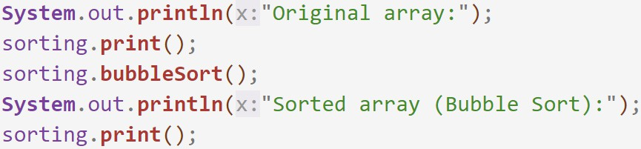
        - Run the program and observe the results.
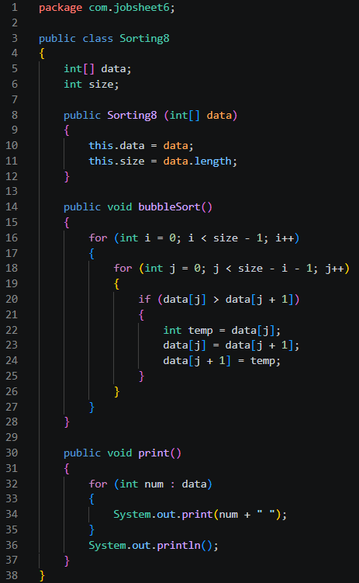
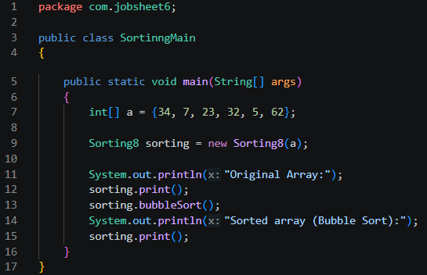
    - Verification of Experiment Results
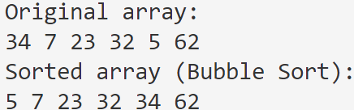

SORTING – SELECTION SORT
  - In the Sorting<Attendance Number> class created in the previous step, add the
selectionSort method that implements sorting using the selection sort algorithm.
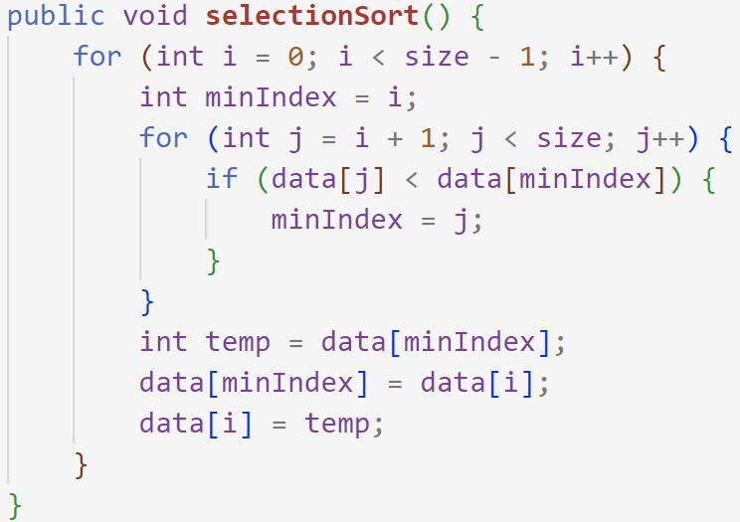

  - Declare an array named b[] in the SortingMain<Attendance Number> class, then fill it.

  - Create a new object named sorting2, which is an instantiation of the Sorting class, then assign in its parameters.
  - Call the selectionSort and print methods.
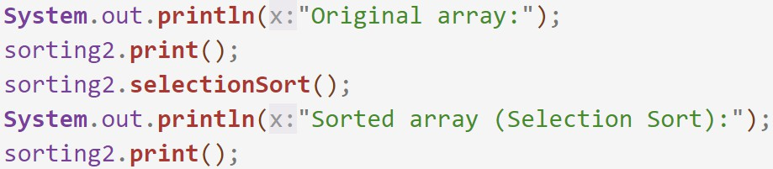

  - Run the program and observe the results.
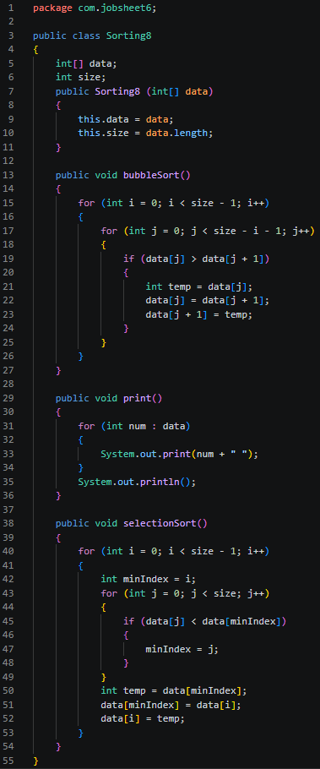
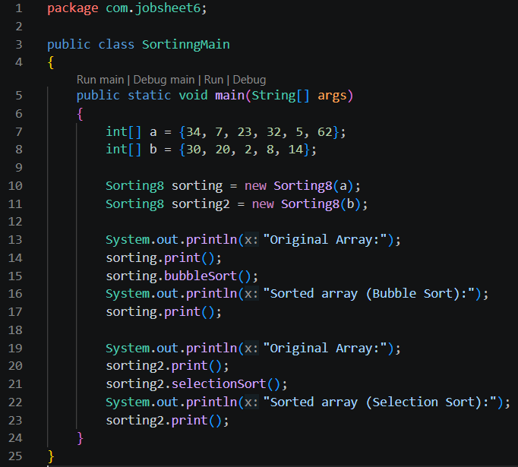
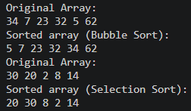
    - Verification of Experiment Results
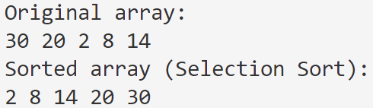

SORTING – INSERTION SORT
  - In the Sorting<Attendance Number> class created in the previous step, add the
insertionSort method that implements sorting using the insertion sort algorithm.
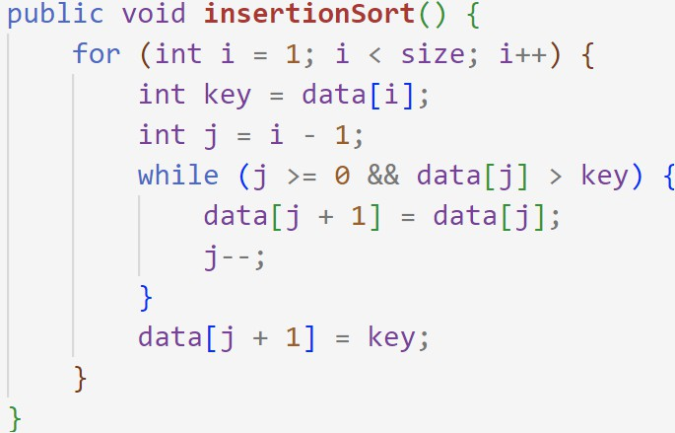
  - Declare an array named c[] in the SortingMain<Attendance Number> class, then fill it.
  - Create a new object named dataurut3, which is an instantiation of the Sorting class, then fill in its parameters.
  - Call the insertionSort and display methods.

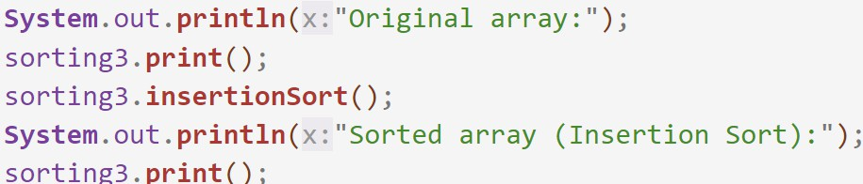

  - Run the program and observe the results!
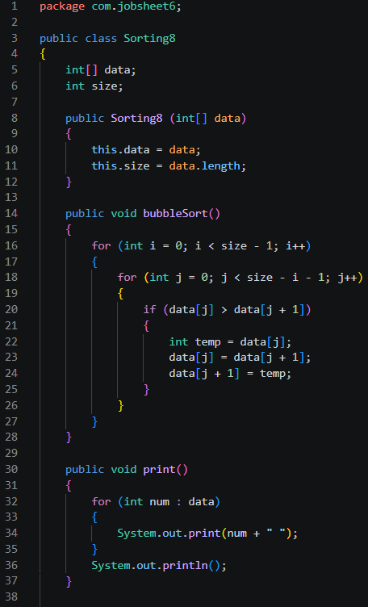
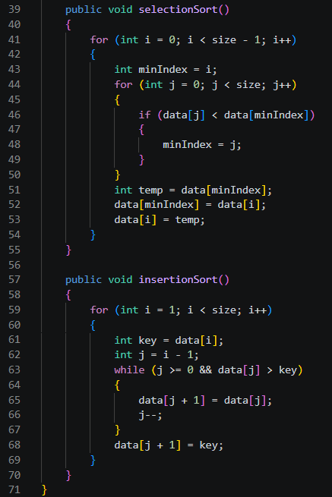
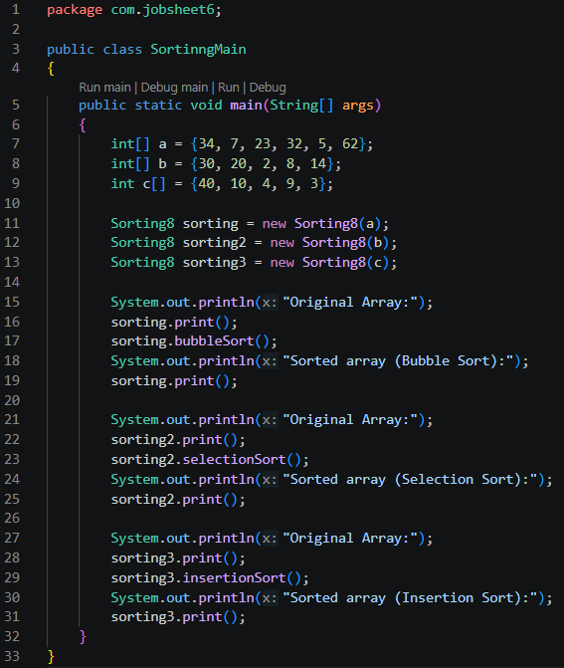
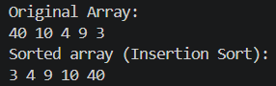

Verification of Experiment Results
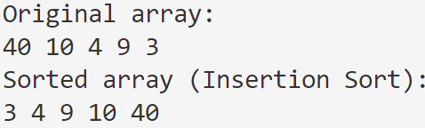

    - Questions!

- Explain the function of the following program code:
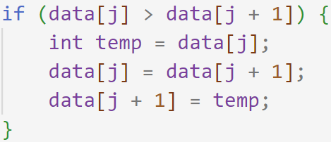
It compares two adjacent elements in the array. If the current element data[j] is greater than the next element data[j + 1], a swap is performed using a temporary variable temp.
- Show the program code that implements the minimum value search algorithm in selection sort!
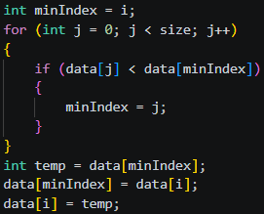
- In insertion sort, explain the purpose of the condition in the loop.
- j >= 0 Prevents the index from going out of bounds (below index 0).
- data[j] > key Keeps shifting elements to the right as long as they are larger than the key (the element being inserted).
- In insertion sort, what is the purpose of the given command?
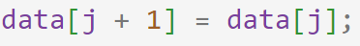
This command shifts the element at position j one position to the right (to position j + 1), making room for the key to be inserted in its correct sorted position. It simply copies it one slot forward.

Experiment 2- Sorting Using an Array of Objects Duration: 45 minutes
    - Experiment Steps - Sorting Student Data Based on GPA (Bubble Sort)
Observe the Student class diagram below! This diagram will serve as a reference for creating the Student class.
Student
nim: String name: String
studentClass: String
gpa: double
Student ()
Student (nm: String, name: String, clsNm: String, gpa: double)
print(): void

The Student class will be used to create student objects that will be inserted into an array. It has a default constructor, a parameterized constructor, and a function print() to show all attributes data.
TopStudents
listStudent: Student[5]
idx: int
add(std: Student): void print(): void
bubbleSort(): void
This class performs operations on the array of student objects, such as adding, displaying, and sorting students using the Bubble Sort algorithm based on GPA.

Experiment Steps
- Create a class named Student<Attendance Number>.
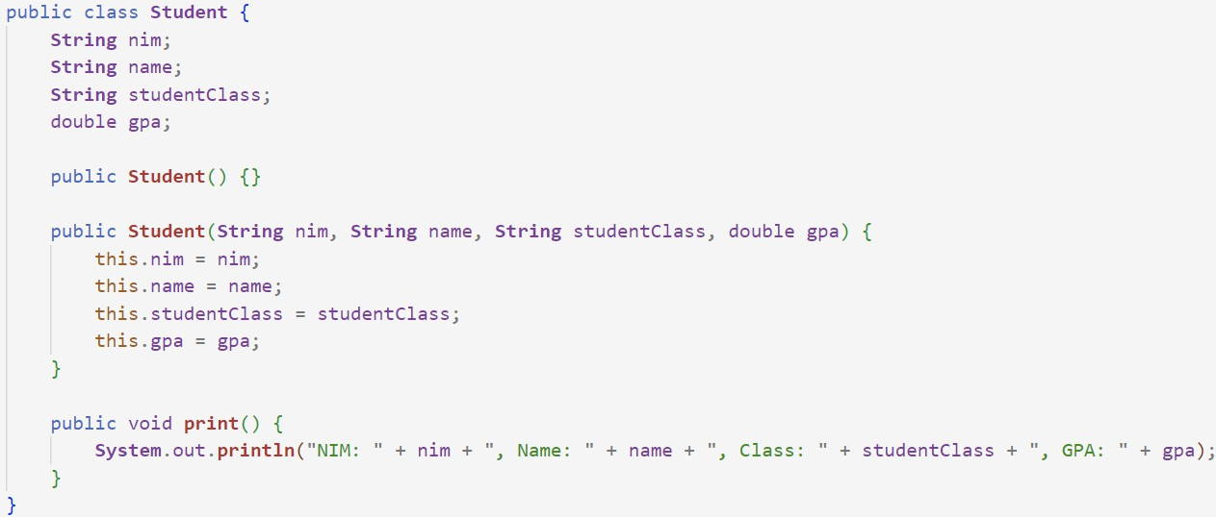
- Complete the Student class with the following code!

- Create a class TopStudents<Attendance Number>.
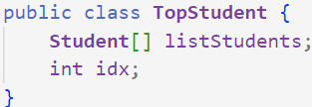
- Add a method add() in this class to insert student objects into the listStudents attribute.

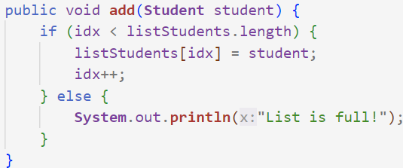
- Add a method print() in this class to display all students.
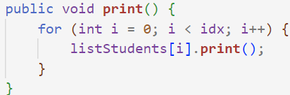
- Add a method bubbleSort() in this class!
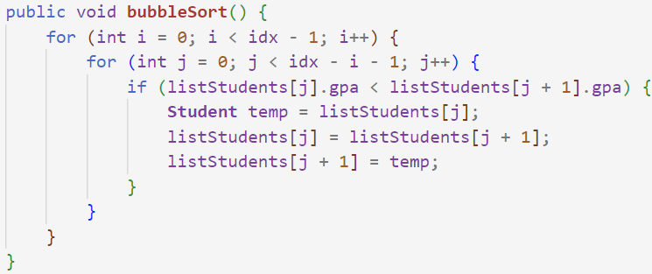
- Create a class StudentDemo<Attendance Number>, instantiate a TopStudents object, create 5 student objects, and add them using the add function. Call print(), then sort the data using bubbleSort(), and finally call print() again.
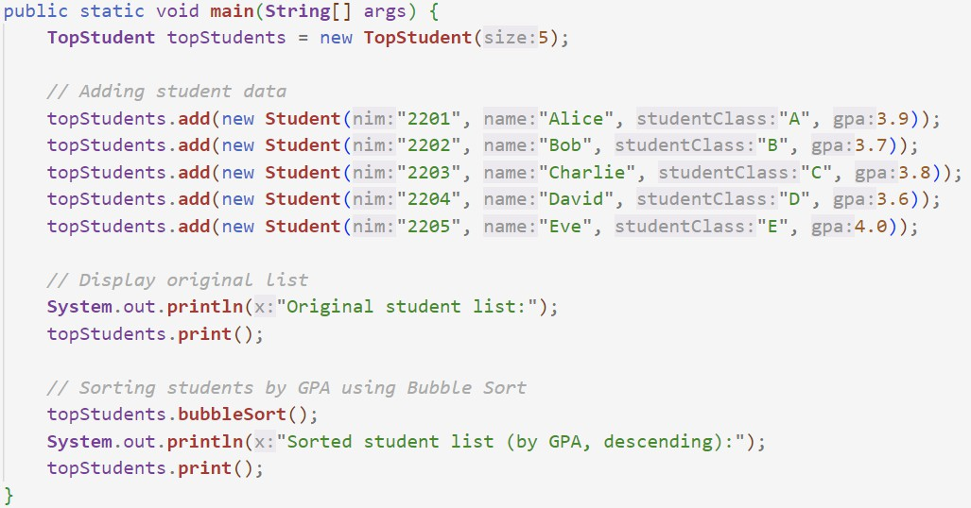

Verification of Experiment Results
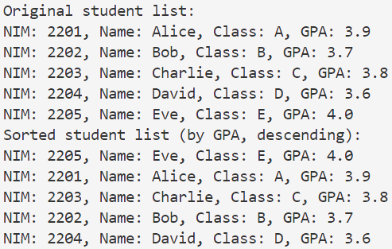
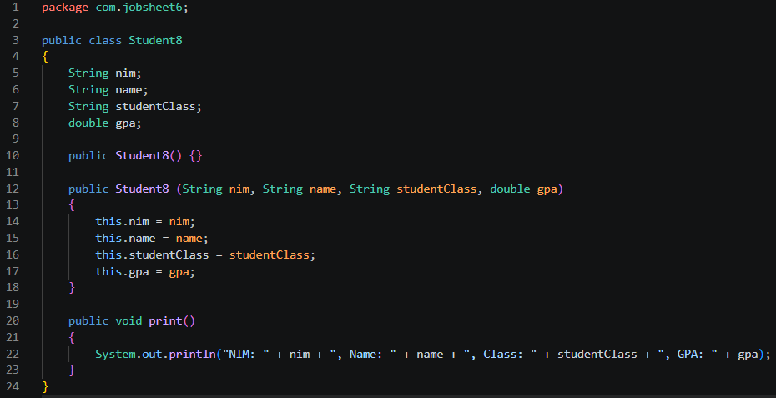
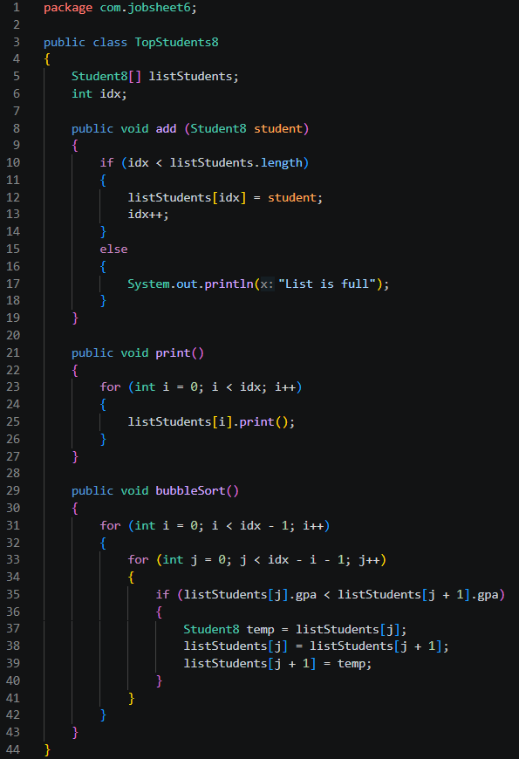
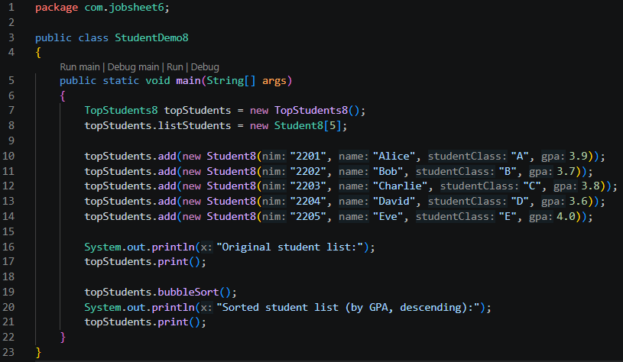
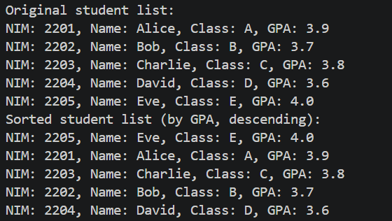
    - Questions!
- From the following code snippet, answer question a-c:
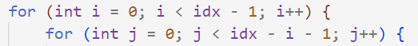
  - Why is the condition in the bubbleSort() loop i < idx - 1?
The outer loop controls the number of passes through the array. After each pass, the largest unsorted element is guaranteed to be placed at its correct position at the end.
  - Why is the condition in the bubbleSort() loop j < idx - i - 1?
After each pass i, the last i elements are already sorted and in their final positions. There is no need to compare those elements again.
  - If the number of data in listStudents is 50, how many times will the i loop execute? How many stages of Bubble Sort will be performed?
- Number of i loop executions: idx - 1 = 50 - 1 = 49 times
- Number of Bubble Sort stages (total comparisons): 49 + 48 + 47 + … + 1 = $\frac{49 × 50}{2}$ = 1,225 comparisons
- Modify the above program to allow dynamic student data input (from the keyboard) consisting of nim, name, studentClass, and gpa.
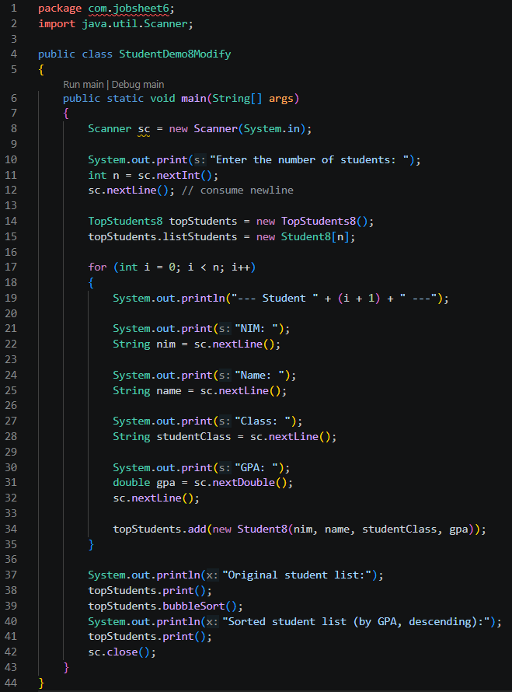

Sorting Student Data Based on GPA (Selection Sort) Duration: 30 minutes
If we previously sorted students based on GPA using Bubble Sort in descending order, we will now add a function to sort using Selection Sort in ascending order.

Experiment Steps
- Modify TopStudents to include a selectionSort() method.
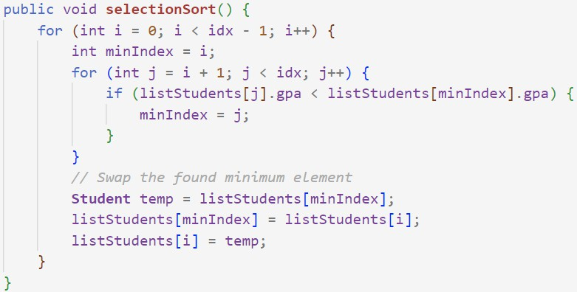

- Modify StudentDemo and add program lines in main() to call selectionSort() and print().
- Run StudentDemo and observe if the data is sorted in ascending order.
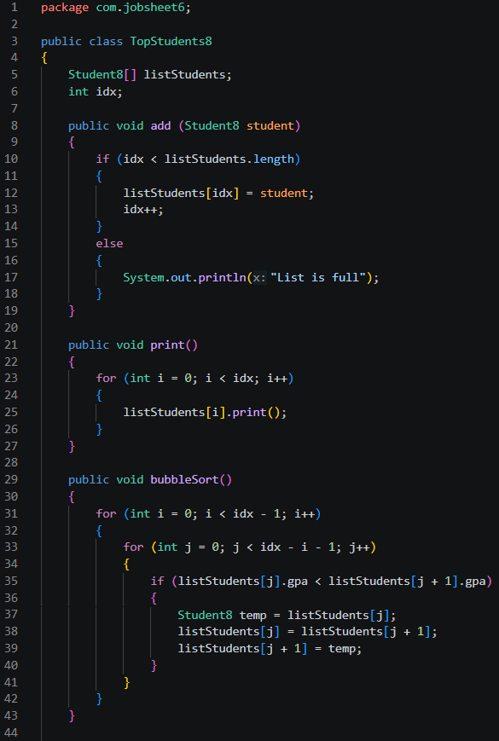
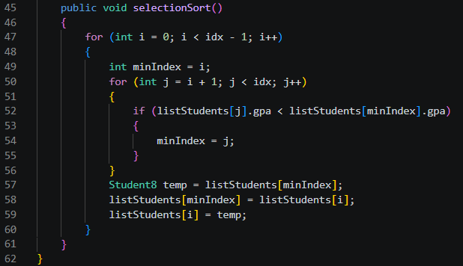
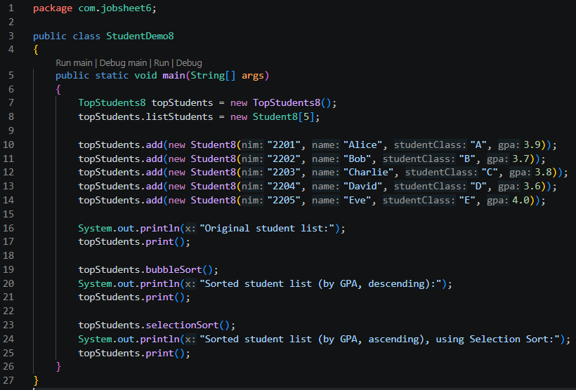
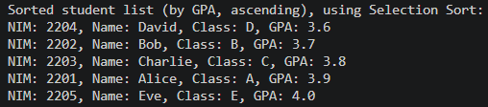

Verification of Experiment Results
Make sure the output of your code is like the following image.
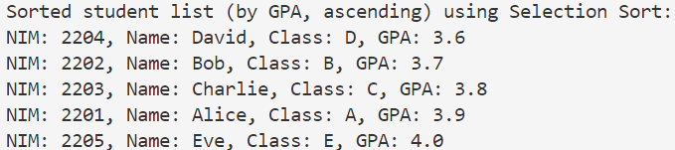

Questions!
Explain the following code snippet in the correlation with the selection sort!
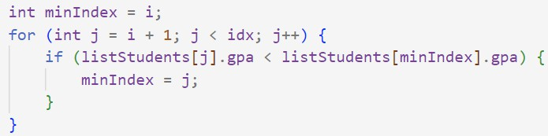

It sorts objects by comparing a specific attribute (gpa). Each pass guarantees that the student with the lowest GPA among the remaining unsorted students is moved to its correct position, resulting in a list sorted by GPA in ascending order.

Sorting Student Data Based on GPA Using Insertion Sort Duration: 30 minutes
    - Experiment Steps
- Modify TopStudents to include an insertionSort() method.
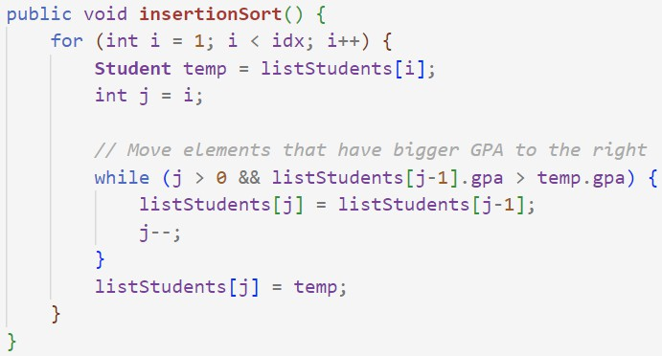
- Modify StudentDemo and add program lines in main() to call insertionSort() and print().

- Run StudentDemo and observe if the data is sorted in ascending order.
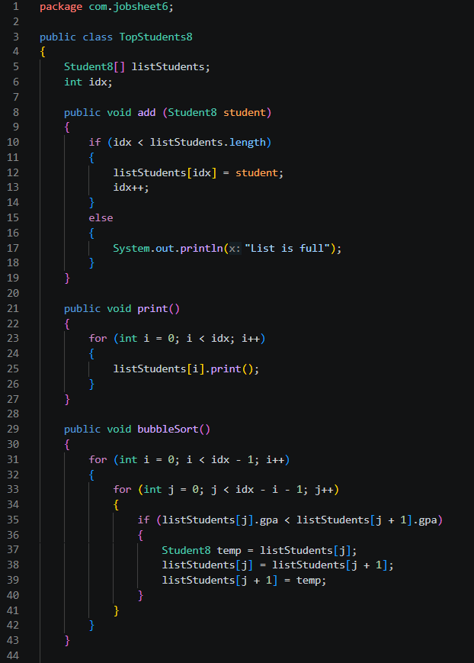
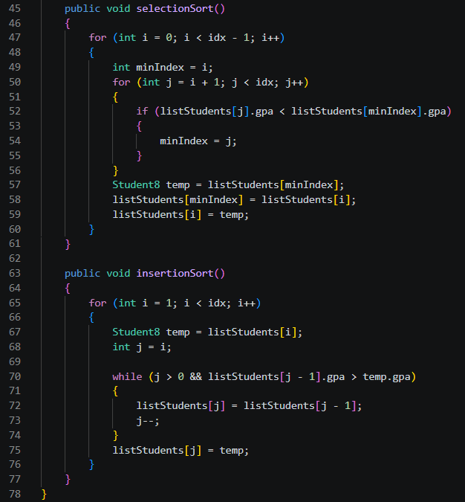
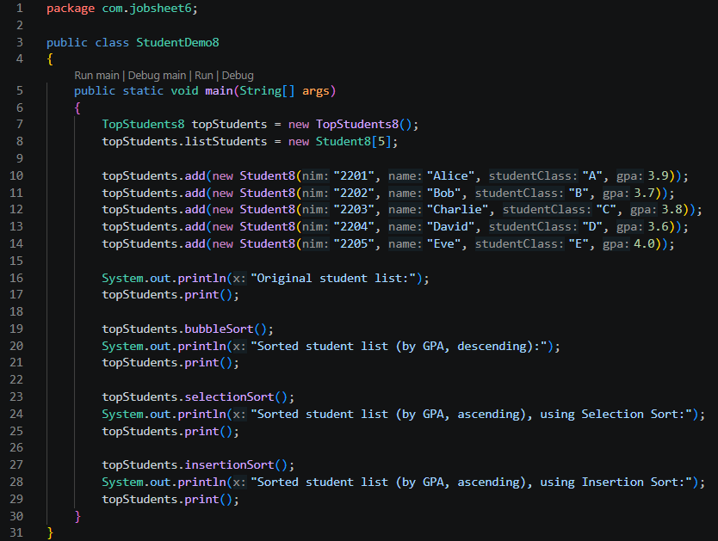
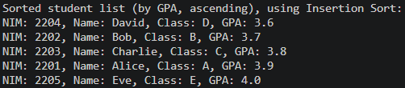

Verification of Experiment Results
Make sure the output of your code is like the following image.
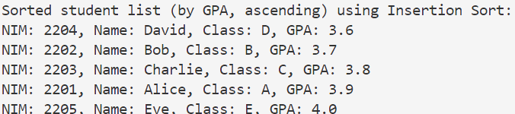

Question
Modify the insertionSort() method so that it can perform a descending sorting!
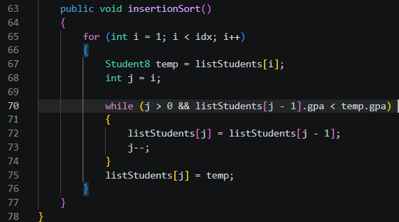

Assignment
Duration: 45 minutes
Observe the following class diagram and create a program that performs the following menu options:
- Add Data - Add lecturer data.
- Display Data - Show all lecturer data.
- Sort ASC - Sort lecturers by age from youngest to oldest using Bubble Sort.
- Sort DSC - Sort lecturers by age from oldest to youngest using Selection Sort or Insertion Sort.
Lecturer
id: String name: String
gender: Boolean
age: int
Lecturer(id: String, name: String, gender: Boolean, age: int)
print(): void

LecturerData
lecturerData: Lecturer[10]
idx: int
add(dsn: Dosen): void
print(): void

sortingASC(): void
sortingDSC():void

