JIRA TOOL

AJIRA tool: It is used for **bug tracking, issue tracking,**and**project management**. The basic use of this tool is to track issues, and bugs related to your software and mobile apps. It is also used for project management. The JIRA dashboard consists of many useful functions and features which make handling of issues easy.

Under Issues, you will find other useful features like

* Issue Types
* Workflow's
* Screens
* Fields
* Issue Attributes
* **JIRA ISSUES:**
* Issue Type displays all types of items that can be created and tracked via JIRA. JIRA Issues are classified under various forms like new feature, sub-task, bug, etc.

There are two types of Issue types schemes in JIRA, one is

* **Default Issue Type Scheme:**In default issue type scheme all newly created issues will be added automatically to this scheme
* **Agile Scrum Issue Type Scheme:**Issues and project associated with Agile Scrum will use this scheme
* Apart from these two issue type schemes, you can also add schemes manually as per requirement, for example we have created **IT & Support** scheme, for these we will **drag and drop** the issue types from the **Available Issue type to Issue type for current scheme.**

JIRA COMPONENTS: Components are sub-sections of a project; they are used to group issues within a project into smaller parts. Components add some structures to the projects, breaking it up into features, teams, modules, subprojects and more. Using components you can generate reports, collect statistics, and display it on dashboards and so on.

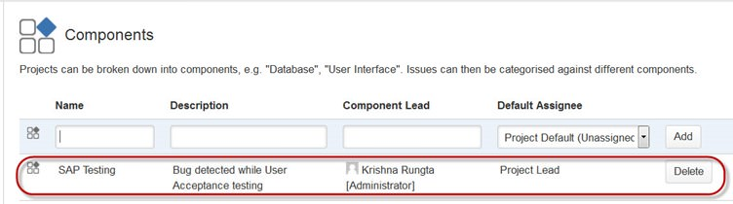­­­­­­­

**JIRA SCREEN**: When issue is created in JIRA, it will be arranged and represented into different fields, this display of field in JIRA is known as a screen. This field can be transitioned and edited through workflow. For each issue, you can assign the screen type as shown in the screen-shot. To add or associate an issue operation with a screen you have to go in main menu and click on **Issues** then click on Screen **Schemes** and then click on **"Associate an issue operation with a screen"**and add the screen according to the requirement.

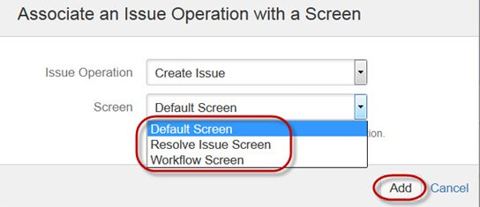

**ISSUE ATTRIBUTES:** Issue Attributes encompasses

* Statuses
* Resolutions
* Priorities

Statuses: Different statuses are used to indicate the progress of a project like To do, InProgress, Open, Closed, ReOpened, and Resolved.Likewise, you have resolutions and priorities, in resolution it again tells about the progress of issue like Fixed, Won't fix, Duplicate, Incomplete, Cannot reproduce, Donealso you can set the priorities of the issue whether an issue is critical, major, minor, blocker and Trivial.

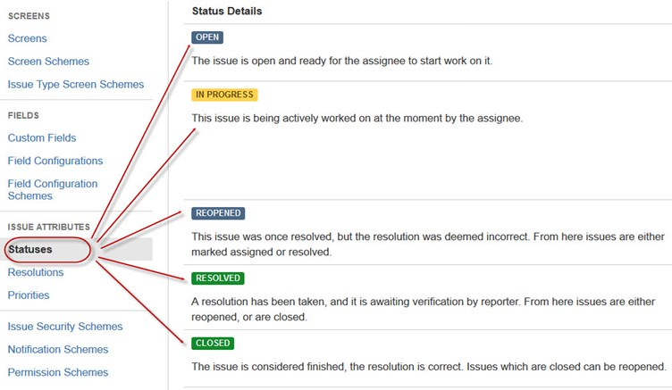

**HOW TO CREATE AN ISSUE:** JIRA Dashboard will open when you enter your user ID and password. Under JIRA dashboard you will find option **Project,**when you click on it, it will open a window that list out options like **Simple Issue Tracking, Project Management, Agile Kanban, Jira Classic** and so on as shown in screen shot below.

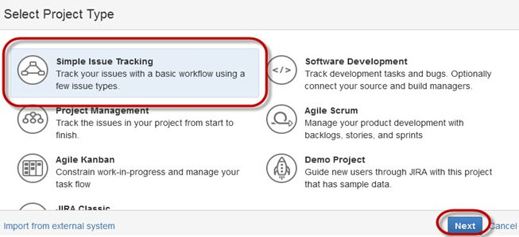

When you click on option Simple Issue Tracking,another window will open, where you can mention all the details about the issue and also assign the issue to the responsible person.

[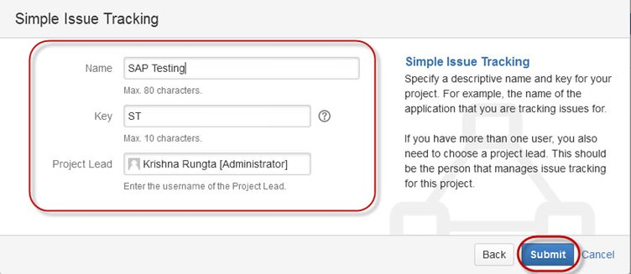](http://cdn.guru99.com/images/jira/111014_0555_JIRA8.jpg)

When you click on "Submit" button, a window will open where you can perform a list of work like creating issues, assigning issues, check the status of issues like- resolved, In-Progress or closed and so on.

ssigning issues, check the status of issues like- resolved, In-Progress or closed and so on.

[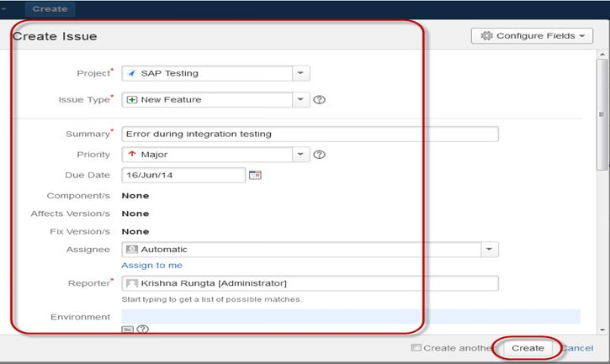](http://cdn.guru99.com/images/jira/111014_0555_JIRA9.jpg)

Once the issue is created a pop-up will appear on your screen saying your issue is created successfully as shown in the screen shot below

[](http://cdn.guru99.com/images/jira/111014_0555_JIRA10.jpg)

Now if you want to edit an issue or you want to export the issue to XML or Word document, then you can hover your mouse on main panel and click on **Issues**. Under **Issues** options click on **search for issues**that will open a window from where you can locate your issues and perform multiple functions.

[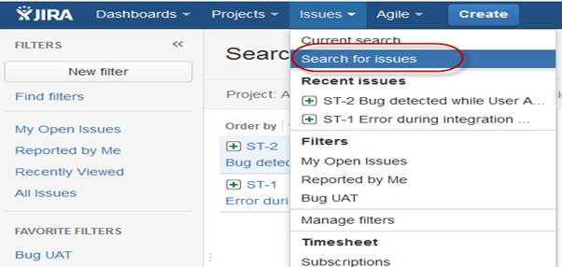](http://cdn.guru99.com/images/jira/111014_0555_JIRA11.png)

When you select the **"search for Issues"** under **Issues,** a window will appear as shown in the screen shot

[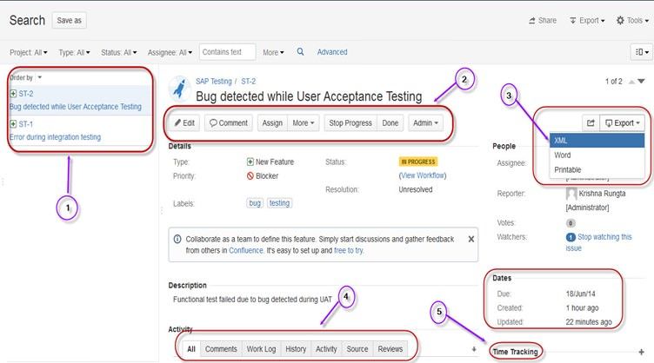](http://cdn.guru99.com/images/jira/111014_0555_JIRA12.jpg)

1. **Search for issues** option will bring you to a window where you can see the issues created by you like here we have issues ST1 and ST2
2. Here in the screen shot you can see the issue "Bug detected while User Acceptance Testing"and all the details related to it. From here, you can perform multiple tasks like you can stop the progress on issues, edit the issues, comment on the issues, assigning issuesand so on
3. Even you can export issue details to a XML or Word document.
4. Also, you can view activity going on the issue, reviews on the issue, work log, history of the issue and so on.
5. Under the time tracking option, you can even see the estimation time to resolve the issues

In the same window, you can set a filter for the issue and save them under **Favorite Filters**, so when you want to search or view a particular issue you can locate it using the filter.

To view the summary of the issue, you can click on options **summary,** this will open a window which will show all the details of your project and progress on this chart. On the right-hand side of the summary window, there is an **Activity Stream**which gives the details about the issues and comments made by the assignee on the issue.

[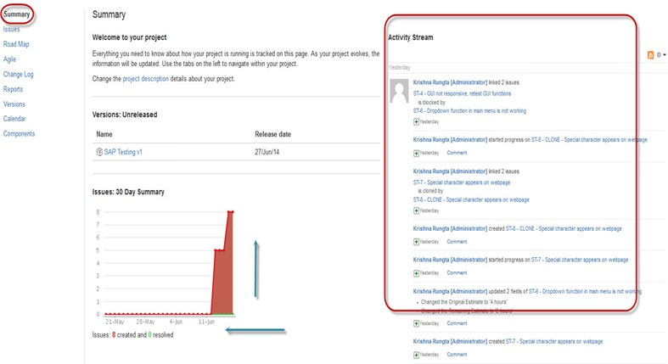](http://cdn.guru99.com/images/jira/111014_0555_JIRA13.jpg)

**Sub-Task**

Subtask issues are useful for splitting up a parent issue into a number of smaller tasks that can be assigned and tracked separately. It addresses issues more comprehensively and segregates the task into smaller chunks of task to do.

**How to create Sub-Task**

Sub-Task can be created in two ways

* Create sub-task under parent issue
* Creating an issue into a sub-task

To create sub-task in JIRA, you have to select an issue in which you want to assign the sub-task. Under the issue window, click on **Assign more** option, and then click on **create sub-task** as shown in the screenshot below. You can also select **convert to sub-task**under same tab to convert the parent issue into a sub-task.

[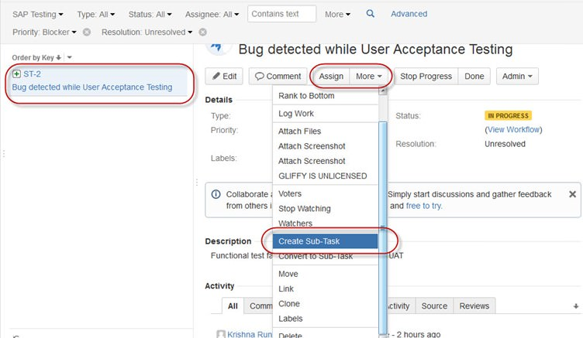](http://cdn.guru99.com/images/jira/111014_0555_JIRA14.jpg)

Once you click on **Create Sub-Task**, a window will pop up to add sub-task issue. Fill up the details about the sub-task and click on **Create**as shown in below screen-shot,and this will create sub-task for the parent issue.

[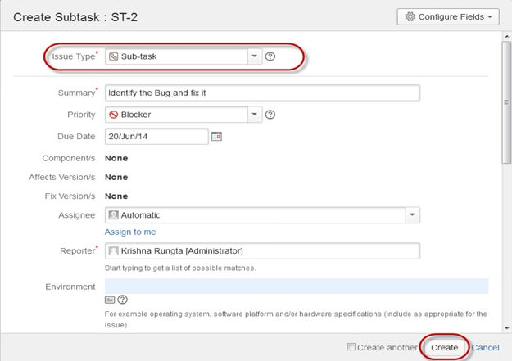](http://cdn.guru99.com/images/jira/111014_0555_JIRA15.jpg)

It will create a sub-task under parent issues, and details will appear about when to complete the task on the issue type page as shown in the screenshot below. If you would like to add more sub-task, you can click on the plus (+) sign on the corner of the sub-task panel. Likewise, if you want to note down the time spent on the present task, click on (+) plus sign in the corner of the time tracking and put down the details in the log sheet.

[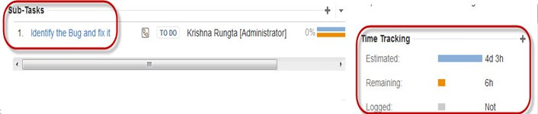](http://cdn.guru99.com/images/jira/111014_0555_JIRA16.jpg)

Some important points to remember while creating Sub-Task

* You can have as many sub-task as needed under an Issue
* You cannot have a sub-task for a sub-task
* Once a sub-task is created under a parent, parent cannot be converted into a sub-task
* A sub-task can however be converted into a parent issue

You can work on your sub-task without having navigating away from the parent issue.